**Ee**

|  |  |  |  |
| --- | --- | --- | --- |
| **E** | **E** | **E** | **E** |
| **E** | **E** | **E** | **E** |
| **E** | **E** | **E** | **E** |
| **E** | **E** | **E** | **E** |
| **E** | **E** | **E** | **E** |
| **E** | **E** | **E** | **E** |
| **E** | **E** | **E** | **E** |
| **E** | **E** | **E** | **E** |

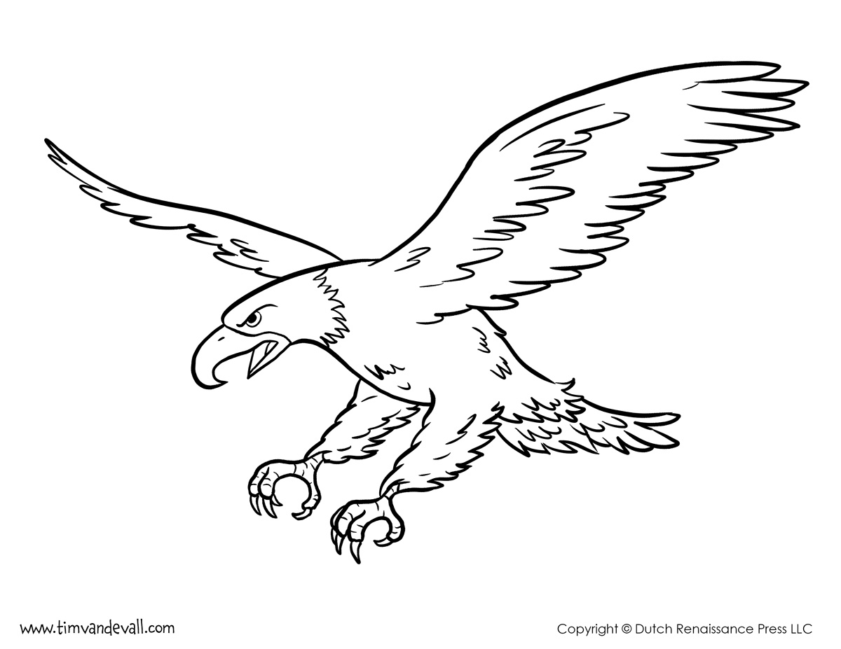

**Elang**

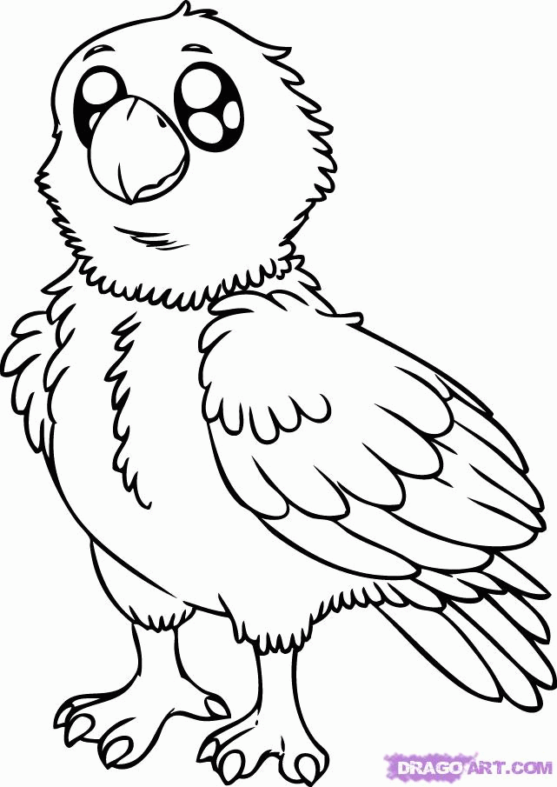

**Ee**

|  |  |  |  |
| --- | --- | --- | --- |
| **e** | **e** | **e** | **e** |
| **e** | **e** | **e** | **e** |
| **e** | **e** | **e** | **e** |
| **e** | **e** | **e** | **e** |
| **e** | **e** | **e** | **e** |
| **e** | **e** | **e** | **e** |
| **e** | **e** | **e** | **e** |
| **e** | **e** | **e** | **e** |

**Elang**