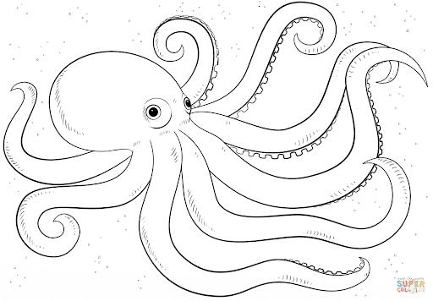

**Gg**

|  |  |  |  |
| --- | --- | --- | --- |
| **G** | **G** | **G** | **G** |
| **G** | **G** | **G** | **G** |
| **G** | **G** | **G** | **G** |
| **G** | **G** | **G** | **G** |
| **G** | **G** | **G** | **G** |
| **G** | **G** | **G** | **G** |
| **G** | **G** | **G** | **G** |
| **G** | **G** | **G** | **G** |

**Gurita**

**Gg**

|  |  |  |  |
| --- | --- | --- | --- |
| **g** | **g** | **g** | **g** |
| g | g | g | g |
| g | g | g | g |
| g | g | g | g |
| g | g | g | g |
| g | g | g | g |
| g | g | g | g |
| g | g | g | g |



**Gurita**