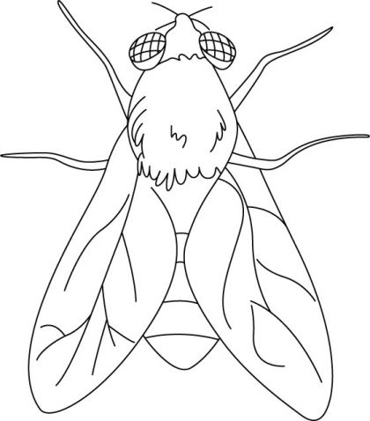

**Lalat**

**Ll**

|  |  |  |  |
| --- | --- | --- | --- |
| **L** | **L** | **L** | **L** |
| **L** | **L** | **L** | **L** |
| **L** | **L** | **L** | **L** |
| **L** | **L** | **L** | **L** |
| **L** | **L** | **L** | **L** |
| **L** | **L** | **L** | **L** |
| **L** | **L** | **L** | **L** |
| **L** | **L** | **L** | **L** |

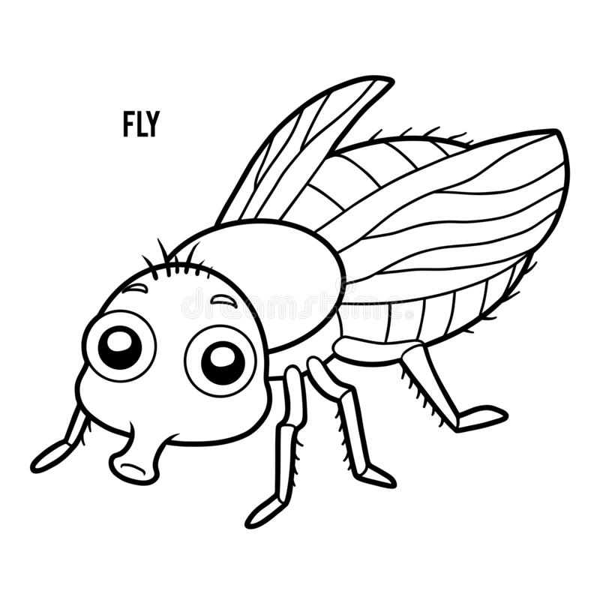

**Lalat**

**Ll**

|  |  |  |  |
| --- | --- | --- | --- |
| **l** | **l** | **l** | **l** |
| l | l | l | l |
| l | l | l | l |
| l | l | l | l |
| l | l | l | l |
| l | l | l | l |
| l | l | l | l |
| l | l | l | l |