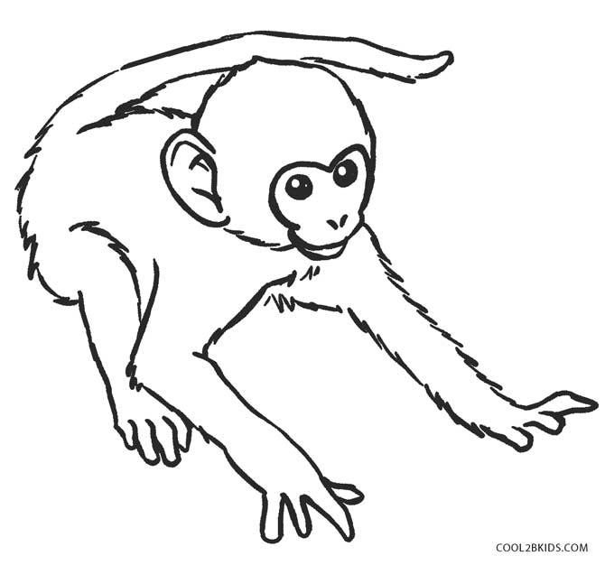

**Mm**

|  |  |  |  |
| --- | --- | --- | --- |
| **M** | **M** | **M** | **M** |
| **M** | **M** | **M** | **M** |
| **M** | **M** | **M** | **M** |
| **M** | **M** | **M** | **M** |
| **M** | **M** | **M** | **M** |
| **M** | **M** | **M** | **M** |
| **M** | **M** | **M** | **M** |
| **M** | **M** | **M** | **M** |

**Monyet**

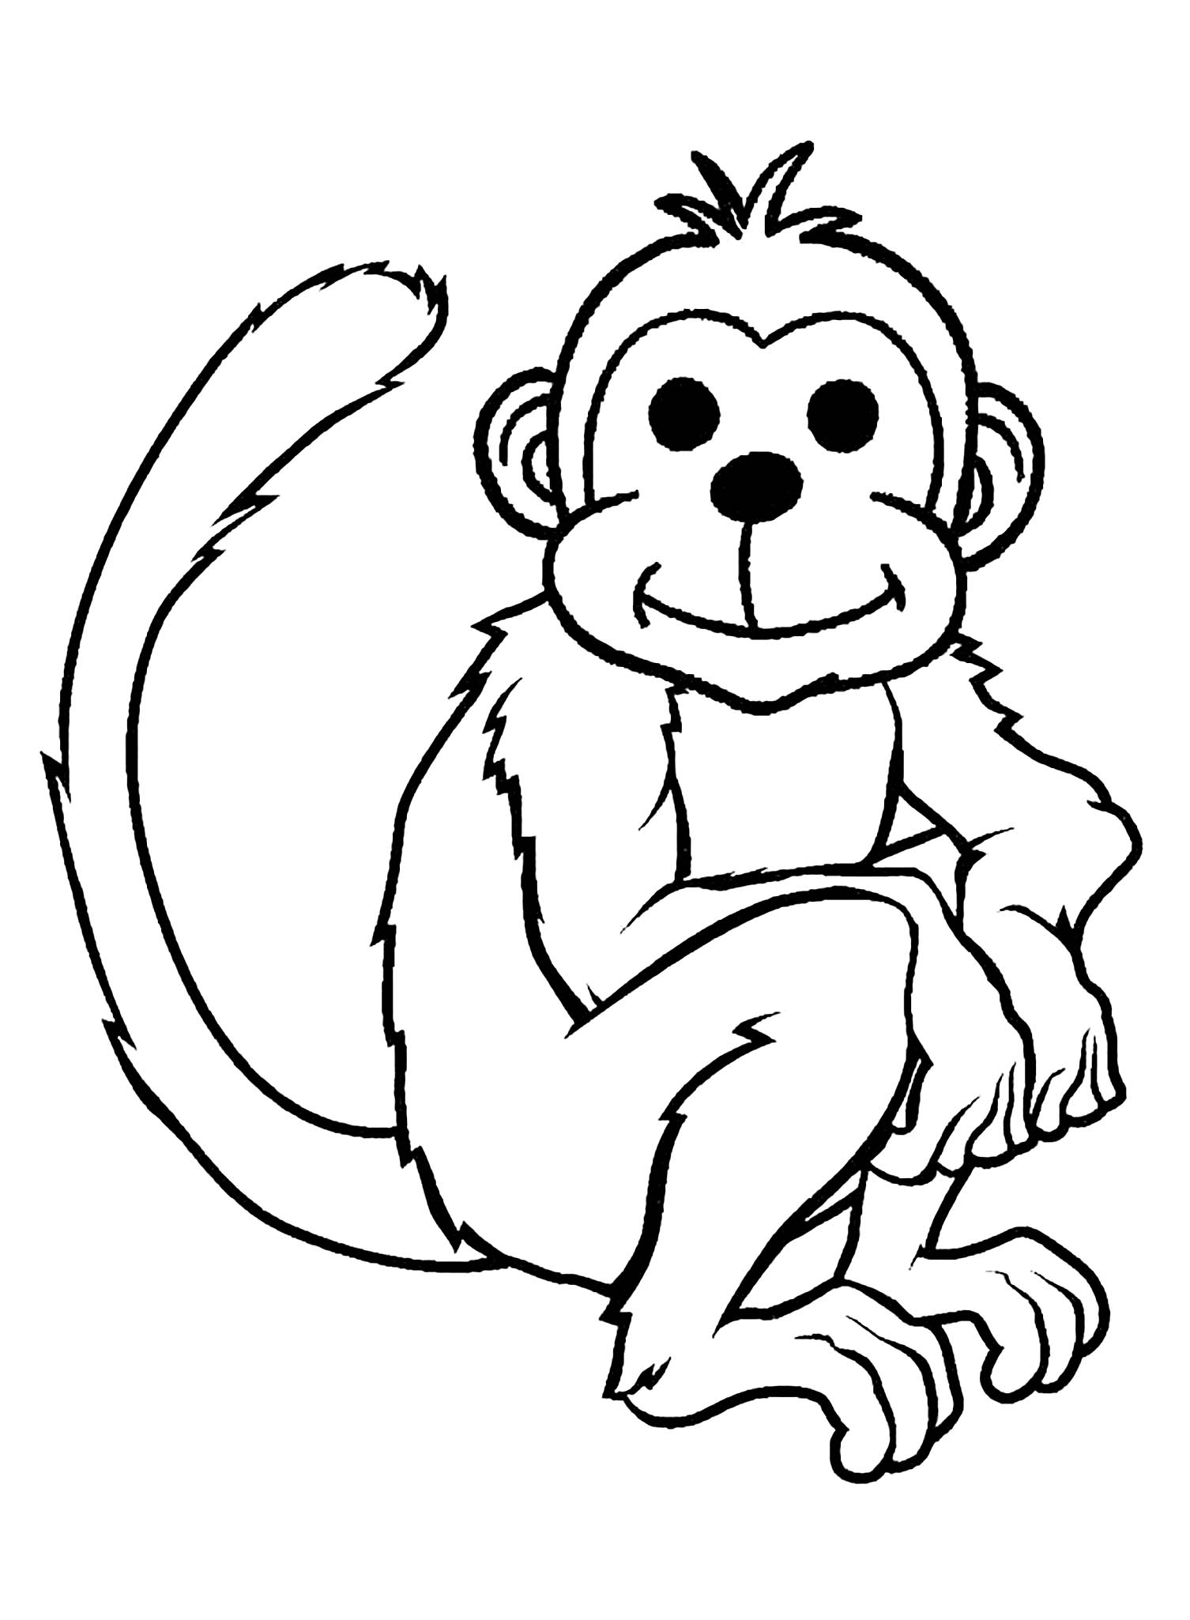

**Mm**

|  |  |  |  |
| --- | --- | --- | --- |
| **m** | **m** | **m** | **m** |
| m | m | m | m |
| m | m | m | m |
| m | m | m | m |
| m | m | m | m |
| m | m | m | m |
| m | m | m | m |
| m | m | m | m |

**Monyet**