**Nn**

|  |  |  |  |
| --- | --- | --- | --- |
| **N** | **N** | **N** | **N** |
| **N** | **N** | **N** | **N** |
| **N** | **N** | **N** | **N** |
| **N** | **N** | **N** | **N** |
| **N** | **N** | **N** | **N** |
| **N** | **N** | **N** | **N** |
| **N** | **N** | **N** | **N** |
| **N** | **N** | **N** | **N** |

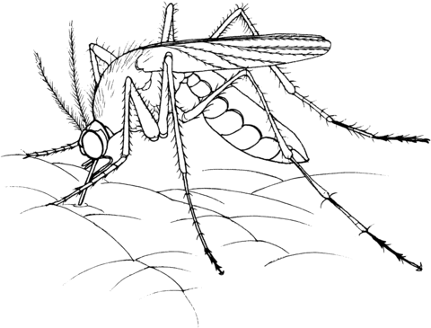

**Nyamuk**

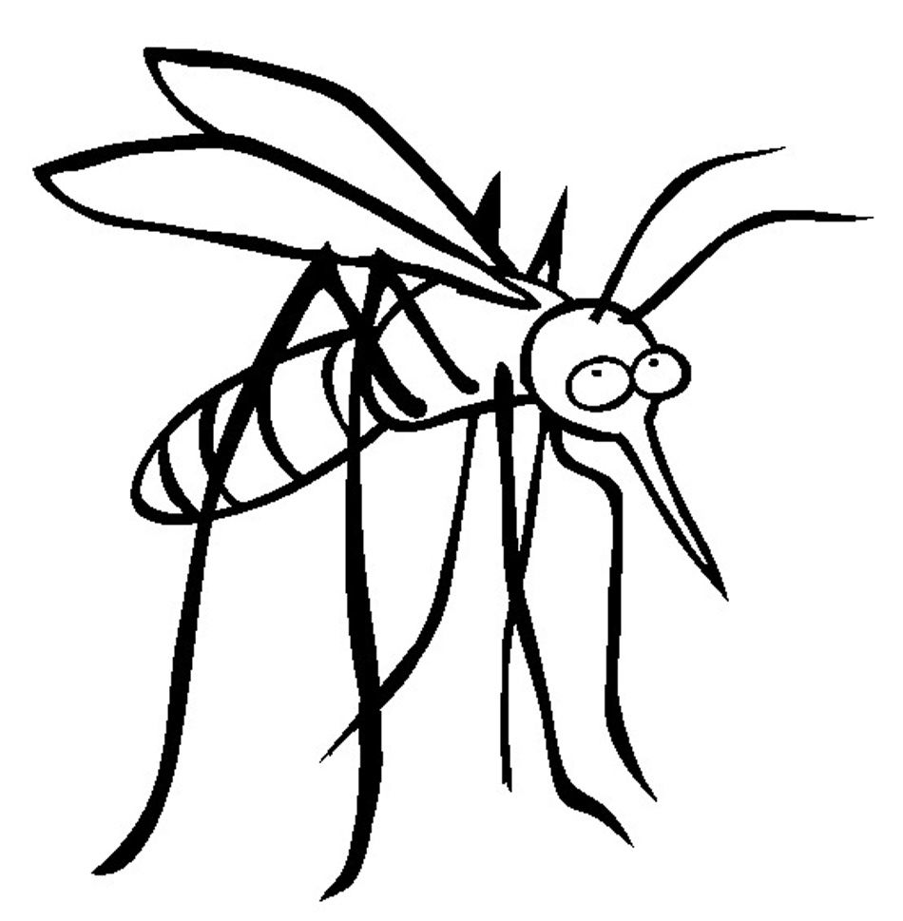

**Nn**

|  |  |  |  |
| --- | --- | --- | --- |
| **n** | **n** | **n** | **n** |
| **n** | **n** | **n** | **n** |
| **n** | **n** | **n** | **n** |
| **n** | **n** | **n** | **n** |
| **n** | **n** | **n** | **n** |
| **n** | **n** | **n** | **n** |
| **n** | **n** | **n** | **n** |
| **n** | **n** | **n** | **n** |

**Nyamuk**