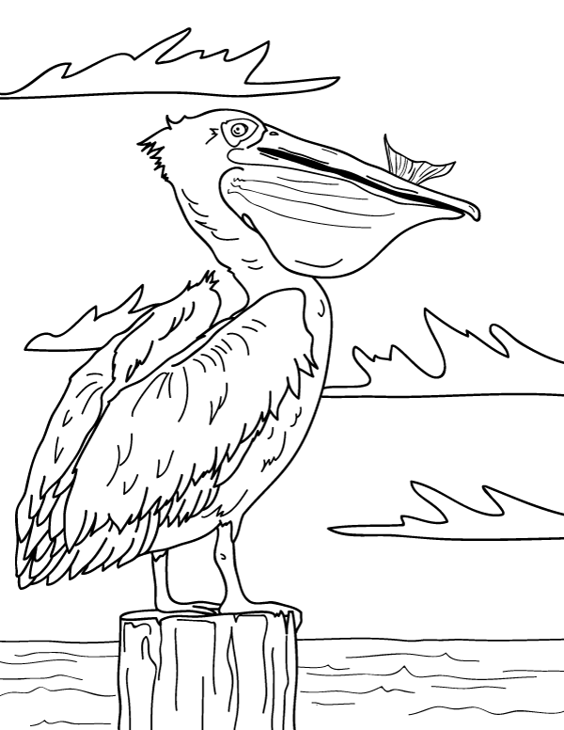

**Pelikan**

**Pp**

|  |  |  |  |
| --- | --- | --- | --- |
| **P** | **P** | **P** | **P** |
| **P** | **P** | **P** | **P** |
| **P** | **P** | **P** | **P** |
| **P** | **P** | **P** | **P** |
| **P** | **P** | **P** | **P** |
| **P** | **P** | **P** | **P** |
| **P** | **P** | **P** | **P** |
| **P** | **P** | **P** | **P** |

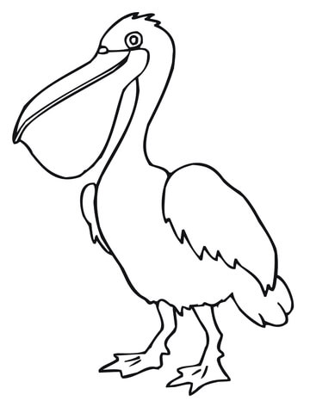

**Pelikan**

**Pp**

|  |  |  |  |
| --- | --- | --- | --- |
| **p** | **p** | **p** | **p** |
| **p** | **p** | **p** | **p** |
| **p** | **p** | **p** | **p** |
| **p** | **p** | **p** | **p** |
| **p** | **p** | **p** | **p** |
| **p** | **p** | **p** | **p** |
| **p** | **p** | **p** | **p** |
| **p** | **p** | **p** | **p** |