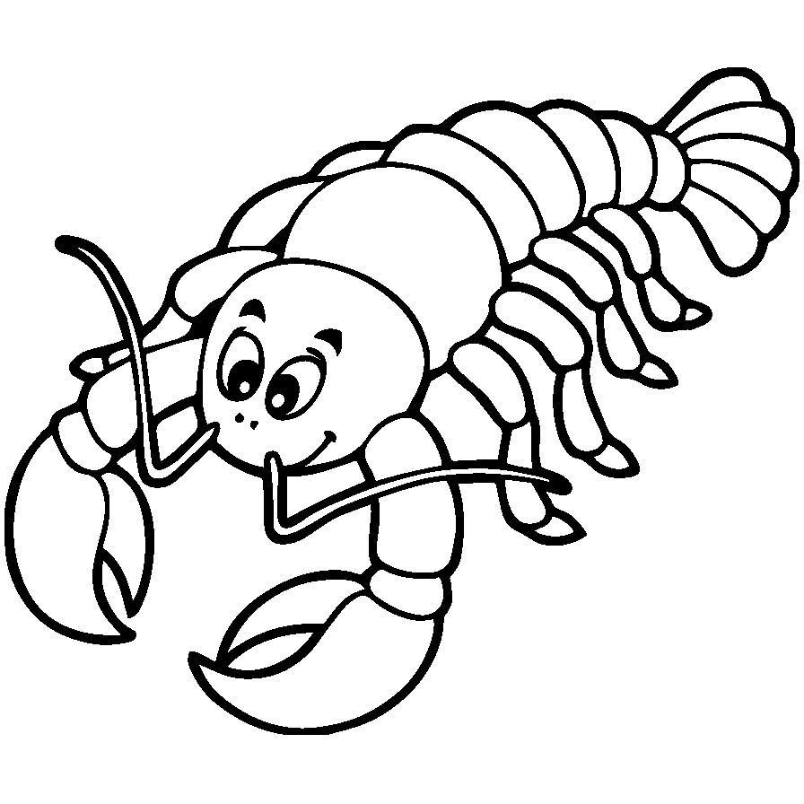

|  |  |  |  |
| --- | --- | --- | --- |
| **U** | **U** | **U** | **U** |
| **U** | **U** | **U** | **U** |
| **U** | **U** | **U** | **U** |
| **U** | **U** | **U** | **U** |
| **U** | **U** | **U** | **U** |
| **U** | **U** | **U** | **U** |
| **U** | **U** | **U** | **U** |
| **U** | **U** | **U** | **U** |

**Uu**

**Udang**

|  |  |  |  |
| --- | --- | --- | --- |
| **u** | **u** | **u** | **u** |
| **u** | **u** | **u** | **u** |
| **u** | **u** | **u** | **u** |
| **u** | **u** | **u** | **u** |
| **u** | **u** | **u** | **u** |
| **u** | **u** | **u** | **u** |
| **u** | **u** | **u** | **u** |
| **u** | **u** | **u** | **u** |

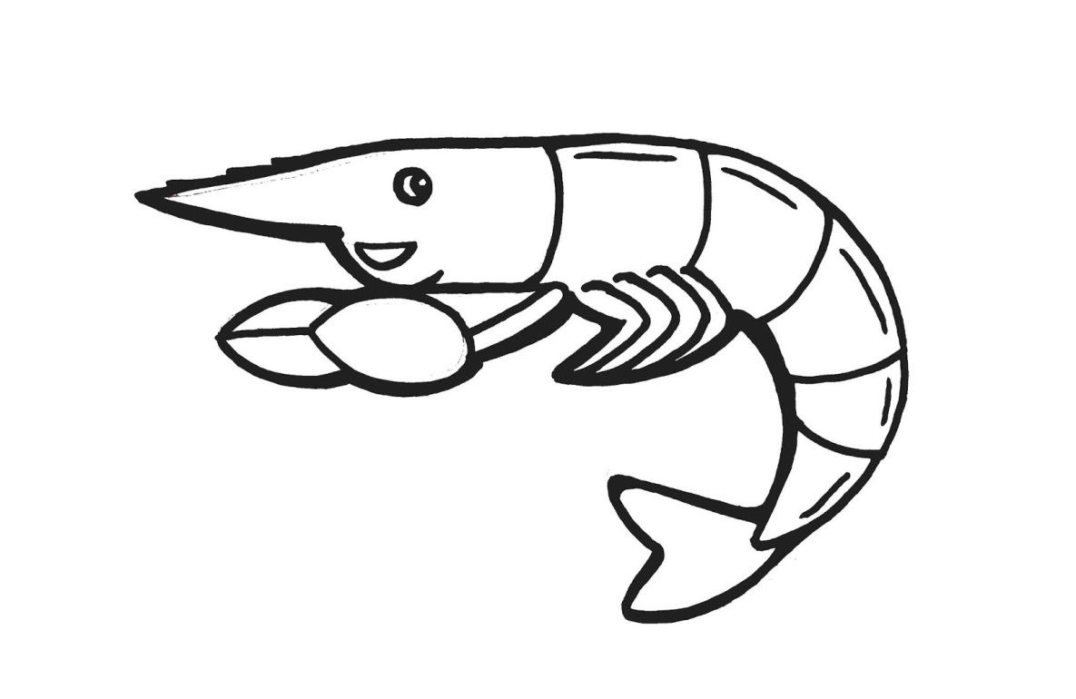

**Udang**

**Uu**