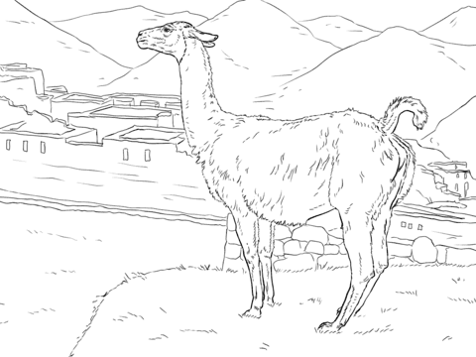

**Vv**

|  |  |  |  |
| --- | --- | --- | --- |
| **V** | **V** | **V** | **V** |
| **V** | **V** | **V** | **V** |
| **V** | **V** | **V** | **V** |
| **V** | **V** | **V** | **V** |
| **V** | **V** | **V** | **V** |
| **V** | **V** | **V** | **V** |
| **V** | **V** | **V** | **V** |
| **V** | **V** | **V** | **V** |

**Vikuna**

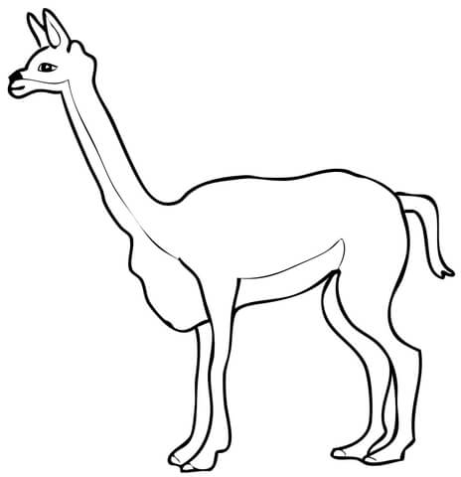

**Vikuna**

**Vv**

|  |  |  |  |
| --- | --- | --- | --- |
| **v** | **v** | **v** | **v** |
| **v** | **v** | **v** | **v** |
| **v** | **v** | **v** | **v** |
| **v** | **v** | **v** | **v** |
| **v** | **v** | **v** | **v** |
| **v** | **v** | **v** | **v** |
| **v** | **v** | **v** | **v** |
| **v** | **v** | **v** | **v** |