**Yy**

|  |  |  |  |
| --- | --- | --- | --- |
| **Y** | **Y** | **Y** | **Y** |
| **Y** | **Y** | **Y** | **Y** |
| **Y** | **Y** | **Y** | **Y** |
| **Y** | **Y** | **Y** | **Y** |
| **Y** | **Y** | **Y** | **Y** |
| **Y** | **Y** | **Y** | **Y** |
| **Y** | **Y** | **Y** | **Y** |
| **Y** | **Y** | **Y** | **Y** |

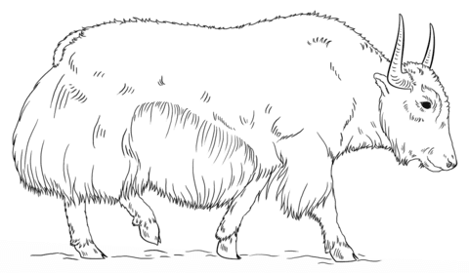

**Yak**

**Yak**

**Yy**

|  |  |  |  |
| --- | --- | --- | --- |
| **y** | **y** | **y** | **y** |
| **y** | **y** | **y** | **y** |
| **y** | **y** | **y** | **y** |
| **y** | **y** | **y** | **y** |
| **y** | **y** | **y** | **y** |
| **y** | **y** | **y** | **y** |
| **y** | **y** | **y** | **y** |
| **y** | **y** | **y** | **y** |

