Project I - Social Media Data Analysis for Twitter
Project Github Link: https://github.com/fguo10/SocialMediaDataAnalysis
In this project, I use twitter token and tweepy package to crawl twitter friends data, as well as process and report some analysis on my extracted data.
It contains 3 steps here:
- Data Collection
- Data Visualization
- Network Measures Calculation

- Data Collection
Create an account on Twitter, then visit the link: https://developer.twitter.com/en.
Then click on Apply for a Developer account, we can select Specify the type of application, and Specify the type of application, put in why you want to apply for the developer account. When the API developer is approved, we can get token details:
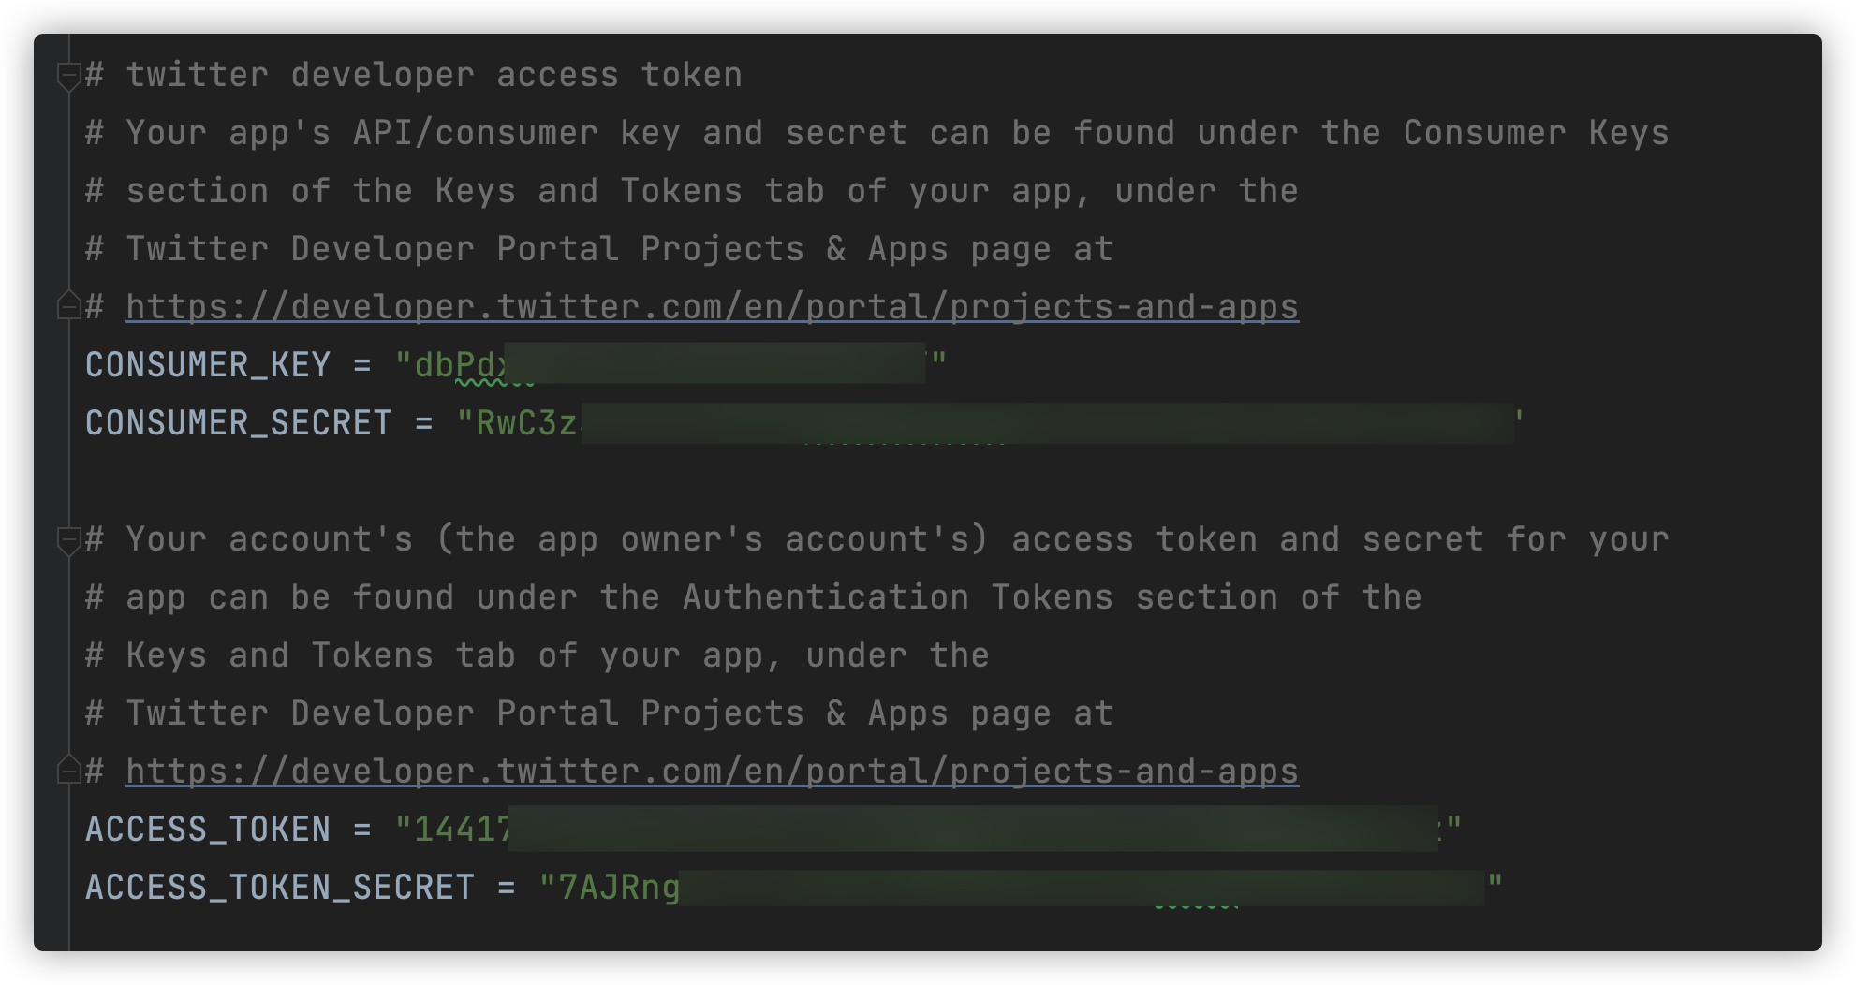
Base on the API token, we can use tweepy python package esaily get twitter user friends.As we know, Tweepy is an open source Python package that makes it easy to access Twitter and get information about friends for developers to use.
Firstly, Setting the authentication credentials.
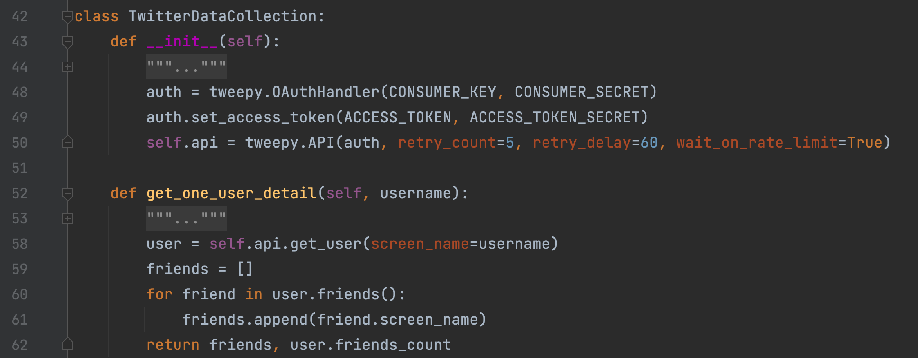
However, Twitter has a rate limit on the number of requests made to the Twitter API. Allow 900 requests /15 minutes. If get the request error because of too many request, we need wait 15 minutes and try again, the code as below:
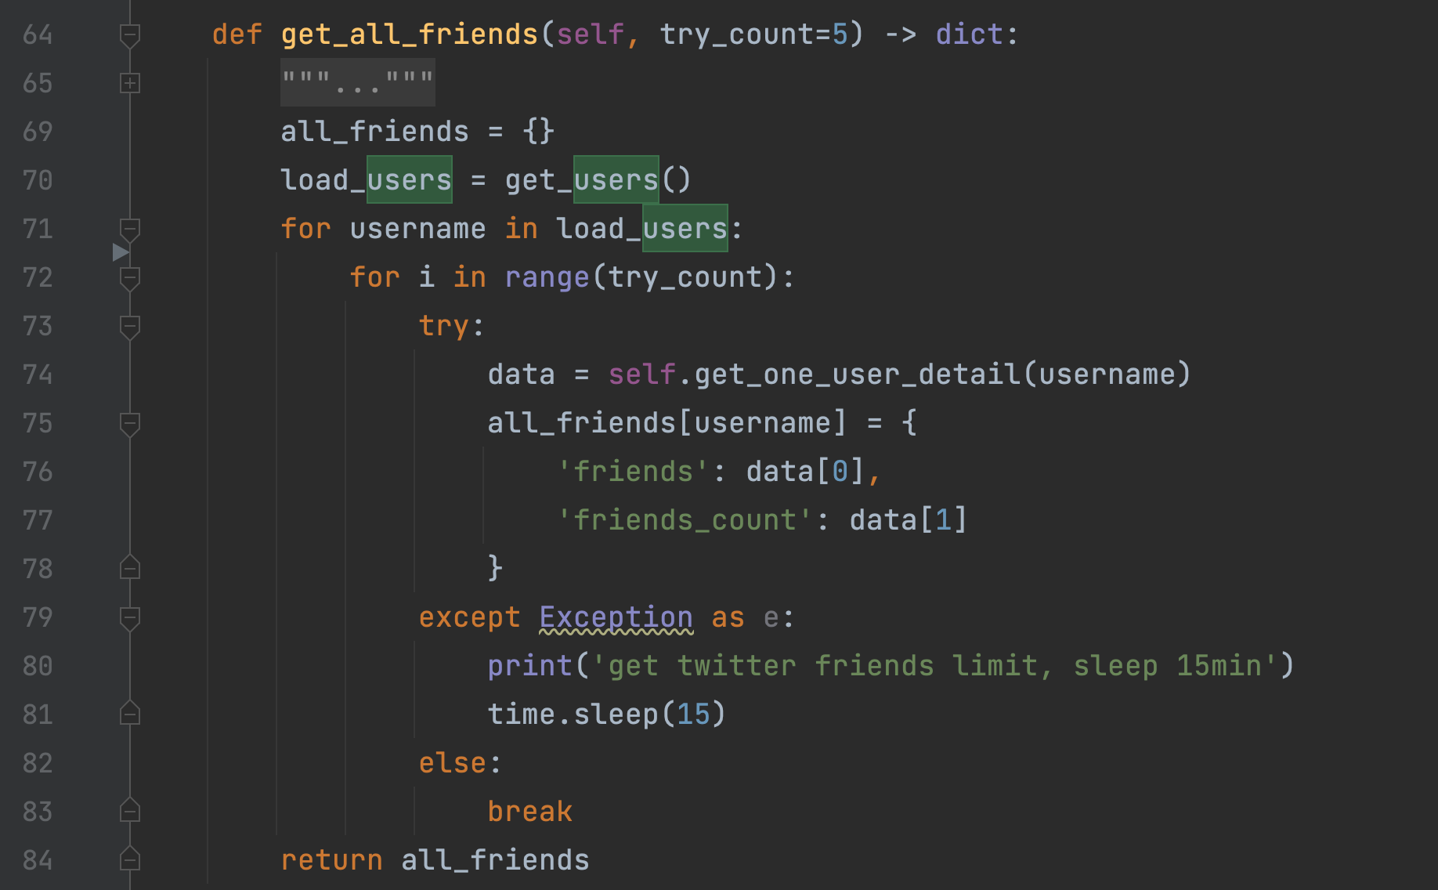

Meanwhile, to reduce the number of Twitter requests, I save the data into files doc/all_friends.txt. When analyzing data, we don't have to collect friends of a given user on Twitter every time. The code details as follows:

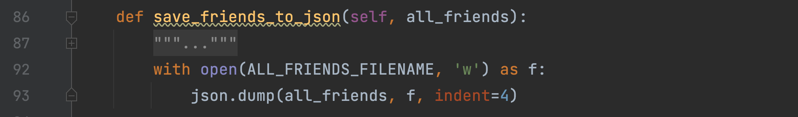

The part about data collection has been completed, the steps executed are stored in the function crawl_data, and the file doc/all_friends.txt will be generated after the execution, the details are as follows:
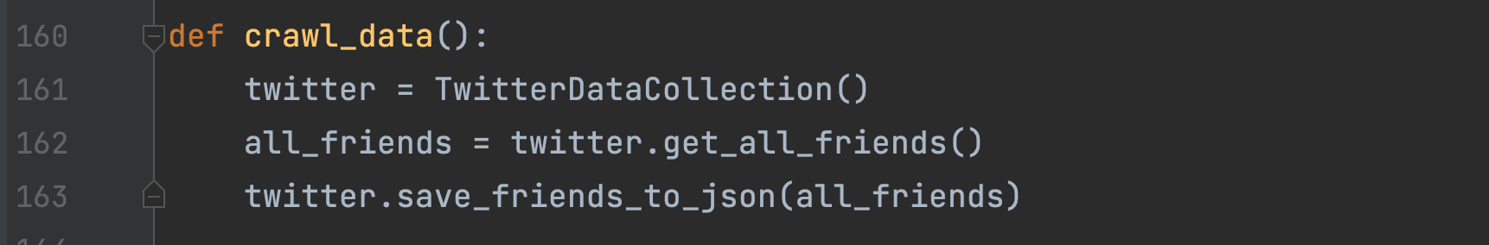
- Data Visualization
I have fetched the data, in this step, I use networkx to visualize network as graph. The core code here:
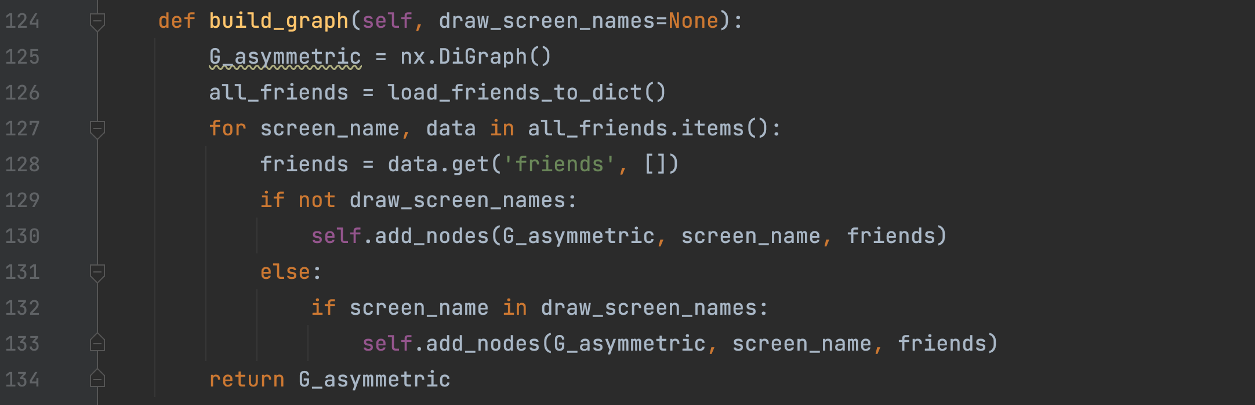
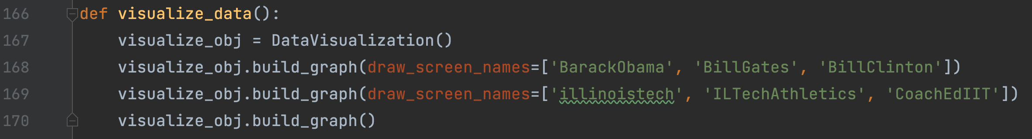

When I use all the data(400+ nodes) here, I got a complex graph:
When I choose screen_users: ['BarackObama', 'BillGates', 'BillClinton'], get a simple graph here:

Then I choose screen_users: ['illinoistech', 'ILTechAthletics', 'CoachEdIIT']
, get a simple graph here:

- Network Measures Calculation
In this step, I use networkx and matplotlib to caculation Degree Distribution and Pagerank, and plot it as histogram. The core code here:
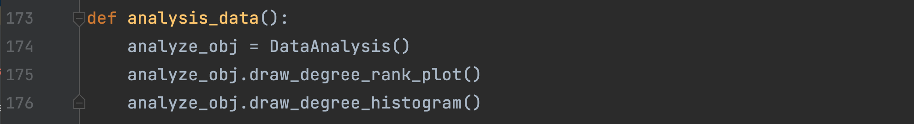
Then the degree histogram as the picture shows:

The degree-rank plot for the Graph as the picture shows:

- Conclusion
In this project, Firstly, get twitter data from API and save data into file. Secondly, we do data visualize about 100+ nodes and 400+nodes, At the end , we do various type of statistical analysis on the tweets. After the completion of the project, I learned a lot about online network analysis

Project Github Link: https://github.com/fguo10/SocialMediaDataAnalysis

