Independent Study: Face Detection Based on Haar Cascades

Name: Hao Fu

Abstract
Face detection is a very popular topic in the past two or three decades. OpenCV also integrates an object recognition algorithm, which is based on a machine learning object detection algorithm proposed by Paul Viola and Michael Jones in 2001 in the paper Rapid Object Detection using a Boosted Cascade of Simple Features. [1]
The innovation of the Viola & Jones algorithm is that it integrates the following three contributions for face recognition for the first time: The first is Applying Haar-like features and calculate the values using integral image. The second is Adaboost algorithm to select a small number of the most crucial features from a large set. The third contribution is a method for combining increasingly more complex classifiers in a “cascade” which allows background regions of the image to be quickly discarded while spending more computation on promising object-like regions.
Having read through the paper and the main code of the algorithm, this article is my understanding to them and my learning process. I will go through each of the 3 methods in the report.

1 HAAR-like Features and Integral Image

The algorithm does not use pixel-based features, but uses HAAR-like features. Looking at the definition of CvHaarEvaluator::generateFeatures() in the folder opencv\sources\apps\traincascade\haarfeatures.cpp, there are 14 different types of features to generate. More specifically, we can divide them into 3 kinds.
The code to the first type of features is below:
// haar_x2
if ( (x+dx*2 <= winSize.width) && (y+dy <= winSize.height) )// to judge that if the feature is bigger than the window size
{
features.push_back( Feature( offset, false,
x, y, dx*2, dy, -1,
x+dx, y, dx , dy, +2 ) );
}

All of the if-statements are wrapped in two double-loops. The first is manipulating X and Y, and the second one is DX and DY . X and Y are the starting coordinates of the feature. DX and DY are the width and height of the feature for this time. Whenever the feature is smaller than the window size we generate this feature and push it in the features vector and leave it to be evaluated. According to the code, the general figure for this feature is two adjacent rectangles with different weight(-1 and +2).
Based on the code, we can derive all the figures that represent the feature as below: 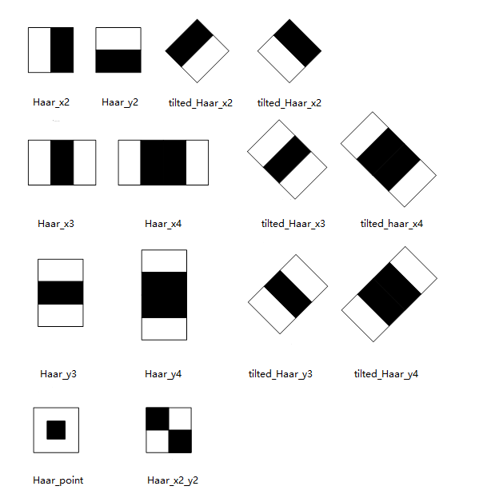figure 1

From figure 1 we can see that each HAAR-like feature is a template that includes a black area and a white area. Actually there are 3 kinds of features, which are two-rectangle features, three-rectangle features and four-rectangle features. According to the definition, The value of a two-rectangle feature is the difference between the sum of the pixels within two rectangular regions. The value of three-rectangle is the difference between the sum of the pixels within two outside rectangles subtracted from the sum in a center rectangle. There is a special case for Haar_point and Haar_x2_y2, while the basic idea is the same -- the value is always the difference between white and black regions.
According to the statistics, there will be approximately 180,000 features for a 24X24 image(for face detection). It seems like to calculate the values of the features is highly time-consuming. Fortunately the most attractive part of the algorithm is the introduction of Integral Image, which makes the computation of the features very rapid. The integral image at location x, y contains the sum of the pixel above and to the left of x, y, inclusive:
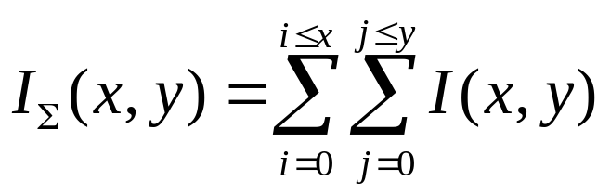
Based on that, the computation of integral image is very simple. For example, if we want to calculate the rectangle ABCD in figure 2:
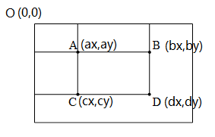
figure 2

It is easy to get the following equations:

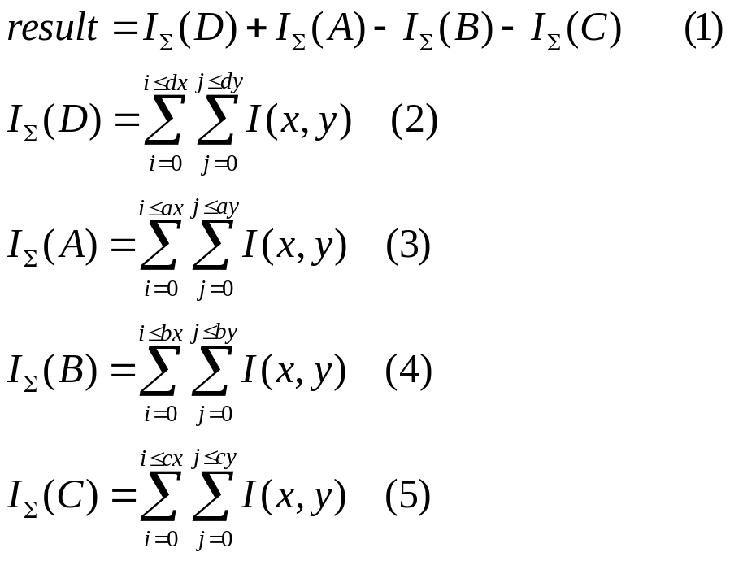

2 Adaboost Algorithm

The reason why Adaboost is applied is that, from my point of view, we need to select the features that are essentially suitable to the object we want to detect. For example, when it is face, there will be a huge number of features that are irrelevant to human faces. If we would not discard these features at the very first place, it would waste a lot of time and resources.
AdaBoost algorithm ends up with a strong classifier through a linear combination of a series of weak classifiers. Although the classification effect of the weak classifier may be only a little better than a random classification, the final strong classifier can get a surprising classification ability.
Speaking of weak classifier, the first weak classifier would be a fundamental Haar features. This is how we evaluate the feature -- We compare the value we calculate out with a preset threshold value. If it is less than the threshold, it will be one of the ideal features we want. Otherwise the evaluation stops and we dequeue the feature from the vector then work on the next one. The general formula is shown in the paper:
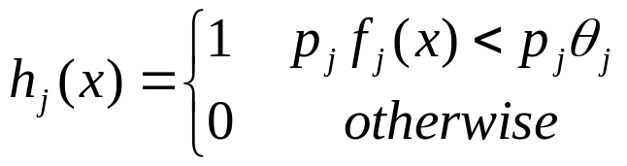
Here X is a 24x24 pixel sub-window of an image. f(x) is the value of the feature, which is calculated using integral image. Ɵ is the threshold.
This is how we get a weak-classifier. Once we get a weak-classifier successfully, we move forward to get the next one(next specific feature) until the final strong classifier is obtained. This will be like a decision tree. This process would discard the vast majority of features.
Looking at the definition of CvCascadeBoost::train in folder opencv\sources\apps\traincascade\boost.cpp. I have read through the code and added my comments to it.

bool CvCascadeBoost::train( const CvFeatureEvaluator* _featureEvaluator,
int _numSamples,
int _precalcValBufSize, int _precalcIdxBufSize,
const CvCascadeBoostParams& _params )
//_precalcValBufSizeCache size for storing pre-computed feature values in MB
//_precalcIdxBufSizethe buffer size used to store pre-computed feature indexes in MB
//_params the parameters that adaboost requires, which is an object
{
bool isTrained = false; // the returning Boolean value
CV_Assert( !data ); // to confirm that the data folder, which stores the classifier, is ready
clear();
/*
instantiate CvCascadeBoostTrainData，calls CvCascadeBoostTrainData::setData to set the data that the strong classifier requires，The precalculate function is also called in the setData function. Its function is to calculate the eigenvalues of all training images in parallel and store them in the valCache matrix. The number of feature value calculated in advance is determined by the input parameter _precalcValBufSize, and those that are not calculated. The nvalue is done by calling the CvCascadeBoostTrainData::get_ord_var_data function when building the decision tree, so in principle the bigger the values of _precalcValBufSize and _precalcIdxBufSize values are, the shorter the time it will take to build a decision tree.
*/
data = new CvCascadeBoostTrainData( _featureEvaluator, _numSamples,
_precalcValBufSize, _precalcIdxBufSize, _params );
CvMemStorage *storage = cvCreateMemStorage(); // allocation
//weak represents a weak classifier queue for storing the weak classifiers
weak = cvCreateSeq( 0, sizeof(CvSeq), sizeof(CvBoostTree*), storage );
storage = 0;

set_params( _params ); //passes in _params
//logit or gentle adaboost, I don’t know too much about them
if ( (_params.boost_type == LOGIT) || (_params.boost_type == GENTLE) )
data->do_responses_copy();
//initialize weights
update_weights( 0 );

cout << "+----+---------+---------+" << endl;
cout << "| N | HR | FA |" << endl;
cout << "+----+---------+---------+" << endl;

do //enters the iteration
{
//instantiate CvCascadeBoostTree class，variable tree is a decision tree consist of weak classifiers
CvCascadeBoostTree* tree = new CvCascadeBoostTree;

if( !tree->train( data, subsample_mask, this ) )
{
//to make sure we get the corresponding decision tree
delete tree;
break;
}
cvSeqPush( weak, &tree ); //push the decision tree into the weak classifier queue
update_weights( tree ); //update weights
//trim_wights is used to discard those whose weights are too low to be kept
trim_weights();
//determine that is it the time to quit iteration
if( cvCountNonZero(subsample_mask) == 0 )
break;
}
//if the error rate is desired or the amount of weak classifiers is enough, quit
while( !isErrDesired() && (weak->total < params.weak_count) );

if(weak->total > 0)
{
data->is_classifier = true;
data->free_train_data();
isTrained = true;
}
else
clear();

return isTrained;
}

From my point of view, The birth of a strong classifier requires a T-round iteration, as below:

1. Given a training set S, a total of N samples, where X and Y are positive and negative samples, respectively; T is the maximum number of cycles of training;
2. The initial sample weights are 1/N, which is the initial probability distribution of the training samples;
3. Train the N samples for the first iteration to get the first optimal weak classifier.
4. Normalize the weights of the samples that were misjudged in the previous round;
5. Put the new samples together with the samples that were mis-classified the last time for a new round of training.
6. Repeat steps 4-5 until we get T optimal weak classifiers after T round.
The strong classifier stands out more like a democratic voting system. United we stand, divided we fall. Like the saying goes, the strong classifier is not the product of individual heroism, but the power of unity. From a macro perspective, the entire AdaBoost algorithm is like a weak classifier from caterpillar to butterfly.

3 Classifier Cascade

The strong classifier obtained by the AdaBoost algorithm is not enough for face recognition, because there are two problems involved here. The first problem is that in the actual detection process, the number of face images will be much smaller than the number of non-face images. We should first remove the images that are obviously not human faces, that is, we should not spend too much resources on detection of non-face regions. The second problem is that while we increase the detection rate, the false positive rate will also increase significantly, that is, the detection rate and the false positive rate have the same trend. The detection rate here is the percentage of the positive samples get identified, and the false positive rate refers to the percentage of the negative samples get identified. For example, there are a total of 200 samples, 100 positive and negative samples, we can identify all positive samples, thus the detection rate is 100%, but 50 negative samples are also treated as positive samples. Thus the false positive rate is 50%.
To solve the above two problems, the Viola & Jones algorithm uses the concept of a cascaded classifier. Simpler classifiers are used to reject the majority of sub-windows before more complex classifiers are called upon to achieve low false positive rates.
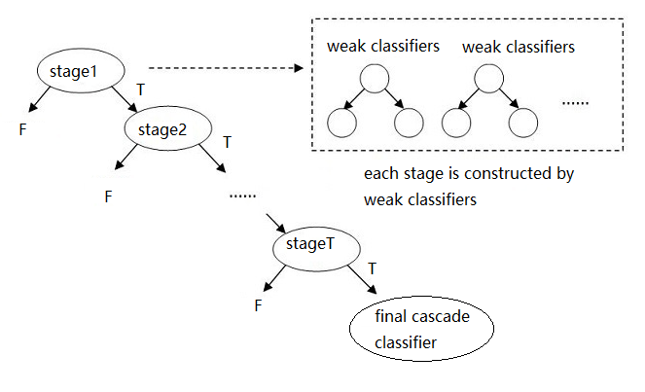
figure 3
In the training process of the cascade classifier, note that training AdaBoost strong classifier needs re-updating the training sample set, that is, the samples that satisfy the latter strong classifier must be stronger than the former one. The classifier identifies those samples that are classified as positive samples. To do it we identify the positive and negative samples by using the currently obtained cascade classifier, and select those positive samples that were classified into positive samples that satisfy a certain number of requirements as the positive training sample set of the AdaBoost strong classifier. And those negative samples that were mis-classified as positive samples are used as negative training samples. Since we have a higher minimum detection rate, we can update the positive training set without using the positive set as the positive training sample set.

4 Training classifier using OpenCV
To practice my study, I tried to train a classifier using OpenCV2.4.9. I downloaded a free data set for the training from CSDN, and the URL is https://download.csdn.net/download/u010508800/7592985.This is a very complete data set, with description files for both positive samples and negative samples. Since my computer is a 64-bit windows 10 system with Visual Studio 2019. I went to opencv\build\x64\vc12\bin then wrote two .bat file to perform the training.
The first one is createsampl.bat:
@echo
opencv_createsamples.exe
-info C:\Users\Richard\Downloads\opencv\face\posdata\pos.txt
-bg C:\Users\Richard\Downloads\opencv\face\negdata\neg.txt
-vec C:\Users\Richard\Downloads\opencv\face\pos.vec -num 18587 -w 20
-h 20
Pause

This is to create .vec file for the next step.
And the important parameters are:
-info: description file for positive samples
-bg: description file for negative samples
-vec: the .vec file to output, I name this file pos.vec
-num: The number of positive sample photo images
-w: the width of the positive sample image (pixels)
-h: the height of the positive sample image (pixels)
The terminal execution result looks like this:
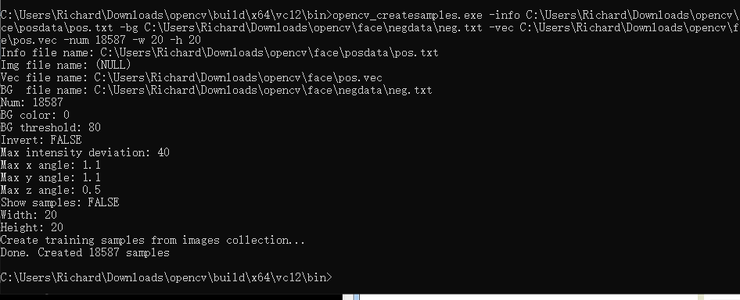
The second .bat file is traincascade.bat:
@echo
opencv_traincascade.exe
-data C:\Users\Richard\Downloads\opencv\face\data
-vec C:\Users\Richard\Downloads\opencv\face\pos.vec
-bg C:\Users\Richard\Downloads\opencv\face\negdata\neg.txt -numPos 18587 -numNeg 10927 -numStages 10 -precalcValBufSize 2048 -precalcIdxBufSize 2048 -w 20 -h 20 -maxDepth 1 -maxWeakCount 100 -mode ALL -minHitRate 0.999 -maxFalseAlarmRate 0.5
Pause
This is to train the cascade classifier.
The important parameters are:
-data: folder name, used to save various xml files generated by training. This folder must be created in advance, otherwise the system will report an error.
-numStages: The number of levels of the resulting cascaded classifier, we set it to 12
-precalcValBufSize: The size of the memory space used to store the pre-computed eigenvalues ​​in MB.
-precalcIdxBufSize: The size of the memory space used to store the precomputed feature index in MB.
-minHitRate: Minimum detection rate for each classifier
-maxWeakCount: The maximum number of decision trees contained in the strong classifier. This value is also related to the maximum false alarm rate.
Since my computer's memory is 8G, in order to maximize the use of this memory, I defined the two parameter values -precalcValBufSize and -precalcIdxBufSize as 2048, which is 2G.
When I was executing the command, the terminal first printed out some imformation of the parameters, then there was the information of the strong classifier for each stage.
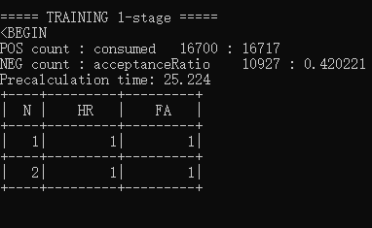
So it says I am training the 1-stage strong classifier.
POS count : consumed 18587 : 18587
18587 positive sample images can be used when training this class of strong classifiers

NEG count : acceptanceRatio 10927 : 0.420221
When training this class of strong classifier, 10927 negative sample images can be used. This number is the number specified by the parameter numNeg in the opencv_traincascade.exe command. The following 0.420221 indicates the acceptance rate of the negative sample, which is before the current strong classifier. The false rate of the cascade classifiers formed by all the strong classifiers (0-stage in this case), that is, after being predicted by the current cascade classifier, these are predicted to be positive samples and actually negative samples. The 10927 images were obtained from how many negative sample images. The categorization classifier is characterized in that the strong classifier in the latter stage only receives data that the previous classifier considers to be a positive sample, and predicts the negative sample as a positive sample. This situation will increase with the increase of the training level. Increase, of course, this difficulty level is also related to the maximum error rate maxFalseAlarmRate set in the opencv_traincascade.exe command. The lower the error rate is set, the more difficult it will be. In the training of the last class of strong classifiers in this example, this value can even be as high as one billion. So in the training process time is mainly taken here.

Precalculation time
Indicates the time spent pre-calculating the feature values, that is, before constructing the strong classifier, we calculate a part of the feature values, which are related to the parameters precalcValBufSize and precalcIdxBufSize in the opencv_traincascade.exe command, that is, the larger the memory allocated, the more feature values are saved, so the longer it takes to calculate these feature values. Since the feature values to be used are already calculated before building the strong classifier, the time to build a strong classifier is greatly reduced.
While doing this, I encountered a very strange issue, which said “OpenCV Error: Bad argument (Can not get new positive sample. The most possible reason is insufficient count of samples in given vec-file.”It took me a long time to figure out what the problem was. Finally I found that was because I took too high minHitRate and too large numPos. The point is that I need unique samples, and it can't take one object and then warp it in different ways to get many samples. If my numPos was set literally equal to the number of my positive samples, then it can't get enough samples to satisfy my minHitRate which was 99.9%.
I eventually made it to 10 stages, which means the final classifier cascades 10 strong classifiers together. I tried to train the eleventh stage but it seemed it would take forever on my machine to finish the training.
The cascade classifier is literally not strong and satisfactory enough. But if we pass in appropriate parameters in our test bench it will detect faces:
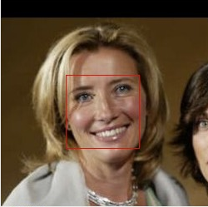

5 Conclusion

I haven't reached the field of computer vision and machine learning before. This research was a big challenge for me. It involves a lot of mathematics, line generation, statistics, mathematical analysis, etc. Although It was very difficult, I did find it promising, especially in the field of machine learning.

- Viola and Jones, "Rapid object detection using a boosted cascade of simple features", Computer cool Vision and Pattern Recognition, 2001

