Visualization of TryTryp and HomoC tRNA genes as inputs for tsfm

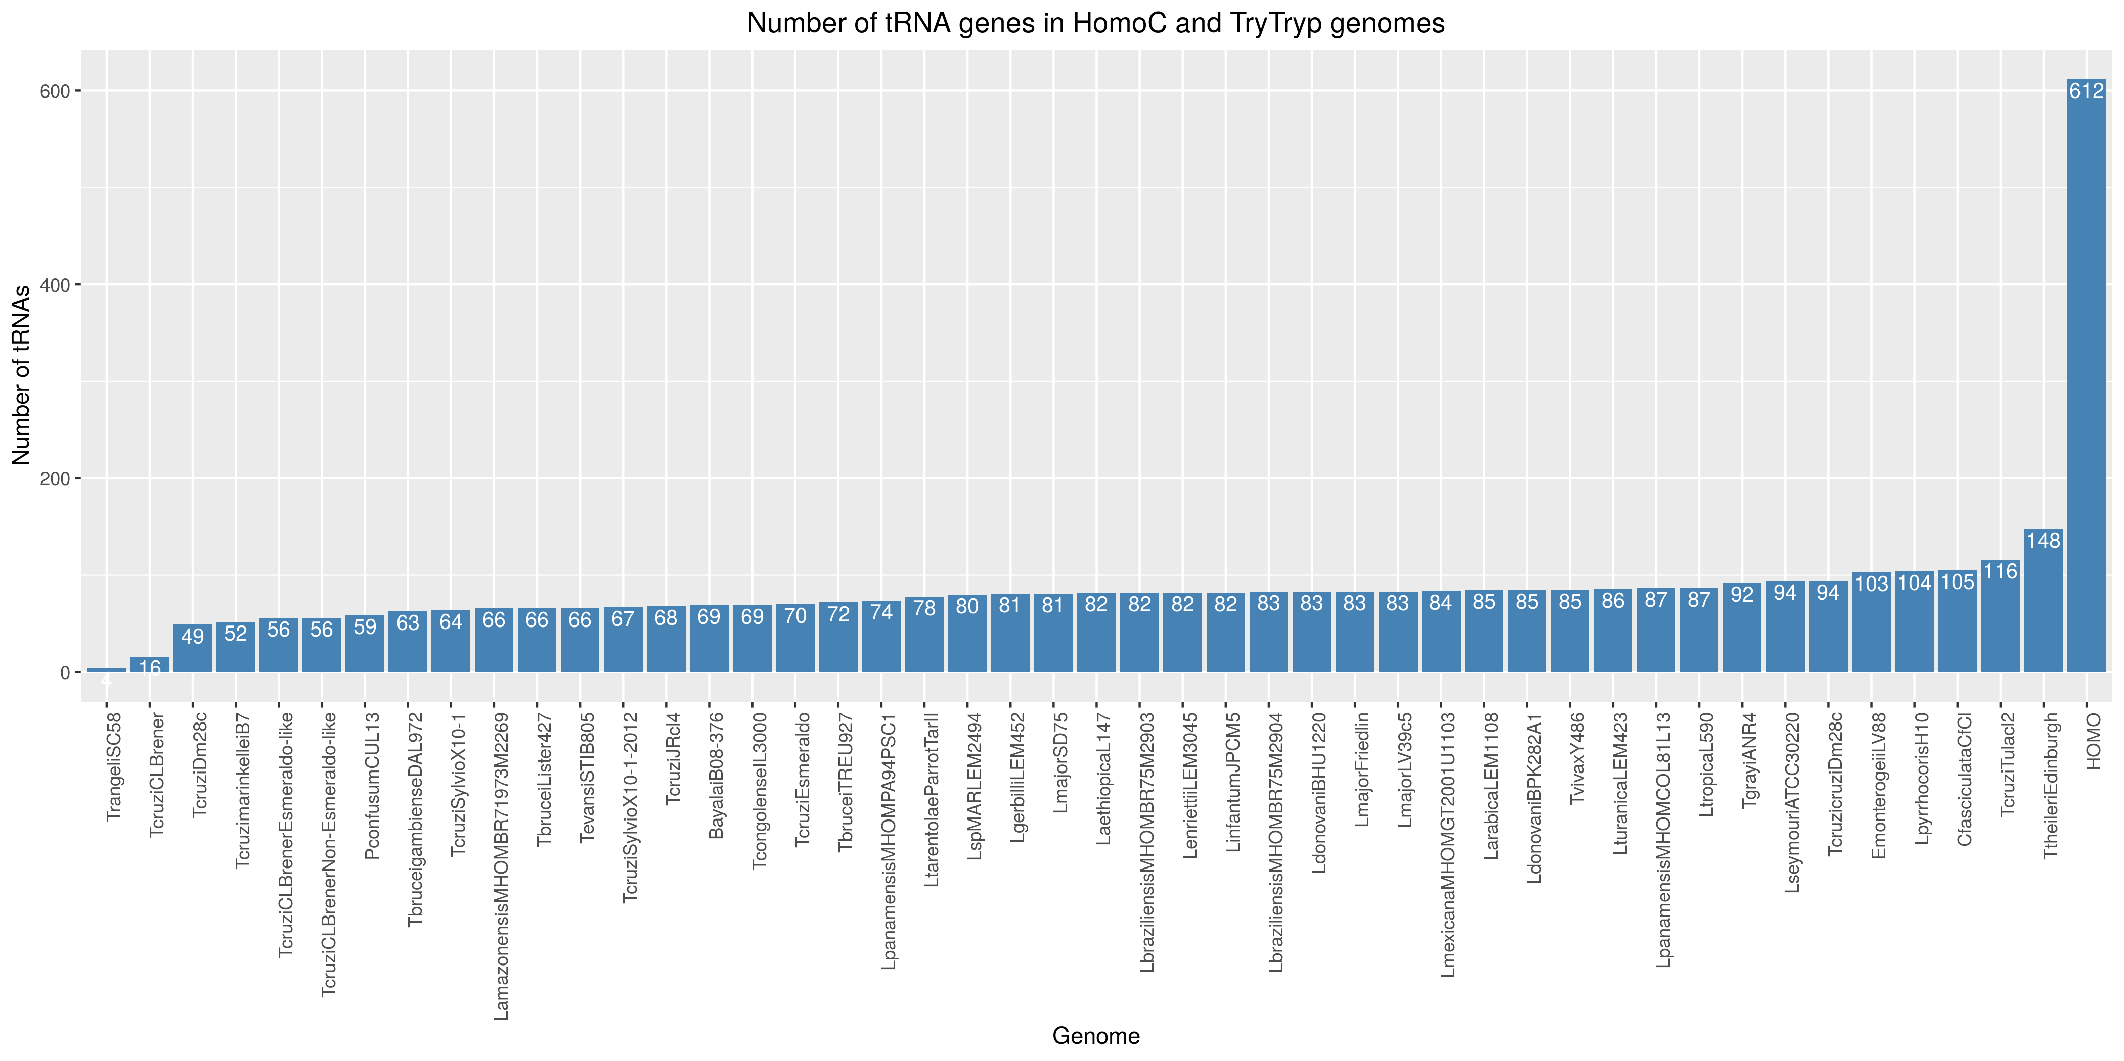

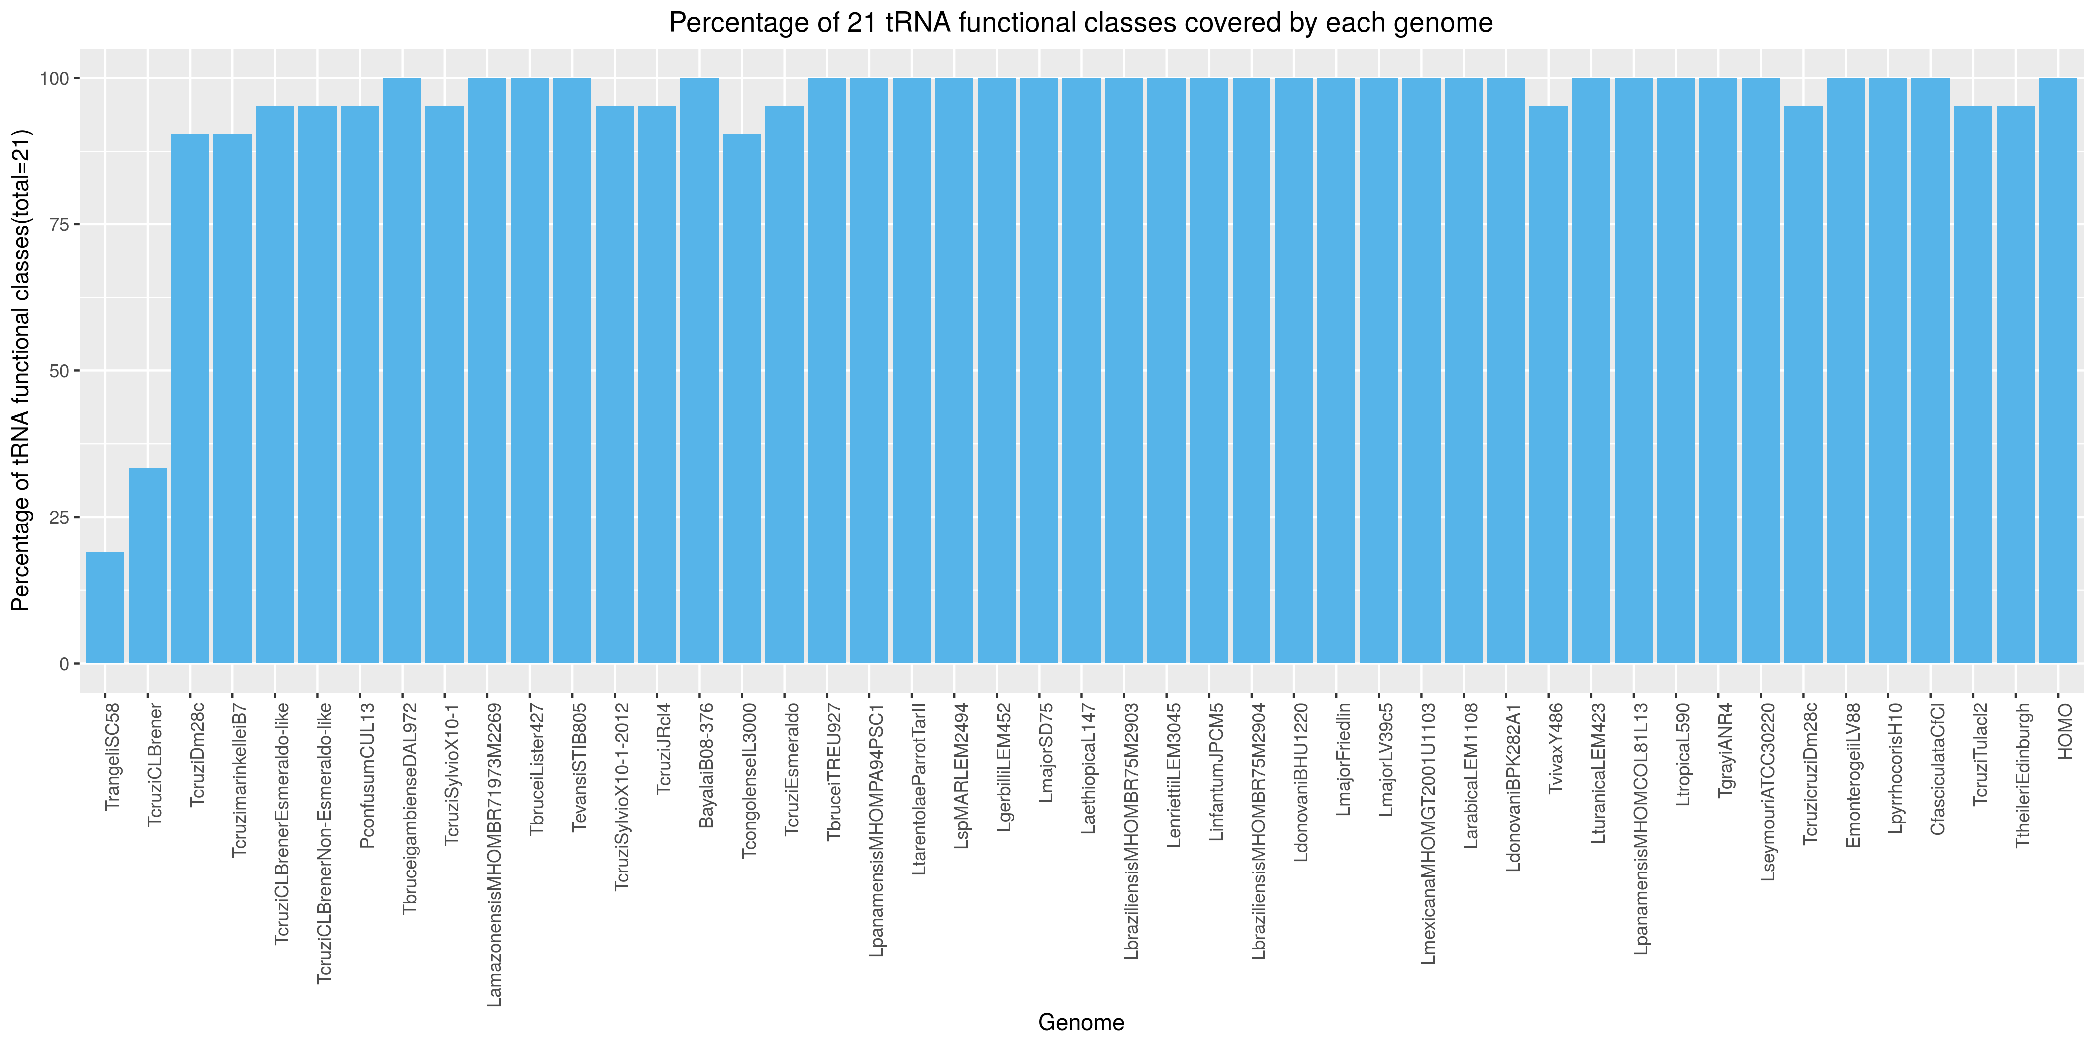

Data and script can be found here!

