Two of the methods I used for filtering genes were:
1. gene should be detected by both ara and tse and
2. both tse and ara should agree on functional class of the genes found by both of them
Here I will study all the cases in our filtered gene-set in which at least of one the functional classes (21 types excluding Z) is missing in a genome.

1) TtheileriEdinburgh missing D: both ara and tse were missing D
2) TTcruziTulacl2 missing Y: genes found by both ara and tse, however, they did not agree on the functional class. Tse reported Y, Ara reported N( as you see in the picture ARA is considering an intron in between the anticodon) . In another case a gene was reported as Y but it was only found by ara.
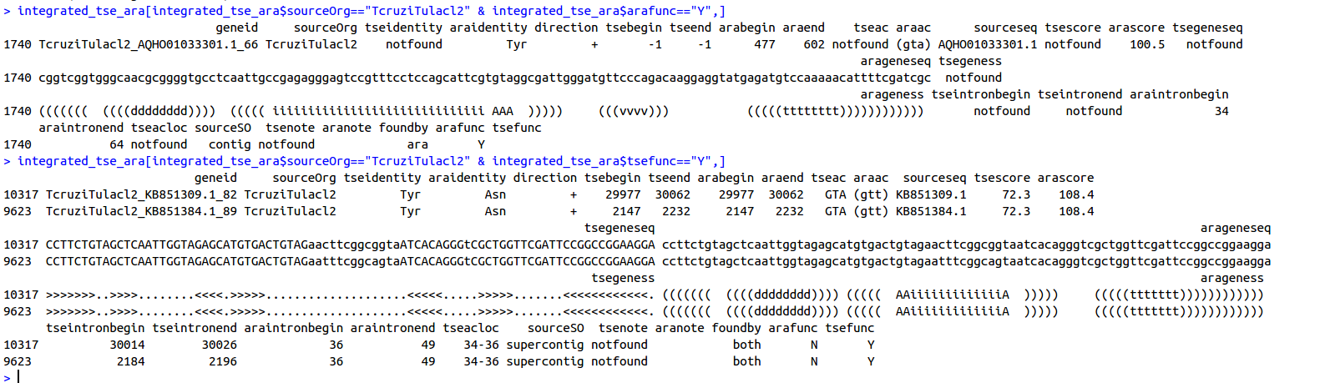

cruzicruziDm28c missing :
integrated_tse_ara[integrated_tse_ara$sourceOrg=="TcruzicruziDm28c" & integrated_tse_ara$tsefunc=="Y",]
again we have the same issue. ara and tse do not agree on Y/N types

3) TvivaxY486 missing Y: it was found only by tse.
4) PconfusumCUL13 missing D : it was only found by ara not tse
5) TcongolenseIL3000 missing S: both tse and ara found tRNA genes of type S. however they were exclusive to either ara or tse!
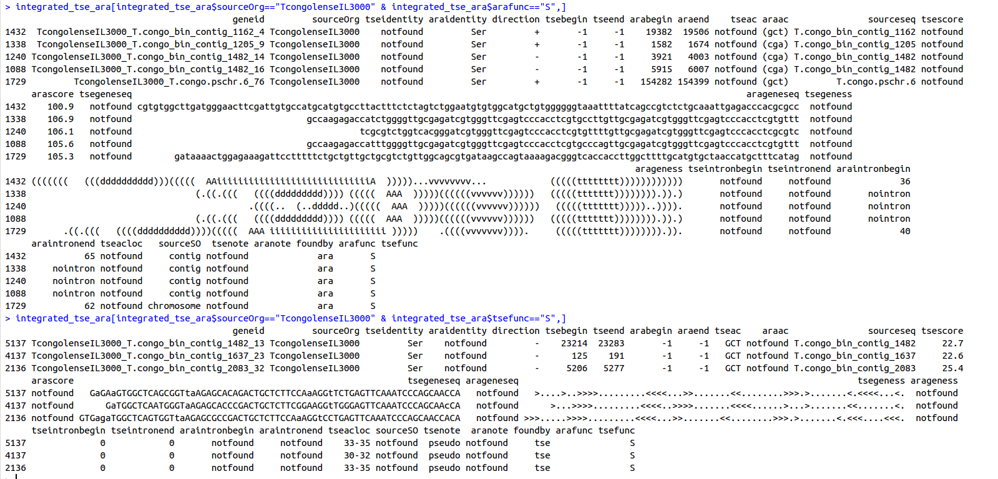

6) TcruziEsmeraldo missing Y: Ara and tse did not agree on the functional class. Tse reported Y, Ara reported N
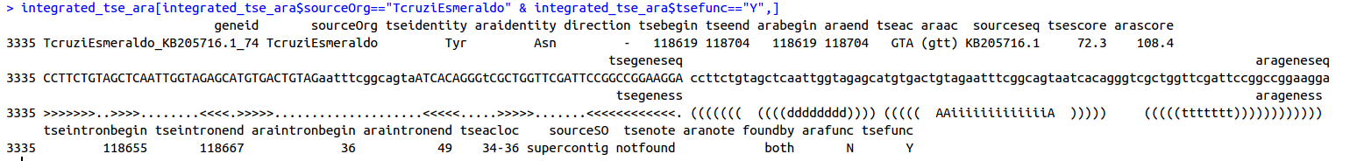

7) TcruziSylvioX10-1-2012 missing Y: Ara and tse did not agree on the functional class. Tse reported Y, Ara reported N
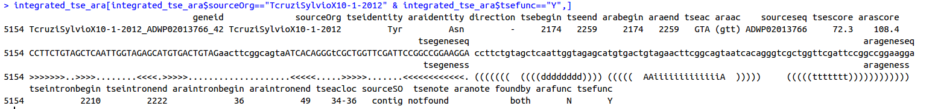

8) TcruzimarinkelleiB7 missing Y and W: Both Y and W were found only by ara and not tse

9) TcruziCLBrenerEsmeraldo-like missing Y: Ara and tse did not agree on the functional class. Tse reported Y, Ara reported N

9) TcruziCLBrenerNon-Esmeraldo-like missing Y: Ara and tse did not agree on the functional class. Tse reported Y, Ara reported N

Conclusions: Apparently the main reason for Y being missed is ARA and TSE not agreeing on the functional class of the tRNA genes found by both of them. This is the result of their intron displacement in anticodon loop which seems to be only one base.

