Visualization of TryTryp and HomoC tRNA genes as inputs for tsfm

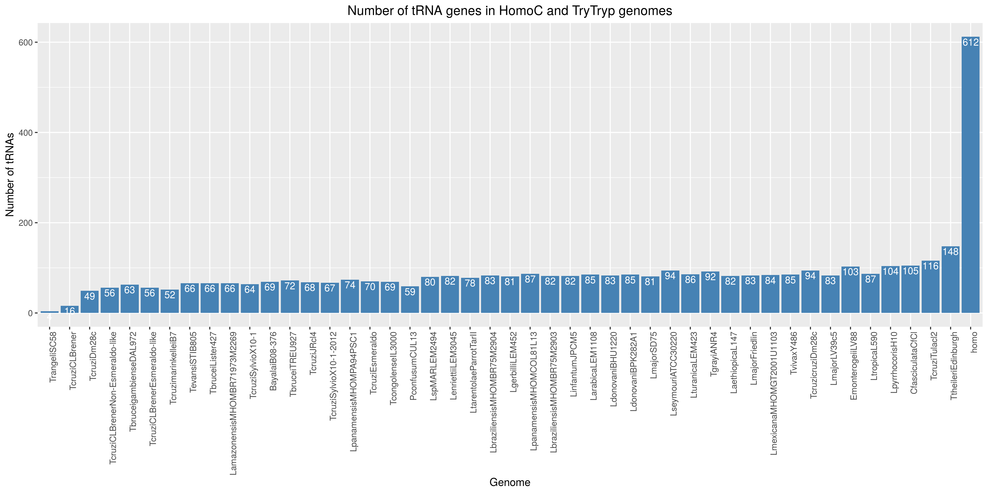

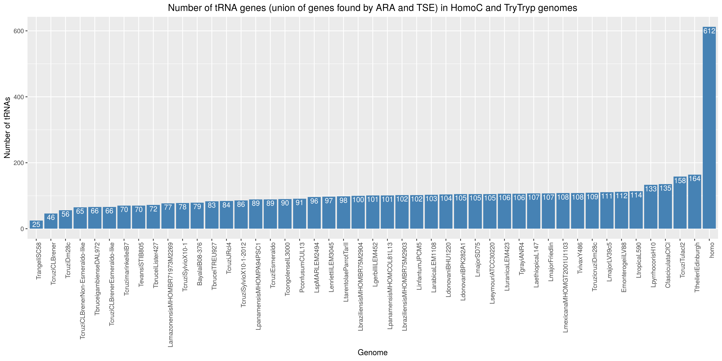

Data and script can be found here!

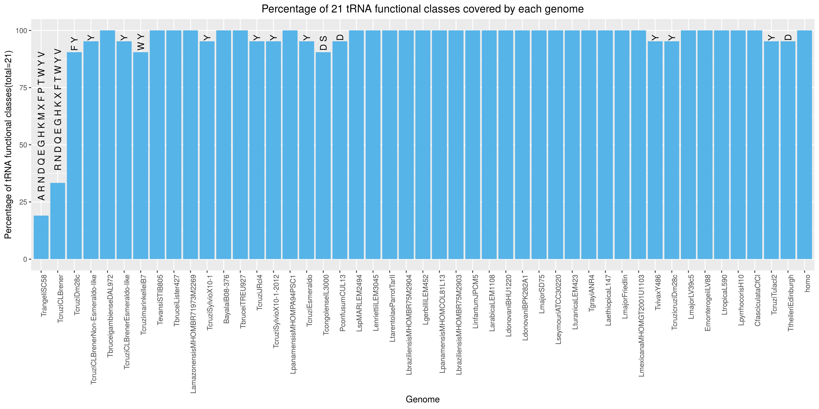

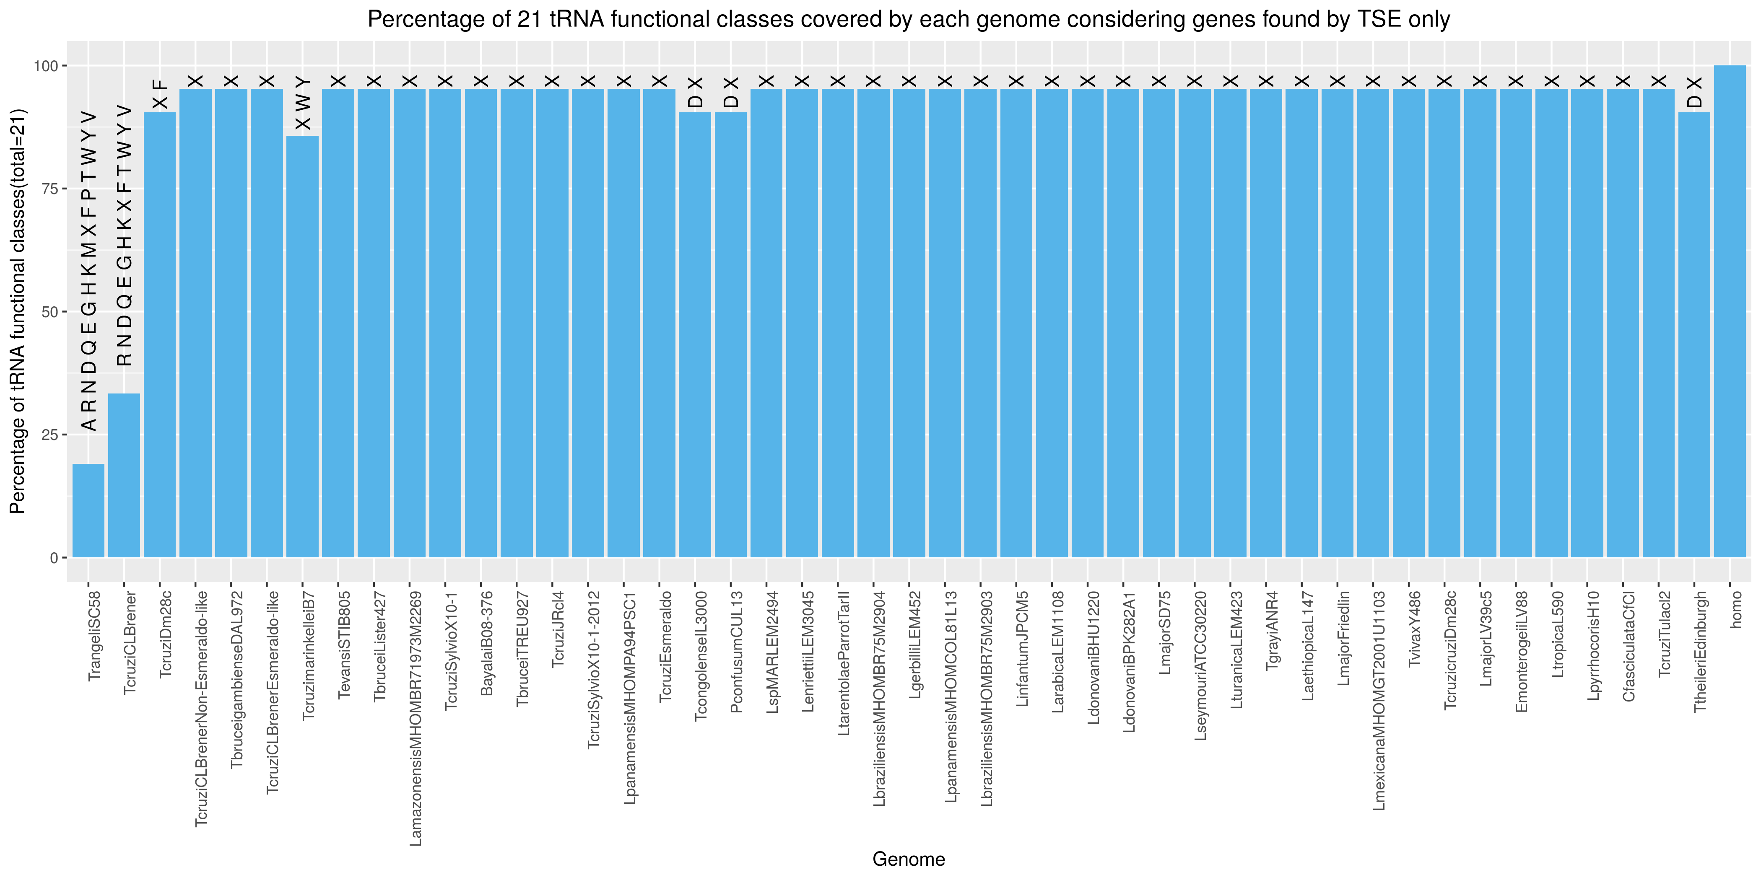

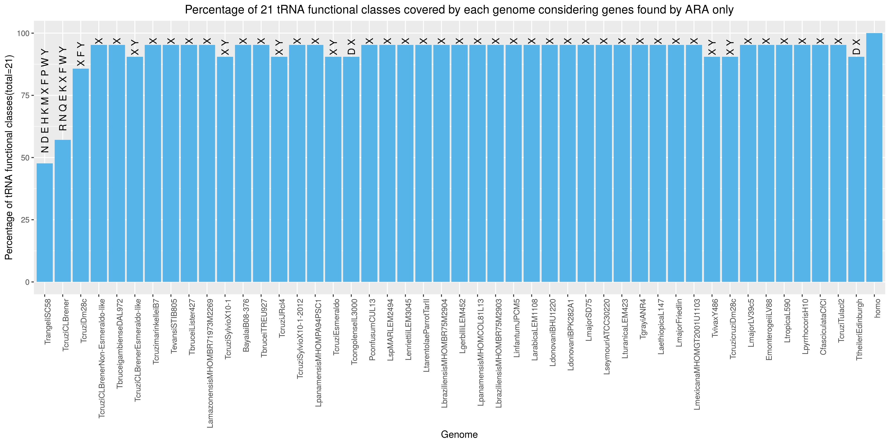

Genes found by both tRNAscan-SE and Aragorn with different identities

<Aragorn Identity> | <tRNAScan Identity> | D|I | L|? | L|E | L|M | N|Y | O|M | S|R | W|G
frequency | 5 | 3 | 1 | 9 | 11 | 2 | 1 | 3

