Predicting potential anti-codon shifts (alloaccepter shifts) in TryTryp tRNA models

Method:

- Using the co-aligned 3542 genes from intersection of two gene-finders Aragorn and tRNAscan-SE (tRNA genes with the same predicted identity by both gene-finders), generated profiles for 22 models similar to tfam.

Number of sequences used for making each profile:
A C D E F G H I K L M N P Q R S T V W X Y Z
211 64 105 160 104 228 80 171 183 336 97 125 200 162 347 228 218 241 52 76 78 76

- Calculated the score of each sequence (from training set), against each profile using leave-one-out method.
- Using the output of step 2, calculated the z score of each sequence against each model.
- For each sequence compared the model with the highest z score or the model with the highest score with the model reported by two gene-finders.
- Defined the potential anti-codon shifts for each sequence as models with the highest z score or highest score which do not match the model predicted by gene-finders.

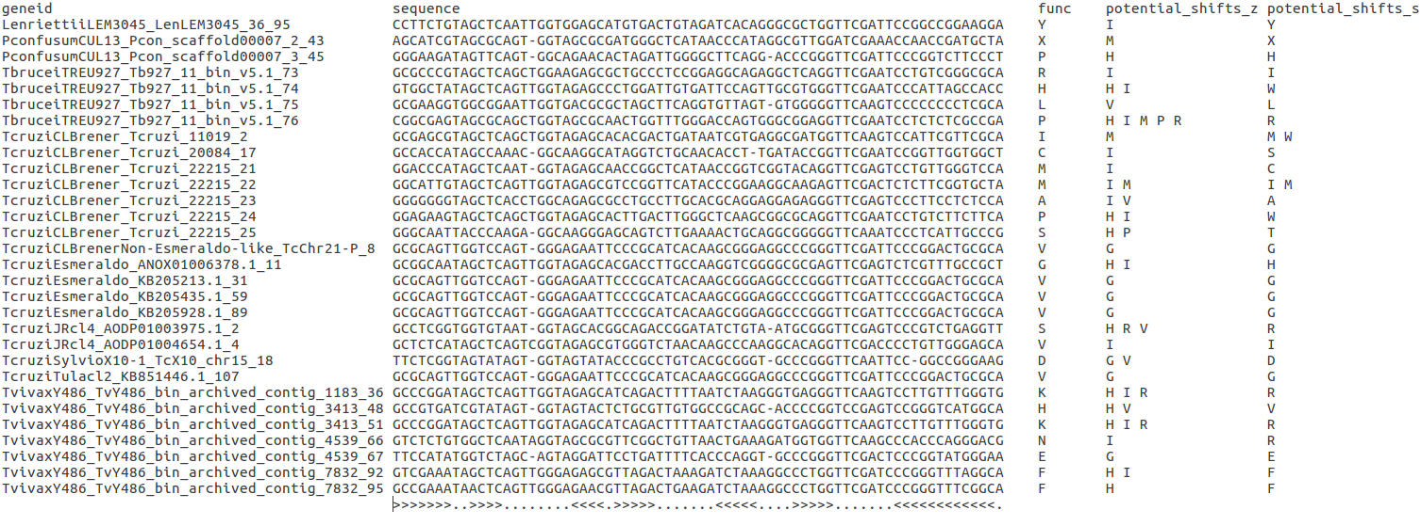
Figure 1: the list of sequences along with their predicted model by gene finders as column “func”. The last two columns shows potential anti-codon shifts based on z-score and score, in order. The last row shows the final structure of the aligned sequences.

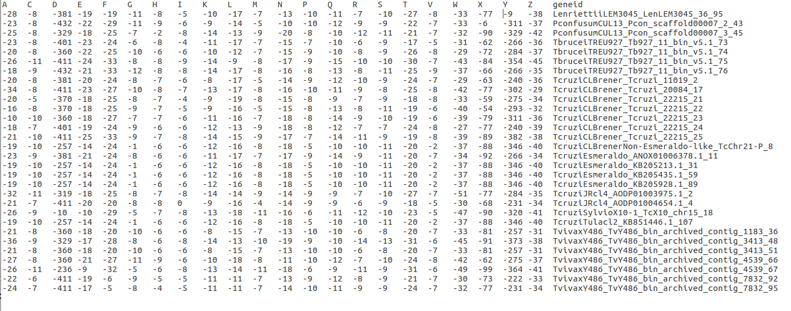
figure 2: z-score of each tRNA sequence against each profile.

figure 2: Score of each tRNA sequence against each profile.

