Predicting potential anti-codon shifts (alloaccepter shifts) in TryTryp tRNA models

After investigating each of the sequences in previous report, I listed some of the most possible anti-codon shifts here.

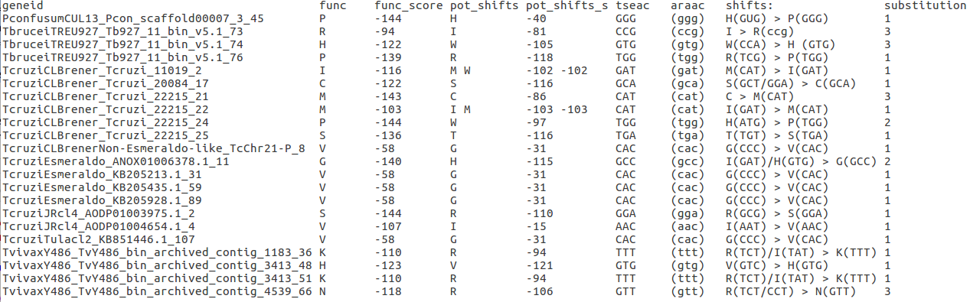

func: Functions predicted by gene-finders
func_score: The score of the functions in column “Func” from the classifier.
pot_shifts : Profile models with the highest score from the classifier.
pot_shifts_s : The highest score from the classifier (score of models listed in column pot_shifts )
tseac/araac : TSE/ARA anti-codon
shift: Most possible anti-codon shifts
substitution : Minimum number of substitutions needed for the shifts

For example: tRNA sequence with geneid “TcruziJRcl4_AODP01004654.1_4” is predicted as model V with anti-codon AAC. However, it is very similar to model I from classifier, and the best anti-codon distance from model I to model V(with andi-codon AAC) is only 1 substitution. Also, the sample size of these two models is relatively high, so the models are relatively reliable.

Model: A C D E F G H I K L M N P Q R S T V W X Y Z
frequency: 211 64 105 160 104 228 80 171 183 336 97 125 200 162 347 228 218 241 52 76 78 76

