Question: Comparing the sets of bubble-plots for each cluster to find the evolution of differences across TryTrypDB.

Answer: To answer this question I made a bar-plot for each of 21 tRNA models. To make each bar-plot, I read the bubble-plots (or the tables we use to make the bubble plots) of model X for all the TryTryp genomes. Each stack is equivalent to one position of bubble plots of model X for all TryTryp genomes. The size of each section of the stack is equal to the width of bubble at that position. The color of each section is the color of bubble at that position.
Figure 1 shows the bar-plot for model “A” and state “A” of all TryTryp bubbleplots against Homo. As you see in position 16, cluster 7 has more variation than other clusters in form of “gain of information”. You can see the bar-plots here and new bubble-plots here.
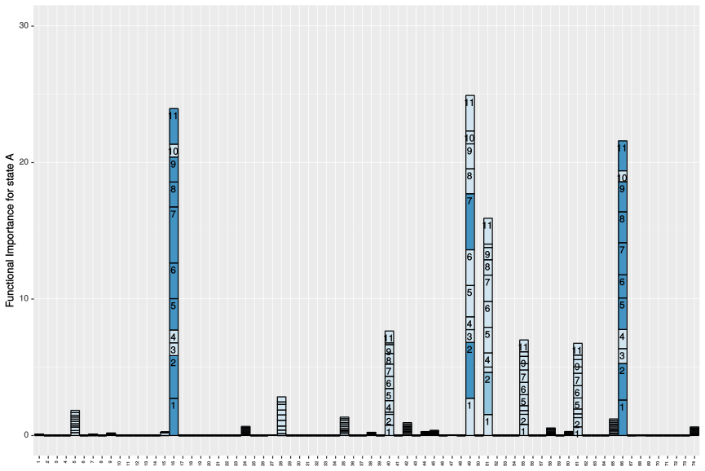
Figure 1: Bar-plot to compare the variation across TryTryp Genomes for model A state A
Figure 2 shows the legend for color of bubble plots.

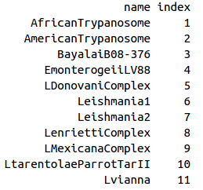


Gain of function in TryTryp Genomes
Change of function in TryTryp Genomes

Figure 2: Legend of Bubble Plots

Questions :
1. Are we comparing the variation across TryTryp genomes by looking at their variation against HomoC?
I don’t think that we can do this because KLD is not symmetric.

2. In our bubble-plots, we have up to 4 bubbles at each position for 4 states. So, to look at the difference of differences, or to compare these bubble plots, do we need to compare the bubbles of each state together? Or should we pick the biggest bubbles of that position?
For the bar-plots, for each model, I have 4 bar-plots for 4 states.

3. to validate the bubble-plots. I looked at your result for Leishmania from the proposal. The bubbles look very similar except that in our alignment, we have 74 positions, so I see displacement of 1 or 2 bases for bubbles. Also, our method of KLD is different from the method used in this proposal. The reason we do not have a high change of function is because we calculated KLD using pseudo counts.

