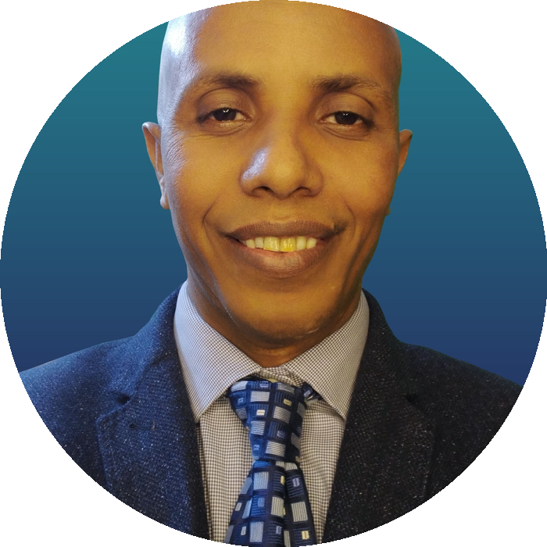 | FILMON HAGOS KAHSAY  IT HELP DESK & TECHNICAL SUPPORT SPECIALIST  Cairo, Egypt · +201222508266  fhagos45@gmail.com · filmonhagos45@hotmail.com  Portfolio: fhagos45-wq.github.io/TCBMEDIA/ · tcb.freedev.app
PROFESSIONAL PROFILE
IT Help Desk & Technical Support Specialist with 8 years of hands-on experience supporting desktop computers, laptops, Windows systems, software, networks, peripherals, and end users. Experienced across the complete support process—from computer preparation and Windows installation to software configuration, hardware/software troubleshooting, maintenance, networking, and remote assistance. Also experienced as an OBS Studio Master/Operator supporting computer-based live production environments. Additional technical capabilities include WordPress, web technologies, Microsoft Office, graphic design, photo editing, video editing, and motion graphics. webcam setup, and full installation, cabling, maintenance, and repair of CCTV security camera surveillance systems.
PROFESSIONAL EXPERIENCE
IT HELP DESK / IT SUPPORT SPECIALIST
8 Years of Professional Experience
Provide hands-on technical support for desktop and laptop computers, Windows systems, software, peripherals, and users. Prepare systems, diagnose problems, resolve technical issues, maintain equipment, support networks, and assist users remotely.
- Prepare, configure, maintain, troubleshoot, and repair desktop and laptop computers.
- Install and configure Windows operating systems, drivers, applications, and required software.
- Diagnose and resolve hardware, software, and operating-system problems.
- Perform computer maintenance and restore systems experiencing technical problems.
- Support and troubleshoot Local Area Network (LAN) and Wide Area Network (WAN) environments.
- Provide remote technical assistance for computer and software problems.
- Assist users with day-to-day technical issues and provide clear, practical solutions.
OBS STUDIO MASTER / OPERATOR
Operate and manage OBS Studio as an OBS Master/Operator for computer-based live production, with responsibility for preparing the technical environment and keeping live operations stable.
- Prepare the computer and technical environment for live production.
- Configure OBS scenes, sources, and audio/video inputs.
- Monitor live audio and video output.
- Troubleshoot technical problems during live operations.
- Maintain reliable operation of the live production environment.
TECHNICAL SKILLS
IT Systems & Networking: Windows · Desktop & Laptop Support · Hardware Troubleshooting · Software Troubleshooting · Computer Maintenance · LAN · WAN · Remote Technical Support
Microsoft Office: Microsoft Word · Microsoft Excel · Microsoft PowerPoint
Web Development & WordPress: HTML · CSS · JavaScript · PHP · WordPress Website Design · Website Configuration · Website Deployment
Graphic & Digital Media: Adobe Photoshop · Adobe Illustrator · Photo Editing · Graphic Design · Adobe Premiere Pro · Video Editing · Adobe After Effects · Motion Graphics
EDUCATION
Bachelor of Science (B.Sc.) in Computer Science
Mekelle University · 2018
LANGUAGES
English: Professional Working Proficiency
Amharic · Tigrinya · Arabic
ADDITIONAL INFORMATION
Nationality: Ethiopian · Location: Cairo, Egypt
References available upon request.

