Analyse the current health status of Australians.
What does the data tell us:
-Mortality rates for Conary heart disease (80% decrease) and Cancer (32% decrease) , since the 1960s have decreased.
- Chronic conditions such as dementia and mental illnesses continue to increase in prevalence resulting in an substantial rates of ill health, disability and premature death
- Decline in daily smoking and tobacco use, as well as risky alcohol use
- Increasing rate of e-cigarette use and obesity.
- Despite their being significant improvements in the health status of Aboriginal and Torres-Strait Islander people there remains a significant health gap with other Australians.

What are the major causes of morbidity, mortality and the life expectancy for males, females and the general population:
Morbidity: Morbidity refers to the ill health of an individual and levels of ill health in a population or group.
Males experience a higher total burden than females overall and across most age groups.
Specific disease burdens vary due to age:
Ages 5-44: Mental health conditions and substance use disorders
Ages 45-84: Musco skeletal conditions, cardiovascular disease and cancer
Ages >65: Neurological conditions (dementia)

The effects of disease and injury on the community are often measured in terms of disability-adjusted life years (DALYs), combining the years of healthy life lost due to living with ill-health (non-fatal burden/YLDs) with the years of life lost due to dying prematurely (fatal burden/YLLs)

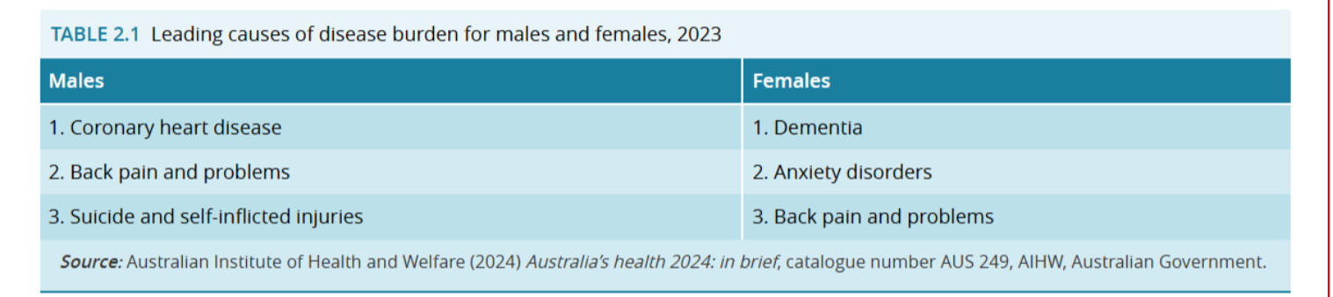

Burden of Disease Trends
1. Cancer rates have decreased due to ‘improvements in early detection’
2. Mental health and substance issues rates have increased due to ‘covid-19’ and an ‘increase in the number of diagnoses’
3. Musco skeletal conditions rates have decreased due an improvement in early detection in infants and increase in technology.
4. Cardiovascular disease rates have decreased due to an increased awareness of lifestyle factors
5. Neurological disorder rates have increased due to an aging population

Mortality:
Is defined by the number or rate of deaths in a population during a given time period.
Dementia: is the leading cause of death in Australia 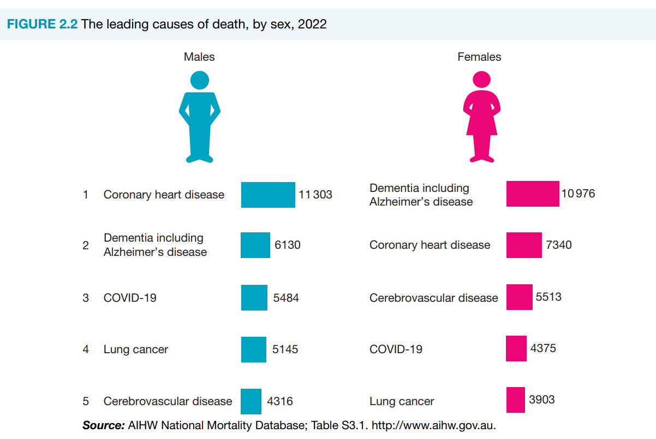

Life Expectancy:
Life expectancy measures how long, on average, a person is expected to live, based on current age and sex-specific death rates often expressed as the number of years a person born today is expected to live.
- life expectancy increased dramatically between 1881 and 1995 and has been fairly steady since the mid-1990s (only slightly increasing)
- The first drop in L.E since the 1960s was in 2020-22, due to the impact of COVID-19 and the increase in number of deaths that resulted.

Significant contributions towards increasing life expectancy in Australia include….
- Advancements in medicine, technology and infrastructure,
- understanding the human body,
-implementing health policies and preventive strategies and health promotion
- greater control of infectious disease

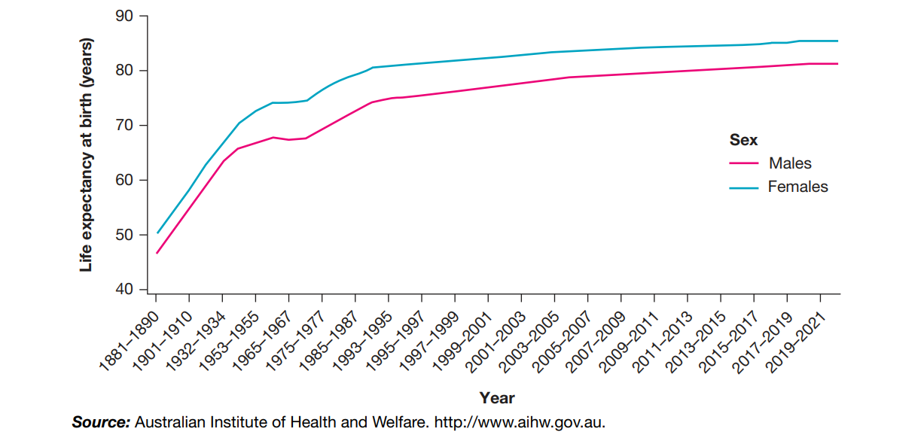

What are the sociological causes of risky health behaviours?
Sociological causes
Are defined as the societal influences or factors influencing human behaviour, these can influence risky health behaviours.
Health behaviours
refer to a person’s beliefs and actions regarding their health and wellbeing.
- A health behaviour is considered risky when it increases the likelihood of negative health outcomes, such as injury. Illness or premature death
-- Health behaviours are influenced greatly by sociological cause

Sociological Causes/influences include:
1. Social relationships:
2. Social interaction:
3. Culture of everyday life:

2.
3.

Negative health outcomes due to risky health behaviours include:
-Increased risk of disease or illness including chronic diseases and STDs
CHD, cancer, diabetes’ + HIV/AIDS
- Potential for immediate harm or injury
Driving under the influence can cause fatal car accidents
- Long-term health consequences due to cumulative damage to the body
Diets high in ultra processed foods, tobacco use, alcohol abuse
-Negative impacts on mental health
Substance abuse can worsen mental health conditions, leads to addiction, isolation and decline in overall wellbeing.

Where do inequities exist and what can we do about them?
Health inequities:
‘the differences in health status or in the distribution of health resources between different population groups’
- In Australia, there are numerous health inequities that exist for males and females

 | Male | Female
What Health Inequities are there | - Males who need to see a GP, wait longer to make an appointment.  - higher rates of risk-taking behaviours,  -socialized hesitation to seek help for mental health  - Males are more likely to die prematurely  -
What can be done about these health inequities | Reducing exposure to specific risk factors such as tobacco, being overweight, dietary risk, alcohol and drug use.  e.g. Banning vapes, choosing public transport, taxing alcohol and cigarettes  - Improving awareness + health literacy for men through health promotion campaigns.  -Emphasising regular checkups and early intervention.  - Encouraging men to choose positive/ protective health behaviours  e.g. Public health campaigns, targeted programs specific to men.
‘the differences in health status or in the distribution of health resources between different population groups’
- In Australia, there are numerous health inequities that exist for males and females

 | Male | Female
What Health Inequities are there | - Males who need to see a GP, wait longer to make an appointment.  - higher rates of risk-taking behaviours,  -socialized hesitation to seek help for mental health  - Males are more likely to die prematurely  - | females experience higher rates of mental health issues. (due to men not being diagnosed).  - Females have specific sexual and reproductive needs which change over their lives  -Women are more likely to face delays in diagnosis, be overprescribed medications, and have their symptoms inadequately investigated
What can be done about these health inequities | Reducing exposure to specific risk factors such as tobacco, being overweight, dietary risk, alcohol and drug use.  e.g. Banning vapes, choosing public transport, taxing alcohol and cigarettes  - Improving awareness + health literacy for men through health promotion campaigns.  -Emphasising regular checkups and early intervention.  - Encouraging men to choose positive/ protective health behaviours  e.g. Public health campaigns, targeted programs specific to men. | Increase the availability of women-centred healthcare services  Increased funding for women’s health research,  Training healthcare practitioners to recognise unconscious bias which may influence diagnosis and treatment decisions for women.  Foster a collaborative approach between healthcare providers and female patients, where women are encouraged to participate actively in their care decisions.

