How does Edson’s text reaffirm or challenge the ideas put forward in Donne’s poetry?934
The power of textual conversations lies in its ability to explore the resonances and dissonances between texts and how they reflect their different contexts. John Donne’s 17th century poetry dismantles Renaissance salvation anxiety through non-traditional wit and metaphysical conceits. Written during the rise of secularism and individualism, Margaret Edson’s ply ‘Wit’ (1991) explores Donne’s concepts through a witty metatheatrical performance incorporating the arrogant and intellectual views of death in ‘Death be not proud.’ However, while Donne finds peace in his relationship with God as seen in ‘This is my play’s last scene’, Edson reconstructs this in a secular context by asserting that true peace is found through human connection.

Donne begins the conversation with an intellectually arrogant defiance of death in his sonnet ‘Death be Not Proud”. He dismantles the salvation anxiety pervasive in Renaissance England, a period marked by religious upheaval following the Reformation and a growing tension between medieval fatalism and emerging humanistic optimism. Donne’s use of apostrophe in directly addressing “Death” and an imperative command of “be not proud” immediately establishes his intellectual confidence. He patronises death as a “poor,” pitiable figure, stripping it of the reverence it traditionally inspires. Donne satirically reduces death to a mere “slave” of “Fate, Chance, kings, and desperate men,” the asyndeton challenging traditional notions of death as an all-powerful force. The paradox of “death shall be no more, death, […] shalt die” showcases Donne’s academic conceit, as he personifies death as a victim to its own threats, asserting dominance over mortality. Donne has not only told death that it has no real power but that in waking “eternally” in heaven, death will no longer exist.

In ‘W;t’, Margaret Edson affirms Donne’s intellectual defiance in the context of late 20th-century America, a period defined by the rise of secularism and individualism. Like Donne, Vivian Bearing in ‘W;t’ initially responds to her terminal cancer diagnosis with intellectual arrogance. She breaks the fourth wall as she proudly introduces herself as the narrator as “a professor of […] the Holy Sonnets of John Donne,” arrogantly asserting that she “know[s] all about life and death.” She muses that she “Must read something about cancer. Must get some books,” the truncated stream of consciousness indicating how Vivian places complete faith in analysis and academia. Vivian’s objective detachment mirrors Donne’s poetry, both using wit to distance themselves from death’s emotional weight. Her self-aware dismissal of her lack of visitors – “none, to be precise” – further highlights her triviality of personal relationships. Furthermore, Vivian tries to make her illness meaningful by focusing on her role as a "prized patient" in a prestigious study, believing that this, like her academic work, will outlive her. Hence, Vivian is initially intellectually arrogant, believing that her mastery of Donne’s poetry equips her to face death with composure.

Nearing the end of his life, Donne abandons his intellectual arrogance and finds peace in his relationship with God in ‘this is my plays last scene’, reflecting his Christian context. Approaching his death, Donne’s faith assures him that he will be ‘ever waking’ after death and will ‘see [God’s] face’. Realising the incapacity of his own intellectual wit, he turns to the comfort of his religious beliefs. He commands ‘fall my sins’, while his ‘soul’ will ‘take flight’ to heaven, his sureness strengthened by his belief in ontological duality in alignment with Christian doctrine. Donne asks to be ‘impute[d] righteous”, revealing his reliance on divine mercy and humility in his relationship with God, contrasting his earlier arrogance. Donne states that he will ‘leave the world, the flesh, the devil” the tricolon signifying a rejection of earthly attachments, including his pride and arrogance. He finds comfort in Christian doctrine and his relationship with God instead of his own intellect.

While Donne abandons his intellectual arrogance and turns to the Christian God, Edson reconstructs this idea as Vivian also realises the futility of academia in the face of death but finds peace in human connection in a secular world. The form of a one act, ninety minute play allows audiences to witness and engage emotionally with Vivian as she confronts “[her] life and [her] death”. The fragmented syntax of her admission that she is ‘frightened’ and ‘out of control’ exposes her loss of intellectual composure. Confronted with Jason’s clinical detachment, Vivian recognises in him a reflection of her own past arrogance, understanding that "now is a time for kindness." The simple dialogue of Vivian’s “child[like]” acceptance and sharing of Susie’s "popsicle” stresses how she finds comfort in tangible kindness given by Susie.
Significantly, Vivian recognises that Donne’s poems offer a path to reconciling oneself with mortality, finally accepting that “nothing but a breath – a comma – separates life from life everlasting.” When she passes away, the shedding of her medical equipment symbolises the removal of earthy attachments like Donne, and the stage direction that she walk vulnerably ‘toward the light’ symbolises how her friendship with Susie allowed a calm acceptance of death. Unlike Donne, who found peace in his relationship with the Christian God, Vivian finds peace by embracing the fundamental human need for kindness.

Ultimately, Donne and Edson both explore intellectually arrogant views about death, but to vastly different ends. Donne finds peace through his Christian faith, while Vivian in W;t realises that human relationships provide true comfort. Through this contrast, both texts speak to modern audiences through their timeless explorations of mortality, intellectual pride and the search for meaningful connection.

Alternate 3rd paragraphs
This is my playes last scene
Nearing the end of his life, Donne abandons his intellectual arrogance and finds peace in his relationship with God in ‘this is my plays last scene’, reflecting his Christian context. Approaching his death, Donne’s faith assures him that he will be ‘ever waking’ after death and will ‘see [God’s] face’. Realising the incapacity of his own intellectual wit, he turns to the comfort of his religious beliefs. He commands ‘fall my sins’, while his ‘soul’ will ‘take flight’ to heaven, his sureness strengthened by his belief in ontological duality in alignment with Christian doctrine. Donne asks to be ‘impute[d] righteous”, revealing his reliance on divine mercy and humility in his relationship with God, contrasting his earlier arrogance. Donne states that he will ‘leave the world, flesh, devil” the tricolon signifying a rejection of earthly attachments, including his pride and arrogance. He finds comfort in Christian doctrine and his relationship with God instead of his own intellect.
At the round earths imagin’d corners
In “At the round earths imagined corners”, Donne abandons his intellectual arrogance and finds peace in his relationship with God, reflecting his Christian context. Though at first Donne seems to be arrogant in the octave as he commands the angels to “blow [their] trumpets” and the dead to “arise, arise,” he pauses and asks God to “let them sleep, Lord”. He requests a delay in the final judgement, not out of defiance, but to give himself time to seek God’s mercy. His pivot reveals his reliance on God’s patience and grace, acknowledging that only through divine mercy can he find peace. The plea for time to "mourn" suggests an emotional and spiritual process of turning inward, recognising his sins, and preparing his soul for reconciliation with God.
Donne begs God to “Teach [him] how to repent”, openly admitting his inadequacy, asking God to guide him in repentance, a clear surrender to divine will. This humility and trust in God’s mercy contrast sharply with the earlier arrogance and reliance on his own wit, illustrating how Donne achieved peace though reliance on God.
Hymne to God my God, in my sicknesse
Nearing the end of his life due to a sickness, Donne abandons his intellectual arrogance and finds peace in his relationship with God in ‘Hymne to God my God, in my sicknesse’, reflecting his Christian context.
- Donne is preparing for death/heaven (what I must do then, think now before) like Vivian will
- Donne trusts in God’s mercy and begs that he will, “in [Jesus’s] purple wrapp’d, receive me, Lord”
If Poisonous minerals
In “If poisonous minerals”, Donne ultimately stops relying on his own wit and turns to God for peace and redemption, reflecting his Christian context. Though at first Donne seems to be arrogant in the octave, demanding answers from God about His judgement on him compared to animals, he stops questioning God and becomes reflective and humble, asking “who am I, that dare dispute with Thee?” He begs God to “forget” his sins instead of “claim[ing it] as debt,” recognising that, instead of God owing him answers, he is in debt to God.
This humility and trust in God’s “mercy” contrast sharply with the earlier arrogance and reliance on his own wit, illustrating how Donne achieved peace though reliance on God.
A Valediction: forbidding mourning
Donne remains intellectually arrogant throughout his life, including in his marriage with his wife Anne as shown in ‘a Valediction: forbidding mourning’.
arrogance in relationships
- Contrasts his relationship with the melodramatic "dull sublunary lovers" who rely solely on physical presence, elevating their love above others, implying a superiority in their bond—spiritual and intellectual rather than merely physical.
- their love is "so much refined" suggests he’s confident in its exceptional nature, boastful in their superior capability to part quietly.
- Believes their relationship is “greater far”
- They are like “virtuous men” – separate quietly
The Sunne Rising
Donne remains intellectually arrogant throughout his life as seen in “The Sunne Rising” where he uses his arrogance to rebuke the Sun.
Rather than allowing the sun's "motions" across the sky to govern him, Donne challenges the sun's authority and wittily turns the sun into something below him.
- “Busy old fool, unruly sun”, “saucy pedantic wretch” – apostrophe . sun is not only foolish but needs to be ruled by greater authority – him. demonstrates his intellectual confidence.
- Donne rejects the Sun’s power, with the logic that “I could eclipse and cloud them with a wink,”
- Donne not only gives the sun orders to annoy “Late school boys” and “court harvestmen” instead of him and his lover, but he's also ordering the sun to actually serve the lovers by “warming [them]” in their bed. The lovers thus become the greater authority that the sun itself ought to obey.
The Apparition
Donne remains intellectually arrogant throughout his life, as seen in “The apparition’, where he reclaims control over a rejecting lover by fantasising her downfall, turning heartbreak into empowerment.
- Still believes he has power over death
- Etc.

W;t extra quotes and analysis
Viv: “Donne’s wit is … a way to see how good you really are. […] no one is quite as good as I.” | Arrogance.
Kelekian: “And, as research, it will make a significant contribution to our knowledge”  Jason: “Got to have a girl here. Some crazy clinical rule”  “Lower the dose? No way.”  “I really have not got time for this”  (of bedside manner) “colossal waste of time for researchers” “Just cut the crap, I say.”  “She’s Research!”  Vivian: “I think they foresee celebrity status for themselves upon the appearance of the journal article they will no doubt write about me” | Doesn’t care about patients as human, just research. Edson critiques the modern medical system which can tend toward dehumanisation, etc. at the expense of patient wellbeing.
Jason: “Jesus!” (shock)  Kelekian: “Jesus God.” (frustration) | Unprofessional, v. diff context from Donne
Vivian: “Oh God!” (repeated) | Mirrors Donne,
Stage direction: Vivian: (uncomfortable with kindness)
Friday morning grand rounds  “they read me like a book”  They “anatomise [her]”  “the article will not be about me, it will be about my ovaries.”  “specimen jar”, “dust jacket” | Compares with hymn to god, being studied and analysed  But she is ultimately unimportant as a person to the researchers – all they care about are her ovaries
Susie: “lowering the dose […] its too much for her”  “What’s the trouble, sweetheart?”  “it’s all right. I know. It hurts. I know. It’s all right. Do you want a tissue? It’s all right.”  “Vivian, would you like a Popsicle?”  Vivian: “You’re still going to take care of me, aren’t you?”  “Now is a time for simplicity”  Teaches Susie what ‘soporific’ means – but teaches with compassion, not like before.  Susie: “it’s just nice to do” | Kindness, compassion
Ashford: “A little allegory of the soul. No matter where it hides, God will find it.” | Relates to Donne’s Christian context. Ashford an esteemed academic, but still had a balanced life (e.g. has grandkids

PRACTICE QUESTIONS
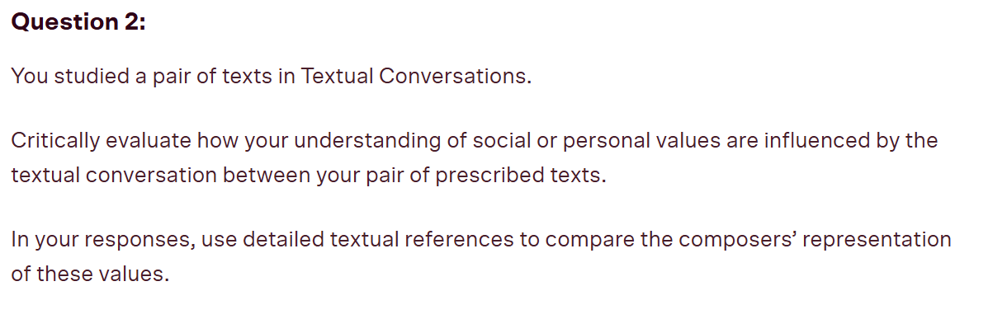
P1: Donne values intellect and wit
P2: Vivian values intellect and wit
P3: Donne values Christian beliefs and find peace
P4: Vivian values secular human kindness and finds peace

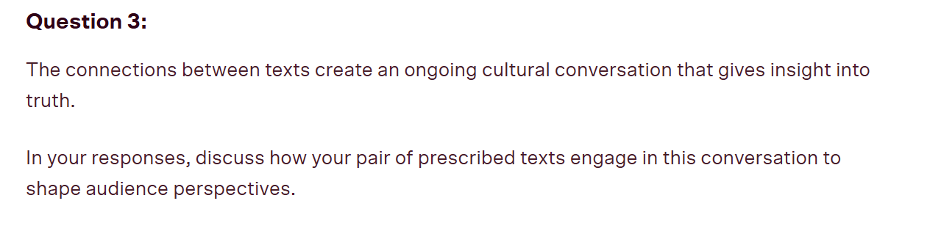
P1: Donne gives insight to the truth that Death can be overcome by wit, shaping renaissance audience who had salvation anxiety
P2: Vivian gives insight to the truth that Death can be overcome by wit
P3: Donne gives insight to the truth that relationship with God is valuable
P4: Vivian gives insight to the truth that human relationship is valuable
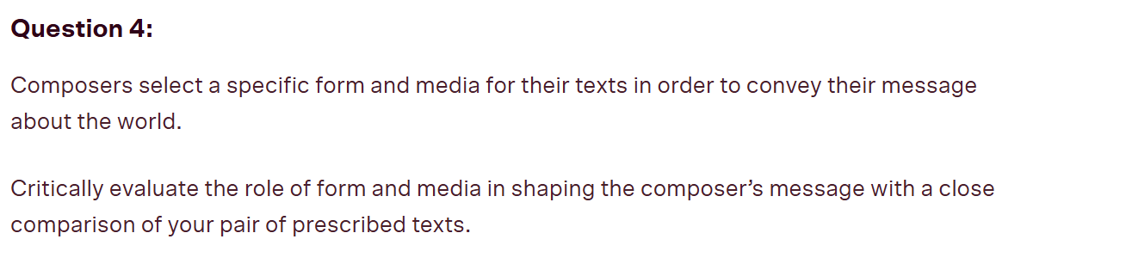
P1: Donne uses metaphysical poetry (unconventional form) to convey (unconventional) intellectual response to death, dismantle salvation anxiety
P2: Vivian uses metatheatre to convey the intellectual response to death
P3: Donne uses metaphysical poetry to convey relationship with God gives peace
P4: Vivian uses metatheatre to convey how human connection leads to peace, allows viv to be vulnerable, etc
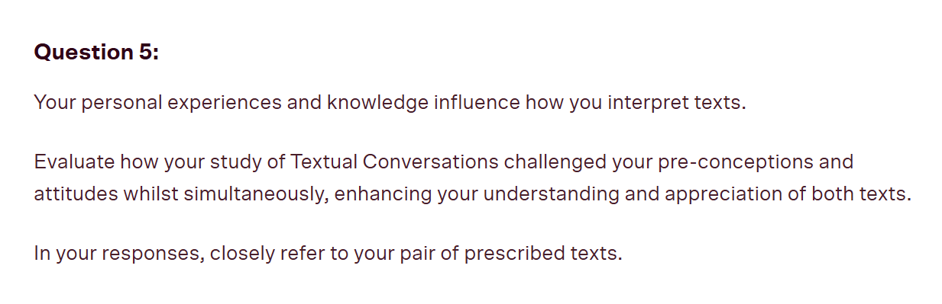
P1: Donne challenges my preconceived attitude of fearing death
P2: W;t challenges my preconceived attitude of fearing death
P3: Donne enhances my understanding of the value of religious beliefs
P4: W;t enhances my understanding of the value of human connection

"To what extent does your perspective of Donne’s poetry determine your interpretation and appreciation of Edson’s play Wit?"
Thesis: My perspective of Donne’s poetry greatly allows me to appreciate how Edson modernises Donne’s reliance and later rejection of intellectual arrogance in a secular context, relevant to modern society,
Edson transforms his abstract metaphysical ideas into a human, emotional confrontation with mortality.
P1: Donne is intellectually arrogant
P2: Which illuminates Vivians similar detachment to death, provides a lens to understand it through
P3: Donne rejects arrogance, which helps understand vivian’s transformation. This shift in Donne allows us to see how intellect alone is ultimately insufficient in the face of mortality—a realisation Vivian too comes to accept.
P4: By understanding the spiritual resolution Donne ultimately finds in his relationship with God, we better appreciate how Edson reconstructs this resolution in a secular context, revealing that kindness—not divine faith—offers peace in the face of death.
"To what extent does your perspective of Edson’s play Wit determine your interpretation and appreciation of Donne’s poetry?"
Thesis: My perspective of Wit greatly allows me to appreciate how Edson modernises Donne’s reliance and later rejection of intellectual arrogance in a secular context, relevant to modern society,
Edson’s transformation of his abstract metaphysical ideas into a human, emotional confrontation with mortality allows modern audiences to better appreciate Donne’s work via post modern means
P1: Donne is intellectually arrogant
P2: Vivians similar detachment to death provides a lens to understand donne through
P3: Donne rejects arrogance, This shift in Donne allows us to see how intellect alone is ultimately insufficient in the face of mortality—a realisation Vivian too comes to accept.
P4: can better understands donne’s struggles by seeing it in a modern context – abandonment of intellect
‘Everything is being dismantled, reconstructed, recycled. To what end? For what purpose?’ To what extent is this statement true of the texts you have studied in this module?
Thesis: This statement is greatly true, with concepts dismantled, reconstructed and recycled to challenge preconceived assumptions and convey the importance of relationships near the end of ones life.
- Donne dismantles salvation anxiety to give defiance of death
- Edson recycles/ reconstructs donnes intellect in modern context
- Donne dismantles his previous idea and relies on god
- Edson reconstructs donnes idea to convey how relationship gives you peace
In textual conversations, the later text is often seen as a shadow, lacking the originality and power of the earlier. To what extent is this statement true of the two prescribed texts you have studied in Module A?
Thesis: this statement is false to a great extent as Wit is a dynamic reimagining that extends his metaphysical ideas into a contemporary context. Through their textual conversation, Edson both affirms Donne’s insights on mortality and challenges his intellectual arrogance, suggesting that compassion, not intellect, leads to peace. Both texts speak powerfully to their audiences
- Donne defiance of death
- Wit defiance of death – gives new relevance to this idea in a modern age
- Donne relies on God
- Edson reconstructs to show importance of human connection – equally profound conclusion, reflecting the context
When we engage with a text, the question we must ask ourselves is, ‘What is this text really about?’ Consider the pair of prescribed texts that you have studied in Module A. To what extent does your engagement with the later text make you ask this question about the earlier text?
Thesis: Engaging with W;t deepens and transforms our understanding of Donne’s poetry — showing that beneath Donne’s intellectual wit, his poems are really about the human search for spiritual or emotional peace in the face of mortality. Both texts confront same q diff context.
- At first, Donne’s poetry seems to be an intellectual defiance of death
- Edson’s defiance of death, critiquing a surface level read of donne
- What donne is really about Engaging with W;t transforms our understanding of Donne’s poetry: it is not about defeating death but about finding peace in god.
- through W;t, we understand that Donne’s poetry is really about the human need for relationship in the face of mortality.

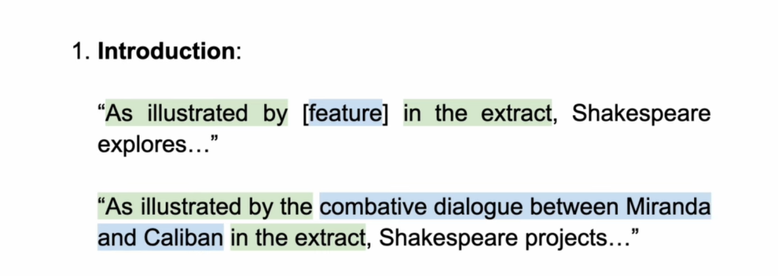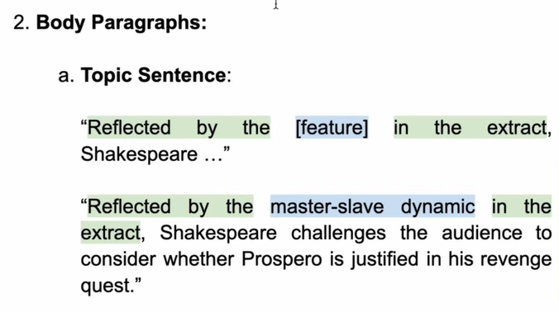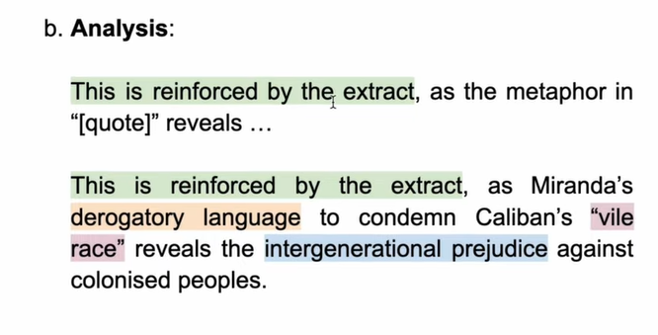

Agrees | Disagrees | Realises | Shows
Resonates  Recycles  Affirms  Echoes  Supports  Mirrors  Aligns  Reflects  Imitates  Replicates | Dissonates  Dismantles  Pulls apart  Contrasts  Demolishes  Antithesis  Juxtaposes  Challenges  Contradicts  Reimagines  Reconstructs | Recognises  Sees  Acknowledges  Admits  Understands  Comprehends  Accepts | Portrays  Conveys  Demonstrates  Depicts  Displays  Illustrates  Illuminates  Showcases  Highlights  Expresses  Establishes  Indicates  Reveals  Symbolises  Emphasises  Encapsulates  Exhibits  Exposes  Stresses  Presents  Implies  Reinforces  Suggests

