 | Hotspur | Henry | Hal
Deception/ leadership / machiavellian / context | Not deceptive -> lost and died | Deceptive but no empathy -> unrest | Deceptive and empathetic -> success
honour | Overly obsessed -> leads to lack of foresight / adaptability | Tries to uphold honour though Machiavellianism, but -> conflict | Uses honour to his advantage /tool -> success
Appearance v reality / nuance | Seems honourable / successful -> but leads to his downfall | Seems honourable, good king, but his illegitimate, sneaky ways -> unrest | Appears as a rebel, turns out to be a good king bc of his time in the tavern.
comedy | Contrast between Falstaff and hotsur’s views of honour -> necessity for adaptability | No comedy in Henry’s court (instead, full of conflict) vs comedy in the tavern -> necessity of empathy, strategy | Uses comedic world (tavern) to prepare him for leadership

General topics:
Textual integrity, distinctive qualities, significance: explores the qualities of a good leader throughout the play through the contrasting characters in their distinctive settings, which has timeless relevance to society.
Imaginative qualities: exaggeratedly honourable Hotspur; the unrest of Henry’s reign; age gap of Hal and Hotspur, Falstaff, transformation
Deception/Machiavellianism/leadership/context
Thesis: emotionally intelligent Machiavellianism is necessary for good leadership (reflecting succession anxiety elizabeth context)
- Hotspur is honourable, not diplomatic, brutally honest -> failed (lost battle, died)
- King henry is Machiavellian but no emotional intelligence -> failed (civil unrest)
- Hal is Machiavellian and emotionally intelligent -> success (rises to power, matures, etc)
OR
- Hotspur: cares for his people, but not deceptive
- Henry: deceptive, but doesn’t care about people
- Hal: deceptive and cares for his people
Is honour important/how is honour presented
Thesis: An adaptive, emotionally intelligent Machiavellian approach to honour is necessary for good leadership.
- Hotspur is overly obsessed with honour -> leads to lack of foresight/adaptability bc he is only focused on honour -> leads to his failure (hamartia)
- Henry tried to uphold his honour through Machiavellianism, but bc he is distant from his people, it results in civil conflict
- Hal uses honour to his advantage, he is only engaging in these political manipulations for good reasons. Hal’s time in the tavern is important in moulding him into a noble Prince. Uses honour as a tool in his transformation, resulting in his success.
Appearance vs reality / performance / deception
Thesis: an emotionally intelligent deceptive appearance is necessary for good leadership
- Hotspur is not deceptive, not diplomatic, brutally honest, shows the reailty -> failed (lost battle and died)
- King henry is cunningly deceptive but no emotional intelligence -> failed (civil unrest, unstable)
- Hal is cunningly deceptive (transformation) and emotionally intelligent (compassionate) -> success (rises to power, matures, etc)
Comedy
Thesis: Comedy is a critical lens to explore leadership, honour, and legitimacy. Through Falstaff, Shakespeare satirises rigid ideals of chivalry and exposes the absurdities of political ambition, ultimately reinforcing the play’s argument that effective leadership requires adaptability, emotional intelligence, and self-awareness.
- Contrast between Hotspur’s honour and Falstaff’s mocking of honour shows how leadership cant be built on such rigid principles alone
- Absence of comedy in Henrys world (instead, full of conflict, etc due to his rigid, distant reign), contrasts with Falstaff as a leader in the tavern,
- Hal uses the comedic world (tavern) strategically as a training ground and to prepare him for leadership, ultimately revealing to be the best leader as an adaptive, emotionally intelligent Machiavellian
Setting/ construction
Thesis: contrasting settings used to explore competing models of power, honour, and leadership. Through this spatial contrast, he shows the need for adaptive, etc.
- Battlefield: traditional chivalric space. Hotspur thrives here, sees it as the only legitimate site for glory, but refuses to adapt out of this setting - is not diplomatic, brutally honest -> failed (lost battle and died)
- Court: performance space. King henry uses court to maintain mystique and authority – but is cold, formal and isolated from his people. Court symbolises Henry’s Machiavellian control and lack of emotional accessibility -> failed (civil unrest)
- Tavern: Hal uses tavern time to mature, grow in compassion, etc. uses it deliberately (in his plan). He is able to move effortlessly between court, battlefield and tavern. The tavern causes Hal to be Machiavellian and emotionally intelligent -> success (rises to power, matures, etc)
How important is family?
Thesis: a adaptive, empathetic Machiavellian view of family is necessary for good leadership.
- Hotspur is the son Henry wishes to have, as he embodies honour – yet his obsessive familial honour to the percys leads to his downfall. destructive consequences of loyalty based on pride and legacy.
- King Henry has a strained relationship with Hal as he was always distant, as he was with his people, causing civil unrest. Longs for reconciliation but no. state of the country mirrors his relationship with his son.
- First presented as bad son, reveals his plan for reconciliation with father, becoming an ideal son is an act of strategic filial duty, positioning him as both a devoted son and a politically astute heir. Ultimately rejects the other father figure Falstaff, Drawing on Machiavellian principles, Hal consciously reconstructs his identity to meet his father’s expectations and win public trust, ultimately succeeding as king.
What does the play say about the nature of rebellion?
Thesis: rebellion is a tool to criticise the inflated version of honour. Only an adaptive, empathetic Machiavellian model of rebellion can lead to stable leadership.
- Hotspur: rigid, honourable model of rebellion, not deceptive -> fails.
- Henry: uses a rigid Machiavellian model of rebellion (rebelling against divine anointed line of succession and conventional kingness) -> civil unrest and rebellion. Rebellion breeds rebellion.
- Hal: adaptive, empathetic Machiavellian model of rebellion (truant to prince) -> succeds.
Sample questions:
PHCS 2025 “The complexity of Shakespeare’s characters is central to the play’s significance.” How does Henry IV invite audiences to form nuanced understandings of more than one character and their motivation?
Thesis: Through exploring what is needed for effective leadership, Henry IV invites readers to form nuanced opinions of Henry, Hal and Hotspur through their complex motivations of and approaches to leadership.
- Hotspur: motivated by honour (which seems good) -> brutally honest -> downfall
- Henry: motivated by legitimacy (which seems good), -> machiavellianism-> unrest as he is distant
- Hal: motivated to prove his worth and lead people -> spend time with people, diplomatic, Machiavellian, transforms-> success
How does Shakespeare’s Henry IV use the interplay of contrasting characters,
such as Hal and Hotspur, to explore the complexities of leadership and honour,
and what does this reveal about the play’s enduring relevance?
Thesis: Shakespeare explores the complexities of leadership and honour through the contrast between Hal, Hotspur, and King Henry IV, revealing that effective leadership requires a flexible, emotionally intelligent, Machiavellian model of honour.
- Hotspur is overly obsessed with honour -> leads to lack of foresight/adaptability bc he is only focused on honour -> leads to failed leadership (hamartia)
- Henry tried to uphold his honour through Machiavellianism, but bc he is distant from his people, it results in civil conflict
- Hal uses honour to his advantage. Hal’s time in the tavern is important in moulding him into a noble Prince. Uses honour as a tool in his transformation. Hal is Machiavellian and emotionally intelligent (contrasts hotspur and henry) -> success (rises to power, matures, etc)
To what extent has the play’s construction contributed to your appreciation of its insights about relationships?
Thesis: The play’s tripartite settings and contrasting characters greatly help me understand the impact of familial relationships on both an individual’s character and their leadership.
- Hotspur: obsessive familial honour -> blunt, etc -> death and failure of rebellion
- King Henry: distant from hal and people-> strained relationship with hal and people-> causing civil unrest. Longs for reconciliation but no. his relationship w son impacts the way he leads his people. state of the country mirrors his relationship with his son.
- Hal: relationship with falstaff -> deceptive, cunning -> transformed, good leader. Though first presented as bad son, reveals his plan for reconciliation with father, becoming an ideal son is an act of strategic filial duty, positioning him as both a devoted son and a politically astute heir. Hal consciously reconstructs his identity to meet his father’s expectations and win public trust, ultimately succeeding as a leader.
In what ways does Shakespeare’s use of language and dramatic techniques in
Henry IV reflect the tensions between personal identity and political
responsibility, and how do these contribute to the play’s textual integrity?
Thesis: Shakespeare’s use of language and dramatic techniques reflects the tension between personal identity and political responsibility in characters like Hotspur, King Henry IV, and Hal, reinforcing the cohesive themes of honour and leadership and textual integrity of Henry IV, Part 1.
- Hotspur has personal identity of honour, which leads him to abandon political responsibility in reckless pursuit of honour -> failure as a leader
- Henry has politically calculated persona, but doesn’t take proper responsibility for his illegitimate actions and is instead distant -> civil unrest, failed leader
- Hal has a Machiavellian transformed personal identity (tavern -> prince) and ultimately takes responsibility for his people (gets to know them) -> successful leader
To what extent does Henry IV engage with the Elizabethan context to examine
the nature of power and legitimacy, and how might these themes resonate with
contemporary audiences?
Thesis: It engages deeply with Elizabethan anxieties around succession and unstable power, examining how emotionally intelligent Machiavellianism is necessary for good leadership, a message still relevant to modern political discourse.
- Hotspur is honourable, not diplomatic, brutally honest -> failed (lost battle, died)
- King henry is Machiavellian but no emotional intelligence -> failed (civil unrest)
- Hal is Machiavellian and emotionally intelligent -> success (rises to power, matures, etc)
(same points as original essay)
2021 Through the precise and close examination of literature, we can gain a greater understanding of the use of history and composition to form a new meaning to an audience. To what extent does this statement align with your understanding of king henry iv part 1?
Thesis: a Machiavellian, emotionally intelligent approach to kingship, reflecting current time. Recontextualises historical events to create a powerful commentary on leadership.
- Hotspur is honourable, not diplomatic, brutally honest -> failed (lost battle, died)
- King henry is Machiavellian but no emotional intelligence -> failed (civil unrest)
- Hal is Machiavellian and emotionally intelligent -> success (rises to power, matures, etc)
(same points as original essay)
2022 How has your study of King henry iv part 1 altered and expanded your understanding of dishonour?
Thesis: My study of Shakespeare altered my understand of dishonour from simply a moral flaw/failing but is more nuanced – good leadership requires a willingness to appear dishonourable in the short term. dishonour can be inherited, constructed, and even weaponised
- Hotspur is completely honourable -> failed (lost battle and died)
- King henry is completely dishonourable in how he gets throne, as he tries to manage public appearance, but he has lost public trust, distant from people, no emotional intelligence -> failed (civil unrest)
- Hal adopts temporary dishonour to later claim genuine leadership. True leadership requires a willingness to appear dishonourable in the short term -> success (rises to power, matures, etc)
2023 Evaluate how your personal and intellectual engagement with your prescribed text has been intensified by its construction.
Thesis: my personal and intellectual engagement with the question of leadership has bene greatly intensified though the 3 settings, juxtaposing characters, etc.
- Battlefield is place of chivalry. Hotspur is honourable, not diplomatic, brutally honest. Cant adapt out of this setting -> failed (lost battle and died)
- Court is place of performance, King henry is Machiavellian. but no emotional intelligence, isolated form people in the court -> failed (civil unrest)
- Tavern: Hal is Machiavellian and emotionally intelligent bc his time in tavern can move effortlessly between court, tavern and field. -> success (rises to power, matures, etc)
- (same points as setting q)
“All the world’s a stage and all the men and women are merely players.” How does this reflect your understanding of King Henry IV?
Thesis: it is only through ‘playing’ (being deceptive and versatile/adaptive) that one can become a successful ruler.
- Hotspur is honourable, not diplomatic, no acting, stuck in battlefield (chivalric) setting -> failed (lost battle, died)
- King henry is acting but cannot shift away from the court setting -> failed (civil unrest)
- Hal is the ablest player- acts as rebel then transforms, can shift between settings, planner -> success (rises to power, matures, etc)

Evaluate how the artistry and integrity of your prescribed text has influenced your understanding of its literary value.
Thesis: Shakespere’s innovative artistry of the tripartite setting aids in King Henry 1v part 1’s exploration of the qualities of effective leadership, thus contributing to the textual integrity, thus enhances its literary value across time.
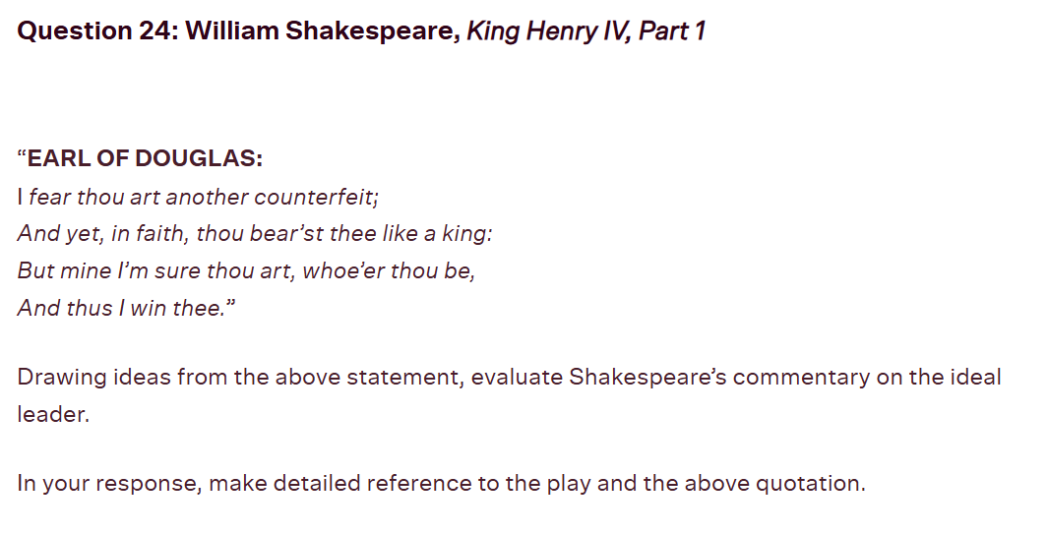
Thesis: The quote reveals Douglas mistaking King Henry of a ‘counterfeit’ even though he ‘bear’st thee like a king’ exposing Shakespeare’s commentary on the necessity of deception in ideal leadership.

Extra analysis
Additionally, he rashly describes the king as “vile”, “ingrate and cankered,” the mocking tone and emotive imagery shows his open, unfiltered disrespect – a dangerous move when planning rebellion, highlighting his lack of cunning foresight.
As HT Edmondson argues in “Temperament and Leadership in Henry IV”, “Hotspur, though more apparently mature, is temperamentally unsuited for leadership” highlighting how the pursuit of personal honour causes Hotspur to be an unfit leader.

Quotes to know:
Hotspur
- Thou art the king of honour – douglas to hotspur
- I cannot flatter – hotspur
- Die all die merrily – hotspur
- Food for … for worms, brave percy – hal – honour doesn’t help hotspur in the end
- Tis dangerous to take a cold, to sleep, to drink
- While you live, tell truth and shame the devil!
- I better brook the loss of brittle life
Than those proud titles thou hast won of me.
- “the spirit within thee hath been so at war, and thus has so bestirred thee in thy sleep”, - haunted by the battlefield in his sleep, obsessed.
- “wasp stung and impatient fool” – Northumberland’s description of hotspur
- “Harry to harry”
Henry
- Should be the father to so blest a son
- Night tripping fairy
- Whilst I, by looking on the praise of him, See riot and dishonor stain the brow of my young Harry.
- Then would I have his Harry, and he mine.
Hal:
- “when I am king of England, … I can drink with any tinker in his own language” - adaptive
- I shall hereafter […] be more myself – hal
- Yet herein I will imitate the sun
- I will redeem all this on Percy’s head
- Falstaff: Banish plump Jack, and banish all the world.
Prince Henry: I do, I will.

Falstaff
- S’blood, was time to counterfeit
- Hal, if I tell thee a lie, spit in my face, call me horse. – Falstaff
- Food for powder, food for powder – Falstaff
- fat-witted

