VALPROATE ANALGESIA IN CARRAGEENAN-INDUCED THERMAL HYPERALGESIA IN RATS HAS A BIMODAL DOSE-RESPONSE EFFECT CURVE

Karolinne Souto de Figueiredo¹, Maria Luisa Azevedo de Oliveira Sales¹, Juvenia Bezerra Fontenele, PhD², Glauce Socorro de Barros Viana, PhD¹, Giovany Michely Pinto da Cruz¹, Francisco Hélder Cavalcante Félix, MD³
¹Department of Biophysiology and Pharmacology, Faculdade de Medicina de Juazeiro do Norte.
²Professor of Pharmacy, Department of Pharmacy, Faculdade de Farmacia, Odontologia e Enfermagem, Universidade Federal do Ceara.
³Pediatric Hemato-oncologist and Pharmacologist, Pediatric Hemato-oncology Service, Hospital Infantil Albert Sabin

Correspondence to: Francisco Hélder Cavalcante Félix, Pediatric Hemato-oncology Service, Hospital Infantil Albert SabinR Alberto Montezuma, 350 - Vila Uniao - 60410-770 - Fortaleza - CE – Brazil, e-mail: helderfelix@hias.ce.gov.br

Conflicts of interest:
There are not potential sources of conflicts of interest.

The authors declare that this material has not been published or is under active consideration by another journal. This research was conducted in accordance with the Declaration of Helsinki and with the Guide for the Care and Use of Laboratory Animals as adopted and promulgated by the United States National Institutes of Health.

Pages: 15
Abstract word count: 159
Text word count: 1454
Figures: 03
References: 16
Abstract:
Valproate, an indirect γ-aminobutiric acid agonist approved for using as anti-epileptic drug has been successfully used in various painful conditions like trigeminal neuralgia, migraine and diabetic neuropathy. Despite its frequent clinical use, limited pre-clinical and clinical testing data is available for valproate analgesic effect. We tested valproate p.o. in increasing doses (10, 25, 50, 100 mg/kg) in the plantar test model of acute primary thermal hyperalgesia induced by carragenan in rats, comparing its effects to a non-treated control and amytriptiline (10 mg/kg) or indometacine (10 mg/kg). The results showed a statiscally significant (p<0.001) dose-response analgesic effect of valproate in this model, with a maximum effect comparable to the effect of a high dose of amytriptiline. The analgesia induced by valproate in this model was not reverted by reserpine pre-treatment. Rotorod test showed apparently no central effect of valproate on locomotor activity. Surprisingly, the maximum effect of valproate on this model occurred at a dose of 50mg/kg and the higher dose of 100mg/kg showed a minor effect. We have fit a linear regression model with the first 3 doses, finding an equation with slope 0.14 (CI95 = 0.11-0.17), significantly different from zero (p<0.05), r² = 0.99 and not significantly deviating from linearity.
Introduction:
Valproic acid (valproate, di-n-propylacetic acid) is a short chain fatty acid that was used infrequently since its synthesis in 1882 as a “metabolically inert” solvent for organic compounds. In the 60s its effect as an anticonvulsant was discovered serendipitously in France. Since then it has been widely used for the treatment of seizures in adults and children {Cloyd, 2003}. Valproate increases the brain concentration of γ-aminobutiric acid (GABA), indirectly acting as an agonist of this inhibitory transmitter. Unlike drugs that act as indirect GABA agonists by increasing GABA availability (eg, tiagabine and vigabatrin), valproate acts through more than one mechanism in providing its broad pharmacological activity: inhibition of degradation, increased synthesis and decreased turnover. The increase in glutamic acid decarboxylase (GAD) activity is rapid and temporally correlates with the acute anticonvulsant activity of valproate, though very high doses of valproate are associated with inhibition of GAD and reduce GABA concentrations. Although there are a number of other biochemical actions of valproate, their role in mediating its efficacy is not well established {Owens, 2003}.
Anti-epileptic drugs (AED) are frequently used as analgesic in chronic but not acute pain conditions, even though a recent meta-analysis has demonstrated that there is little clinical evidence to support their widespread use {Wiffen, 2005}. However, there is an extensive biological and preclinical rationale for their effect in pain conditions {Rogawski, 2004}. Valproate is approved in the USA for migraine treatment {Rogawski, 2004} and has been shown to possess analgesic effect in acute migraine in adults and children {Freitag, 2003;Fragoso, 2003;Stillman, 2004;Reiter, 2005;Leniger, 2005}. It has been used for more than 20 years for migraine patients and is frequently used by pain specialists for treating neuropathic pain of various etiologies {Freitag, 2003;Sindrup, 2003}. Preclinical data and mechanism of action knowledge about its use as analgesic are scarce and inconclusive, even though its basic pharmacology indicates that it could be useful in neuropathic pain {Frenk, 1988;Loscher, 1985;Cutrer, 1996;Sindrup, 2003}. Recently, authors have issue moderate to strong strength recommendations of valproate to treat diabetic neuropathy and migraine {Rogawski, 2004;Goodyear-Smith, 2009}, whereas others have not cited it in their reviews {Veves, 2008}.
Because valproate is widely used but preclinical and clinical test data are largely lacking for its analgesic effect we sought to test it in a widely used animal model of thermal hyperalgesia, the Hargreaves plantar test {Hargreaves, 1988} and to evaluate monoamine participation in this effect with a general cathecolamine block using reserpine pre-treatment. We also wanted to rule out motor impairment or sedation with a rotorod test.
Material and Methods:
We used female Wistar rats weighing a mean of 200 g in groups of ten animals each. Animals were housed in a climatized room, kept in a 12h light-dark cycle, food and water was withdrawn for 4 h and animals habituated to the laboratory before tests.
Carrageenan-Induced Thermal Hyperalgesia. Plantar test was performed as previously described {Hargreaves, 1988}. A group was tested without any treatment (SHAM). This same group was tested after carrageenan administration (Control). The other groups were treated with valproate sodium in increasing doses of 10 (group I), 25 (group II), 50 (group III), and 100 mg/kg (group IV), in a single p.o. dose, 2h before plantar test. Group V and VI were treated with amytriptiline 10 mg/kg, p.o. and indometacine 10 mg/kg, p.o., respectivelly in the same way as in the valproate groups. Groups VII and VIII were pre-treated with reserpine (Sigma), 1.0 mg/kg, dissolved in 0.5 ml of glacial acetic acid and 9.5 ml of saline and administered i.p. (0.2ml/animal), 6 h before plantar test. Group VIII animals were treated with valproate sodium in a single p.o. dose of 50 mg/kg, 4 h after reserpine administration and 2 h before plantar test. Carrageenan (1 mg/0.1 ml) was injected in the right hindpaw at the same time of drug (valproate, amytriptiline, indometacine) treatment, in groups I through VIII and in Control group, 2 h before plantar test. Group IX animals were treated with valproate sodium in a single p.o. dose of 50 mg/kg, 2 h before plantar test, without carrageenan injection. Reaction time (paw withdrawal upon thermal stimulus) was measured by automated method (model 7370; Ugo Basile, Comerio, Italy) and recorded in seconds.
Rotorod Test. The effects of valproate on motor performance were evaluated using a Rotorod. All animals were given 3 initial training trials of 120 s, approximately 10 min apart, to maintain posture on a Rotorod (model 7650; Ugo Basile, Comerio, Italy), 3 cm in diameter, and rotating at a constant 12 revolutions/ min. The day after the initial training trials, a 60 s test trial was conducted, 2 hours after administration of valproate sodium in a single p.o. dose of 50 mg/kg. The number of falls of each animal was recorded.
The results were compared using one-way analysis of variance, with Newman-Keuls multiple comparison as a post hoc test if significant (p < 0.05). Rotorod results were compared with Fischer exact test of independence. The statistical package used was GraphPad Prism 4.0 (La Jolla, CA – USA).
Results:
Reaction time in seconds (mean ± standard error of mean – SEM) for the controls were 11.1 ± 1.1 (SHAM) and 6.0 ± 1.6 (control). Valproate showed an acute analgesic dose-response effect in the plantar test. Reaction time in seconds (mean ± SEM) were 9.5 ± 1.0 (10 mg/kg), 11.4 ± 1.5 (25 mg/kg), 14.9 ± 1.5 (50 mg/kg) and 9.5 ± 1.4 (100 mg/kg). SHAM group, valproate 25, 100 mg/kg groups (p < 0.05) and valproate 50 mg/kg (p < 0.001) had reaction times that were significantly different from control (fig.1). The maximum effect of valproate was elicited with the 50 mg/kg dose and the 100 mg/kg dose showed an effect with a magnitude comparable to the 10 mg/kg dose effect. We did not test any further dose, because we were concerned with possible acute toxicity complicating the results. Amytriptiline 10 mg/kg had an analgesic effect on plantar test, prolonging reaction time to 11.1 ± 1.5 seconds (p < 0.05 compared to control). In the same way indometacine 10 mg/kg showed an analgesic effect on plantar test, prolonging reaction time to 12.7 ± 1.9 seconds (p < 0.01 compared to control). Valproate 50 mg/kg without carrageenan injection (Group IX) showed an analgesic effect on plantar test, prolonging reaction time to 18.1 ± 1.5 seconds (p < 0.001 compared to control). Pre-treatment with reserpine 1 mg/kg 4h before the valproate administration and 6h before plantar test did not modify the analgesia induced by valproate (fig.2). Group VII (reserpine control) reaction time was 6.7 ± 1.7 seconds and Group VIII (pre-treated with reserpine, treated with valproate) reaction time was 14.2 ± 1.3 seconds (p < 0.05 compared to reserpine control). The results of incremental valproate doses (excluding the 100 mg/kg dose) were used to fit a linear dose-response curve with r2 = 0.99 (fig.3).
In rotorod test, valproate treated animals experienced no falls in the test period, like the control animals. Statistical tests were not performed, given the null results.
Discussion and Conclusion:
Our results confirm that valproate has analgesic potential and had an anti-hyperalgesic effect in the plantar test model, seemingly as potent as a high dose of amytriptiline or indometacine. This action seem not to be dependent on central nervous system effects, like sedation or motor skill impairment, once animals did not show any alteration in rotorod test. The analgesic effect of valproate was not reverted by pre-treatment with reserpine, which may indicate that it do not depend on monoamines. Once valproate still showed marked analgesia in reserpine pre-treated animals, one can rule out the confounding factor of regulation of cutaneous vasoconstrictor tone and skin temperature by the sympathetic nervous system. The most remarkable finding, however, was the bimodal dose-response relation that valproate showed in this model. {Gray, 1998}.
We conclude that valproate, a drug used for weigh loosing that have a positive effect in cardiovascular risk profile of patients, has analgesic effect at least in this animal model. It may be additionally tested in pre-clinical models and in clinical trials with patients that suffer from chronic pain and are at higher cardiovascular risk due to metabolic syndrome or co-morbidities, like diabetic neuropathy and FMS, with the expected double benefit of reducing pain and cardiovascular risk.
References:
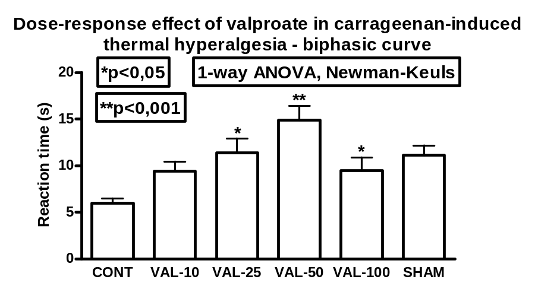
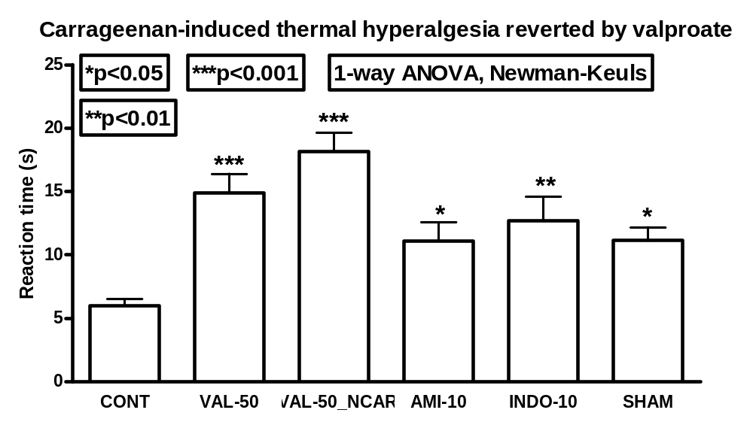
Figure 1: Valproate reversal of carrageenan-induced acute thermal hyperalgesia. Plantar test was performed as previously described. SHAM group (SHAM) had no pharmacological treatment. Control group had a 1 mg carrageenan plantar injection in right hindpaw 2 h before the test. Groups I to VI (VAL-10, VAL-25, VAL-50, VAL-100, AMI-10, and INDO-10) animals were treated with valproate 10 to 100 mg/kg, amytriptiline 10 mg/kg or indometacine 10 mg/kg at the same time of carrageenan injection. Group IX (VAL-50_NCAR) was treated with valproate 50 mg/kg. Reaction time to thermal stimulus (mean ± SEM) was plotted. Statistical significance is depicted when present.
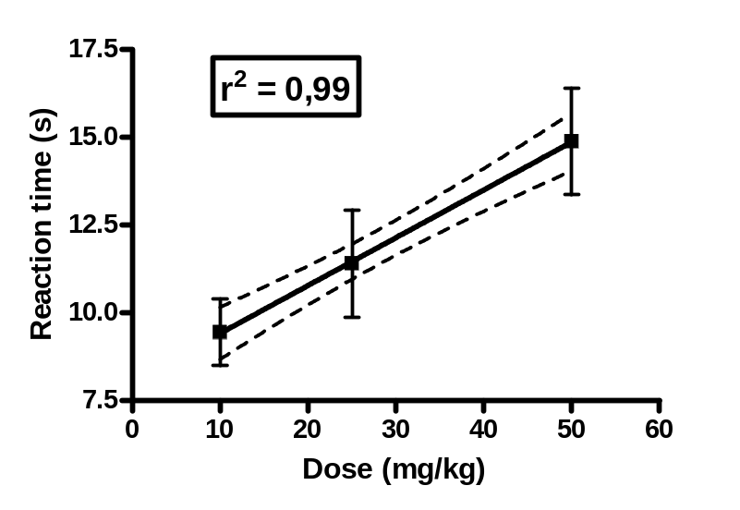
Figure 2: Dose-response curve of the anti-hyperalgesic effect of valproate in the plantar test. Dose was plotted against reaction time (s). The curve was obtained by linear regression. r² = 0.99

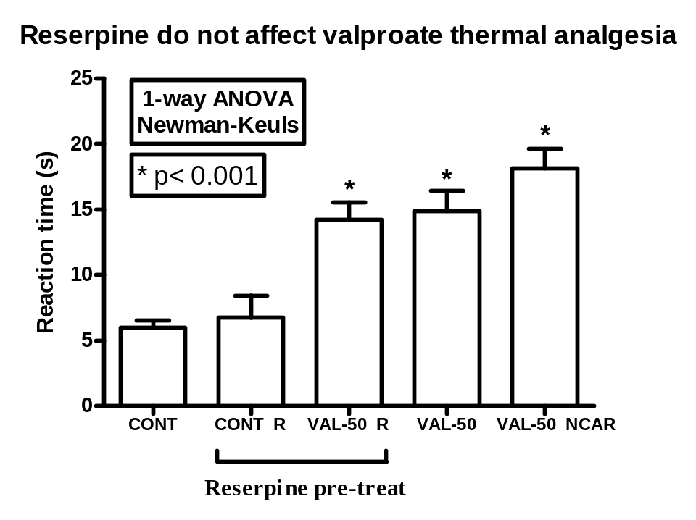
Figure 3: Reserpine did not revert the analgesia determined by valproate in the plantar test. Plantar test was performed as previously described. Both groups had a 1mg carrageenan plantar injection in right hindpaw 2 h before the test. Groups VII and VIII (CONT e SIB-5) animals were pre-treated with reserpine (Sigma), 1.0 mg/kg, dissolved in 0.5 ml of glacial acetic acid and 9.5ml of saline and administered i.p. (0.2 ml/animal), 6h before plantar test. Group VIII animals were treated with valproate sodium in a single p.o. dose of 50 mg/kg, 4h after reserpine administration and 2 h before plantar test. Reaction time to thermal stimulus (mean ± SEM) was plotted. Statistical significance is depicted.

