Title: SIBUTRAMINE INHIBITION OF CARRAGEENAN-INDUCED THERMAL HYPERALGESIA IS NOT REVERTED BY RESERPINE IN RATS
Authors:
1) Maria Luisa Azevedo de Oliveira Sales
Department of Biophysiology and Pharmacology, Faculdade de Medicina de Juazeiro do Norte.
Address: Av. Leao Sampaio Km 3 S/N – 63040 – 000 – Juazeiro do Norte – CE – Brazil
e-mail: maluaos@hotmail.com
2) Karolinne Souto de Figueiredo
Department of Biophysiology and Pharmacology, Faculdade de Medicina de Juazeiro do Norte.
Address: Av. Leao Sampaio Km 3 S/N – 63040 – 000 – Juazeiro do Norte – CE – Brazil
e-mail: karolinne_sf@msn.com
3) Juvenia Bezerra Fontenele, PhD
Professor of Pharmacy, Department of Pharmacy, Faculdade de Farmacia, Odontologia e Enfermagem, Universidade Federal do Ceara.
Address: Rua Capitao Francisco Pedro, 1210 - 60430-370 - Fortaleza - CE - Brazil
e-mail: juvenia@ufc.br
4) Glauce Socorro de Barros Viana, PhD
Professor of Pharmacology, Coordinator of the Department of Biophysiology and Pharmacology, Faculdade de Medicina de Juazeiro do Norte.
Address: Av. Leao Sampaio Km 3 S/N – 63040 – 000 – Juazeiro do Norte – CE – Brazil
e-mail:gbviana@live.com
5) Giovany Michely Pinto da Cruz
Professor of Physiology, Department of Biophysiology and Pharmacology, Faculdade de Medicina de Juazeiro do Norte.
Address: Av. Leao Sampaio Km 3 S/N – 63040 – 000 – Juazeiro do Norte – CE – Brazil
e-mail: giovanycruz@hotmail.com
6) Francisco Hélder Cavalcante Félix, MD (corresponding author)
Pediatric Hemato-oncologist
Pediatric Hemato-oncology Service, Hospital Infantil Albert Sabin
Address: R Alberto Montezuma, 350 - Vila Uniao - 60410-770 - Fortaleza - CE - Brazil
e-mail: helderfelix@hias.ce.gov.br

Conflicts of interest:
There are not potential sources of conflicts of interest.

The authors declare that this material has not been published or is under active consideration by another journal. This research was conducted in accordance with the Declaration of Helsinki and with the Guide for the Care and Use of Laboratory Animals as adopted and promulgated by the United States National Institutes of Health.
Introduction:
Sibutramine is a serotonin (5HT) and norepinephrine (NE) reuptake inhibitor approved for using as anti-obesity drug. It induces significant weight reduction in experimental animals and human patients [2, 5]. Anti-depressant drugs with a similar mechanism of action, like venlafaxine and duloxetine (serotonin and norepinephrine reuptake inhibitors – SNRI) show analgesic action, specially in chronic pain and have been approved for clinical use in chronic pain syndromes. A recent systematic review concluded that tricyclic antidepressants (TCA) and SNRI are equipotent as analgesics in chronic pain [14]. The possibility that sibutramine, despite its lack of anti-depressant effect, could have analgesic properties is supported by at least one publication using an experimental animal model of pain and two non-controlled, non-randomized reports from clinical usage in humans [4, 7, 12]. Recently, it was demonstrated a relationship between cardiovascular risk, metabolic syndrome and chronic pain, including FMS [3, 11]. It could be possible that sibutramine administration to chronic pain patients, like fibromyalgia (FM), benefited them not only with its analgesic action, but also with the expected weight reduction that would diminish cardiovascular risk. There are scanty pre-clinical and clinical reports of analgesic efficacy of sibutramine in published literature. We sought to test its analgesic effect in a widely used animal model of thermal hyperalgesia, the Hargreaves plantar test [8] and to evaluate monoamine participation in this effect with a general cathecolamine block using reserpine pre-treatment. We also wanted to rule out motor impairment or sedation with a rotorod test.
Material and Methods:
We used female Wistar rats weighing a mean of 200g in groups of ten animals each. Animals were housed in a climatized room, kept in a 12h light-dark cycle, food and water was withdrawn for 4h and animals habituated to the laboratory before tests.
Carrageenan-Induced Thermal Hyperalgesia. Plantar test was performed as previously described [8]. A group was tested without any treatment (SHAM). This same group was tested after carrageenan administration (Control). The other groups were treated with sibutramine hydrochloride in increasing doses of 0.1 (group I), 0.5 (group II), 1.5 (group III), and 5mg/kg (group IV), in a single p.o. dose, 2h before plantar test. Group V was treated with amytriptiline 10 mg/kg, p.o. in the same way as in the sibutramine groups. Group VI was treated with indometacine 10 mg/kg, p.o. in the same way as in the sibutramine groups. Groups VII and VIII were pre-treated with reserpine (Sigma), 1.0mg/kg, dissolved in 0.5ml of glacial acetic acid and 9.5ml of saline and administered i.p. (0.2ml/animal), 6h before plantar test. Group VIII animals were treated with sibutramine hydrochloride in a single p.o. dose of 1.5mg/kg, 4h after reserpine administration and 2h before plantar test. Carrageenan (1mg/0.1ml) was injected in the right hindpaw at the same time of drug (sibutramine, amytriptiline, indometacine) treatment, in groups I through VIII and in Control group, 2h before plantar test. Group IX animals were treated with sibutramine hydrochloride in a single p.o. dose of 1.5mg/kg, 2h before plantar test, without carrageenan injection. Reaction time (paw withdrawal upon thermal stimulus) was measured by automated method and recorded in seconds.
Rotorod Test. The effects of sibutramine on motor performance were evaluated using a Rotorod. All animals were given 3 initial training trials of 120 s, approximately 10 min apart, to maintain posture on a Rotorod (model 7650; Ugo Basile, Comerio, Italy), 3 cm in diameter, and rotating at a constant 12 revolutions/ min. The day after the initial training trials, a 60-s test trial was conducted, 2 hours after administration of sibutramine hydrochloride in a single p.o. dose of 1.5mg/kg. The number of falls of each animal was recorded.
The results were compared using one-way analysis of variance, with Newman-Keuls multiple comparison as a post hoc test if significant (p < 0.05). Rotorod results were compared with Fischer exact test of independence. The statistical package used was GraphPad Prism 4.0 (La Jolla, CA – USA).
Results:
Reaction time in seconds (mean ± standard error of mean – SEM) for the controls were 10.0±0.5 (SHAM) and 6.0±0.5 (control). Sibutramine showed an acute analgesic dose-response effect in the plantar test. Reaction time in seconds (mean ± SEM) were 6.6±0.8 (0.1 mg/kg), 8.8±0.9 (0.5 mg/kg), 14.2±1.3 (1.5 mg/kg) and 14.9±1.3 (5 mg/kg). SHAM group (p < 0.01), sibutramine 1.5 and 5 mg/kg groups (p < 0.001) had reaction times that were significantly different from control (fig.1). Amytriptiline 10 mg/kg had an analgesic effect on plantar test, prolonging reaction time to 11.1±1.5 seconds (p < 0.05 compared to control). Indometacine 10 mg/kg had an analgesic effect on plantar test, prolonging reaction time to 12.7±1.9 seconds (p < 0.01 compared to control). Sibutramine 1.5mg/kg without carrageenan injection (Group IX) showed an analgesic effect on plantar test, prolonging reaction time to 16.7±1.8 seconds (p < 0.001 compared to control). Pre-treatment with reserpine 5mg/kg 4h before the sibutramine administration and 6h before plantar test did not modify the analgesia induced by sibutramine. Group VII (reserpine control) reaction time was 6.7±1.7 seconds and Group VIII (pre-treated with reserpine, treated with sibutramine) reaction time was 15.2±2.7 seconds (p < 0.05 compared to reserpine control). The results of incremental sibutramine doses were used to make a sigmoidal log dose-response curve with R2 = 0.94 and ED50 = 0.72 mg/kg (95% confidence interval = 0.16 – 3.22) (fig.2). Runs test showed that the results did not deviate significantly from the model (p = 1.00).
In rotorod test, sibutramine treated animals experienced no falls in the test period, like the control animals. Statistical tests were not performed, given the null results.
Discussion and Conclusion:
Drugs with a mechanism of action similar to sibutramine (SNRI) are used successfully in patients with chronic pain. Duloxetine, one of the newer SNRI, has been reported to have analgesic effect in patients with neuropathic pain and FM. It was approved for use in diabetic neuropathy and FM [1, 13]. Today, duloxetine can be used as an appropriate first choice treatment for chronic neuropathic pain and FM, although the question of what type of analgesic anti-depressant should be primarily used for chronic pain patients is still debated [10]. Treatment individualization will depend on clinical characteristics of the patients and therapeutic as well as side effects profile of the drugs. Tricyclic drugs, like amytriptiline, are the most widely used anti-depressant drugs for chronic pain treatment, but are generally regarded as having a negatibe cardiovascular side-effect profile, in contrast to duloxetine and SNRI [16].
Recently, autonomic reactivity and cardiovascular dysfunction were implicated in FM pain pathogenesis [6, 15]. A nested case-control analysis of a cohort of patients with systemic lupus erythematosus reported that BMI correlates with secondary FMS [3]. A transversal analytical study comparing women with FMS and healthy controls showed larger waist circumference, higher glycosylated hemoglobin, serum cholesterol and triglycerides, higher blood pressure and more frequently metabolic syndrome in FMS patients [11]. Sibutramine was reported as inducing significant weigh loss, better health-related quality of life scores in the responders and less glycosylated hemoglobin and bodily pain in patients with type II diabetes [9]. Thus, if sibutramine, a SNRI, could also have clinical useful analgesic properties, it could become an important drug with dual targeting effect in patients with chronic pain, especially FM.
Our results confirm that sibutramine has analgesic potential and had an anti-hyperalgesic effect in the plantar test model, seemingly as potent as a high dose of amytriptiline or indometacine. This action seem not to be dependent on central nervous system effects, like sedation or motor skill impairment, once animals did not show any alteration in rotorod test. Unexpectedly, the analgesic effect of sibutramine was not reverted by pre-treatment with reserpine, which may indicate that it do not depend on monoamines, although sibutramine known mechanism of action involves monoamine recaptation inhibition. Once sibutramine still showed marked analgesia in reserpine pre-treated animals, one can rule out the confounding factor of regulation of cutaneous vasoconstrictor tone and skin temperature by the sympathetic nervous system. A previous publication had showed analgesic effects of sibutramine in non-thermal pain evoked animal model [7].
We conclude that sibutramine, a drug used for weigh loosing that have a positive effect in cardiovascular risk profile of patients, has analgesic effect at least in this animal model. It may be additionally tested in pre-clinical models and in clinical trials with patients that suffer from chronic pain and are at higher cardiovascular risk due to metabolic syndrome or co-morbidities, like diabetic neuropathy and FMS, with the expected double benefit of reducing pain and cardiovascular risk.
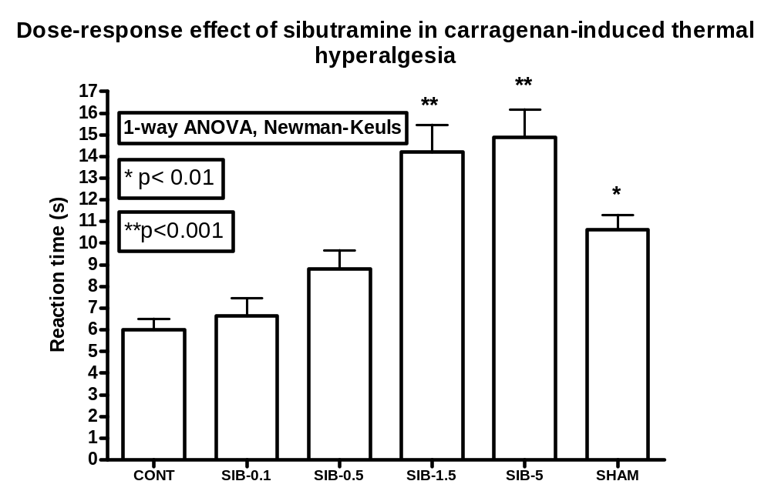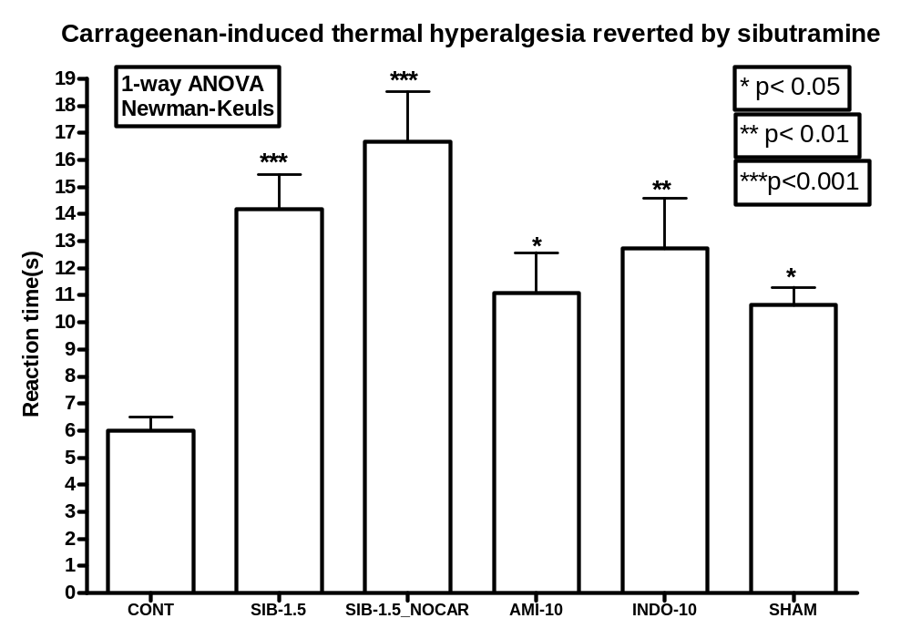
Figure 1:

Sibutramine reversal of carrageenan-induced acute thermal hyperalgesia. Plantar test was performed as previously described (8). Negative control group (NegCont) had no treatment. Control group had a 1mg carrageenan plantar injection in right hindpaw 2 h before the test. Groups I to V (Sib-0.1, Sib-0.5, Sib-1.5, Sib-5 and AMI-10) were treated with sibutramine 0.1 to 5 mg/kg or amytriptiline 10 mg/kg at the same time of carrageenan injection. Reaction time to thermal stimulus (mean ± SEM) was plotted. Statistical significance is depicted when present.

Figure 2:

Dose-response curve of the anti-hyperalgesic effect of sibutramine in the plantar test. Log of dose was plotted against reaction time (s). The curve was obtained by sigmoidal regression. EC50 = 0.72 mg/kg (95% confidence interval = 0.16 – 3.22). Runs test showed no deviation from the model.

References:

[1] L.M. Arnold, Y.L. Pritchett, D.N. D'Souza, D.K. Kajdasz, S. Iyengar, J.F. Wernicke, Duloxetine for the treatment of fibromyalgia in women: pooled results from two randomized, placebo-controlled clinical trials, J Womens Health (Larchmt) 16 (2007) 1145-1156.
[2] M. Brown, C. Bing, P. King, L. Pickavance, D. Heal, J. Wilding, Sibutramine reduces feeding, body fat and improves insulin resistance in dietary-obese male Wistar rats independently of hypothalamic neuropeptide Y, Br J Pharmacol 132 (2001) 1898-1904.
[3] S. Chaiamnuay, A.M. Bertoli, M. Fernández, M. Apte, L.M. Vilá, J.D. Reveille, G.S. Alarcón, The impact of increased body mass index on systemic lupus erythematosus: data from LUMINA, a multiethnic cohort (LUMINA XLVI) [corrected], J Clin Rheumatol 13 (2007) 128-133.
[4] J.L. Davis, Use of sibutramine hydrochloride monohydrate in the treatment of the painful peripheral neuropathy of diabetes, Diabetes Care 23 (2000) 1594-1595.
[5] N. Finer, Sibutramine: its mode of action and efficacy, Int J Obes Relat Metab Disord 26 Suppl 4 (2002) S29-33.
[6] J.B. Fontenele, F.H.C. Felix, Fibromyalgia and Related Medically Unexplained Symptoms: A Lost Link Between Cardiovascular and Nociception Modulation. Haworth Press Inc, 2009, pp. 67-79.
[7] A.M. Gray, P.S. Spencer, R.D. Sewell, The involvement of the opioidergic system in the antinociceptive mechanism of action of antidepressant compounds, Br J Pharmacol 124 (1998) 669-674.
[8] K. Hargreaves, R. Dubner, F. Brown, C. Flores, J. Joris, A new and sensitive method for measuring thermal nociception in cutaneous hyperalgesia, Pain 32 (1988) 77-88.
[9] J.K. Kaukua, T.A. Pekkarinen, A.M. Rissanen, Health-related quality of life in a randomised placebo-controlled trial of sibutramine in obese patients with type II diabetes, Int J Obes Relat Metab Disord 28 (2004) 600-605.
[10] G.O. Littlejohn, E.K. Guymer, Fibromyalgia syndrome: which antidepressant drug should we choose, Curr Pharm Des 12 (2006) 3-9.
[11] B.L. Loevinger, D. Muller, C. Alonso, C.L. Coe, Metabolic syndrome in women with chronic pain, Metabolism 56 (2007) 87-93.
[12] M. Palangio, J.A. Flores, S.V. Joyal, Treatment of fibromyalgia with sibutramine hydrochloride monohydrate: comment on the article by Goldenberg et al, Arthritis Rheum 46 (2002) 2545-2546; author reply 2546.
[13] I.J. Russell, P.J. Mease, T.R. Smith, D.K. Kajdasz, M.M. Wohlreich, M.J. Detke, D.J. Walker, A.S. Chappell, L.M. Arnold, Efficacy and safety of duloxetine for treatment of fibromyalgia in patients with or without major depressive disorder: Results from a 6-month, randomized, double-blind, placebo-controlled, fixed-dose trial, Pain 136 (2008) 432-444.
[14] T. Saarto, P.J. Wiffen, Antidepressants for neuropathic pain, Cochrane Database Syst Rev (2007) CD005454.
[15] C. Solano, A. Martinez, L. Becerril, A. Vargas, J. Figueroa, C. Navarro, C. Ramos-Remus, M. Martinez-Lavin, Autonomic Dysfunction in Fibromyalgia Assessed by the Composite Autonomic Symptoms Scale (COMPASS), J Clin Rheumatol (2009).
[16] J. Wernicke, A. Lledó, J. Raskin, D.K. Kajdasz, F. Wang, An evaluation of the cardiovascular safety profile of duloxetine: findings from 42 placebo-controlled studies, Drug Saf 30 (2007) 437-455.

