VALPROATE ANALGESIA IN CARRAGEENAN-INDUCED THERMAL HYPERALGESIA IN RATS HAS A BIMODAL DOSE-RESPONSE EFFECT CURVE

Karolinne Souto de Figueiredo¹, Maria Luisa Azevedo de Oliveira Sales¹, Juvenia Bezerra Fontenele, PhD², Glauce Socorro de Barros Viana, PhD¹, Giovany Michely Pinto da Cruz¹, Francisco Hélder Cavalcante Félix, MD³
¹Department of Biophysiology and Pharmacology, Faculdade de Medicina de Juazeiro do Norte.
²Professor of Pharmacy, Department of Pharmacy, Faculdade de Farmacia, Odontologia e Enfermagem, Universidade Federal do Ceara.
³Pediatric Hemato-oncologist and Pharmacologist, Pediatric Hemato-oncology Service, Hospital Infantil Albert Sabin

Correspondence to: Francisco Hélder Cavalcante Félix, Pediatric Hemato-oncology Service, Hospital Infantil Albert SabinR Alberto Montezuma, 350 - Vila Uniao - 60410-770 - Fortaleza - CE – Brazil, e-mail: helderfelix@hias.ce.gov.br
Type of article: original research
Running title: Valproate has a bimodal dose-response effect in plantar test
Keywords: Valproic acid; analgesia; thermal hyperalgesia; dose-response relationship
Conflicts of interest:
There are not potential sources of conflicts of interest.

The authors declare that this material has not been published or is under active consideration by another journal. This research was conducted in accordance with the Declaration of Helsinki and with the Guide for the Care and Use of Laboratory Animals as adopted and promulgated by the United States National Institutes of Health.

Pages: 15
Abstract word count: 239
Text word count: 1901
Figures: 03
References: 32
Abstract:
Valproate, an indirect γ-aminobutiric acid agonist approved for using as anti-epileptic drug has been successfully used in various painful conditions like trigeminal neuralgia, migraine and diabetic neuropathy. Despite its frequent clinical use, limited pre-clinical and clinical testing data is available for valproate analgesic effect. We tested valproate p.o. in increasing doses (10, 25, 50, 100 mg/kg) in the plantar test model of acute primary thermal hyperalgesia induced by carragenan in rats, comparing its effects to a non-treated control and amytriptiline (10 mg/kg) or indometacine (10 mg/kg). The results showed a statiscally significant (p<0.001) dose-response analgesic effect of valproate in this model, with a maximum effect comparable to the effect of a high dose of amytriptiline. The analgesia induced by valproate in this model was not reverted by reserpine pre-treatment. Rotorod test showed apparently no central effect of valproate on locomotor activity. Surprisingly, the maximum effect of valproate on this model occurred at a dose of 50mg/kg and the higher dose of 100mg/kg showed a minor effect. We have fit a linear regression model with the first 3 doses, finding an equation with slope 0.14 (CI95 = 0.11-0.17), significantly different from zero (p<0.05), r² = 0.99 and not significantly deviating from linearity. Valproate showed a bimodal dose-response analgesic effect in the Hargreaves plantar test in rats. It should be thoroughly tested in multiple preclinical models and in clinical trials in order to ascertain its usefulness as analgesic in clinical settings.
Introduction:
Valproic acid (valproate, di-n-propylacetic acid) is a short chain fatty acid that was used infrequently since its synthesis in 1882 as a “metabolically inert” solvent for organic compounds. In the 60s its effect as an anticonvulsant was discovered serendipitously in France. Since then it has been widely used for the treatment of seizures in adults and children (Cloyd et al., 2003). Valproate increases the brain concentration of γ-aminobutiric acid (GABA), indirectly acting as an agonist of this inhibitory transmitter. Unlike drugs that act as indirect GABA agonists by increasing GABA availability (eg, tiagabine and vigabatrin), valproate acts through more than one mechanism in providing its broad pharmacological activity: inhibition of degradation, increased synthesis and decreased turnover. The increase in glutamic acid decarboxylase (GAD) activity is rapid and temporally correlates with the acute anticonvulsant activity of valproate, though very high doses of valproate are associated with inhibition of GAD and reduce GABA concentrations. Although there are a number of other biochemical actions of valproate, their role in mediating its efficacy is not well established (Owens and Nemeroff, 2003).
Anti-epileptic drugs (AED) are frequently used as analgesic in chronic but not acute pain conditions, even though a recent meta-analysis has demonstrated that there is little clinical evidence to support their widespread use (Wiffen et al., 2005). However, there is an extensive biological and preclinical rationale for their effect in painful diseases (Rogawski and Loscher, 2004). Valproate is approved in the USA for migraine treatment (Rogawski and Loscher, 2004) and has been shown to possess analgesic effect in acute migraine in adults and children (Freitag, 2003, Fragoso, 2003, Stillman et al., 2004, Reiter et al., 2005, Leniger et al., 2005). It has been used for more than 20 years for migraine patients and is frequently used by pain specialists for treating neuropathic pain of various etiologies (Freitag, 2003, Sindrup et al., 2003). Preclinical data and mechanism of action knowledge about its use as analgesic are scarce and inconclusive, even though its basic pharmacology indicates that it could be useful in neuropathic pain (Frenk et al., 1988, Loscher and Vetter, 1985, Cutrer and Moskowitz, 1996, Sindrup et al., 2003). Recently, authors have issued moderate to strong strength recommendations of using valproate to treat diabetic neuropathy and migraine (Rogawski and Loscher, 2004, Goodyear-Smith and Halliwell, 2009), whereas others have not cited it in their reviews (Veves et al., 2008).
Because valproate is widely used but preclinical and clinical test data are largely lacking for its analgesic effect we sought to test it in a widely used animal model of thermal hyperalgesia, the Hargreaves plantar test (Hargreaves et al., 1988) and to evaluate monoamine participation in this effect with a general cathecolamine block using reserpine pre-treatment. We also wanted to rule out motor impairment or sedation with a rotorod test.
Material and Methods:
We used female Wistar rats weighing a mean of 200 g in groups of ten animals each. Animals were housed in a climatized room, kept in a 12h light-dark cycle, food and water was withdrawn for 4 h and animals habituated to the laboratory before tests. Experiments were undertaken following strictly the internationally accepted rules for use of laboratory animals for research and no unnecessary pain or discomfort was inflicted to the experimental animals in this research.
Carrageenan-Induced Thermal Hyperalgesia. Plantar test was performed as previously described (Hargreaves et al., 1988). A group was tested without any treatment (SHAM). This same group was tested after carrageenan administration (Control). The other groups were treated with valproate in increasing doses of 10 (group I), 25 (group II), 50 (group III), and 100 mg/kg (group IV), in a single p.o. dose, 2h before plantar test. Group V and VI were treated with amytriptiline 10 mg/kg, p.o. and indometacine 10 mg/kg, p.o., respectivelly in the same way as in the valproate groups. Groups VII and VIII were pre-treated with reserpine (Sigma), 1.0 mg/kg, dissolved in 0.5 ml of glacial acetic acid and 9.5 ml of saline and administered i.p. (0.2ml/animal), 6 h before plantar test. Group VIII animals were treated with valproate in a single p.o. dose of 50 mg/kg, 4 h after reserpine administration and 2 h before plantar test. Carrageenan (1 mg/0.1 ml) was injected in the right hindpaw at the same time of drug (valproate, amytriptiline, indometacine) treatment, in groups I through VIII and in Control group, 2 h before plantar test. Group IX animals were treated with valproate in a single p.o. dose of 50 mg/kg, 2 h before plantar test, without carrageenan injection. Reaction time (paw withdrawal upon thermal stimulus) was measured by automated method (model 7370; Ugo Basile, Comerio, Italy) and recorded in seconds.
Rotorod Test. The effects of valproate on motor performance were evaluated using a Rotorod. All animals were given 3 initial training trials of 120 s, approximately 10 min apart, to maintain posture on a Rotorod (model 7650; Ugo Basile, Comerio, Italy), 3 cm in diameter, and rotating at a constant 12 revolutions/ min. The day after the initial training trials, a 60 s test trial was conducted, 2 hours after administration of valproate in a single p.o. dose of 50 mg/kg. The number of falls of each animal was recorded.
The results were compared using one-way analysis of variance, with Newman-Keuls multiple comparison as a post hoc test if significant (p < 0.05). Rotorod results were compared with Fischer exact test of independence. The statistical package used was GraphPad Prism 4.0 (La Jolla, CA – USA).
Results:
Reaction time in seconds (mean ± standard error of mean – SEM) for the controls were 11.1 ± 1.1 (SHAM) and 6.0 ± 1.6 (control). Valproate showed an acute analgesic dose-response effect in the plantar test. Reaction time in seconds (mean ± SEM) were 9.5 ± 1.0 (10 mg/kg), 11.4 ± 1.5 (25 mg/kg), 14.9 ± 1.5 (50 mg/kg) and 9.5 ± 1.4 (100 mg/kg). SHAM group, valproate 25, 100 mg/kg groups (p < 0.05) and valproate 50 mg/kg (p < 0.001) had reaction times that were significantly different from control (fig.1). The maximum effect of valproate was elicited with the 50 mg/kg dose and the 100 mg/kg dose showed an effect with a magnitude comparable to the 10 mg/kg dose effect. We did not test any further dose, because we were concerned with possible acute toxicity complicating the results. Amytriptiline 10 mg/kg had an analgesic effect on plantar test, prolonging reaction time to 11.1 ± 1.5 seconds (p < 0.05 compared to control). In the same way indometacine 10 mg/kg showed an analgesic effect on plantar test, prolonging reaction time to 12.7 ± 1.9 seconds (p < 0.01 compared to control). Valproate 50 mg/kg without carrageenan injection (Group IX) showed an analgesic effect on plantar test, prolonging reaction time to 18.1 ± 1.5 seconds (p < 0.001 compared to control). Pre-treatment with reserpine 1 mg/kg 4h before the valproate administration and 6h before plantar test did not modify the analgesia induced by valproate (fig.2). Group VII (reserpine control) reaction time was 6.7 ± 1.7 seconds and Group VIII (pre-treated with reserpine, treated with valproate) reaction time was 14.2 ± 1.3 seconds (p < 0.05 compared to reserpine control). The results of incremental valproate doses (excluding the 100 mg/kg dose) were used to fit a linear dose-response curve finding an equation with slope 0.14 (CI95 = 0.11-0.17), significantly different from zero (p<0.05), r² = 0.99 and not significantly deviating from linearity. (fig.3).
In rotorod test, valproate treated animals experienced no falls in the test period, like the control animals. Statistical tests were not performed, given the null results.
Discussion and Conclusion:
Our results confirm that valproate has analgesic potential and showed an anti-hyperalgesic effect in the plantar test model, seemingly as potent as a high dose of amytriptiline or indometacine. This action seem not to be dependent on central nervous system effects, like sedation or motor skill impairment, once animals did not show any alteration in rotorod test. The analgesic effect of valproate was not reverted by pre-treatment with reserpine, which may indicate that it do not depend on monoamines. Once valproate still showed marked analgesia in reserpine pre-treated animals, one can rule out the confounding factor of regulation of cutaneous vasoconstrictor tone and skin temperature by the sympathetic nervous system. The most remarkable finding, however, was the bimodal dose-response relation that valproate showed in this model. As far as we know, this is the first report of a bimodal behavior of valproate analgesic effect.
Analgesic effect of valproate has been observed for decades in clinical practice, and it is widely used by pain specialists and others to treat different painful syndromes. Reports of its clinical usage as analgesic in neuropathic pain are almost contemporaneous to its introduction as anti-epileptic (Raftery, 1979, Carraz and Emin, 1967, Barnes and Bower, 1975). However, evidence is scarce to this analgesic effect of valproate. Preclinical and clinical reports have shown since the 80’s that valproate had possible efficacy in pain patients due to its effect in GAD and GABA (Hitchcock and Teixeira, 1982, Loscher and Vetter, 1985, Swerdlow and Cundill, 1981). There has been no definitive progress in the elucidation of the exact mechanisms of action of valproate in pain states, and it seems that GABAergic theory is the only accepted paradigm, in the same fashion as with its anticonvulsant action (Loscher, 1999, Balfour and Bryson, 1994). Few randomized controlled clinical trials have been performed testing valproate as analgesic, most of them for migraine (Jensen et al., 1994). A trial of valproate in central pain secondary to spinal trauma reported no analgesic effect (Drewes et al., 1994). A group has published results of a double blind, randomized trial showing that valproate was effective in diabetic neuropathy patients (Kochar et al., 2002). However, their results were argued because of methodological issues (Sindrup et al., 2003). Recently, the analgesic effect of valproate has been questioned in the face of preclinical and clinical data (Otto et al., 2004, Munro et al., 2007).
Munro et al have found no effect of i.p. valproate in the rat formalin test (Munro et al., 2007). Nevertheless, Czuczwar et al reported analgesic effect of valproate with the same test, but in mice (Czuczwar et al., 2001). In a model of heat-induced pain in mice, Aley & Kulkarni found no analgesia mediated by valproate (Aley and Kulkarni, 1989). By contrast, Abulaban et al reported analgesic effect o chronic orally administered valproate in mice using heat-induced pain (hotplate)(Abulaban et al., 1997). It seems that valproate analgesic effect is highly dependent of the animal model or the methodology used for testing it. Our results could indicate, additionally, that dosing is also important for the determination of analgesic effect and that, paradoxically, it may be better observed in low doses contrasted with high doses (depending on the experimental model and animal used). This knowledge could have implications for the interpretation of clinical trials in human, as well. We did not explore the possible mechanism of this bimodal effect, but as far as GABAergic mechanism of valproate is thought to be important for analgesia, one could hypothesize a dose differential effect of valproate analogous to that on GAD. Other possibility could stem from the recently described effect of valproate in inhibiting hystone deacetylase related gene silencing, thus enhancing the expression of cell proteins (Hoffmann et al., 2008).
We conclude that valproate, a drug clinically used for treatment of neuropathic pain and migraine almost since its initial use as anticonvulsant, showed a bimodal analgesic effect in the Hargreaves thermal hyperalgesia model in rats. It should be additionally tested in a greater number of pre-clinical models and in clinical trials with patients that suffer from chronic pain in order to assure its effectiveness and mechanism of action.
References:
Abulaban FS, Dhariwal MA, al-Bekairi AM, Raza M. Antinociceptive activity of sodium valproate in mice after chronic treatment. Gen Pharmacol1997 Sep;29(3):463-7.
Aley KO, Kulkarni SK. GABAergic agents-induced antinociceptive effect in mice. Methods Find Exp Clin Pharmacol1989 Oct;11(10):597-601.
Balfour JA, Bryson HM. VALPROIC ACID - A REVIEW OF ITS PHARMACOLOGY AND THERAPEUTIC POTENTIAL IN INDICATIONS OTHER THAN EPILEPSY. Cns Drugs1994;2(2):144-73.
Barnes SE, Bower BD. Sodium valproate in the treatment of intractable childhood epilepsy. Dev Med Child Neurol1975 Apr;17(2):175-81.
Carraz G, Emin N. [Anticonvulsive action of di-n-propylacetic acid monoureide and of hydantoin derivatives of this acid]. Therapie1967 May-Jun;22(3):641-52.
Cloyd J, Dutta S, Cao G, Walch J, Collins S, Granneman G. Valproate unbound fraction and distribution volume following rapid infusions in patients with epilepsy. Epilepsy Res2003 Feb;53(1-2):19-27.
Cutrer FM, Moskowitz MA. Wolff Award 1996. The actions of valproate and neurosteroids in a model of trigeminal pain. Headache1996 Nov-Dec;36(10):579-85.
Czuczwar M, Kis J, Swiader M, Turski WA, Przesmycki K. Evaluation of interaction between valproate and baclofen in the formalin test in mice. Pol J Pharmacol2001 Jan-Feb;53(1):51-4.
Drewes AM, Andreasen A, Poulsen LH. Valproate for treatment of chronic central pain after spinal cord injury. A double-blind cross-over study. Paraplegia1994 Aug;32(8):565-9.
Fragoso YD. Low dose of sodium divalproate for the treatment of migraine. MedGenMed2003 Mar 12;5(1):32.
Freitag FG. Divalproex in the treatment of migraine. Psychopharmacol Bull2003;37 Suppl 2:98-115.
Frenk H, Bossut D, Mayer DJ. Is substance P a primary afferent neurotransmitter for nociceptive input? III. Valproic acid and chlordiazepoxide decrease behaviors elicited by intrathecal injection of substance P and excitatory compounds. Brain Res1988 Jul 12;455(2):240-6.
Goodyear-Smith F, Halliwell J. Anticonvulsants for neuropathic pain: gaps in the evidence. Clin J Pain2009 Jul-Aug;25(6):528-36.
Hargreaves K, Dubner R, Brown F, Flores C, Joris J. A new and sensitive method for measuring thermal nociception in cutaneous hyperalgesia. Pain1988 Jan;32(1):77-88.
Hitchcock E, Teixeira M. Anticonvulsant activation of pain-suppressive systems. Appl Neurophysiol1982;45(6):582-93.
Hoffmann K, Czapp M, Loscher W. Increase in antiepileptic efficacy during prolonged treatment with valproic acid: role of inhibition of histone deacetylases? Epilepsy Res2008 Oct;81(2-3):107-13.
Jensen R, Brinck T, Olesen J. Sodium valproate has a prophylactic effect in migraine without aura: a triple-blind, placebo-controlled crossover study. Neurology1994 Apr;44(4):647-51.
Kochar DK, Jain N, Agarwal RP, Srivastava T, Agarwal P, Gupta S. Sodium valproate in the management of painful neuropathy in type 2 diabetes - a randomized placebo controlled study. Acta Neurol Scand2002 Nov;106(5):248-52.
Leniger T, Pageler L, Stude P, Diener HC, Limmroth V. Comparison of intravenous valproate with intravenous lysine-acetylsalicylic acid in acute migraine attacks. Headache2005 Jan;45(1):42-6.
Loscher W, Vetter M. In vivo effects of aminooxyacetic acid and valproic acid on nerve terminal (synaptosomal) GABA levels in discrete brain areas of the rat. Correlation to pharmacological activities. Biochem Pharmacol1985 May 15;34(10):1747-56.
Loscher W. Valproate: a reappraisal of its pharmacodynamic properties and mechanisms of action. Prog Neurobiol1999 May;58(1):31-59.
Munro G, Erichsen HK, Mirza NR. Pharmacological comparison of anticonvulsant drugs in animal models of persistent pain and anxiety. Neuropharmacology2007 Oct;53(5):609-18.
Otto M, Bach FW, Jensen TS, Sindrup SH. Valproic acid has no effect on pain in polyneuropathy: a randomized, controlled trial. Neurology2004 Jan 27;62(2):285-8.
Owens MJ, Nemeroff CB. Pharmacology of valproate. Psychopharmacol Bull2003;37 Suppl 2:17-24.
Raftery H. The management of post herpetic pain using sodium valproate and amitriptyline. Ir Med J1979 Sep 28;72(9):399-401.
Reiter PD, Nickisch J, Merritt G. Efficacy and tolerability of intravenous valproic acid in acute adolescent migraine. Headache2005 Jul-Aug;45(7):899-903.
Rogawski MA, Loscher W. The neurobiology of antiepileptic drugs for the treatment of nonepileptic conditions. Nat Med2004 Jul;10(7):685-92.
Sindrup SH, Otto M, Bach FW, Jensen TS. Sodium valproate in painful diabetic polyneuropathy. Acta Neurol Scand2003 Dec;108(6):443-4.
Stillman MJ, Zajac D, Rybicki LA. Treatment of primary headache disorders with intravenous valproate: initial outpatient experience. Headache2004 Jan;44(1):65-9.
Swerdlow M, Cundill JG. Anticonvulsant drugs used in the treatment of lancinating pain. A comparison. Anaesthesia1981 Dec;36(12):1129-32.
Veves A, Backonja M, Malik RA. Painful diabetic neuropathy: epidemiology, natural history, early diagnosis, and treatment options. Pain Med2008 Sep;9(6):660-74.
Wiffen P, Collins S, McQuay H, Carroll D, Jadad A, Moore A. Anticonvulsant drugs for acute and chronic pain. Cochrane Database Syst Rev2005(3):CD001133.
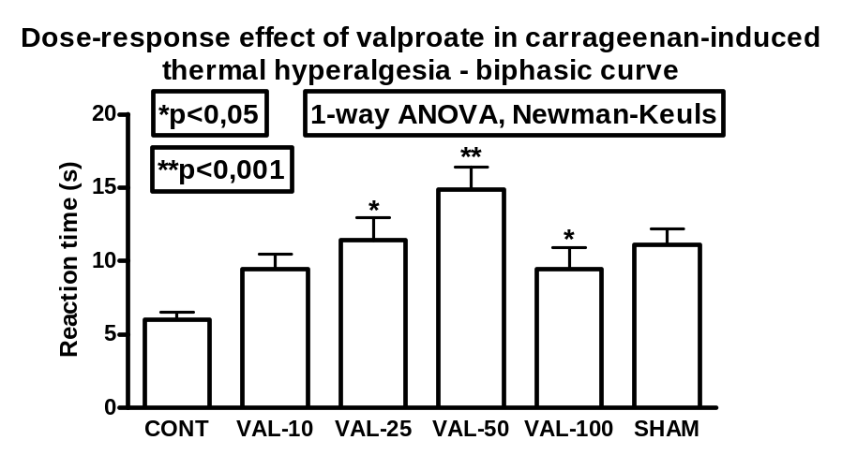
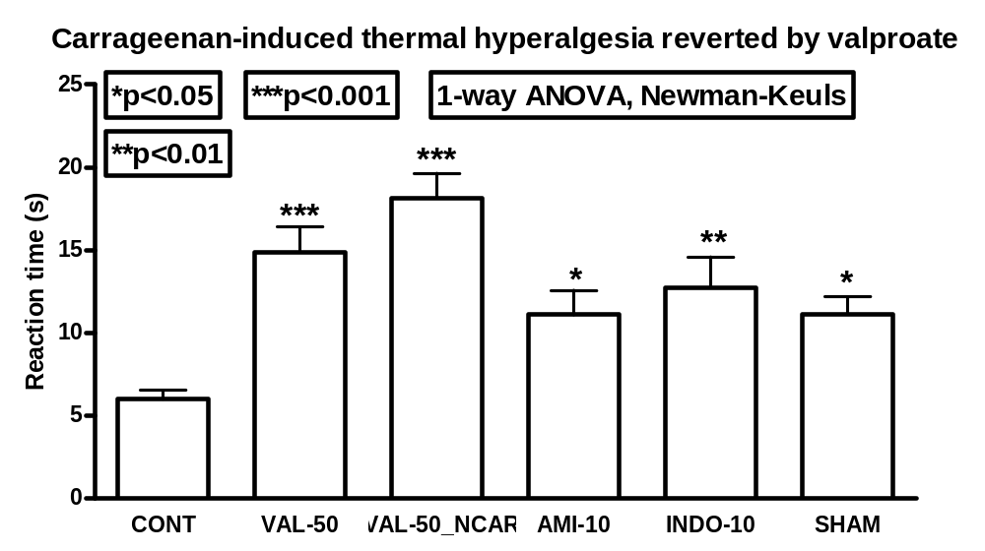
Figure 1: Valproate reversal of carrageenan-induced acute thermal hyperalgesia. Plantar test was performed as previously described. SHAM group (SHAM) had no pharmacological treatment. Control group had a 1 mg carrageenan plantar injection in right hindpaw 2 h before the test. Groups I to VI (VAL-10, VAL-25, VAL-50, VAL-100, AMI-10, and INDO-10) animals were treated with valproate 10 to 100 mg/kg, amytriptiline 10 mg/kg or indometacine 10 mg/kg at the same time of carrageenan injection. Group IX (VAL-50_NCAR) was treated with valproate 50 mg/kg. Reaction time to thermal stimulus (mean ± SEM) was plotted. Statistical significance is depicted when present.

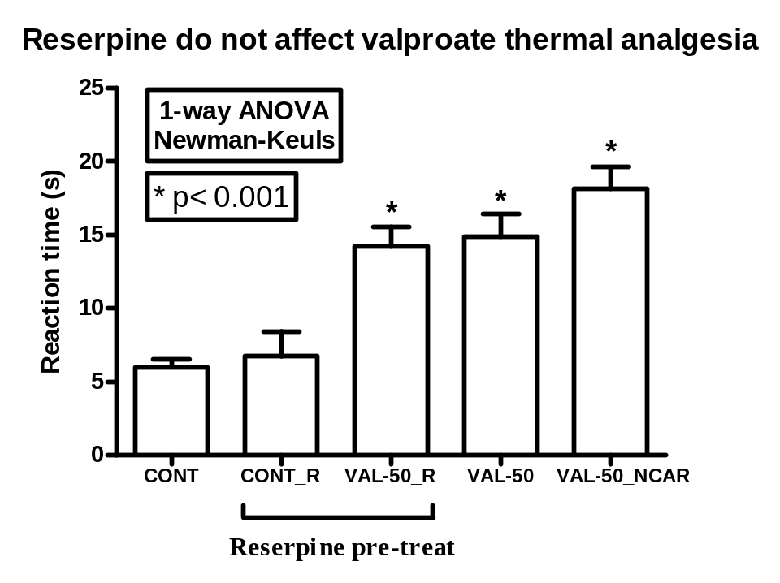
Figure 2: Reserpine did not revert the analgesia determined by valproate in the plantar test. Plantar test was performed as previously described. Both groups had a 1mg carrageenan plantar injection in right hindpaw 2 h before the test. Groups VII and VIII (CONT e SIB-5) animals were pre-treated with reserpine (Sigma), 1.0 mg/kg, dissolved in 0.5 ml of glacial acetic acid and 9.5ml of saline and administered i.p. (0.2 ml/animal), 6h before plantar test. Group VIII animals were treated with valproate in a single p.o. dose of 50 mg/kg, 4h after reserpine administration and 2 h before plantar test. Reaction time to thermal stimulus (mean ± SEM) was plotted. Statistical significance is depicted.

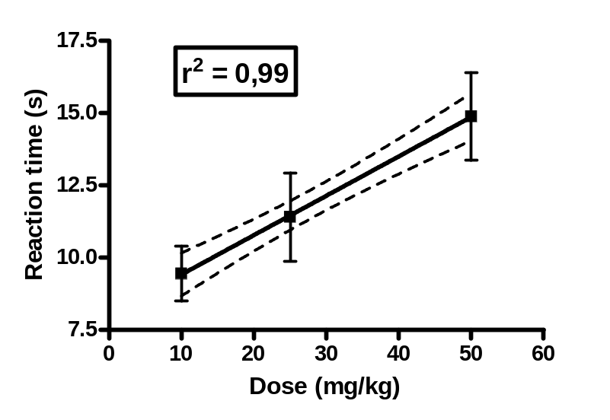
Figure 3: Dose-response curve of the anti-hyperalgesic effect of valproate in the plantar test. Dose was plotted against reaction time (s). The curve was obtained by linear regression. Slope 0.14 (CI95 = 0.11-0.17), r² = 0.99

