Cancer Imaging Informatics
April, 2024
Table of Contents

About this Course
This course is part of a series of courses for the Informatics Technology for Cancer Research (ITCR) called the Informatics Technology for Cancer Research Education Resource. This material was created by the ITCR Training Network (ITN) which is a collaborative effort of researchers around the United States to support cancer informatics and data science training through resources, technology, and events. This initiative is funded by the following grant: National Cancer Institute (NCI) UE5 CA254170. Our courses feature tools developed by ITCR Investigators and make it easier for principal investigators, scientists, and analysts to integrate cancer informatics into their workflows. Please see our website at www.itcrtraining.org for more information.

0.1 Available course formats
This course is available in multiple formats which allows you to take it in the way that best suites your needs. You can take it for certificate which can be for free or fee.
- The material for this course can be viewed without login requirement on this Bookdown website. This format might be most appropriate for you if you rely on screen-reader technology.
- This course can be taken for free certification through Leanpub.
- This course can be taken on Coursera for certification here (but it is not available for free on Coursera).
- Our courses are open source, you can find the source material for this course on GitHub.

1 Introduction
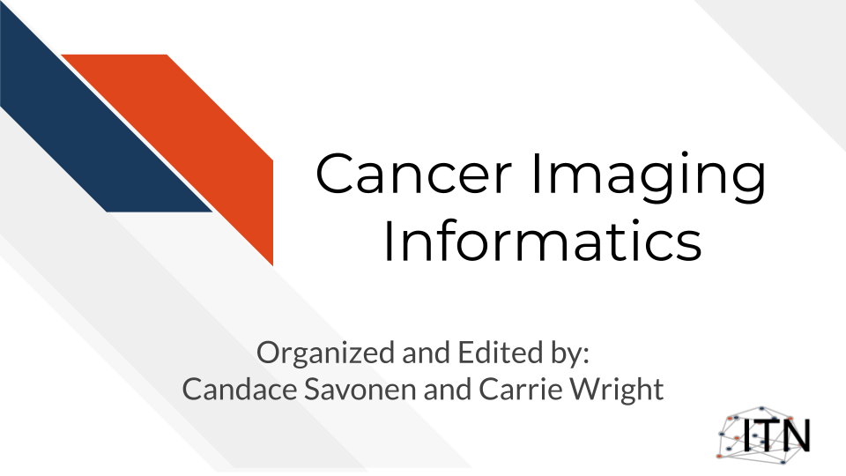
This is a living course meaning it is constantly changing and being updated. The goal for this course is to be a “wikipedia” of imaging data. If you’d like to contribute, you can file a pull request on GitHub if you are comfortable with that sort of thing or email csavonen@fredhutch.org to ask how to get started.

1.1 Target Audience
The course is intended for students in the biomedical sciences and researchers who have been given imaging data and don’t know what to do with it or would like an overview of the different imaging data types that are out there.
This course is written for individuals who:
- Have imaging data and don’t know what to do with it.
- Want a basic overview of imaging data types.
- Want to find resources for processing and interpreting imaging data.
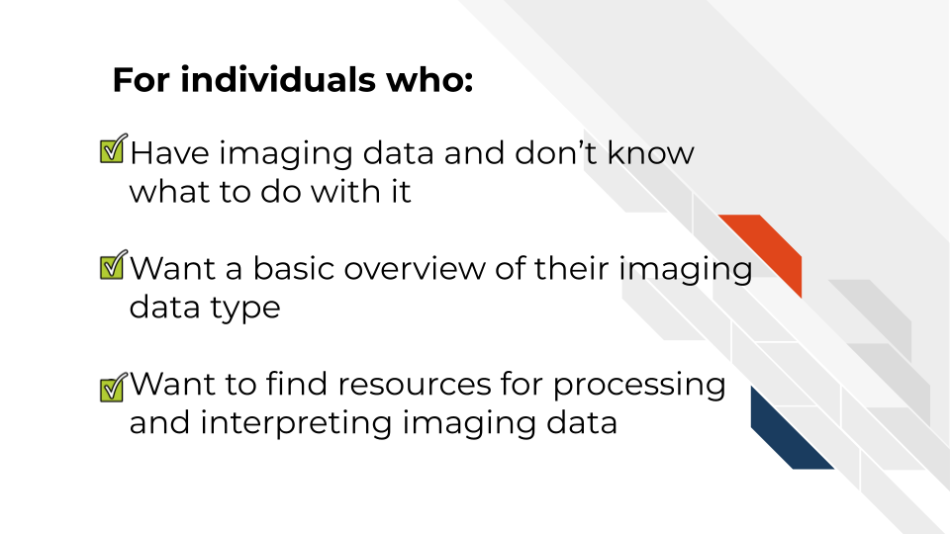

1.2 Topics covered:
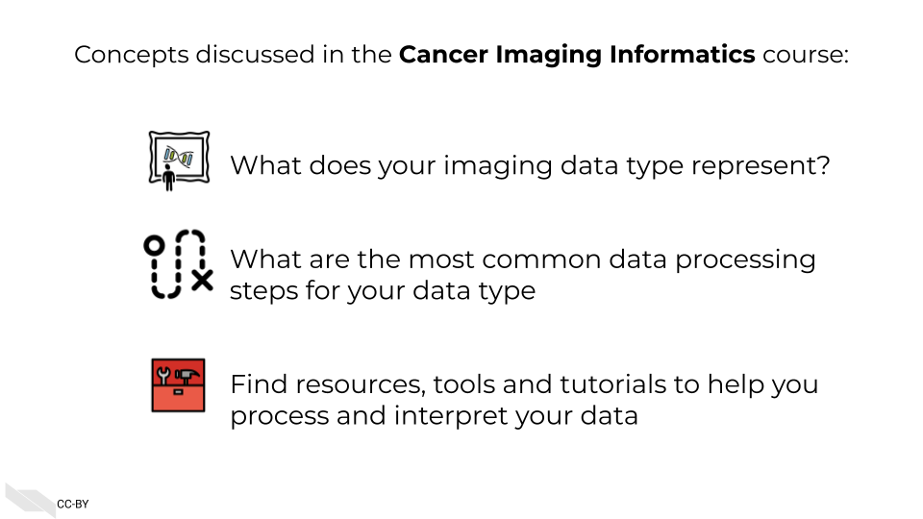

1.3 Motivation
Cancer imaging data hold untold amounts of information regarding cancer biology but have particular challenges in handling these data properly. Cancer researchers are working to apply their expertise to the analysis of these vast amounts of data but training opportunities to properly equip them in these efforts can be sparse.
Often students and researchers need to utilize imaging data to reach the next steps of their research but may not have formal training in computational methods or the basics of the imaging data they are attempting to utilize.
This course attempts to give this researcher the basic bearings and resources regarding imaging data, in hopes that they will be equipped and informed about how to properly handle the data and obtain insights for cancer biology.

1.4 Curriculum
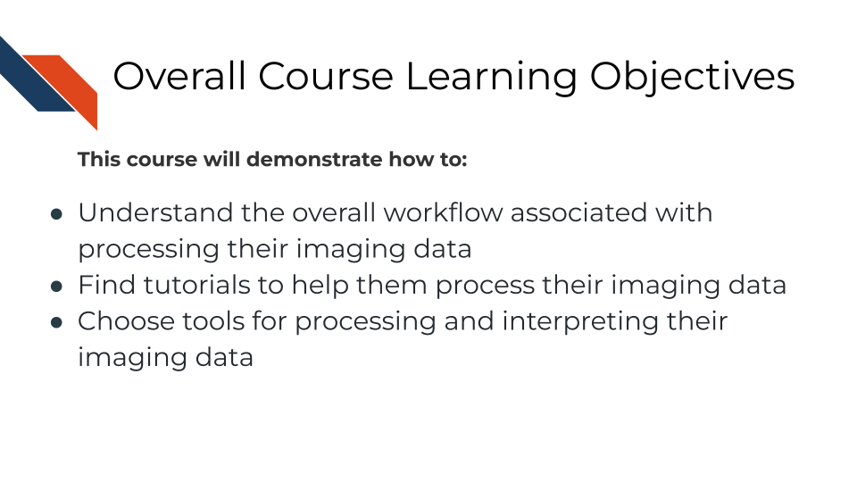
Goal of this course:
Equip learners with tutorials and resources so they can understand and interpret their imaging data in a way that helps them meet their goals and handle the data properly and appropriately. This includes helping learners formulate questions they will need to ask others about their data
What is not the goal
Teach learners about choosing parameters or about the ins and outs of every imaging tool they might be interested in. This course is meant to connect people to other resources that will help them with the specifics of their imaging data and help learners have more efficient and fruitful discussions about their data with imaging informatic experts.

1.5 How to use the course
This course is designed to be a jumping off point to more specific resources based on a imaging data type the learner is working with. We encourage learners to follow links to resources we provide and feel free to jump around to chapters that are most useful for them.

2 Introduction to Imaging

2.1 Learning Objectives


2.2 What are general guidelines of using imaging data?

2.3 An overview of the imaging types

2.3.1 Radiology

2.3.2 Histology/Pathology

3 Introduction to Imaging

3.1 Learning Objectives


3.2 Basics about image file types

3.2.1 What file prefixes are there and what different file types are common in imaging data?

3.2.2 How do you know what files are what?

3.2.3 What kind of metadata is associated with imaging data?

4 Radiology Overview

4.1 Learning Objectives


5 Basics of MRI

5.1 Learning Objectives


6 Basics of X-Ray

6.1 Learning Objectives


7 Basics of CT

7.1 Learning Objectives


8 Basics of PET

8.1 Learning Objectives


9 Basics of Ultrasound

9.1 Learning Objectives


10 Considerations for choosing radiology tools

10.1 Learning Objectives


10.2 Tools for image standardization

10.3 Why would you use one tool over the other?

10.4 What parameters, or caveats should be known about each tool?

11 Pathology Histology Overview

11.1 Learning Objectives


12 Basics of Histology/Pathology & Digital Pathology

12.1 Learning Objectives


13 Basics of Microscopy

13.1 Learning Objectives


14 Basics of Whole Slide Imaging

14.1 Learning Objectives


15 Basics of Immunohistochemistry, immunofluorescence, and multispectral imaging

15.1 Learning Objectives


16 Machine Learning for Pathology

16.1 Basics of Machine Learning

16.1.1 Learning Objectives


16.2 Tumor Heterogeneity/Diversity

16.2.1 Learning Objectives


16.3 Tissue/cell Segmentation

16.3.1 Learning Objectives


16.4 Quantification Methods

16.4.1 Learning Objectives


17 Considerations for choosing histology tools

17.1 Learning Objectives


17.2 Tools for image standardization

17.3 Why would you use one tool over the other?

17.4 What parameters, or caveats should be known about each tool?

18 ITCR Imaging Tool Glossary
Here’s all the tools that have been mentioned in this course or are otherwise recommended for your use. The list is in alphabetical order.

About the Authors
These credits are based on our course contributors table guidelines.

Credits | Names
Pedagogy
Lead Content Instructor(s) | FirstName LastName
Lecturer(s) (include chapter name/link in parentheses if only for specific chapters) - make new line if more than one chapter involved | Delivered the course in some way - video or audio
Content Author(s) (include chapter name/link in parentheses if only for specific chapters) - make new line if more than one chapter involved | If any other authors besides lead instructor
Content Contributor(s) (include section name/link in parentheses) - make new line if more than one section involved | Wrote less than a chapter
Content Editor(s)/Reviewer(s) | Checked your content
Content Director(s) | Helped guide the content direction
Content Consultants (include chapter name/link in parentheses or word “General”) - make new line if more than one chapter involved | Gave high level advice on content
Acknowledgments | Gave small assistance to content but not to the level of consulting
Production
Content Publisher(s) | Helped with publishing platform
Content Publishing Reviewer(s) | Reviewed overall content and aesthetics on publishing platform
Technical
Course Publishing Engineer(s) | Helped with the code for the technical aspects related to the specific course generation
Template Publishing Engineers | Candace Savonen, Carrie Wright, Ava Hoffman
Publishing Maintenance Engineer | Candace Savonen
Technical Publishing Stylists | Carrie Wright, Ava Hoffman, Candace Savonen
Package Developers (ottrpal) Candace Savonen, John Muschelli, Carrie Wright
Art and Design
Illustrator(s) | Created graphics for the course
Figure Artist(s) | Created figures/plots for course
Videographer(s) | Filmed videos
Videography Editor(s) | Edited film
Audiographer(s) | Recorded audio
Audiography Editor(s) | Edited audio recordings
Funding
Funder(s) | Institution/individual who funded course including grant number
Funding Staff | Staff members who help with funding

## ─ Session info ───────────────────────────────────────────────────────────────
## setting value
## version R version 4.0.2 (2020-06-22)
## os Ubuntu 20.04.5 LTS
## system x86_64, linux-gnu
## ui X11
## language (EN)
## collate en_US.UTF-8
## ctype en_US.UTF-8
## tz Etc/UTC
## date 2024-04-26
##
## ─ Packages ───────────────────────────────────────────────────────────────────
## package * version date lib source
## assertthat 0.2.1 2019-03-21 [1] RSPM (R 4.0.5)
## bookdown 0.24 2024-03-13 [1] Github (rstudio/bookdown@88bc4ea)
## cachem 1.0.8 2023-05-01 [1] CRAN (R 4.0.2)
## callr 3.5.0 2020-10-08 [1] RSPM (R 4.0.2)
## cli 3.6.2 2023-12-11 [1] CRAN (R 4.0.2)
## crayon 1.3.4 2017-09-16 [1] RSPM (R 4.0.0)
## desc 1.2.0 2018-05-01 [1] RSPM (R 4.0.3)
## devtools 2.3.2 2020-09-18 [1] RSPM (R 4.0.3)
## digest 0.6.25 2020-02-23 [1] RSPM (R 4.0.0)
## ellipsis 0.3.1 2020-05-15 [1] RSPM (R 4.0.3)
## evaluate 0.23 2023-11-01 [1] CRAN (R 4.0.2)
## fastmap 1.1.1 2023-02-24 [1] CRAN (R 4.0.2)
## fs 1.5.0 2020-07-31 [1] RSPM (R 4.0.3)
## glue 1.4.2 2020-08-27 [1] RSPM (R 4.0.5)
## htmltools 0.5.7 2023-11-03 [1] CRAN (R 4.0.2)
## knitr 1.33 2024-03-13 [1] Github (yihui/knitr@a1052d1)
## magrittr 2.0.3 2022-03-30 [1] CRAN (R 4.0.2)
## memoise 2.0.1 2021-11-26 [1] CRAN (R 4.0.2)
## pkgbuild 1.1.0 2020-07-13 [1] RSPM (R 4.0.2)
## pkgload 1.1.0 2020-05-29 [1] RSPM (R 4.0.3)
## prettyunits 1.1.1 2020-01-24 [1] RSPM (R 4.0.3)
## processx 3.4.4 2020-09-03 [1] RSPM (R 4.0.2)
## ps 1.4.0 2020-10-07 [1] RSPM (R 4.0.2)
## R6 2.4.1 2019-11-12 [1] RSPM (R 4.0.0)
## remotes 2.2.0 2020-07-21 [1] RSPM (R 4.0.3)
## rlang 1.1.3 2024-01-10 [1] CRAN (R 4.0.2)
## rmarkdown 2.10 2024-03-13 [1] Github (rstudio/rmarkdown@02d3c25)
## rprojroot 2.0.4 2023-11-05 [1] CRAN (R 4.0.2)
## sessioninfo 1.1.1 2018-11-05 [1] RSPM (R 4.0.3)
## stringi 1.5.3 2020-09-09 [1] RSPM (R 4.0.3)
## stringr 1.4.0 2019-02-10 [1] RSPM (R 4.0.3)
## testthat 3.0.1 2024-03-13 [1] Github (R-lib/testthat@e99155a)
## usethis 1.6.3 2020-09-17 [1] RSPM (R 4.0.2)
## withr 2.3.0 2020-09-22 [1] RSPM (R 4.0.2)
## xfun 0.26 2024-03-13 [1] Github (yihui/xfun@74c2a66)
## yaml 2.2.1 2020-02-01 [1] RSPM (R 4.0.3)
##
## [1] /usr/local/lib/R/site-library
## [2] /usr/local/lib/R/library

19 References

