BioDIGS: Biosynthetic Gene Clusters

October 16, 2024

Table of Contents

# About this Book

This is a companion training guide for BioDIGS, a GDSCN project that brings a research experience into the classroom. In this module, students will explore microbiome data for the presence of biosynthesis genes. They will run analyses using antiSMASH as implemented on Galaxy. Visit the BioDIGS (BioDiversity and Informatics for Genomics Scholars) website [here](https://biodigs.org/) for more information about this collaborative, distributed research project, including how you can get involved!

The GDSCN (Genomics Data Science Community Network) is a consortium of educators who aim to create a world where researchers, educators, and students from diverse backgrounds are able to fully participate in genomic data science research. You can find more information about its mission and initiatives [here](https://www.gdscn.org/home).

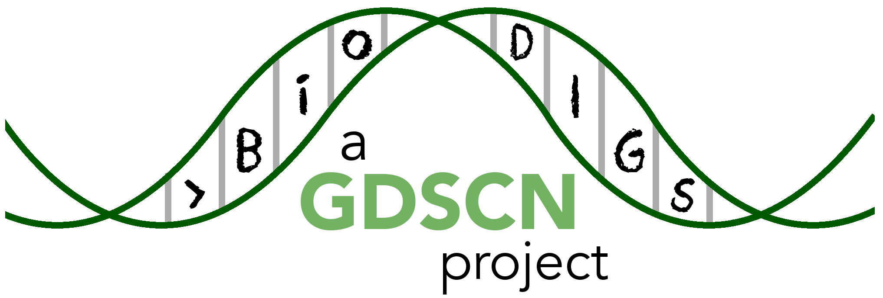

## 0.1 Skills Level

The activities in this guide are written for undergraduate students and beginning graduate students.

*Genetics*

*Programming skills*

## 0.2 Platform

The activities in this guide are demonstrated on NHGRI’s [AnVIL](https://anvilproject.org/) cloud computing platform. AnVIL is the preferred computing platform for the GDSCN. However, all of these activities can be done using your personal installation of R or using the online [Galaxy](usegalaxy.org) portal.

Please check out our full collection of AnVIL and related resources: <https://hutchdatascience.org/AnVIL_Collection/>

## 0.3 Data

The data generated by the BioDIGS project is available through the [BioDIGS website](biodigs.org), as well as through an [AnVIL workspace](https://anvilproject.org).

Data about the soil itself as well as soil metal content was generated by the [Delaware Soil Testing Program](https://www.udel.edu/canr/cooperative-extension/environmental-stewardship/soil-testing/) at the University of Delaware. Sequences were generated by the [Johns Hopkins University Genetic Resources Core Facility](https://grcf.jhmi.edu/) and by [PacBio](https://www.pacb.com/).

# 1 Student Guide

## 1.1 Activity One

You might want to create a student guide that contains a different subset of Rmd files from your book, or renders to a different output format (e.g. word document). You can specify the output and Rmd files that will be used for the student guide using the _output.yml and _bookdown.yml files in the student-guide directory.

## 1.2 Activity Two

Steps of the guide could go here.

# 2 References