About
Welcome! This is the main website for the Genomics Education Modules (GEMs) Program, a collaborative project between Fred Hutch Cancer Center, Clovis Community College, Guttman Community College, El Paso Community College, and Georgetown University.
Our team focuses specifically on genomic data science, an interdisciplinary field that combines both biology and computational skills. Here, you will be able to find links to our modules to use in the classroom or workplace.
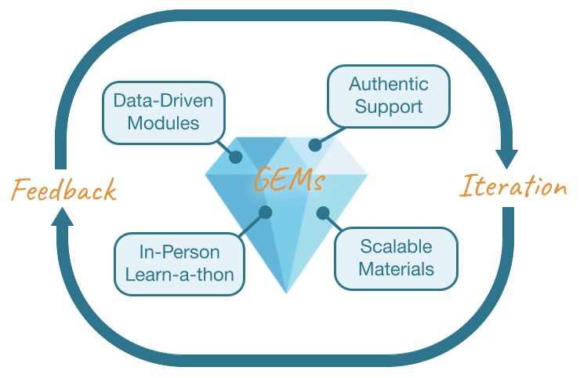

Our Team
- Rosa Alcazar (Clovis CC)
- Carolina Chianelli (El Paso CC)
- Stephanie Coffman (Clovis CC)
- Karla Fuller (Guttman CC)
- Ava Hoffman (Fred Hutch)
- Elizabeth Humphries (Fred Hutch)
- Andrew Lee (Georgetown)
- Allison Peters (Fred Hutch)

Contact Us
If you have questions please contact: gems at fredhutch dot org

