### **About**

Welcome! This is the main website for the Genomics Education Modules (GEMs) Program, a collaborative project between [Fred Hutch Cancer Center](https://www.fredhutch.org/en.html), [Clovis Community College](https://www.cloviscollege.edu/), [Guttman Community College](https://guttman.cuny.edu/), and [Northern Virginia Community College](https://www.nvcc.edu/).

Our team focuses specifically on [genomic data science](https://www.genome.gov/about-genomics/fact-sheets/Genomic-Data-Science), an interdisciplinary field that combines both biology and computational skills. Here, you will be able to find links to our modules to use in the classroom or workplace.

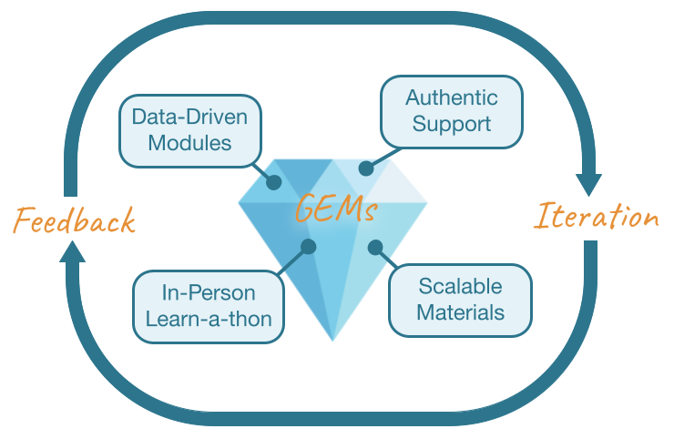

### **Our Team**

* Rosa Alcazar (Clovis CC)
* Stephanie Coffman (Clovis CC)
* Karla Fuller (Guttman CC)
* [Ava Hoffman](https://avahoffman.com) (Fred Hutch)
* Elizabeth Humphries (Fred Hutch)
* Andrew Lee (NVCC)
* Allison Peters (Fred Hutch)

### **Contact Us**

If you have questions please contact: Ava Hoffman (ahoffma2 **at** fredhutch **dot** org)