**Family Markers: Using Multiply-Affected Families to Identify Risk Genes**

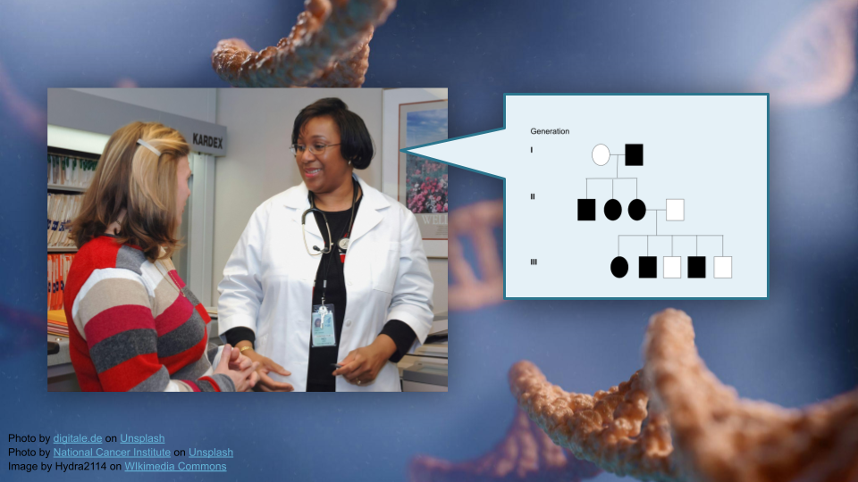

## Overview

This activity teaches students to interpret pedigree information and use bioinformatics tools (R) to build pedigrees for tracking disease traits in families. Students will work with real data from a bipolar disorder genetics study to understand how researchers understand risk genes using pedigrees.

**Duration:** Approximately 2-3 hours (depending on student familiarity with R)

## Learning Objectives

1. Interpret pedigree information to determine the suitability of a DNA marker for tracking a disease trait in a family (see [GSA](https://genetics-gsa.org/education/genetics-learning-framework/) learning objectives).
2. Build a pedigree using bioinformatics tools (R).

## Materials and Setup

* Students will need either:
  + An internet connection for this activity as written (using Posit Cloud)
  + A local installation of R or RStudio (with data downloaded and kinship2 package installed ahead of time)
* Required R package: kinship2
* Data hosting: https://genomicseducation.org/data/pedigree_data.csv
* Download the R student activity as:
  + [Web page](https://genomicseducation.org/module/family_markers_student_guide.html)
  + [Quarto (qmd)](https://github.com/fhdsl/GEMs/blob/main/module/family_markers_student_guide.qmd)
  + [Word (docx)](https://github.com/fhdsl/GEMs/raw/main/docs/docx/module/family_markers_student_guide.docx)
  + [Google Doc](https://docs.google.com/document/d/1PBGugINV2mOrq-knq5MXPOC-WcQSxnMA/edit?usp=sharing&ouid=116032995747974603894&rtpof=true&sd=true)
* Google Slides presentation available for borrowing images [here](https://docs.google.com/presentation/d/1dhP4CeUIJAqy3z7mKxuFzk8b8LhLrPBPHb1bpYpbk3c/edit?usp=sharing).
* Answer key available [here](https://docs.google.com/document/d/1KcX30s2fYzFw16boGVO4MlhSAA2Pr3OzqwmndeO043U/edit?usp=sharing). Please message Ava Hoffman (ahoffma2 at fredhutch dot org) to get access.

## Scientific Topics

The activity is based a [published research study](https://www.nature.com/articles/s41380-022-01609-4) “Rare variants implicate NMDA receptor signaling and cerebellar gene networks in risk for bipolar disorder.” Students will gain exposure to the following:

* Bipolar Disorder: Neuropsychiatric condition affecting ~1% of population, with 10-25% risk for children of affected parents
* Cerebellum: Brain region containing 50% of neurons despite being 10% of brain volume; involved in motor coordination and emotional regulation
* NMDA Receptors: Glutamate receptors crucial for memory and learning; blocked by substances like alcohol and ketamine
* DAO Gene: D-amino acid oxidase gene identified as significantly associated with bipolar disorder risk

## Outline

* Part 1: Background and Setup (30-45 minutes)
* Part 2: Basic Pedigree Construction (20-30 minutes)
* Part 3: Adding Diagnostic Information (15-20 minutes)
* Part 4: Genotype Mapping and Analysis (30-40 minutes)