Untitled

John Muschelli

8/10/2017

I think the $α$ parameter needs to be set better in the model:

$$x=αϕ$$

I think the paper by Eloyan and Ghosh (2013) is awesome! I like to cite it by (Eloyan and Ghosh 2013).

## R Markdown

This is an R Markdown document. Markdown is a simple formatting syntax for authoring HTML, PDF, and MS Word documents. For more details on using R Markdown see <http://rmarkdown.rstudio.com>.

When you click the **Knit** button a document will be generated that includes both content as well as the output of any embedded R code chunks within the document. You can embed an R code chunk like this:

summary(cars)

## speed dist   
## Min. : 4.0 Min. : 2.00   
## 1st Qu.:12.0 1st Qu.: 26.00   
## Median :15.0 Median : 36.00   
## Mean :15.4 Mean : 42.98   
## 3rd Qu.:19.0 3rd Qu.: 56.00   
## Max. :25.0 Max. :120.00

The mean distance of each car is 42.98 miles.

The equation was

$$\begin{matrix}Y_{i} & = & α+βx_{i}+ε_{i} \\ Z_{i} & = & γ+βx_{i}+ε_{i}\end{matrix}$$

model = lm( mpg ~ cyl + carb, data = mtcars)  
tab = broom::tidy(model, conf_int = TRUE)  
knitr::kable(tab)

|  |  |  |  |  |
| --- | --- | --- | --- | --- |
| term | estimate | std.error | statistic | p.value |
| (Intercept) | 37.812739 | 2.0540223 | 18.409118 | 0.0000000 |
| cyl | -2.625023 | 0.3755924 | -6.989020 | 0.0000001 |
| carb | -0.526146 | 0.4152914 | -1.266932 | 0.2152603 |

# DT::datatable(tab)  
pander::pander(tab)

|  |  |  |  |  |
| --- | --- | --- | --- | --- |
| term | estimate | std.error | statistic | p.value |
| (Intercept) | 37.81 | 2.054 | 18.41 | 1.532e-17 |
| cyl | -2.625 | 0.3756 | -6.989 | 1.102e-07 |
| carb | -0.5261 | 0.4153 | -1.267 | 0.2153 |

## Including Plots

You can also embed plots, for example:

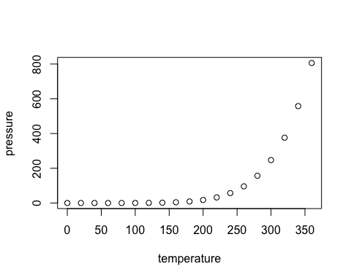

Note that the echo = FALSE parameter was added to the code chunk to prevent printing of the R code that generated the plot.

# References

Eloyan, Ani, and Sujit K Ghosh. 2013. “A Semiparametric Approach to Source Separation Using Independent Component Analysis.” *Computational Statistics & Data Analysis* 58. Elsevier: 383–96.