Informatics Technology for Cancer Research (ITCR): Bench to Bytes

June, 2024

Table of Contents

# About this Course

This course is part of a series of courses for the [Informatics Technology for Cancer Research (ITCR)](https://itcr.cancer.gov/) called the Informatics Technology for Cancer Research Education Resource. This material was created by the ITCR Training Network (ITN) which is a collaborative effort of researchers around the United States to support cancer informatics and data science training through resources, technology, and events. This initiative is funded by the following grant: [National Cancer Institute (NCI)](https://www.cancer.gov/) UE5 CA254170. Our courses feature tools developed by ITCR Investigators and make it easier for principal investigators, scientists, and analysts to integrate cancer informatics into their workflows. Please see our website at <www.itcrtraining.org> for more information. This course introduces motivations for learning computational and data science skills that can be beneficial for both wet and dry lab researchers across all scientific fields.

## 0.1 Available course formats

This course is available in multiple formats which allows you to take it in the way that best suites your needs. You can take it for certificate which can be for free or fee.

* The material for this course can be viewed without login requirement on this [course website](https://hutchdatascience.org/bench_to_bytes/). This format might be most appropriate for you if you rely on screen-reader technology.
* This course can be taken for [free certification through Leanpub](LINK%20HERE).
* This course can be taken on [Coursera for certification here](LINK%20HERE) (but it is not available for free on Coursera).
* Our courses are open source, you can find the [source material for this course on GitHub](https://github.com/fhdsl/bench_to_bytes).

# 1 Introduction

## 1.1 Motivation

This course aims to provide motivations for learning computational skills and discuss specific examples or ways computational skills could benefit or supplement wet lab work.

## 1.2 Target Audience

The course is intended for wet lab researchers who have very little to no computational research experience (for example: users of Excel or GraphPad Prism, but non-“coders”)

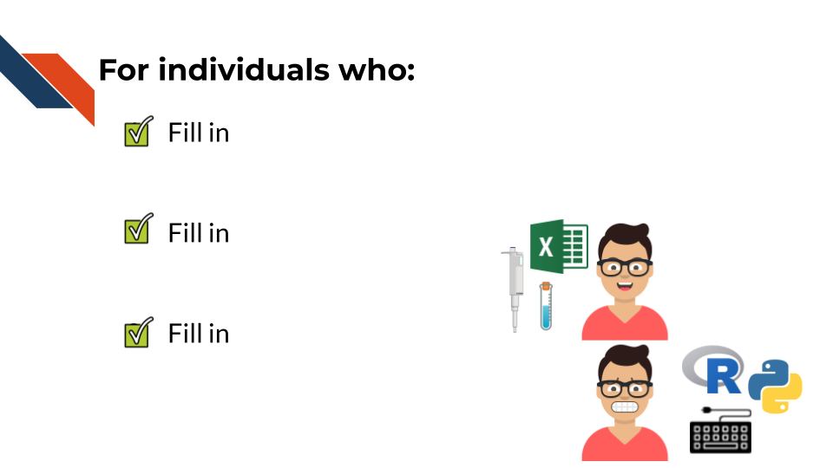

## 1.3 Curriculum

The course covers…

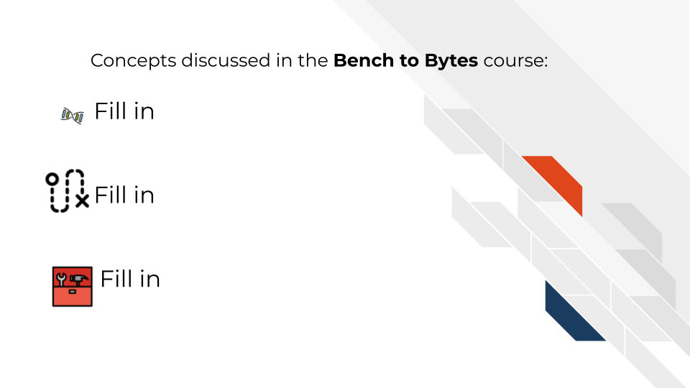

## 1.4 Objectives

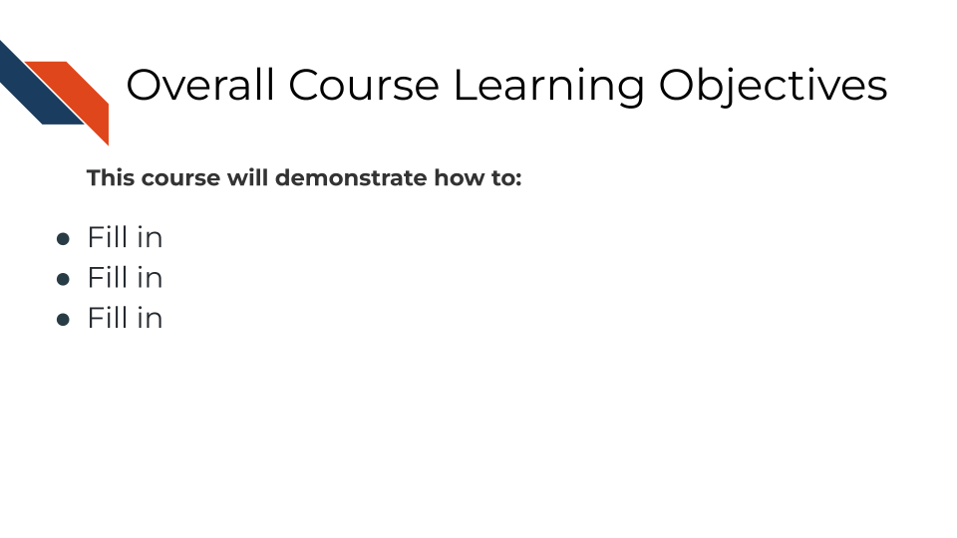

devtools::session_info()

## ─ Session info ───────────────────────────────────────────────────────────────  
## setting value  
## version R version 4.3.2 (2023-10-31)  
## os Ubuntu 22.04.4 LTS  
## system x86_64, linux-gnu  
## ui X11  
## language (EN)  
## collate en_US.UTF-8  
## ctype en_US.UTF-8  
## tz Etc/UTC  
## date 2024-06-21  
## pandoc 3.1.1 @ /usr/local/bin/ (via rmarkdown)  
##   
## ─ Packages ───────────────────────────────────────────────────────────────────  
## package * version date (UTC) lib source  
## askpass 1.2.0 2023-09-03 [1] RSPM (R 4.3.0)  
## bookdown 0.39.1 2024-06-11 [1] Github (rstudio/bookdown@f244cf1)  
## cachem 1.0.8 2023-05-01 [1] RSPM (R 4.3.0)  
## cli 3.6.2 2023-12-11 [1] RSPM (R 4.3.0)  
## curl 5.2.0 2023-12-08 [1] RSPM (R 4.3.0)  
## devtools 2.4.5 2022-10-11 [1] RSPM (R 4.3.0)  
## digest 0.6.34 2024-01-11 [1] RSPM (R 4.3.0)  
## ellipsis 0.3.2 2021-04-29 [1] RSPM (R 4.3.0)  
## evaluate 0.23 2023-11-01 [1] RSPM (R 4.3.0)  
## fansi 1.0.6 2023-12-08 [1] RSPM (R 4.3.0)  
## fastmap 1.1.1 2023-02-24 [1] RSPM (R 4.3.0)  
## fs 1.6.3 2023-07-20 [1] RSPM (R 4.3.0)  
## glue 1.7.0 2024-01-09 [1] RSPM (R 4.3.0)  
## hms 1.1.3 2023-03-21 [1] RSPM (R 4.3.0)  
## htmltools 0.5.7 2023-11-03 [1] RSPM (R 4.3.0)  
## htmlwidgets 1.6.4 2023-12-06 [1] RSPM (R 4.3.0)  
## httpuv 1.6.14 2024-01-26 [1] RSPM (R 4.3.0)  
## httr 1.4.7 2023-08-15 [1] RSPM (R 4.3.0)  
## jsonlite 1.8.8 2023-12-04 [1] RSPM (R 4.3.0)  
## knitr 1.47.3 2024-06-11 [1] Github (yihui/knitr@e1edd34)  
## later 1.3.2 2023-12-06 [1] RSPM (R 4.3.0)  
## lifecycle 1.0.4 2023-11-07 [1] RSPM (R 4.3.0)  
## magrittr 2.0.3 2022-03-30 [1] RSPM (R 4.3.0)  
## memoise 2.0.1 2021-11-26 [1] RSPM (R 4.3.0)  
## mime 0.12 2021-09-28 [1] RSPM (R 4.3.0)  
## miniUI 0.1.1.1 2018-05-18 [1] RSPM (R 4.3.0)  
## openssl 2.1.1 2023-09-25 [1] RSPM (R 4.3.0)  
## ottrpal 1.2.1 2024-06-11 [1] Github (jhudsl/ottrpal@828539f)  
## pillar 1.9.0 2023-03-22 [1] RSPM (R 4.3.0)  
## pkgbuild 1.4.3 2023-12-10 [1] RSPM (R 4.3.0)  
## pkgconfig 2.0.3 2019-09-22 [1] RSPM (R 4.3.0)  
## pkgload 1.3.4 2024-01-16 [1] RSPM (R 4.3.0)  
## profvis 0.3.8 2023-05-02 [1] RSPM (R 4.3.0)  
## promises 1.2.1 2023-08-10 [1] RSPM (R 4.3.0)  
## purrr 1.0.2 2023-08-10 [1] RSPM (R 4.3.0)  
## R6 2.5.1 2021-08-19 [1] RSPM (R 4.3.0)  
## Rcpp 1.0.12 2024-01-09 [1] RSPM (R 4.3.0)  
## readr 2.1.5 2024-01-10 [1] RSPM (R 4.3.0)  
## remotes 2.4.2.1 2023-07-18 [1] RSPM (R 4.3.0)  
## rlang 1.1.4 2024-06-04 [1] CRAN (R 4.3.2)  
## rmarkdown 2.27.1 2024-06-11 [1] Github (rstudio/rmarkdown@e1c93a9)  
## sessioninfo 1.2.2 2021-12-06 [1] RSPM (R 4.3.0)  
## shiny 1.8.0 2023-11-17 [1] RSPM (R 4.3.0)  
## stringi 1.8.3 2023-12-11 [1] RSPM (R 4.3.0)  
## stringr 1.5.1 2023-11-14 [1] RSPM (R 4.3.0)  
## tibble 3.2.1 2023-03-20 [1] CRAN (R 4.3.2)  
## tzdb 0.4.0 2023-05-12 [1] RSPM (R 4.3.0)  
## urlchecker 1.0.1 2021-11-30 [1] RSPM (R 4.3.0)  
## usethis 2.2.3 2024-02-19 [1] RSPM (R 4.3.0)  
## utf8 1.2.4 2023-10-22 [1] RSPM (R 4.3.0)  
## vctrs 0.6.5 2023-12-01 [1] RSPM (R 4.3.0)  
## xfun 0.44.4 2024-06-11 [1] Github (yihui/xfun@9da62cc)  
## xml2 1.3.6 2023-12-04 [1] RSPM (R 4.3.0)  
## xtable 1.8-4 2019-04-21 [1] RSPM (R 4.3.0)  
## yaml 2.3.8 2023-12-11 [1] RSPM (R 4.3.0)  
##   
## [1] /usr/local/lib/R/site-library  
## [2] /usr/local/lib/R/library  
##   
## ──────────────────────────────────────────────────────────────────────────────

# 2 The who, what, when, where, and why of Computational Biology

## 2.1 Learning Objectives

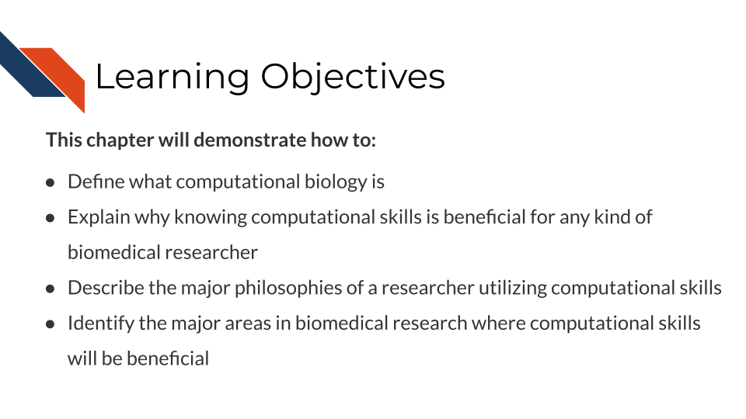

## 2.2 What are computational biology and data science?

## 2.3 Motivations for computational work in general and to learn computational skills yourself

## 2.4 Examples of the application of computational work to wet lab research

## 2.5 The philosophies and best practices of computational work

### 2.5.1 Rigor and ethics in computational work

## 2.6 Which computational skills are the most important to prioritize learning as a wet lab scientist

### 2.6.1 Data Wrangling

### 2.6.2 Data Visualization

### 2.6.3 Reproducibility and Transparency

### 2.6.4 Sharing and reusing public data, code, or tools

## 2.7 Summary

In conclusion, the benefits of knowing computational skills as a wet lab scientist …

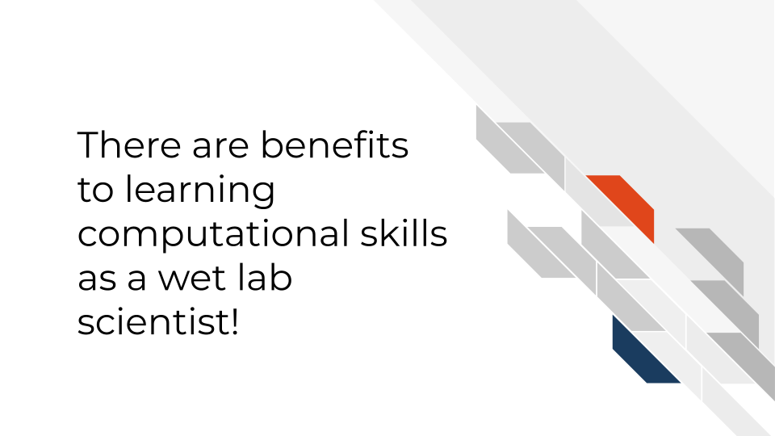

Rather than a scientist being a wet-lab researcher or a dry-lab researcher, in the future we hope scientists have and utilize lab and computational skills for their research.

# 3 Data cleaning

The first “why computational skill are useful” theme that we’ll explore is data cleaning.

## 3.1 Learning Objectives

This chapter will cover:

* {LO1}
* {LO2}

# 4 Data visualization

The second “why computational skill are useful” theme that we’ll explore is data visualization

## 4.1 Learning Objectives

This chapter will cover:

* {LO1}
* {LO2}

# 5 Reproducibility

The third “why computational skill are useful” theme that we’ll explore is reproducibility.

## 5.1 Learning Objectives

This chapter will cover:

* {LO1}
* {LO2}

# 6 Public Data and Code Sharing and Reuse

The final “why computational skill are useful” theme that we’ll explore is public data and code sharing and reuse

## 6.1 Learning Objectives

This chapter will cover:

* {LO1}
* {LO2}

# About the Authors

These credits are based on our [course contributors table guidelines](https://www.ottrproject.org/more_features.html#giving-credits-to-contributors).

| Credits | Names |
| --- | --- |
| **Pedagogy** |  |
| Lead Content Instructor(s) | [FirstName LastName](link%20to%20personal%20website) |
| Lecturer(s) (include chapter name/link in parentheses if only for specific chapters) - make new line if more than one chapter involved | Delivered the course in some way - video or audio |
| Content Author(s) (include chapter name/link in parentheses if only for specific chapters) - make new line if more than one chapter involved | If any other authors besides lead instructor |
| Content Contributor(s) (include section name/link in parentheses) - make new line if more than one section involved | Wrote less than a chapter |
| Content Editor(s)/Reviewer(s) | Checked your content |
| Content Director(s) | Helped guide the content direction |
| Content Consultants (include chapter name/link in parentheses or word “General”) - make new line if more than one chapter involved | Gave high level advice on content |
| Acknowledgments | Gave small assistance to content but not to the level of consulting |
| **Production** |  |
| Content Publisher(s) | Helped with publishing platform |
| Content Publishing Reviewer(s) | Reviewed overall content and aesthetics on publishing platform |
| **Technical** |  |
| Course Publishing Engineer(s) | Helped with the code for the technical aspects related to the specific course generation |
| Template Publishing Engineers | [Candace Savonen](https://www.cansavvy.com/), [Carrie Wright](https://carriewright11.github.io/), [Ava Hoffman](https://www.avahoffman.com/) |
| Publishing Maintenance Engineer | [Candace Savonen](https://www.cansavvy.com/) |
| Technical Publishing Stylists | [Carrie Wright](https://carriewright11.github.io/), [Ava Hoffman](https://www.avahoffman.com/), [Candace Savonen](https://www.cansavvy.com/) |
| Package Developers ([ottrpal](https://github.com/jhudsl/ottrpal)) [Candace Savonen](https://www.cansavvy.com/), [John Muschelli](https://johnmuschelli.com/), [Carrie Wright](https://carriewright11.github.io/) |  |
| **Art and Design** |  |
| Illustrator(s) | Created graphics for the course |
| Figure Artist(s) | Created figures/plots for course |
| Videographer(s) | Filmed videos |
| Videography Editor(s) | Edited film |
| Audiographer(s) | Recorded audio |
| Audiography Editor(s) | Edited audio recordings |
| **Funding** |  |
| Funder(s) | Institution/individual who funded course including grant number |
| Funding Staff | Staff members who help with funding |

## ─ Session info ───────────────────────────────────────────────────────────────  
## setting value  
## version R version 4.3.2 (2023-10-31)  
## os Ubuntu 22.04.4 LTS  
## system x86_64, linux-gnu  
## ui X11  
## language (EN)  
## collate en_US.UTF-8  
## ctype en_US.UTF-8  
## tz Etc/UTC  
## date 2024-06-21  
## pandoc 3.1.1 @ /usr/local/bin/ (via rmarkdown)  
##   
## ─ Packages ───────────────────────────────────────────────────────────────────  
## package * version date (UTC) lib source  
## bookdown 0.39.1 2024-06-11 [1] Github (rstudio/bookdown@f244cf1)  
## cachem 1.0.8 2023-05-01 [1] RSPM (R 4.3.0)  
## cli 3.6.2 2023-12-11 [1] RSPM (R 4.3.0)  
## devtools 2.4.5 2022-10-11 [1] RSPM (R 4.3.0)  
## digest 0.6.34 2024-01-11 [1] RSPM (R 4.3.0)  
## ellipsis 0.3.2 2021-04-29 [1] RSPM (R 4.3.0)  
## evaluate 0.23 2023-11-01 [1] RSPM (R 4.3.0)  
## fastmap 1.1.1 2023-02-24 [1] RSPM (R 4.3.0)  
## fs 1.6.3 2023-07-20 [1] RSPM (R 4.3.0)  
## glue 1.7.0 2024-01-09 [1] RSPM (R 4.3.0)  
## htmltools 0.5.7 2023-11-03 [1] RSPM (R 4.3.0)  
## htmlwidgets 1.6.4 2023-12-06 [1] RSPM (R 4.3.0)  
## httpuv 1.6.14 2024-01-26 [1] RSPM (R 4.3.0)  
## knitr 1.47.3 2024-06-11 [1] Github (yihui/knitr@e1edd34)  
## later 1.3.2 2023-12-06 [1] RSPM (R 4.3.0)  
## lifecycle 1.0.4 2023-11-07 [1] RSPM (R 4.3.0)  
## magrittr 2.0.3 2022-03-30 [1] RSPM (R 4.3.0)  
## memoise 2.0.1 2021-11-26 [1] RSPM (R 4.3.0)  
## mime 0.12 2021-09-28 [1] RSPM (R 4.3.0)  
## miniUI 0.1.1.1 2018-05-18 [1] RSPM (R 4.3.0)  
## pkgbuild 1.4.3 2023-12-10 [1] RSPM (R 4.3.0)  
## pkgload 1.3.4 2024-01-16 [1] RSPM (R 4.3.0)  
## profvis 0.3.8 2023-05-02 [1] RSPM (R 4.3.0)  
## promises 1.2.1 2023-08-10 [1] RSPM (R 4.3.0)  
## purrr 1.0.2 2023-08-10 [1] RSPM (R 4.3.0)  
## R6 2.5.1 2021-08-19 [1] RSPM (R 4.3.0)  
## Rcpp 1.0.12 2024-01-09 [1] RSPM (R 4.3.0)  
## remotes 2.4.2.1 2023-07-18 [1] RSPM (R 4.3.0)  
## rlang 1.1.4 2024-06-04 [1] CRAN (R 4.3.2)  
## rmarkdown 2.27.1 2024-06-11 [1] Github (rstudio/rmarkdown@e1c93a9)  
## sessioninfo 1.2.2 2021-12-06 [1] RSPM (R 4.3.0)  
## shiny 1.8.0 2023-11-17 [1] RSPM (R 4.3.0)  
## stringi 1.8.3 2023-12-11 [1] RSPM (R 4.3.0)  
## stringr 1.5.1 2023-11-14 [1] RSPM (R 4.3.0)  
## urlchecker 1.0.1 2021-11-30 [1] RSPM (R 4.3.0)  
## usethis 2.2.3 2024-02-19 [1] RSPM (R 4.3.0)  
## vctrs 0.6.5 2023-12-01 [1] RSPM (R 4.3.0)  
## xfun 0.44.4 2024-06-11 [1] Github (yihui/xfun@9da62cc)  
## xtable 1.8-4 2019-04-21 [1] RSPM (R 4.3.0)  
## yaml 2.3.8 2023-12-11 [1] RSPM (R 4.3.0)  
##   
## [1] /usr/local/lib/R/site-library  
## [2] /usr/local/lib/R/library  
##   
## ──────────────────────────────────────────────────────────────────────────────

# 7 References