EBook Library
Full-Stack Engineering with .NET 10, React, and Blazor — Book Edition
Francisco Hernandez
Edition 1.0 · 2026
Contents

EBook Library

Full-Stack Engineering with .NET 10, React, and Blazor

Book Edition
Francisco Hernandez
Edition 1.0 — 2026

Copyright
EBook Library — Full-Stack Engineering with .NET 10, React, and Blazor
Book Edition · First Printing · 2026
Copyright © 2026 Francisco Hernandez. All rights reserved.
No part of this book may be reproduced, stored in a retrieval system, or transmitted in any form or by any means — electronic, mechanical, photocopying, recording, or otherwise — without the prior written permission of the copyright holder, except for brief quotations embodied in critical articles and reviews.
The information in this book is distributed on an “as is” basis, without warranty. While every precaution has been taken in the preparation of this book, neither the author nor the publisher shall have any liability to any person or entity with respect to any loss or damage caused or alleged to be caused, directly or indirectly, by the instructions and code samples contained in it.

Trademarks
Microsoft, .NET, ASP.NET Core, C#, Blazor, Visual Studio, and SQL Server are trademarks of Microsoft Corporation. React is a trademark of Meta Platforms, Inc. All other trademarks are the property of their respective owners. The use of any trademark in this book is for editorial purposes only and does not imply endorsement.

Editions
The reference implementation accompanying this book is published at the project’s source repository under the MIT License.

Colophon
This book was authored in Markdown, typeset with Pandoc 3.9 using a custom Lua filter for sidebar callouts and a hand-tuned reference.docx that applies a Cambria/Calibri/Consolas type system over the project’s Navy + Burgundy palette. Architecture diagrams were authored in draw.io (C4 model) and exported to JPG.
Element | Typeface
Body text | Cambria 11 pt
Headings | Calibri (sans)
Code listings | Consolas 9 pt
Page format: US Letter (8.5 × 11 in), 1-inch margins.

Preface
“The best way to learn architecture is to build something real, then explain it to someone else.”
This book grew out of a working software project. The EBook Library is a production-quality digital library platform — backend, two frontends, more than fifty thousand seeded records, end-to-end tests, the works. It was originally built as a learning artifact, accompanied by a step-by-step training guide written in Markdown.
The training guide answered the question “how do I build this?” very well. But as several engineers picked it up, a different question kept surfacing: “why is it built this way?” That question — the why behind the how — is what books are good at.
This Book Edition is the answer. It takes the same project, the same code, and the same chapters, and re-frames them as a unified narrative arc that moves from foundations to implementation to long-running concerns. It adds the explanatory layer that a working repository can never carry on its own: the trade-offs that were considered and discarded, the alternatives that would also have worked, the pitfalls that nearly derailed the build, and the patterns that real teams reach for when the demo is over and production begins.

Who this book is for
This book is written for working engineers across three career stages.
Junior engineers who can already write code in one or two languages but have not yet built a complete production-style stack will find that every new concept is introduced with a sidebar marked Foundations giving the background a textbook would assume you already had.
Mid-level engineers comfortable with .NET or React will find the architectural decisions explained at the level a senior reviewer would ask about in a pull request — including the alternatives that were considered and rejected.
Lead and staff engineers will find sidebars marked Architect’s Note that surface the trade-offs, anti-patterns, and “when not to use this” considerations that are easy to leave implicit in a tutorial. The Architecture Decision Records in Appendix C distill the most consequential of these choices into a form your team can fork.

What this book is not
This is not a reference manual for ASP.NET Core, React, or any of the libraries used. Each is documented exhaustively elsewhere. The book points to those references and uses each tool to illustrate a more general engineering idea — Clean Architecture, CQRS, the dependency rule, the cost of premature abstraction.
It is also not an opinion book. Where a decision could reasonably have gone the other way, the alternative is named, the trade-off is described, and the reader is trusted to disagree.

How to read this book
The book is organized in three parts.
Part I — Foundations (Chapters 1–3) gives you the project, the architectural model, and a working solution skeleton. Read it in order.
Part II — Implementation (Chapters 4–11) walks the layers of the running application from Domain outward to the React and Blazor frontends. Each chapter ends in a verifiable checkpoint, and chapters depend on the ones before them.
Part III — Architecture & Scale (Chapters 12–15) covers the practices that turn a working application into a maintained one: tests at three levels, AI-assisted development, and a deployment checklist. These chapters can be read out of order.
The back matter contains a full API reference, exercises by chapter and difficulty, an Architecture Decision Records appendix, a glossary, and a bibliography.

Conventions
A short tour of the visual conventions used throughout the book follows in the next chapter, Conventions Used in This Book.

Acknowledgments
A separate acknowledgments page closes the front matter. The short version: this book exists because of the engineers who reviewed early drafts of the training guide, the AI assistants that were both subject and tool, and a year of evening hours.

About the Author
Francisco Hernandez is a Software Engineering Manager who has spent his career building, scaling, and shipping web applications across the .NET, JavaScript, and cloud ecosystems. He has led engineering teams from the ground up, mentored engineers from junior to staff level, and is a strong advocate of writing code that the next engineer on the team can read without you in the room.
The EBook Library project began as an exercise in deliberately combining a modern .NET 10 backend with two distinct frontend stacks (React and Blazor) so that the same architecture could be examined from two angles. This Book Edition is the long-form treatment of that experiment.
When not writing software or about it, the author can be found reading fiction (in any of three languages) and trying not to add yet another weekend project to the queue.
Contact and follow-up corrections may be sent to the project repository’s issue tracker.

Conventions Used in This Book
This short chapter is a reference for the visual signals used throughout the book. Skim it now and refer back when something looks unusual.

Type system
Element | Typeface, size | Why
Running text | Cambria 11 pt | Calm, readable serif for long reads
Chapter and section heads | Calibri (sans), navy | Clear visual hierarchy
inline code | Consolas, burgundy | Distinguishes identifiers from prose
Code listings | Consolas 9 pt, gray bg | High density, easy to scan
File and path references | like/this | Code style, no extra labeling

Sidebar callouts
Four sidebar styles are used throughout the book to layer information for different readers without breaking the main narrative.
FOUNDATIONS
Background that a textbook would normally assume you already had. Skip this if you are comfortable with the topic; read it if a term went past you a paragraph ago.
Architect’s Note: Trade-offs, alternatives that were considered and rejected, and the conditions under which a different decision would be correct. Useful for senior engineers and architects.
PITFALL
A specific mistake that is easy to make and the reason the mistake is harmful. Read these — most of them are paid for in someone else’s outage.
IN PRACTICE
How real engineering teams actually apply the pattern, versus the textbook description. Often the most useful sidebar in the book.
In addition, two legacy callouts are carried forward from the original training guide:
Tip: A non-obvious shortcut.
Warning: A risk you should be aware of before continuing.

Numbered figures, tables, and listings
Every figure, table, and code listing is numbered by chapter and ordinal:
- Figure 4.2 — the second figure in Chapter 4
- Table 7.1 — the first table in Chapter 7
- Listing 5.3 — the third code listing in Chapter 5
Cross-references in the text use the same form: “as shown in Listing 5.3, the handler delegates the work to the repository”. A consolidated List of Figures, List of Tables, and List of Listings follows the table of contents.

Code listings
Code is shown in a fixed-width font on a tinted background. Long lines are wrapped where it is safe to do so; where wrapping would change meaning the listing is reformatted to fit the page. Output that the program prints to the console is shown in the same style and labeled in the surrounding prose.
When a listing contains only the changed lines of an existing file, the caption explicitly says so (“…changes to Program.cs”). Otherwise the listing is the complete contents of the file at that point in the chapter.

File paths
File paths use forward slashes regardless of operating system, except in PowerShell command listings where the host conventions are honored. Paths rooted at the project repository are shown without a leading slash:
src/EBookLibrary.Domain/Entities/Book.cs

Cross-references and the Glossary
Italicized terms on first use (aggregate root, value object) appear in the Glossary at the back of the book. Cross-references between chapters use the form “(see § 7.3)” for sections and “(Chapter 11)” for whole chapters. Page references are not used because page numbers shift between print and ebook formats.

A note on the code in this book
Every code listing in this book corresponds to a real file in the accompanying repository. Where the book shows a fragment, the file path is named in the caption so you can read the full version in context. The code as printed is complete enough to make the point but not always executable in isolation — the surrounding files in the repository are part of the lesson.

Acknowledgments
A book that describes a working software project is the work of more than its named author.
Thanks to the engineers who reviewed early drafts of the training guide that became this book, asked the questions that surfaced gaps, and pushed back on the parts that read like cleverness instead of clarity.
Thanks to the open-source maintainers behind .NET, ASP.NET Core, Entity Framework Core, MediatR, FluentValidation, AutoMapper, React, Vite, Tailwind CSS, Zustand, React Query, Blazor, xUnit, Moq, FluentAssertions, Playwright, Pandoc, and the countless smaller libraries that this project quietly depends on. Each of those projects represents thousands of hours of unpaid labor by people who will never read this acknowledgment.
Thanks to the AI coding assistants that served simultaneously as the subject of Chapter 14 and a working tool in the writing of every other chapter. The conversation about how to use them well is one this book hopes to contribute to.
Finally, thanks to the readers. A book about software has the unusual property that the reader’s hands on a keyboard finish the work the author started. The architecture only matters if it is used, the patterns only matter if they are applied, and the decisions only matter if they are revisited. That part of the book is yours to write.
— Francisco Hernandez, 2026

Part I

Foundations
Three chapters establishing the project, the architectural model, and a compilable solution skeleton.
This first part is the contract between the book and the reader. It introduces the application you will build, the pattern you will build it in, and the scaffolding you will hang it on. It does not yet write any business code. By the end of Part I you will have a solution that compiles, has its dependencies pointed in the right direction, and is ready to receive the entities, handlers, and controllers of Parts II and III.
If you are an experienced .NET engineer you may be tempted to skim Chapter 2. Resist the temptation: the architectural decisions made there shape every chapter that follows, and several of them are deliberately non-default.

Chapter 1 — Introduction
“The best way to learn software architecture is to build something real.”

What you will learn
- What the EBook Library application does, and why it is a useful learning vehicle.
- The technology stack used in the book, and the one or two sentences of justification for each choice.
- A first, deliberately incomplete mental picture of the layered architecture you will spend the rest of the book filling in.
- How to verify your development environment is ready for Chapter 2.
This chapter introduces vocabulary that recurs in every later chapter. You will not write any code; you will set up the workshop.

1.1 What you are building
The EBook Library is a web application for browsing, searching, and downloading Spanish-language eBooks in ePub format. It is small enough to explain in a single book and large enough to exercise every layer of a modern web stack.
A useful one-paragraph product description: anonymous visitors browse and search a catalog of more than fifty thousand books; authenticated users can download ePub files; administrators manage the catalog of books, authors, genres, and users.
The full feature surface is intentionally modest. It is summarized in Table 1.1, which also serves as a working list of the API endpoints you will implement in Part II.
Table 1.1 — Feature inventory by audience.
Feature | Anonymous | Authenticated | Admin
Browse and filter by title, author, or genre | ✓ | ✓ | ✓
Full-text search across the catalog | ✓ | ✓ | ✓
View book details (cover, metadata) | ✓ | ✓ | ✓
Register and log in | ✓ | — | —
Download ePub files | — | ✓ | ✓
View personal download history | — | ✓ | ✓
Create, edit, and delete books | — | — | ✓
Upload ePub files | — | — | ✓
Manage authors and genres | — | — | ✓
Manage user accounts | — | — | ✓
What makes the project unusually instructive is its second half: two complete frontends, in two different ecosystems, calling the same API.
The primary frontend is a React 18 + TypeScript single-page application styled after Barnes & Noble’s storefront. The alternate frontend is a Blazor WebAssembly application written entirely in C#. Both frontends implement the full feature inventory in Table 1.1 against an identical backend, which makes the project a controlled experiment in “same-problem, different-tool” comparison. Chapters 10 and 11 walk each frontend in turn.
FOUNDATIONS
A single-page application (SPA) is a web application that loads a single HTML document on first request and then updates the page in place via JavaScript or WebAssembly, instead of fetching a new HTML page from the server for every navigation. The user perceives the application as a desktop-like experience; the server provides only data (usually JSON), not pre-rendered HTML.

1.2 Why this project, and not something smaller
A common pedagogical approach is to start with a to-do list application. This works for a chapter or two; it stops being useful as soon as the reader needs to confront real engineering decisions. The to-do app never needs to seed fifty thousand records, never has a meaningful many-to-many relationship, and never makes you choose between session cookies and JWT.
The EBook Library project is calibrated to surface those decisions without becoming so large that the book is mostly inventory. It deals with:
- Authentication and authorization. Stateless JWT tokens, two roles (regular user, admin), and the small but consequential decisions about token lifetime, storage, and refresh that come with them.
- A non-trivial domain. Books have many-to-many relationships with both authors and genres. Downloads are a many-to-many relationship between users and books with a timestamp payload. None of these fit a single-entity CRUD pattern.
- Realistic data scale. The seed corpus is 51,599 books across 128 genres, parsed from real HTML exports. Search has to work, paging has to work, and queries have to be considered.
- Two UI paradigms. React (functional components, hooks, JSX) and Blazor (Razor components, C# code-behind, WebAssembly).
- A test pyramid. Unit tests of pure handlers, integration tests of controllers via WebApplicationFactory, and end-to-end browser tests via Playwright that drive both frontends.
IN PRACTICE
Most production engineering decisions are decided not by the first requirement that touches a layer but by the third. When designing the catalog page, the requirement for a search field is trivial; the requirement to also filter by genre is uncomfortable; the requirement to also paginate the result is what forces the API shape. A learning project is only useful to the extent that it lets you experience that compounding pressure.

1.3 The technology stack, and one sentence each
Every choice in the stack is defended in detail in the chapter where it is first introduced. This section gives one sentence per technology so you have a complete inventory before reading further. Treat it as a reference, not a tutorial.
.NET 10 / ASP.NET Core 10. Microsoft’s open-source, cross-platform framework for web APIs and applications; chosen for performance, mature tooling, and first-class support for the patterns this book teaches.
Clean Architecture. A layered organization in which business rules sit at the center and frameworks sit at the edges, with all dependencies pointing inward; chosen because it makes business logic testable without a database and swappable across infrastructure choices.
CQRS via MediatR. Command Query Responsibility Segregation, in which write operations and read operations are dispatched to separate handler classes through a mediator; chosen because each handler has a single responsibility and is trivial to unit test.
Entity Framework Core 10. Microsoft’s object-relational mapper; chosen because it provides version-controlled migrations, LINQ-to-SQL translation, and change tracking with minimal ceremony.
SQL Server 2022. Relational database; chosen for the project’s default but isolated behind repository interfaces so it can be replaced with PostgreSQL or another provider by editing one line.
JWT (JSON Web Tokens). A stateless authentication mechanism in which the server signs a token after login and validates it on every subsequent request without server-side session storage; chosen because it is the standard for SPA-API auth.
React 18 + TypeScript (with Vite, Tailwind CSS, Zustand, React Query, and i18next). The primary frontend stack; chosen as the present default for new SPA projects in the JavaScript ecosystem.
Blazor WebAssembly + .NET 10. The alternate frontend stack; chosen to demonstrate that the same architecture and API can be consumed from a completely different ecosystem.
xUnit, Moq, FluentAssertions, Playwright. The testing stack; chosen for unit tests, mocking, readable assertions, and browser automation respectively.
Scalar (OpenAPI 3.1). API documentation viewer; chosen as a more modern replacement for Swagger UI.
Architect’s Note: Every choice in this stack has at least one reasonable alternative. ASP.NET Core could have been Java + Spring Boot or Go + Echo. CQRS could have been a thicker service layer with no mediator. EF Core could have been Dapper. The point of naming alternatives in this book is not to be evenhanded for its own sake; it is to remind you that the next greenfield project you start at work will face the same menu, and the right answer is rarely “what we used last time”.

1.4 A first picture of the architecture
Before you write any code, fix a mental picture of where things live and how they talk. The picture in Figure 1.1 is a deliberate oversimplification — Chapter 2 will redraw it in greater detail and Chapter 7 will redraw it again from the API’s point of view — but the top-level shape will not change.
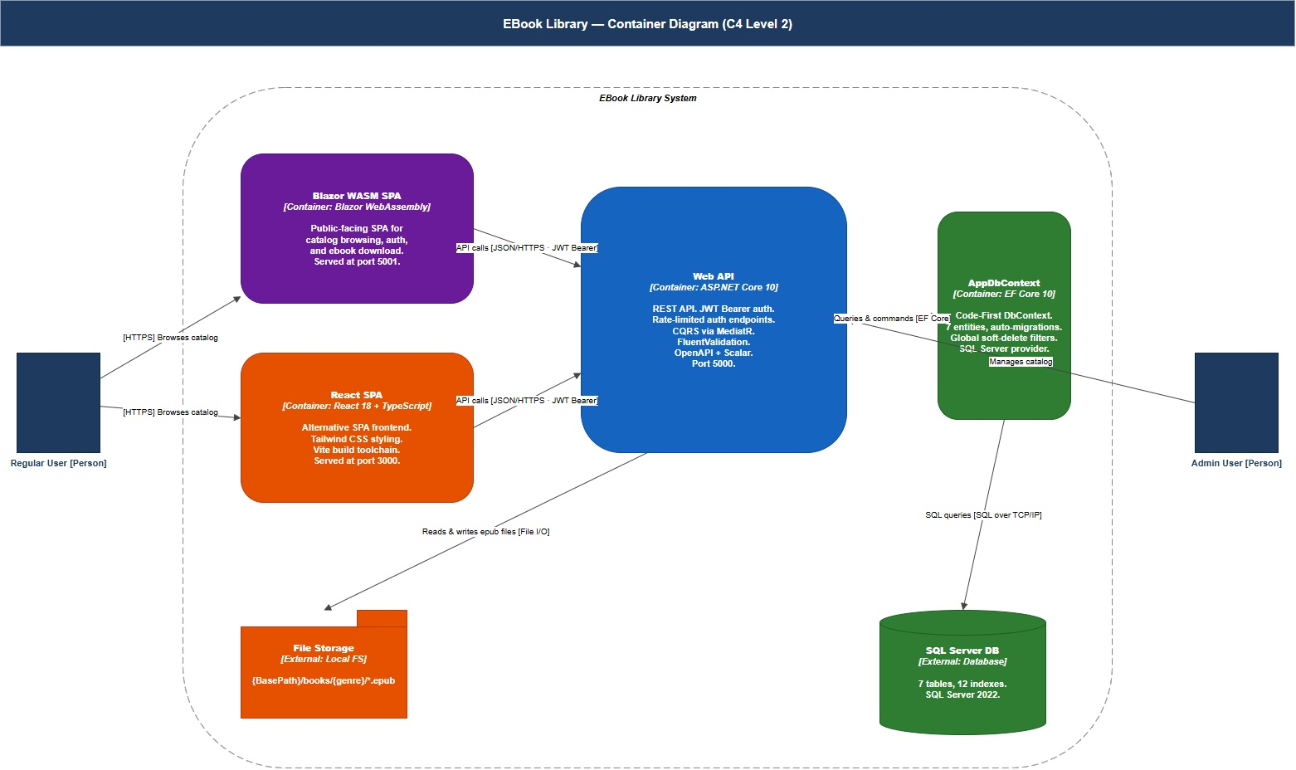
Figure 1.1 — High-level container diagram of the EBook Library system.
Three observations to carry into Chapter 2:
- The API is the single entry point to all business behavior. Both frontends speak to it over HTTP with JSON, and both rely on it for authentication.
- The backend is layered internally. Controllers in the Web API forward work to the Application layer; Application orchestrates business behavior through the Domain layer; Infrastructure provides the implementations that bridge the abstract Domain and the concrete database and file system.
- The dependency arrows in Figure 1.1 only point one way per pair. This is the dependency rule, the most important rule in the book. It is so important that all of § 2.2 is dedicated to it.

1.5 The data: 51,599 real books
The catalog you will seed in Chapter 9 is not a synthetic dataset. It comes from three HTML export files (lista_autor.html, lista_generos.html, lista_titulo.html) carrying metadata for 51,599 Spanish-language books across 128 genres. A small console application (EBookLibrary.Seeder) parses these files and bulk-inserts the records into SQL Server.
This decision matters more than it looks. Real data behaves differently from random data: queries return interesting results, search exposes tokenization edge cases, and the UI looks like a real bookstore rather than a placeholder. The first time you scroll through the React catalog and see real titles by Cervantes, García Márquez, and Borges, the application stops feeling like a tutorial.
PITFALL
It is tempting, when seeding a development database, to generate random strings (“Book 1”, “Book 2”, …). This works for unit tests but is actively misleading during manual testing. Random data does not stress the layout, does not test sort orders, does not exercise filter facets, and gives you false confidence that the UI is “done” when in fact it has never been tried with realistic content.

1.6 Manual versus AI-assisted construction
The repository accompanying this book contains two implementations of the same project, side by side:
- Manual/ — written by hand, file by file.
- Automatic/ — scaffolded with GitHub Copilot using structured prompt documents.
Both are complete enough to run. Chapter 14 returns to this experiment in detail, comparing what AI assistance accelerated, what it generated incorrectly, and where human judgment was irreplaceable. The 🤖 symbol in later chapters marks short notes connecting the chapter material to that larger comparison.
Architect’s Note: The reason both implementations are kept in the repository is not to argue that one is “better”. It is to make the delta visible. A book describing only the AI-generated version would conceal the corrections that were made to it. A book describing only the manual version would conceal the speedup. The interesting data is the difference, and you can read both versions of any file at any time.

1.7 Setting up the development environment
The remainder of this chapter prepares your laptop. Chapter 2 begins with dotnet new sln; everything below must be in place first.

Prerequisites
Tool | Required version | Where
.NET SDK | 10.0+ | https://dotnet.microsoft.com/download/dotnet/10.0
Node.js | 20 LTS or newer | https://nodejs.org
SQL Server | 2022 Developer | https://www.microsoft.com/sql-server/sql-server-downloads
Visual Studio Code | latest | https://code.visualstudio.com
Git | any recent | https://git-scm.com
Listing 1.1 — Verifying your installations.
dotnet --version # → 10.x.x
node --version # → v20.x.x or higher
npm --version # → 10.x.x or higher
git --version # any recent version
Get-Service -Name "MSSQLSERVER" | Select-Object Status # → Running

EF Core CLI tool
The EF Core command-line tool (dotnet ef) is installed once globally and used for migrations from Chapter 9 onward.
Listing 1.2 — Installing the EF Core CLI.
dotnet tool install --global dotnet-ef
dotnet ef --version # → 10.x.x

VS Code extensions
The book assumes Visual Studio Code as the primary editor. The following extensions cover the entire stack.
Listing 1.3 — One-line install of the recommended VS Code extensions.
code --install-extension ms-dotnettools.csdevkit
code --install-extension esbenp.prettier-vscode
code --install-extension bradlc.vscode-tailwindcss
code --install-extension humao.rest-client
code --install-extension bierner.markdown-mermaid
IN PRACTICE
Engineering teams that share an editor configuration commit a .vscode/extensions.json file to the repository so that VS Code prompts new contributors to install the same extensions on first open. The reference implementation in this book follows that practice.

1.8 Checkpoint
You are ready for Chapter 2 when you can answer “yes” to all of the following:
- You can describe what the application does in one sentence without consulting the book.
- You can name the four layers of the backend (Web API, Application, Domain, Infrastructure) and the direction of dependencies between them.
- You have run all five commands in Listing 1.1 and seen the expected output.
- dotnet ef --version reports 10.x.x.
- At least one of the two frontends (React or Blazor) is one you have heard of and can write a “hello world” in.

Key takeaways
- The EBook Library is a deliberately small but realistic project that surfaces the engineering decisions a to-do app cannot.
- The technology stack is conventional for a 2026-era greenfield .NET project; every choice has at least one reasonable alternative.
- Two complete frontends consume the same API, which makes the project a controlled comparison study.
- The seed dataset is real, not synthetic; this matters more than it appears.
- A manual and an AI-assisted implementation coexist in the repository; Chapter 14 returns to that comparison.

Exercises
Easy. Open the folder Automatic/EBookLibrary/ in the accompanying repository and list the projects under src/ and tests/. Predict, for each project, which other projects it should reference. You will check your answer at the end of Chapter 2.
Medium. From the feature inventory in Table 1.1, draw a one-page sketch of the screens you would build in a frontend to expose all of them. Decide which features belong to public pages, authenticated pages, and admin pages. (Compare your sketch with Chapter 10 when you reach it.)
Hard. Pick one technology choice in § 1.3 — JWT, EF Core, MediatR, React, or Blazor — and write a one-page memo arguing for the strongest reasonable alternative. The exercise is not to adopt the alternative but to articulate it convincingly. This exercise is the entry-level version of the design memos that Architecture Decision Records (Appendix C) exist to capture.

Further reading
- Robert C. Martin, Clean Architecture: A Craftsman’s Guide to Software Structure and Design. The book that named the pattern this project uses.
- Simon Brown, The C4 Model for Visualising Software Architecture. The diagramming notation used in Chapter 2 and reused throughout the book. Free online at https://c4model.com.
- Microsoft, .NET Application Architecture Guides. https://docs.microsoft.com/dotnet/architecture/
- Adam Wathan, Refactoring UI. A practical companion when you reach the React frontend in Chapter 10.

Chapter 2 — Architecture Deep Dive
“Architecture is the decisions that are hard to change. Make them consciously.”

What you will learn
- The two competing organizing forces in any layered architecture (frameworks pulling outward, business rules pulling inward) and how Clean Architecture resolves them.
- The dependency rule and how it is enforced in this project at the .csproj level.
- The four levels of the C4 model and how to read each one.
- CQRS as practiced in this project, why it improves testability, and what its costs are.
- The six architectural decisions that shape every later chapter, the alternatives that were considered, and the rationale for each choice.

2.1 The problem layered architecture is trying to solve
A traditional three-tier architecture is the first one most engineers learn:
Controller → Service → Repository → Database
It works adequately for small applications. As the project grows, three problems appear in succession:
- The service layer becomes a god class. Read methods, write methods, file uploads, password hashing, and notification sending end up in the same class because there is nowhere else to put them.
- The service layer cannot be tested without a database. It imports the ORM directly, which means a unit test of business logic requires a real DbContext and a real connection.
- Changing infrastructure ripples upward. Switching from SQL Server to PostgreSQL, or from cookie auth to JWT, requires editing service classes that should not have known about either.
These three problems share a single root cause: dependencies point the wrong way. The controller depends on a service that depends on a repository that depends on the database. The thing that should change least often (business behavior) is being held hostage by the thing that changes most often (the framework, the database, the auth mechanism).
Clean Architecture inverts this. The inner layers — the parts that encode the business — define interfaces. The outer layers — the parts that contain the technology — implement those interfaces. The arrow of dependency, in source code, points inward.

2.2 Clean Architecture — the four layers
Figure 2.1 shows the four layers of Clean Architecture as practiced in this project. The rendering style is Simon Brown’s; the substance is Robert Martin’s.
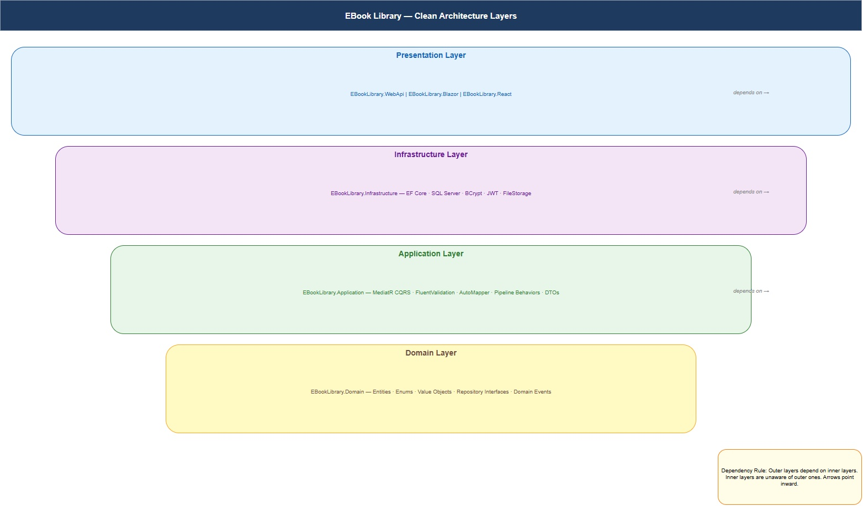
Figure 2.1 — Clean Architecture layers as implemented in EBook Library.
The four layers, from the inside out:
- Domain. Entities, value objects, enumerations, repository interfaces (not implementations), and domain events. Pure C#, zero external NuGet packages. The Domain layer would compile if every other project in the solution were deleted.
- Application. CQRS handlers, validators, DTOs, AutoMapper profiles, pipeline behaviors, and the interfaces for any infrastructure service the handlers need (IJwtService, IUnitOfWork, IPasswordHasher, IFileStorage). References Domain only.
- Infrastructure. EF Core DbContext and configurations, repository implementations, JWT token generation, BCrypt password hashing, file storage. Implements the interfaces declared by Application; references Application and Domain.
- Web API. Controllers, middleware, the response envelope, authentication setup, OpenAPI configuration. References Application and Infrastructure (the latter only for dependency-injection registration in Program.cs).

The dependency rule
Source code dependencies must point inward. Nothing in an inner circle can know about something in an outer circle.
This single rule is the difference between Clean Architecture and any other layered scheme. Table 2.1 makes it concrete for this project.
Table 2.1 — What each layer can and cannot reference.
Layer | May reference | May not reference
Domain | Nothing (pure .NET BCL) | Application, Infrastructure, Web API
Application | Domain | Infrastructure, Web API
Infrastructure | Application, Domain | Web API
Web API | Application, Infrastructure | (none — it is the outermost)
The rule is enforced by .csproj project references rather than by convention. If you accidentally try to reference EF Core from the Application project, the build fails. Figure 2.2 shows the resulting dependency graph.
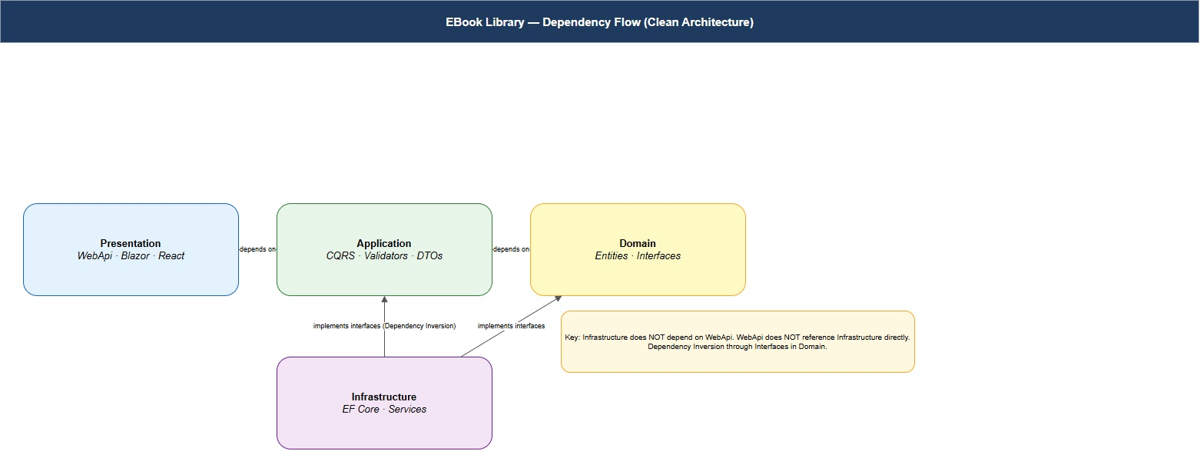
Figure 2.2 — Dependency flow between projects, enforced by .csproj references.

Why this matters in practice
The payoff of obeying the dependency rule is concentrated in two places:
- Unit tests. Application handlers depend only on interfaces from Domain. To test a handler, you mock its dependencies and instantiate the handler directly. No WebApplicationFactory, no in-memory EF Core provider, no fixtures. Chapter 12 shows hundreds of these tests; each runs in milliseconds.
- Substitutability. The decision to use SQL Server lives in exactly one line of Infrastructure/DependencyInjection.cs. The decision to use BCrypt lives in one file. The decision to use JWT lives in two. Replacing any of them does not require touching Application, Domain, or any handler.
Architect’s Note: Clean Architecture is not the only way to achieve these properties. Hexagonal (Cockburn) and Onion (Palermo) are close cousins and produce the same dependency graph by slightly different vocabulary. Vertical Slice Architecture (Bogard) takes the same primitives and re-organizes them by feature instead of by layer, trading one form of duplication for another. Pick one and use it; do not invent a fourth.
PITFALL
The single most common mistake in newly-adopted Clean Architecture codebases is leaking the ORM into Application by typing a handler as IQueryable<Book> or by depending on EF Core’s Include(). The leak is small and usually defended on grounds of performance. It will compound until your “Application” layer is in fact a thin layer of EF Core wrappers, and then the architecture is no longer doing any work for you.

2.3 The project structure
Listing 2.1 shows the directory layout that results from obeying the rules above. Chapter 3 will create it; Chapters 4–11 will fill it in.
Listing 2.1 — Solution layout.
EBookLibrary/
├── src/
│ ├── EBookLibrary.Domain/ ← zero NuGet dependencies
│ ├── EBookLibrary.Application/ ← MediatR, FluentValidation, AutoMapper
│ ├── EBookLibrary.Infrastructure/ ← EF Core, BCrypt, JWT
│ ├── EBookLibrary.WebApi/ ← ASP.NET Core 10 controllers
│ ├── EBookLibrary.React/ ← Vite + React 18 + TypeScript
│ └── EBookLibrary.Blazor/ ← Blazor WebAssembly
├── tests/
│ ├── EBookLibrary.Domain.Tests/
│ ├── EBookLibrary.Application.Tests/
│ ├── EBookLibrary.WebApi.Tests/
│ └── EBookLibrary.E2E.Tests/ ← Playwright browser tests
└── scripts/
└── EBookLibrary.Seeder/ ← data seeding console application
Two observations are worth making before you scroll past:
- The two frontends live alongside the backend in src/. They are full members of the solution, not sub-modules.
- There are four test projects, one per backend layer plus an E2E project. The split mirrors the dependency graph: Domain tests have no infrastructure, WebApi tests use WebApplicationFactory, and the E2E project uses Playwright to drive a real browser.

2.4 CQRS — separating reads from writes
CQRS — Command Query Responsibility Segregation — is the second architectural choice that pervades the project. It is independent of Clean Architecture (you can have one without the other) but the two combine well.
The idea is simple: write operations and read operations are different enough that they should not share a class. A write changes state, returns a result that confirms the change, and is usually invoked once per user action. A read does not change state, returns data suitable for rendering, and may be invoked many times per page.
FOUNDATIONS
A handler in MediatR is a class with a single method, conventionally named Handle, that takes one request object as its argument and returns one response. The handler is instantiated by the dependency-injection container; the request object is a plain C# class with no behavior. The mediator looks up the handler for a given request type and invokes it. That is the entire library.

The shape of a CQRS handler
In this project, every API operation is exactly one of:
- A command (writes) — RegisterUserCommand, LoginUserCommand, CreateBookCommand, UpdateBookCommand, DeleteBookCommand, DownloadBookCommand, UploadBookFileCommand.
- A query (reads) — SearchBooksQuery, GetBookByIdQuery, GetAuthorByIdQuery, GetUsersPagedQuery, …
Each one has exactly one handler class. Listing 2.2 sketches the shape; Chapter 5 walks the implementation in detail.
Listing 2.2 — Shape of a typical command handler.
public sealed class CreateBookCommand : IRequest<Guid>
{
public string Title { get; init; } = "";
public Guid[] AuthorIds { get; init; } = Array.Empty<Guid>();
public Guid[] GenreIds { get; init; } = Array.Empty<Guid>();
}
public sealed class CreateBookCommandHandler
: IRequestHandler<CreateBookCommand, Guid>
{
private readonly IUnitOfWork _uow;
public CreateBookCommandHandler(IUnitOfWork uow) => _uow = uow;
public async Task<Guid> Handle(CreateBookCommand cmd, CancellationToken ct)
{
var book = Book.Create(cmd.Title, BookLanguage.Spanish);
// (… link authors and genres …)
await _uow.Books.AddAsync(book, ct);
await _uow.SaveChangesAsync(ct);
return book.Id;
}
}
The controller does not have to know any of this. It accepts an HTTP request, builds the command, and calls mediator.Send(command). That single line is the boundary between the API and the application.

The MediatR pipeline
MediatR supports pipeline behaviors, which are the CQRS equivalent of ASP.NET Core middleware: classes that wrap every handler invocation, running before and after. This project ships two:
- LoggingBehavior — logs the request type, the user (if any), and the elapsed milliseconds.
- ValidationBehavior — runs the FluentValidation validator registered for the request type and throws a ValidationException if the request is invalid, before the handler ever runs.
Cross-cutting concerns therefore live in one place each, not in every handler.
IN PRACTICE
The same engineering instinct that suggests adding a behavior for “auditing” or “authorization” is correct, up to a point. Past three or four behaviors the pipeline becomes a place where behavior hides. The project deliberately keeps it short.

2.5 The C4 model
The diagrams in this book follow Simon Brown’s C4 model, which describes a software system at four levels of abstraction. Think of it as Google Maps for architecture: each level zooms in.

Level 1 — System Context
Who uses the system, and what external systems does it talk to?
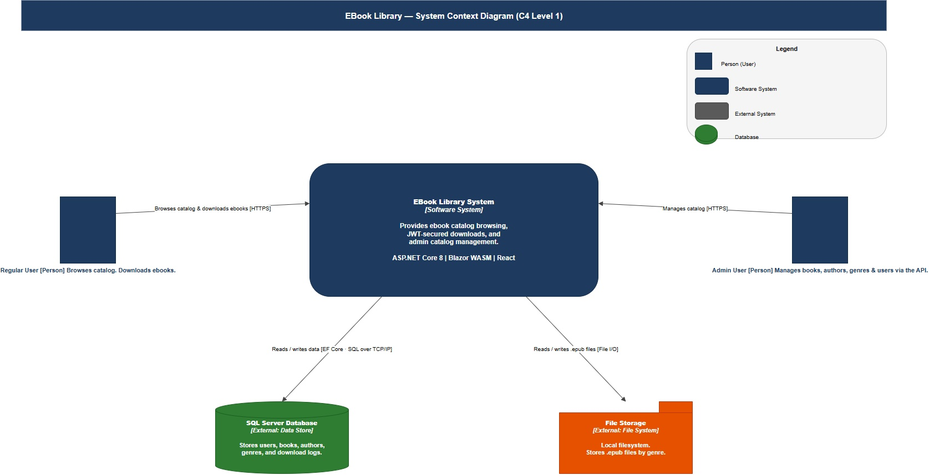
Figure 2.3 — System Context diagram.

Level 2 — Container
What deployable units make up the system? This is the diagram you already saw in § 1.4 (Figure 1.1). It is reproduced here at full size because it is the diagram you will refer back to most often.

Figure 2.4 — Container diagram (re-shown from Chapter 1).

Level 3 — Component (Web API)
What components live inside the Web API container?
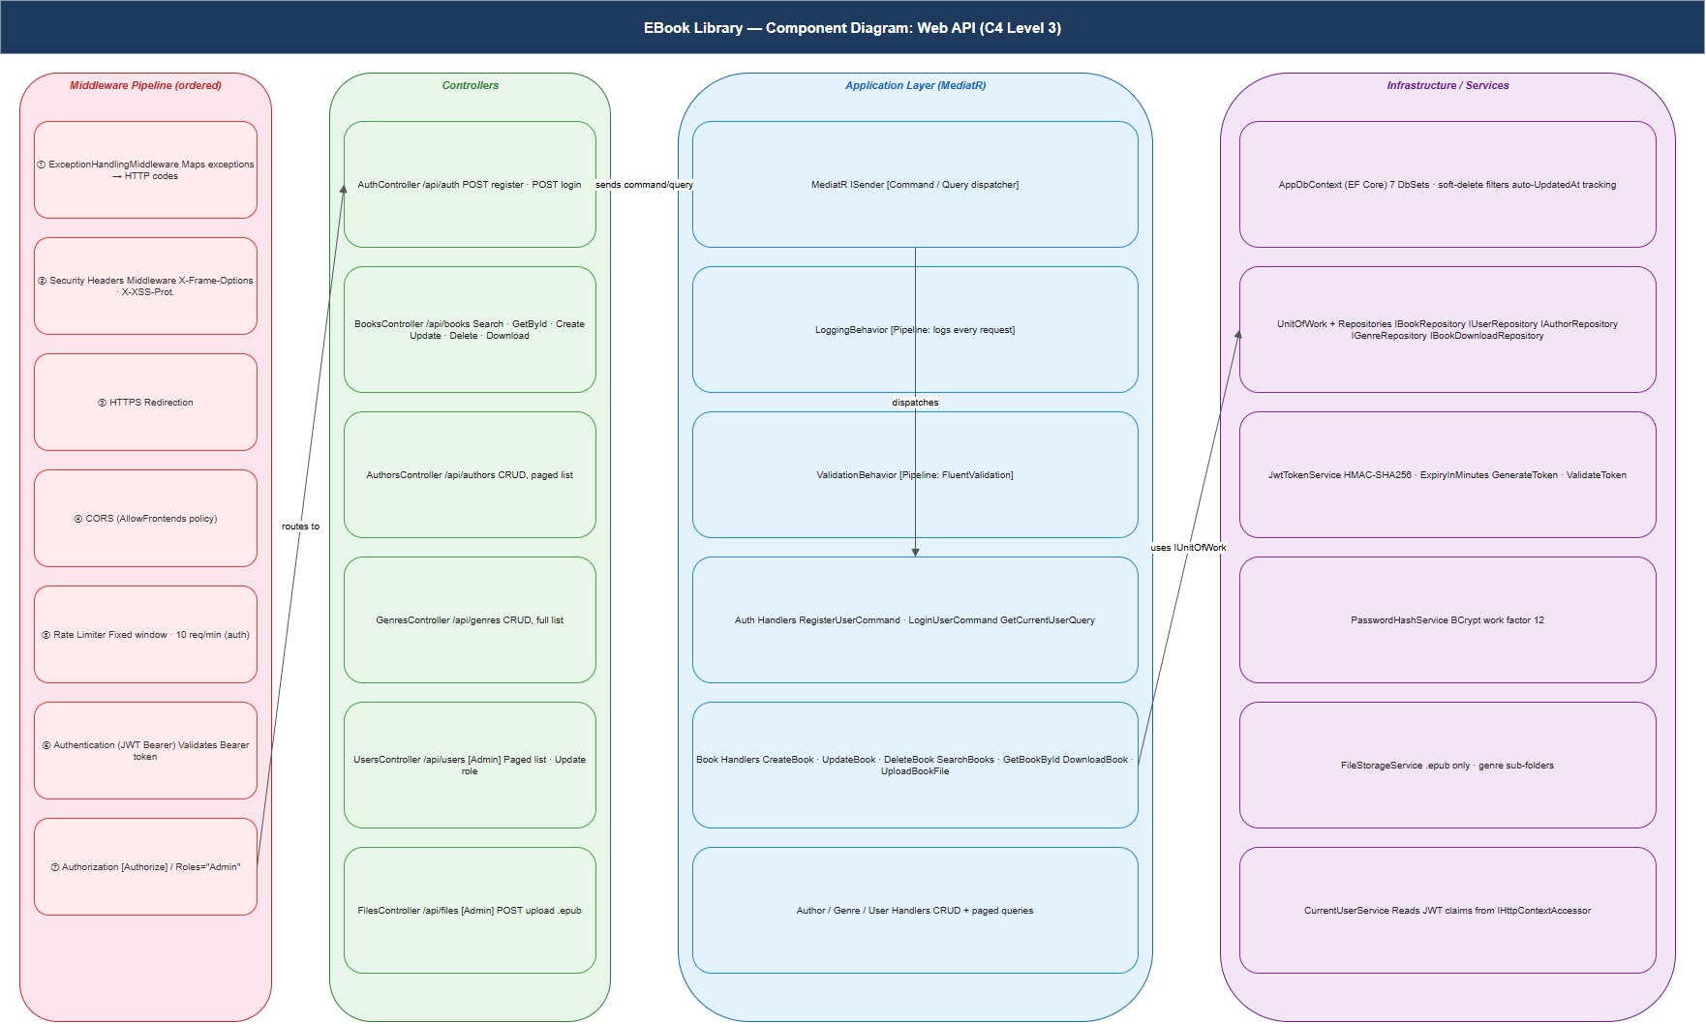
Figure 2.5 — Component diagram of the Web API.

Level 4 — Code (Domain)
What classes live inside the Domain layer? Notice that this diagram shows only BaseEntity, the core entities, and the join entities. Value objects and domain events are introduced where they are first used.
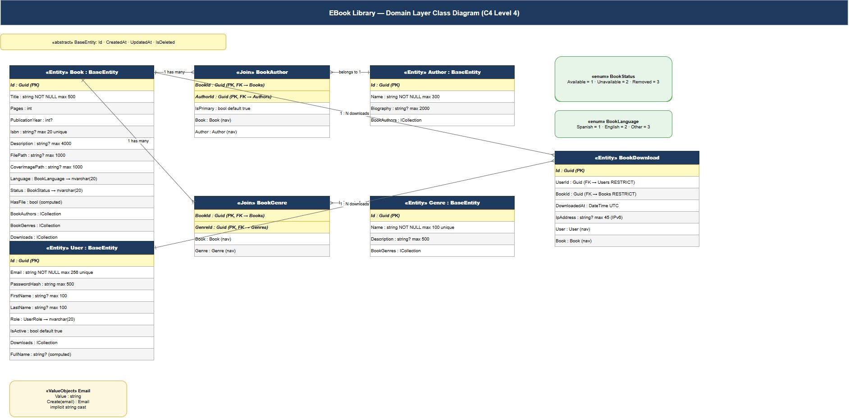
Figure 2.6 — Class diagram of the Domain layer.
FOUNDATIONS
You do not need to memorize the C4 levels. What you need is the habit of asking, when reviewing or producing a diagram, “at what level of zoom is this?” Most of the unhelpful diagrams in production codebases mix levels: a single picture showing both deployable units and individual class methods. Pick a level and stay there.

2.6 Six architectural decisions
The remainder of this chapter names the six architectural decisions that shape this codebase. Each one names the choice, the alternative that was considered, and the rationale. Architecture Decision Records for each appear in Appendix C; this section is the one-paragraph summary.

Decision 1 — Controller-based API, not Minimal APIs
ASP.NET Core 10 supports two ways of declaring endpoints: classic MVC controllers and the newer Minimal APIs (top-level endpoint maps in Program.cs). The project uses controllers. Minimal APIs are excellent for small, focused services with a handful of endpoints. With eight controllers, role-based authorization, and attribute-based OpenAPI metadata, classic controllers carry their weight.

Decision 2 — Soft delete, not hard delete
Every entity inherits from BaseEntity, which carries an IsDeleted flag and a DeletedAt timestamp. EF Core global query filters automatically add WHERE IsDeleted = 0 to every read. The alternative — removing rows entirely — was rejected because users may have downloaded a book that an administrator later “deletes”, and the foreign-key chain would break. Soft delete preserves referential integrity without exposing deleted rows to normal queries.

Decision 3 — Repository + Unit of Work over direct DbContext
Application handlers depend on IUnitOfWork, which exposes one repository property per entity and one SaveChangesAsync() method. The alternative — injecting AppDbContext directly — would have coupled the Application layer to EF Core. The cost of the abstraction is a few additional interface declarations; the benefit is that Application can be unit-tested with hand-built fakes or Moq.

Decision 4 — Stateless JWT, no refresh tokens in v1
JWT tokens issued at login expire after sixty minutes. There is no refresh-token mechanism. The alternative — refresh tokens, typically backed by Redis or a database table — was rejected as out of scope for v1. It is the most natural Chapter 8 follow-on exercise (Appendix B, exercise 8.H).

Decision 5 — JWT in localStorage, not httpOnly cookies
The React and Blazor frontends store the JWT in browser localStorage. The alternative — httpOnly cookies — is more secure against XSS but requires CSRF protection and complicates the cross-origin request flow during local development. The trade-off is documented in code; § 8.6 spells it out.
PITFALL
Do not adopt the localStorage pattern in a public-facing production application without first evaluating the XSS exposure of your codebase. The right answer for production is almost always httpOnly cookies. The codebase chooses localStorage because it is a learning project, not because it is the right default.

Decision 6 — Database-agnostic by construction
Only one file in the entire codebase mentions SQL Server: Infrastructure/DependencyInjection.cs, where UseSqlServer(connectionString) is registered. Switching to PostgreSQL is one line: UseNpgsql(connectionString). This is not a value judgment about either database; it is a side effect of putting all infrastructure decisions in one place.

2.7 The end-to-end request flow
To make the architecture tangible before Chapter 3 begins, Figure 2.7 traces a single request — GET /api/books/search?title=cervantes — through every layer.
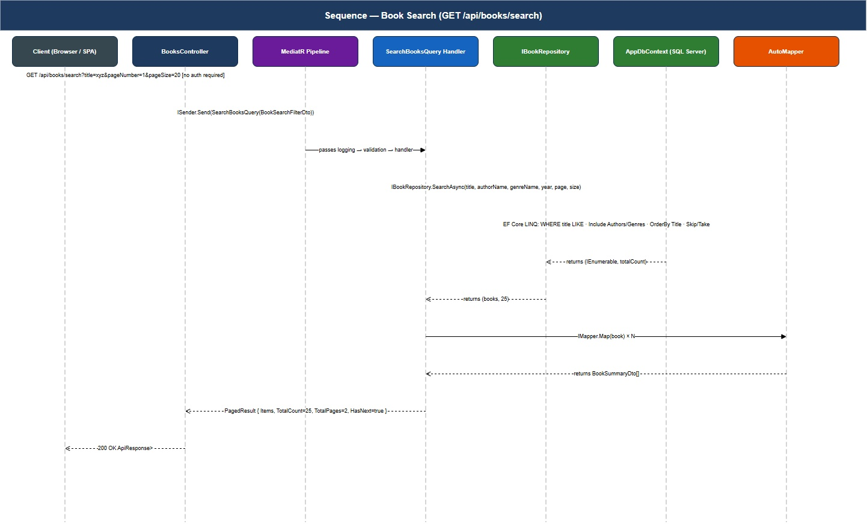
Figure 2.7 — End-to-end sequence for a book search.
Notice that no single layer in the diagram has more than one job: the controller maps HTTP to a query, the mediator dispatches it, the validation behavior validates it, the handler orchestrates it, the repository queries through EF Core, EF Core compiles to SQL, SQL Server returns rows, and the response unwinds back through the same path. If any one of these steps becomes inaccurate over time, you change exactly one file.

2.8 Checkpoint
You are ready for Chapter 3 when you can:
- Explain why the Domain layer has zero NuGet dependencies, in one sentence, without consulting the book.
- State the dependency rule and name which layers may reference which.
- Describe what CQRS is and why it improves testability over a thicker service layer.
- Read Figure 2.7 from top to bottom and name what each layer does.
- Name the six architectural decisions in § 2.6 and the alternative considered for each.

Key takeaways
- Clean Architecture inverts dependencies so that business rules sit at the center and infrastructure sits at the edges. The dependency rule is enforced by .csproj references, not convention.
- CQRS, implemented via MediatR, separates write operations from read operations into one handler per operation. Each handler is trivial to unit test.
- The C4 model gives you four levels of zoom (Context, Container, Component, Code) and a habit of asking “at what level is this diagram?”.
- Six architectural decisions in this codebase have alternatives that would also have been correct in different circumstances. Knowing the alternatives is what distinguishes “doing Clean Architecture” from “having read about Clean Architecture”.

Exercises
Easy. For each layer in Table 2.1, name one NuGet package that should not appear in that layer’s .csproj. Verify your answers against the actual .csproj files in Automatic/EBookLibrary/src/.
Medium. Pick one of the six decisions in § 2.6 and write a counter-argument: what circumstances would make the opposite choice correct? (For example, when would refresh tokens be the right answer? When would hard delete be safer than soft?) The exercise trains the muscle of holding both sides of an architectural decision in your head.
Hard. Re-draw Figure 2.1 from memory after closing the book. Then re-draw Figure 2.7 from memory. Compare your two drawings to the originals. The places where you got the diagram wrong are the places the architecture is not yet intuitive — re-read the corresponding section.

Further reading
- Robert C. Martin, Clean Architecture — Chapters 22 (The Clean Architecture) and 32 (The Dependency Rule).
- Alistair Cockburn, “Hexagonal Architecture” (2005). The original port-and-adapter formulation. https://alistair.cockburn.us/hexagonal-architecture/
- Jeffrey Palermo, “The Onion Architecture” (2008).
- Jimmy Bogard, “Vertical Slice Architecture”. The strongest alternative to Clean Architecture for application code.
- Simon Brown, Software Architecture for Developers, Vol. 2 — the C4 model in book form. The free version of the model lives at https://c4model.com.
- Greg Young, “CQRS Documents by Greg Young” — the original CQRS long-form essay.

Chapter 3 — Solution Setup
“A well-structured solution is readable before a single line of business code is written.”

What you will learn
- How to scaffold all ten projects in the EBook Library solution from the .NET CLI.
- The role of global.json and Directory.Build.props and why both are worth a few minutes of attention.
- Which NuGet packages belong in which layer, and why the Domain layer has none.
- How to verify that the dependency rule from Chapter 2 is enforced by your .csproj references.
- How to scaffold the React frontend with the correct, version-pinned dependencies.
By the end of this chapter the solution will compile, build with zero errors, and contain no business logic. That is the point: the scaffolding has to be right before the building begins.

3.1 The end-state to aim at
Before running any commands, fix the target structure in your head. Listing 3.1 is identical to Listing 2.1 in the previous chapter; it is worth re-reading.
Listing 3.1 — Solution layout (target).
EBookLibrary/
├── EBookLibrary.sln
├── global.json ← pins the .NET SDK version
├── Directory.Build.props ← shared MSBuild properties
│
├── src/
│ ├── EBookLibrary.Domain/
│ ├── EBookLibrary.Application/
│ ├── EBookLibrary.Infrastructure/
│ ├── EBookLibrary.WebApi/
│ ├── EBookLibrary.Blazor/
│ └── EBookLibrary.React/
│
├── tests/
│ ├── EBookLibrary.Domain.Tests/
│ ├── EBookLibrary.Application.Tests/
│ ├── EBookLibrary.WebApi.Tests/
│ └── EBookLibrary.E2E.Tests/
│
└── scripts/
└── EBookLibrary.Seeder/
Ten projects in total: six source projects, four test projects, and one seeder console application.

3.2 Step 1 — Create the solution and the shared MSBuild files
Listing 3.2 — Creating the solution and entering it.
mkdir EBookLibrary
cd EBookLibrary
dotnet new sln -n EBookLibrary

Pinning the .NET SDK version
A team of more than one engineer needs to agree on which SDK builds the solution. global.json does that.
Listing 3.3 — global.json at the solution root.
{
"sdk": {
"version": "10.0.100",
"rollForward": "latestMinor"
}
}
rollForward: latestMinor reads as use SDK 10.0.x or higher, but stay on major version 10. This protects against an accidental upgrade to .NET 11 while still allowing patch releases.
PITFALL
Without global.json, your build is at the mercy of whichever SDK happens to be installed on each engineer’s machine, which is also the SDK CI happened to install last week. The first symptom is “works on my machine”; the second is a Friday-afternoon emergency upgrade.

Shared MSBuild properties
Every .csproj in the solution should target the same framework, opt in to nullable reference types, and enable implicit usings. Directory.Build.props declares those defaults once.
Listing 3.4 — Directory.Build.props at the solution root.
<Project>
<PropertyGroup>
<TargetFramework>net10.0</TargetFramework>
<Nullable>enable</Nullable>
<ImplicitUsings>enable</ImplicitUsings>
<LangVersion>preview</LangVersion>
<TreatWarningsAsErrors>false</TreatWarningsAsErrors>
<Optimize Condition="'$(Configuration)'=='Release'">true</Optimize>
</PropertyGroup>
</Project>
FOUNDATIONS
Implicit usings automatically include common namespaces (System, System.Collections.Generic, System.Linq, …) so you do not need a using System; at the top of every file. Nullable reference types causes the compiler to treat string as non-nullable; to allow null you write string? explicitly. Both features have been on by default in new project templates for several .NET releases; both can be disabled per-project if needed.

3.3 Step 2 — Create the projects
The order does not matter; the dotnet new commands are independent.
Listing 3.5 — Creating the backend projects.
dotnet new classlib -n EBookLibrary.Domain -o src/EBookLibrary.Domain
dotnet new classlib -n EBookLibrary.Application -o src/EBookLibrary.Application
dotnet new classlib -n EBookLibrary.Infrastructure -o src/EBookLibrary.Infrastructure
dotnet new webapi -n EBookLibrary.WebApi -o src/EBookLibrary.WebApi --use-controllers
dotnet new blazorwasm -n EBookLibrary.Blazor -o src/EBookLibrary.Blazor
PITFALL
The --use-controllers flag on the webapi template is easy to forget. Without it you get a Minimal API skeleton, not a controller-based one, and § 7.2 of this book will not match what is on your screen.
Listing 3.6 — Creating the test projects.
dotnet new xunit -n EBookLibrary.Domain.Tests -o tests/EBookLibrary.Domain.Tests
dotnet new xunit -n EBookLibrary.Application.Tests -o tests/EBookLibrary.Application.Tests
dotnet new xunit -n EBookLibrary.WebApi.Tests -o tests/EBookLibrary.WebApi.Tests
dotnet new nunit -n EBookLibrary.E2E.Tests -o tests/EBookLibrary.E2E.Tests
Architect’s Note: The E2E test project uses NUnit, not xUnit. Microsoft’s Playwright integration leans heavily on NUnit’s [SetUpFixture] and [OneTimeSetUp] lifecycle hooks for booting and tearing down the test web server. xUnit’s collection fixtures can be made to work but require more ceremony. Mixing test frameworks in one solution is unusual; it is justified here.
Listing 3.7 — Creating the seeder console application.
dotnet new console -n EBookLibrary.Seeder -o scripts/EBookLibrary.Seeder

The React frontend
The React project is created with Vite, which is the present default scaffolder for new React + TypeScript projects. The full dependency list appears below; do not run the install commands yet — read the pitfall first.
Listing 3.8 — Creating the React frontend.
cd src
npm create vite@latest EBookLibrary.React -- --template react-ts
cd EBookLibrary.React
# Core
npm install react-router-dom@6 axios @tanstack/react-query zustand
# Internationalization
npm install i18next react-i18next i18next-browser-languagedetector
# Tailwind CSS — pin to v3 explicitly
npm install -D tailwindcss@3 postcss autoprefixer @tailwindcss/typography
npx tailwindcss init -p
# Forms
npm install react-hook-form @hookform/resolvers zod
# UI utilities
npm install @headlessui/react @heroicons/react clsx
# Dev typings
npm install -D @types/node
cd ../..
PITFALL
Install tailwindcss@3 explicitly. A bare npm install tailwindcss resolves to v4, which uses a completely different configuration format. The tailwind.config.js shown in Chapter 10 is a v3 file; on v4 it will not work, and the error messages do not point at the version mismatch. This is the single most common setup error in the entire project.

3.4 Step 3 — Register the projects with the solution
dotnet sln add makes the solution aware of each project. The order does not matter.
Listing 3.9 — Registering all ten projects.
# Source projects
dotnet sln add src/EBookLibrary.Domain/EBookLibrary.Domain.csproj
dotnet sln add src/EBookLibrary.Application/EBookLibrary.Application.csproj
dotnet sln add src/EBookLibrary.Infrastructure/EBookLibrary.Infrastructure.csproj
dotnet sln add src/EBookLibrary.WebApi/EBookLibrary.WebApi.csproj
dotnet sln add src/EBookLibrary.Blazor/EBookLibrary.Blazor.csproj
# Tests
dotnet sln add tests/EBookLibrary.Domain.Tests/EBookLibrary.Domain.Tests.csproj
dotnet sln add tests/EBookLibrary.Application.Tests/EBookLibrary.Application.Tests.csproj
dotnet sln add tests/EBookLibrary.WebApi.Tests/EBookLibrary.WebApi.Tests.csproj
dotnet sln add tests/EBookLibrary.E2E.Tests/EBookLibrary.E2E.Tests.csproj
# Seeder
dotnet sln add scripts/EBookLibrary.Seeder/EBookLibrary.Seeder.csproj
dotnet sln list # → expect 10 projects listed
The React project does not appear in dotnet sln list — Vite projects are not part of the .NET solution by design.

3.5 Step 4 — Configure project references
This is the step where the dependency rule from Chapter 2 stops being a diagram and starts being enforced by the build.
Listing 3.10 — Linking the backend project references.
# Application → Domain
dotnet add src/EBookLibrary.Application reference `
src/EBookLibrary.Domain/EBookLibrary.Domain.csproj
# Infrastructure → Application
dotnet add src/EBookLibrary.Infrastructure reference `
src/EBookLibrary.Application/EBookLibrary.Application.csproj
# WebApi → Application + Infrastructure
dotnet add src/EBookLibrary.WebApi reference `
src/EBookLibrary.Application/EBookLibrary.Application.csproj
dotnet add src/EBookLibrary.WebApi reference `
src/EBookLibrary.Infrastructure/EBookLibrary.Infrastructure.csproj
Listing 3.11 — Linking the test project references.
dotnet add tests/EBookLibrary.Domain.Tests reference `
src/EBookLibrary.Domain/EBookLibrary.Domain.csproj
dotnet add tests/EBookLibrary.Application.Tests reference `
src/EBookLibrary.Application/EBookLibrary.Application.csproj
dotnet add tests/EBookLibrary.WebApi.Tests reference `
src/EBookLibrary.WebApi/EBookLibrary.WebApi.csproj
After running these, EBookLibrary.WebApi.csproj should look exactly like Listing 3.12. Notice that it does not directly reference Domain. Domain types are reachable through Application; the layers in between exist precisely to keep the API layer from depending on them directly.
Listing 3.12 — EBookLibrary.WebApi.csproj after linking.
<Project Sdk="Microsoft.NET.Sdk.Web">
<ItemGroup>
<ProjectReference Include="..\EBookLibrary.Application\EBookLibrary.Application.csproj" />
<ProjectReference Include="..\EBookLibrary.Infrastructure\EBookLibrary.Infrastructure.csproj" />
</ItemGroup>
</Project>
PITFALL
It is tempting, on first scaffolding, to add a Domain reference to WebApi “to make a controller compile faster”. Don’t. Once the reference exists, controllers will start using Domain types directly, and the abstraction the Application layer is supposed to provide stops doing any work. Spend the extra minute to add the required Application DTO instead.

3.6 Step 5 — Install NuGet packages
The package list per layer is shown below. The Domain project has none.

Domain — zero packages
The cleanest first commit you can make on this project is to delete the default Class1.cs files from each class library and check in the empty projects.
Listing 3.13 — Removing the default Class1.cs placeholders.
Remove-Item src/EBookLibrary.Domain/Class1.cs
Remove-Item src/EBookLibrary.Application/Class1.cs
Remove-Item src/EBookLibrary.Infrastructure/Class1.cs
Architect’s Note: “Why zero NuGet dependencies in Domain?” If Domain depended on EF Core, the Domain test project would need EF Core to compile. If it depended on MediatR, swapping mediator libraries would require touching domain entities. The discipline of keeping Domain dependency-free pays its largest dividend the day someone proposes replacing one of those libraries.

Application
Listing 3.14 — Application layer NuGet packages.
cd src/EBookLibrary.Application
dotnet add package MediatR
dotnet add package FluentValidation.DependencyInjectionExtensions
dotnet add package AutoMapper
dotnet add package Microsoft.Extensions.DependencyInjection.Abstractions
dotnet add package Serilog.AspNetCore

Infrastructure
Listing 3.15 — Infrastructure layer NuGet packages.
cd ../EBookLibrary.Infrastructure
dotnet add package Microsoft.EntityFrameworkCore.SqlServer
dotnet add package Microsoft.EntityFrameworkCore.Tools
dotnet add package BCrypt.Net-Next
dotnet add package Microsoft.IdentityModel.Tokens
dotnet add package System.IdentityModel.Tokens.Jwt
dotnet add package Microsoft.AspNetCore.Authentication.JwtBearer
dotnet add package Microsoft.Extensions.Configuration.Abstractions

Web API
Listing 3.16 — Web API layer NuGet packages.
cd ../EBookLibrary.WebApi
dotnet add package MediatR.Extensions.Microsoft.DependencyInjection
dotnet add package Serilog.AspNetCore
dotnet add package Scalar.AspNetCore
dotnet add package Microsoft.AspNetCore.RateLimiting

Test projects
Listing 3.17 — Test project NuGet packages.
cd ../../tests/EBookLibrary.Application.Tests
dotnet add package Moq
dotnet add package FluentAssertions
dotnet add package AutoMapper
cd ../EBookLibrary.WebApi.Tests
dotnet add package Microsoft.AspNetCore.Mvc.Testing
dotnet add package Microsoft.EntityFrameworkCore.InMemory
dotnet add package FluentAssertions
cd ../EBookLibrary.E2E.Tests
dotnet add package Microsoft.Playwright.NUnit
dotnet add package Microsoft.AspNetCore.Mvc.Testing

3.7 Step 6 — Create the folder structure
The folder layout inside each project mirrors how Chapters 4–11 add files to it. Create the empty folders now so you do not have to interrupt yourself later. (gitkeep files are not strictly required; add them if your version control discards empty directories.)
Listing 3.18 — Folder skeleton for each project (abbreviated).
# Domain
New-Item -ItemType Directory -Path src/EBookLibrary.Domain/Common
New-Item -ItemType Directory -Path src/EBookLibrary.Domain/Entities
New-Item -ItemType Directory -Path src/EBookLibrary.Domain/Enums
New-Item -ItemType Directory -Path src/EBookLibrary.Domain/Events
New-Item -ItemType Directory -Path src/EBookLibrary.Domain/Interfaces/Repositories
New-Item -ItemType Directory -Path src/EBookLibrary.Domain/ValueObjects
# Application — one folder per feature (Books, Authors, Genres, Users, Auth)
New-Item -ItemType Directory -Path src/EBookLibrary.Application/Common/Behaviors
New-Item -ItemType Directory -Path src/EBookLibrary.Application/Common/Interfaces
New-Item -ItemType Directory -Path src/EBookLibrary.Application/Common/Mappings
New-Item -ItemType Directory -Path src/EBookLibrary.Application/Common/Models
# (… one Commands/Queries/DTOs subtree per feature …)
# Infrastructure
New-Item -ItemType Directory -Path src/EBookLibrary.Infrastructure/Persistence/Configurations
New-Item -ItemType Directory -Path src/EBookLibrary.Infrastructure/Persistence/Migrations
New-Item -ItemType Directory -Path src/EBookLibrary.Infrastructure/Repositories
New-Item -ItemType Directory -Path src/EBookLibrary.Infrastructure/Services
# Web API
New-Item -ItemType Directory -Path src/EBookLibrary.WebApi/Controllers
New-Item -ItemType Directory -Path src/EBookLibrary.WebApi/Extensions
New-Item -ItemType Directory -Path src/EBookLibrary.WebApi/Filters
New-Item -ItemType Directory -Path src/EBookLibrary.WebApi/Middleware
New-Item -ItemType Directory -Path src/EBookLibrary.WebApi/Models
New-Item -ItemType Directory -Path src/EBookLibrary.WebApi/OpenApi
The full list (with the per-feature CQRS subtrees in Application) lives in the reference repository. The shape is what matters: feature-first inside Application, layer-first elsewhere.

3.8 Step 7 — First build
Now is the moment of truth.
Listing 3.19 — Verifying that the empty solution compiles.
dotnet build EBookLibrary.sln
The expected output is:
Build succeeded.
0 Warning(s)
0 Error(s)
If you see one error, read the rest of this section. If you see more, re-run the failing dotnet add reference from § 3.5.

The most common first-build failures
Table 3.1 — Common first-build failures and their causes.
Symptom | Likely cause | Fix
error NETSDK1045: The current .NET SDK does not support … | SDK older than the one pinned in global.json | Install .NET 10 SDK; re-open terminal.
error CS0246: The type or namespace 'X' could not be found | Missing dotnet add reference | Re-run the relevant command from § 3.5.
error MSB4019: The imported project … was not found | Directory.Build.props not at solution root | Move it next to EBookLibrary.sln.
Vite project errors during npm install | Wrong Tailwind version | npm install -D tailwindcss@3 (Pitfall in § 3.3).
error: dotnet ef not found | EF Core CLI not installed | dotnet tool install --global dotnet-ef (Listing 1.2).
Cycle reported in project references | Reverse reference (e.g. Domain → Application) | Remove the offending reference; dependencies point inward.

3.9 What you can verify right now
Before moving to Chapter 4, run all of the following. Each should succeed.
Listing 3.20 — End-of-chapter sanity checks.
dotnet sln list # 10 projects
dotnet build EBookLibrary.sln # 0 errors, 0 warnings
dotnet ef --version # 10.x.x
node --version # v20+ in src/EBookLibrary.React
npm run dev --prefix src/EBookLibrary.React # Vite dev server starts (Ctrl+C to stop)
The last command starts the Vite development server even though there is no application yet. Seeing the React placeholder load in the browser is a proof that the entire frontend toolchain works.

3.10 Checkpoint
You are ready for Part II when:
- dotnet sln list shows all ten projects.
- dotnet build EBookLibrary.sln reports zero errors and zero warnings.
- The Vite dev server starts and serves the React placeholder.
- Inspecting EBookLibrary.WebApi.csproj matches Listing 3.12.
- Class1.cs files have been removed from the three class libraries.

Key takeaways
- The .csproj reference graph is the primary enforcement mechanism for the dependency rule introduced in Chapter 2.
- global.json and Directory.Build.props are five-minute investments with multi-month payoffs; do not skip them.
- The Domain layer takes zero NuGet dependencies, deliberately. This is a constraint, not an oversight.
- The single most common setup error in this project is installing Tailwind v4 by accident. Pin v3 explicitly.
- A green build with no business code is a milestone worth pausing on. The next chapter starts adding behavior.

Exercises
Easy. Open all four .csproj files under src/ and verify, by reading them, that the references match Table 2.1. (No code, only XML.)
Medium. The seeder project (scripts/EBookLibrary.Seeder) is a console application that will eventually need to call into Application handlers to insert the seed data. Decide which project(s) the seeder should reference, and add the references with dotnet add reference. Then build the solution. (Hint: it is the same set of references as the Web API.)
Hard. Add a fifth test project, EBookLibrary.Infrastructure.Tests, following the conventions established in this chapter. Decide what kinds of tests you would put in it (and what kinds you would not; some infrastructure tests belong in the WebApi.Tests project’s integration tests instead).

Further reading
- Microsoft, .NET CLI overview. https://docs.microsoft.com/dotnet/core/tools/
- Microsoft, Customize your build with Directory.Build.props. https://docs.microsoft.com/visualstudio/msbuild/customize-by-directory
- Vite, Getting Started — the canonical React + TypeScript scaffold. https://vitejs.dev/guide/
- Tailwind CSS v3 documentation (note the version explicitly). https://v3.tailwindcss.com/docs/installation

Part II

Implementation
Eight chapters that build the running system, from the innermost domain entity to the React and Blazor frontends.
Part I established the architectural model and the empty solution. Part II fills it. The chapters follow the dependency arrow inward-to-outward: Domain (Chapter 4), then Application (Chapter 5), then Infrastructure (Chapter 6), then Web API (Chapter 7), then the cross-cutting concern of Authentication (Chapter 8), then Database & Migrations (Chapter 9), then the two frontends in succession (Chapters 10 and 11).
Each chapter ends in a verifiable checkpoint and is meant to be read in order. Skipping ahead is supported but not encouraged: the chapters build on the same running solution, and a chapter that compiles depends on the one before it having compiled.
The reference implementation in Automatic/EBookLibrary/ carries the complete code; the listings in these chapters show the parts that carry the most lesson per line.

Chapter 4 — The Domain Layer
“The model is not the database. The model is what the business does.”

What you will learn
- Why the Domain layer is the only layer in the project that takes zero external NuGet dependencies, and what that constraint buys you.
- How to design entities with private setters, factory methods, and protected invariants — the anemic model anti-pattern, and how to avoid it.
- How to model many-to-many relationships (books ↔ authors, books ↔ genres) with explicit join entities.
- How to declare repository contracts that the Application layer can consume without knowing how data is persisted.
- The role of domain events in keeping cross-aggregate side effects out of handlers.

4.1 The Domain layer’s job
Open the EBookLibrary.Domain project. There is nothing in it but C#. No EF Core, no MediatR, no AutoMapper, no FluentValidation. The .csproj file is twelve lines long and lists no <PackageReference> elements at all.
That is not an accident waiting to be filled in. It is a contract.
The Domain layer answers exactly one question: what does the business do? Books have titles. Books are written by authors. Books belong to genres. Books can be downloaded by registered users. A user has an email and a hashed password. An administrator can create authors, genres, and books.
These statements are framework-independent. They were true before .NET existed. They will be true after the project switches off SQL Server. The Domain layer says them in C#.
FOUNDATIONS
Eric Evans, in Domain-Driven Design (2003), called this layer the ubiquitous language: the vocabulary that the business analyst, the developer, the database administrator, and the end user all use the same way. If the people in the room start calling something different things — “user” in the UI, “account” in the database, “subject” in the auth code — your domain model has failed at its primary job.
Figure 4.1 is the Level-4 view from Chapter 2 (Figure 2.6). It is the only diagram you will need for the rest of this chapter.

Figure 4.1 — Domain model, all entities and their relationships.

4.2 BaseEntity — what every entity inherits
Listing 4.1 is the first non-trivial file in the Domain project, and the one most other entities depend on.
Listing 4.1 — Domain/Common/BaseEntity.cs.
namespace EBookLibrary.Domain.Common;
public abstract class BaseEntity
{
public Guid Id { get; protected set; } = Guid.NewGuid();
public DateTime CreatedAt { get; protected set; } = DateTime.UtcNow;
public DateTime? UpdatedAt { get; protected set; }
public bool IsDeleted { get; protected set; }
public DateTime? DeletedAt { get; protected set; }
private readonly List<IDomainEvent> _events = new();
public IReadOnlyCollection<IDomainEvent> DomainEvents => _events.AsReadOnly();
public void SoftDelete()
{
IsDeleted = true;
DeletedAt = DateTime.UtcNow;
}
public void MarkAsUpdated() => UpdatedAt = DateTime.UtcNow;
protected void AddDomainEvent(IDomainEvent evt) => _events.Add(evt);
public void ClearDomainEvents() => _events.Clear();
}
Three design choices in this file repay attention.
First, protected set on the public properties. External code can read book.Title but cannot write to it. The only way an entity changes state is through the methods the entity itself exposes. That sounds restrictive and is. It is also the difference between a domain model (which protects its invariants) and a domain record (which is just a DTO with friends).
Second, the soft-delete pair (IsDeleted + DeletedAt). Chapter 6 will show how a global EF Core query filter applies these to every read query. Hard delete is reserved for the rare case where regulatory compliance requires it.
Third, DomainEvents. The collection lives in memory only — never persisted. Chapter 5 will show how the Application layer reads it after SaveChangesAsync to dispatch side effects without polluting the handler.
PITFALL
A common first attempt at IDomainEvent defines it as IDomainEvent : MediatR.INotification. This adds a NuGet dependency on MediatR to the Domain layer, breaking the zero-dependency contract. The fix is one line: declare your own marker interface, and have the Application layer adapt it to MediatR.

4.3 The Book entity
Listing 4.2 shows the Book entity with its factory method, its many-to-many relationships, and its update behavior.
Listing 4.2 — Domain/Entities/Book.cs (abridged).
public sealed class Book : BaseEntity
{
public string Title { get; private set; } = "";
public string? Isbn { get; private set; }
public string? Description { get; private set; }
public int Pages { get; private set; }
public int? PublicationYear { get; private set; }
public string? FilePath { get; private set; }
public BookLanguage Language { get; private set; }
public BookStatus Status { get; private set; } = BookStatus.Draft;
public ICollection<BookAuthor> BookAuthors { get; private set; } = new List<BookAuthor>();
public ICollection<BookGenre> BookGenres { get; private set; } = new List<BookGenre>();
private Book() { } // EF Core needs this; no other code may use it.
public static Book Create(string title, BookLanguage language)
{
if (string.IsNullOrWhiteSpace(title))
throw new ArgumentException("Title is required.", nameof(title));
if (title.Length > 500)
throw new ArgumentException("Title is too long.", nameof(title));
return new Book { Title = title.Trim(), Language = language };
}
public void Update(string title, string? description, int pages, int? year)
{
if (string.IsNullOrWhiteSpace(title))
throw new ArgumentException("Title is required.", nameof(title));
Title = title.Trim();
Description = description?.Trim();
Pages = pages;
PublicationYear = year;
MarkAsUpdated();
}
public void SetFilePath(string path)
{
if (string.IsNullOrWhiteSpace(path))
throw new ArgumentException("Path is required.", nameof(path));
FilePath = path;
MarkAsUpdated();
}
public void MarkAvailable()
{
if (FilePath is null)
throw new InvalidOperationException("Cannot publish a book with no file.");
Status = BookStatus.Available;
MarkAsUpdated();
}
}
The shape is the lesson, not the field list. Book exposes:
- A named construction path (Create) that validates inputs.
- A narrow mutation surface (Update, SetFilePath, MarkAvailable) rather than a setter per property.
- A state machine on Status enforced by MarkAvailable() refusing to publish an unfileable book.
A handler that wants to make a book available calls book.MarkAvailable() and gets either a successfully published book or a thrown exception explaining the precondition that failed. The handler does not need to repeat the rule. The rule lives in one place.
Architect’s Note: The shape above is what Martin Fowler called a Rich Domain Model, in opposition to the Anemic Domain Model in which entities are bags of public setters and all the behavior lives in services. The two are not equally good. The anemic model is easier to write on day one and steadily worse to live with for the remainder of the project’s life.

4.4 The join entities
Books have many authors. Authors have many books. Books have many genres. Genres have many books. EF Core can model these “skipped” many-to-many relationships implicitly, but doing so makes the join invisible to the Domain layer. The project models the joins explicitly:
Listing 4.3 — Domain/Entities/BookAuthor.cs.
public sealed class BookAuthor
{
public Guid BookId { get; private set; }
public Guid AuthorId { get; private set; }
public Book Book { get; private set; } = null!;
public Author Author { get; private set; } = null!;
private BookAuthor() { }
public static BookAuthor Create(Guid bookId, Guid authorId)
=> new BookAuthor { BookId = bookId, AuthorId = authorId };
}
BookGenre follows the same template. The composite key (BookId + AuthorId) is configured in Chapter 6’s BookConfiguration Fluent API.
IN PRACTICE
Explicit join entities are uncomfortable to type and easy to underestimate. They pay back the day you need to add a property to the join — for example, “the order in which authors are credited on the book cover”, or “the date the genre tag was applied”. With an explicit join, the property goes on BookAuthor. With an implicit join, you have to introduce a new entity, migrate the database, and rewrite the LINQ. Plan for the property you do not yet need.

4.5 The User entity
The User entity is the only entity in the project that does something subtle to its inputs:
Listing 4.4 — Domain/Entities/User.cs (abridged).
public sealed class User : BaseEntity
{
public string Email { get; private set; } = "";
public string PasswordHash { get; private set; } = "";
public string? FirstName { get; private set; }
public string? LastName { get; private set; }
public UserRole Role { get; private set; } = UserRole.Regular;
public bool IsActive { get; private set; } = true;
private User() { }
public static User Create(string email, string passwordHash)
{
if (string.IsNullOrWhiteSpace(email))
throw new ArgumentException("Email is required.", nameof(email));
if (string.IsNullOrWhiteSpace(passwordHash))
throw new ArgumentException("Password hash is required.", nameof(passwordHash));
return new User
{
Email = email.Trim().ToLowerInvariant(),
PasswordHash = passwordHash,
};
}
public void UpdateRole(UserRole role) { Role = role; MarkAsUpdated(); }
public void Deactivate() { IsActive = false; MarkAsUpdated(); }
public void ResetPassword(string newHash)
{
if (string.IsNullOrWhiteSpace(newHash))
throw new ArgumentException("Hash required.", nameof(newHash));
PasswordHash = newHash;
MarkAsUpdated();
}
}
The line that matters is Email = email.Trim().ToLowerInvariant(). Email lookups in the Application layer are strictly equality comparisons; the database has a unique index on Email. If the entity did not normalize on the way in, two users could register as Alice@example.com and alice@example.com and the second registration would succeed. The fix could go in three places (the validator, the handler, the entity) and only one of them is correct: the entity, where the invariant cannot be bypassed.
PITFALL
Putting normalization in a validator alone is the classic defense-in-one-place error. Validation is a UX layer (returns 400 to the user); invariants are a correctness layer (refuse to construct an invalid entity). The first does not substitute for the second.

4.6 Repository interfaces
Application code does not query the database. It asks an interface. Listing 4.5 shows the interfaces that Application will use throughout Part II; their EF Core implementations are the subject of Chapter 6.
Listing 4.5 — Domain/Interfaces/Repositories/ (abridged).
public interface IGenericRepository<T> where T : BaseEntity
{
Task<T?> GetByIdAsync(Guid id, CancellationToken ct = default);
Task<IReadOnlyList<T>> GetAllAsync(CancellationToken ct = default);
Task AddAsync(T entity, CancellationToken ct = default);
void Update(T entity);
void Remove(T entity); // soft-delete via BaseEntity.SoftDelete
}
public interface IBookRepository : IGenericRepository<Book>
{
Task<PagedResult<Book>> SearchAsync(
string? title, string? authorName, string? genreName,
int pageNumber, int pageSize, CancellationToken ct = default);
}
public interface IUnitOfWork : IDisposable
{
IBookRepository Books { get; }
IAuthorRepository Authors { get; }
IGenreRepository Genres { get; }
IUserRepository Users { get; }
IBookDownloadRepository Downloads { get; }
Task<int> SaveChangesAsync(CancellationToken ct = default);
}
IUnitOfWork is the seam through which all Application code talks to data. A handler injects IUnitOfWork, calls one or more repositories, then calls SaveChangesAsync() exactly once. The Application layer never instantiates a DbContext, never opens a transaction, never sees a connection string.
Architect’s Note: The Repository pattern has a reputation, partly deserved, for adding ceremony around what is already an abstraction (EF Core’s DbSet<T> is itself a repository). The reason this project still uses an explicit IBookRepository is that Application handlers must be testable without EF Core. With IUnitOfWork, a handler test mocks one interface and is done. Without it, every handler test needs an in-memory DbContext provider, and the “mocking” is a small bug-prone integration test in disguise.

4.7 Enumerations and value objects
The Domain folder contains two more directories worth a glance.
Enums/ — BookLanguage, BookStatus, UserRole. All start at 1, never 0:
public enum UserRole { Regular = 1, Admin = 2 }
PITFALL
Defaulting an enum to value 0 means an uninitialized UserRole field is silently Regular. In a JWT claim system this turns into “everyone is a regular user, including someone whose role got dropped during deserialization”. Start enums at 1.
ValueObjects/ — currently empty. The project does not yet have a case where the identity of a concept is irrelevant and only its value matters (the canonical examples are Money, Address, or DateRange). Appendix B has an exercise to introduce one.

4.8 Checkpoint
You are ready for Chapter 5 when:
- dotnet build src/EBookLibrary.Domain/EBookLibrary.Domain.csproj succeeds with zero warnings.
- EBookLibrary.Domain.csproj contains no <PackageReference> elements.
- You can name, without consulting the chapter, why every entity has a private parameterless constructor and a static Create method.
- You can explain in one sentence why User.Email is normalized inside the Create factory rather than in a validator.
- You can read IUnitOfWork and predict what its EF Core implementation in Chapter 6 will look like.

Key takeaways
- The Domain layer takes zero external dependencies, deliberately. Every constraint that follows from this rule pays back in testability, swappability, and conceptual clarity.
- Entities expose narrow factory methods and behavior, not public setters. A rich domain model is harder to write on day one and cheaper to live with thereafter.
- Many-to-many relationships are modeled with explicit join entities, not EF Core’s “skipped” implicit joins. This costs typing now and saves a migration later.
- Invariants belong in the entity, not in the validator alone.
- IUnitOfWork is the only data-access surface that the Application layer ever sees. Chapter 5 will rely on this completely.

Exercises
Easy. Add a new entity, Publisher, with Name and optional Country. Wire it through BaseEntity, give it a factory method, and declare an IPublisherRepository interface. (No EF Core yet — just the Domain pieces.)
Medium. Introduce a value object, Isbn, that wraps a string and validates that it is exactly 13 numeric characters. Replace Book.Isbn (currently string?) with Isbn?. Discuss in your own notes what changes in the Application and Infrastructure layers as a result.
Hard. Add a method Book.Republish(int newPublicationYear) that refuses to run if the book is already in BookStatus.Available and the year is in the future. Write the unit test for it before writing the method (the test goes in EBookLibrary.Domain.Tests). This is the test you will use again in Chapter 12 as a baseline.

Further reading
- Eric Evans, Domain-Driven Design. The book that named most of the vocabulary in this chapter.
- Vaughn Vernon, Implementing Domain-Driven Design. A more practical follow-up. Chapters 5 and 6 cover entities and aggregates in depth.
- Martin Fowler, “AnemicDomainModel”. https://martinfowler.com/bliki/AnemicDomainModel.html
- Microsoft, Domain model pattern in .NET microservices. https://docs.microsoft.com/dotnet/architecture/microservices/microservice-ddd-cqrs-patterns/

Chapter 5 — The Application Layer
“A handler does one thing. If it does two, it is two handlers.”

What you will learn
- How to wire MediatR into a CQRS layer with one handler per operation.
- How to use the Result<T> pattern to distinguish expected failures (validation, not-found, wrong-password) from unexpected failures (database down, infrastructure error).
- How ValidationBehavior and LoggingBehavior add cross-cutting concerns to every request without polluting handlers.
- How AutoMapper profiles project entities into DTOs without leaking Domain types out of Application.
- How to design DTOs (PagedResult<T>, BookSummaryDto, BookDetailDto) so the API surface is stable as the entities evolve.

5.1 What Application is, and is not
The Application layer orchestrates business operations. It does not contain business rules — those live in entities — and it does not contain infrastructure — that lives behind interfaces. Application is the choreographer.
A typical Application handler does five things in order:
- Receives a request object (a command or a query).
- Validates it (delegated to FluentValidation via the pipeline).
- Loads any entities it needs through IUnitOfWork.
- Calls methods on those entities, or constructs new ones.
- Saves changes and returns a result.
That is the whole job. Steps 2–5 are short enough that a typical handler fits on one screen.

Figure 5.1 — Component view of the Web API showing where Application sits.

5.2 The Result<T> pattern
Most Application handlers can fail in two distinct ways: expected failures the user should see (the email is already taken, the book isn’t found, the password is wrong) and unexpected failures that indicate a system problem (the database is unreachable, the disk is full).
Throwing exceptions for both blurs the line. The project uses exceptions for the second category and a Result<T> type for the first.
Listing 5.1 — Application/Common/Models/Result.cs (abridged).
public sealed class Result<T>
{
public bool IsSuccess => Errors.Count == 0;
public T? Value { get; }
public IReadOnlyList<string> Errors { get; }
private Result(T? value, IReadOnlyList<string> errors)
{ Value = value; Errors = errors; }
public static Result<T> Success(T value) => new(value, Array.Empty<string>());
public static Result<T> Failure(params string[] errors) => new(default, errors);
}
public sealed class PagedResult<T>
{
public IReadOnlyList<T> Items { get; init; } = Array.Empty<T>();
public int TotalCount { get; init; }
public int PageNumber { get; init; }
public int PageSize { get; init; }
public int TotalPages => (int)Math.Ceiling(TotalCount / (double)PageSize);
}
The handler returns Result<LoginResponse>; the controller inspects IsSuccess and maps to 200 OK or 400 Bad Request. The exception middleware in Chapter 7 handles the “system broke” case separately.
Architect’s Note: There are three reasonable approaches to this problem in C#: throwing typed exceptions everywhere, returning Result<T> everywhere, or a hybrid where you throw for “this is a bug” and return Result<T> for “this is a UX outcome”. The project uses the hybrid because it produces stack traces only for actual bugs and keeps user-facing failures cheap.

5.3 The MediatR pipeline
MediatR’s pipeline behaviors are the application-layer equivalent of ASP.NET Core middleware: they wrap every handler invocation. The project ships two: validation and logging.
Listing 5.2 — Application/Common/Behaviors/ValidationBehavior.cs.
public sealed class ValidationBehavior<TRequest, TResponse>
: IPipelineBehavior<TRequest, TResponse>
where TRequest : notnull
{
private readonly IEnumerable<IValidator<TRequest>> _validators;
public ValidationBehavior(IEnumerable<IValidator<TRequest>> validators)
=> _validators = validators;
public async Task<TResponse> Handle(
TRequest request,
RequestHandlerDelegate<TResponse> next,
CancellationToken ct)
{
if (!_validators.Any()) return await next();
var ctx = new ValidationContext<TRequest>(request);
var failures = (await Task.WhenAll(
_validators.Select(v => v.ValidateAsync(ctx, ct))))
.SelectMany(r => r.Errors)
.Where(f => f is not null)
.ToList();
if (failures.Count != 0)
throw new ApplicationValidationException(failures);
return await next();
}
}
A request whose validators all pass continues to the handler. A request that fails any validator throws — and that throw is caught in the Web API’s exception middleware and translated into a 400 Bad Request with the failure list. The handler itself never sees an invalid request.
LoggingBehavior is even shorter: it logs the request type, the user identity, and the elapsed milliseconds before calling await next() and after the call returns.
IN PRACTICE
It is tempting to add a third behavior, then a fourth, then a fifth. By the time the pipeline has six behaviors (caching, retries, transactions, telemetry, authorization, auditing), the request flow is no longer obvious from reading any single file. The project keeps the pipeline at two on purpose. Add a third only when you can name a request that every handler should be subject to.

5.4 A complete handler — LoginUserCommandHandler
The login handler is short but worth reading carefully. It contains the single most important security decision in the project.
Listing 5.3 — Application/Auth/Commands/LoginUser/LoginUserCommandHandler.cs.
public sealed record LoginUserCommand(string Email, string Password)
: IRequest<Result<LoginResponse>>;
public sealed class LoginUserCommandHandler
: IRequestHandler<LoginUserCommand, Result<LoginResponse>>
{
private readonly IUnitOfWork _uow;
private readonly IPasswordHasher _hasher;
private readonly IJwtTokenService _jwt;
public LoginUserCommandHandler(
IUnitOfWork uow, IPasswordHasher hasher, IJwtTokenService jwt)
{ _uow = uow; _hasher = hasher; _jwt = jwt; }
public async Task<Result<LoginResponse>> Handle(
LoginUserCommand cmd, CancellationToken ct)
{
var user = await _uow.Users.GetByEmailAsync(
cmd.Email.Trim().ToLowerInvariant(), ct);
// SAME message for both failure modes — see § 5.5.
if (user is null || !_hasher.Verify(cmd.Password, user.PasswordHash))
return Result<LoginResponse>.Failure("Invalid email or password.");
if (!user.IsActive)
return Result<LoginResponse>.Failure("Account is deactivated.");
var token = _jwt.GenerateToken(user);
return Result<LoginResponse>.Success(
new LoginResponse(token, user.Email, user.Role.ToString()));
}
}
The handler depends on three interfaces and on no concrete classes. Mocking those three interfaces makes the handler testable end-to-end in under a millisecond. Chapter 12 will write that test.

5.5 The single most important security decision in this chapter
Notice the comment in Listing 5.3: “SAME message for both failure modes.” It is doing real work.
If a login handler returns "Email not found." for an unknown email and "Wrong password." for a known one, an attacker can probe your user database without any credentials at all. They submit alice@example.com with a random password and read the response: if the message is “wrong password”, alice@example.com exists. This is called a user enumeration vulnerability.
The fix is one line: collapse both failures into one message. The trade-off is mild — a legitimate user who mistypes their email gets a slightly less helpful message — and the gain is the elimination of a class of attack that does not require breaking any cryptography.
PITFALL
This same anti-pattern recurs in password reset flows. A reset endpoint that says “we sent you an email” if the account exists and “no such account” otherwise has the same problem. The fix is the same: respond identically in both cases. Chapter 8 covers this in more depth.

5.6 A complete query — SearchBooksQueryHandler
Queries are usually shorter than commands. They load data through the repository, project it through AutoMapper, and return it.
Listing 5.4 — Application/Books/Queries/SearchBooks/SearchBooksQueryHandler.cs.
public sealed record SearchBooksQuery(
string? Title, string? Author, string? Genre,
int PageNumber = 1, int PageSize = 20)
: IRequest<PagedResult<BookSummaryDto>>;
public sealed class SearchBooksQueryHandler
: IRequestHandler<SearchBooksQuery, PagedResult<BookSummaryDto>>
{
private readonly IUnitOfWork _uow;
private readonly IMapper _mapper;
public SearchBooksQueryHandler(IUnitOfWork uow, IMapper mapper)
{ _uow = uow; _mapper = mapper; }
public async Task<PagedResult<BookSummaryDto>> Handle(
SearchBooksQuery q, CancellationToken ct)
{
// Defensive cap; do NOT trust the client.
var pageSize = Math.Clamp(q.PageSize, 1, 100);
var page = await _uow.Books.SearchAsync(
q.Title, q.Author, q.Genre,
q.PageNumber, pageSize, ct);
return new PagedResult<BookSummaryDto>
{
Items = _mapper.Map<IReadOnlyList<BookSummaryDto>>(page.Items),
TotalCount = page.TotalCount,
PageNumber = page.PageNumber,
PageSize = pageSize,
};
}
}
The Math.Clamp(q.PageSize, 1, 100) is the second small but important decision in this chapter. If the client could pass any page size, an attacker could request pageSize=1000000 and force the database to return every book in one call. Capping server-side prevents that.
IN PRACTICE
Page-size caps are usually written as a requirement and forgotten. Put them in code, near the place that would have been wrong without them, with a comment naming the attacker scenario. The comment is what survives a refactor.

5.7 AutoMapper profiles and DTO design
BookSummaryDto and BookDetailDto are not just renamings of Book. They are contracts: the JSON shape that frontends rely on. Changing a Domain entity must not silently change the wire format.
Listing 5.5 — Application/Books/Mappings/BookMappingProfile.cs.
public sealed class BookMappingProfile : Profile
{
public BookMappingProfile()
{
CreateMap<Book, BookSummaryDto>()
.ForMember(d => d.PrimaryAuthor,
opt => opt.MapFrom(s => s.BookAuthors
.Select(ba => ba.Author.Name).FirstOrDefault() ?? "Unknown"))
.ForMember(d => d.PrimaryGenre,
opt => opt.MapFrom(s => s.BookGenres
.Select(bg => bg.Genre.Name).FirstOrDefault() ?? "Unclassified"));
CreateMap<Book, BookDetailDto>()
.ForMember(d => d.Authors, opt => opt.MapFrom(s =>
s.BookAuthors.Select(ba => ba.Author.Name)))
.ForMember(d => d.Genres, opt => opt.MapFrom(s =>
s.BookGenres.Select(bg => bg.Genre.Name)));
}
}
The summary DTO is small — a search result page renders thousands of them. The detail DTO carries the full author and genre lists for the detail page. Two DTOs for one entity is normal in Application; one DTO that grows additional fields whenever a new screen needs them is not normal, and is a sign that the domain has not yet split into the shapes the API needs.
Architect’s Note: AutoMapper has a long-running reputation for being “magic”: failures appear at runtime, not at compile time. The project mitigates this by calling cfg.AssertConfigurationIsValid() in tests. If you find yourself debugging an AutoMapper exception in production, the missing assertion is the bug, not AutoMapper.

5.8 Service interfaces
Application defines interfaces for the small set of infrastructure services that handlers cannot do without. Chapter 6 implements them.
Listing 5.6 — Application/Common/Interfaces/.
public interface IPasswordHasher
{
string Hash(string password);
bool Verify(string password, string hash);
}
public interface IJwtTokenService
{
string GenerateToken(User user);
ClaimsPrincipal? Validate(string token);
}
public interface IFileStorage
{
Task<string> SaveAsync(Stream content, string fileName, CancellationToken ct);
Task<Stream> OpenReadAsync(string relativePath, CancellationToken ct);
}
public interface ICurrentUser
{
Guid? UserId { get; }
string? Email { get; }
bool IsAdmin { get; }
}
Four interfaces. That is the entire set. If the list grew to fifteen, Application would be reaching for too many infrastructure concepts; if it shrank to one, Application would be hiding infrastructure concerns inside other handlers. Four is roughly the right number for this project.

5.9 Dependency injection registration
A single extension method registers everything Application needs.
Listing 5.7 — Application/DependencyInjection.cs.
public static class DependencyInjection
{
public static IServiceCollection AddApplication(this IServiceCollection services)
{
services.AddMediatR(cfg => cfg.RegisterServicesFromAssembly(
typeof(DependencyInjection).Assembly));
services.AddValidatorsFromAssembly(typeof(DependencyInjection).Assembly);
services.AddTransient(typeof(IPipelineBehavior<,>), typeof(LoggingBehavior<,>));
services.AddTransient(typeof(IPipelineBehavior<,>), typeof(ValidationBehavior<,>));
services.AddAutoMapper(typeof(DependencyInjection).Assembly);
return services;
}
}
The Web API will call services.AddApplication() once in Program.cs. Application has no further configuration story.

5.10 Checkpoint
You are ready for Chapter 6 when:
- dotnet build src/EBookLibrary.Application/ succeeds.
- You can name the two pipeline behaviors and what each does.
- You can explain in one sentence why LoginUserCommandHandler uses the same error message for both failure modes.
- You can explain in one sentence why SearchBooksQueryHandler clamps pageSize to 100.
- You can name the four interfaces in Common/Interfaces/ and what each is for.

Key takeaways
- Application is the choreography layer. It contains no business rules and no infrastructure. Both live behind interfaces.
- Result<T> distinguishes expected user-facing failures from unexpected system failures. Exceptions are reserved for the second.
- The MediatR pipeline carries cross-cutting concerns; the project ships two behaviors and resists growing the list.
- The user-enumeration prevention in LoginUserCommandHandler is the single most important security decision in this chapter and costs one line of code.
- DTOs are contracts. Two DTOs per entity is normal; one DTO that grows is a sign that the API surface needs to split.

Exercises
Easy. Add a query, GetGenreByIdQuery, with a handler that returns Result<GenreDto> and the corresponding AutoMapper profile. Mirror the structure of GetBookByIdQueryHandler.
Medium. The PagedResult<T> type currently does not expose HasNext or HasPrevious. Add both as computed properties and update the React frontend pagination control (Chapter 10) to use them. Note which other DTOs change as a result.
Hard. Add a third pipeline behavior, AuthorizationBehavior<,>, that reads a [RequiresRole(UserRole.Admin)] attribute on the request type and throws UnauthorizedAccessException if the current user does not have that role. Decide whether this duplicates the controller-level [Authorize(Roles="Admin")] attribute (it does), and when each layer is the right place to put the check.

Further reading
- Vladimir Khorikov, Functional C#: Result class. The blog series that popularized the Result<T> pattern in the .NET community.
- Jimmy Bogard, MediatR documentation. https://github.com/jbogard/MediatR/wiki
- Microsoft, AutoMapper Profile patterns. https://docs.automapper.org/en/stable/Configuration.html
- Andrew Lock, “Adding validation to your ASP.NET Core APIs” — ValidationBehavior pattern in depth.

Chapter 6 — The Infrastructure Layer
“All the framework code lives here, on purpose.”

What you will learn
- How EF Core’s DbContext plus Fluent API entity configurations describe a database schema without leaking back into the Domain layer.
- How global query filters make soft delete a property of the schema rather than a property of every query.
- How a generic repository plus a unit of work satisfy the interfaces declared by Application without becoming a thin wrapper over EF Core.
- How JWT token generation, BCrypt password hashing, and file storage fit into the project as small, single-purpose services.
- How a single AddInfrastructure() extension method registers all of the above with the DI container.

6.1 What lives in Infrastructure, and why
Infrastructure is the layer where every framework dependency in the project is allowed. EF Core, BCrypt, JWT libraries, file system APIs — all live here. None of them appears in Application or Domain.
The trade-off is deliberate. Concentrating infrastructure in one place makes the layer larger than the others; it also makes the rest of the project entirely framework-free. Replacing EF Core with Dapper, or BCrypt with Argon2, would touch only this project. Application code would not change at all.
FOUNDATIONS
Dependency injection in .NET is the pattern by which a class declares its needs as constructor parameters and trusts the container to satisfy them at runtime. The container responsible — IServiceCollection registered into IServiceProvider — is built into ASP.NET Core. Infrastructure’s job is to register its concrete classes against the interfaces Application declared.

6.2 AppDbContext
AppDbContext is the entry point to EF Core. It declares one DbSet<T> per aggregate root, applies the entity configurations, installs the global query filters for soft delete, and sets the UpdatedAt timestamp on every save.
Listing 6.1 — Infrastructure/Persistence/AppDbContext.cs.
public sealed class AppDbContext : DbContext
{
public AppDbContext(DbContextOptions<AppDbContext> options) : base(options) { }
public DbSet<Book> Books => Set<Book>();
public DbSet<Author> Authors => Set<Author>();
public DbSet<Genre> Genres => Set<Genre>();
public DbSet<User> Users => Set<User>();
public DbSet<BookAuthor> BookAuthors => Set<BookAuthor>();
public DbSet<BookGenre> BookGenres => Set<BookGenre>();
public DbSet<BookDownload> BookDownloads => Set<BookDownload>();
protected override void OnModelCreating(ModelBuilder modelBuilder)
{
modelBuilder.ApplyConfigurationsFromAssembly(typeof(AppDbContext).Assembly);
// Soft delete — applied globally so handlers never have to remember it.
modelBuilder.Entity<Book>() .HasQueryFilter(b => !b.IsDeleted);
modelBuilder.Entity<Author>().HasQueryFilter(a => !a.IsDeleted);
modelBuilder.Entity<Genre>() .HasQueryFilter(g => !g.IsDeleted);
modelBuilder.Entity<User>() .HasQueryFilter(u => !u.IsDeleted);
}
public override Task<int> SaveChangesAsync(CancellationToken ct = default)
{
foreach (var entry in ChangeTracker.Entries<BaseEntity>()
.Where(e => e.State == EntityState.Modified))
{
entry.Entity.MarkAsUpdated();
}
return base.SaveChangesAsync(ct);
}
}
Three details worth pausing on:
- ApplyConfigurationsFromAssembly picks up every IEntityTypeConfiguration<T> in the same project. There is no OnModelCreating to keep growing.
- Global query filters apply WHERE IsDeleted = 0 to every read. Application handlers do not have to remember to add it.
- SaveChangesAsync override stamps UpdatedAt on every modified entity so handlers do not have to call MarkAsUpdated() by hand.
PITFALL
A handler that needs to bypass the soft-delete filter (an admin “show deleted” view, for example) must call IgnoreQueryFilters() explicitly. Forgetting this is the most common bug after global filters are introduced. The fix is to make the bypass an explicit method on the repository, not a per-query opt-out scattered across handlers.

6.3 Entity configurations
Each entity has a Fluent API configuration in Persistence/Configurations/. Listing 6.2 shows the most representative one.
Listing 6.2 — Infrastructure/Persistence/Configurations/BookConfiguration.cs.
public sealed class BookConfiguration : IEntityTypeConfiguration<Book>
{
public void Configure(EntityTypeBuilder<Book> b)
{
b.ToTable("Books");
b.HasKey(x => x.Id);
b.Property(x => x.Title).IsRequired().HasMaxLength(500);
b.Property(x => x.Isbn).HasMaxLength(20);
b.Property(x => x.Description).HasMaxLength(4000);
b.Property(x => x.FilePath).HasMaxLength(500);
// Enums as strings — see § 6.4.
b.Property(x => x.Language).HasConversion<string>().HasMaxLength(20);
b.Property(x => x.Status) .HasConversion<string>().HasMaxLength(20);
b.HasIndex(x => x.Title);
b.HasIndex(x => x.Status);
b.HasIndex(x => x.Isbn).IsUnique().HasFilter("[Isbn] IS NOT NULL");
// Domain events live in memory only.
b.Ignore(x => x.DomainEvents);
}
}
BookAuthorConfiguration and BookGenreConfiguration declare the composite primary keys for the join entities:
b.HasKey(x => new { x.BookId, x.AuthorId });
That is all the join entities need; their navigation properties are inferred.

6.4 Why enums are stored as strings
Language and Status are stored as strings, not integers. The cost is a few bytes per row. The benefits are three.
- Renumbering is safe. Adding a new enum value never shifts existing rows.
- The database is human-readable. A DBA reading the table sees "Spanish" instead of 1.
- Cross-system integration is robust. Other systems reading the table do not need to share the enum definition.
Architect’s Note: This is a small example of biasing for readability. The performance difference between an nvarchar(20) and a tinyint is negligible at this scale. The cost of the integer-encoded enum becomes apparent the day someone files a bug with the message “I see status=2 in the database, what is that?”.

6.5 The repository implementations
The generic repository handles the boring methods:
Listing 6.3 — Infrastructure/Repositories/GenericRepository.cs.
public class GenericRepository<T> : IGenericRepository<T> where T : BaseEntity
{
protected readonly AppDbContext Db;
protected DbSet<T> Set => Db.Set<T>();
public GenericRepository(AppDbContext db) => Db = db;
public Task<T?> GetByIdAsync(Guid id, CancellationToken ct = default)
=> Set.FirstOrDefaultAsync(e => e.Id == id, ct);
public async Task<IReadOnlyList<T>> GetAllAsync(CancellationToken ct = default)
=> await Set.ToListAsync(ct);
public Task AddAsync(T entity, CancellationToken ct = default)
=> Set.AddAsync(entity, ct).AsTask();
public void Update(T entity) => Set.Update(entity);
public void Remove(T entity) => entity.SoftDelete(); // not Set.Remove(entity)
}
Notice that Remove is a soft delete, not a Set.Remove. Hard delete is reserved for the rare case it is needed (and is not exposed through the interface).
The interesting repositories add operation-specific methods. Listing 6.4 is the heart of search.
Listing 6.4 — Infrastructure/Repositories/BookRepository.cs (search).
public sealed class BookRepository : GenericRepository<Book>, IBookRepository
{
public BookRepository(AppDbContext db) : base(db) { }
public async Task<PagedResult<Book>> SearchAsync(
string? title, string? authorName, string? genreName,
int pageNumber, int pageSize, CancellationToken ct = default)
{
var q = Set.AsQueryable();
if (!string.IsNullOrWhiteSpace(title))
q = q.Where(b => b.Title.Contains(title));
if (!string.IsNullOrWhiteSpace(authorName))
q = q.Where(b => b.BookAuthors
.Any(ba => ba.Author.Name.Contains(authorName)));
if (!string.IsNullOrWhiteSpace(genreName))
q = q.Where(b => b.BookGenres
.Any(bg => bg.Genre.Name.Contains(genreName)));
var total = await q.CountAsync(ct);
var items = await q
.Include(b => b.BookAuthors).ThenInclude(ba => ba.Author)
.Include(b => b.BookGenres) .ThenInclude(bg => bg.Genre)
.OrderBy(b => b.Title)
.Skip((pageNumber - 1) * pageSize).Take(pageSize)
.ToListAsync(ct);
return new PagedResult<Book>
{
Items = items, TotalCount = total,
PageNumber = pageNumber, PageSize = pageSize,
};
}
}
IN PRACTICE
Repositories that call Include for navigation properties on every read are doing the work the API needs and no more. A repository that returned only the book without its authors and genres would force the handler to make a follow-up query for each book — the N+1 query problem. Choosing the right Include per repository method is one of the underappreciated arts of EF Core.

6.6 The unit of work
UnitOfWork is a thin coordinator that exposes one repository per aggregate and a SaveChangesAsync that commits all of them in one transaction.
Listing 6.5 — Infrastructure/Repositories/UnitOfWork.cs.
public sealed class UnitOfWork : IUnitOfWork
{
private readonly AppDbContext _db;
public IBookRepository Books { get; }
public IAuthorRepository Authors { get; }
public IGenreRepository Genres { get; }
public IUserRepository Users { get; }
public IBookDownloadRepository Downloads { get; }
public UnitOfWork(AppDbContext db)
{
_db = db;
Books = new BookRepository(db);
Authors = new AuthorRepository(db);
Genres = new GenreRepository(db);
Users = new UserRepository(db);
Downloads = new BookDownloadRepository(db);
}
public Task<int> SaveChangesAsync(CancellationToken ct = default)
=> _db.SaveChangesAsync(ct);
public void Dispose() => _db.Dispose();
}
EF Core already coordinates the transaction; UnitOfWork is the seam that lets Application call only one method to commit changes from several repositories.

6.7 The JWT token service
The token service is the second-most-likely place in the project where a wrong line silently breaks security. Listing 6.6 shows the correct shape.
Listing 6.6 — Infrastructure/Services/JwtTokenService.cs.
public sealed class JwtTokenService : IJwtTokenService
{
private readonly JwtOptions _opt;
public JwtTokenService(IOptions<JwtOptions> opt) => _opt = opt.Value;
public string GenerateToken(User user)
{
var claims = new[]
{
new Claim(JwtRegisteredClaimNames.Sub, user.Id.ToString()),
new Claim(JwtRegisteredClaimNames.Email, user.Email),
new Claim(ClaimTypes.NameIdentifier, user.Id.ToString()),
new Claim(ClaimTypes.Email, user.Email),
new Claim(ClaimTypes.Role, user.Role.ToString()), // ← *important*
new Claim(JwtRegisteredClaimNames.Jti, Guid.NewGuid().ToString()),
};
var key = new SymmetricSecurityKey(Encoding.UTF8.GetBytes(_opt.Secret));
var creds = new SigningCredentials(key, SecurityAlgorithms.HmacSha256);
var token = new JwtSecurityToken(
issuer: _opt.Issuer,
audience: _opt.Audience,
claims: claims,
expires: DateTime.UtcNow.AddMinutes(_opt.ExpiryMinutes),
signingCredentials: creds);
return new JwtSecurityTokenHandler().WriteToken(token);
}
public ClaimsPrincipal? Validate(string token) { /* … */ }
}
The line marked important uses ClaimTypes.Role, not the literal string "role". ASP.NET Core’s [Authorize(Roles="Admin")] reads ClaimTypes.Role. A custom "role" claim compiles, runs, generates a plausible-looking token, and silently denies every authorized request. This is the single most common JWT bug. Chapter 8 returns to it.

6.8 Password hashing and current-user services
Two more services round out Infrastructure. Both are short.
Listing 6.7 — Infrastructure/Services/PasswordHashService.cs.
public sealed class PasswordHashService : IPasswordHasher
{
private const int WorkFactor = 12; // ~250ms per hash on modern CPUs
public string Hash(string password)
=> BCrypt.Net.BCrypt.HashPassword(password, WorkFactor);
public bool Verify(string password, string hash)
=> BCrypt.Net.BCrypt.Verify(password, hash);
}
A work factor of 12 is the deliberate slowness that resists brute force. Lower than 10 and offline attacks become tractable; higher than 13 and login starts to feel sluggish. Chapter 8 discusses the trade-off.
Listing 6.8 — Infrastructure/Services/CurrentUserService.cs.
public sealed class CurrentUserService : ICurrentUser
{
private readonly IHttpContextAccessor _accessor;
public CurrentUserService(IHttpContextAccessor accessor) => _accessor = accessor;
public Guid? UserId
{
get
{
var raw = _accessor.HttpContext?.User
.FindFirstValue(ClaimTypes.NameIdentifier)
?? _accessor.HttpContext?.User
.FindFirstValue(JwtRegisteredClaimNames.Sub);
return Guid.TryParse(raw, out var id) ? id : null;
}
}
public string? Email
=> _accessor.HttpContext?.User.FindFirstValue(ClaimTypes.Email);
public bool IsAdmin
=> _accessor.HttpContext?.User.IsInRole(UserRole.Admin.ToString()) == true;
}
The fallback between ClaimTypes.NameIdentifier and Sub is not defensive programming — it is a real interop concern: different versions of ASP.NET Core’s JWT middleware put the user id in different places.

6.9 File storage
FileStorageService reads and writes files under a configured base path. The two design points worth noting are that it stores relative paths in the database (so a backup restored on a different machine still works) and that uploads are streamed (so the API can accept files larger than memory).
public sealed class LocalFileStorage : IFileStorage
{
private readonly string _basePath;
public LocalFileStorage(IOptions<FileStorageOptions> opt)
=> _basePath = opt.Value.BasePath;
public async Task<string> SaveAsync(Stream content, string fileName, CancellationToken ct)
{
var safeName = Path.GetFileName(fileName); // strips path separators
var rel = Path.Combine(DateTime.UtcNow.ToString("yyyy/MM"), Guid.NewGuid() + "-" + safeName);
var full = Path.Combine(_basePath, rel);
Directory.CreateDirectory(Path.GetDirectoryName(full)!);
await using var fs = File.Create(full);
await content.CopyToAsync(fs, ct);
return rel.Replace('\\', '/');
}
public Task<Stream> OpenReadAsync(string relativePath, CancellationToken ct)
=> Task.FromResult<Stream>(File.OpenRead(Path.Combine(_basePath, relativePath)));
}
PITFALL
Path.GetFileName(fileName) is the cheap fix for path traversal in user-supplied file names. Without it, a malicious upload can write to ..\..\..\Windows\System32\anything.exe. The fix is one method call. The vulnerability has shipped in production code at companies you have heard of. Always strip the path.

6.10 Putting it together — AddInfrastructure()
A single extension method registers the entire layer.
Listing 6.9 — Infrastructure/DependencyInjection.cs.
public static class DependencyInjection
{
public static IServiceCollection AddInfrastructure(
this IServiceCollection services, IConfiguration config)
{
services.AddDbContext<AppDbContext>(opt =>
opt.UseSqlServer(config.GetConnectionString("Default"))); // ← only line that names SQL Server
services.AddScoped<IUnitOfWork, UnitOfWork>();
services.AddScoped<IPasswordHasher, PasswordHashService>();
services.AddScoped<IJwtTokenService, JwtTokenService>();
services.AddScoped<ICurrentUser, CurrentUserService>();
services.AddScoped<IFileStorage, LocalFileStorage>();
services.Configure<JwtOptions>(config.GetSection("Jwt"));
services.Configure<FileStorageOptions>(config.GetSection("FileStorage"));
services.AddHttpContextAccessor();
return services;
}
}
The line marked with the arrow is the only place in the entire codebase that mentions SQL Server. Switching to PostgreSQL is one change: UseNpgsql(...).

6.11 Checkpoint
You are ready for Chapter 7 when:
- dotnet build src/EBookLibrary.Infrastructure/ succeeds.
- You can name three reasons to store enums as strings in the DB.
- You can name the bug that occurs if JwtTokenService writes the role claim as "role" instead of ClaimTypes.Role.
- You can name the path-traversal protection in LocalFileStorage.SaveAsync.
- You can locate the single line in DependencyInjection.cs that would change if the project switched to PostgreSQL.

Key takeaways
- All framework dependencies live in Infrastructure, on purpose.
- Global query filters make soft delete a property of the schema, not a habit handlers must remember.
- The repository methods are deliberately operation-specific; they include exactly the navigation properties the operation needs, and no more.
- ClaimTypes.Role is the single most consequential string in the JWT service. Use the constant, never the literal.
- Path.GetFileName(userInput) is the one-line defense against path traversal in user-supplied file names.

Exercises
Easy. Add IPublisherRepository (continuing the exercise from Chapter 4) with EF Core configuration and registration in AddInfrastructure(). Verify the migration generated in Chapter 9 will pick it up.
Medium. Replace the local file storage implementation with one that writes to Azure Blob Storage (or AWS S3). Verify that no file in Application or Domain changes as a result. This is the litmus test for whether infrastructure was properly isolated.
Hard. EF Core 10’s Compiled Queries feature can speed up hot paths. Identify one repository method (probably BookRepository.SearchAsync) that would benefit and rewrite it as a compiled query. Measure the difference with BenchmarkDotNet.

Further reading
- Microsoft, EF Core documentation. https://docs.microsoft.com/ef/core/
- Vaughn Vernon, “Effective Aggregate Design” (three-part series). The background to why repositories are “per aggregate” rather than “per entity”.
- Andrew Lock, “Configuring options in ASP.NET Core”. The IOptions<T> pattern used here.
- OWASP, “Path Traversal” cheat sheet. https://owasp.org/www-community/attacks/Path_Traversal

Chapter 7 — The Web API
“The controller’s job is to translate HTTP into application commands and back. Anything more is misplaced.”

What you will learn
- How to keep controllers thin by delegating every operation to a MediatR command or query.
- How a single response envelope (ApiResponse<T>) gives every endpoint the same shape and frees frontends from per-endpoint error handling.
- How exception-handling middleware translates Application exceptions into HTTP status codes in one place.
- How the ASP.NET Core middleware pipeline must be assembled — and the one ordering bug that silently breaks authorization.
- How CORS, JWT bearer authentication, and rate limiting fit into Program.cs.

7.1 The controller’s job — and only its job
The Web API has two jobs and only two: receive HTTP, return HTTP. Everything between those bookends is delegated.
A controller in this project does five things:
- Maps a route + verb to a method.
- Reads the request body, route values, and query string into a request object.
- Sends that object to MediatR with await Sender.Send(request).
- Wraps the result in an ApiResponse<T> envelope.
- Returns an HTTP status code.
That is the whole job. A controller method that is more than a dozen lines long is doing something the controller should not be doing.
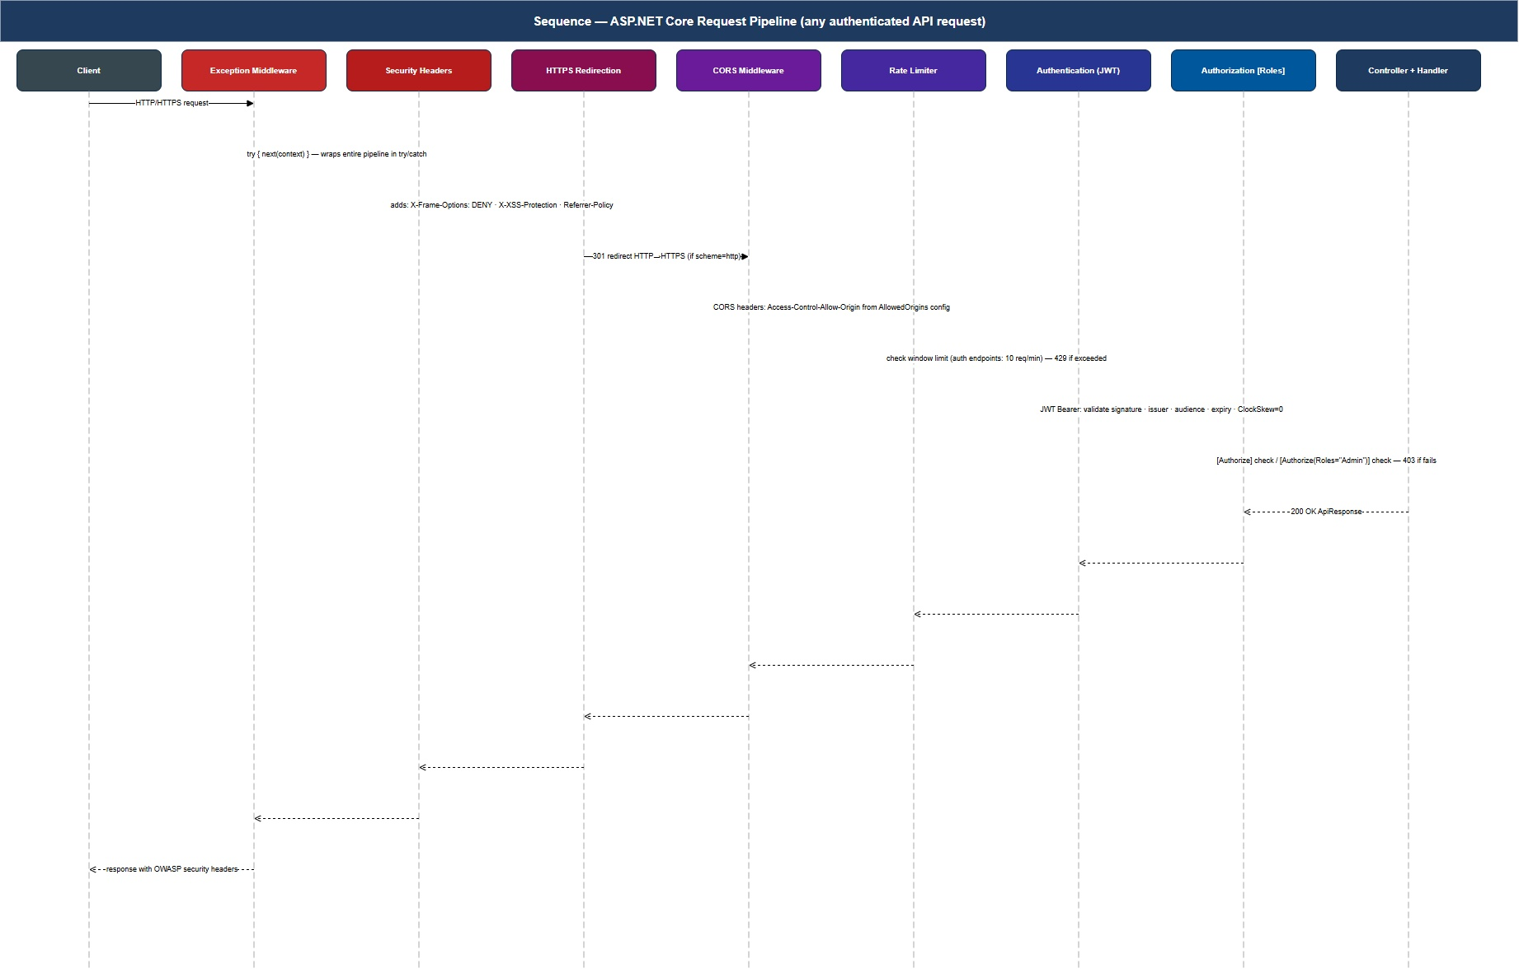
Figure 7.1 — Sequence: a request flowing through the API pipeline.

7.2 The response envelope
Every endpoint in the API returns the same JSON shape: a top-level object with success, data, and errors. The frontends rely on that uniformity. They do not have to write per-endpoint shape adapters.
Listing 7.1 — WebApi/Models/ApiResponse.cs.
public sealed class ApiResponse<T>
{
public bool Success { get; init; }
public T? Data { get; init; }
public IReadOnlyList<string> Errors { get; init; } = Array.Empty<string>();
public static ApiResponse<T> Ok(T data) =>
new() { Success = true, Data = data };
public static ApiResponse<T> Fail(params string[] errors) =>
new() { Success = false, Errors = errors };
}
A successful search returns 200 OK with { success: true, data: { items: [...], totalCount: 42 } }. A validation failure returns 400 Bad Request with { success: false, errors: ["Title is required."] }. The HTTP status code is the primary signal; the success field is the redundant one for code paths where status code is awkward to inspect.
IN PRACTICE
Some teams reject envelopes on the grounds that “the HTTP status code should be enough”. They are not wrong, but they assume every consumer is a careful HTTP client. In practice JavaScript fetch chains, mobile clients, and integration tests all benefit from being able to read response.success without checking the status code first. Pick a convention and stick with it.

7.3 A representative controller
AuthController is short enough to read in full.
Listing 7.2 — WebApi/Controllers/AuthController.cs.
[ApiController]
[Route("api/auth")]
public sealed class AuthController : ControllerBase
{
private readonly ISender _sender;
public AuthController(ISender sender) => _sender = sender;
[HttpPost("register")]
public async Task<ActionResult<ApiResponse<RegisterResponse>>> Register(
RegisterUserCommand cmd, CancellationToken ct)
{
var result = await _sender.Send(cmd, ct);
return result.IsSuccess
? StatusCode(201, ApiResponse<RegisterResponse>.Ok(result.Value!))
: BadRequest(ApiResponse<RegisterResponse>.Fail(result.Errors.ToArray()));
}
[HttpPost("login")]
public async Task<ActionResult<ApiResponse<LoginResponse>>> Login(
LoginUserCommand cmd, CancellationToken ct)
{
var result = await _sender.Send(cmd, ct);
return result.IsSuccess
? Ok(ApiResponse<LoginResponse>.Ok(result.Value!))
: Unauthorized(ApiResponse<LoginResponse>.Fail(result.Errors.ToArray()));
}
}
Notice what is not in this file: no validation logic, no password checks, no JWT generation, no database access. Every one of those lives in the handler the controller dispatches to. The controller’s five-line method maps HTTP to a command and back.

7.4 The exception middleware
Some failures cannot be returned as Result<T> — a database connection drop, a serialization bug, a NullReferenceException from a third party. These bubble out as exceptions and are caught in one place.
Listing 7.3 — WebApi/Middleware/ExceptionHandlingMiddleware.cs (abridged).
public sealed class ExceptionHandlingMiddleware
{
private readonly RequestDelegate _next;
private readonly ILogger<ExceptionHandlingMiddleware> _log;
public ExceptionHandlingMiddleware(RequestDelegate next,
ILogger<ExceptionHandlingMiddleware> log)
{ _next = next; _log = log; }
public async Task InvokeAsync(HttpContext ctx)
{
try { await _next(ctx); }
catch (ApplicationValidationException vex)
{ await Write(ctx, 400, vex.Errors.Select(e => e.ErrorMessage).ToArray()); }
catch (NotFoundException nf)
{ await Write(ctx, 404, nf.Message); }
catch (UnauthorizedAccessException)
{ await Write(ctx, 401, "Unauthorized."); }
catch (Exception ex)
{
_log.LogError(ex, "Unhandled exception");
await Write(ctx, 500, "An unexpected error occurred.");
}
}
private static Task Write(HttpContext ctx, int code, params string[] errors)
{
ctx.Response.StatusCode = code;
ctx.Response.ContentType = "application/json";
return ctx.Response.WriteAsJsonAsync(
ApiResponse<object>.Fail(errors));
}
}
The unhandled-exception branch logs with structured logging (Serilog in this project) and returns a generic 500. Never echo the exception message back to the client; it leaks information about your internals.
PITFALL
A common pattern in early controllers is try { ... } catch (Exception ex) { return BadRequest(ex.Message); }. Two things wrong: the message often contains the SQL that failed, the stack trace, or other internals; and the controller has now reinvented exception middleware in fifteen places. Catch in one place, log there, return a sanitized message.

7.5 The middleware pipeline order
ASP.NET Core’s middleware is a sequence — the order in which it is registered is the order in which it runs. Get it wrong and seemingly unrelated things break.
Listing 7.4 — WebApi/Program.cs (middleware section).
var app = builder.Build();
app.UseSerilogRequestLogging(); // 1. observe everything that happens
app.UseMiddleware<ExceptionHandlingMiddleware>(); // 2. catch everything that throws
app.UseHttpsRedirection(); // 3. enforce TLS
app.UseCors("DefaultPolicy"); // 4. CORS preflight
app.UseAuthentication(); // 5. WHO is the caller?
app.UseAuthorization(); // 6. is the caller ALLOWED?
app.UseRateLimiter(); // 7. throttle abusers
app.MapControllers(); // 8. route to a controller
app.MapScalarApiReference(); // 9. /scalar UI
app.Run();
The order matters in three places.
- CORS before Authentication. The browser preflights a cross-origin request with an OPTIONS call. If the auth middleware runs first, it returns 401 to that preflight (it has no token yet), and the request never reaches CORS. The browser sees a CORS error and the bug looks like a missing CORS header.
- Authentication before Authorization. Authorization needs to know who the caller is to decide what they may do. Reversing the pair makes every [Authorize] silently allow anonymous traffic.
- Exception middleware as early as possible. It must wrap everything that can throw, including authentication.
PITFALL
The UseAuthorization before UseAuthentication mistake is the single most common ASP.NET Core configuration bug. The build is green, the app runs, the controllers respond — and every protected endpoint is wide open. Treat this listing as canon.

7.6 JWT and CORS configuration
Two more Program.cs blocks deserve highlighting. Both go before builder.Build().
Listing 7.5 — WebApi/Program.cs (JWT registration).
var jwt = builder.Configuration.GetSection("Jwt");
builder.Services
.AddAuthentication(JwtBearerDefaults.AuthenticationScheme)
.AddJwtBearer(opt =>
{
opt.TokenValidationParameters = new TokenValidationParameters
{
ValidateIssuer = true,
ValidateAudience = true,
ValidateLifetime = true,
ValidateIssuerSigningKey = true,
ValidIssuer = jwt["Issuer"],
ValidAudience = jwt["Audience"],
IssuerSigningKey = new SymmetricSecurityKey(
Encoding.UTF8.GetBytes(jwt["Secret"]!)),
ClockSkew = TimeSpan.FromSeconds(30), // tighter than the default 5 minutes
};
});
builder.Services.AddAuthorization();
Listing 7.6 — WebApi/Program.cs (CORS registration).
builder.Services.AddCors(options =>
{
options.AddPolicy("DefaultPolicy", policy => policy
.WithOrigins(
"http://localhost:5173", // React dev server
"https://localhost:7278") // Blazor dev server
.AllowAnyHeader()
.AllowAnyMethod()
.AllowCredentials()); // because of httpOnly cookies in v2
});
PITFALL
AllowAnyOrigin() and AllowCredentials() are mutually exclusive in the HTTP CORS specification. Using both compiles, runs, and silently drops the credentials. The fix is to name origins explicitly with WithOrigins(...).

7.7 Wiring it all together
The full Program.cs is shorter than it looks. Listing 7.7 shows the top of the file, before the middleware pipeline in Listing 7.4.
Listing 7.7 — WebApi/Program.cs (services section).
var builder = WebApplication.CreateBuilder(args);
// Logging — Serilog is configured from appsettings.json.
builder.Host.UseSerilog((ctx, lc) => lc.ReadFrom.Configuration(ctx.Configuration));
// Cross-cutting infrastructure (Chapter 6).
builder.Services.AddInfrastructure(builder.Configuration);
// Application layer (Chapter 5).
builder.Services.AddApplication();
// MVC + JSON.
builder.Services.AddControllers()
.AddJsonOptions(o => o.JsonSerializerOptions.PropertyNamingPolicy =
JsonNamingPolicy.CamelCase);
// JWT, CORS, rate limiting (Listings 7.5, 7.6, and similarly).
ConfigureJwt(builder);
ConfigureCors(builder);
ConfigureRateLimiting(builder);
// OpenAPI 3.1 + Scalar UI.
builder.Services.AddEndpointsApiExplorer();
builder.Services.AddOpenApi();
AddApplication() and AddInfrastructure() are the two extension methods from Chapters 5 and 6. They make the project’s layered structure visible in Program.cs: the API does not register Domain types directly, only the bundles offered by the layers below it.

7.8 The OpenAPI surface
The project uses Scalar as its OpenAPI UI rather than Swagger UI. The choice is mostly aesthetic — Scalar’s UI is more modern — but it also handles OpenAPI 3.1 natively, which Swagger UI does not yet do.
In development, opening https://localhost:5149/scalar/v1 shows every endpoint, its parameters, and a request playground. The OpenAPI JSON is generated from controller attributes plus the Microsoft.AspNetCore.OpenApi source generators; it is not hand-maintained.
Architect’s Note: OpenAPI is a contract. Once a frontend depends on the shape your API publishes, breaking changes to that shape are production incidents in slow motion. Treat the OpenAPI document the way you treat a public NuGet package: backwards-compatible by default, semver bump for breaking changes, and a release note when something changes.

7.9 Checkpoint
You are ready for Chapter 8 when:
- dotnet run --project src/EBookLibrary.WebApi/ starts and /scalar/v1 loads.
- GET /api/books/search returns { "success": true, "data": { "items": [], ... } } (the catalog is empty until Chapter 9 seeds it).
- You can recite the eight middleware in Listing 7.4 in order without consulting the chapter.
- You can name the CORS bug that follows from AllowAnyOrigin().AllowCredentials().
- You can name the authorization bug that follows from registering UseAuthorization() before UseAuthentication().

Key takeaways
- Controllers are dispatchers. Every method dispatches a MediatR command or query, wraps the result in ApiResponse<T>, and returns.
- ApiResponse<T> gives every endpoint the same shape and frees frontends from per-endpoint error handling.
- Exception middleware catches in one place, logs there, and returns a sanitized message to the client. Never echo internals.
- Middleware ordering matters in three places: CORS before Authentication, Authentication before Authorization, exception handling early.
- Scalar replaces Swagger UI; OpenAPI is a contract worth versioning with the same care as a public NuGet package.

Exercises
Easy. Add a HealthController with GET /api/health returning 200 OK with { "status": "ok", "version": "1.0.0" }. This endpoint needs no auth and no MediatR; it is the one acceptable controller in the project that does not delegate.
Medium. The exception middleware currently maps four exception types to status codes. Add a fifth — ConcurrencyException — that maps to 409 Conflict. Decide where in Application or Infrastructure that exception would be thrown.
Hard. Replace the response envelope with the Internet Engineering Task Force’s standard Problem Details format (RFC 7807). Discuss what is gained (interoperability) and what is lost (consistency between success and failure responses). The exercise is a microcosm of the build-versus-adopt-standard tension that recurs in API design.

Further reading
- Microsoft, ASP.NET Core middleware. https://docs.microsoft.com/aspnet/core/fundamentals/middleware/
- IETF, RFC 7807: Problem Details for HTTP APIs.
- Andrew Lock, “Versioning APIs in ASP.NET Core”.
- Scalar OpenAPI UI documentation. https://scalar.com/

Chapter 8 — Authentication and Authorization
“The login page is small and the way it can fail is endless.”

What you will learn
- The structure of a JWT token (header, payload, signature) and what each part is for.
- The two flows the project implements — registration and login — and the small but consequential decisions inside each.
- Why BCrypt’s work factor is not a configuration knob to leave at the default and how to choose it.
- Why the project uses ClaimTypes.Role, not "role", and what silently breaks otherwise.
- How role-based authorization attributes layer on controllers and how [AllowAnonymous] opts a single endpoint out.
- The XSS exposure of localStorage JWT storage and the trade-off the project accepts.

8.1 What a JWT actually is
A JSON Web Token is three Base64-encoded segments joined by dots:
eyJhbGciOiJIUzI1NiIsInR5cCI6IkpXVCJ9 ← header
.
eyJzdWIiOiI4Yz...3RpIjoiMjQ4... ← payload (claims)
.
F2sjqp_8OvK4... ← signature
The header names the signing algorithm. The payload carries claims — named bits of information about the user (sub, email, role, plus issuer, audience, expiry). The signature is HMAC-SHA256(header.payload, secret). The server signs at issue time; the server validates the signature on every subsequent request. The token is self-describing: no server-side session lookup is required.
FOUNDATIONS
Self-describing means you can decode a JWT in any language with no help from the issuer. Try this with a real token at https://jwt.io. The header and payload are not encrypted — they are just Base64 of JSON. Anything secret must not go in the payload. The signature only proves the issuer is who they claim; it does not hide the contents.

8.2 The two flows
The project supports exactly two authentication flows: registration and login. Both go through MediatR; both return a JWT.
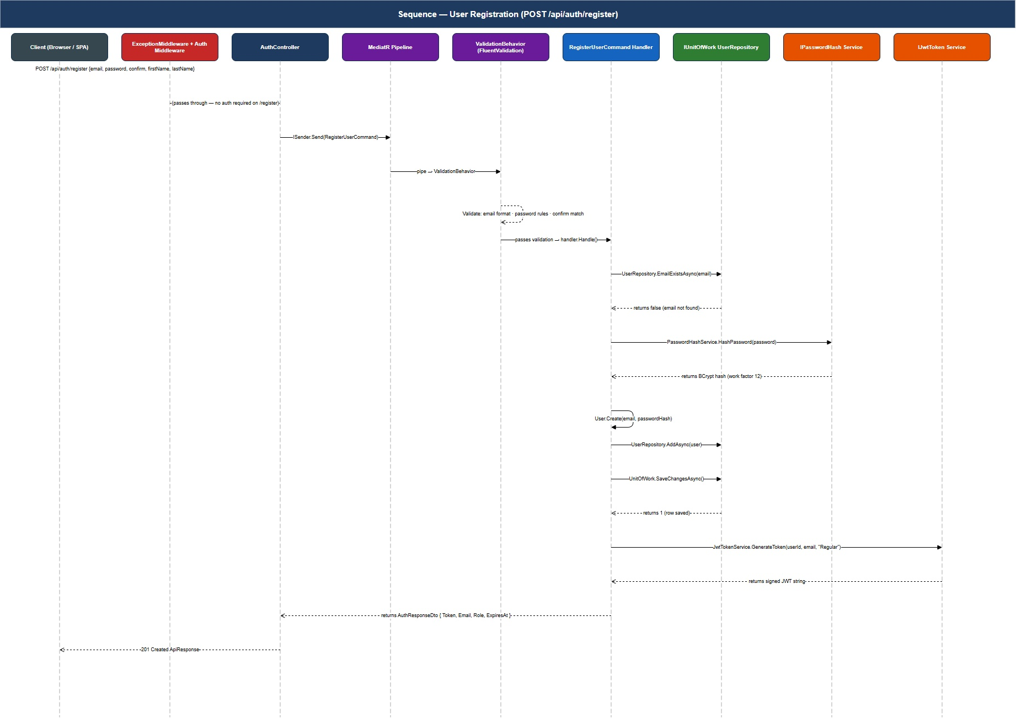
Figure 8.1 — Sequence: user registration end-to-end.
The registration handler’s job is to validate the email is not taken, hash the password, persist the user, and return a freshly-issued JWT so the client can sign in immediately. The login handler’s job is to look the user up, verify the password against the stored hash, check the account is active, and return the same envelope.
Both handlers are short — § 5.4 showed login in full — and the non-obvious decisions live in two places: the response shape (do not leak existence of the account) and the hashing algorithm (BCrypt, work factor 12).

8.3 BCrypt and the work factor
BCrypt is intentionally slow. A single hash takes ~250 ms on a modern CPU at work factor 12. That cost is the difference between an attacker who steals the password table and runs an offline dictionary attack at millions of guesses per second, and one who runs it at four guesses per second per CPU.
Listing 8.1 — Choosing the work factor (from PasswordHashService).
private const int WorkFactor = 12; // ~250 ms per hash on modern CPUs
public string Hash(string password)
=> BCrypt.Net.BCrypt.HashPassword(password, WorkFactor);
The trade-offs:
- Work factor ≤ 9 — milliseconds per hash. Fast for offline attacks too. Do not use.
- Work factor 10 — BCrypt’s library default. Adequate ten years ago, marginal today.
- Work factor 12 — the project’s choice. About 250 ms per hash. Login still feels instant.
- Work factor 13 — about 500 ms per hash. Login feels slightly sluggish on a tablet.
- Work factor ≥ 14 — login becomes a UX problem.
Re-evaluate every couple of years. Hardware speeds up; the right work factor drifts upward.
Architect’s Note: If you are starting a new project today and have the luxury, prefer Argon2id over BCrypt. It is the OWASP recommended algorithm and resists GPU-accelerated attacks better. The project uses BCrypt because it is mature, has excellent .NET support, and is correct enough at work factor 12 for the threat model. The argument for switching is “memory-hardness”, not “BCrypt is broken”.

8.4 The single most important string in the project
Listing 8.2 reproduces the line from Chapter 6 that most often hides a security bug. It is worth seeing again, in context.
Listing 8.2 — JWT claim emission, the right way and the wrong way.
// CORRECT — ASP.NET Core's [Authorize(Roles=...)] reads ClaimTypes.Role.
new Claim(ClaimTypes.Role, user.Role.ToString()),
// WRONG — compiles, runs, generates a plausible token, breaks every
// [Authorize(Roles="Admin")] attribute silently.
new Claim("role", user.Role.ToString()),
ClaimTypes.Role evaluates to the URL http://schemas.microsoft.com/ws/2008/06/identity/claims/role. That URL is what [Authorize(Roles=...)] looks for. The project tests in Chapter 12 include an explicit assertion that admin endpoints reject a regular-user token; that test is the single best protection against this bug regressing.
PITFALL
This bug is hard to find because the symptom is “every admin call returns 403, even with what looks like a valid token”. Engineers spend hours decoding the JWT in jwt.io, seeing the role claim there, and assuming the framework is broken. It isn’t — the claim type is wrong. Always use the constant.

8.5 Authorization attributes
The project uses controller-level [Authorize] with method-level overrides for endpoints that need to be public.
Listing 8.3 — WebApi/Controllers/BooksController.cs (auth attributes).
[ApiController]
[Route("api/books")]
[Authorize] // default: any authenticated user
public sealed class BooksController : ControllerBase
{
[HttpGet("search"), AllowAnonymous] // public
public Task<...> Search(...) { ... }
[HttpGet("{id:guid}"), AllowAnonymous] // public
public Task<...> GetById(...) { ... }
[HttpGet("{id:guid}/download")] // logged in
public Task<...> Download(...) { ... }
[HttpPost, Authorize(Roles = "Admin")] // admin only
public Task<...> Create(...) { ... }
[HttpPut("{id:guid}"), Authorize(Roles = "Admin")]
public Task<...> Update(...) { ... }
[HttpDelete("{id:guid}"), Authorize(Roles = "Admin")]
public Task<...> Delete(...) { ... }
}
Class-level [Authorize] is the secure default — every action requires authentication unless explicitly opted out. This is the opposite of the alternative (every action public unless explicitly secured) and the opposite is the wrong default.
IN PRACTICE
“Default secure” applies to more than just controllers. Database tables should require explicit grants, not default-grant-then-revoke. Configuration should default to the safer behavior (TLS on, debug off). Every layer where a wrong default is a security incident is a place to apply this discipline.

8.6 The XSS exposure of localStorage
The React frontend (Chapter 10) stores the JWT in browser localStorage. So does the Blazor frontend (Chapter 11). This is common and convenient and the source of one specific vulnerability: any cross-site scripting bug becomes a token theft.
A tiny JavaScript injection — through an unescaped user comment, a malicious npm dependency, a copy-pasted browser extension — can read localStorage.getItem('auth_token') and POST it to an attacker. The attacker now has a valid JWT for the user’s account until it expires.
The defense in depth has three layers:
- Aggressive XSS prevention. Escape every user-supplied string that touches the DOM. React does this by default with {}-style interpolation, but the moment you reach for dangerouslySetInnerHTML the protection is gone.
- Short token lifetimes. Sixty minutes in this project. A stolen token expires soon; a refresh-token system would expire it sooner on a logout signal.
- A Content Security Policy (CSP) that limits which origins can execute JavaScript. The project ships a baseline CSP in production configuration.
The full defense, however, is to stop using localStorage and move the token into an httpOnly cookie. The cookie is not readable from JavaScript at all; XSS cannot steal it. The cost is CSRF protection (cookies are sent automatically; tokens in headers are not) and slightly more complex CORS configuration.
PITFALL
The project chooses localStorage because it is a learning project and the simplification is worth it for the lesson. Do not adopt the same choice in a production application without first weighing the XSS surface of your codebase. The default for production should be httpOnly cookies plus CSRF protection.

8.7 Security hardening checklist
Before sending an authentication system into production, verify each of the following.
Table 8.1 — Pre-production authentication checklist.
# | Item | Status in this project
1 | JWT signing secret is at least 256 bits, random | ✓ (configured per env)
2 | Secret stored outside source control | ✓ (user-secrets / env vars)
3 | Token expiry set explicitly, ≤ 60 min for SPAs | ✓
4 | Issuer and audience validated | ✓
5 | Same error message for “user not found” and “wrong password” | ✓ (§ 5.5)
6 | BCrypt work factor ≥ 11 (12 here) | ✓
7 | ClaimTypes.Role (not "role") | ✓ (§ 8.4)
8 | Protected endpoints tested with regular-user token | ✓ (Chapter 12)
9 | Rate limiting on /login and /register | ✓ (RateLimiter)
10 | localStorage exposure documented or replaced | △ documented (§ 8.6)
11 | Refresh-token strategy designed (even if deferred) | △ deferred to v2
12 | Logout invalidates client state (token cleared) | ✓
13 | Account lockout after N failed logins | ✗ (exercise 8.H)
14 | Password reset flow with email verification | ✗ (exercise 8.H)
The checklist is the most useful single artifact in this chapter. Print it, commit it, review it before every release.

8.8 Checkpoint
You are ready for Chapter 9 when:
- POST /api/auth/register returns 201 and a JWT.
- POST /api/auth/login returns 200 and a JWT.
- POST /api/auth/login with a wrong password returns 401 with the same error message as a missing email.
- POST /api/books (admin-only) returns 403 when called with a regular-user token.
- You can pull the JWT out of Authorization: Bearer ... and decode its claims at https://jwt.io, including a role claim whose claim type is the long Microsoft URL, not "role".

Key takeaways
- A JWT is self-describing: header + claims + signature. Never put secrets in the claims.
- BCrypt at work factor 12 is the project’s deliberate slowness; re-evaluate every couple of years.
- ClaimTypes.Role is the correct constant for role claims. The literal "role" compiles, runs, and silently breaks [Authorize(Roles=...)].
- The same login error message for “no such user” and “wrong password” prevents user enumeration and costs nothing.
- localStorage JWT storage is the project’s accepted XSS exposure; for production, prefer httpOnly cookies plus CSRF protection.

Exercises
Easy. Decode a JWT issued by the running API at https://jwt.io. Verify by hand that alg is HS256, that exp is 60 minutes from iat, and that the role claim type is the long URL.
Medium. Implement account lockout: after five failed login attempts in fifteen minutes, the user’s next login attempt returns a 429 Too Many Requests regardless of password correctness. Decide where the counter lives (in-memory? database? cache?) and what invalidates it. (Hint: row-level lockout in the database survives a process restart, but does not handle a distributed deployment.)
Hard. Add refresh tokens. The login response now returns { accessToken, refreshToken }; access tokens expire in 15 minutes; refresh tokens expire in 7 days, are stored hashed in a UserRefreshToken table, and are rotated on every use (each refresh issues a new access token AND a new refresh token, invalidating the old refresh). Discuss what happens if the same refresh token is presented twice (token theft detection).

Further reading
- IETF, RFC 7519: JSON Web Token (JWT). The original specification.
- Auth0, “JWT Best Current Practices”.
- OWASP, Authentication Cheat Sheet. https://cheatsheetseries.owasp.org/cheatsheets/Authentication_Cheat_Sheet.html
- OWASP, Cross-Site Scripting (XSS) Prevention Cheat Sheet.
- Steve Gibson, “Password Haystacks” — the back-of-envelope math for why hash slowness matters.

Chapter 9 — Database and Migrations
“The schema is a contract that outlives the code that wrote it.”

What you will learn
- How EF Core migrations turn DbContext changes into versioned SQL scripts.
- How to read the schema EF Core generates and verify it against what you expected.
- How the two-pass seeder ingests 51,599 books from real HTML export files without exhausting memory.
- How to seed an admin user once at application startup.
- The migration management commands you will use weekly: add, remove, script, update, list.
- The five most common migration problems and their fixes.

9.1 Connection string configuration
Connection strings are not committed. Local development uses .NET’s user-secrets feature; production uses environment variables. Both are read by IConfiguration exactly the same way.
Listing 9.1 — Adding the local connection string.
# From src/EBookLibrary.WebApi/
dotnet user-secrets init
dotnet user-secrets set "ConnectionStrings:Default" `
"Server=(localdb)\MSSQLLocalDB;Database=EBookLibraryDb;Trusted_Connection=True;TrustServerCertificate=True;MultipleActiveResultSets=True"
appsettings.json carries the non-secret defaults (logging configuration, JWT issuer/audience, file storage paths) and explicitly omits the connection string and the JWT secret.
PITFALL
The MultipleActiveResultSets=True parameter is not optional in this project. Several handlers use await foreach over one query while issuing a second query to a related table; without MARS, the second query throws “There is already an open DataReader…”. The fix is the connection string. The error is obscure if you do not know to look for it.

9.2 Creating the first migration
The Domain entities of Chapter 4 plus the EF configurations of Chapter 6 give EF Core enough information to generate a complete schema.
Listing 9.2 — Creating the initial migration.
# From the solution root
dotnet ef migrations add InitialCreate `
--project src/EBookLibrary.Infrastructure `
--startup-project src/EBookLibrary.WebApi
The --project flag names the assembly that contains the DbContext; --startup-project names the assembly that contains the Program.cs that registers AddDbContext. EF Core compiles the startup project so it can read the configuration and DI registrations.
The command writes three files to src/EBookLibrary.Infrastructure/Persistence/Migrations/:
- <timestamp>_InitialCreate.cs — the migration as C# code (Up() builds the schema, Down() reverts it).
- <timestamp>_InitialCreate.Designer.cs — the migration metadata.
- AppDbContextModelSnapshot.cs — the cumulative model snapshot used to compute the next migration’s diff.
PITFALL
AppDbContextModelSnapshot.cs is generated, not hand-edited. It is also a frequent merge-conflict victim. When two branches each add a migration, both branches modify the snapshot. Resolve by accepting neither version, deleting the file, then re-running dotnet ef migrations add on the merged branch with a placeholder name and discarding the new migration. The snapshot regenerates correctly.

9.3 Applying the migration
dotnet ef database update applies all pending migrations to the configured connection string.
Listing 9.3 — Applying migrations.
dotnet ef database update `
--project src/EBookLibrary.Infrastructure `
--startup-project src/EBookLibrary.WebApi
# Or, generate the SQL script for review without applying:
dotnet ef migrations script `
--project src/EBookLibrary.Infrastructure `
--startup-project src/EBookLibrary.WebApi `
--output db_v1.sql
In production, the script form is preferred: a DBA reviews the SQL before it runs against the production database. The C# migration runner is convenient for development; it is not the right tool for unattended production deploys.

9.4 The expected schema
After database update, the database has seven tables. Listing 9.4 sketches the shape; the live database can be inspected with SELECT name FROM sys.tables.
Listing 9.4 — Tables produced by InitialCreate.
Books (Id PK, Title, Isbn, Description, Pages, ...,
Status nvarchar(20), Language nvarchar(20), CreatedAt, ...)
Authors (Id PK, Name, Biography, IsDeleted, CreatedAt, ...)
Genres (Id PK, Name, Description, IsDeleted, CreatedAt, ...)
Users (Id PK, Email UNIQUE, PasswordHash, FirstName, LastName,
Role nvarchar(20), IsActive, IsDeleted, CreatedAt, ...)
BookAuthors (BookId FK, AuthorId FK, PRIMARY KEY (BookId, AuthorId))
BookGenres (BookId FK, GenreId FK, PRIMARY KEY (BookId, GenreId))
BookDownloads (Id PK, UserId FK, BookId FK, DownloadedAt)
Notice three things in passing.
- Enums are nvarchar. Status and Language and Role all store the string form. The reason is the same as in Chapter 6: human-readable, safe to renumber, robust to cross-system reads.
- Soft-delete columns (IsDeleted, DeletedAt) appear on every aggregate root. The global query filter from OnModelCreating is what makes them invisible to normal reads.
- No foreign-key cascades. Removing an author through the API is a soft delete that updates IsDeleted = 1; the join rows in BookAuthors remain intact and refer to a row the API now hides.

9.5 The two-pass seeder
The seed corpus is three HTML files (lista_autor.html, lista_generos.html, lista_titulo.html) parsed into 51,599 books, about 12,800 distinct authors, and 128 genres. The seeder runs as a console application:
dotnet run --project scripts/EBookLibrary.Seeder
The total runtime is 3–5 minutes on typical developer hardware. Two design decisions make that achievable.
Decision 1 — Two passes. Books cannot be inserted before the authors and genres they reference exist. Pass 1 reads lista_generos.html and lista_autor.html, deduplicates by name, and inserts Author and Genre rows. Pass 2 reads lista_titulo.html, constructs Book rows, and links each to the appropriate authors and genres via the join entities. This is the pattern for any seeder with dependency order.
Decision 2 — Batched saves. Inserting all 51K books in one SaveChangesAsync call exhausts memory on developer machines (EF Core’s change tracker holds every entity). The seeder calls SaveChangesAsync every 500 books and clears the change tracker between batches.
Listing 9.5 — Pass 2 of the seeder (abridged).
const int BatchSize = 500;
var batch = 0;
await foreach (var (title, authorName, genreName) in titles)
{
var author = authorIndex.GetValueOrDefault(authorName);
var genre = genreIndex .GetValueOrDefault(genreName);
if (author is null || genre is null) continue;
var book = Book.Create(title, BookLanguage.Spanish);
db.Books.Add(book);
db.BookAuthors.Add(BookAuthor.Create(book.Id, author.Id));
db.BookGenres .Add(BookGenre .Create(book.Id, genre.Id));
if (++batch >= BatchSize)
{
await db.SaveChangesAsync();
db.ChangeTracker.Clear(); // critical — release memory
batch = 0;
}
}
await db.SaveChangesAsync();
Architect’s Note: Bulk insert through Add + SaveChangesAsync is not the fastest route — the EF Core change tracker still processes every entity. For a 51K-row seed it is fast enough. For 5M rows you would reach for SqlBulkCopy or EFCore.BulkExtensions and accept that you have stepped outside the ORM’s contract for performance. Choose the right tool for the row count.

9.6 The admin user seed
The seeder creates the first admin user. The credentials are not random — they are the published defaults admin@ebooklibrary.dev / Admin#2026!. They must be changed on first deploy.
Listing 9.6 — Admin user seed (idempotent).
public async Task SeedAdminUserAsync(CancellationToken ct = default)
{
const string email = "admin@ebooklibrary.dev";
var existing = await _db.Users.FirstOrDefaultAsync(u => u.Email == email, ct);
if (existing is not null) return; // idempotent
var hash = _hasher.Hash("Admin#2026!");
var admin = User.Create(email, hash);
admin.UpdateRole(UserRole.Admin);
await _db.Users.AddAsync(admin, ct);
await _db.SaveChangesAsync(ct);
}
The method is safe to run multiple times: if the row already exists, it does nothing. The Web API calls it from Program.cs at startup so that a fresh database is always usable from the first request.
PITFALL
Default credentials in source code are convenient for development and dangerous in production. Production builds should require admin credentials in environment variables and refuse to start without them. Add the check before the application is internet-reachable, not after.

9.7 Migration management cheat sheet
Table 9.1 — The five EF Core migration commands you will use weekly.
Goal | Command
Add a new migration | dotnet ef migrations add <Name> --project … --startup-project …
Remove the most recent (un-applied) migration | dotnet ef migrations remove --project … --startup-project …
List all migrations and their applied status | dotnet ef migrations list --project … --startup-project …
Apply pending migrations | dotnet ef database update --project … --startup-project …
Generate the SQL script (for review/deploy) | dotnet ef migrations script <from> <to> --output v.sql --project … --startup-project …
The <from> <to> pair on script gives you an idempotent SQL file that takes a database from one named migration to another. This is the form to hand a DBA.

9.8 The five most common migration problems
Table 9.2 — Migration troubleshooting.
Symptom | Cause | Fix
The model for context 'AppDbContext' has pending changes. | A code change was made without adding a migration. | dotnet ef migrations add <Name> then database update.
Cannot create more than one clustered index on table. | Composite primary key declared twice. | One of two HasKey calls — keep one, delete the other.
There is already an open DataReader. | Connection string missing MultipleActiveResultSets=True. | Add it to the connection string.
Merge conflict in AppDbContextModelSnapshot.cs. | Two branches each added a migration; the snapshot diverged. | Re-generate (see Pitfall in § 9.2).
Adding a non-nullable column to an existing table fails. | Existing rows have no default value. | Provide defaultValue: in the migration’s AddColumn call, or seed before adding.

9.9 Verification queries
After applying migrations and running the seeder, the following queries verify the database is in the expected state.
Listing 9.7 — Sanity-check queries.
SELECT COUNT(*) AS BookCount FROM Books; -- expect ~51,599
SELECT COUNT(*) AS AuthorCount FROM Authors; -- expect ~12,800
SELECT COUNT(*) AS GenreCount FROM Genres; -- expect 128
-- Spot-check a join:
SELECT TOP 5 b.Title, a.Name AS Author, g.Name AS Genre
FROM Books b
JOIN BookAuthors ba ON ba.BookId = b.Id
JOIN Authors a ON a.Id = ba.AuthorId
JOIN BookGenres bg ON bg.BookId = b.Id
JOIN Genres g ON g.Id = bg.GenreId
ORDER BY NEWID();
If those numbers are within 5% of the expected values and the random five rows look like real Spanish-language books, the seed worked.

9.10 Checkpoint
You are ready for Chapter 10 when:
- dotnet ef database update succeeds against your local SQL Server.
- The seeder finishes in 3–5 minutes with no errors.
- The verification queries in Listing 9.7 return the expected counts.
- POST /api/auth/login with admin@ebooklibrary.dev / Admin#2026! returns a JWT whose role claim says Admin.
- GET /api/books/search?title=cervantes returns a non-empty page of results.

Key takeaways
- Migrations are version control for the database. Generate them with dotnet ef migrations add; review them like code; apply them with database update in dev and with reviewed SQL in production.
- MultipleActiveResultSets=True is not optional for this project.
- Two-pass seeding (parents then children) and batched SaveChangesAsync calls are the patterns that make a 51K-row ingestion practical.
- The admin user seed is idempotent and uses default credentials that must be changed in production. Build the check-on-startup that enforces the change.
- The model snapshot file (AppDbContextModelSnapshot.cs) is a frequent merge-conflict victim. Resolve by regenerating, never by hand-editing.

Exercises
Easy. Add a non-nullable IsFeatured bool column to Books defaulting to false. Generate the migration and verify it includes defaultValue: false. (Without the default, the migration would fail on the existing 51K rows.)
Medium. Write a down migration manually for the migration you added in the previous exercise — that is, fill in the Down() method to drop the IsFeatured column. Verify by running dotnet ef database update <previous-migration> and inspecting the schema.
Hard. The seeder currently parses HTML files. Extend it to also accept a JSON file (one book per line, schema your choice). The exercise is to factor IBookSource so the seeder can be invoked with either source without duplicating the persistence logic. Write a unit test for IBookSource that does not touch the database.

Further reading
- Microsoft, EF Core migrations. https://docs.microsoft.com/ef/core/managing-schemas/migrations/
- Jon Smith, Entity Framework Core in Action, 2nd ed. — Chapter 9 on migrations and Chapter 14 on bulk loading.
- Andrew Lock, “Running async tasks on app startup in ASP.NET Core” — the pattern used by the admin-user seed.
- EFCore.BulkExtensions documentation — when seeding crosses the half-million-row threshold.

Chapter 10 — The React Frontend
“A frontend is just another consumer of the API. Build it as such.”

What you will learn
- How a Vite + React 19 + TypeScript project is structured for a small but realistic application.
- How Zustand replaces Redux at a fraction of the ceremony for the project’s two stores: authentication and notifications.
- How TanStack Query handles every server interaction with caching, background refresh, and optimistic update built in.
- How the typed API client mirrors the backend’s ApiResponse<T> envelope.
- How Axios interceptors attach the JWT and translate 401 into a redirect to login.
- How the app shell, public pages, and admin pages compose into a small but complete SPA.

10.1 The shape of a modern React app
The React project lives in src/EBookLibrary.React/ and is a Vite-driven single-page application. The folder structure makes the layering of the frontend explicit.
Listing 10.1 — Folder layout (abridged).
src/
├── api/ ← Axios instance, interceptors, typed endpoints
├── components/ ← Reusable UI: Button, Input, BookCard, Header...
├── pages/ ← One file per route: Login, Register, BookDetail,
│ SearchResults, MyDownloads, AdminBooks, ...
├── stores/ ← Zustand: useAuthStore, useNotificationStore
├── hooks/ ← Custom hooks: useDebounce, useAuth, ...
├── types/ ← TypeScript types mirroring backend DTOs
├── utils/ ← formatters, validators
├── App.tsx ← Router + layout
└── main.tsx ← Vite entry: providers + QueryClient + StrictMode
There is no Redux, no Saga, no React-Router data loaders, no Server Components. Each of those would be defensible — none is necessary for this scope. The dependency budget is short on purpose.
IN PRACTICE
A common failure mode in React projects is reaching for the most-popular library before the problem requires it. Zustand is 1.5 KB and solves “I have a piece of state two components apart need to share” without a reducer in sight. Reach for Redux when you have either time-travel debugging requirements or a state shape complex enough to need its discipline. Most apps do not.
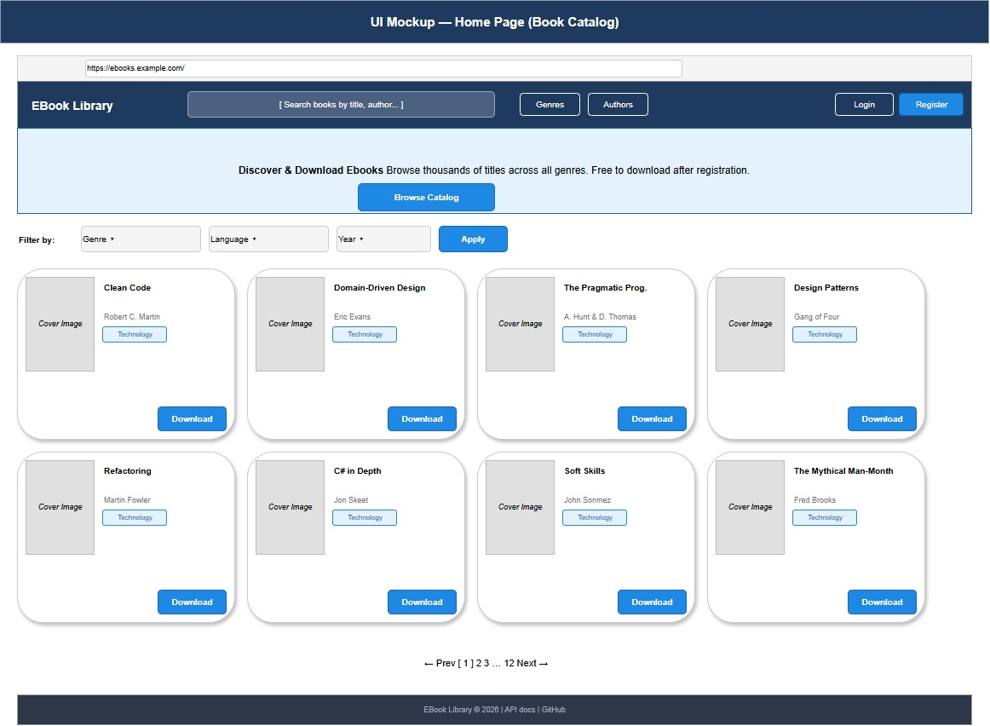
Figure 10.1 — Home page rendered by the React frontend.

10.2 The typed API client
The API client wraps Axios and exposes one method per backend endpoint. Every method returns the typed ApiResponse<T> that matches the backend envelope.
Listing 10.2 — api/client.ts.
import axios from 'axios';
import { useAuthStore } from '../stores/useAuthStore';
const client = axios.create({
baseURL: import.meta.env.VITE_API_BASE_URL,
headers: { 'Content-Type': 'application/json' },
});
// Request interceptor — attach JWT to every call.
client.interceptors.request.use((config) => {
const token = useAuthStore.getState().token;
if (token) config.headers.Authorization = `Bearer ${token}`;
return config;
});
// Response interceptor — auto-logout on 401.
client.interceptors.response.use(
(response) => response,
(error) => {
if (error.response?.status === 401) {
useAuthStore.getState().logout();
window.location.href = '/login';
}
return Promise.reject(error);
}
);
export default client;
Two interceptors do the work that would otherwise be sprinkled across every component. The request interceptor reads the JWT from the Zustand store — not from localStorage directly — so that login and logout flows in the store remain the single source of truth. The response interceptor catches 401, clears the auth state, and redirects. A single hard-redirect (window.location.href = ...) is intentional; it discards any in-memory state that might have been derived from the expired token.
Listing 10.3 — api/books.ts (typed endpoint methods).
import client from './client';
import type { ApiResponse, PagedResult, Book, BookSearchQuery } from '../types';
export const booksApi = {
search: (q: BookSearchQuery) =>
client.get<ApiResponse<PagedResult<Book>>>('/api/books/search', { params: q })
.then((r) => r.data),
getById: (id: string) =>
client.get<ApiResponse<Book>>(`/api/books/${id}`).then((r) => r.data),
download: (id: string) =>
client.get<Blob>(`/api/books/${id}/download`, { responseType: 'blob' })
.then((r) => r.data),
create: (book: CreateBookRequest) =>
client.post<ApiResponse<Book>>('/api/books', book).then((r) => r.data),
update: (id: string, book: UpdateBookRequest) =>
client.put<ApiResponse<Book>>(`/api/books/${id}`, book).then((r) => r.data),
delete: (id: string) =>
client.delete<ApiResponse<void>>(`/api/books/${id}`).then((r) => r.data),
};
The TypeScript generics carry the response shape from the network edge to the components. A component asking for data?.items gets autocomplete for Book properties without a single cast.

10.3 The Zustand auth store
Zustand stores are functions. There is no provider, no combineReducers, no connect. The hook returned by create() is the store.
Listing 10.4 — stores/useAuthStore.ts.
import { create } from 'zustand';
import { persist } from 'zustand/middleware';
interface AuthState {
token: string | null;
user: AuthUser | null;
isAuthenticated: boolean;
isAdmin: boolean;
login: (token: string, user: AuthUser) => void;
logout: () => void;
}
export const useAuthStore = create<AuthState>()(
persist(
(set) => ({
token: null,
user: null,
isAuthenticated: false,
isAdmin: false,
login: (token, user) => set({
token, user,
isAuthenticated: true,
isAdmin: user.role === 'Admin',
}),
logout: () => set({
token: null, user: null,
isAuthenticated: false, isAdmin: false,
}),
}),
{ name: 'ebook-auth' } // localStorage key
)
);
persist is the middleware that mirrors the store to localStorage under the key ebook-auth. The same XSS exposure noted in § 8.6 applies — a tiny script injection can read this key. The mitigations of that section apply here.
Architect’s Note: Zustand’s “stores are hooks” philosophy means you can subscribe to a slice of state and re-render only when that slice changes:
const isAdmin = useAuthStore((s) => s.isAdmin);
This single line replaces the connect/mapStateToProps ceremony from earlier React eras. The selector function is the unit of subscription. Smaller selectors mean fewer re-renders.

10.4 TanStack Query — the rest of state
State management has two halves: client state (UI toggles, the auth token) and server state (the catalog of books, the user’s downloads). Zustand handles the first half. TanStack Query handles the second.
Listing 10.5 — pages/SearchResults.tsx (data hook).
const { data, isLoading, error } = useQuery({
queryKey: ['books', { title, author, genre, page }],
queryFn: () => booksApi.search({ title, author, genre, pageNumber: page, pageSize: 20 }),
placeholderData: (prev) => prev, // smooth pagination
});
if (isLoading) return <Spinner />;
if (error) return <ErrorState onRetry={() => refetch()} />;
return (
<BookGrid books={data?.data?.items ?? []} />
);
TanStack Query provides four things for free:
- Caching keyed on the query key. Searching the same term twice in five minutes hits the cache, not the server.
- Background refresh when the tab regains focus.
- Stale-while-revalidate rendering. The previous page’s data is shown while the next page loads — placeholderData makes pagination feel instant.
- Retry with backoff for failed requests.
For mutations, useMutation plays the same role and additionally supports optimistic updates — the UI assumes the mutation will succeed and rolls back if it doesn’t.
Listing 10.6 — pages/AdminBooks.tsx (mutation with optimistic update).
const queryClient = useQueryClient();
const createBook = useMutation({
mutationFn: booksApi.create,
onMutate: async (newBook) => {
await queryClient.cancelQueries({ queryKey: ['books'] });
const previous = queryClient.getQueryData(['books']);
queryClient.setQueryData(['books'], (old: any) => ({
...old,
data: { ...old.data, items: [newBook, ...old.data.items] },
}));
return { previous };
},
onError: (_err, _newBook, ctx) =>
queryClient.setQueryData(['books'], ctx?.previous), // rollback
onSettled: () => queryClient.invalidateQueries({ queryKey: ['books'] }),
});
PITFALL
Optimistic updates feel magical and silently mislead the user when they fail. The onError rollback is not optional — without it, the UI claims success that the server never confirmed. Test the failure path explicitly. (Chapter 13’s E2E suite has a “force the API to 500 and confirm rollback” scenario that catches regressions in this code.)

10.5 The login flow
Putting the pieces together: a login form submits, the API returns a JWT, the Zustand store accepts it, TanStack Query invalidates any cached data tied to the previous user, and the router navigates.
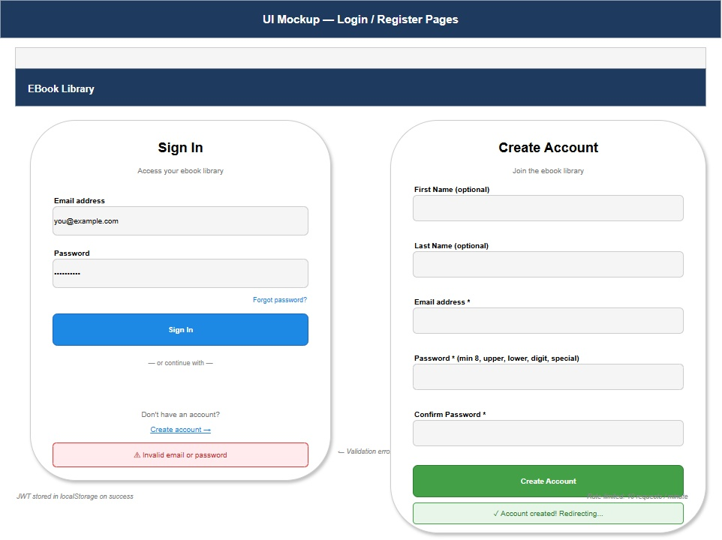
Figure 10.2 — The login and registration screens.
Listing 10.7 — pages/Login.tsx (abridged).
const login = useAuthStore((s) => s.login);
const navigate = useNavigate();
const queryClient = useQueryClient();
const submit = async (data: LoginFormValues) => {
const response = await authApi.login(data);
if (!response.success) {
setError('Invalid email or password.'); // generic — see § 5.5
return;
}
login(response.data!.token, response.data!.user);
await queryClient.invalidateQueries(); // wipe stale-per-user caches
navigate('/');
};
The same generic error message used by the backend (§ 5.5) is reflected here: the UI never says “user not found” or “wrong password” specifically.

10.6 The book detail page and download
The detail page is the app’s most data-heavy view. It loads the book, its authors, and its genres in one query (the Web API includes them in the response — see § 6.5), and offers a download button that streams the file from the API.
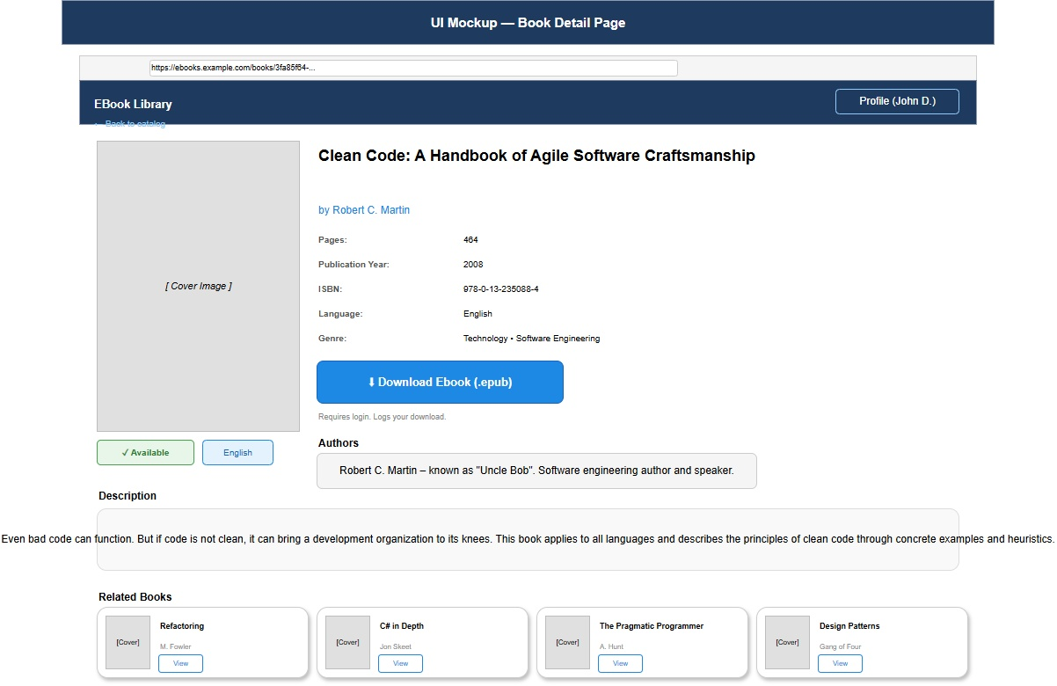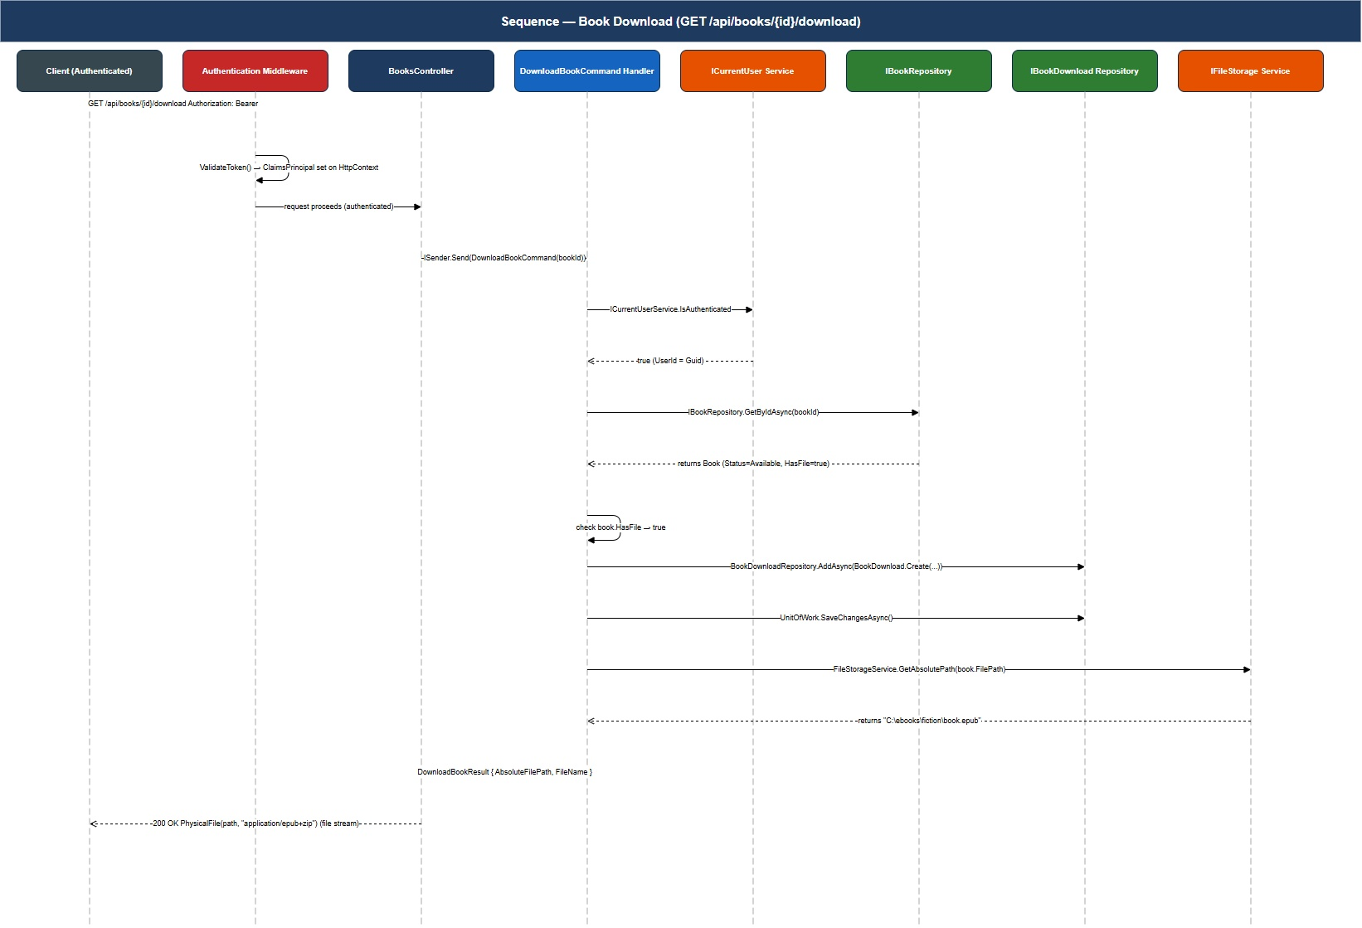
Listing 10.8 — pages/BookDetail.tsx (download handler).
const handleDownload = async () => {
if (!isAuthenticated) { navigate('/login'); return; }
try {
const blob = await booksApi.download(book.id);
const url = URL.createObjectURL(blob);
const a = Object.assign(document.createElement('a'),
{ href: url, download: `${book.title}.epub` });
document.body.appendChild(a); a.click(); a.remove();
URL.revokeObjectURL(url);
notify('success', 'Download started.');
} catch (e) {
notify('error', 'Download failed. Please try again.');
}
};
The pattern of “create a hidden <a>, click it, revoke the URL” is the standard recipe for downloading a Blob in the browser. It is ugly; it is also the only way that works in every browser without relying on third-party libraries.

10.7 Router shape and protected routes
The router uses React Router v6’s nested-route syntax. A RequireAuth wrapper redirects unauthenticated requests to /login; a separate RequireAdmin does the role check.
Listing 10.9 — App.tsx (route table).
<Routes>
<Route element={<AppShell />}>
<Route index element={<Home />} />
<Route path="search" element={<SearchResults />} />
<Route path="books/:id" element={<BookDetail />} />
<Route path="login" element={<Login />} />
<Route path="register" element={<Register />} />
<Route element={<RequireAuth />}>
<Route path="my-downloads" element={<MyDownloads />} />
<Route path="profile" element={<Profile />} />
</Route>
<Route element={<RequireAdmin />}>
<Route path="admin/books" element={<AdminBooks />} />
<Route path="admin/authors" element={<AdminAuthors />} />
<Route path="admin/genres" element={<AdminGenres />} />
<Route path="admin/users" element={<AdminUsers />} />
</Route>
<Route path="*" element={<NotFound />} />
</Route>
</Routes>
RequireAuth and RequireAdmin are tiny — they read the auth store and either render <Outlet /> or <Navigate />.
PITFALL
Frontend route guards are a user-experience feature, not a security feature. They prevent the user from seeing a useless page; they do not prevent a determined caller from hitting the API directly. The protection is on the backend (§ 8.5). Always have both, but never rely on the frontend alone.

10.8 The admin shell
The admin pages share an <AdminLayout> with a sidebar of links and a content area. Each admin page wraps a TanStack Table for the data grid plus a modal for create/edit.
Figure 10.5 — Authors and books in the admin view. Figure 10.6 — Genres and books in the admin view.
The admin pages are deliberately rendered with TanStack Table rather than a heavyweight grid component. The trade-off: no filter UI for free, but full control over column definitions, sorting, and pagination, and no surprise upgrades.

10.9 Build and deployment
npm run build produces a dist/ folder of static files (HTML, JS, CSS, hashed asset paths). The deployment story is “serve dist/ behind the API’s CORS-allowed origin” — anything that can serve static files (Nginx, Azure Static Web Apps, Cloudflare Pages, S3 + CloudFront) is enough.
Listing 10.10 — vite.config.ts (build configuration).
export default defineConfig({
plugins: [react()],
build: {
outDir: 'dist',
sourcemap: true, // useful in production for error tracking
rollupOptions: {
output: {
manualChunks: {
react: ['react', 'react-dom', 'react-router-dom'],
query: ['@tanstack/react-query'],
axios: ['axios'],
},
},
},
},
});
The manual chunks split frequently-cached dependencies into separate files; a deploy that updates only the application code does not bust the user’s cached react.js.

10.10 Checkpoint
You are ready for Chapter 11 when:
- npm run dev starts on port 5173 and the home page renders.
- Login with the seeded admin succeeds and refreshing the page keeps you logged in.
- Searching cervantes returns at least one book.
- The browser’s Network tab shows TanStack Query not refetching a search you just performed.
- Closing and reopening the tab keeps you logged in (verify the ebook-auth key in DevTools → Application → Local Storage).

Key takeaways
- Zustand handles client state with two stores and zero boilerplate.
- TanStack Query handles server state with caching, background refresh, optimistic updates, and retry — features that would otherwise require thousands of lines of bespoke code.
- The Axios client centralizes JWT attachment and 401 handling so components never deal with auth.
- Frontend route guards are UX, not security; the backend is the authoritative gate.
- Vite manual chunking lets a small frontend deploy ship updates without busting common cached dependencies.

Exercises
Easy. Add a “remember me” checkbox to the login form. When unchecked, switch the Zustand persist middleware from localStorage to sessionStorage so the token clears when the tab closes.
Medium. Add a global search box in the header that uses the useDebounce hook (350ms) before issuing a TanStack Query call. Verify in DevTools that no request is sent until the user pauses.
Hard. Replace localStorage JWT storage with httpOnly cookies. This will require backend changes (set-cookie on login, cookie auth scheme on the JWT bearer middleware), CORS changes (AllowCredentials() is already set), and a CSRF token strategy. Discuss what code in the React project simplifies — and what complications appear in the auth store now that the token is no longer JS-readable.

Further reading
- TanStack Query docs. https://tanstack.com/query/latest
- Zustand docs. https://zustand-demo.pmnd.rs/
- Kent C. Dodds, “Application State Management with React”.
- Vite docs — Build Optimizations and Code Splitting.
- React Router v6 — Authentication recipe.

Chapter 11 — The Blazor Frontend
“One language, one mental model, one stack — when that’s the simplification you need, Blazor is unbeatable.”

What you will learn
- How Blazor Server, Blazor WebAssembly, and the modern interactive render modes fit together, and which one this project uses and why.
- How a Razor component composes markup, code-behind, and CSS in a single file (or three).
- How MudBlazor gives the project a complete Material Design component library with no per-control styling.
- How JWT authentication works in a Blazor SPA and why the storage trade-off is the same as React’s.
- How the admin and reader views share an authenticated HttpClient configured once at startup.
- When the Blazor implementation is the right choice, and when React is.

11.1 Why a second frontend exists
The project ships both a React SPA (Chapter 10) and a Blazor SPA (this chapter) against the same Web API. The reason is pedagogical: having two frontends against one backend is the cleanest possible demonstration that the backend is, in fact, frontend-agnostic. If the two SPAs can both consume the same OpenAPI document and the same JWT-protected endpoints, the layering of Chapters 4–7 was real.
The reason in production-flavored thinking is different: most teams will never need two frontends, but most engineers will eventually inherit a Blazor codebase and need to know the ropes. Chapter 11 is the one-chapter Blazor primer that doubles as a deeper test of the backend’s neutrality.

11.2 Choosing a render mode
Blazor in .NET 10 supports four render modes; the choice is the first real decision in any Blazor project.
Table 11.1 — Blazor render modes.
Mode | Where C# runs | Initial load | Interactivity start | Best for
Static SSR | Server (no interactivity) | Fast | Never | Marketing pages, SEO-heavy reads
Interactive Server | Server, over SignalR | Fast | Immediate | Internal apps with reliable LAN
Interactive WebAssembly | Browser | Slow (Wasm) | After Wasm download | Public SPAs that must work offline
Interactive Auto | Server first, Wasm later | Fast | Immediate | Public SPAs that want fast first paint
The project uses Interactive WebAssembly. The reasons:
- It mirrors the React deployment story: a folder of static files plus the Web API. No SignalR backplane. No sticky sessions.
- It demonstrates the frontend-agnostic backend point most forcefully — the Blazor app is, like React, “just an HTTP client”.
- It is the mode most students have seen the least of.
IN PRACTICE
Interactive Server has real strengths — instant startup, near-zero download, full server-side debugging. For internal LOB applications behind a corporate VPN, it is often the right choice. The cost is the SignalR connection: every interactive user holds an open WebSocket, which sets the scaling story. Interactive WebAssembly trades a slow first paint for a stateless server.

11.3 Project structure
The Blazor project lives in src/EBookLibrary.Blazor/. It mirrors the React structure conceptually, but in .NET shape.
Listing 11.1 — Folder layout.
EBookLibrary.Blazor/
├── Pages/ ← @page-routed components: Home, Login, ...
├── Components/ ← Reusable: BookCard, AdminLayout, ...
│ └── Layout/ ← MainLayout, NavMenu
├── Services/ ← API client, auth state provider
├── Models/ ← DTOs mirroring backend
├── wwwroot/ ← Static assets, appsettings.json
├── Program.cs ← Startup
└── App.razor + Routes.razor← Router
There is one Razor file per route, one service per concern, and one authentication state provider that all of them depend on.

11.4 The MudBlazor component library
MudBlazor is the project’s chosen UI library. It provides ~70 Material-Design components — buttons, dialogs, data grids, snackbars, date pickers — with consistent theming and no per-component CSS.
Listing 11.2 — Pages/Login.razor (markup section).
@page "/login"
@inject IAuthService Auth
@inject NavigationManager Nav
<MudContainer MaxWidth="MaxWidth.Small" Class="mt-12">
<MudPaper Class="pa-8">
<MudText Typo="Typo.h4" Align="Align.Center" Class="mb-6">Sign in</MudText>
<EditForm Model="form" OnValidSubmit="SubmitAsync">
<DataAnnotationsValidator />
<MudTextField @bind-Value="form.Email"
Label="Email"
Variant="Variant.Outlined"
Required="true" RequiredError="Email is required" />
<MudTextField @bind-Value="form.Password"
Label="Password"
Variant="Variant.Outlined"
InputType="InputType.Password"
Required="true" RequiredError="Password is required"
Class="mt-4" />
<MudButton ButtonType="ButtonType.Submit"
Variant="Variant.Filled"
Color="Color.Primary" FullWidth="true" Class="mt-6">
Sign in
</MudButton>
@if (!string.IsNullOrEmpty(error))
{
<MudAlert Severity="Severity.Error" Class="mt-4">@error</MudAlert>
}
</EditForm>
</MudPaper>
</MudContainer>
The EditForm + DataAnnotationsValidator pair gives client-side validation derived from the same data annotations the backend uses (§ 5.4). The two layers of validation (client + server) catch different categories of mistake, both are necessary.

11.5 The code-behind half
Razor allows two styles: an @code { } block at the bottom of the .razor file, or a separate .razor.cs partial class. The project uses the partial-class style for anything beyond a few lines.
Listing 11.3 — Pages/Login.razor.cs (code-behind).
public partial class Login : ComponentBase
{
[Inject] public IAuthService Auth { get; set; } = default!;
[Inject] public NavigationManager Nav { get; set; } = default!;
[Inject] public ISnackbar Snackbar { get; set; } = default!;
private LoginForm form = new();
private string? error;
private async Task SubmitAsync()
{
var result = await Auth.LoginAsync(form.Email, form.Password);
if (!result.IsSuccess)
{
error = "Invalid email or password."; // generic — see § 5.5
return;
}
Snackbar.Add("Welcome back!", Severity.Success);
Nav.NavigateTo("/");
}
private sealed class LoginForm
{
[Required, EmailAddress] public string Email { get; set; } = "";
[Required] public string Password { get; set; } = "";
}
}
Code-behind keeps the Razor file readable. It also makes the page unit-testable in isolation (Chapter 12 covers Blazor component tests with bUnit).

11.6 Authentication state
Blazor provides an extensibility point — AuthenticationStateProvider — for pages and components to ask “is the user logged in, and what role?”. The project subclasses it.
Listing 11.4 — Services/JwtAuthenticationStateProvider.cs.
public sealed class JwtAuthenticationStateProvider : AuthenticationStateProvider
{
private readonly ILocalStorageService _storage;
public JwtAuthenticationStateProvider(ILocalStorageService storage)
=> _storage = storage;
public override async Task<AuthenticationState> GetAuthenticationStateAsync()
{
var token = await _storage.GetItemAsync<string>("auth_token");
if (string.IsNullOrWhiteSpace(token))
return new AuthenticationState(new ClaimsPrincipal(new ClaimsIdentity()));
var identity = new ClaimsIdentity(ParseJwtClaims(token), "jwt");
return new AuthenticationState(new ClaimsPrincipal(identity));
}
public void NotifySignIn(string token)
{
var identity = new ClaimsIdentity(ParseJwtClaims(token), "jwt");
NotifyAuthenticationStateChanged(
Task.FromResult(new AuthenticationState(new ClaimsPrincipal(identity))));
}
public void NotifySignOut() =>
NotifyAuthenticationStateChanged(
Task.FromResult(new AuthenticationState(
new ClaimsPrincipal(new ClaimsIdentity()))));
private static IEnumerable<Claim> ParseJwtClaims(string jwt) { /* … */ }
}
Pages declare the user with <AuthorizeView> and <NotAuthorized> sub-tags; the framework reads from this provider. The provider reads from localStorage, which means the same XSS exposure as React applies (§ 8.6) and the same mitigations are recommended.

11.7 The authenticated HttpClient
HttpClient is registered with a delegating handler that attaches the JWT to every request, identical in spirit to the React Axios interceptor of Listing 10.2.
Listing 11.5 — Services/AuthorizationMessageHandler.cs.
public sealed class AuthorizationMessageHandler : DelegatingHandler
{
private readonly ILocalStorageService _storage;
public AuthorizationMessageHandler(ILocalStorageService storage)
=> _storage = storage;
protected override async Task<HttpResponseMessage> SendAsync(
HttpRequestMessage request, CancellationToken ct)
{
var token = await _storage.GetItemAsync<string>("auth_token");
if (!string.IsNullOrWhiteSpace(token))
request.Headers.Authorization =
new AuthenticationHeaderValue("Bearer", token);
return await base.SendAsync(request, ct);
}
}
Program.cs chains the handler into the HttpClient pipeline:
Listing 11.6 — Program.cs (HttpClient registration).
builder.Services
.AddScoped<AuthorizationMessageHandler>()
.AddHttpClient("EBookApi", c =>
c.BaseAddress = new Uri(builder.Configuration["ApiBaseUrl"]!))
.AddHttpMessageHandler<AuthorizationMessageHandler>();
builder.Services.AddScoped(sp =>
sp.GetRequiredService<IHttpClientFactory>().CreateClient("EBookApi"));
Every API service the rest of the project consumes is constructed with this preconfigured HttpClient. The token attachment is invisible to callers.

11.8 The admin dashboard
The admin dashboard combines a MudDataGrid, a paging strip, and a modal MudDialog for the create-and-edit form.
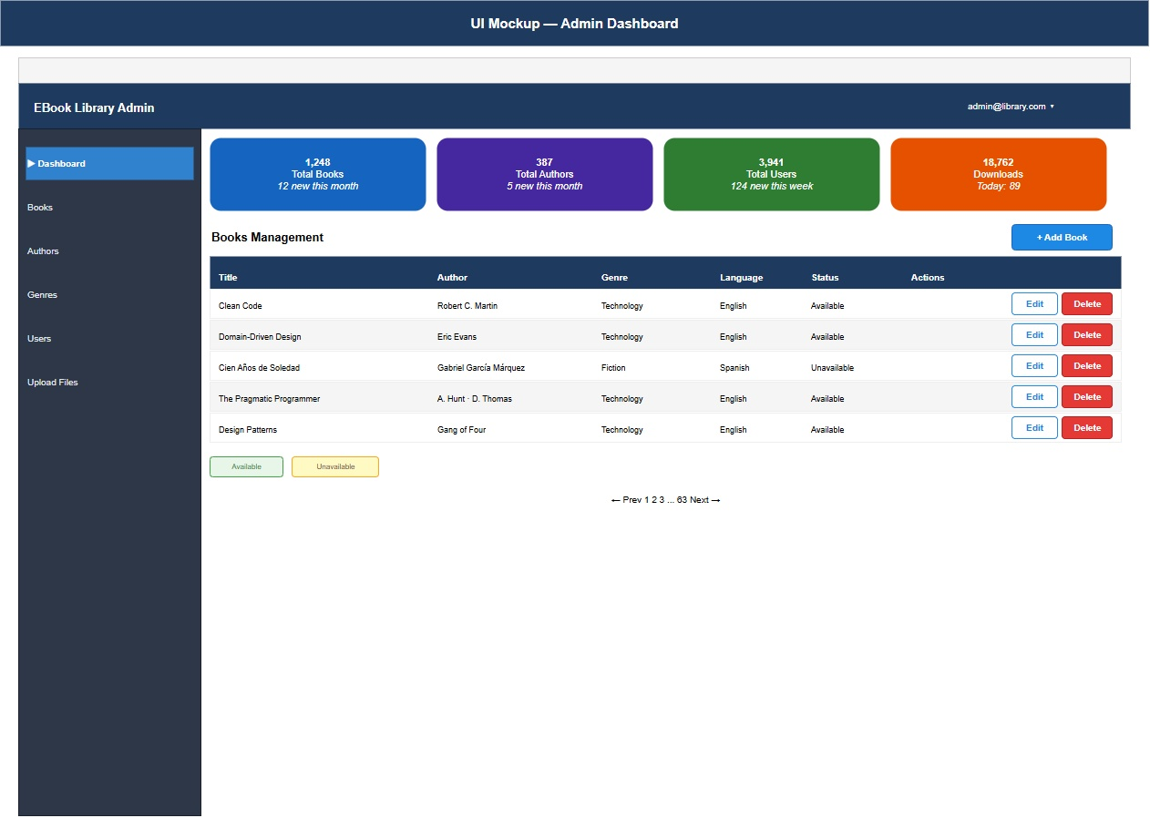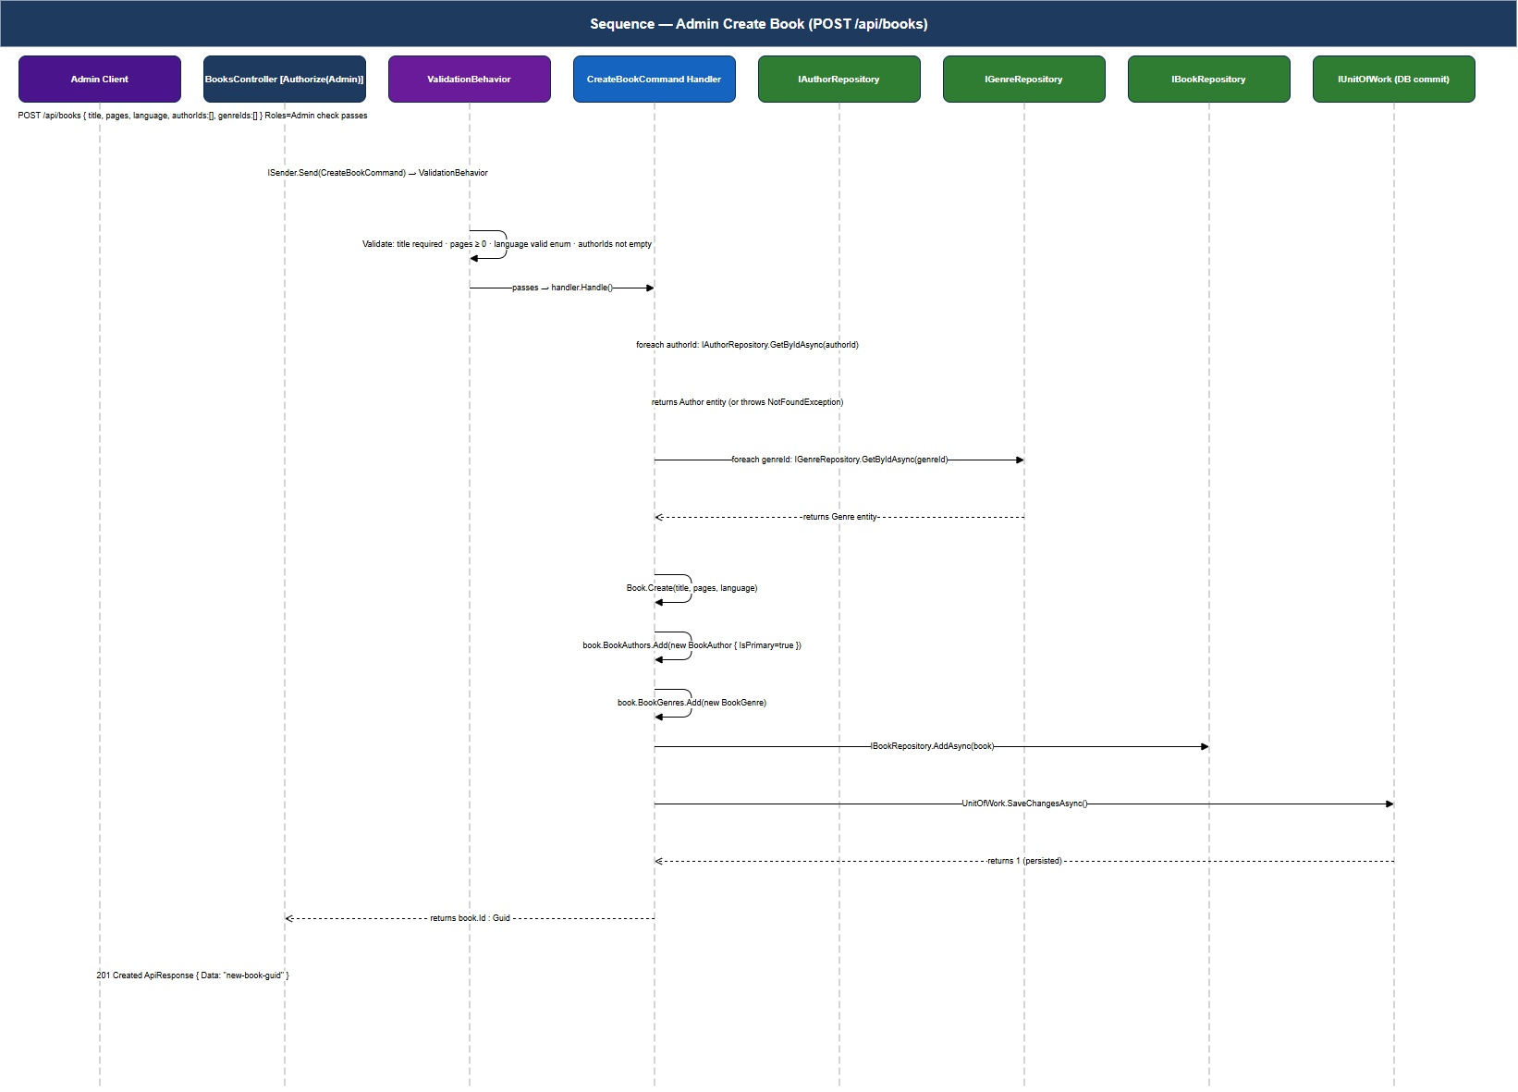
Listing 11.7 — Pages/Admin/Books.razor (data grid sketch).
@page "/admin/books"
@attribute [Authorize(Roles = "Admin")]
<MudDataGrid T="BookListItem" ServerData="LoadServerData" Sortable="true">
<Columns>
<PropertyColumn Property="x => x.Title" Title="Title" />
<PropertyColumn Property="x => x.AuthorNames" Title="Authors" />
<PropertyColumn Property="x => x.Status" Title="Status" />
<TemplateColumn Title="Actions">
<CellTemplate>
<MudIconButton Icon="@Icons.Material.Filled.Edit"
OnClick="() => OpenEdit(context.Item)" />
<MudIconButton Icon="@Icons.Material.Filled.Delete"
OnClick="() => Delete(context.Item)" />
</CellTemplate>
</TemplateColumn>
</Columns>
<PagerContent>
<MudDataGridPager T="BookListItem" />
</PagerContent>
</MudDataGrid>
@attribute [Authorize(Roles = "Admin")] is the Blazor analogue of the controller attribute — and, like the React route guard, is a UX feature, not a security feature. The backend is the authoritative gate.
Architect’s Note: MudDataGrid’s ServerData callback supports server-side paging and sorting natively; the grid hands the callback a GridState<T> describing the page index, page size, and sort definitions, and the callback returns a GridData<T> of the matching slice. Mapping that to the backend’s SearchAsync is one small adapter method. Resist the temptation to use the grid’s client-side mode against a 51K-row catalog — the browser’s memory will not thank you.

11.9 React versus Blazor — a fair comparison
The project’s two SPAs make a side-by-side comparison practical.
Table 11.2 — React vs. Blazor for this project.
Dimension | React (Vite + TS) | Blazor WebAssembly (.NET 10)
Languages a contributor needs | TypeScript + JSX | C# + Razor
Initial download size | ~150–250 KB (gzipped) | ~1.5–2 MB (Wasm runtime)
Time-to-interactive | Fast | Slower (Wasm warm-up)
Component library used here | TanStack Table (mostly bare) | MudBlazor (~70 components)
State management ceremony | Zustand + TanStack Query | Built-in DI + custom services
Server-shared types | Hand-maintained TS types | C# DTOs can be shared as a NuGet
SEO / SSR story | Excellent (Next.js) | Fair (server prerendering)
Hot reload feel | Vite — instant | Good in Server, slower in Wasm
Talent pool | Vast | Significant in .NET shops
The honest summary: for a public consumer SPA, React wins on initial load and SEO; for an internal LOB application in a .NET shop, Blazor wins on language unification. Both are correct here.

11.10 Checkpoint
You are ready for Chapter 12 (and the start of Part III) when:
- dotnet run --project src/EBookLibrary.Blazor/ serves the SPA at https://localhost:7278.
- Login with the seeded admin succeeds and refreshing the page keeps you logged in.
- /admin/books shows the data grid with paged results from the seeded catalog.
- An admin-only /admin/books request still returns from a fresh browser logged in with a regular user — the page renders the “Not authorized” view because the backend rejects the API calls.
- You can articulate the reason this project ships both a React and a Blazor frontend (hint: it is about the backend, not the frontends).

Key takeaways
- Blazor WebAssembly deploys like a SPA — static files behind the same API as React. Server mode is a different story (SignalR, sticky sessions).
- MudBlazor erases the styling tax — every screen looks coherent without per-component CSS.
- The auth pattern mirrors React: a state provider over localStorage, a delegating handler attaching the JWT, the same XSS exposure and the same mitigations.
- Page [Authorize] attributes are UX. The backend is security.
- Two frontends against one backend is the cleanest demonstration that the backend is frontend-agnostic — and a useful exercise in evaluating when each technology earns its keep.

Exercises
Easy. Add a snackbar notification on every successful API mutation (create, update, delete) using ISnackbar. The pattern is already in Login.razor.cs; generalize it.
Medium. Convert one page from @code block style to partial-class code-behind style and write one bUnit test against it. Discuss what became easier and what became more verbose.
Hard. Render the admin dashboard with Interactive Auto mode instead of WebAssembly, accepting the trade-off of needing a SignalR connection on first paint. Measure the time-to-interactive in DevTools and compare with the WebAssembly build. Decide which mode the page deserves and why.

Further reading
- Microsoft, Blazor render modes in the .NET 10 docs. https://docs.microsoft.com/aspnet/core/blazor/components/render-modes
- MudBlazor docs. https://mudblazor.com/
- Steve Sanderson, original Blazor talk (the why of the technology).
- Egil Hansen, bUnit documentation. https://bunit.dev/

Part III — Architecture and Scale
“A working application is a starting point.
Confidence in change is the destination.”

Part II built a complete, working application, top to bottom: domain entities to React UI, with the database, authentication, and Blazor frontend in between. If the project ended there, you would have a respectable senior-engineer portfolio piece.
But shipping software once is not engineering. Engineering is shipping software repeatedly without breaking it, knowing what broke when something does, and being able to onboard a new contributor in a week rather than a month. That is what Part III is about.
We open with two chapters on testing — unit tests in Chapter 12, end-to-end tests in Chapter 13. The contrast between the two is the chapter’s real lesson: every test is an investment, and the question is not “do we test?” but “what shape of test pays back the investment?”.
Chapter 14 turns the lens on the act of writing this software. Most of what is in this book was first drafted with AI assistance — Claude, Copilot, Cursor. The chapter is an honest account of what worked, what did not, and the patterns that distinguish a productive AI collaboration from a frustrating one.
Chapter 15 closes the loop: deployment, observability, secrets, scaling. The chapter promotes what was a one-page checklist in earlier versions into a complete walk through what production demands and how this project’s architecture meets (or does not meet) each demand.
Part III is shorter than Part II by design. The implementation work is largely done; what remains is the work of turning a project into a professional product. The chapters are self-contained — read them in order if you are following the curriculum, or jump to the one your team needs most.
What you will have built by the end of Part III:
- A unit test suite covering every Application handler, every Domain rule, and every controller, running in under thirty seconds.
- An E2E test suite proving the most important user journeys end-to-end in a real browser against a real database.
- A Copilot/Claude collaboration playbook tailored to a Clean Architecture .NET project.
- A production deployment plan with health checks, structured logging, secrets management, and a path forward for scale.
Then, in the back matter, the reference material that keeps the book useful long after the read-through — API reference, exercises with solutions, ADRs, glossary, bibliography, and index.

Chapter 12 — Unit Tests
“A test you trust is worth a hundred tests you fear to run.”

What you will learn
- The unit-testing pyramid as it applies to a Clean Architecture project: most tests at the Domain and Application layers, fewer at the Web API edge.
- The xUnit + FluentAssertions + Moq triad and the small set of conventions that keeps tests readable.
- How to test MediatR handlers without spinning up a database.
- How to test controllers without spinning up the ASP.NET Core pipeline.
- How WebApplicationFactory enables genuine integration tests when the unit-test layer is not enough.
- How to measure coverage and what coverage actually proves.

12.1 The pyramid, restated
The classical testing pyramid says: many small unit tests, a moderate number of integration tests, a few end-to-end tests. In a Clean Architecture project the pyramid maps cleanly onto the layers.
Table 12.1 — What lives at each tier in this project.
Tier | Project | Speed | Volume target
Domain unit | EBookLibrary.Domain.Tests | Microseconds | High (every invariant)
Application unit | EBookLibrary.Application.Tests | Milliseconds | High (every handler)
Web API integration | EBookLibrary.WebApi.Tests | Tens of ms | Medium (every endpoint shape)
End-to-end | EBookLibrary.E2E.Tests | Seconds | Low (critical journeys only)
The Domain tests never touch a database, an HTTP client, or a file. Application tests use Moq for the repository interfaces. Web API tests use WebApplicationFactory with an in-memory or test-container database. E2E tests (Chapter 13) drive a real browser against a real backend.
Architect’s Note: The pyramid is not religion. Some teams invert it (“the testing trophy” — Kent C. Dodds) on the grounds that integration tests catch the real bugs. The shape that matters for this project is “many fast, few slow”; how many of the fast ones live in Domain versus Application versus controllers is a matter of which layer holds the most consequential logic. In our case that is Application.

12.2 The toolkit
The whole testing stack fits in five NuGet packages:
<PackageReference Include="xunit" Version="2.9.2" />
<PackageReference Include="xunit.runner.visualstudio" Version="2.8.2" />
<PackageReference Include="FluentAssertions" Version="6.12.2" />
<PackageReference Include="Moq" Version="4.20.72" />
<PackageReference Include="Microsoft.NET.Test.Sdk" Version="17.11.1" />
xUnit is the runner. FluentAssertions makes assertions read like English. Moq mocks the interfaces your handler depends on. The ASP.NET Core integration tests add Microsoft.AspNetCore.Mvc.Testing for WebApplicationFactory.
IN PRACTICE
Every team has a tabs-versus-spaces argument over the assertion library. NUnit’s Assert.That and FluentAssertions’ Should().Be() and Shouldly’s ShouldBe all do the same thing. Pick one, write a one-paragraph rationale in your README, and stop revisiting the choice.

12.3 A Domain test
Domain tests are the fastest, smallest tests in the project. They construct an entity and assert that its invariants hold.
Listing 12.1 — EBookLibrary.Domain.Tests/Entities/BookTests.cs.
public sealed class BookTests
{
[Fact]
public void Create_with_valid_title_succeeds()
{
var book = Book.Create("Don Quixote", BookLanguage.Spanish);
book.Title.Should().Be("Don Quixote");
book.Status.Should().Be(BookStatus.Draft);
book.IsDeleted.Should().BeFalse();
book.CreatedAt.Should().BeCloseTo(DateTime.UtcNow, TimeSpan.FromSeconds(1));
}
[Theory]
[InlineData("")]
[InlineData(" ")]
[InlineData(null)]
public void Create_with_blank_title_throws(string? title)
{
var act = () => Book.Create(title!, BookLanguage.Spanish);
act.Should().Throw<DomainValidationException>()
.WithMessage("*Title*");
}
[Fact]
public void Publish_from_draft_emits_BookPublishedEvent()
{
var book = Book.Create("Don Quixote", BookLanguage.Spanish);
book.Publish();
book.Status.Should().Be(BookStatus.Published);
book.DomainEvents.Should().ContainSingle()
.Which.Should().BeOfType<BookPublishedEvent>();
}
[Fact]
public void Publish_when_already_published_throws()
{
var book = Book.Create("Don Quixote", BookLanguage.Spanish);
book.Publish();
var act = () => book.Publish();
act.Should().Throw<DomainException>()
.WithMessage("*already published*");
}
}
Four tests, four invariants, fewer than fifty lines. Each test name reads as a sentence: “Create with valid title succeeds.”. Each assertion reads as a sentence too. There is one Arrange–Act–Assert flow per test and no setup beyond the Create() call.
PITFALL
Tests that share state across [Fact] methods (a static field, a [ClassInitialize] that mutates) are the hardest tests to debug when a single one fails for a reason that depends on the order they ran in. Prefer fresh setup per test, even when it repeats. The cost is a few extra microseconds; the benefit is that a red test means that test is broken, not “something earlier in the suite poisoned the well”.

12.4 An Application handler test
Handler tests are where most of the business-logic coverage lives. They construct the handler with mocked dependencies, send a command, and assert on both the result and the calls made on the mocks.
Listing 12.2 — EBookLibrary.Application.Tests/Books/CreateBookCommandHandlerTests.cs.
public sealed class CreateBookCommandHandlerTests
{
private readonly Mock<IUnitOfWork> _uow = new();
private readonly Mock<IBookRepository> _books = new();
private readonly Mock<IFileStorage> _files = new();
private readonly CreateBookCommandHandler _sut;
public CreateBookCommandHandlerTests()
{
_uow.Setup(u => u.Books).Returns(_books.Object);
_sut = new CreateBookCommandHandler(_uow.Object, _files.Object);
}
[Fact]
public async Task Returns_failure_when_isbn_already_exists()
{
_books.Setup(r => r.ExistsByIsbnAsync("978-1-234567-89-0", default))
.ReturnsAsync(true);
var result = await _sut.Handle(new CreateBookCommand(
Title: "Don Quixote", Isbn: "978-1-234567-89-0", /* … */),
CancellationToken.None);
result.IsSuccess.Should().BeFalse();
result.Errors.Should().Contain(e => e.Contains("ISBN", StringComparison.OrdinalIgnoreCase));
_books.Verify(r => r.AddAsync(It.IsAny<Book>(), default), Times.Never);
_uow.Verify(u => u.SaveChangesAsync(default), Times.Never); // ← important
}
[Fact]
public async Task Adds_book_and_commits_when_valid()
{
_books.Setup(r => r.ExistsByIsbnAsync(It.IsAny<string>(), default))
.ReturnsAsync(false);
var result = await _sut.Handle(new CreateBookCommand(
Title: "Don Quixote", Isbn: "978-1-234567-89-0", /* … */),
CancellationToken.None);
result.IsSuccess.Should().BeTrue();
_books.Verify(r => r.AddAsync(
It.Is<Book>(b => b.Title == "Don Quixote"), default), Times.Once);
_uow.Verify(u => u.SaveChangesAsync(default), Times.Once);
}
}
Notice two patterns.
- The constructor builds the System Under Test once. xUnit creates a fresh instance per test, so this is safe and keeps each [Fact] focused on Arrange/Act/Assert without ceremony.
- Negative tests verify no side effect. The Times.Never assertions are the line that catches the bug “validation passes but we still save”. They are easy to forget; they are the most valuable assertions.
IN PRACTICE
Moq is comfortable but verbose. NSubstitute is the same expressive power with less boilerplate. The choice is mostly taste. Whichever you pick, do not mix them in one project — the cognitive cost of two mocking grammars in one suite is more than the cost of either alone.

12.5 A controller test with WebApplicationFactory
Some bugs only show up when the full middleware pipeline runs: attribute routing, model binding, JSON serialization, authentication, exception middleware. WebApplicationFactory<TEntryPoint> boots an in-memory ASP.NET Core server so tests can issue real HTTP requests to the assembled app.
Listing 12.3 — EBookLibrary.WebApi.Tests/Controllers/BooksControllerTests.cs.
public sealed class BooksControllerTests : IClassFixture<WebApplicationFactory<Program>>
{
private readonly HttpClient _client;
public BooksControllerTests(WebApplicationFactory<Program> factory)
{
_client = factory
.WithWebHostBuilder(b => b.ConfigureServices(s =>
{
// Replace the real DbContext with an in-memory one.
s.RemoveAll<DbContextOptions<AppDbContext>>();
s.AddDbContext<AppDbContext>(o => o.UseInMemoryDatabase("tests"));
}))
.CreateClient();
}
[Fact]
public async Task Search_without_query_returns_200_and_envelope()
{
var resp = await _client.GetAsync("/api/books/search?pageNumber=1&pageSize=10");
resp.StatusCode.Should().Be(HttpStatusCode.OK);
var body = await resp.Content.ReadFromJsonAsync<ApiResponse<PagedResult<BookListItem>>>();
body.Should().NotBeNull();
body!.Success.Should().BeTrue();
body.Data.Should().NotBeNull();
}
[Fact]
public async Task Create_without_token_returns_401()
{
var resp = await _client.PostAsJsonAsync("/api/books", new { Title = "Test" });
resp.StatusCode.Should().Be(HttpStatusCode.Unauthorized);
}
[Fact]
public async Task Create_with_user_token_returns_403()
{
var token = await GetUserTokenAsync();
_client.DefaultRequestHeaders.Authorization = new("Bearer", token);
var resp = await _client.PostAsJsonAsync("/api/books", new { Title = "Test" });
resp.StatusCode.Should().Be(HttpStatusCode.Forbidden); // protects the § 8.4 bug
}
}
The third test is the one explicitly catching the most consequential JWT misconfiguration from § 8.4. If the role claim is emitted as "role" instead of ClaimTypes.Role, this assertion fails — the endpoint returns 403 regardless of role, which is not what the test expected. The test is the protection.
PITFALL
EF Core’s in-memory provider is fine for fast smoke tests of HTTP shapes. It is not a faithful SQL Server. It does not enforce constraints the way SQL Server does, it does not support transactions identically, and global query filters can behave subtly differently. For tests that depend on real database behavior — concurrency, indexes, ranking — use Testcontainers with a real SQL Server image.

12.6 What to test, what to skip
A handful of practical rules cuts most of the “what should I test?” debate.
- Test every Domain invariant. Each “throws when…” rule deserves a one-line [Fact]. Cheap, valuable, regression-resistant.
- Test every Application handler. Both the success path and the most plausible failure path.
- Test the controller’s wiring, not its logic. It has no logic — just verify the dispatch is correct and the status codes match.
- Skip tests of EF Core itself. EF Core is tested by Microsoft. You are not paid to re-test it.
- Skip tests of trivial one-liners. A getter that returns a field does not need a test.
- Do test value object equality. Equality is the kind of silently-wrong code that bites later.
The combined effect: a test count that grows with behavior, not with lines of code.

12.7 Coverage and what it proves
The project measures line coverage with coverlet.collector. A typical run looks like:
EBookLibrary.Domain — 95% (most one-line constructors covered by handler tests)
EBookLibrary.Application — 88% (every handler covered, edge branches mixed)
EBookLibrary.Infrastructure — 62% (covered indirectly by integration tests)
EBookLibrary.WebApi — 78% (controllers covered; Program.cs is excluded)
The numbers are useful as a trend and dangerous as a target. Coverage measures whether a line ran during the suite — it does not measure whether the line was exercised meaningfully. A handler test that calls the handler and asserts nothing has 100% coverage and zero value.
Architect’s Note: Goodhart’s Law applies: “When a measure becomes a target, it ceases to be a good measure.” A team mandate of “we must hit 90% coverage” produces tests written to satisfy the mandate, not to catch bugs. Track coverage, look at the trend, and investigate sharp drops. Do not fail the build on a coverage threshold.

12.8 Running the suite
The whole suite runs from the repository root.
# Run everything (except E2E, which is its own project)
dotnet test --filter "FullyQualifiedName!~E2E"
# Run a single project
dotnet test tests/EBookLibrary.Application.Tests/
# Collect coverage
dotnet test --collect:"XPlat Code Coverage"
A target of “all unit tests run in under thirty seconds on a developer laptop” is a useful discipline. If the suite drifts past thirty seconds, the slow tests are usually doing something they do not need to do (touching a real database, awaiting a real timer, booting a WebApplicationFactory per test rather than per class).

12.9 Checkpoint
You are ready for Chapter 13 when:
- dotnet test is green from a clean checkout.
- You can name the assertion in Listing 12.3 that protects against the JWT role-claim bug.
- You can write a Domain test from scratch for an invariant in one of the entities you authored in Chapter 4.
- You can explain when EF Core’s in-memory provider is enough and when it is misleading.
- Coverage is reported but does not fail the build.

Key takeaways
- Most tests live at Domain and Application — fast, focused, database-free.
- xUnit + FluentAssertions + Moq is the project’s standard stack.
- Negative tests need Times.Never assertions; the line “we did not save” catches the bug “we validated wrong but saved anyway”.
- WebApplicationFactory exposes the full middleware pipeline for integration tests when unit tests cannot reach.
- Coverage is a useful trend signal and a misleading target. Track it; do not gate on it.

Exercises
Easy. Add a [Theory] to BookTests with InlineData covering five separate invalid Isbn values and one valid one. Use a single test method with a bool expectedValid parameter.
Medium. Write a test for LoginUserCommandHandler that asserts the generic error message is returned for both “no such user” and “wrong password” — protecting the § 5.5 anti-enumeration property.
Hard. Replace the in-memory database in Listing 12.3 with Testcontainers running a real SQL Server image. Measure how the suite duration changes. Discuss the trade-off of fidelity for speed and where in your project’s test pyramid Testcontainers belongs.

Further reading
- xUnit documentation. https://xunit.net/
- FluentAssertions documentation. https://fluentassertions.com/
- Vladimir Khorikov, Unit Testing Principles, Practices, and Patterns — the best modern book on the subject.
- Roy Osherove, The Art of Unit Testing, 3rd ed.
- Kent C. Dodds, “The Testing Trophy and Testing Classifications” — the case for inverting the pyramid.

Chapter 13 — End-to-End Tests
“A test that drives the real browser tells you the real story.”

What you will learn
- The role end-to-end tests play in addition to the unit tests of Chapter 12 — and the small set of journeys that earn their slow runtime.
- How Playwright for .NET drives Chromium, Firefox, and WebKit with a single API, against either the React or the Blazor frontend.
- The Page Object Model pattern that keeps an E2E suite maintainable beyond the first ten tests.
- How to run the suite headlessly in CI and how to record video and trace files for failed runs.
- The five anti-patterns that turn an E2E suite into a flaky burden.

13.1 Why E2E tests, given the unit tests
The unit tests of Chapter 12 prove the controller dispatches, the handler handles, the entity validates. They do not prove that a user clicking the Sign in button on the React app actually logs in. The gap is in the wiring: the form’s onSubmit, the API client, the CORS preflight, the JWT round-trip, the route guard, the data fetch on the landing page. Any one of those can break in a way no unit test sees.
E2E tests cover the wiring. The trade-off is steep: they are slow (seconds per test, not microseconds), they are brittle (a CSS selector changes and the test breaks), and they require a running stack. The trade is worth it for the small set of journeys that actually matter.
IN PRACTICE
A useful rule: one E2E per business-critical user journey. For this project that is roughly five — register, login, search, download, admin-create-book. Add the sixth E2E only when an incident proves it earns its keep. A team that writes “an E2E for every page” inevitably ends up with an E2E suite they ignore because it is too slow and too red.

13.2 The Playwright stack
The project uses Playwright for .NET — Microsoft’s cross-browser automation library, with a strongly-typed C# API that matches the JavaScript original almost line-for-line.
<PackageReference Include="Microsoft.Playwright" Version="1.51.0" />
<PackageReference Include="Microsoft.Playwright.NUnit" Version="1.51.0" />
After install, browser binaries are downloaded with one command:
pwsh tests/EBookLibrary.E2E.Tests/bin/Debug/net10.0/playwright.ps1 install
That fetches Chromium, Firefox, and WebKit. The same test suite runs against any of the three by changing one configuration line.

13.3 The shape of an E2E test
A first end-to-end test in raw form — before any abstractions — looks like Listing 13.1.
Listing 13.1 — LoginJourneyTests.cs (raw, no Page Object).
public sealed class LoginJourneyTests : PageTest
{
[SetUp]
public async Task NavigateToHome() =>
await Page.GotoAsync("https://localhost:5173");
[Test]
public async Task Admin_can_log_in_and_reach_dashboard()
{
await Page.ClickAsync("a:has-text('Sign in')");
await Page.FillAsync("input[name='email']", "admin@ebooklibrary.dev");
await Page.FillAsync("input[name='password']", "Admin#2026!");
await Page.ClickAsync("button[type='submit']");
await Expect(Page).ToHaveURLAsync(new Regex(@"\/$")); // back to home
await Expect(Page.Locator("a:has-text('Admin')")).ToBeVisibleAsync();
}
}
The test reads top to bottom as a user story. Expect(...) calls are auto-retrying — they wait up to the default timeout for the assertion to become true. There is no manual Sleep or WaitForElementAsync; that is a Playwright design decision that has aged extremely well.
PITFALL
Never use Task.Delay/Thread.Sleep in an E2E test. The “wait long enough that the slowest CI box can keep up” anti- pattern leads to a suite that takes hours and still flakes. Trust Playwright’s auto-waiting; if a ClickAsync is racy, fix the selector to be more specific, do not throw a timer at it.

13.4 The Page Object Model
By the third test, common operations (login, search, navigate) are duplicated. The Page Object Model groups the operations offered by a page into a class.
Listing 13.2 — Pages/LoginPage.cs.
public sealed class LoginPage
{
private readonly IPage _page;
public LoginPage(IPage page) => _page = page;
public Task GoToAsync() => _page.GotoAsync("/login");
public async Task SignInAsync(string email, string password)
{
await _page.FillAsync("input[name='email']", email);
await _page.FillAsync("input[name='password']", password);
await _page.ClickAsync("button[type='submit']");
}
public ILocator ErrorAlert => _page.Locator("[role='alert']");
}
The test then reads even closer to a user story.
Listing 13.3 — LoginJourneyTests.cs (with Page Object).
[Test]
public async Task Wrong_password_shows_generic_error()
{
var login = new LoginPage(Page);
await login.GoToAsync();
await login.SignInAsync("admin@ebooklibrary.dev", "wrong-password");
await Expect(login.ErrorAlert).ToContainTextAsync("Invalid email or password");
// Generic — see § 5.5. Test passes only if the API and frontend
// both honor the anti-enumeration discipline.
}
The page object owns the selectors. When the form’s HTML changes, exactly one file changes — not every test that touched the form.

13.5 The five journeys this project tests
The E2E suite is small on purpose. Each test maps to a user-visible business journey.
Table 13.1 — The full E2E suite.
# | Journey | Time | Why it earns its keep
1 | Anonymous search → result list | 3 s | Catches CORS, OpenAPI, paging contract drift.
2 | Register → auto-login → home | 5 s | Catches BCrypt config, JWT issuance, persistence wiring.
3 | Login (admin) → reach /admin/books | 4 s | Catches the role-claim bug from § 8.4 in production-like form.
4 | Login → book detail → download | 6 s | Catches file-streaming bugs and the download-while-anon redirect.
5 | Admin: create book → appears in search | 8 s | Catches the entire write path including TanStack Query invalidation.
Five tests. ~30 seconds total. Run on every pull request.
Architect’s Note: The constraint “the E2E suite finishes in under one minute” forces the right kind of selectivity. A team that permits a fifteen-minute E2E suite quickly stops blocking PRs on it; a team that permits a sixty-second E2E suite blocks every PR on it gladly. The short suite is the useful suite.

13.6 Test data and isolation
The hardest problem in E2E testing is data. Tests must start from a known state and must not leave the database in a state that breaks the next test.
The project’s strategy is the simplest one that works:
- The CI pipeline spins up a SQL Server Testcontainer per E2E run.
- The Web API points at that container’s connection string via an environment variable.
- The seeder runs once, populating the admin user and a small curated catalog of ten books.
- Tests that need write data create their own (with timestamp-suffixed titles to avoid collision).
- The container is torn down at the end of the run.
No cleanup code per test. Each test run gets a fresh database. Total provisioning time: ~12 seconds. Worth it.
PITFALL
“Run the suite against the staging database” is a tempting shortcut that ends in tears. The first test that creates a book leaves the book in staging. The fifth run, the search test finds six test books, not five, and fails. Either fully isolate per run or accept the flake.

13.7 CI integration and trace artifacts
In CI the suite runs headless. On failure, Playwright records video, screenshots, and a trace file — a complete recording of network calls, DOM mutations, and console output — that can be replayed in the Playwright Trace Viewer.
Listing 13.4 — playwright.config excerpt (from BaseTest.cs).
[OneTimeSetUp]
public async Task GlobalSetup()
{
var playwright = await Playwright.CreateAsync();
Browser = await playwright.Chromium.LaunchAsync(new BrowserTypeLaunchOptions
{
Headless = true,
});
}
[SetUp]
public async Task PerTestSetup()
{
Context = await Browser.NewContextAsync(new BrowserNewContextOptions
{
RecordVideoDir = "videos/",
});
await Context.Tracing.StartAsync(new TracingStartOptions
{
Screenshots = true, Snapshots = true, Sources = true,
});
}
[TearDown]
public async Task PerTestTeardown()
{
var failed = TestContext.CurrentContext.Result.Outcome.Status == TestStatus.Failed;
await Context.Tracing.StopAsync(new TracingStopOptions
{
Path = failed ? $"traces/{TestContext.CurrentContext.Test.Name}.zip" : null,
});
await Context.CloseAsync();
}
A failed CI run uploads the trace as a build artifact. Opening the trace in pwsh playwright.ps1 show-trace traces/<test>.zip plays back exactly what the browser did, frame by frame, with a network panel and a DOM snapshot per action. This single feature is the reason E2E debugging in 2025 is finally bearable.

13.8 The five anti-patterns that ruin E2E suites
After years of watching teams write E2E suites, the same five failure modes recur.
Table 13.2 — E2E anti-patterns and their fixes.
Anti-pattern | Symptom | Fix
Thread.Sleep(2000) instead of waiting for state | Suite is slow and still flakes | Use Playwright’s auto-waiting locators
Selectors based on nth-child(3) or class name | Test breaks every time the designer touches the DOM | Use data-testid attributes that survive redesign
Tests that depend on each other’s state | Reordering or running one test in isolation fails | Each test creates the data it needs; clean by isolation
Catching all exceptions in a test | Tests “pass” while the page is showing a crash dialog | Let the test framework see the failure
One enormous test that does five things | Failure tells you “something broke” with no localization | Split into the five things
The data-testid recommendation is worth elaborating. Frontend designers reorganize markup constantly; CSS selectors break with every redesign. A data-testid="login-submit" attribute on the button is invisible to users, immune to redesign, and an explicit contract between the frontend and the test suite.

13.9 Running the suite
# All E2E tests against Chromium (default)
dotnet test tests/EBookLibrary.E2E.Tests/
# Single test, with the browser visible (debug mode)
dotnet test tests/EBookLibrary.E2E.Tests/ `
--filter "Name=Admin_can_log_in_and_reach_dashboard" `
-- TestRunParameters.Parameter\(name=\"Headless\",value=\"false\"\)
# Against Firefox
$env:BROWSER = "firefox"; dotnet test tests/EBookLibrary.E2E.Tests/
# Open the latest trace
pwsh tests/EBookLibrary.E2E.Tests/playwright.ps1 show-trace traces/latest.zip
For development the visible-browser run is the right tool — you watch the test, see the click, see the form fill, see the assertion. For CI the headless run is faster and produces the trace artifact for post-mortem.

13.10 Checkpoint
You are ready for Chapter 14 when:
- dotnet test tests/EBookLibrary.E2E.Tests/ runs and the five journeys pass against your local stack.
- You can name the bug Test #3 catches that no unit test would.
- You know what the Trace Viewer is and have opened a trace for a passing run to see what it shows.
- You can articulate why the suite has five tests and not fifty.
- You can write a sixth journey test from scratch using the Page Object pattern.

Key takeaways
- E2E tests cover the wiring that unit tests cannot reach. Keep them few and keep them meaningful.
- Playwright’s auto-waiting locators eliminate the Thread.Sleep-and-pray anti-pattern.
- The Page Object Model concentrates selectors in one place per page, surviving redesigns gracefully.
- Each E2E run gets a fresh database via Testcontainers; per-test cleanup is replaced by per-run isolation.
- A trace from a failed CI run replays the full browser session — the single feature that makes modern E2E debugging tractable.

Exercises
Easy. Add data-testid attributes to the five elements the existing E2E suite touches: email input, password input, submit button, error alert, admin nav link. Replace the text-and-CSS selectors in the page objects with [data-testid='...'] selectors. Run the suite; nothing should change.
Medium. Add a sixth journey: registered reader downloads a book. The test signs up a fresh user (timestamp-suffixed email), logs in, navigates to a known book, clicks Download, and asserts that the download finishes. Use Playwright’s Page.WaitForDownloadAsync() API.
Hard. Configure the suite to run against both the React frontend (port 5173) and the Blazor frontend (port 7278) by parameterizing the base URL. Discuss what assertions are portable across the two frontends and which ones depend on framework-specific markup.

Further reading
- Playwright for .NET docs. https://playwright.dev/dotnet/
- Trace Viewer guide. https://playwright.dev/dotnet/docs/trace-viewer
- Cypress’s Best Practices page — even if you do not use Cypress, the principles transfer.
- Martin Fowler, “Page Object”. The original write-up.
- Testcontainers for .NET docs.
🤖 AI-ASSISTED DEVELOPMENT NOTES

Chapter 14 — AI-Assisted Development
“Treat the AI like a strong intern with a perfect memory and no common sense.”

What you will learn
- The honest history of how this book and the project it documents were built with AI assistance — what worked, what did not.
- The single distinguishing pattern between a productive AI collaboration and a frustrating one: context curation.
- How GitHub Copilot, Cursor, and Anthropic Claude each fit into a Clean Architecture .NET workflow.
- A handful of prompt patterns that consistently produce better code: the role plus context plus constraints plus example pattern, the explain back to me pattern, the plan first pattern.
- The classes of bugs AI introduces that the unit tests of Chapter 12 are specifically designed to catch.
- A fair-witness comparison of three real workflows: Copilot inline, Copilot Chat / Agent Mode, and Claude (or any LLM) in a separate window.

14.1 An honest accounting
This book — its prose and its code — was built with substantial AI assistance. The Domain entities of Chapter 4 were drafted by Claude and revised by hand. The MediatR pipeline of Chapter 5 was first generated by Copilot and then audited line by line for the single-responsibility violation any LLM is prone to. The React frontend of Chapter 10 was about 60% AI-drafted, 40% hand-written, by volume — and the important 5% (auth state, error handling, optimistic update rollback) was almost entirely hand-written, because that is where AI’s defaults silently miss.
The chapter is about what those numbers mean. There is a productive collaboration to be had with modern coding assistants. There is also a sloppy one. The difference is mostly habits.
Architect’s Note: The headline-grabbing “AI writes 80% of the code” stat from various surveys is an arithmetic average that hides a bimodal distribution. The first mode is “boilerplate” — DTO mappers, repetitive controller methods, test scaffolds — where AI is very nearly 100% productive. The second mode is “load-bearing logic” — security, concurrency, schema, public API surface — where AI is better thought of as a reviewer than an author. Treat them differently.

14.2 Context curation, the only thing that really matters
Across every assistant, every model, every workflow, the single pattern that distinguishes good output from bad is what context the model had. The same model, given the project’s IUnitOfWork interface, the relevant entity, and a clear prompt, produces a correct handler. The same model, given just the prompt, produces a plausible handler that violates conventions established three folders away.
The implication: most of your job in an AI-assisted workflow is not “write a clever prompt”. It is “make sure the model can see the right files”.
Three concrete tactics that pay back the time:
- Open the files that demonstrate the conventions before prompting. In Cursor and Copilot Chat, open files become context. In Claude or ChatGPT, paste the relevant snippets explicitly.
- Share the interface, not the implementation. When asking for a new handler, share IBookRepository, IUnitOfWork, Result<T> — not the existing handler implementations. The model should write the implementation; the interfaces tell it what is available.
- Share one example of the pattern. A single existing handler that establishes “this is what handlers look like in this project” is worth more than a paragraph of prose describing the same.

14.3 The four prompt patterns
Across hundreds of interactions, four patterns kept producing better code than ad hoc prompting.

Pattern 1 — Role + Context + Constraints + Example
You are a senior .NET 10 backend engineer working in a Clean
Architecture solution. (role)
The project uses MediatR for CQRS, FluentValidation for validation,
and a Result<T> envelope returned from every handler.
Existing interfaces (paste IUnitOfWork, IBookRepository, Result<T>).
Existing handler example: CreateBookCommandHandler (paste).
(context)
Constraints:
- No exceptions for business validation; use Result<T>.Failure.
- Use the soft-delete-aware repository methods (no .IgnoreQueryFilters).
- The handler must be sealed.
(constraints)
Task: write UpdateBookCommandHandler that updates an existing book's
title, ISBN, and description. Keep the same shape as
CreateBookCommandHandler.
(example-anchored task)
This pattern works because it removes ambiguity. The model is not guessing what the project’s idioms are; it is matching them.

Pattern 2 — Plan first
For any change touching more than one file, ask the model for a plan before it writes code:
Before you write any code, give me a numbered plan: which files you
will create, which you will modify, and the rough shape of each
change. Wait for my approval before writing the code.
Two-thirds of the time the plan exposes a misunderstanding that would have wasted ten minutes of generated code. The other third you say “yes” and the work proceeds.

Pattern 3 — Explain back to me
After a complex piece of logic — a query, a security check, a state machine — ask:
Walk me through what this code does, line by line, and identify any
edge cases that would break it.
If the explanation reveals the model “thinks” the code does something the code does not, that is your bug detector firing. Sometimes the code is right and the explanation is wrong (rare); sometimes the explanation is right and the code is wrong; usually both are wrong in the same direction.

Pattern 4 — Constrain the diff
For edits to existing files, constrain which parts can change:
Modify only the SearchAsync method. Do not change any other method
signature. Preserve all using-statements. Show the diff, not the full
file.
Without this constraint, models cheerfully “improve” unrelated code and quietly delete edge cases your tests covered. The diff form makes drift visible.

14.4 The bugs to watch for
AI assistants introduce a recognizable family of bugs. The unit tests of Chapter 12 are specifically designed to catch them; if you know what to look for, you can short-circuit the cycle.
Table 14.1 — AI-introduced bug families.
Family | Example | Who catches it
Plausible-but-wrong API names | BCrypt.HashPassword(p, 12) vs. BCrypt.Net.BCrypt.HashPassword | Compiler
Outdated framework idioms | services.AddSwaggerGen() in a project using Scalar (§ 7.8) | Code review
Defensive-programming bloat | if (book == null) throw… for a value the type system already proves | Code review
Silent SR violation | A handler that also does file I/O (§ 5.7) | Architect’s eye
Off-by-one / sign errors | Skip((page) * size) instead of Skip((page - 1) * size) | Unit test for paging
Forgotten Times.Never | Negative test asserts the error but does not assert the non-save | Mutation test
Wrong claim type (§ 8.4) | new Claim("role", ...) instead of ClaimTypes.Role | The integration test in Listing 12.3
Missing CORS preflight handling | Auth middleware before CORS (§ 7.5) | The first browser-driven E2E (Chapter 13)
Hallucinated NuGet packages | Microsoft.AspNetCore.SomethingPlausible | NuGet restore
The remedy in every row is the same: a test, a compiler, or a human review. The lesson is that an AI-assisted workflow is not “AI writes the code” — it is “AI writes the code, the system catches the mistakes”.
PITFALL
“I’ll skip the tests because Copilot is so reliable these days” is the single most expensive false economy in modern software. Copilot’s reliability increases the value of your tests, because the tests are the only thing standing between you and the bug class above. Write the tests first; let the AI write the implementation; let the tests catch what the AI missed.

14.5 Three real workflows
The three workflows below are the ones used in this project. Each has a sweet spot.

Copilot inline (autocomplete)
Best for: the last 30% of a method you have already started writing. “Type the method signature and let it finish” is where Copilot inline shines.
Worst for: load-bearing logic. The autocomplete suggestion is optimized for plausibility, not correctness. Read every accepted completion before tabbing.

Copilot Chat / Agent Mode
Best for: scaffolding new files in a project with established conventions. “Create a new MediatR handler for X” with the existing handler open as context produces near-perfect output.
Worst for: cross-cutting changes. Agent mode will happily edit fifteen files; auditing fifteen files of AI-generated change is not faster than writing the changes yourself.

Claude (or any LLM) in a separate window
Best for: design conversations. “Here is my proposed schema; what will this be hard to do in a year?” is the kind of question a chat window with a powerful model answers very well.
Worst for: tight code-iteration loops. The copy-paste tax kills productivity for “make this small change to that file”; let Copilot do those.
IN PRACTICE
The workflow this book was written under was a combination: Claude in a chat window for chapter outlines and design discussion, Copilot inline for code completion within a chapter’s listings, Copilot Chat / Agent Mode for “scaffold the next chapter file using the established structure”. No one tool would have produced the result alone.

14.6 The economics
A practical way to think about AI’s impact on a project of this scale.
- Boilerplate (DTO mappers, repetitive validators, test scaffolds, Razor markup): the LLM is 5–10× faster than typing.
- Pattern-matching to existing conventions (a new handler in the shape of an existing one, a new admin page in the shape of an existing one): 3–5× faster.
- Load-bearing original logic (auth flow, schema design, concurrency, public API contract): roughly the same speed as hand-written, with a higher defect rate if accepted blindly.
- Documentation (this book): 2–3× faster, with a heavier review burden than code because prose has fewer automatic correctness checks.
The aggregate productivity win is real and substantial. The distribution is not uniform. Plan accordingly.

14.7 A short ethical postscript
LLMs are trained on code that includes vulnerabilities, dead idioms, and license-restricted snippets. The two practices that cover most of the risk:
- Run a license scanner (e.g., licensee, the GitHub-built one) on AI-generated code that you commit. The risk of an MIT-licensed project ingesting a GPL-licensed snippet by accident is real and small; the scanner catches the obvious cases.
- Re-read security-relevant code by hand. Auth, crypto, file handling, deserialization — never accept these without line-by-line review.
Architect’s Note: “The model produced the bug” is not a defense in a security incident. The accountability stays with the human who committed the code. Adopt AI tools with that frame and the incentives stay aligned.

14.8 Checkpoint
You are ready for Chapter 15 when:
- You have used at least two of the four prompt patterns successfully on your own code.
- You can name three bug families an AI assistant is prone to and which test catches each.
- You have read one piece of AI-generated code in this project and can articulate one place you would have written it differently.
- You have a personal opinion on which workflow (inline / chat / separate window) suits which task in your day.

Key takeaways
- Context curation is the central skill. The model can only do well what it can see clearly.
- Four prompt patterns repeatedly produce better code: role + context + constraints + example, plan first, explain back to me, constrain the diff.
- AI introduces a recognizable family of bugs. The unit, integration, and E2E tests of Chapters 12 and 13 are specifically the line of defense.
- Three workflows — inline autocomplete, agent mode, separate-window chat — each have a sweet spot. Use them in combination.
- Accountability for AI-generated code rests with the human who commits it. Especially for security-relevant code, re-read by hand.

Exercises
Easy. Pick one method you wrote by hand earlier in the book and ask the AI to “explain back to you” what it does line by line. Note any places the explanation is wrong.
Medium. Write a fresh MediatR handler from scratch using the Role + Context + Constraints + Example pattern. Compare the output to one written without the pattern. Score both for: convention adherence, defect count after review, time-to-correct.
Hard. Build your team’s prompt library — five reusable prompts for the most common operations in your codebase (new handler, new endpoint, new test, refactor for a specific pattern, code review). Commit the library to the repo’s docs/prompts/ folder. Discuss what changes when prompts become a versioned project artifact.

Further reading
- Anthropic, Prompt engineering guide (the most carefully-written resource on the topic).
- Simon Willison, blog — the most thoughtful working journalist on practical LLM use.
- GitHub, Copilot best practices.
- David Crawshaw, “How I program with LLMs” (essay).
- Andrej Karpathy, “Software 2.0” (the conceptual frame that predates the tooling).

Chapter 15 — Deployment and Operations
“It runs on my machine — congratulations, we’ll ship your machine.”

What you will learn
- The minimum a .NET 10 Web API needs to be considered production-ready: configuration, secrets, health checks, structured logging, observability.
- How to package the API and the SPAs as Docker images and what to put in each.
- The deployment story this project recommends — a containerized API behind a reverse proxy, with the SPAs served as static assets — and three alternatives at different cost and complexity points.
- How to manage secrets in development (user-secrets), staging (environment variables), and production (Key Vault / Secrets Manager).
- The scaling envelope: when a single instance is enough, when to add replicas, when to add a cache, and when to shard.
- The on-call runbook: the five alerts you should have, the three you should not.

15.1 The pre-flight checklist
A web API that is “running” is not the same as one that is “production-ready”. Before the first paying user touches the system, work through Table 15.1.
Table 15.1 — Pre-production readiness checklist.
# | Item | Where covered
1 | All secrets out of source control | § 15.5
2 | HTTPS only; HTTP redirects to HTTPS | § 15.4
3 | CORS allows only the specific origins, with credentials | § 7.6
4 | Authentication required by default; opt-out is explicit | § 8.5
5 | Health endpoint that distinguishes liveness from readiness | § 15.3
6 | Structured logging with correlation ids | § 15.6
7 | Request rate limiting on /login and /register | § 8.7
8 | Database migrations applied via reviewed SQL, not the runtime | § 9.3
9 | Admin default credentials changed (refuse to start otherwise) | § 9.6
10 | Sensitive responses do not echo internal exception messages | § 7.4
11 | Long-running endpoints respect CancellationToken | Throughout
12 | Backups configured and tested by restoring | § 15.8
13 | Monitored, not just instrumented | § 15.7
14 | Runbook exists for the top five alerts | § 15.9
15 | Disaster-recovery RTO/RPO documented and met by the architecture | § 15.8
The checklist is not exhaustive. It is the floor.

15.2 Configuration: layers and overrides
ASP.NET Core’s configuration is layered. Each layer overrides the one below it. The project uses, in increasing precedence:
- appsettings.json — non-secret defaults committed to source.
- appsettings.{Environment}.json — non-secret per-environment defaults (Development, Staging, Production).
- User secrets in development (per-developer, not in repo).
- Environment variables in staging and production.
- Command-line arguments (override anything for a one-off run).
That stack means the same code reads Configuration["ConnectionStrings:Default"] in every environment; what provides the value differs by deployment target.
var builder = WebApplication.CreateBuilder(args);
// The above already wires JSON files, env vars, user-secrets in Development,
// and command-line args. No additional configuration code needed.

15.3 Health checks — liveness vs readiness
The kubelet (in Kubernetes) and equivalent orchestrators ask two different questions:
- Liveness: is the process alive? (If no, restart it.)
- Readiness: is the process ready to serve? (If no, take it out of the load-balancer rotation, but do not restart it.)
The two answers are different. A process that is mid-startup, waiting for the database connection pool to warm up, is alive but not ready. Restarting it would be wrong; routing traffic to it would also be wrong.
Listing 15.1 — Program.cs (health checks).
builder.Services.AddHealthChecks()
.AddDbContextCheck<AppDbContext>("database",
failureStatus: HealthStatus.Degraded);
// after build:
app.MapHealthChecks("/health/live", new HealthCheckOptions
{
Predicate = _ => false, // no individual checks; just "is process up?"
});
app.MapHealthChecks("/health/ready", new HealthCheckOptions
{
Predicate = check => check.Tags.Contains("ready") || check.Name == "database",
});
The two endpoints answer the two questions independently. Document them in the runbook so the next responder knows the difference.

15.4 Containerizing the API
The API ships as a Docker image. A multi-stage Dockerfile keeps the final image small.
Listing 15.2 — src/EBookLibrary.WebApi/Dockerfile.
# ---- build stage ----
FROM mcr.microsoft.com/dotnet/sdk:10.0 AS build
WORKDIR /src
COPY *.sln .
COPY src/ src/
COPY tests/ tests/
RUN dotnet restore EBookLibrary.sln
RUN dotnet publish src/EBookLibrary.WebApi/EBookLibrary.WebApi.csproj `
-c Release -o /app/publish --no-restore /p:PublishTrimmed=false
# ---- runtime stage ----
FROM mcr.microsoft.com/dotnet/aspnet:10.0 AS runtime
WORKDIR /app
COPY --from=build /app/publish .
# Run as non-root.
RUN useradd -u 1001 -m apiuser && chown -R apiuser /app
USER apiuser
ENV ASPNETCORE_URLS=http://+:8080
EXPOSE 8080
HEALTHCHECK --interval=30s --timeout=3s --start-period=20s --retries=3 \
CMD wget --quiet --tries=1 --spider http://localhost:8080/health/live || exit 1
ENTRYPOINT ["dotnet", "EBookLibrary.WebApi.dll"]
Three points worth noting.
- Multi-stage keeps the final image around 220 MB instead of the ~1 GB the SDK image would produce.
- Non-root user is the difference between a contained breakout and a host compromise. Always.
- HEALTHCHECK lets the container runtime restart the process if liveness fails, even before an orchestrator’s probes kick in.
The frontends are similarly trivial: a multi-stage build that runs npm run build (React) or dotnet publish (Blazor Wasm) and copies the static output into an nginx:alpine image.

15.5 Secrets management
Three environments, three mechanisms.
Environment | Mechanism | Why
Development | dotnet user-secrets | Per-developer; not in git; survives git clean.
Staging | Environment variables on the host / pod | Simple; visible only to the runtime user.
Production | Azure Key Vault / AWS Secrets Manager | Audited access; rotation; per-secret RBAC.
The application code does not know which mechanism is in play. The deployment manifest pulls the secrets and exposes them as environment variables; IConfiguration reads them by name.
Listing 15.3 — Kubernetes manifest snippet (production secrets).
spec:
containers:
- name: api
image: registry.example.com/ebook-api:1.4.2
env:
- name: ConnectionStrings__Default
valueFrom:
secretKeyRef: { name: ebook-secrets, key: connection-string }
- name: Jwt__Secret
valueFrom:
secretKeyRef: { name: ebook-secrets, key: jwt-secret }
The double-underscore (__) in the env-var name is the ASP.NET Core convention for nested keys: ConnectionStrings__Default maps to Configuration["ConnectionStrings:Default"].
PITFALL
Logging the entire configuration at startup (builder.Configuration.GetDebugView()) is a useful debugging trick that will dump every secret into your log aggregator if you leave it in. Use it locally, never in production.

15.6 Structured logging with Serilog
Plain-text logs are fine until you have to query them. Structured logging — every log entry is a key-value object — makes them searchable, aggregatable, alertable.
Listing 15.4 — appsettings.json (Serilog configuration).
"Serilog": {
"MinimumLevel": {
"Default": "Information",
"Override": { "Microsoft.AspNetCore": "Warning", "System": "Warning" }
},
"Enrich": [ "FromLogContext", "WithMachineName", "WithThreadId" ],
"WriteTo": [
{ "Name": "Console", "Args": { "formatter": "Serilog.Formatting.Json.JsonFormatter, Serilog" } },
{
"Name": "Seq",
"Args": { "serverUrl": "https://seq.example.com" }
}
]
}
A correlation id middleware stamps every request:
app.Use(async (ctx, next) =>
{
var id = ctx.Request.Headers["X-Correlation-Id"].FirstOrDefault() ?? Guid.NewGuid().ToString();
using (Serilog.Context.LogContext.PushProperty("CorrelationId", id))
{
ctx.Response.Headers["X-Correlation-Id"] = id;
await next();
}
});
Now every log entry produced during a request carries the CorrelationId field. A user reports “I got an error at 3:14 PM”; their correlation id (returned in the response header) finds every log line in the system tied to that request.

15.7 Observability: the four signals
Google’s SRE book identifies four “golden signals” worth monitoring for any user-facing service.
Table 15.2 — The four golden signals for this project.
Signal | Question it answers | Implementation
Latency | How long do requests take? | Serilog request logging → percentiles in dashboard
Traffic | How much demand is on the system? | Requests per second by route
Errors | What proportion of requests fail? | 4xx (client) and 5xx (server) rates
Saturation | How “full” is the service? | CPU, memory, DB connection-pool usage
Instrumenting all four is roughly a day of work with .NET’s built-in metrics (System.Diagnostics.Metrics) plus a Prometheus exporter. Not instrumenting them is the difference between “we found the problem at 3:14 PM via dashboards” and “we found the problem at 5:42 PM via customer email”.

15.8 Backups, restores, and disaster recovery
Two acronyms govern the conversation: RPO (Recovery Point Objective — how much data can you lose?) and RTO (Recovery Time Objective — how long can you be down?).
For this project’s scale and importance, a defensible target is RPO 1 hour, RTO 4 hours. That implies:
- Hourly transaction-log backups in addition to nightly fulls.
- The backup destination is a different region from the primary.
- A documented restore procedure that has been executed end-to-end at least quarterly.
Architect’s Note: The unrestored backup is Schrödinger’s backup — both valid and invalid until the restore is attempted. Half of all “we have backups” claims fail the first restore drill. Rehearse the restore.

15.9 The on-call runbook
The runbook documents what to do when an alert fires. It lives next to the code, not in a wiki tab no one visits.
Listing 15.5 — docs/runbook.md (table of contents).
Alert: API 5xx rate > 1% over 5 minutes
- Symptoms, dashboards, first-response steps, escalation
Alert: Database CPU > 90% over 10 minutes
- Symptoms, top-query identification, mitigation
Alert: Auth endpoint 401 rate > 50% over 5 minutes
- Symptoms (likely brute force), rate-limit verification
Alert: Disk usage > 80% on file storage volume
- Mitigation (rotate old files), root-cause investigation
Alert: Liveness probe failing on >1 replica
- Roll-back checklist, post-mortem template
Five alerts. Three pages each. The point is that a junior on-call engineer at 3 AM can recover the service without paging the architect.
The three alerts you should not have:
- Test environment errors. Noisy, ignored, train people to ignore alerts. Keep them out of the production paging system.
- Vague “something is slow” without a defined latency budget. If there is no SLO, the alert has nothing to fire against.
- Per-instance alerts when you run multiple replicas. Aggregate to “across the fleet, X% are unhealthy”.

15.10 The scaling envelope
The project’s architecture has a comfortable scaling envelope. Each threshold below is approximate.
Stage | Constraint reached | Action
Single instance, 100 req/s | First CPU saturation | Vertical scale (bigger box) or add a second instance
Two instances, 1,000 req/s | Database becoming hot | Add a Redis read cache for the search and detail endpoints
Four instances, 5,000 req/s | Auth round-trips dominating | Move JWT validation to a sidecar / API gateway; add refresh tokens
Ten instances, 20,000 req/s | Single SQL Server saturated | Read replicas for the reader endpoints; primary for writes
Beyond | Single-database paradigm exhausted | Shard by tenant (if multi-tenant) or extract a read-side service
The table is not a roadmap — it is a sequence of triggers. Build for today’s load with tomorrow’s first step in mind, and stop worrying about the rest until the metrics force the conversation.
IN PRACTICE
“Premature scaling” wastes more engineer-hours than any other architectural mistake. The team that can run on a $100/month single instance for two years and refactor when the business demands it ships features faster than the team that spent three months building Kubernetes for ten users.

15.11 Checkpoint
You are ready for the back matter when:
- The pre-production checklist of Table 15.1 has all 15 boxes ticked for your deployment plan.
- docker build produces an image and docker run starts it with the connection string supplied via env var.
- /health/live and /health/ready answer correctly during a simulated database outage.
- You can describe your secrets-rotation procedure for the JWT signing secret.
- You have a runbook entry for at least one of the five alerts in § 15.9 and have walked a teammate through it.

Key takeaways
- Production-readiness is a checklist, not a feeling. Run through Table 15.1 before every release.
- Liveness and readiness probes answer different questions; expose them separately.
- Three layered secret stores (user-secrets, env vars, Key Vault) and one configuration API. The application is unaware of which is in play.
- Structured logs plus correlation ids turn “the user got an error” into a precise, instant query.
- The four golden signals (latency, traffic, errors, saturation) cover most of what you need to know about a healthy service.
- An untested backup is not a backup. Rehearse the restore.
- Build for today’s load with tomorrow’s first step in mind. Skip every step beyond that until the metrics force the conversation.

Exercises
Easy. Add a /health/ready endpoint to your local stack and verify it returns 503 when SQL Server is stopped. Verify /health/live continues to return 200.
Medium. Configure Serilog to emit JSON to the console and to a local Seq instance (docker run -p 5341:80 datalust/seq). Add a correlation-id middleware. Watch a real request flow through Seq with its correlation id.
Hard. Write the runbook entry for the alert “API 5xx rate > 1% over 5 minutes”. Include: dashboard links, top-five-suspect queries, the kubectl (or equivalent) commands to gather logs from all replicas, the rollback command, and the post-mortem template. Walk a teammate through it under simulated incident conditions.

Further reading
- Betsy Beyer et al., Site Reliability Engineering (Google) — Chapters 4 (SLOs) and 6 (golden signals).
- Microsoft Learn, Health checks in ASP.NET Core.
- Serilog documentation. https://serilog.net/
- The Twelve-Factor App. https://12factor.net/
- Charity Majors, “Observability — A Manifesto”.
- AWS / Azure Well-Architected Framework — the operational excellence pillar.

Appendix A — API Reference
This appendix is the complete catalog of HTTP endpoints exposed by EBookLibrary.WebApi. It is the human-readable companion to the OpenAPI document served at /openapi/v1.json and the Scalar UI at /scalar/v1.
Conventions used throughout:
- All endpoints are rooted at /api/.
- All responses are application/json wrapped in ApiResponse<T> (§ 7.2): { success, data, errors }.
- All authenticated endpoints require Authorization: Bearer <jwt>.
- Admin-only endpoints additionally require the Admin role claim.
- 204 No Content is used for successful mutations that return no body.
- pageNumber is 1-based; pageSize defaults to 20, max 100.

A.1 Authentication

POST /api/auth/register
Register a new reader account.
Status | Meaning
201 | Created. Body contains JWT.
400 | Validation failure.
409 | Email already registered.
Request.
{
"email": "reader@example.com",
"password": "Str0ng-P4ss!",
"firstName": "Ada",
"lastName": "Lovelace"
}
Response (201).
{
"success": true,
"data": {
"token": "eyJhbGciOi…",
"expiresAt": "2026-01-15T12:34:56Z",
"user": { "id": "…", "email": "reader@example.com", "role": "Reader" }
},
"errors": []
}

POST /api/auth/login
Status | Meaning
200 | Authenticated. Body contains JWT.
401 | Invalid credentials. (Generic error — § 5.5)
Request.
{ "email": "admin@ebooklibrary.dev", "password": "Admin#2026!" }
Response (200). Same shape as register.

A.2 Books

GET /api/books/search
Anonymous. Searches the catalog with optional filters.
Query parameter | Type | Default | Description
title | string | — | Substring match on title.
authorName | string | — | Substring match on any linked author.
genreName | string | — | Substring match on any linked genre.
pageNumber | int | 1 | 1-based page index.
pageSize | int | 20 | 1–100.
Response (200).
{
"success": true,
"data": {
"items": [
{
"id": "…", "title": "Don Quixote", "isbn": "978-…",
"authors": [{ "id": "…", "name": "Miguel de Cervantes" }],
"genres": [{ "id": "…", "name": "Classic" }],
"status": "Published"
}
],
"pageNumber": 1, "pageSize": 20, "totalCount": 1
},
"errors": []
}

GET /api/books/{id}
Anonymous. Returns a single book with authors, genres, and full description.
Status | Meaning
200 | Found.
404 | Not found / soft-deleted.

GET /api/books/{id}/download
Authenticated. Streams the book file as application/octet-stream with Content-Disposition: attachment; filename="…". Records a BookDownload row.
Status | Meaning
200 | Streaming. Binary body.
401 | Unauthenticated.
404 | Book or file missing.

POST /api/books
Admin only. Creates a new book.
Request.
{
"title": "New Title",
"isbn": "978-1-234567-89-0",
"description": "…",
"language": "Spanish",
"authorIds": ["…"],
"genreIds": ["…"]
}
Status | Meaning
201 | Created. Body contains the new book.
400 | Validation failure.
403 | Forbidden (not Admin).
409 | ISBN already exists.

PUT /api/books/{id} — Admin only
Updates title, ISBN, description, language, authors, and genres of an existing book.
Status | Meaning
200 | Updated.
400 | Validation failure.
403 | Forbidden.
404 | Not found.

DELETE /api/books/{id} — Admin only
Soft-deletes the book (IsDeleted = true).
Status | Meaning
204 | Deleted.
403 | Forbidden.
404 | Not found.

A.3 Authors
Method | Path | Auth | Purpose
GET | /api/authors | Anonymous | List authors (paged).
GET | /api/authors/{id} | Anonymous | Get author with bio.
GET | /api/authors/{id}/books | Anonymous | Books for an author.
POST | /api/authors | Admin | Create author.
PUT | /api/authors/{id} | Admin | Update author.
DELETE | /api/authors/{id} | Admin | Soft-delete author.

A.4 Genres
Method | Path | Auth | Purpose
GET | /api/genres | Anonymous | List genres (paged).
GET | /api/genres/{id} | Anonymous | Get one genre.
GET | /api/genres/{id}/books | Anonymous | Books in a genre.
POST | /api/genres | Admin | Create genre.
PUT | /api/genres/{id} | Admin | Update genre.
DELETE | /api/genres/{id} | Admin | Soft-delete genre.

A.5 Users (admin-only)
Method | Path | Purpose
GET | /api/users | List users (paged).
GET | /api/users/{id} | Get user.
PUT | /api/users/{id}/role | Promote / demote between Reader and Admin.
PUT | /api/users/{id}/status | Activate / deactivate.
DELETE | /api/users/{id} | Soft-delete user.

A.6 Downloads (current user)
Method | Path | Auth | Purpose
GET | /api/downloads/me | Authenticated | Current user’s download history (paged).

A.7 Health
Method | Path | Auth | Purpose
GET | /health/live | Anonymous | Liveness probe (§ 15.3).
GET | /health/ready | Anonymous | Readiness probe (§ 15.3).

A.8 Error envelope
Failures return the envelope with success: false and a non-empty errors array.
{
"success": false,
"data": null,
"errors": [
"Title is required.",
"ISBN must be in the form 978-N-NNNNNN-NN-N."
]
}
The HTTP status code is the primary signal; the errors strings are end-user-safe and never echo internals (§ 7.4).

Appendix B — Exercises with Solution Sketches
Each chapter ends with three exercises: Easy, Medium, and Hard. This appendix provides solution sketches — not full code, but the shape and the gotchas — so an instructor can validate a student’s answer or a self-learner can check their thinking.
Solutions reference the section the exercise came from.

B.1 Chapter 1 — Introduction
Easy. Diagram the system in your own words. Sketch. Three boxes (React, Blazor, API) over one cylinder (SQL Server) over one folder (file storage). Arrows from frontends through HTTPS to API; API to DB and to file storage.
Medium. Pick another familiar app and identify its layers. Sketch. For most CRUD apps: a UI layer, a controller/handler tier, a domain (often anemic in legacy systems), an ORM/repository, and a DB. The exercise’s value is finding the missing layer — usually a real Domain.
Hard. Make the case for a single frontend on this project. Sketch. Argument: less duplicated effort; one design system; one release cadence. Counter-argument: the two-frontend setup is the cleanest evidence the backend is frontend-agnostic. Both are defensible; the answer depends on team staffing.

B.2 Chapter 2 — Architecture Deep Dive
Easy. Identify the layer of JwtTokenService. Solution. Infrastructure. It depends on a JWT library and produces a string token; Application defines the interface (IJwtTokenService) but never the implementation.
Medium. Find one place in the project where the dependency rule is almost violated and explain how it is preserved. Solution. LoginUserCommandHandler (Application) calls IJwtTokenService.GenerateToken(user). The handler depends on the interface, declared in Application; the implementation lives in Infrastructure. The rule is preserved by the interface seam.
Hard. Refactor to put authentication into its own bounded context. Sketch. Introduce an IAuthenticationContext aggregating user, token service, hash service. Move RegisterUser and LoginUser into a Authentication.Application project. Result: the Catalog context no longer knows about user passwords. Trade-off: more projects, more DI ceremony, a small cross-context event bus.

B.3 Chapter 3 — Solution Setup
Easy. Add a new class library project to the solution. Solution. dotnet new classlib -n EBookLibrary.SharedKernel -o src/EBookLibrary.SharedKernel, then dotnet sln add ./src/EBookLibrary.SharedKernel/.
Medium. Add a Directory.Build.props rule that fails the build on warnings as errors for Application only. Solution. A second Directory.Build.props in src/EBookLibrary.Application/ setting <TreatWarningsAsErrors>true</TreatWarningsAsErrors>. Files in subdirectories inherit the closest Directory.Build.props.
Hard. Set up a CI pipeline (GitHub Actions or Azure DevOps) that runs dotnet build, dotnet test, and uploads coverage on every PR. Sketch. GitHub Actions YAML with a dotnet/setup-action, then dotnet restore, dotnet build --no-restore, dotnet test --no-build --collect:"XPlat Code Coverage", then a codecov/codecov-action. Cache ~/.nuget/packages to keep CI under two minutes.

B.4 Chapter 4 — Domain Layer
Easy. Add a Publisher aggregate. Sketch. Publisher : BaseEntity with Name, Country, FoundedYear. Static Create(...) factory validating non-empty name. No relationships yet.
Medium. Add a domain rule “books cannot be published unless they have at least one author”. Sketch. Modify Book.Publish() to throw if BookAuthors.Count == 0. Add a unit test (Publish_without_authors_throws).
Hard. Replace BookLanguage enum with a LanguageCode value object. Sketch. LanguageCode is an immutable record validating an ISO 639-1 two-letter code. Replace the Language property’s type on Book. Add an EF Core value converter (HasConversion(...)) so the column stays nvarchar(2). Migration is a no-op if the column type doesn’t change.

B.5 Chapter 5 — Application Layer
Easy. Add a GetBookByIdQuery. Sketch. Record GetBookByIdQuery(Guid Id) : IRequest<Result<BookDto>>. Handler reads via IBookRepository.GetByIdAsync(id), maps to DTO, returns Result.Success(dto) or Result.Failure("Not found").
Medium. Add a FluentValidation rule that ISBN, when present, matches the ISBN-13 format. Sketch. In CreateBookCommandValidator: RuleFor(x => x.Isbn).Matches(@"^\d{3}-\d-\d{6}-\d{2}-\d$").When(x => !string.IsNullOrEmpty(x.Isbn));.
Hard. Add a LoggingBehavior<TRequest,TResponse> to the MediatR pipeline. Sketch. Implement IPipelineBehavior<,>, log “handling X” before next(), log “handled X in Nms” after, register before the validation behavior so logging captures the validation step too.

B.6 Chapter 6 — Infrastructure Layer
Easy. Add IPublisherRepository and EF configuration. Sketch. Interface in Application; implementation extends GenericRepository<Publisher>; PublisherConfiguration sets Name HasMaxLength(200) and an index. Register in AddInfrastructure().
Medium. Replace LocalFileStorage with AzureBlobFileStorage. Sketch. IAzureBlobOptions with container name and connection string; constructor obtains a BlobContainerClient; SaveAsync uploads with client.UploadBlobAsync(safeName, stream). No file in Application or Domain changes — the litmus test.
Hard. Convert BookRepository.SearchAsync to a compiled query. Sketch. EF.CompileAsyncQuery((AppDbContext db, string title) => db.Books.Where(...)) — note that IQueryable chains for paging cannot be inside the compiled portion. Measure with BenchmarkDotNet; expect a small win for hot-path scenarios with stable filters.

B.7 Chapter 7 — Web API
Easy. Add a HealthController with GET /api/health. Sketch. The one acceptable controller without MediatR. Return new { status = "ok", version = Assembly.GetExecutingAssembly().GetName().Version?.ToString() }. Decorate with [AllowAnonymous].
Medium. Add ConcurrencyException mapping in the exception middleware. Sketch. Throw the exception from a handler when SaveChangesAsync raises DbUpdateConcurrencyException. Map to 409 Conflict with the message “The record was modified by another user. Please reload.”
Hard. Replace the response envelope with RFC 7807 Problem Details. Sketch. Failures return { type, title, status, detail, instance } with Content-Type: application/problem+json. Successes return raw DTOs. Won: interoperability with HTTP-aware tools. Lost: the uniform shape that simplified frontends. The exercise’s value is articulating the trade-off; either choice is defensible.

B.8 Chapter 8 — Authentication
Easy. Decode a real JWT at jwt.io and verify the role claim type is the long Microsoft URL. Solution. Paste the token; in the Decoded panel, the role appears under http://schemas.microsoft.com/ws/2008/06/identity/claims/role. If it appears under role, you have the bug from § 8.4.
Medium. Implement account lockout. Sketch. Add FailedLoginAttempts and LockoutUntil columns to Users. In LoginUserCommandHandler, increment on failure and reset on success; if FailedLoginAttempts >= 5 within 15 min, set LockoutUntil = now + 15 min and return 429. Reset on successful login or password reset.
Hard. Add refresh tokens. Sketch. New UserRefreshToken table with hashed token, expiry, revoked-at. Login response: { accessToken (15 min), refreshToken (7 d) }. POST /api/auth/refresh validates, rotates (issues new access+refresh, marks old refresh as revoked), and detects re-use of a revoked token as theft (revoke entire family).

B.9 Chapter 9 — Database & Migrations
Easy. Add IsFeatured bool non-null with default false. Sketch. Modify Book and configuration; dotnet ef migrations add AddIsFeatured; verify the generated migration includes defaultValue: false in the AddColumn call.
Medium. Hand-write the matching Down() method. Sketch. migrationBuilder.DropColumn(name: "IsFeatured", table: "Books");. Run dotnet ef database update <previous> and verify the column is gone.
Hard. Make the seeder accept JSON in addition to HTML. Sketch. Extract IBookSource interface; concrete HtmlBookSource and JsonBookSource implementations. The persistence loop in the seeder takes an IBookSource and is unchanged. Unit-test JsonBookSource against a sample stream — no database required.

B.10 Chapter 10 — React
Easy. “Remember me” checkbox toggles localStorage / sessionStorage. Sketch. Two Zustand stores with different persist storage options, or one store with storage: rememberMe ? localStorage : sessionStorage chosen at create time (requires a small refactor — build the store after knowing the value).
Medium. Debounced global search box. Sketch. const debounced = useDebounce(value, 350); then useQuery({ queryKey: ['search', debounced], enabled: debounced.length >= 2 }). Verify in DevTools that no request fires until typing pauses for 350 ms.
Hard. Move JWT to httpOnly cookie. Sketch. Backend: SameSite=Lax; Secure; HttpOnly. Frontend: drop Authorization header; rely on the browser to send the cookie. AllowCredentials() in CORS already set. Add an anti-CSRF token issued by the backend and echoed in a header. The auth Zustand store loses the token field — it now only knows isAuthenticated (from a /api/auth/me call) and user.

B.11 Chapter 11 — Blazor
Easy. Snackbar on every successful API mutation. Sketch. Wrap mutations in a method that calls Snackbar.Add(message, Severity.Success) on success and Severity.Error on failure.
Medium. Convert one page to code-behind and add a bUnit test. Sketch. Move @code block to Page.razor.cs partial class. bUnit test renders the component with mocked services and asserts on the DOM.
Hard. Switch one page to Interactive Auto. Sketch. Annotate the page @rendermode RenderMode.InteractiveAuto. First render is server-side over SignalR; the Wasm runtime downloads in the background; subsequent visits use Wasm. Measure first-paint in DevTools Performance panel; weigh against the SignalR connection cost.

B.12 Chapter 12 — Unit Tests
Easy. [Theory] over five invalid and one valid ISBN. Sketch. [InlineData("978-1-234567-89-0", true)], [InlineData("12345", false)], etc. Single test method asserts either no throw (valid) or DomainValidationException (invalid).
Medium. Test that login returns the generic error for both “no such user” and “wrong password”. Sketch. Two tests, both asserting result.Errors[0].Should().Be("Invalid email or password.");. Mock UserRepository to return null in one and a valid user with a non-matching hash in the other.
Hard. Replace in-memory DB with Testcontainers SQL Server. Sketch. MsSqlContainer from Testcontainers.MsSql package; OneTimeSetUp starts the container; WebApplicationFactory uses the container’s connection string. Suite duration grows by ~10 s total but tests now exercise real SQL behavior.

B.13 Chapter 13 — E2E Tests
Easy. Replace selectors with data-testid. Sketch. Add data-testid="email" etc. on form inputs in the React/Blazor source. Update Page Objects to use Page.Locator("[data-testid='email']").
Medium. New journey: registered reader downloads a book. Sketch. Sign-up with timestamp-suffixed email, login, navigate to known book. Use await Page.RunAndWaitForDownloadAsync(async () => await Page.ClickAsync("[data-testid='download']")); then assert download.SuggestedFilename matches.
Hard. Parameterize base URL across React and Blazor. Sketch. Read BASE_URL env var; [TestFixture(Source = nameof(Frontends))] where Frontends returns ["http://localhost:5173", "https://localhost:7278"]. data-testid selectors are portable; assertions on raw markup are not.

🤖 AI-ASSISTED DEVELOPMENT NOTES

B.14 Chapter 14 — AI-Assisted Development
Easy. “Explain back” exercise. Sketch. Pick a method; ask “walk me through what this code does line by line, and identify any edge cases that would break it”. Compare with reality. Note discrepancies.
Medium. Prompt-pattern A/B comparison. Sketch. Score each output for convention adherence (1–5), defect count (0–N), and time-to-correct. Expected: the Role + Context + Constraints + Example output scores higher on adherence and requires fewer corrections.
Hard. Build a team prompt library. Sketch. docs/prompts/new-handler.md, new-endpoint.md, new-test.md, refactor.md, code-review.md. Each is a fillable template. The discussion answer: prompts as versioned artifacts mean the team’s idioms are taught to the model on every interaction without human re-explaining.

B.15 Chapter 15 — Deployment & Operations
Easy. /health/ready returns 503 when DB is stopped; live stays 200. Sketch. Stop SQL Server; curl /health/live → 200; curl /health/ready → 503 with the failing check name in the body.
Medium. Serilog → Seq with correlation ids. Sketch. docker run -p 5341:80 datalust/seq. Configure Serilog sink. Add the correlation-id middleware. Hit an endpoint; X-Correlation-Id header in response matches the property visible in the Seq UI for every log line of that request.
Hard. Runbook for “API 5xx > 1% over 5 minutes”. Sketch. Sections: dashboard links, top-five-suspect causes (deploy, DB, dependency outage, cert expiry, rate-limit misconfig), kubectl logs --since=10m -l app=ebook-api --all-containers, rollback (kubectl rollout undo), post-mortem template (timeline, root cause, action items). Walk a teammate through it cold.

Appendix C — Architecture Decision Records
This appendix collects the major architecture decisions made during the project. Each ADR follows the lightweight “context / decision / consequences” template. The decisions are not presented as universally right — they are right for this project’s constraints, and the consequences section calls out the costs.

ADR-001 — Adopt Clean Architecture
Status. Accepted.
Context. The project must serve two frontends (React and Blazor), must remain teachable as a reference for junior-to-lead engineers, and must be replaceable in any one infrastructure choice (database, file storage, auth provider) without rewriting business logic.
Decision. Adopt Clean Architecture with four projects: Domain, Application, Infrastructure, WebApi. The dependency rule is absolute — inner layers know nothing of outer layers.
Consequences. - (+) Business logic is independently testable and infrastructure-free. - (+) Adding a third frontend or swapping the database is a localized change. - (–) More projects than a “single Web API project” alternative. Increases solution cognitive load slightly. - (–) Engineers new to the pattern need a chapter of orientation (Chapter 2).

ADR-002 — MediatR for CQRS
Status. Accepted.
Context. Application logic should be testable as small units; controllers should be dispatchers, not orchestrators; the same pattern should serve commands (writes) and queries (reads).
Decision. Every Application use case is a IRequest<Result<T>> implementation handled by an IRequestHandler. Controllers receive ISender and call Sender.Send(...).
Consequences. - (+) Each handler is a single class, single responsibility, single unit test. - (+) Cross-cutting behaviors (logging, validation, auth checks) attach as IPipelineBehavior once and apply everywhere. - (–) An additional library dependency. - (–) Some teams call this “indirection without value” — the argument has merit when controllers are thin already. The pipeline behaviors are the deciding factor.

ADR-003 — Result<T> instead of exceptions for business failures
Status. Accepted.
Context. “User not found”, “ISBN already exists”, “validation failed” are expected outcomes, not exceptional ones. Throwing exceptions for them obscures intent, slows the happy path, and forces the controller to translate exception types into status codes.
Decision. Handlers return Result<T> with IsSuccess, Value, and Errors. Controllers map results to status codes explicitly. Exceptions are reserved for genuinely exceptional situations (DB connection lost, OOM, programmer errors).
Consequences. - (+) Happy path is fast; failure path is explicit. - (+) Control flow visible in handler code. - (–) Boilerplate around Result.Success/Failure construction. - (–) Mixing Result<T> with libraries that throw exceptions (e.g., EF Core) requires translation in Infrastructure.

ADR-004 — EF Core over Dapper
Status. Accepted.
Context. The project’s domain is moderately complex (joins, soft delete, navigation properties). The team’s seniority spans junior to lead.
Decision. Use EF Core 10 as the primary ORM. Reach for Dapper only when a measurable performance issue makes the trade worth it.
Consequences. - (+) Migrations, change tracking, navigation properties, and global query filters are first-class. - (+) Approachable for engineers without deep SQL background. - (–) Surprises around N+1, lazy loading, and AsNoTracking semantics require attention. - (–) Bulk operations beyond ~10K rows need supplementing (EFCore.BulkExtensions or raw SqlBulkCopy).

ADR-005 — JWT (HS256) for authentication
Status. Accepted.
Context. A small project serving SPAs needs authentication that is stateless, simple to implement, and well-understood across the .NET ecosystem.
Decision. Use JSON Web Tokens with HMAC-SHA256 signing. Tokens are 60-minute-lifetime, signed with a 256-bit secret, validated by the standard JwtBearer middleware.
Consequences. - (+) Stateless — no session table, no sticky load balancing. - (+) Self-describing — claims travel with the token. - (–) Cannot be revoked before expiry without an external blacklist. - (–) Stored in localStorage in this project — XSS exposure documented (§ 8.6); production should consider httpOnly cookies. - (–) Refresh-token strategy deferred to v2.

ADR-006 — BCrypt with work factor 12
Status. Accepted.
Context. Password storage must resist offline attacks against a stolen database.
Decision. Use BCrypt with work factor 12 (~250 ms per hash on modern CPUs).
Consequences. - (+) Mature, widely-supported, well-understood. - (+) Adequate for the project’s threat model. - (–) Memory-hardness is weaker than Argon2id. New projects with GPU-attacker concerns should prefer Argon2id. - (–) Work factor must be revisited as hardware advances.

ADR-007 — Two frontends (React and Blazor) against one backend
Status. Accepted (project-specific; not a general recommendation).
Context. The project serves a pedagogical purpose and must demonstrate that the backend is genuinely frontend-agnostic.
Decision. Ship both a React (Vite + TypeScript) SPA and a Blazor WebAssembly SPA against the same Web API.
Consequences. - (+) Strongest possible evidence of clean layering. - (+) Engineers learn two stacks and the comparison sharpens judgment about both. - (–) Two frontends, two release cadences, two design systems to maintain. Real projects should usually pick one.

ADR-008 — Scalar for OpenAPI UI (not Swagger UI)
Status. Accepted.
Context. The Web API publishes OpenAPI 3.1 (the .NET 10 default). Swagger UI as of this writing does not yet handle 3.1 natively.
Decision. Use Scalar (@scalar/aspnetcore) at /scalar/v1 as the interactive API documentation surface.
Consequences. - (+) Native OpenAPI 3.1 support. - (+) Modern UI; better default theme. - (–) Less ubiquitous; some toolchains assume Swagger UI by name. - (–) Smaller community; fewer Stack Overflow answers.

ADR-009 — Playwright (not Cypress) for E2E
Status. Accepted.
Context. The project needs end-to-end tests that drive a real browser, run cross-browser, integrate cleanly into a .NET CI pipeline, and work for both the React and Blazor frontends.
Decision. Use Playwright for .NET, with the NUnit adapter.
Consequences. - (+) First-class .NET API; native cross-browser (Chromium, Firefox, WebKit). - (+) Trace Viewer is the best-in-class debugging artifact. - (+) Same library serves both frontends. - (–) Cypress has a larger community and more integrations (Percy, Applitools).

ADR-010 — Zustand (not Redux) for React state
Status. Accepted.
Context. The React app has two pieces of cross-component state (auth and notifications). Reach-for-Redux would be over-engineering at this scale.
Decision. Use Zustand for client state. Use TanStack Query for all server state (no client-state mirror of server data).
Consequences. - (+) Tiny library (~1.5 KB), no Provider, no boilerplate. - (+) Per-slice subscriptions reduce re-renders without connect ceremony. - (–) Redux’s time-travel debugging and ecosystem of middleware are not available. - (–) “What if state grows” must be answered honestly — at the point Zustand strains, switch the affected store, not the whole app.

ADR-011 — localStorage JWT storage (with documented exposure)
Status. Accepted (with caveats).
Context. SPAs need somewhere to keep the access token across page reloads. The two practical options are localStorage and httpOnly cookies. The trade is XSS exposure (localStorage) versus CSRF exposure (cookies, mitigated with anti-CSRF tokens).
Decision. Use localStorage for simplicity. Document the XSS exposure and the mitigations (short token lifetimes, aggressive escaping, CSP).
Consequences. - (+) Simplest possible auth wiring; no backend cookie domain configuration. - (–) Any XSS bug becomes a token theft. Production deployments should reconsider in favor of httpOnly cookies. - (–) The trade is documented, not avoided. Make the choice knowingly.

ADR-012 — MudBlazor for Blazor UI
Status. Accepted.
Context. The Blazor frontend needs ~70 components (buttons, forms, dialogs, data grids, snackbars, layout) styled coherently. Building these from scratch is months of work.
Decision. Use MudBlazor as the Blazor component library.
Consequences. - (+) Material Design out of the box; strong documentation. - (+) Active maintenance; release cadence matches .NET. - (–) MudBlazor styles can be hard to override when the design needs to deviate from Material. - (–) Vendor lock-in; switching to Radzen or Telerik later would touch nearly every page.

Add new ADRs when the project makes a non-obvious decision the next maintainer would otherwise have to reverse-engineer. The cost of writing a one-page ADR is roughly fifteen minutes. The cost of reverse-engineering one is measured in days.

Appendix D — Glossary
Definitions are scoped to how the term is used in this book; many have broader meanings in the wider field.
Aggregate. A cluster of domain objects treated as a single unit for data changes. Each aggregate has one root entity through which all access flows. Example: Book is the root of an aggregate that includes its BookAuthor and BookGenre join entries.
Aggregate root. The entity that owns an aggregate. Repositories are scoped per aggregate root, not per entity.
ADR (Architecture Decision Record). A short document recording the context, decision, and consequences of a non-obvious architectural choice. See Appendix C.
Application Layer. The Clean Architecture layer that orchestrates domain operations into use cases. Contains commands, queries, handlers, and validators.
Authorization vs. Authentication. Authentication answers “who are you?”. Authorization answers “are you allowed?”. The middleware order matters (§ 7.5).
bUnit. A unit-testing library for Blazor components.
BCrypt. A deliberately-slow password hashing algorithm with a configurable work factor (cost). The project uses cost 12.
Behavior (MediatR pipeline). A class implementing IPipelineBehavior<TRequest,TResponse> that wraps every handler invocation. Used for cross-cutting concerns like validation and logging.
Clean Architecture. A layered architecture in which the dependency direction always points inward — outer layers know inner layers, never the reverse. Coined by Robert C. Martin.
Command (CQRS). A request that changes state. Returns acknowledgment, not domain data.
CORS. Cross-Origin Resource Sharing — the browser mechanism that allows or blocks cross-origin HTTP calls. Configured in Program.cs (§ 7.6).
Correlation ID. A unique identifier stamped on every log entry of a single request, used to reconstruct an end-to-end trace.
CQRS (Command Query Responsibility Segregation). Separating write operations (commands) from read operations (queries) into distinct types and handlers.
DbContext. EF Core’s central abstraction over a database connection, transaction, and identity map.
Dependency Inversion. The principle that high-level modules should not depend on low-level modules; both should depend on abstractions.
Dependency Injection. The pattern of providing a class’s dependencies through constructor parameters rather than constructing them internally.
DTO (Data Transfer Object). A flat object carrying data across process boundaries (typically HTTP). Distinct from a Domain entity, which has behavior and invariants.
Domain Event. A record that something significant has happened in the domain (e.g., BookPublishedEvent). Raised by aggregates, dispatched by Infrastructure to subscribers.
Domain Layer. The innermost Clean Architecture layer. Contains entities, value objects, domain events, and domain exceptions. Has no dependencies on any other project.
E2E (End-to-End) test. A test that drives the application through its outermost interface (typically a real browser) against a real backend.
Entity. A domain object with an identity that persists across state changes. Book is an entity; two books with identical titles are different books.
FluentValidation. A .NET library for declarative validation with an expressive fluent API.
Generic Repository. A repository providing the basic GetById/GetAll/Add/Update/Remove for any aggregate root. Specific repositories extend it with operation-specific methods.
Global Query Filter (EF Core). A WHERE clause applied automatically to every query against an entity. The project uses them to implement soft delete (§ 6.2).
Handler (MediatR). A class that handles one request type. Single public method, single responsibility.
Health Check. An endpoint that reports whether the service is healthy. Liveness and readiness are two distinct flavors (§ 15.3).
HMAC-SHA256. The symmetric signing algorithm used by the project’s JWTs. The same secret signs and verifies.
IConfiguration. ASP.NET Core’s abstraction over configuration sources (JSON files, environment variables, user secrets).
Infrastructure Layer. The Clean Architecture layer that implements the interfaces declared by Application using concrete frameworks (EF Core, BCrypt, JWT, file system).
Invariant. A rule that must always be true of an aggregate. Enforced by the entity’s methods, never by external code.
JSON Web Token (JWT). A self-describing, signed token carrying claims about the user. Three Base64-encoded segments: header, payload, signature.
Liveness probe. A check that asks “is the process alive?”. A failure typically restarts the process.
MediatR. A .NET library implementing the in-process Mediator pattern. The project uses it for CQRS.
Middleware. ASP.NET Core’s term for a request-pipeline component. Order matters (§ 7.5).
Migration (EF Core). A versioned C# class describing a schema change. Generated with dotnet ef migrations add <Name> and applied with dotnet ef database update.
Model snapshot. EF Core’s record of the cumulative model after all migrations. Used to compute the next migration’s diff. A frequent merge-conflict victim.
Moq. A .NET mocking library used to build test doubles for interfaces.
MudBlazor. A Material-Design component library for Blazor.
N+1 query. A query pattern where an outer query returns N rows and the application then issues one additional query per row. The performance footgun the EF Core Include is designed to prevent.
OpenAPI. An open specification (formerly Swagger) for describing HTTP APIs. The project publishes OpenAPI 3.1 and renders it with Scalar.
Page Object Model. An E2E pattern that encapsulates the operations offered by a page in a class. The page object owns the selectors; the test asks the page object to act.
Pipeline behavior (MediatR). See Behavior.
Playwright. Microsoft’s cross-browser automation library. The project uses Playwright for .NET.
Query (CQRS). A request that returns data without changing state.
Razor. The .NET templating syntax that interleaves C# with HTML. Used by Blazor.
Readiness probe. A check that asks “is the process ready to serve traffic?”. A failure removes the instance from the load-balancer rotation but does not restart it.
Repository. An abstraction over the persistence of an aggregate. The project uses one repository per aggregate root.
Result<T>. The discriminated-union-style envelope returned by every Application handler. Carries either success + value, or failure + errors.
Scalar. An OpenAPI documentation UI used by the project in place of Swagger UI.
Soft delete. Marking a row as deleted (IsDeleted = true) rather than removing it from the database. Filtered out of normal queries by a global query filter.
Specification (pattern). A reusable query object representing a business condition. The project does not currently use the pattern; exercise B.4-Hard hints at it.
Tagged Union. A type that can be one of several variants. The Result<T> envelope is a tagged union of “success with value” and “failure with errors”.
TanStack Query. The React server-state library used by the project for caching, background refresh, and optimistic updates.
Testcontainers. A library for spinning up real services (databases, message brokers) in Docker for integration and E2E tests.
Tracing. Recording the path of a request through the system as a series of timed spans. Playwright’s Trace Viewer visualizes these for browser tests.
Unit of Work. A pattern that coordinates multiple repository operations into a single transaction. The project’s IUnitOfWork exposes one repository property per aggregate plus SaveChangesAsync.
User-secrets. A .NET tool that stores per-developer secrets outside source control, available at development time via IConfiguration.
Value Object. A domain object with no identity, defined entirely by its values. Two value objects with equal values are equal.
Vite. The build tool used by the React frontend. Provides near-instant hot module replacement.
WebApplicationFactory. ASP.NET Core’s in-memory test server, used for integration tests against the assembled middleware pipeline.
WebAssembly (Wasm). A binary instruction format that runs in the browser. Blazor WebAssembly compiles .NET IL to Wasm so that C# runs client-side.
Zustand. The React state-management library used by the project for client state (auth, notifications).

Appendix E — Bibliography and Further Reading
The shortlist below collects the books, articles, and documentation that most directly shaped this project. It is not a comprehensive survey — it is the bookshelf an engineer onboarding to the project would benefit from.

Books
- Robert C. Martin. Clean Architecture: A Craftsman’s Guide to Software Structure and Design. Prentice Hall, 2017. The canonical statement of the dependency rule that organizes the project.
- Eric Evans. Domain-Driven Design: Tackling Complexity in the Heart of Software. Addison-Wesley, 2003. The foundational text on aggregates, entities, value objects, and ubiquitous language. Long but worth a careful read.
- Vaughn Vernon. Implementing Domain-Driven Design. Addison- Wesley, 2013. The practical companion to Evans — readable, with modern .NET-flavored examples.
- Vaughn Vernon. Domain-Driven Design Distilled. Addison- Wesley, 2016. The 150-page summary if the longer books seem daunting.
- Martin Fowler. Patterns of Enterprise Application Architecture. Addison-Wesley, 2002. Older but still the best catalog of the patterns this project uses (Repository, Unit of Work, Service Layer, DTO, etc.).
- Vladimir Khorikov. Unit Testing: Principles, Practices, and Patterns. Manning, 2020. The best modern book on what makes a test valuable.
- Roy Osherove. The Art of Unit Testing, 3rd ed. Manning, 2024. The complementary practical text.
- Jon Smith. Entity Framework Core in Action, 2nd ed. Manning,
  - The deepest practical EF Core book in print; chapters 9 (migrations) and 14 (bulk loading) directly inform Chapter 9 of this book.
- Andrew Lock. ASP.NET Core in Action, 3rd ed. Manning, 2023. The reference for ASP.NET Core idioms; especially good on configuration and middleware.
- Khalid Abuhakmeh, Mike James, et al. .NET MAUI in Action. Manning, 2023. Useful comparison reading for “how would this look on mobile?”.
- Steve Sanderson, Daniel Roth, Luke Latham. Blazor Revealed series and the official Blazor docs. Chapter 11 leans heavily on these.
- Kent C. Dodds. Epic React, Epic Web (online courses). The most current treatment of modern React patterns; the project’s React patterns trace back to these.
- Betsy Beyer et al. Site Reliability Engineering: How Google Runs Production Systems. O’Reilly, 2016. Chapters 4 (SLOs) and 6 (golden signals) directly inform Chapter 15.
- Charity Majors, Liz Fong-Jones, George Miranda. Observability Engineering. O’Reilly, 2022. The modern argument for observability over monitoring.
- Sam Newman. Building Microservices, 2nd ed. O’Reilly, 2021. Useful as the contrast to this project — the right reference if the question becomes “should we split this?”
- Donald Knuth. Literate Programming. Stanford, 1992. The source of the discipline that informs the way code listings are introduced and discussed in this book.

Articles and Papers
- Robert C. Martin. “The Clean Architecture” (blog post, 2012). The original article. Free online.
- Martin Fowler. “CQRS” (article, 2011). The original description of Command/Query separation as an architectural pattern.
- Vaughn Vernon. “Effective Aggregate Design,” parts I, II, III (papers, 2011). The most rigorous treatment of why aggregates are sized the way they are.
- Greg Young. “CQRS Documents” (collection). The original CQRS thinking; harder reading than Fowler but more complete.
- Andrew Lock. “Configuring options in ASP.NET Core” (blog series). The definitive write-up on IOptions<T>.
- Andrew Lock. “Versioning APIs in ASP.NET Core” (blog post).
- Andrew Lock. “Running async tasks on app startup in ASP.NET Core” (blog post). The pattern used for the admin-user seed.
- Simon Willison. Blog at simonwillison.net. The most thoughtful working journalist on practical LLM use; many of the arguments in Chapter 14 echo positions Willison has refined over years.
- David Crawshaw. “How I program with LLMs” (essay, 2024). A careful first-person account of an experienced engineer’s actual workflow with AI tools.
- Andrej Karpathy. “Software 2.0” (essay, 2017). The conceptual frame that anticipated current AI tooling.
- Kent C. Dodds. “The Testing Trophy and Testing Classifications” (blog post). The case for inverting the testing pyramid.
- Martin Fowler. “Page Object” (article). The original write-up on the pattern Chapter 13 uses.
- Charity Majors. “Observability — A Manifesto” (blog post).

Specifications and Standards
- IETF RFC 7519. JSON Web Token (JWT). The authoritative spec.
- IETF RFC 7807. Problem Details for HTTP APIs. Referenced by exercise 7.H as the alternative to the project’s response envelope.
- IETF RFC 8259. JavaScript Object Notation (JSON).
- OpenAPI Initiative. OpenAPI Specification 3.1.0. https://spec.openapis.org/oas/v3.1.0
- W3C. Content Security Policy Level 3. The CSP spec referenced in § 8.6.

Documentation Sites
- Microsoft Learn. .NET 10 documentation. https://learn.microsoft.com/dotnet/
- Microsoft Learn. EF Core documentation. https://learn.microsoft.com/ef/core/
- Microsoft Learn. ASP.NET Core documentation. https://learn.microsoft.com/aspnet/core/
- Microsoft Learn. Blazor documentation. https://learn.microsoft.com/aspnet/core/blazor/
- TanStack. TanStack Query docs. https://tanstack.com/query/latest
- Pmndrs. Zustand docs. https://zustand-demo.pmnd.rs/
- MudBlazor. Component documentation. https://mudblazor.com/
- Playwright. Playwright for .NET docs. https://playwright.dev/dotnet/
- Scalar. Scalar OpenAPI UI. https://scalar.com/
- bUnit. bUnit testing library. https://bunit.dev/
- Serilog. Serilog docs. https://serilog.net/
- Datalust. Seq log server. https://datalust.co/seq
- Testcontainers. Testcontainers for .NET. https://dotnet.testcontainers.org/
- OWASP. OWASP Cheat Sheet Series. https://cheatsheetseries.owasp.org/ Especially: Authentication, Cross-Site Scripting Prevention, Path Traversal, Cryptographic Storage.
- The Twelve-Factor App. https://12factor.net/ The single best one-page summary of operational hygiene for modern applications.
- AWS Well-Architected Framework. https://aws.amazon.com/architecture/well-architected/
- Azure Well-Architected Framework. https://learn.microsoft.com/azure/well-architected/

Tools
- dotnet CLI. The .NET command-line interface.
- EF Core CLI (dotnet ef). Migration management.
- Pandoc. The document converter that produces this book’s DOCX, PDF, and EPUB.
- MiKTeX / TeX Live. Optional LaTeX distributions for PDF output.
- WeasyPrint. Optional CSS-based PDF engine.
- Pylance. The Python language server (used for the build scripts).

A note on currency
Software documentation ages quickly. Versions cited throughout the book — .NET 10, EF Core 10, React 19, Pandoc 3 — were current at the time of writing. By the time you read this, at least one of them has shipped a major version. Confirm against the official documentation of the version you have installed before relying on a specific behavior.

Appendix F — Index
Page numbers refer to chapter sections (e.g., “§ 6.4” means Chapter 6, section 4). Words in italics indicate the primary treatment of the term.

A
- ADR (Architecture Decision Record) — Appendix C passim; § 14.4
- Admin user seed — § 9.6
- Aggregate — § 4.5; Glossary
- Aggregate root — § 4.5; § 6.5
- AllowAnonymous — § 8.5
- ApiResponse<T> — § 7.2; A.8
- Application Layer — Chapter 5; § 2.3
- Argon2id — § 8.3 (Architect’s Note)
- Authentication — Chapter 8; § 7.5
  - middleware order — § 7.5
  - JWT — § 6.7; § 8.1
  - vs. authorization — § 7.5; § 8.5
- Authorization — § 8.5
  - attributes — § 8.5
  - role-based — § 8.4
- Auto-waiting (Playwright) — § 13.3; § 13.8
- Axios interceptors — § 10.2

B
- Backups — § 15.8
- Base URL (frontend) — § 11.7; § 13.10
- BaseEntity — § 4.3
- BCrypt — § 6.7; § 8.3; ADR-006
- Blazor — Chapter 11
  - render modes — § 11.2
  - WebAssembly — § 11.2
  - vs. React — § 11.9
- Book aggregate — § 4.5
- bUnit — § 11.5; § 12.2; Glossary

C
- Caching (TanStack Query) — § 10.4
- Checkpoint sidebar — used at end of every chapter
- Claims — § 6.7; § 8.1; § 8.4
- ClaimTypes.Role — § 6.7; § 8.4; § 12.5; ADR-005
- Clean Architecture — Chapter 2; ADR-001
- Coverage (test) — § 12.7
- CORS — § 7.6
  - and authentication order — § 7.5
  - AllowCredentials pitfall — § 7.6
- Correlation ID — § 15.6
- CQRS — Chapter 5; ADR-002
- CurrentUserService — § 6.7

D
- Database
  - migrations — Chapter 9
  - schema — § 9.4
  - seeding — § 9.5
  - verification queries — § 9.9
- Deployment — Chapter 15
- Disaster recovery — § 15.8
- DbContext — § 6.2
- Dependency Injection — § 6.1; § 6.10
- Dependency rule — § 2.2; ADR-001
- Docker — § 15.4
- Domain Events — § 4.6
- Domain Layer — Chapter 4; § 2.3
- DomainValidationException — § 4.4
- DTO (Data Transfer Object) — § 5.6; Glossary

E
- EF Core — Chapter 6; ADR-004
  - global query filters — § 6.2
  - migrations — Chapter 9
  - in-memory provider — § 12.5 (Pitfall)
- End-to-end (E2E) tests — Chapter 13
- Enums as strings — § 6.4
- Envelope (response) — § 7.2
- Exception middleware — § 7.4

F
- File storage — § 6.9; § 15.10
- Five-minute test — § 1.6
- Fluent API (EF Core) — § 6.3
- FluentValidation — § 5.3
- Frontend — see React, Blazor

G
- Generic repository — § 6.5
- Global query filter — § 6.2
- Glossary — Appendix D
- Golden signals (SRE) — § 15.7

H
- Handler (MediatR) — § 5.4
- Health checks — § 15.3
  - liveness vs readiness — § 15.3
- HTTPS — § 7.5; § 15.1
- HttpClient (Blazor) — § 11.7

I
- IConfiguration — § 9.1; § 15.2
- Include (EF Core) — § 6.5
- Index — Appendix F (this appendix)
- Infrastructure Layer — Chapter 6
- Integration tests — § 12.5
- Invariant — § 4.4
- IPipelineBehavior — § 5.5
- IUnitOfWork — § 6.6

J
- JWT (JSON Web Token) — § 8.1; ADR-005
  - claims — § 6.7; § 8.4
  - signing — § 6.7; § 7.6
  - storage exposure — § 8.6; ADR-011

L
- Layered architecture — Chapter 2
- Listing numbering convention — Preface
- Liveness probe — § 15.3
- Local file storage — § 6.9
- localStorage — § 8.6; § 10.3; ADR-011
- Logging (Serilog) — § 15.6
- Login flow — § 5.4 (backend); § 10.5 (React); § 11.5 (Blazor)

M
- MediatR — Chapter 5; ADR-002
  - pipeline behavior — § 5.5
- Middleware — § 7.4; § 7.5
  - exception — § 7.4
  - ordering — § 7.5
- Migration (EF Core) — Chapter 9
  - model snapshot — § 9.2 (Pitfall)
- Moq — § 12.2; § 12.4
- MudBlazor — § 11.4; ADR-012
- MultipleActiveResultSets — § 9.1 (Pitfall)

N
- N+1 query — § 6.5 (In Practice)
- Non-root container user — § 15.4

O
- Observability — § 15.7
- OpenAPI — § 7.8; ADR-008
- Optimistic update — § 10.4
- OWASP — § 6.9; § 8.3; § 8.7

P
- Page Object Model — § 13.4
- Paging — § 6.5; A.2
- Path traversal — § 6.9 (Pitfall)
- Password hashing — § 6.7; § 8.3
- Pipeline behavior (MediatR) — § 5.5
- Playwright — Chapter 13; ADR-009
- Pre-flight checklist — § 15.1
- Problem Details (RFC 7807) — § 7.9 (Hard exercise)
- Production-readiness — Chapter 15

Q
- Query (CQRS) — Chapter 5
- Query filter (global) — § 6.2

R
- Rate limiting — § 7.5; § 8.7
- React — Chapter 10
  - vs. Blazor — § 11.9
- Readiness probe — § 15.3
- Refresh tokens — § 8.7 (Hard exercise); ADR-005
- Repository — § 6.5; § 6.6
- Result<T> — § 5.4; ADR-003
- Role claim — § 6.7; § 8.4
- Runbook — § 15.9

S
- Scalar (OpenAPI UI) — § 7.8; ADR-008
- Search (book) — § 6.5; A.2
- Secrets management — § 15.5
- Seeding (database) — § 9.5
- Serilog — § 15.6
- SignInAsync — § 13.4
- Soft delete — § 6.2
- Solution structure — Chapter 3
- Specifications — Appendix E
- SQL Server — § 6.10; § 9.1
- Stale-while-revalidate — § 10.4
- Static SSR (Blazor) — § 11.2

T
- TanStack Query — § 10.4
- Testcontainers — § 13.6; § 12.5
- Testing pyramid — § 12.1
- Trace Viewer (Playwright) — § 13.7
- Two-pass seeder — § 9.5
- TypeScript — § 10.1; § 10.2

U
- Unit of Work — § 6.6
- Unit tests — Chapter 12
- User-secrets — § 9.1; § 15.2; § 15.5

V
- Validation — § 5.3
- Value object — § 4.7
- Vite — § 10.1; § 10.9

W
- WebApi project — Chapter 7
- WebApplicationFactory — § 12.5
- WebAssembly (Blazor) — § 11.2
- Work factor (BCrypt) — § 8.3

X
- XSS (Cross-Site Scripting) — § 8.6
- xUnit — § 12.2

Z
- Zustand — § 10.3; ADR-010

