EBook Library
Architecture Documentation
ASP.NET Core 10 · Blazor WASM · React · SQL Server
April 2026

1. System Overview
EBook Library is a full-stack ebook management and distribution platform built on .NET 10. It provides a REST API for catalog management and authenticated ebook downloads, with two SPA frontends (Blazor WebAssembly and React + TypeScript) and JWT role-based security.

Projects
Project | Type | Responsibility
EBookLibrary.Domain | Class Library | Entities · Enums · Value Objects · Repository Interfaces · Domain Events
EBookLibrary.Application | Class Library | CQRS Handlers (MediatR) · FluentValidation · AutoMapper · Pipeline Behaviors · DTOs
EBookLibrary.Infrastructure | Class Library | EF Core 10 · SQL Server · BCrypt · JWT · FileStorage · Repository implementations
EBookLibrary.WebApi | ASP.NET Core 10 API | REST controllers · Middleware pipeline · OpenAPI + Scalar · Rate limiting
EBookLibrary.Blazor | Blazor WebAssembly | Primary SPA — 11 pages · Auth state · JWT interceptor
EBookLibrary.React | Vite + React + TypeScript | Alternative SPA — Tailwind CSS · Axios
*.Tests (3 projects) | xUnit | 67 tests total — Domain · Application · WebApi integration

2. Architecture Principles

Clean Architecture (Dependency Rule)
Source code dependencies point only inward. Inner layers (Domain, Application) have no knowledge of outer layers (Infrastructure, WebApi). This is enforced by C# project references — WebApi cannot reference Infrastructure directly.

Presentation → Application → Domain
↑
Infrastructure ────┘ (implements Domain interfaces)

CQRS with MediatR
All operations are expressed as Commands (write) or Queries (read), dispatched through MediatR's ISender. The pipeline applies two behaviors to every request:
- LoggingBehavior — logs request name and execution time
- ValidationBehavior — runs all FluentValidation validators; throws ApplicationValidationException on failure

Soft Delete
Entities are never physically deleted. BaseEntity.IsDeleted = true marks them as deleted. EF Core global query filters (WHERE IsDeleted = 0) make deleted records transparent to all queries.

3. C4 Architecture Diagrams
The following diagrams follow the C4 Model (Simon Brown) — four levels of abstraction from system context down to individual class relationships.

3.1 Level 1 — System Context
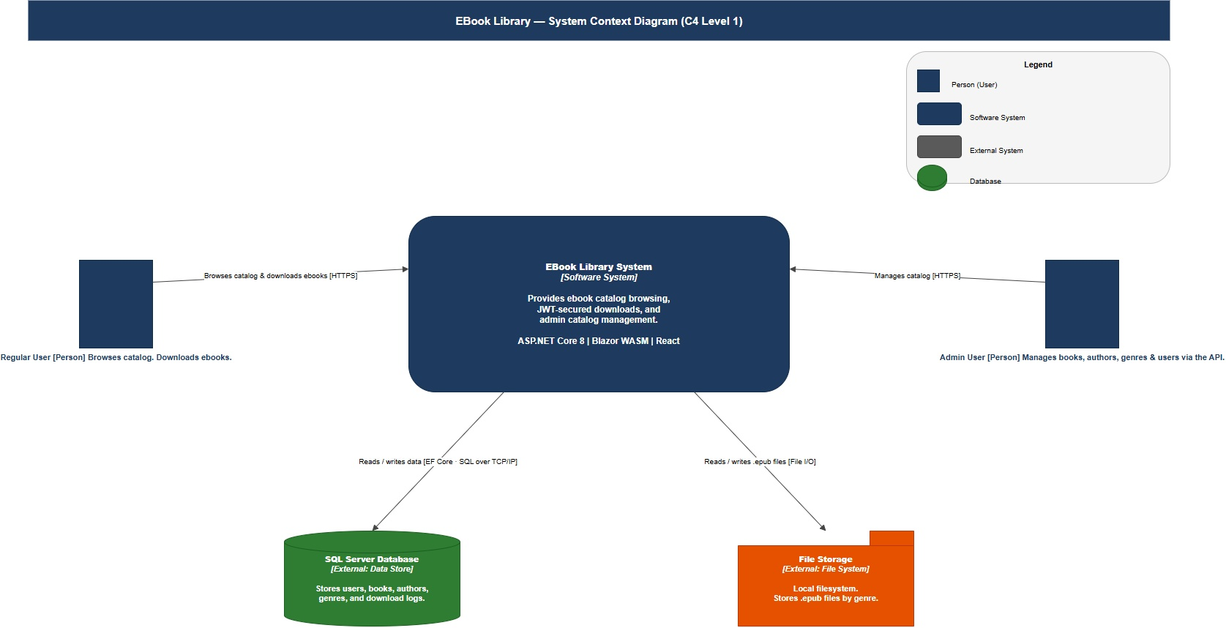
Figure 1 — C4 Level 1: System Context Diagram

The EBook Library System is the central software system. Two user personas interact with it: Regular Users (browse and download ebooks) and Admin Users (manage the catalog). The system stores data in SQL Server and .epub files in the local file system.

3.2 Level 2 — Container Diagram
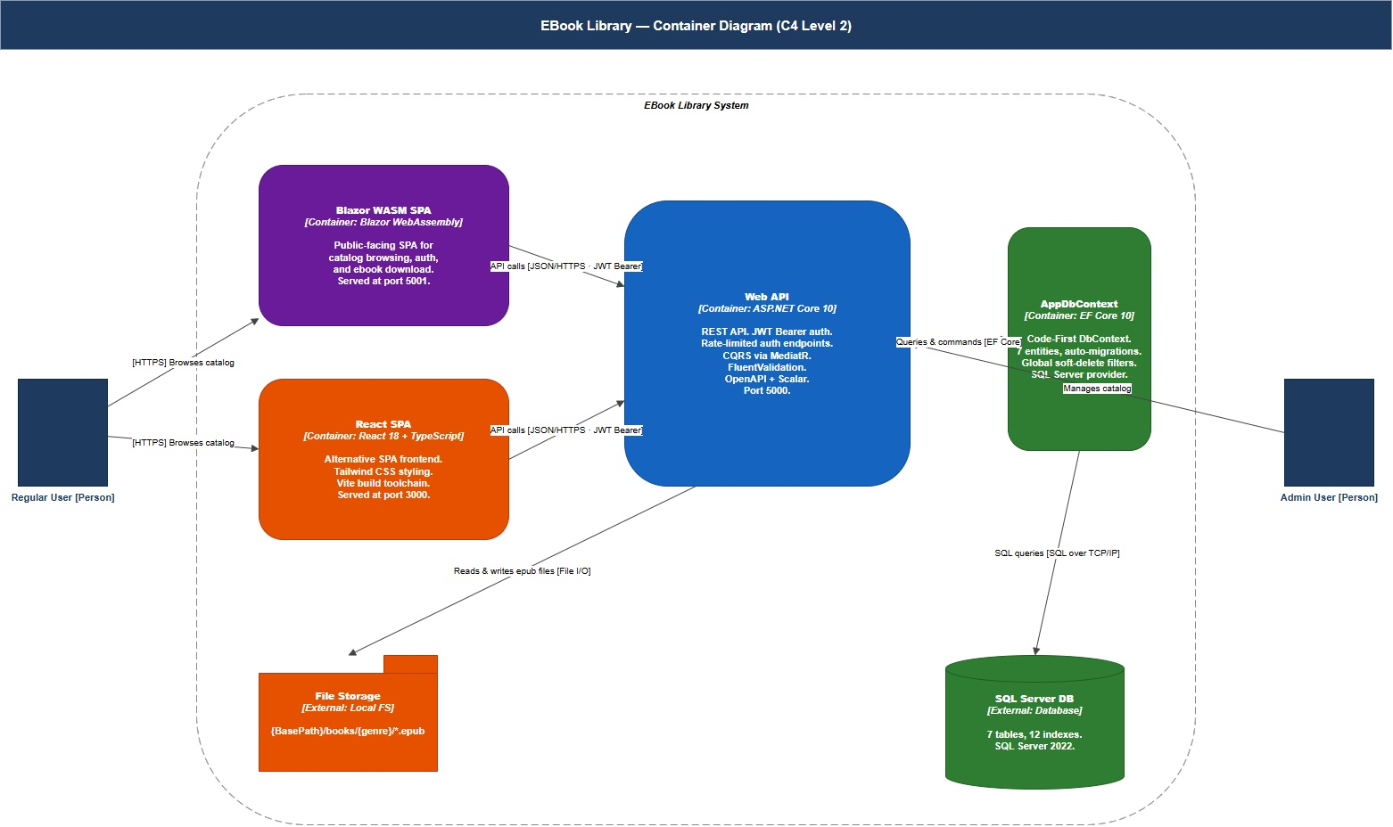
Figure 2 — C4 Level 2: Container Diagram

Inside the system boundary, four containers work together. The Blazor WASM SPA and React SPA are both delivered to the browser and make HTTPS calls to the Web API using JWT Bearer tokens. The Web API uses EF Core (AppDbContext) to read/write to SQL Server and the FileStorageService to manage epub files.

Container | Technology | Description
Blazor WASM SPA | Blazor WebAssembly (.NET 10) | Primary SPA — 11 pages, JWT auth, served at port 5001
React SPA | React 18 + TypeScript + Vite | Alternative SPA — Tailwind CSS, served at port 3000
Web API | ASP.NET Core 10 | REST API — JWT auth, rate limiting, CQRS, OpenAPI + Scalar at port 5000
AppDbContext | EF Core 10 + SQL Server | Code-First DbContext — 7 entities, global filters, auto-migrations

3.3 Level 3 — Component Diagram (Web API)
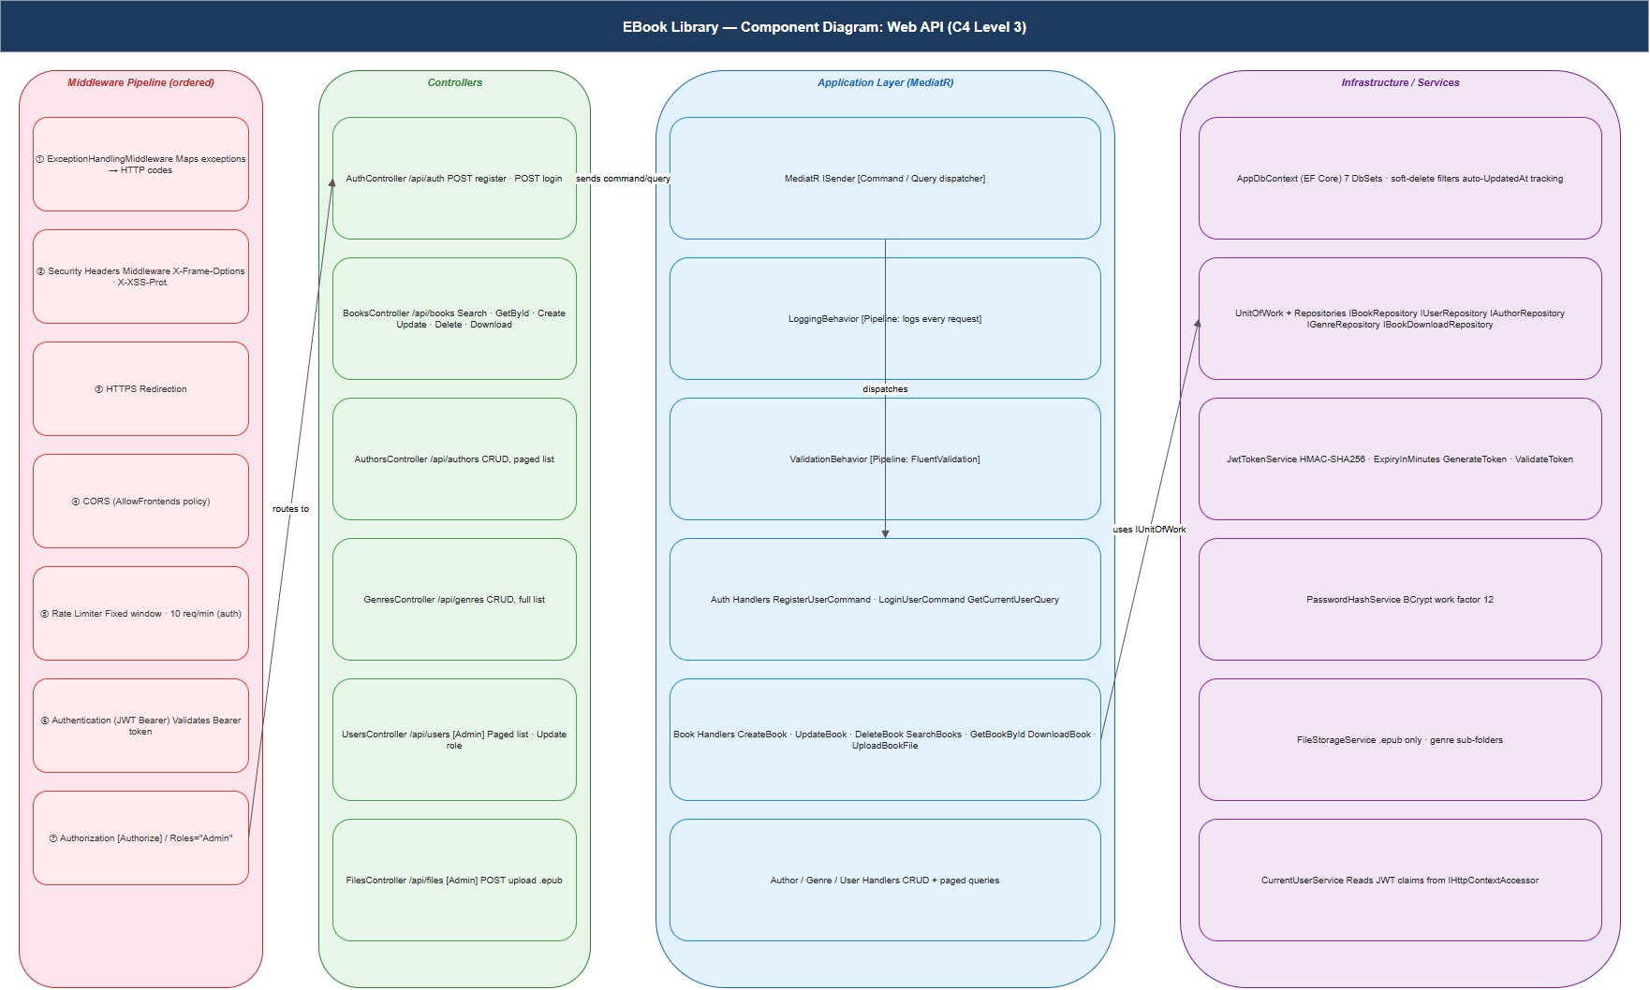
Figure 3 — C4 Level 3: Component Diagram (Web API)

The Web API container decomposes into four areas: a middleware pipeline (7 ordered stages), 6 controllers, an application layer (MediatR + CQRS handlers), and infrastructure services. All controller actions dispatch Commands or Queries through MediatR, which routes through LoggingBehavior → ValidationBehavior → Handler.

3.4 Level 4 — Code / Domain Layer Class Diagram
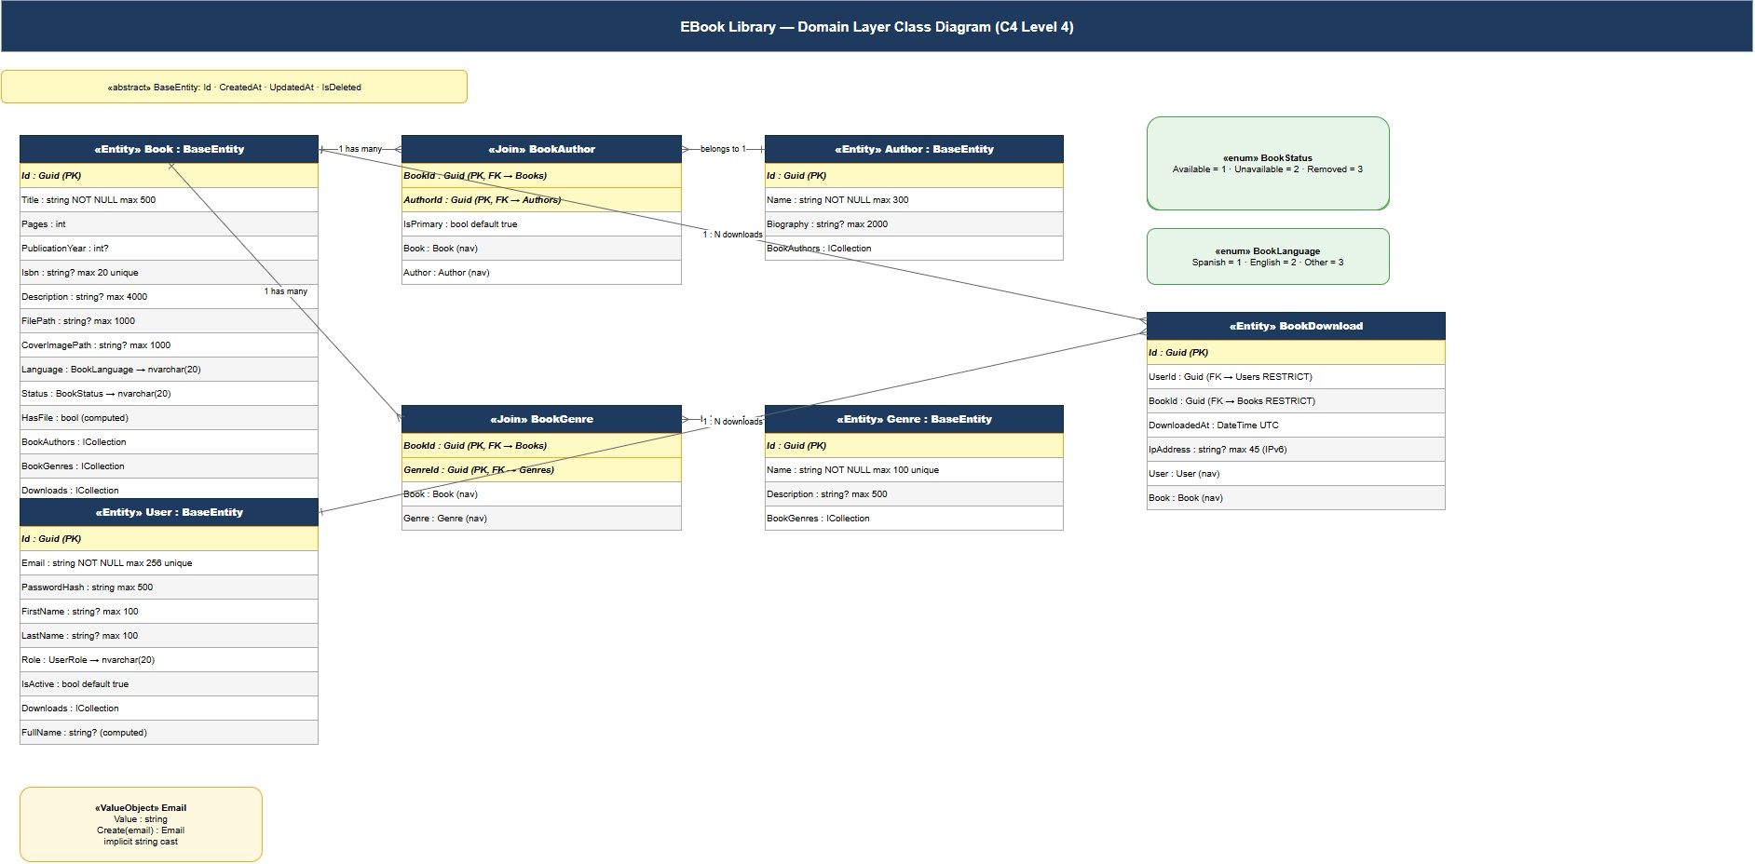
Figure 4 — C4 Level 4: Domain Layer Class Diagram

The Domain layer contains 6 core entities (Book, User, Author, Genre, BookAuthor, BookGenre) and 1 audit entity (BookDownload). All primary entities extend BaseEntity (Id, CreatedAt, UpdatedAt, IsDeleted). Join entities use composite primary keys.

4. Architecture Layer Diagrams

4.1 Clean Architecture Layers
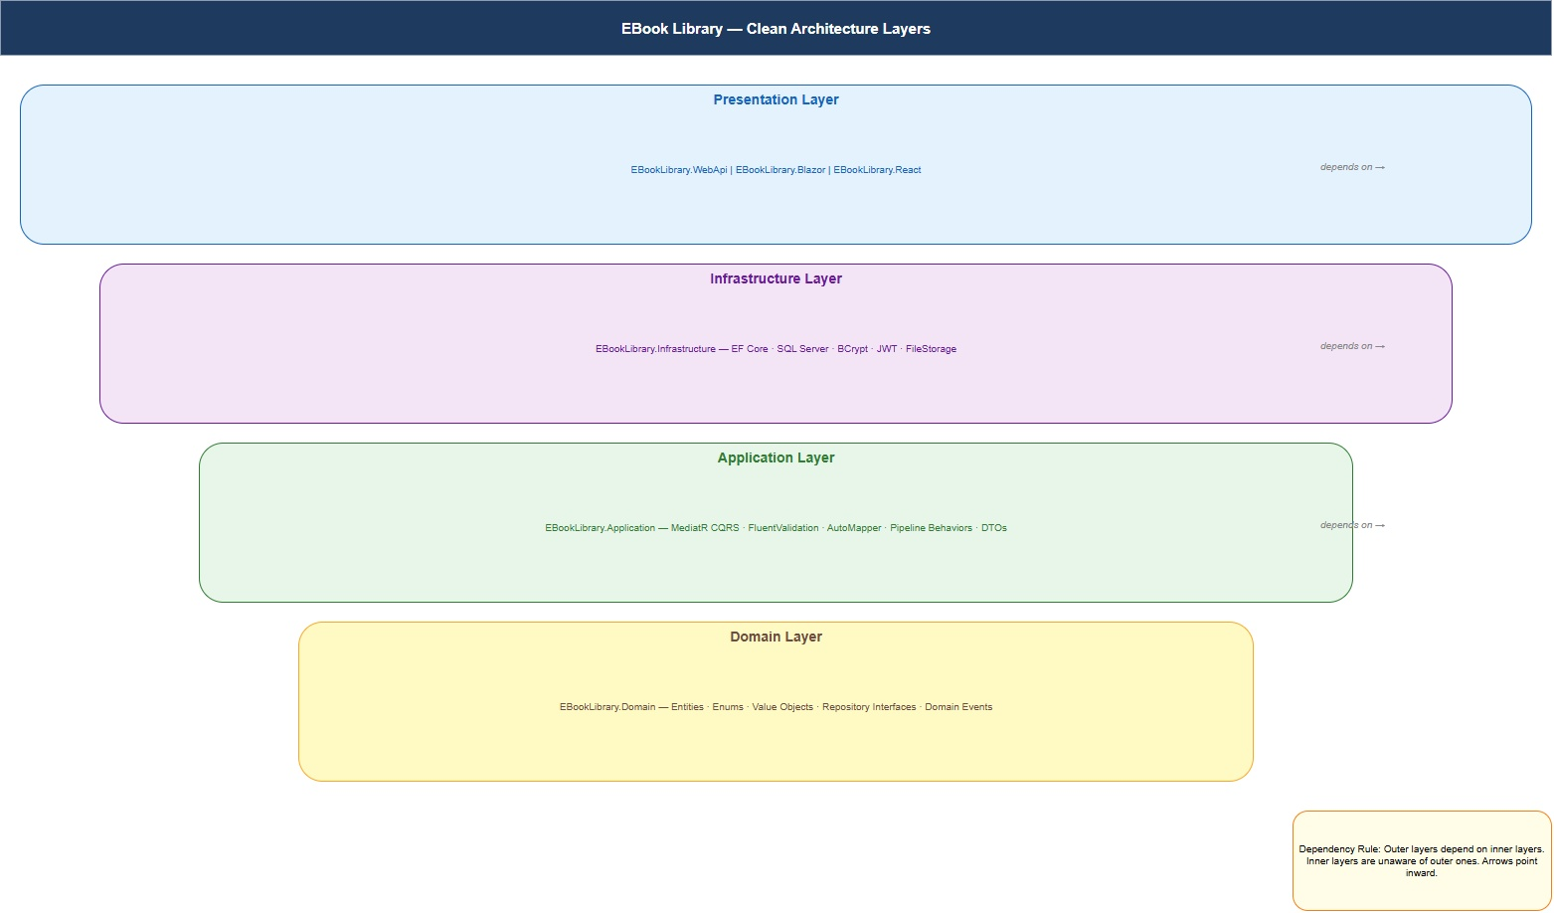
Figure 5 — Clean Architecture Layers

The four concentric layers show how the solution is structured. Each outer layer can see all inner layers, but inner layers cannot reference outer ones:
- Domain — no dependencies; pure C# classes and interfaces
- Application — depends on Domain; uses interfaces only (no EF Core, no HTTP)
- Infrastructure — depends on Application; implements all interfaces using EF Core, BCrypt, JWT
- Presentation — depends on Application; hosts controllers, middleware, and serves the SPAs

4.2 Dependency Flow
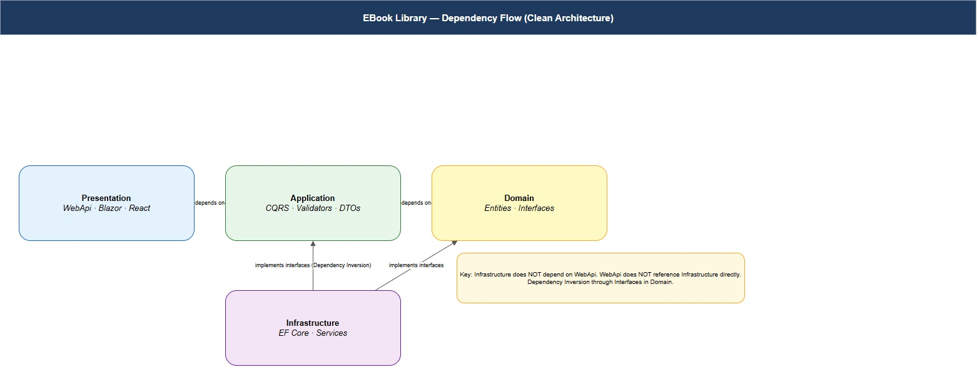
Figure 6 — Dependency Flow

The key insight: Infrastructure depends on Application (to implement its interfaces), and WebApi depends on Application (to dispatch commands/queries). Neither Infrastructure nor WebApi are known to the Application or Domain layers. This is the Dependency Inversion Principle in practice.

5. Sequence Diagrams
The following diagrams show the message flow for the five most important operations in the system.

5.1 User Registration
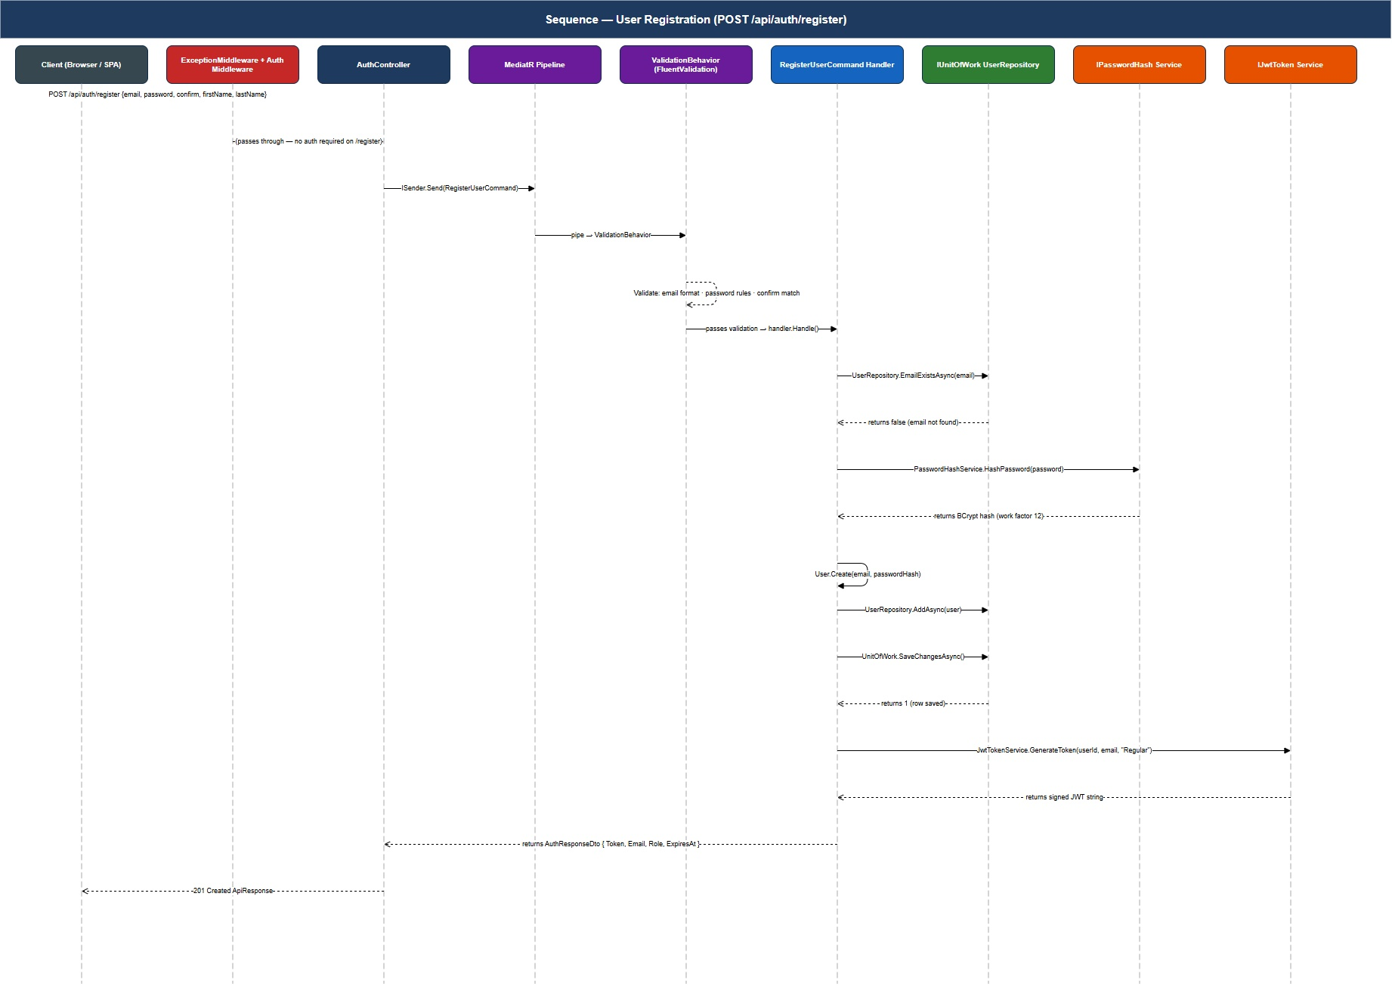
Figure 7 — Sequence Diagram: User Registration

The registration flow validates input via FluentValidation before executing any business logic, hashes the password with BCrypt (work factor 12), persists the user to SQL Server via EF Core, and returns a JWT token on success.

5.2 Book Search
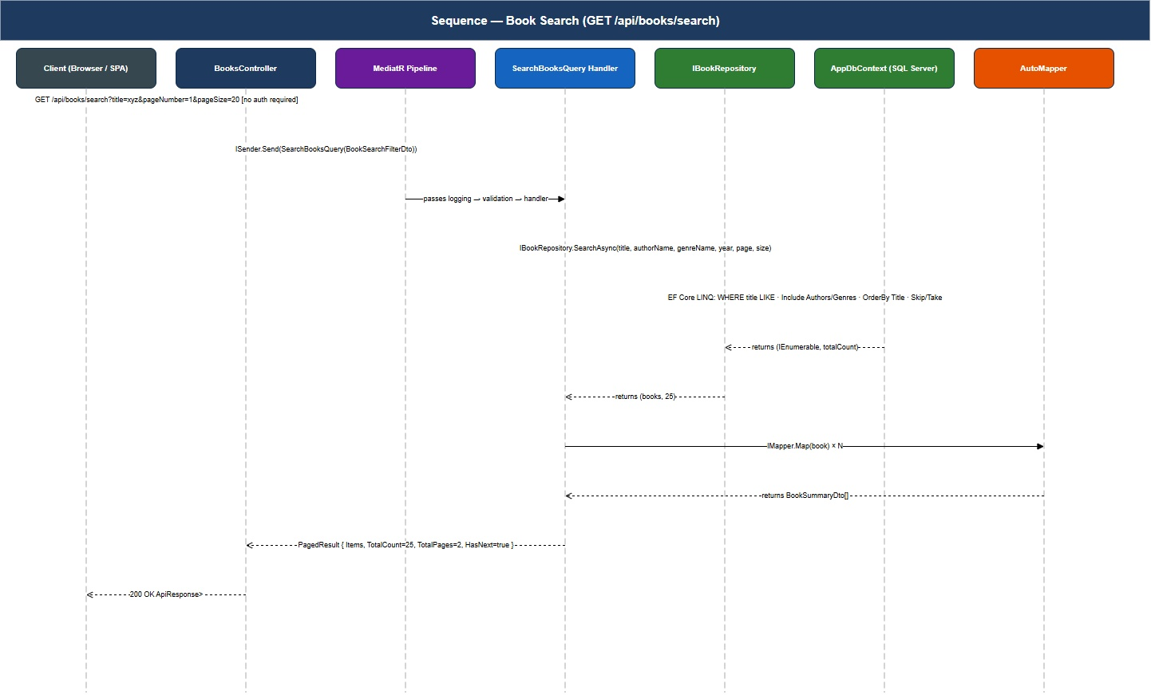
Figure 8 — Sequence Diagram: Book Search

Book search is entirely anonymous — no authentication required. The BookRepository.SearchAsync() method builds a dynamic LINQ query and returns a paged result. AutoMapper transforms domain Book entities to BookSummaryDto records for the API response.

5.3 Book Download
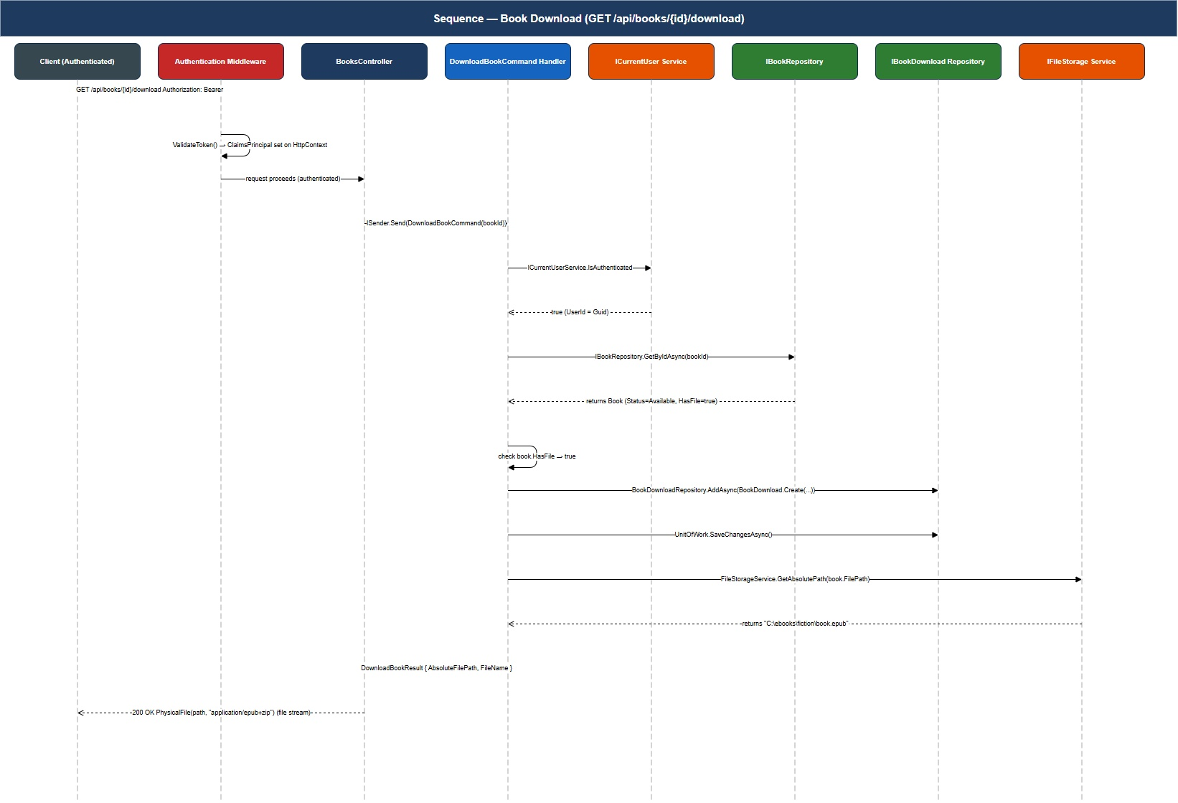
Figure 9 — Sequence Diagram: Book Download

Downloading requires authentication. The middleware validates the JWT Bearer token before the request reaches the controller. Every successful download is logged as a BookDownload audit record with the user ID, book ID, timestamp, and IP address.

5.4 Admin Create Book
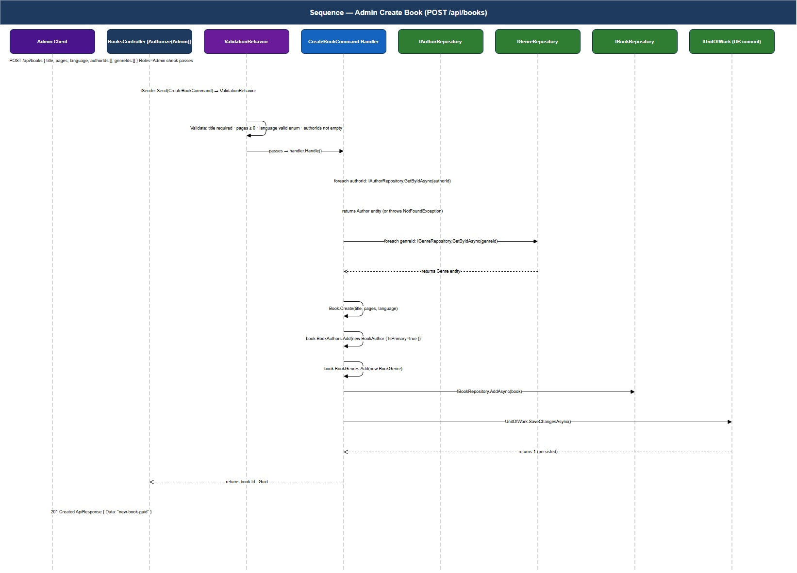
Figure 10 — Sequence Diagram: Admin Create Book

Creating a book requires the Admin role. Both author and genre IDs are validated against the database before the book is persisted. The new book starts with Status = Unavailable — it becomes Available only after an epub file is uploaded via the Files endpoint.

5.5 API Request Pipeline
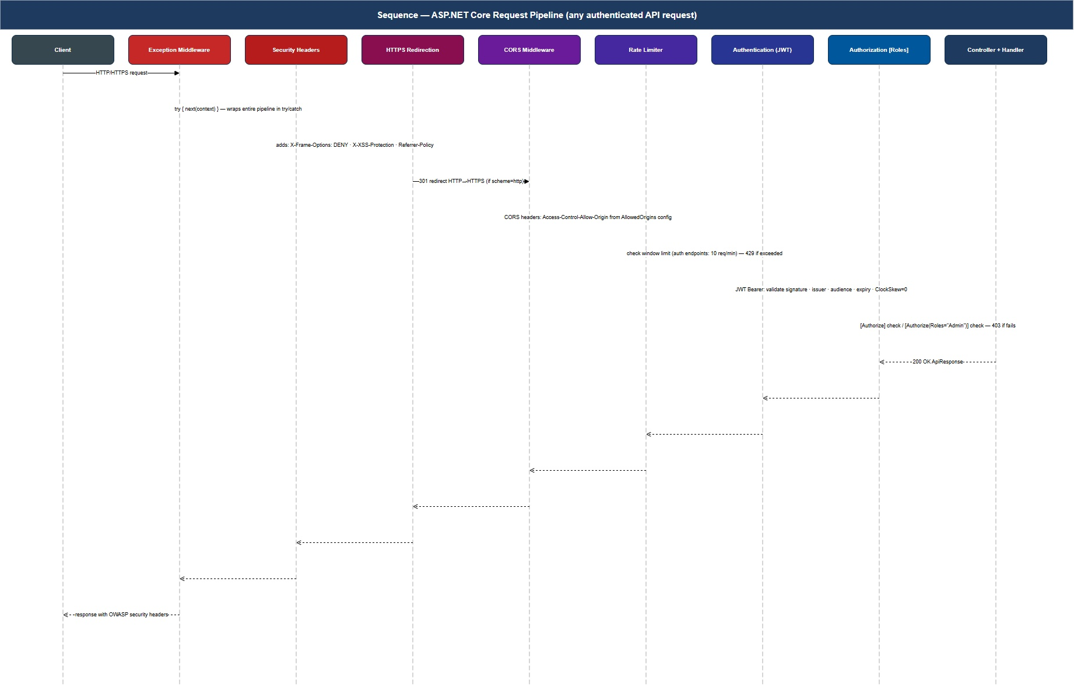
Figure 11 — Sequence Diagram: API Request Pipeline

Every API request traverses 7 middleware stages in order. Security headers are added on both request and response passes. Rate limiting, authentication, and authorization all run before the request reaches any controller. Any exception at any stage is caught by ExceptionHandlingMiddleware and converted to an ApiResponse with the appropriate HTTP status code (400, 401, 403, 404, or 500).

6. Database Diagrams

6.1 Entity Relationship Diagram
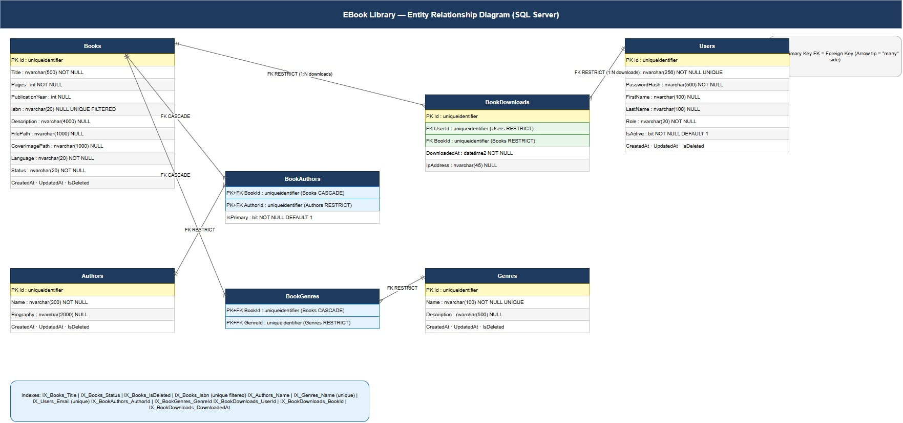
Figure 12 — Database Entity Relationship Diagram

The database has 7 tables connected by 6 foreign key relationships. Books form the center — they have many-to-many relationships with both Authors and Genres (through explicit join tables with additional columns), and a one-to-many relationship with BookDownloads. Users also have a one-to-many relationship with BookDownloads.

Relationship | Cardinality | Delete Rule
Books → BookAuthors | 1 : N | CASCADE — deleting a book removes its author associations
Authors → BookAuthors | 1 : N | RESTRICT — cannot delete an author with books
Books → BookGenres | 1 : N | CASCADE — deleting a book removes its genre associations
Genres → BookGenres | 1 : N | RESTRICT — cannot delete a genre with books
Books → BookDownloads | 1 : N | RESTRICT — download history preserved
Users → BookDownloads | 1 : N | RESTRICT — download history preserved

6.2 Table Details
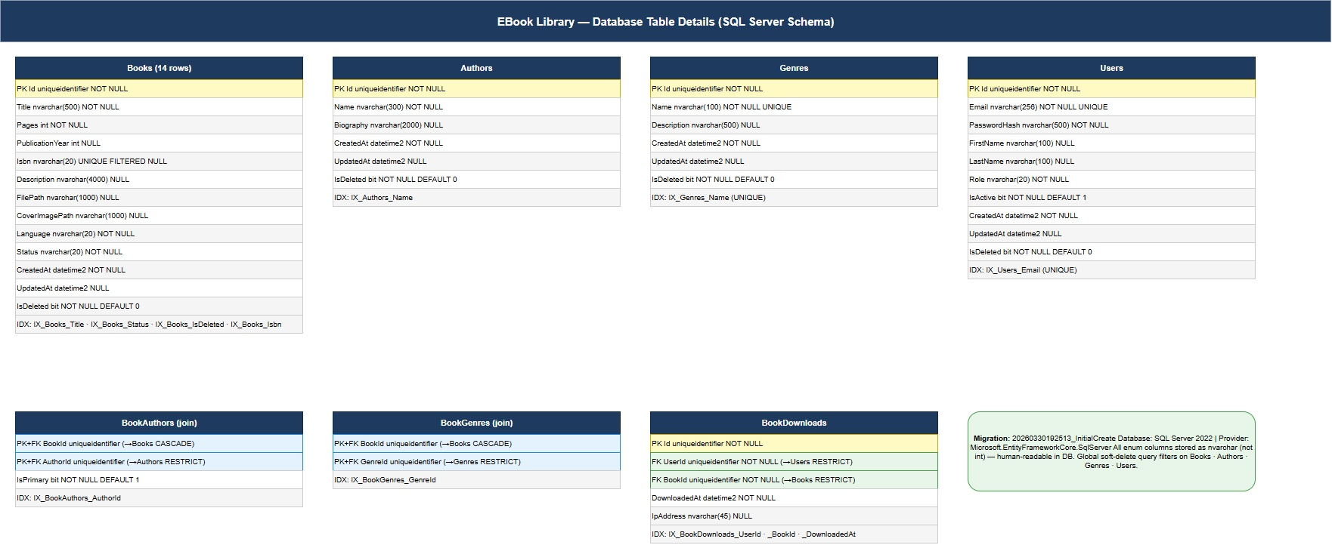
Figure 13 — Database Table Details

Migration: 20260330192513_InitialCreate — SQL Server provider, code-first.
- All PKs are uniqueidentifier (GUID) — safe for distributed generation
- Enum columns stored as nvarchar(20) — human-readable, survives enum renaming
- Books.Isbn uses a filtered unique index (WHERE Isbn IS NOT NULL) — allows nullable ISBN
- Genres.Name and Users.Email have unique database indexes enforced at the DB level
- 12 total indexes covering title search, status filtering, join traversal, and download history

7. UI Mockups
These wireframe mockups represent the Blazor WebAssembly SPA. The React SPA has the same functional layout with Tailwind CSS styling.

7.1 Home Page — Book Catalog
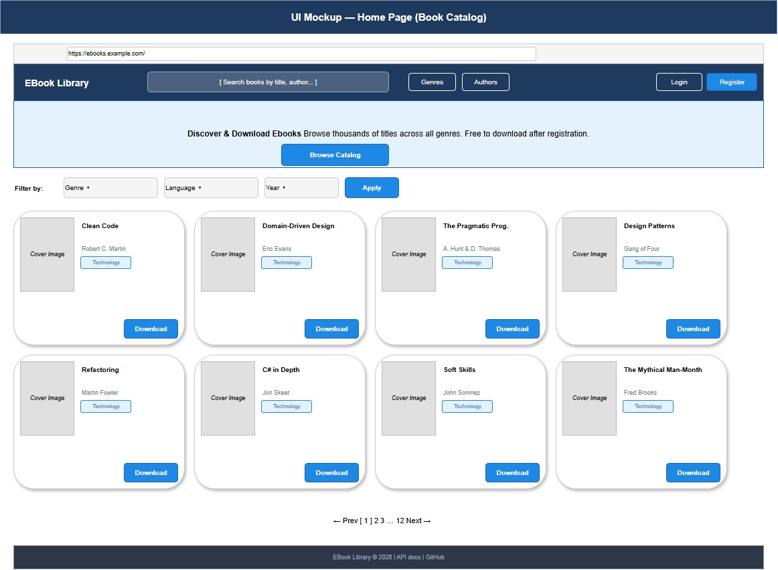
Figure 14 — UI Mockup: Home Page

The home page shows the book catalog with a search bar in the navbar, filter dropdowns by genre/language/year, and a responsive grid of BookCard components. Each card shows a cover image placeholder, title, author, genre tag, and a Download button. Pagination navigates through the full catalog.

7.2 Login / Register Pages
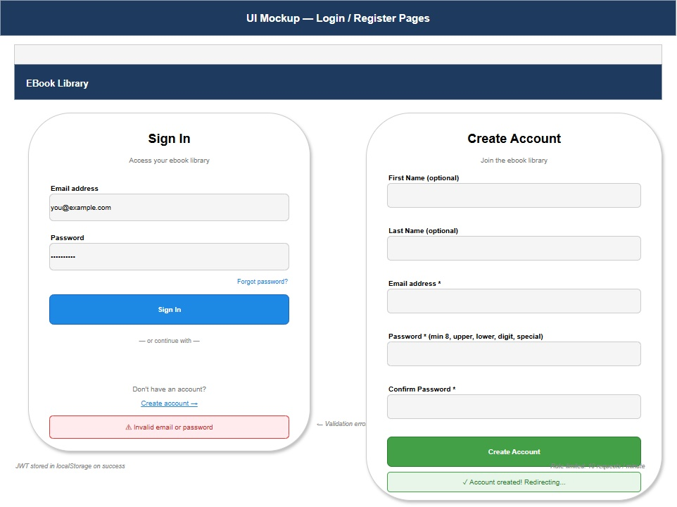
Figure 15 — UI Mockup: Login / Register

The authentication pages show login form (left) and registration form (right). Both are rate-limited to 10 requests per minute. Validation errors from the API (400 responses) are displayed inline. On successful login/register, the JWT is stored in localStorage and the user is redirected to the home page.

7.3 Admin Dashboard
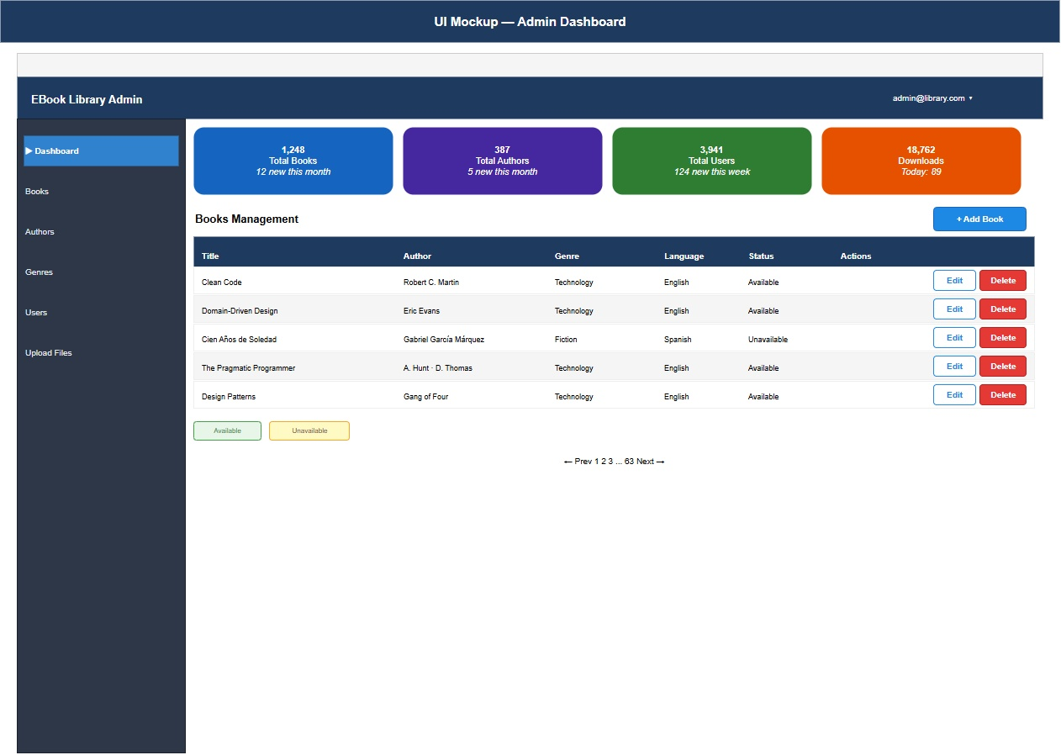
Figure 16 — UI Mockup: Admin Dashboard

The admin dashboard uses a two-column layout: a dark sidebar with navigation links and a main content area. The dashboard shows stats cards (total books, authors, users, downloads) and a paginated books table with Edit/Delete action buttons for each row.

7.4 Book Detail Page
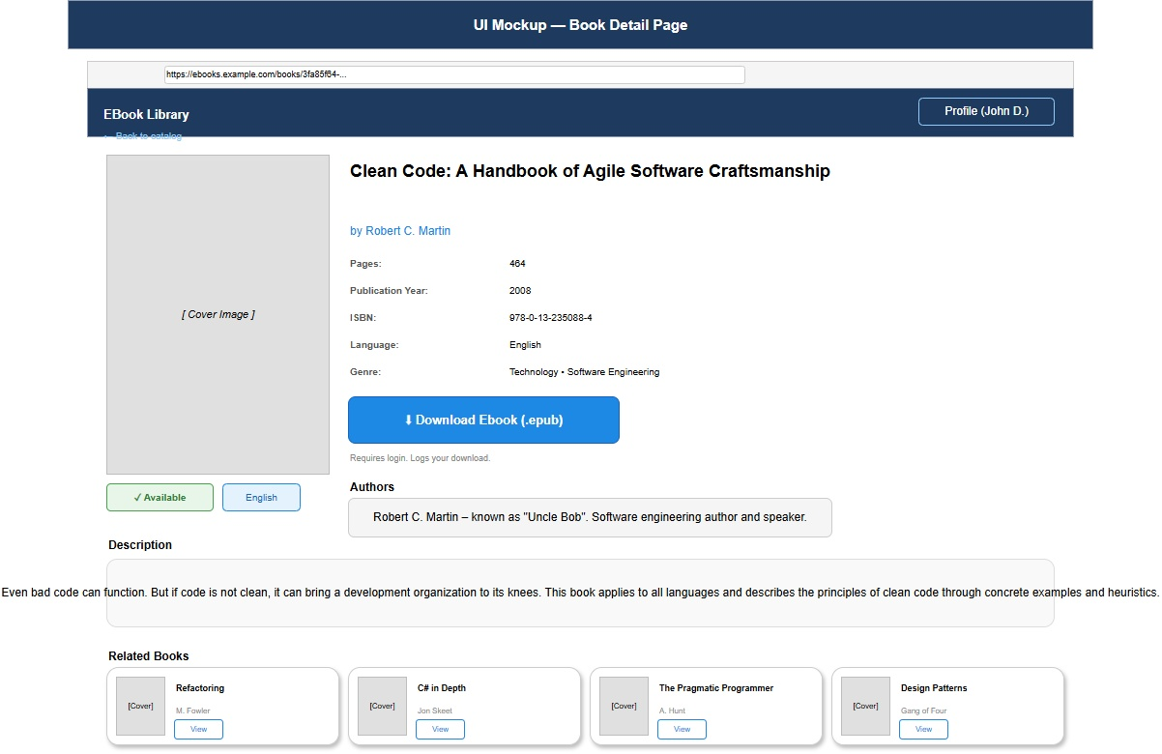
Figure 17 — UI Mockup: Book Detail Page

The book detail page shows the cover image on the left with availability and language badges. The right column contains full metadata, a Download button (requires login), author biography, and a related books section at the bottom.

8. Technology Stack

Backend
Component | Technology | Version
Runtime | .NET | 10.0
Web Framework | ASP.NET Core | 10.0
ORM | Entity Framework Core | 10.0
Database | SQL Server | 2022
Messaging/CQRS | MediatR | 12.x
Validation | FluentValidation | 11.x
Object Mapping | AutoMapper | 13.x
Authentication | JWT Bearer (ASP.NET Core) | 10.0
Password Hashing | BCrypt.Net-Next | 4.0 (work factor 12)
API Documentation | Microsoft.AspNetCore.OpenApi + Scalar | 10.*
Rate Limiting | ASP.NET Core built-in | 10.0 (fixed window)

Frontend — Blazor WASM
Component | Technology
Framework | Blazor WebAssembly (.NET 10)
Token Storage | Blazored.LocalStorage
Auth | Microsoft.AspNetCore.Components.Authorization + CustomAuthStateProvider
HTTP | HttpClient + AuthorizationMessageHandler (auto-injects JWT)

Testing
Component | Technology
Framework | xUnit 2.x / 3.x
Assertions | FluentAssertions 6.x (Domain/App) · 8.x (WebApi)
Mocking | Moq 4.x
Integration | WebApplicationFactory + EF Core InMemory

9. Key Design Decisions
Decision | Rationale
All PKs are GUIDs (uniqueidentifier) | Conflict-free distributed ID generation; no identity column management
Soft delete with EF global filters | Data never physically lost; audit trail preserved; transparent to all queries
Enums stored as nvarchar strings | Human-readable in raw SQL; safe to rename enum values without migrations
Explicit join entities (BookAuthor, BookGenre) | BookAuthor has IsPrimary column — cannot use EF shadow join tables
CQRS + MediatR pipeline | Clear separation of commands/queries; pipeline behaviors extensible without touching handlers
FluentValidation in ValidationBehavior | Validation separated from business logic; reusable validators; consistent error shape
BCrypt work factor 12 | Resistant to GPU brute-force (~300ms per hash); safe even if DB is exfiltrated
JWT ClockSkew = TimeSpan.Zero | Tokens expire at exact stated time; no tolerance window exploitable by attackers
Rate limiting on auth endpoints | 10 req/min fixed window prevents credential stuffing without blocking legitimate users
FileStorageService: .epub only | Validates extension before saving; prevents arbitrary file upload/execution
Auto-migrate on startup (Dev only) | Simplifies developer onboarding; skipped in Production via IsDevelopment() check

10. Security Architecture

Authentication Flow
1. Client POST /api/auth/login {email, password}
2. Server: BCrypt.Verify(password, storedHash)
3. On success: generate HMAC-SHA256 JWT
Claims: sub (userId), email, role, jti, iat
Expiry: JwtSettings.ExpiryInMinutes (default 60)
4. Client stores JWT in localStorage
5. Future requests: Authorization: Bearer <token>
6. Middleware validates: signature + issuer + audience + expiry (ClockSkew=0)
7. [Authorize] = IsAuthenticated check
8. [Authorize(Roles="Admin")] = role claim check

Authorization Matrix
Endpoint | Anonymous | Regular | Admin
GET /api/books/search | YES | YES | YES
GET /api/books/{id} | YES | YES | YES
GET /api/books/{id}/download | NO | YES | YES
POST /api/books | NO | NO | YES
PUT /api/books/{id} | NO | NO | YES
DELETE /api/books/{id} | NO | NO | YES
GET /api/authors | YES | YES | YES
POST /api/authors | NO | NO | YES
GET /api/genres | YES | YES | YES
POST /api/genres | NO | NO | YES
GET /api/users | NO | NO | YES
PATCH /api/users/{id}/role | NO | NO | YES
POST /api/files/books/{id}/upload | NO | NO | YES
POST /api/auth/register (rate-limited) | YES | YES | YES
POST /api/auth/login (rate-limited) | YES | YES | YES

OWASP Top 10 Mitigations
Risk | Mitigation
A01 — Broken Access Control | Role-based JWT claims + [Authorize(Roles)] on every write endpoint; no IDOR (GUIDs are not guessable)
A02 — Cryptographic Failures | BCrypt-12 for passwords (not reversible); HMAC-SHA256 JWT; HTTPS enforced globally
A03 — Injection | EF Core parameterized queries (LINQ); no raw SQL; user input never concatenated into queries
A04 — Insecure Design | CQRS + FluentValidation pipeline; all inputs validated before handler execution
A05 — Security Misconfiguration | OWASP headers middleware (X-Frame-Options, X-XSS-Protection, Referrer-Policy); CORS origin whitelist
A07 — Auth Failures | Fixed window rate limiting on auth; ClockSkew=0; short JWT expiry (60 min); no refresh token stored on server
A08 — Software Integrity | NuGet package lock files; known vulnerability (AutoMapper 13) noted for remediation

