MapReduce, Hadoop, and the Need for
Parallel Processing in the age of Big Data

The amount of data that we generate today is truly mind boggling. Currently, in 2020, every person who has access to technology generates on average about 1.6 megabytes of data every second! Now multiply that by several billion people and you begin to see how truly astronomical our current data infrastructure is. It is simply not feasible to manage this amount of data using conventional computing methods.

Traditionally, computer hardware and software transmitted, stored, and processed data in serial. That is, programs were executed sequentially, step by step, and data was transmitted one bit after the other. Today, however, our many advancements in technology have allowed us to use parallel processes for faster, more efficient computing (see fig.1). Transmission cables now use multiple, parallel wires to send and receive data, computers are linked together in clusters to combine their processing power, and even software is written to perform parallel tasks side by side, instead of sequentially.
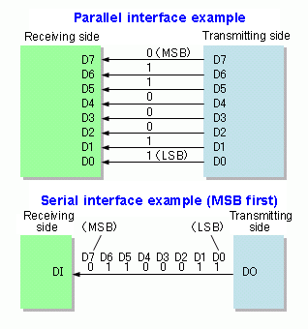

(fig.1) Illustration of Parallel vs. Serial processing.

In the early 2000’s many amazing things began to take place in the realm of parallel computing.
Many of the early challenges companies faced with big data began with their development of cutting edge search engines. With Google at the forefront, these companies began to pioneer advanced techniques for parallel data storage and processing. Google’s solution to storing large data sets was called Google File system (GFS). A year later, in 2004, they published their MapReduce technique for processing those large data sets. The same year, Doug Cutting and Mike Cafarella, building upon the foundations of GFS and MapReduce, created an open source project called Nutch, which shortly after became known as Hadoop.

The Hadoop framework is a collection of open-source utilities that allow for fault tolerant storage, and the processing of huge data sets in parallel, using many different computers. Each of these computers are referred to as nodes, and are all controlled by a single master, or main node. Collectively, the main node and its workers, or slaves, are called a cluster. All of the data is partitioned, replicated and stored onto the worker nodes, and those nodes are managed by the master node. Having only one name node creates a single point of failure in the cluster. To mitigate this, there is another node called the secondary name node. This node is responsible for periodically backing up the data on the name node.
Hadoop consists of three main parts: HDFS, which is its distributed file system, YARN, its resource manager, and MapReduce, which is the logic used to process the data.

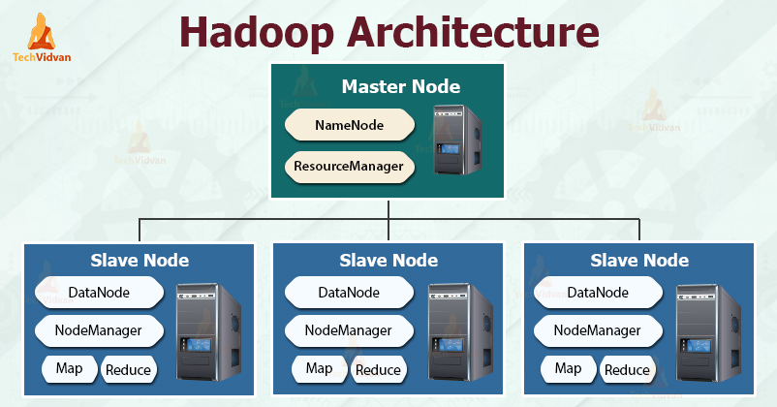

(fig. 2) Basic Hadoop Architecture.

HDFS has two main components, data blocks and nodes that store those blocks. The size of each block is 128MB by default, but can be modified according to requirements. A large file would be divided up into these blocks, and then distributed across each data node in the cluster. The name node or master node would then manage the location of each of these blocks. The data nodes are responsible for storing, retrieving, replicating, and deleting of blocks when requested by the name node. Every block that is stored in the file system is replicated on different data nodes in the cluster. Each block will have 2 copies of itself by default, which are stored on separate data nodes. This is what makes HDFS fault tolerant. HDFS is very capable of storing petabytes of data cost effectively and with no glitches. Because of the sheer volume and large variety of data today, distributed file systems are an absolute requirement in this age of information.

