Elec 374 – Phase 1 report

## Group 2

## Tom Heysel

## Allison Christensen

## Matthieu Roux

## Simon Day

# Current Processor Diagram

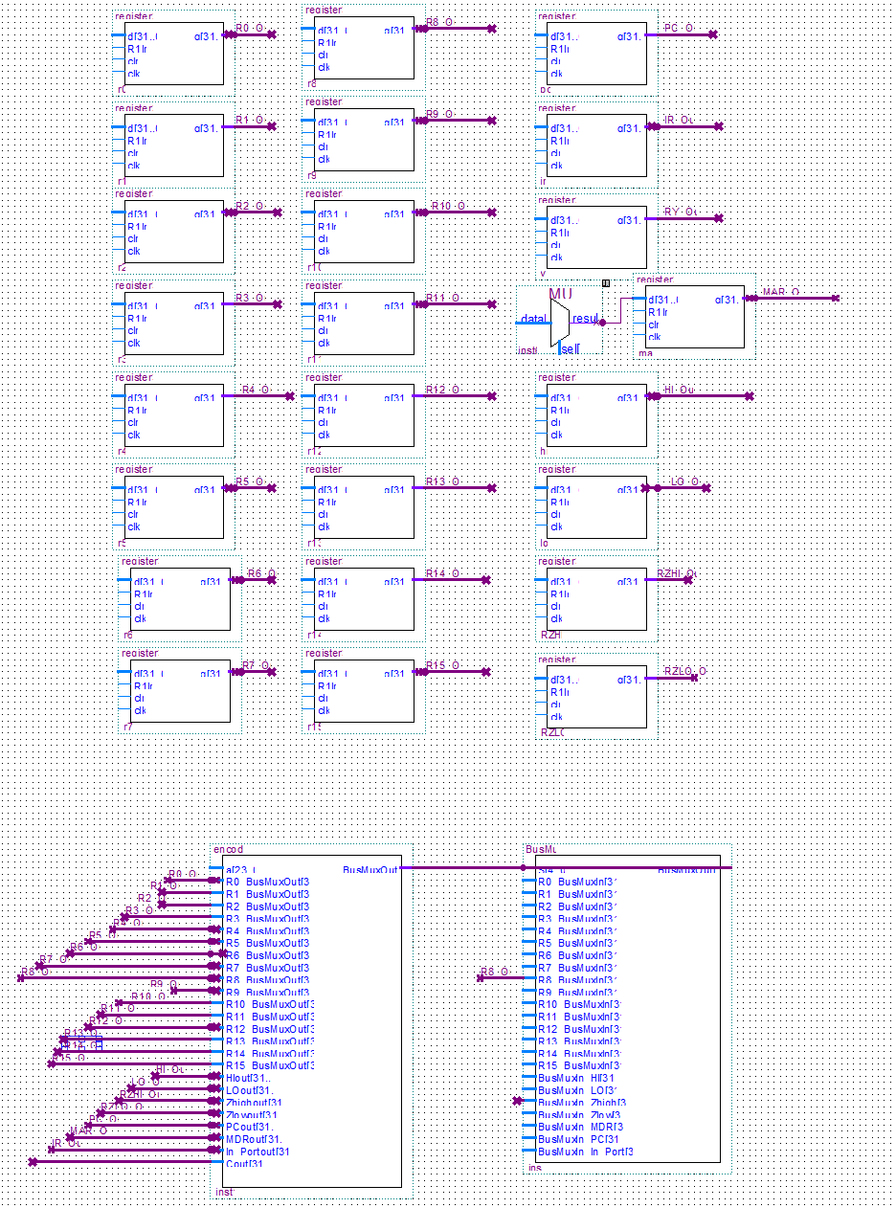

# **VHDL Code**

# 32-5 Bus Encoder

library IEEE;

use IEEE.STD_LOGIC_1164.all;

entity encoder is

port(

    a : in STD_LOGIC_VECTOR(23 downto 0);

    BusMuxOut : out STD_LOGIC_VECTOR(4 downto 0);

    -- Register Inputs

    R0_BusMuxOut : IN STD_LOGIC_VECTOR(31 downto 0);

    R1_BusMuxOut : IN STD_LOGIC_VECTOR(31 downto 0);

    R2_BusMuxOut : IN STD_LOGIC_VECTOR(31 downto 0);

    R3_BusMuxOut : IN STD_LOGIC_VECTOR(31 downto 0);

    R4_BusMuxOut : IN STD_LOGIC_VECTOR(31 downto 0);

    R5_BusMuxOut : IN STD_LOGIC_VECTOR(31 downto 0);

    R6_BusMuxOut : IN STD_LOGIC_VECTOR(31 downto 0);

    R7_BusMuxOut : IN STD_LOGIC_VECTOR(31 downto 0);

    R8_BusMuxOut : IN STD_LOGIC_VECTOR(31 downto 0);

    R9_BusMuxOut : IN STD_LOGIC_VECTOR(31 downto 0);

    R10_BusMuxOut : IN STD_LOGIC_VECTOR(31 downto 0);

    R11_BusMuxOut : IN STD_LOGIC_VECTOR(31 downto 0);

    R12_BusMuxOut : IN STD_LOGIC_VECTOR(31 downto 0);

    R13_BusMuxOut : IN STD_LOGIC_VECTOR(31 downto 0);

    R14_BusMuxOut : IN STD_LOGIC_VECTOR(31 downto 0);

    R15_BusMuxOut : IN STD_LOGIC_VECTOR(31 downto 0);

    HIout : IN STD_LOGIC_VECTOR(31 downto 0);

    LOout : IN STD_LOGIC_VECTOR(31 downto 0);

    Zhighout : IN STD_LOGIC_VECTOR(31 downto 0);

    Zlowout : IN STD_LOGIC_VECTOR(31 downto 0);

    PCout : IN STD_LOGIC_VECTOR(31 downto 0);

    MDRout : IN STD_LOGIC_VECTOR(31 downto 0);

    In_Portout : IN STD_LOGIC_VECTOR(31 downto 0);

    Cout : IN STD_LOGIC_VECTOR(31 downto 0)

);

end encoder;

architecture bhv of encoder is

begin

process(a,

                R0_BusMuxOut ,

                R1_BusMuxOut ,

                R2_BusMuxOut ,

                R3_BusMuxOut ,

                R4_BusMuxOut ,

                R5_BusMuxOut ,

                R6_BusMuxOut ,

                R7_BusMuxOut ,

                R8_BusMuxOut ,

                R9_BusMuxOut ,

                R10_BusMuxOut,

                R11_BusMuxOut,

                R12_BusMuxOut,

                R13_BusMuxOut,

                R14_BusMuxOut,

                R15_BusMuxOut,

                HIout,

                LOout,

                Zhighout,

                Zlowout,

                PCout,

                MDRout,

                In_Portout)

begin

case a is

     when R0_BusMuxOut => BusMuxOut <= "00000";

     when R1_BusMuxOut => BusMuxOut <= "00001";

     when R2_BusMuxOut => BusMuxOut <= "00010";

     when R3_BusMuxOut => BusMuxOut <= "00011";

     when R4_BusMuxOut => BusMuxOut <= "00100";

     when R5_BusMuxOut => BusMuxOut <= "00101";

     when R6_BusMuxOut => BusMuxOut <= "00110";

     when R7_BusMuxOut => BusMuxOut <= "00111";

     when R8_BusMuxOut => BusMuxOut <= "01000";

     when R9_BusMuxOut => BusMuxOut <= "01001";

     when R10_BusMuxOut => BusMuxOut <= "01010";

     when R11_BusMuxOut => BusMuxOut <= "01011";

     when R12_BusMuxOut => BusMuxOut <= "01100";

     when R13_BusMuxOut => BusMuxOut <= "01101";

     when R14_BusMuxOut => BusMuxOut <= "01110";

     when R15_BusMuxOut => BusMuxOut <= "01111";

     when HIout => BusMuxOut <= "10000";

     when LOout => BusMuxOut <= "10001";

     when Zhighout => BusMuxOut <= "10010";

     when Zlowout => BusMuxOut <= "10011";

     when PCout => BusMuxOut <= "10100";

     when MDRout => BusMuxOut <= "10101";

     when In_Portout => BusMuxOut <= "10110";

     when others => BusMuxOut <= "XXXXX";

end case;

end process;

end bhv;

# General Purpose Register

LIBRARY ieee;

USE ieee.std_logic_1164.ALL;

USE ieee.std_logic_arith.ALL;

USE ieee.std_logic_unsigned.ALL;

ENTITY register32 IS PORT(

d : IN STD_LOGIC_VECTOR(31 DOWNTO 0);

R1In : IN STD_LOGIC; -- load/enable.

clr : IN STD_LOGIC; -- async. clear.

clk : IN STD_LOGIC; -- clock.

q : OUT STD_LOGIC_VECTOR(31 DOWNTO 0) -- output

);

END register32;

ARCHITECTURE description OF register32 IS

BEGIN

process(clk, clr)

begin

if clr = '1' then

q <= "00000000";

elsif rising_edge(clk) then

if R1In = '1' then

q <= d;

end if;

end if;

end process;

END description;

# 2-1 MUX for MDR

LIBRARY ieee;

USE ieee.std_logic_1164.ALL;

USE ieee.std_logic_arith.ALL;

USE ieee.std_logic_unsigned.ALL;

entity mux is port

( in1   :in std_logic_vector(31 downto 0);

in2   :in std_logic_vector(31 downto 0);

cs:in std_logic;

output :OUT std_logic_vector(31 downto 0)

);

END mux;

ARCHITECTURE description OF mux IS

BEGIN

process(in1, in2, cs)

begin

if cs = '0' then

output <= in1;

elsif cs = '1' then

output <= in2;

end if;

end process;

END description;

# BUS MUX

LIBRARY ieee;

USE ieee.std_logic_1164.all;

-- Entity Declaration

ENTITY BusMux IS

-- {{ALTERA_IO_BEGIN}} DO NOT REMOVE THIS LINE!

PORT

(

S : IN STD_LOGIC_VECTOR(4 downto 0);

-- Register Inputs

R0_BusMuxIn : IN STD_LOGIC_VECTOR(31 downto 0);

R1_BusMuxIn : IN STD_LOGIC_VECTOR(31 downto 0);

R2_BusMuxIn : IN STD_LOGIC_VECTOR(31 downto 0);

R3_BusMuxIn : IN STD_LOGIC_VECTOR(31 downto 0);

R4_BusMuxIn : IN STD_LOGIC_VECTOR(31 downto 0);

R5_BusMuxIn : IN STD_LOGIC_VECTOR(31 downto 0);

R6_BusMuxIn : IN STD_LOGIC_VECTOR(31 downto 0);

R7_BusMuxIn : IN STD_LOGIC_VECTOR(31 downto 0);

R8_BusMuxIn : IN STD_LOGIC_VECTOR(31 downto 0);

R9_BusMuxIn : IN STD_LOGIC_VECTOR(31 downto 0);

R10_BusMuxIn : IN STD_LOGIC_VECTOR(31 downto 0);

R11_BusMuxIn : IN STD_LOGIC_VECTOR(31 downto 0);

R12_BusMuxIn : IN STD_LOGIC_VECTOR(31 downto 0);

R13_BusMuxIn : IN STD_LOGIC_VECTOR(31 downto 0);

R14_BusMuxIn : IN STD_LOGIC_VECTOR(31 downto 0);

R15_BusMuxIn : IN STD_LOGIC_VECTOR(31 downto 0);

-- Other register Inputs

BusMuxIn_HI : IN STD_LOGIC_VECTOR(31 downto 0);

BusMuxIn_LO : IN STD_LOGIC_VECTOR(31 downto 0);

BusMuxIn_Zhigh : IN STD_LOGIC_VECTOR(31 downto 0);

BusMuxIn_Zlow : IN STD_LOGIC_VECTOR(31 downto 0);

BusMuxIn_MDR : IN STD_LOGIC_VECTOR(31 downto 0);

--Program Counter Input

BusMuxIn_PC : IN STD_LOGIC_VECTOR(31 downto 0);

--???

BusMuxIn_In_Port : IN STD_LOGIC_VECTOR(31 downto 0);

-- Output Port (What will go on the Bus)

BusMuxOut : OUT STD_LOGIC_VECTOR(31 downto 0)

);

-- {{ALTERA_IO_END}} DO NOT REMOVE THIS LINE!

END BusMux;

architecture BusMux_architecture of BusMux is

begin

process(

                R0_BusMuxIn,

                R1_BusMuxIn,

                R2_BusMuxIn,

                R3_BusMuxIn,

                R4_BusMuxIn,

                R5_BusMuxIn,

                R6_BusMuxIn,

                R7_BusMuxIn,

                R8_BusMuxIn,

                R9_BusMuxIn,

                R10_BusMuxIn,

                R11_BusMuxIn,

                R12_BusMuxIn,

                R13_BusMuxIn,

                R14_BusMuxIn,

                R15_BusMuxIn,

                BusMuxIn_HI ,

                BusMuxIn_LO ,

                BusMuxIn_Zhigh,

                BusMuxIn_Zlow ,

                BusMuxIn_PC ,

                BusMuxIn_In_Port,

                BusMuxIn_MDR )

begin

            case S is

                 when "00000" => BusMuxOut <= R0_BusMuxIn;

                 when "00001" => BusMuxOut <= R1_BusMuxIn;

                 when "00010" => BusMuxOut <= R2_BusMuxIn;

                 when "00011" => BusMuxOut <= R3_BusMuxIn;

                 when "00100" => BusMuxOut <= R4_BusMuxIn;

                 when "00101" => BusMuxOut <= R5_BusMuxIn;

                 when "00110" => BusMuxOut <= R6_BusMuxIn;

                 when "00111" => BusMuxOut <= R7_BusMuxIn;

                 when "01000" => BusMuxOut <= R8_BusMuxIn;

                 when "01001" => BusMuxOut <= R9_BusMuxIn;

                 when "01010" => BusMuxOut <= R10_BusMuxIn;

                 when "01011" => BusMuxOut <= R11_BusMuxIn;

                 when "01100" => BusMuxOut <= R12_BusMuxIn;

                 when "01101" => BusMuxOut <= R13_BusMuxIn;

                 when "01110" => BusMuxOut <= R14_BusMuxIn;

                 when "01111" => BusMuxOut <= R15_BusMuxIn;

                 when "10000" => BusMuxOut <= BusMuxIn_HI;

                 when "10001" => BusMuxOut <= BusMuxIn_LO;

                 when "10010" => BusMuxOut <= BusMuxIn_Zhigh;

                 when "10011" => BusMuxOut <= BusMuxIn_Zlow;

                 when "10100" => BusMuxOut <= BusMuxIn_PC;

                 when "10101" => BusMuxOut <= BusMuxIn_MDR;

                 when "10110" => BusMuxOut <= BusMuxIn_In_Port;

                 when others => BusMuxOut <= "XXXXX";

            end case;

end process;

end architecture;

# ALU

library IEEE;

use IEEE.STD_LOGIC_1164.ALL;

use IEEE.NUMERIC_STD.ALL;

entity alu is

Port ( input_a : in signed(31 downto 0);

input_b : in signed(31 downto 0);

selection : in STD_LOGIC_VECTOR (2 downto 0);

AluOut : out signed(3 downto 0));

end alu;

architecture Behavioral of alu is

begin

process(input_a, input_b, selection)

begin

case selection is

when "000" => AluOut<= input_a and input_b; -- AND gate

when "001" => AluOut<= input_a or input_b; -- OR gate

when "010" => AluOut<= not input_a ; -- NOT gate

when "011" => AluOut<= input_a xor input_b; -- XOR gate

when "100" => AluOut<= input_a + input_b; -- addition

when "101" => AluOut<= input_a - input_b; -- subtraction

when "110" => AluOut<= -- multiplication

when "111" => AluOut<= -- division

when others => NULL;

end case;

end process;

end Behavioral;

# Booth Algorithm

LIBRARY ieee;

entity booth_multiplier is

port (

a_input : in std_logic_vector(31 downto 0); -- Input A

b_input : in std_logic_vector(31 downto 0); -- Input B

output : out std_logic_vector(63 downto 0); -- Output

);

end booth_multiplier

architecture booth_multiplier of booth_multiplier is

begin

process(a_input, b_input)

variable result, temp, to_result : std_logic_vector(63 downto 0);

variable ADD, SUB, ZEROES : std_logic_vector(31 downto 0); -- Purpose of the se variables is given below

begin

ADD := a_input; -- Used for when A is to be added

SUB := (0 - a_input); -- Used for when A is to be subrstracted

result := x"0000000000000000" -- Makes the result 0 at start

ZEROES := x"00000000"

for i in 0 to 31 loop

if (i =0) then

if (b_input(0) = 1) then

to_result(31 downto 0) := toSub;

end if;

else

if(b_input(i) = '1' and b_input(i-1) = '0') then

to_result := ZEROES & SUB;

elsif (b_input(i) = '0' and b_input(i-1) = '0') then

to_result:= ZEROES & ADD;

else

to_result := ZEROES & ZEROES;

end if;

end if;

--Sign Extension

if (to_result(31) = '1') then

to_result(63 downto 32) := x"FFFFFFFF";

elsif (to_result(31) = '0') then

to_result(63 downto 32) := x"00000000";

end if;

to_result := STD_LOGIC_VECTOR(SHIFT_LEFT(UNSIGNED(to_result), i));

result := result + to_result;

end loop;

# **Test Benches**

Had our team been able to compile our project successfully, we would have simulated our design using Modelsim. In the Phase 1 instruction set, we were given a sample testbench template in VHDL for the logical AND instruction which we would have been able to use for other instructions with some verification and revision. Our first steps in writing testbenches would be focused on clock generation, adjusting some of the constants in the template to match the target clock rates. With the new signals defined, we would proceed to modify the logic within some given process. The sequential statements inside a process operate on the values they are at immediately before the process begins. To connect these signals and test our device design, we would have started with a reset pulse and a short delay to allow us to see that the machine can be held in this idle state. As we move forward with the remainder of the project, following these steps in writing our testbench should allow us to test the basic functionality of our design and to examine the signals to see that they have been generated correctly.