Test Cases Report

27 April 2024

Function1: Add Player:

Input: 0 0 1

Expected: 2 AI added, 1 Player added

Actual: Added, and the card of Players is showed

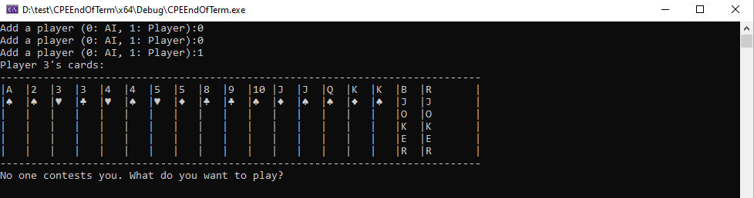

Function 2: put cards

Input: 1 A

Expected Output: Card A disappear

Actual: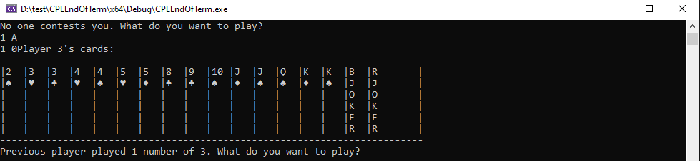

Function 3: pass

Input:-1 -1

Expected Output: No card disappear

Actual: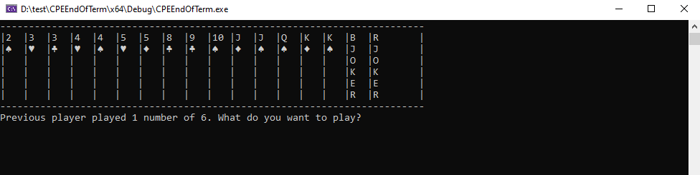

Function 4: AI Logic

Input:3 4

Expected Output: 3 card with a number bigger than 4 but as small as possible is given by computer, or 4 card with the smallest number

Actual:

