Harmonia
Health Information Exchange Platform
ArchiMate 3.2 Technical Architecture Specification & System Reference
Platform Architecture Team <architecture@harmonia.health>
September 2026 — Version 1.0.0

Table of Contents
Executive Summary ▸
ArchiMate 3.2 Architectural Modeling Framework ▸
Classical Architectural Nomenclature \& System Meanings ▸
Chapter 1: Motivation \& Strategy Architecture ▸
Stakeholders \& Key Drivers ▸
Stakeholder Analysis ▸
Core Drivers ▸
Strategic Goals ▸
Core Architectural Principles ▸
Strategic Capabilities \& End-to-End Value Stream ▸
Strategic Value Stream Flow ▸
Chapter 2: Business \& Clinical Architecture ▸
Healthcare Business Actors \& Operational Roles ▸
Clinical Business Services ▸
1. Patient Admission \& Movement Service (\texttt{HL7-ADT ▸
2. Practitioner \& Staff Directory Service (\texttt{HL7-MFN ▸
3. FHIR R5 Clinical Data Discovery Service ▸
4. Operations Telemetry \& Workflow Administration Service ▸
5. Clinical Outbound Notification \& Egress Service (\texttt{HL7-MLLP-OUT ▸
6. FHIR R5 Provider Directory Management Service ▸
Clinical Business Process Workflows ▸
Process: Ingest and Reconcile HL7 ADT Trigger ▸
Process: Outbound MLLP Dispatch and ACK Validation Lifecycle ▸
Process: Governed Provider Registry Change Ingestion \& Verification ▸
Core Business Objects ▸
Chapter 3: Application Architecture ▸
Presentation Tier: \texttt{Iris ▸
\texttt{iris-befe ▸
\texttt{iris-clinical ▸
\texttt{iris-console ▸
Interface \& Gateway Tier: \texttt{Pylai ▸
\texttt{pylai-mllp-in ▸
\texttt{pylai-mllp-out ▸
\texttt{pylai-mllp-base ▸
\texttt{pylai-mllp-cli ▸
\texttt{pylai-fhir-registry ▸
Messaging Transport Subsystem: \texttt{Petasos ▸
\texttt{petasos-api ▸
\texttt{petasos-core ▸
\texttt{petasos-artemis ▸
Workflow Services Subsystem: \texttt{Energeia ▸
\texttt{energeia/ponos ▸
\texttt{energeia/praxis ▸
\texttt{energeia/erga ▸
Data Services Subsystem: \texttt{Hestia ▸
Canonical Schema Repository: \texttt{Calliope ▸
Chapter 4: Data \& Information Architecture ▸
Canonical Domain Models (\texttt{Calliope ▸
1. \texttt{Pragma ▸
2. \texttt{PragmaCheckpoint ▸
3. \texttt{ProviderRegistryChangePragma ▸
4. Canonical Provider Registry Validation Codes ▸
Canonical Outbound Models (\texttt{pylai-mllp-base ▸
1. \texttt{OutboundMllpRequest ▸
2. \texttt{OutboundMllpResponse ▸
3. \texttt{MllpDestinationConfig ▸
The 5-Phase Checkpoint Lifecycle State Flow ▸
\texttt{PetasosMessage ▸
Supported FHIR R5 Resource Schemas ▸
Relational Persistence Schema (\texttt{Mnemosyne-Clinical ▸
Chapter 5: Technology \& Infrastructure Architecture ▸
System Software Runtimes ▸
In-Memory Cache Grid \& Persistence SPI (\texttt{Hestia ▸
Master Platform Port Allocation Specification ▸
Chapter 6: Physical \& High Availability Deployment ▸
Clustering vs. High Availability (HA) Replication ▸
1. Server-Side Clustering (\texttt{petasos-cluster ▸
2. Journal Replication Groups (\texttt{group-a ▸
Isolated Persistent Storage Ownership ▸
Client Reconnection \& Failover Configuration ▸
In-Memory Cache Grid HA Topology (\texttt{Mneme ▸
Docker Compose Multi-Container Deployment ▸
Provider Registry High Availability \& Crash Recovery ▸
Egress Failure Domain Isolation ▸
Appendix A: Paradeigma Clinical Simulation Subsystem ▸
Subsystem Overview \& Architectural Principles ▸
Core Design Principles ▸
ArchiMate Application \& Interface Landscape ▸
Formal Interface Catalogue (PD-01 through PD-09) ▸
MLLP Framing \& Transport Protocol ▸
Synchronous Acknowledgement Contract ▸
Hospital Simulator Microservice Specifications ▸
Patient Administration System Simulator (\texttt{paradeigma-pas ▸
Electronic Medical Record Simulator (\texttt{paradeigma-emr ▸
Laboratory Information System Simulator (\texttt{paradeigma-lms ▸
Radiology Information System \& PACS Simulator (\texttt{paradeigma-rispac ▸
Synthetic Data Models \& Deterministic Generators ▸
Canonical Domain Entities ▸
Seed-Based Deterministic Generation Engine ▸
Scenario Orchestration Engine \& Patient Journey Workflows ▸
9-Step Canonical Patient Journey Sequence ▸
Execution Profiles ▸
Scenario Control REST API ▸
Failure Simulation, Fault Injection \& Automated Recovery ▸
Fault Injection Modes (\texttt{FailureSimulator ▸
Automated Recovery Acceptance Test Suite ▸
Deployment Topology \& Docker Orchestration ▸
Appendix B: Implementation Guide for MLLP Ingress and Egress Services ▸
Overview \& Engineering Objectives ▸
Ingress Architectural Blueprint \& Framing Protocols ▸
MLLP Transport Framing ▸
The 8-Phase Ingress Processing Lifecycle ▸
Ingress Component Implementation ▸
Camel RouteBuilder Configuration ▸
Processor Wrapper \& Context Management ▸
HL7 v2 Data Extraction with HAPI Terser ▸
Canonical FHIR Model Mapping \& Resource Builders ▸
FHIR Communication Resource Construction ▸
FHIR Task (Pragma) Resource Construction ▸
Persistence, Event Dispatch \& Synchronous Acknowledgement ▸
Persistence Integration with Mneme \& Mnemosyne ▸
Synchronous Acknowledgement Mapping Rules ▸
REST Management \& CDI Deployment Configuration ▸
Multi-Instance Egress Architecture \& Queue Partitioning ▸
Head-of-Line Blocking Mitigation \& Destination Isolation ▸
Outbound Configuration \& Destination Registry ▸
Outbound Data Transfer Models ▸
Outbound Queue Consumer \& Camel Dynamic MLLP Routes ▸
Dedicated Task Queue Consumer ▸
Camel Dynamic Outbound Route Builder ▸
Outbound MLLP Processor Header Injection ▸
Downstream HL7 ACK/NACK Deep Inspection ▸
MSA \& ERR Segment Parsing Specification ▸
Downstream ACK Code Decision Matrix ▸
State, Task, and Provenance Lifecycle Management ▸
Outbound State Lifecycle Synchronization ▸
FHIR Provenance Resource Construction ▸
Testing, Verification Harnesses \& Containerization ▸
Tier 1: Unit Testing with HAPI HL7 v2 Parsers ▸
Tier 2: Camel Route Harness Testing ▸
Tier 3: Embedded Mock MLLP Server Integration Testing ▸
Tier 4: Multi-Instance Docker Compose Deployment Topology ▸
Appendix C: Implementation and Deployment Guide for Ergon Workflow Activity Modules ▸
Overview \& Engineering Objectives ▸
Architectural Blueprint \& the ErgonBase Contract ▸
RouteBuilder Inheritance and Processing Topologies ▸
Exchange Headers and Properties Invariants ▸
The Pragma Task Envelope Model ▸
Security Tagging with FhirSecurityTagManager ▸
Step-by-Step Code Development Blueprint ▸
Step 1: Maven Project Configuration ▸
Step 2: Subclassing ErgonBase \& Constructor Wiring ▸
Step 3: Defensive Payload Extraction ▸
Step 4: Clinical Transformation \& Resource Generation ▸
Step 5: Pragma Output \& Checkpoint Recording ▸
Step 6: Structured Exception Handling ▸
Production Reference Implementation: ObservationEnrichmentErgon ▸
Praxis Workflow Orchestration \& Step Chaining ▸
Linear Workflow Sequences ▸
Conditional Branching and Error Recovery ▸
CDI Configuration, Dependency Injection \& Scoping ▸
Bean Scoping: @Dependent vs. @ApplicationScoped ▸
CDI Deployment Descriptor (beans.xml) ▸
Testing Strategies, Test Fixtures \& Validation ▸
CamelTestSupport Unit Testing Pattern ▸
Deployment, Containerization \& Operational Runbook ▸
WildFly \& Ponos Container Architecture ▸
Dynamic Live Reload via ponos-cli ▸
Concurrency Tuning and Thread Pool Sizing ▸
Dead-Letter Queue (DLQ) Recovery Operations ▸
Summary \& Best Practices Checklist ▸
Appendix D: Implementation and Deployment Guide for Praxis Workflow Sequences ▸
Overview \& Engineering Objectives ▸
Architectural Blueprint \& the Praxis Paradigm ▸
Decoupling Definition from Runtime Execution ▸
Topic Subscription Matching \& Hierarchical Routing ▸
Audit Checkpoint Lifecycle across Execution Boundaries ▸
Dual-Cache Architecture in the Mneme Grid ▸
Step-by-Step Praxis Creation Blueprint ▸
Phase 1: Defining Declarative Workflow Metadata ▸
Phase 2: Activity Ordering and Sequence Validation ▸
Phase 3: Route Synthesis and Ingress Conduits ▸
Phase 4: Error Boundary \& Exception Trapping ▸
Production Reference Implementation: PatientCareAdmissionPraxis ▸
Dynamic Route Generation \& Camel Pipeline Topology ▸
Route Synthesis Architecture ▸
Exchange Property Invariants and Header Preservation ▸
Dynamic Discovery, Seeding \& Runtime Registration ▸
CDI Bean Resolution via Jakarta EE Instance ▸
Initial Seeding via TaskSequenceDefaultSeeder ▸
Multi-Tier Testing Strategies ▸
CamelTestSupport Unit Test Harness ▸
Failure Snapshotting and Checkpoint Assertions ▸
Deployment, Cluster Management \& Operational Runbook ▸
Containerization within Ponos WildFly Container ▸
REST Administrative API: /workflow ▸
Dynamic Live Reload via ponos-cli ▸
Summary \& Best Practices Checklist ▸
Appendix E: Implementation and Functional Specification for FHIR R5 Provider Registry Core Services ▸
Overview \& Engineering Objectives ▸
Architectural Topology \& 5-Tier Interaction Model ▸
Synchronous Read and Search Data Path ▸
Asynchronous Governed Change Path ▸
FHIR R5 Provider Registry Resource Model \& Relationship Topology ▸
Relationship Graph and Referential Topology ▸
Endpoint as an Independent First-Class Entity ▸
REST API Gateway Contract \& Interaction Matrix ▸
Multi-Parameter Search Capabilities ▸
CapabilityStatement Specification (\texttt{GET /metadata ▸
Asynchronous Task Polling (\texttt{GET /Task/\{id\ ▸
Governed Change Processing Lifecycle \& Pragma State Machine ▸
State Machine Transition Rules ▸
Per-Resource Ergon Processing Activities \& Referential Integrity Engine ▸
\texttt{ProviderRegistryReferenceValidator ▸
Authoritative Persistence, Optimistic Concurrency \& Versioning Model ▸
Monotonic Version Incrementing ▸
Optimistic Concurrency Control (\texttt{If-Match ▸
Security, RBAC \& Resource-Level Permission Architecture ▸
Resource-Level Permission Scopes ▸
\texttt{FhirSecurityInterceptor ▸
Paradeigma Exemplar Generation \& Verification Testbed ▸
\texttt{SyntheticProviderRegistryGenerator ▸
Automated Integration \& Verification Test Suites ▸
Summary \& Engineering Checklist ▸

List of Figures
Figure 1: ArchiMate 3.2 Visual Modeling Notation, Layer Color Palette, and Relationship Types ▸
Figure 2: ArchiMate Motivation and Strategy Architecture View for Harmonia HIE ▸
Figure 3: ArchiMate Business and Clinical Architecture View for Harmonia HIE ▸
Figure 4: ArchiMate 5-Tier Application Component Landscape for Harmonia HIE ▸
Figure 5: ArchiMate Petasos Messaging Subsystem \& Clustered Transport Architecture ▸
Figure 6: ArchiMate Energeia Workflow Engine \& Sequential Erga Pipeline View ▸
Figure 7: ArchiMate Pragma Task State Machine and 5-Phase Checkpoint Lifecycle ▸
Figure 8: ArchiMate Technology Infrastructure, System Software \& Communication Paths ▸
Figure 9: ArchiMate Hestia In-Memory Data Grid \& Write-Behind Persistence SPI Architecture ▸
Figure 10: ArchiMate Physical Deployment \& Multi-Broker ActiveMQ Artemis HA Architecture ▸
Figure 11: ArchiMate 3.2 Component Landscape for the Paradeigma Simulation Subsystem ▸
Figure 12: ArchiMate 3.2 Component Flow for the MLLP Ingress Service Processing Pipeline ▸
Figure 13: ArchiMate 3.2 Component Flow for the MLLP Egress Multi-Instance Dispatch Pipeline ▸
Figure 14: ArchiMate 3.2 Processing Topology and Component Interaction View for an Ergon Activity Module ▸
Figure 15: ArchiMate 3.2 Praxis Workflow Sequence Architecture and Dynamic Route Synthesis Topology ▸

List of Tables
Table 1: Harmonia Classical Architectural Nomenclature and System Meaning Matrix ▸
Table 2: Harmonia Strategic Capabilities and Subsystem Realization ▸
Table 3: Harmonia Business Actors, Assigned Roles, and Operational Responsibilities ▸
Table 4: Canonical Provider Registry Validation and Error Diagnostic Codes ▸
Table 5: Petasos Standard Message Envelope Attribute Specification ▸
Table 6: Harmonia Supported FHIR R5 Resource Schema Catalog ▸
Table 7: Harmonia Master Technology Infrastructure Port Allocation Matrix ▸
Table 8: ActiveMQ Artemis Broker Storage Isolation and Persistent Volume Mapping ▸
Table 9: Paradeigma Interface Catalogue and Port Mappings ▸
Table 10: Paradeigma Synthetic Pathology LOINC Catalog ▸
Table 11: Scenario Engine REST Control Endpoints ▸
Table 12: FailureSimulator Fault Injection Capabilities ▸
Table 13: Paradeigma Docker Compose Deployment Configuration ▸
Table 14: HL7 v2 to FHIR R5 Task Canonical Mapping Specifications ▸
Table 15: Synchronous HL7 Acknowledgement Response Contracts ▸
Table 16: MLLP Outbound Gateway Environment Configuration Parameters ▸
Table 17: Downstream HL7 Acknowledgement Code Decision Matrix ▸
Table 18: Standardized Exchange Headers and Properties Managed by ErgonBase ▸
Table 19: Production Readiness Checklist for New Ergon Workflow Activity Modules ▸
Table 20: Praxis Workflow Execution Checkpoint Stages and Lifecycle Semantics ▸
Table 21: Mandatory Apache Camel Exchange Properties and Headers in Praxis Pipelines ▸
Table 22: Production Readiness Checklist for Praxis Workflow Sequences ▸
Table 23: FHIR R5 Provider Registry Managed Resource Model Catalog ▸
Table 24: FHIR R5 Provider Registry REST Interaction Matrix ▸
Table 25: Provider Registry Per-Resource Ergon Activity Responsibilities ▸
Table 26: Granular Resource-Level RBAC Permission Matrix ▸
Table 27: Production Readiness Checklist for FHIR R5 Provider Registry Core Services ▸

Executive Summary
{chapter}{Executive Summary}
The Harmonia Health Information Exchange (HIE) is a modular, high-availability, distributed healthcare integration platform engineered for HL7 FHIR Release 5 (R5) compliance, real-time HL7 v2 clinical data ingestion, sub-millisecond in-memory cached access, and resilient asynchronous workflow execution.
Modern healthcare ecosystems demand zero-loss event streaming, high-throughput message translation, resilient task state persistence, and fine-grained clinical data access. Harmonia resolves these challenges through a cohesive five-tier architectural design combining:
- Pylai Ingress & Egress Gateways: High-throughput bidirectional MLLP and REST ingestion and egress dispatch gateways for clinical events.
- Petasos Messaging Subsystem: High-availability, multi-broker active-active Apache ActiveMQ Artemis messaging cluster with native NIO journal replication and dynamic server-side message load balancing.
- Energeia Workflow Engine: Modular Apache Camel task activities (Erga), structured workflow sequence orchestrators (Praxis), and WildFly Jakarta EE 10 execution containers (Ponos) operating on canonical task instances (Pragma).
- Hestia Data Services: Low-latency in-memory data caching grid (Mneme) backed by Infinispan 15+ and durable relational relational disk persistence (Mnemosyne) backed by PostgreSQL 16+ and Spring Boot HAPI FHIR JPA.
- Iris Presentation Services: Dual-port Jakarta EE Backend-For-Frontend gateway (Iris BEFE) and TypeScript / Vue 3 single-page applications for clinical exploration and operational administration.
- Paradeigma Simulation & Resilience Testbed: High-fidelity reference hospital actor simulators (PAS, EMR, LMS, RIS-PAC), multi-system Patient Journey scenario orchestration, and automated fault injection testbed (documented in Appendix~app:paradeigma).
- MLLP Ingress & Egress Implementation Blueprint: Production-grade implementation specifications, ArchiMate process models, Camel route blueprints, and testing harnesses for engineering new MLLP gateway services (documented in Appendix~app:mllp_services).
- Ergon Workflow Activity Module Implementation Blueprint: Production-grade engineering manual, ArchiMate processing models, ErgonBase Camel route lifecycles, Pragma state checkpointing, and Ponos WildFly deployment runbook for authoring new task activities (documented in Appendix~app:ergon_modules).
- Praxis Workflow Sequence Implementation Blueprint: Production-grade engineering guide, ArchiMate sequence topology, dynamic Apache Camel route synthesis, CDI bean discovery, audit checkpointing, and dynamic reload runbook for composing and deploying task sequences (documented in Appendix~app:praxis_workflow).
- FHIR R5 Provider Registry Implementation Blueprint: Production-grade implementation specifications, ArchiMate 5-tier topology, synchronous read/search vs asynchronous governed write models, per-resource Erga activities, referential integrity rules, optimistic concurrency, and Paradeigma test harnesses (documented in Appendix~app:provider_registry).

ArchiMate 3.2 Architectural Modeling Framework
{section}{ArchiMate 3.2 Architectural Modeling Framework}
To ensure complete structural rigor, unambiguous domain boundaries, and formal traceability across business, application, and infrastructure tiers, this specification is authored strictly in accordance with The Open Group ArchiMate 3.2 Standard.
The architecture is described across six formal ArchiMate layers:
- Motivation & Strategy Layer: Captures business stakeholders, regulatory drivers, architectural principles, high-level goals, and strategic interoperability capabilities.
- Business Layer: Models healthcare business actors, operational roles, clinical ingestion services, and business process lifecycles.
- Application Layer: Specifies the component landscape, internal module collaborations, application services, and canonical data object flows across the 27 Maven modules.
- Data & Information Layer: Defines canonical information models, the Pragma task state machine, the PetasosMessage transport envelope, and the 15 supported FHIR R5 resource schemas.
- Technology Layer: Details infrastructure execution nodes, system software runtimes (WildFly, Artemis, Infinispan, PostgreSQL), communication paths, networks, and port allocations.
- Physical & Deployment Layer: Documents multi-broker high-availability replication pairs, containerization topology, failover mechanics, and disaster recovery pathways.
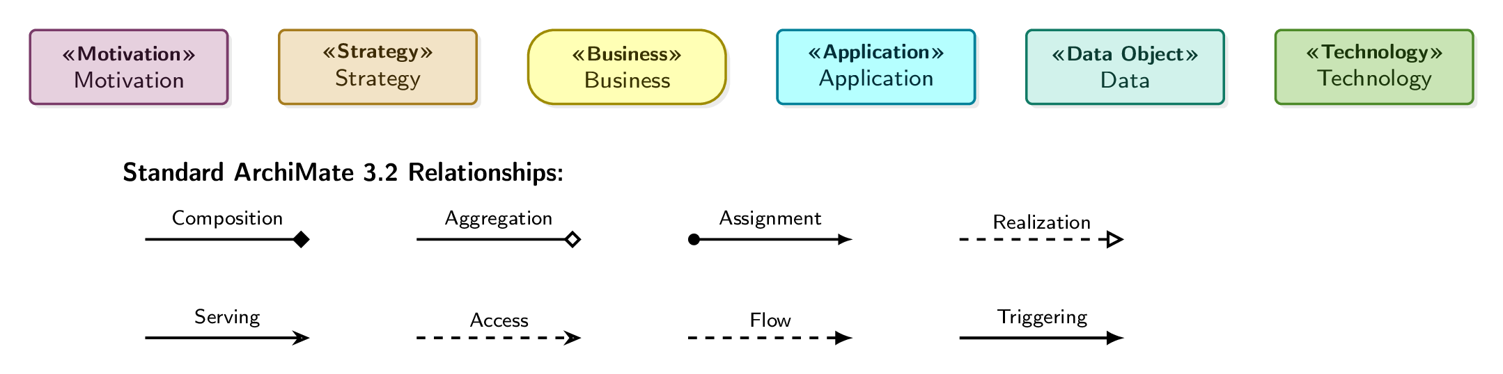
Figure 1: ArchiMate 3.2 Visual Modeling Notation, Layer Color Palette, and Relationship Types

Classical Architectural Nomenclature \& System Meanings
{section}{Classical Architectural Nomenclature & System Meanings}
Harmonia adopts naming conventions rooted in classical Greek mythology and philosophy. Each name explicitly reflects the functional responsibility and domain boundary of the underlying software component.
p{3.5cm} X} Subsystem | Architectural Role | Classical Origin | Platform Responsibilities
Harmonia | Health Integration Environment | Harmonia — Goddess of concord and balance. | Overall platform uniting clinical protocols, streaming messaging, cache grids, and relational storage.
Petasos | Messaging Transport Subsystem | Petasos — Winged hat of Hermes, symbol of swift dispatch. | Clustered ActiveMQ Artemis messaging, durable queues, client failover, and PetasosMessage envelopes.
Energeia | Workflow Services | Energeia — Aristotelian actuality and continuous activity. | Top-level workflow services aggregator containing Ponos, Praxis, Erga, and Ponos CLI.
Ponos | WorkEngine Execution Container | Ponos — Personification of industrious toil and labor. | WildFly Jakarta EE 10 container hosting Camel contexts, Petasos conduits, and REST managers.
Erga | Modular Task Activities | Erga — Plural of Ergon, works, deeds, or tasks. | Single-responsibility Camel route components (ErgonBase) executing discrete clinical mappings.
Praxis | Workflow Sequence Orchestrator | Praxis — Structured action or enactment of theory. | Sequence orchestrator chaining ordered Ergon steps and recording multi-phase state checkpoints.
Pragma | Task Instance / State Entity | Pragma — That which has been done, concrete deed. | Canonical task state model holding inputs, outputs, checkpoints, and bidirectional FHIR Task mapping.
Calliope | Canonical Schema Repository | Calliope — Chief Muse of eloquence and harmonious order. | Shared information models, domain DTOs, schemas, and payload envelopes used across all modules.
Mneme | In-Memory Distributed Cache | Mneme — Muse of active memory and rapid recall. | Infinispan distributed L1 cache grid providing low-latency task-cache and tasksequence-cache.
Mnemosyne | Relational Persistence Tier | Mnemosyne — Titaness of durable memory. | Long-term PostgreSQL storage comprising Spring Boot FHIR JPA and Operations JPA servers.
Hestia | Data Services Subsystem | Hestia — Goddess of the hearth and foundational stability. | Data services aggregator managing caching (Mneme) and persistence (Mnemosyne).
Iris | Presentation Services | Iris — Goddess of the rainbow and divine messenger. | Presentation tier comprising Jakarta EE BEFE gateway, Clinical UI SPA, and Console UI SPA.
Pylai | Gateway / Interface Services | Pylai — Gateways, portals of entry and exit. | Boundary interface services including inbound MLLP gateways (pylai-mllp-in), multi-instance outbound MLLP gateways (pylai-mllp-out), FHIR R5 Provider Registry REST gateway (pylai-fhir-registry), shared integration base library (pylai-mllp-base), and synthetic test CLI (pylai-mllp-cli).
Paradeigma | Clinical Simulation & Testbed | Paradeigma — Model, pattern, exemplar. | Reference clinical simulation subsystem providing deterministic hospital actor emulators (PAS, EMR, LMS, RIS-PAC), multi-system Patient Journey orchestration, and automated fault injection testbed.
Table 1: Harmonia Classical Architectural Nomenclature and System Meaning Matrix

Chapter 1: Motivation \& Strategy Architecture
The Motivation and Strategy layer articulates the fundamental drivers, stakeholder concerns, strategic goals, architecture principles, and business capabilities that shape the Harmonia Health Information Exchange platform.
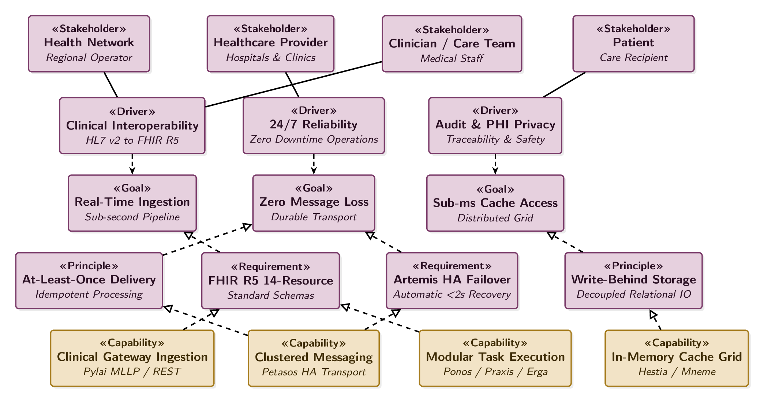
Figure 2: ArchiMate Motivation and Strategy Architecture View for Harmonia HIE

Stakeholders \& Key Drivers
Harmonia is designed to serve four primary healthcare stakeholders, addressing their distinct operational, clinical, and regulatory drivers:

Stakeholder Analysis
- Regional Health Network Operator: Responsible for governing regional health data exchange, ensuring service-level agreement (SLA) adherence, managing cross-facility data governance, and maintaining uninterrupted interoperability bridges.
- Healthcare Providers (Hospitals, Health Systems, Diagnostic Labs): Organizations that produce and consume high volumes of clinical messages (e.g. ADT admissions, ORU lab observations, MDM clinical notes) via legacy MLLP streams and modern REST APIs.
- Healthcare Directory Stewards & Credentialing Authorities: Governance officers, medical registrars, and directory administrators charged with validating practitioner qualifications, managing organizational hierarchies, verifying electronic service endpoints, and maintaining master practitioner registries.
- Clinicians & Care Teams: Physicians, nurses, and allied health staff requiring immediate, accurate, and consolidated longitudinal patient records and up-to-date provider directories at the point of care.
- Patients & Care Recipients: The ultimate beneficiaries of timely, coordinated healthcare delivery whose Protected Health Information (PHI) must be safeguarded with absolute confidentiality.

Core Drivers
- Clinical Interoperability Mandates: The necessity to bridge heterogeneous health protocols (HL7 v2.3–v2.5, HL7 v3, CDA) into standardized HL7 FHIR Release 5 schemas without loss of clinical nuance.
- National Healthcare Directory Interoperability: The requirement to maintain synchronized, standards-compliant FHIR R5 provider directories (Practitioner, PractitionerRole, Organization, Location, HealthcareService, Endpoint, Group) with strict referential integrity and national provider identifier governance (e.g., Australian HPI-I, HPI-O).
- 24/7/365 High-Availability Operations: Mission-critical healthcare environments cannot tolerate system outages, message loss, or pipeline stalls during emergency admissions or acute care events.
- Patient Safety & Identity Integrity: Mismatched patient identities lead to severe clinical errors. Automated, deterministic master patient index (EMPI) reconciliation is paramount.
- PHI Privacy & Regulatory Compliance: Strict adherence to HIPAA, GDPR, and regional privacy frameworks requiring encrypted transport, audit trails (AuditEvent, Provenance), and zero PHI leakage into operational logs.

Strategic Goals
To satisfy these drivers, Harmonia establishes five measurable architectural goals:
- Goal 1: Real-Time Ingestion & Transformation: Ingest, parse, transform, and persist clinical trigger events in under 500 milliseconds end-to-end.
- Goal 2: Zero In-Flight Message Loss: Guarantee that acknowledged messages survive hardware failures, broker restarts, network partitions, and process crashes.
- Goal 3: Sub-Millisecond Cache Response: Deliver read query response times under 1 millisecond for active clinical entities via distributed in-memory data grids.
- Goal 4: Automated Identity & Demographics Reconciliation: Resolve and merge patient identifiers, practitioner roles, and organizational hierarchies across facilities automatically.
- Goal 5: Governed Healthcare Directory Lifecycle: Expose standards-compliant FHIR R5 Provider Registry REST endpoints with sub-50ms synchronous read/search response and asynchronous, resilient change request workflows enforcing referential validation, optimistic concurrency control, and auditability.

Core Architectural Principles
Architectural Principle — At-Least-Once Delivery \& Idempotent Processing: The platform assumes at-least-once message delivery across all messaging transports. Consuming components must be idempotent. Deduplication is enforced at broker level (via ActiveMQ Artemis _AMQ_DUPL_ID caches), client transport level (DuplicateDetector), and business persistence level.
Architectural Principle — Separation of Transport from Business Logic: The messaging framework (Petasos) treats all payloads as opaque byte arrays. Transport routes are unaware of clinical schemas. Transformation logic is strictly isolated in modular task activities (Erga).
Architectural Principle — Governed Asynchronous Change Management for Directory Entities: HTTP POST and PUT interactions on directory resources represent requests for change rather than immediate direct mutations of authoritative state. Every write request generates an immutable ProviderRegistryChangePragma, undergoes validation and automated referential verification in the Energeia pipeline, and commits only upon successful verification.
Architectural Principle — Write-Behind In-Memory Cache Persistence: Workflow pipelines write state snapshots exclusively to the in-memory cache grid (Mneme) to prevent disk I/O bottlenecks. Mneme asynchronously persists snapshots to relational storage (Mnemosyne) via non-blocking write-behind cache stores.
Architectural Principle — Canonical Modeling with Standardized FHIR R5 Boundaries: Internal workflow state is represented using the canonical Pragma domain model in Calliope. All external boundary interactions and REST APIs adhere strictly to HL7 FHIR R5 resource definitions.
Architectural Principle — Strict PHI Privacy \& Zero Payload Logging: Transport engines and pipeline logs must never print clinical payload bodies at any log level (INFO, DEBUG, ERROR). Only structured correlation IDs, message IDs, and status codes may be logged.

Strategic Capabilities \& End-to-End Value Stream
Harmonia delivers six core business capabilities organized into a strategic value stream:
X} Capability | Owning Subsystem | Business Value Delivered
Clinical Gateway Interfaces | Pylai | Multi-protocol MLLP/TCP and REST ingress and reliable egress dispatch accepting and delivering continuous HL7 v2 and FHIR feeds to/from external hospital systems.
FHIR Provider Registry | Pylai / Energeia / Mnemosyne | Standards-compliant FHIR R5 Provider Registry exposing synchronous read/search and governed asynchronous change APIs for practitioners, roles, organizations, locations, services, endpoints, and groups.
High-Availability Messaging | Petasos | Clustered, replicated ActiveMQ Artemis transport ensuring message durability, load redistribution, and automatic failover.
Modular Task Execution | Energeia (Ponos/Praxis/Erga) | Composable Apache Camel processing routes performing parsing, validation, enrichment, and transformation on canonical Pragma tasks.
In-Memory Cache Grid | Hestia (Mneme) | Low-latency Infinispan data grid maintaining active clinical state, task sequences, and write-behind persistence.
Clinical Presentation & API | Iris | Secure RESTful FHIR R5 exploration and administrative operational telemetry for clinicians and engineers.
Table 2: Harmonia Strategic Capabilities and Subsystem Realization

Strategic Value Stream Flow
The end-to-end flow of clinical information across Harmonia realizes the following sequential value stream:
$\text{Ingest Trigger} \longrightarrow \text{Transport & Deduplicate} \longrightarrow \text{Orchestrate Erga} \longrightarrow \text{Update Cache Grid} \longrightarrow \text{Dispatch Egress / Serve FHIR APIs}$

Chapter 2: Business \& Clinical Architecture
The Business Layer specifies the healthcare business environment, defining external business actors, internal operational roles, business services exposed to healthcare facilities, business processes, and the core business objects exchanged across clinical pathways.
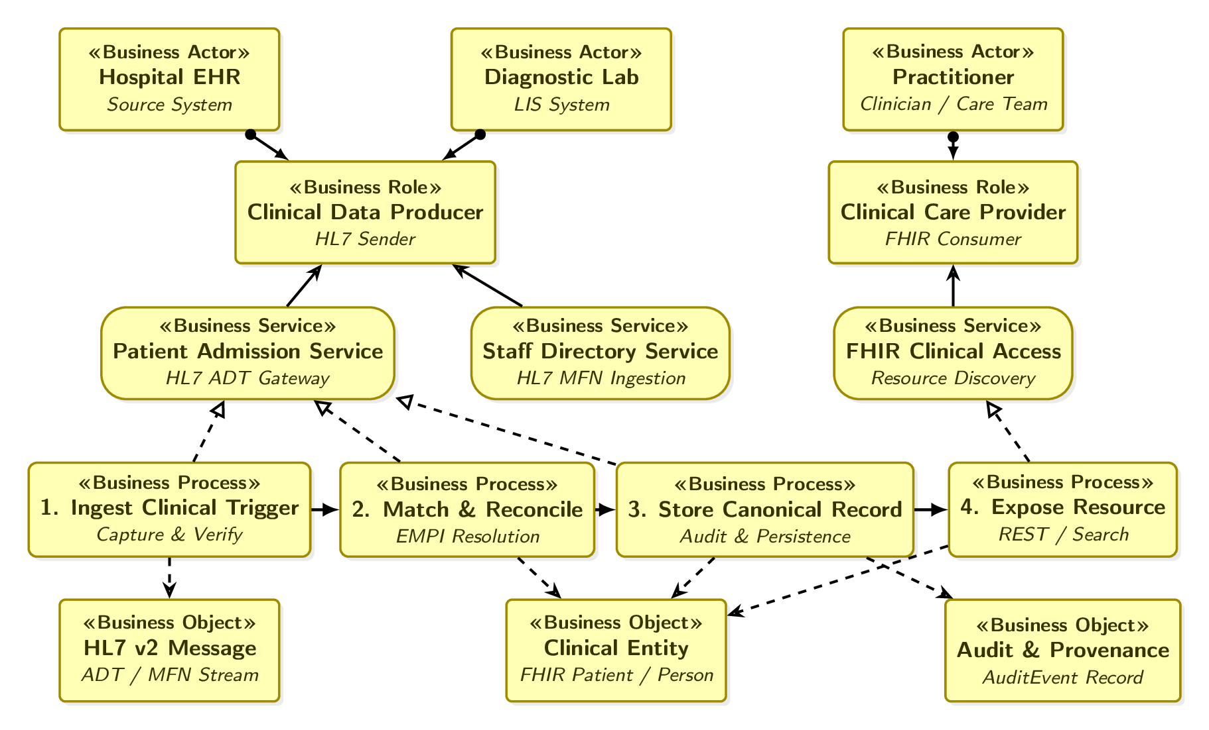
Figure 3: ArchiMate Business and Clinical Architecture View for Harmonia HIE

Healthcare Business Actors \& Operational Roles
Harmonia interacts with a diverse ecosystem of clinical actors, abstracting their interactions through formal business roles:
X} Business Actor | Assigned Business Role | Healthcare Operational Scope
Hospital EHR / PAS | Clinical Data Producer | Sends continuous real-time HL7 v2 ADT feeds (admit, discharge, transfer, demographic updates) over MLLP connections.
Diagnostic Laboratory | Diagnostic Result Producer | Dispatches lab order notifications and observation reports (HL7 ORU / FHIR Observation) to the platform.
External System (HIS / LIS) | Clinical Data Consumer | Receives outbound HL7 v2 triggers, ADT notifications, and MFN directory updates via MLLP connections and returns synchronous acknowledgments (ACK).
Practitioner / Clinician | Clinical Care Provider | Queries longitudinal patient records, reviews historical clinical encounters, inspects diagnostic summaries, and looks up provider directory entries via web UI or FHIR APIs.
Directory Steward | Directory Governance Authority | Governs healthcare provider directory entries, verifies practitioner credentialing, oversees organizational hierarchies, and reviews flagged directory change requests.
Credentialing Authority | Authoritative Identity Source | National or state medical boards (e.g. AHPRA, HI Service) publishing authoritative provider identifiers (HPI-I, HPI-O) and qualification updates.
Health Network Admin | Operations Administrator | Monitors message queue depths, inspects Artemis cluster topologies, triggers task sequence reload, and audits failed pipelines.
Table 3: Harmonia Business Actors, Assigned Roles, and Operational Responsibilities

Clinical Business Services
Harmonia exposes six core business services to external healthcare organizations:

1. Patient Admission \& Movement Service (\texttt{HL7-ADT
)} Accepts real-time patient admission, discharge, and transfer (ADT) event streams adhering to HL7 v2.3–v2.5 standards across standard trigger events:
- ADT\^{}A01 / A04: Patient Admission / Outpatient Registration.
- ADT\^{}A03: Patient Discharge / End of Encounter.
- ADT\^{}A08: Patient Demographics / Record Update.
- ADT\^{}A40: Merge Patient Identifiers (MRN / EMPI consolidation).

2. Practitioner \& Staff Directory Service (\texttt{HL7-MFN
)} Maintains an authoritative, synchronized regional directory of healthcare practitioners, specialties, role assignments, and organizational facility hierarchies via HL7 MFN master file notifications.

3. FHIR R5 Clinical Data Discovery Service
Provides RESTful search, retrieval, and subscription capabilities across 15 FHIR R5 resource types, enabling authorized clinical applications to query patient histories, encounters, and audit logs.

4. Operations Telemetry \& Workflow Administration Service
Exposes real-time health metrics, ActiveMQ Artemis broker statistics, Infinispan cache hit rates, and Ponos task execution statuses to health network operators.

5. Clinical Outbound Notification \& Egress Service (\texttt{HL7-MLLP-OUT
)} Dispatches transformed, enriched clinical trigger events (ADT, MFN, ORU) and outbound clinical notifications to remote hospital information systems and diagnostic endpoints over resilient MLLP/TCP connections, enforcing synchronous HL7 ACK/NACK validation, automatic retries, and audit tracking.

6. FHIR R5 Provider Directory Management Service
Exposes synchronous read/search and governed asynchronous change management APIs for healthcare directory entities (Practitioner, PractitionerRole, Organization, Location, HealthcareService, Endpoint, Group). It enforces automated referential verification, optimistic concurrency locking, duplicate identifier protection, and auditable FHIR Task tracking.

Clinical Business Process Workflows

Process: Ingest and Reconcile HL7 ADT Trigger
The primary clinical ingestion workflow executes through five discrete business stages:
- Stage 1: Capture MLLP Frame: Inbound MLLP gateway receives the TCP stream, validates the MLLP envelope framing (<VT> and <FS><CR>), and returns an immediate HL7 ACK to release the source hospital system.
- Stage 2: Envelope Encapsulation: The raw message is wrapped into a PetasosMessage and published onto the clustered Petasos queue (clinical.tasks.inbound).
- Stage 3: Patient Identity Resolution (EMPI): The PatientIdentityUpdateErgon activity extracts the Medical Record Number (MRN), queries the Enterprise Master Patient Index (EMPI) in Mneme cache, and assigns a canonical patient identifier.
- Stage 4: Demographics Merge & Enrichment: The PatientDemographicsUpdateErgon merges telecom, residential addresses, contact persons, and marital status into a consolidated FHIR Patient resource.
- Stage 5: Audit & Persistence: A Provenance and AuditEvent record is linked to the transaction, and the resulting resources are stored in Mneme cache and Mnemosyne PostgreSQL.

Process: Outbound MLLP Dispatch and ACK Validation Lifecycle
The outbound clinical egress workflow executes through five structured business stages:
- Stage 1: Egress Queue Enqueue: The Ponos WorkEngine or upstream routing activity publishes an outbound dispatch task to the endpoint's dedicated Petasos queue (petasos.queue.mllp.outbound.<endpoint-id>).
- Stage 2: Endpoint Resolution & Dequeue: The dedicated pylai-mllp-out instance consumes the task and verifies target destination parameters (host, port, timeouts) via the dynamic MllpDestinationRegistry.
- Stage 3: MLLP Framing & Wire Transmission: The Apache Camel MLLP client component frames the HL7 v2 payload with standard delimiters (<VT> and <FS><CR>) and transmits the message over a dedicated TCP socket.
- Stage 4: Synchronous ACK / NACK Evaluation: The gateway awaits the remote system's acknowledgment frame, parsing the MSH and MSA segments to validate acknowledgment codes (AA/CA for success vs AE/AR/CE/CR for application/commit errors).
- Stage 5: State Machine Finalization & Audit: The task status is updated in the Mneme cache grid, recording FHIR Communication, Task (Pragma), and Provenance records with remote acknowledgment details and transmission metrics.

Process: Governed Provider Registry Change Ingestion \& Verification
The governed provider directory change workflow executes through five structured business stages:
- Stage 1: Ingestion & Pragma Generation: The pylai-fhir-registry gateway receives a POST or PUT change request, performs structural validation, generates a ProviderRegistryChangePragma, and dispatches a PetasosMessage to Artemis queue harmonia.provider.registry.change.request, returning HTTP 202 Accepted with Location: /Task/{id}.
- Stage 2: Sequence Orchestration: The Ponos WorkEngine consumes the change request and triggers the Praxis sequence seq-provider-registry-change-pipeline, routing the task to the dedicated resource Ergon activity.
- Stage 3: Referential & Business Rule Verification: The Ergon activity queries ProviderRegistryReferenceValidator to verify that all referenced target entities (Practitioner, Organization, Location, HealthcareService, Endpoint) exist and are active in Mnemosyne storage, while verifying identifier uniqueness.
- Stage 4: Automated Approval & Versioned Persistence: If verification passes, the change is approved and committed to Mnemosyne PostgreSQL (hie_fhir_resources), incrementing the resource version_id and updating last_updated. If verification fails, the request transitions to REJECTED with an embedded FHIR OperationOutcome.
- Stage 5: Task Status Reflection: The underlying Pragma transitions to COMPLETED (or REJECTED), making the updated resource immediately visible on synchronous GET read/search paths and reflecting completion on GET /Task/{id}.

Core Business Objects
- HL7 v2 Message Stream: The raw wire-format clinical transmission received from legacy hospital interface engines.
- Canonical Patient Record (FHIR::Patient): The consolidated, deduplicated clinical identity representing the care recipient.
- Task State Record (Pragma): The authoritative audit representation of an in-flight integration task, including all historical state checkpoints.
- Provider Registry Change Pragma: Specialized canonical task entity capturing directory change requests, target resources, correlation IDs, and validation outcomes.
- Authoritative Provider Graph: Interconnected FHIR R5 directory resources representing practitioners, roles, organizations, locations, healthcare services, endpoints, and groups.
- Audit & Provenance Trail (FHIR::AuditEvent / FHIR::Provenance): Immutable compliance records establishing source attribution, timestamping, and processing integrity.

Chapter 3: Application Architecture
The Application Architecture layer models the core software components, internal subsystem collaborations, application services, and application interfaces across Harmonia's 26 Maven modules and presentation SPAs.
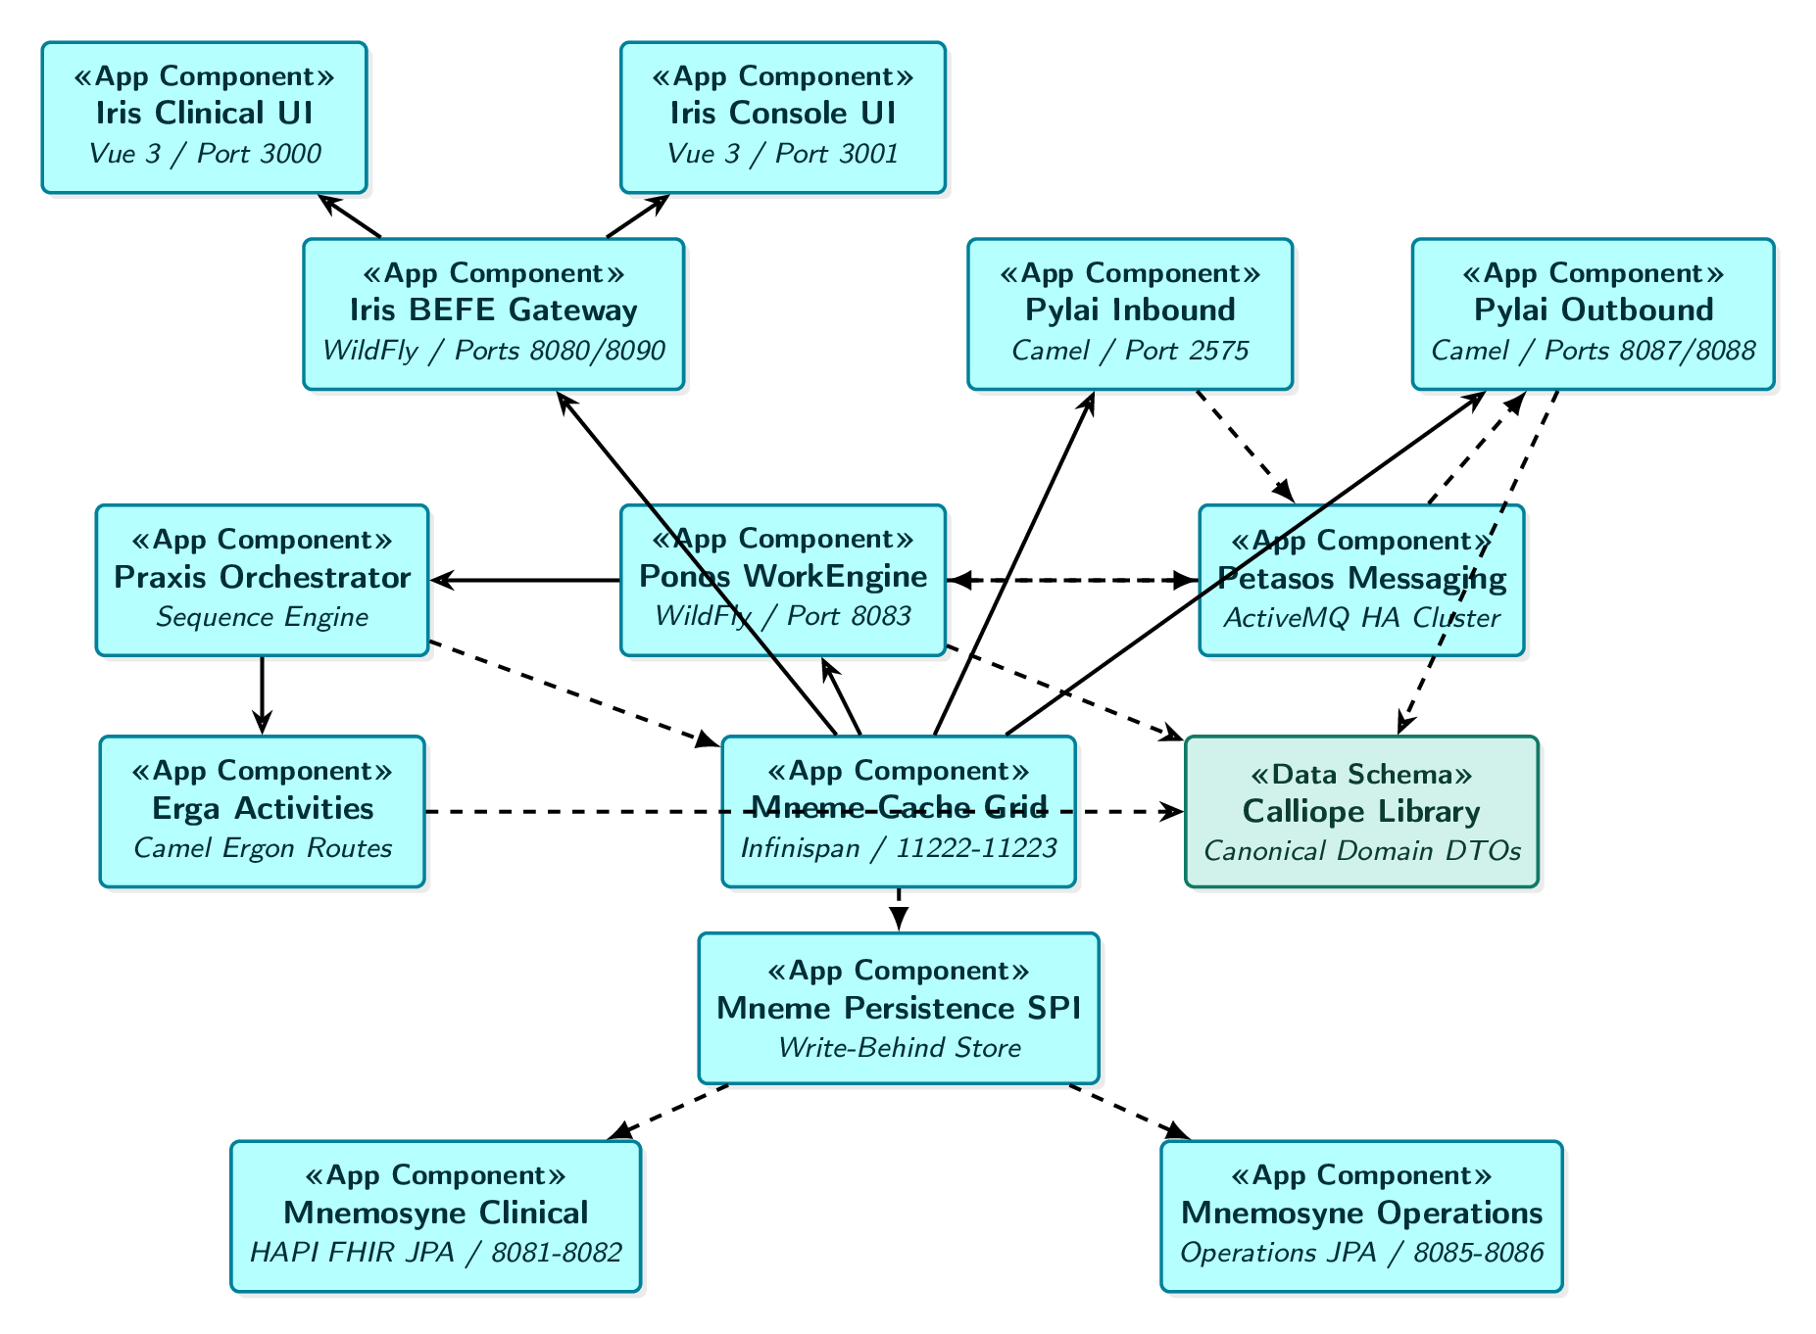
Figure 4: ArchiMate 5-Tier Application Component Landscape for Harmonia HIE

Presentation Tier: \texttt{Iris
Subsystem}
The Iris subsystem delivers user interfaces and API mediation for clinicians, operations engineers, and administrative operators.

\texttt{iris-befe
(Backend-For-Frontend Gateway)} iris-befe is a Jakarta EE 10 microprofile application deployed on WildFly providing dual-port isolated REST endpoints:
- Clinical FHIR Port 8080 (/api/fhir/{resourceType}): Handles clinical resource queries, FHIR search operations, and CRUD verbs, routing requests directly to the Mneme Infinispan data grid via HotRod protocol.
- Operations Port 8090 (/api/operations/{resourceType}): Exposes operational telemetry, Pragma task audit histories, and Artemis cluster monitoring endpoints.

\texttt{iris-clinical
(Clinical Single-Page Application)} A modern web application built with Vue 3, Vite, TypeScript, and Pinia. Provides clinicians with real-time patient lookup, longitudinal medical history timelines, encounter summaries, and diagnostic observation views.

\texttt{iris-console
(Operations & Workflow Console)} An administrative single-page application built with Vue 3 and TypeScript. Enables systems engineers to inspect ActiveMQ Artemis broker queue depths, view Infinispan cache topologies, trigger live reload of task sequence configurations, and inspect failing Pragma pipelines.

Interface \& Gateway Tier: \texttt{Pylai
Subsystem}
Pylai serves as the secure edge gateway through which external healthcare facilities exchange data with Harmonia, providing bidirectional ingestion and egress capabilities.

\texttt{pylai-mllp-in
(Inbound Clinical MLLP Gateway)} Hosts an Apache Camel MLLP listener on TCP port 2575. It captures HL7 v2 frames (<VT>...<FS><CR>), verifies message integrity, issues immediate HL7 commit acknowledgements (ACK), wraps the payload into a PetasosMessage, and publishes it to the Petasos messaging cluster for asynchronous workflow execution.

\texttt{pylai-mllp-out
(Resilient Multi-Instance Outbound MLLP Gateway)} pylai-mllp-out is a dedicated, high-reliability outbound integration gateway deployed as a WildFly Jakarta EE 10 microservice. It provides comprehensive HL7 v2 message transmission to external clinical systems (e.g. Hospital Information Systems, Laboratory Information Systems, and Picture Archiving and Communication Systems).
Key architectural characteristics include:
- Multi-Instance Egress Architecture: Each external clinical destination or tenant is serviced by an independent, isolated gateway instance (e.g., mllp-outbound-his on port 8087 and mllp-outbound-lis on port 8088). This multi-instance model provides hardware and process isolation across remote clinical endpoints.
- Independent Petasos Queues per Destination: Outbound tasks are partitioned into dedicated, destination-specific messaging queues (e.g., petasos.queue.mllp.outbound.<endpoint-id>). Slow, lagging, or offline hospital destinations cannot cause head-of-line blocking or degrade dispatch performance for other destinations.
- Apache Camel MLLP Client Routes: The OutboundMllpRouteBuilder configures synchronous Camel MLLP producer endpoints (direct:mllp-outbound-send), managing TCP socket connections, socket timeouts, keep-alives, and automatic reconnection policies.
- Outbound Processing & ACK/NACK Validation: The OutboundMllpProcessor serializes payloads into standard MLLP frames, while the Hl7AckProcessor performs deep inspection of the returned HL7 ACK frame (MSH and MSA segments), validating acknowledgment codes (AA/CA for success, AE/AR/CE/CR for error states) and extracting error condition descriptions.
- Synchronous REST Dispatch APIs: The OutboundMllpResource exposes high-performance JAX-RS REST endpoints: {itemize}
- POST /api/mllp/outbound/send: Generic HL7 v2 outbound dispatch endpoint.
- POST /api/mllp/outbound/adt/send: Specialized clinical ADT trigger event dispatch.
- POST /api/mllp/outbound/mfn/send: Master file notification directory dispatch.
- GET /api/mllp/outbound/health: Real-time destination connectivity and circuit health status.
Dynamic Destination Management: The MllpDestinationRegistry resolves target endpoint hostnames, TCP ports, timeout thresholds, and retry policies dynamically via MllpDestinationConfig. Mneme Cache State Auditing: Every outbound dispatch updates the Mneme Infinispan data grid with FHIR Communication (sent message, response ACK, latency), Task (Pragma state transition), and Provenance resources. {itemize}

\texttt{pylai-mllp-base
(Shared Gateway Integration Library)} Provides core domain models and shared infrastructure for the Pylai gateway tier, including the OutboundMllpRequest and OutboundMllpResponse DTOs, MllpDestinationConfig, MllpDestinationRegistry, MLLP framing utilities, and Mneme cache connectors.

\texttt{pylai-mllp-cli
(Synthetic Test & Diagnostic Utility)} A command-line diagnostic tool used by integration engineers to generate and dispatch parameterized HL7 v2.4/v2.5 ADT (A01–A40) messages to Pylai gateways for end-to-end functional, egress verification, and throughput benchmarking.

\texttt{pylai-fhir-registry
(FHIR R5 Provider Registry REST Gateway)} pylai-fhir-registry provides an authoritative, standards-compliant HL7 FHIR Release 5 (R5) REST interface for managing healthcare provider directory entities (Practitioner, PractitionerRole, Organization, Location, HealthcareService, Endpoint, Group).
Key architectural components and capabilities include:
- FhirRestGatewayController: Exposes synchronous GET read and multi-parameter search endpoints delegating directly to Mnemosyne persistence, and asynchronous governed write endpoints (POST and PUT) that return HTTP 202 Accepted with Location: /Task/{id}.
- CapabilityStatementProvider: Dynamically generates and serves the server's official FHIR R5 CapabilityStatement on GET /metadata, describing supported resource schemas, search parameters, REST interactions, and security mechanisms.
- ProviderRegistryTaskResourceProvider: Implements standard FHIR GET /Task/{id} polling, mapping the underlying Pragma lifecycle state (ACCEPTED, IN_PROGRESS, COMPLETED, REJECTED, FAILED) to FHIR Task.status and attaching OperationOutcome diagnostics.
- FhirSecurityInterceptor: Fine-grained Spring/JAX-RS security interceptor enforcing role-based and resource-level authorization scopes (e.g. Practitioner.read, PractitionerRole.update.request).
- ChangeRequestSubmissionService: Packages incoming write payloads into canonical ProviderRegistryChangePragma envelopes and publishes PetasosMessage instances to ActiveMQ Artemis.

Messaging Transport Subsystem: \texttt{Petasos
}
Petasos provides reliable, durable, and asynchronous message transportation between all Harmonia subsystems, fully encapsulating Apache ActiveMQ Artemis JMS and Core protocol complexity behind clean domain interfaces.
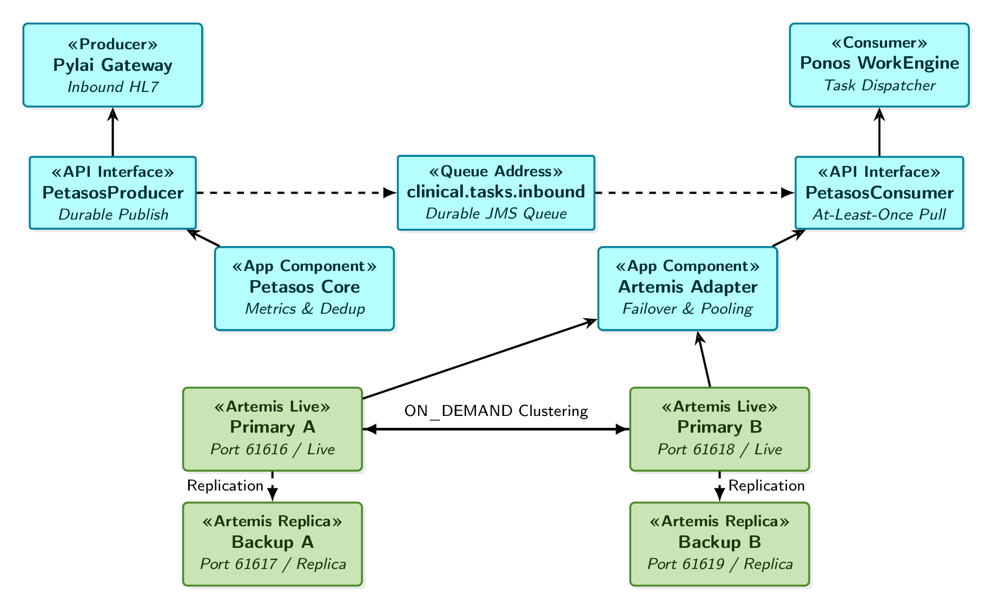
Figure 5: ArchiMate Petasos Messaging Subsystem \& Clustered Transport Architecture

\texttt{petasos-api
(Core Abstractions)} Defines the client-facing contracts used across Harmonia:
- PetasosProducer: Synchronous and asynchronous durable message publishing.
- PetasosConsumer: Thread-safe queue polling and event subscription with lifecycle context hooks.
- PetasosMessage: Immutable metadata envelope encapsulating messageId, correlationId, causationId, schema URIs, and payload byte arrays.
- PetasosDestination: Logical address and queue routing identifiers.

\texttt{petasos-core
(Serialization & Deduplication)}
- JSON Envelope Serialization: High-speed Jackson-based serialization of message headers and payloads.
- DuplicateDetector: An in-memory sliding window cache tracking message IDs to suppress client-side duplicates.
- PetasosMetricsCollector: Thread-safe metrics registry tracking message send/receive counters, failure rates, and reconnection events.

\texttt{petasos-artemis
(Artemis Adapter)}
- ArtemisConnectionManager: Manages pooled JMS connections with automatic reconnect loops, failover listeners (FAILURE_DETECTED, FAILOVER_COMPLETED), and exponential backoff retry policies.
- ArtemisMessageConverter: Bidirectional mapping between PetasosMessage and Artemis Core/JMS messages, automatically setting _AMQ_DUPL_ID for broker-level deduplication.

Workflow Services Subsystem: \texttt{Energeia
}
Energeia hosts the task execution and workflow pipeline framework.
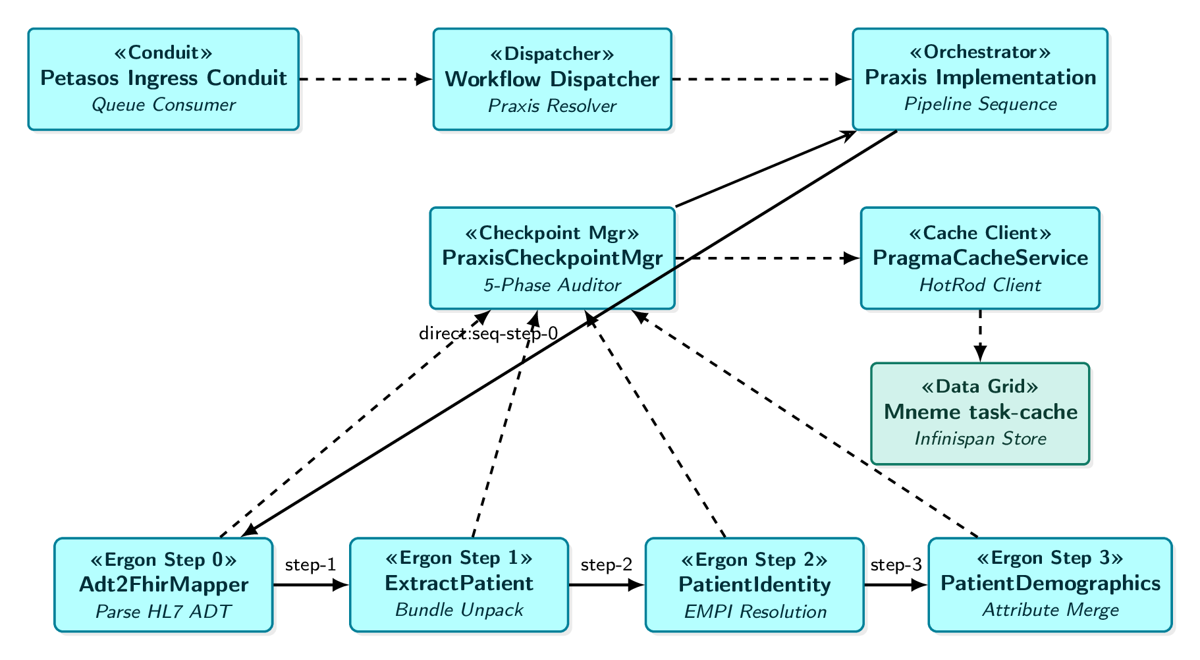
Figure 6: ArchiMate Energeia Workflow Engine \& Sequential Erga Pipeline View

\texttt{energeia/ponos
(WorkEngine Runtime Container)} Deployed on WildFly Jakarta EE 10 (port 8083), Ponos hosts the execution environment:
- PetasosQueueToExchangeConduit: Ingress consumer listening on Petasos queues (including clinical ingestion queues and harmonia.provider.registry.change.request), extracting incoming Pragma payloads, creating Camel exchanges, and managing acknowledgement lifecycles.
- PragmaWorkflowDispatcher: Resolves matching Praxis workflow definitions based on task metadata and routes exchanges to entry direct endpoints.
- CamelContextManager: Manages the lifecycle of Apache Camel contexts and thread pools.

\texttt{energeia/praxis
(Workflow Sequence Orchestration)}
- PraxisImplementation: Orchestrates ordered sequences of Ergon activities over synchronous Camel direct endpoints (direct:seq-<praxisId>-step-<N>).
- ProviderRegistrySequenceBuilder: Configures and seeds the canonical seq-provider-registry-change-pipeline sequence, orchestrating per-resource validation, reference verification, and persistence.
- PraxisCheckpointManager: Records the 5-phase execution audit checkpoints (PIPELINE_INGRESS, PRE_ERGON, POST_ERGON, PIPELINE_COMPLETE, PIPELINE_FAILED) and snapshots state to Mneme cache.
- PragmaCacheService: Interfaces directly with Mneme's task-cache.

\texttt{energeia/erga
(Modular Task Activities)}
- ErgonBase: Abstract Camel RouteBuilder enforcing the single-responsibility contract: reads from pragma.getInput(), executes domain logic via processErgon(Pragma, Exchange), and appends resulting artifacts to pragma.getOutput().
- Clinical Ingestion Catalog: Includes Adt2FhirMapper, Mfn2FhirBundle, ExtractPatientFromBundle, PatientIdentityUpdateErgon, and PatientDemographicsUpdateErgon.
- Provider Registry Erga Suite: 7 dedicated per-resource change processing activities: {itemize}
- PractitionerChangeErgon: Validates individual practitioner names, qualifications, and unique HPI-I/NPI identifiers.
- PractitionerRoleChangeErgon: Validates reference links to Practitioner, Organization, Location, HealthcareService, and Endpoint.
- OrganizationChangeErgon: Validates organization identifiers (HPI-O), active status, and parent/child hierarchies.
- LocationChangeErgon: Validates physical facility coordinates, addresses, and managing organization references.
- HealthcareServiceChangeErgon: Validates provided-by organization and operating location references.
- EndpointChangeErgon: Validates technical connection types, address URIs, and payload MIME types.
- GroupChangeErgon: Validates group member references and membership types.
{itemize}

Data Services Subsystem: \texttt{Hestia
}
Hestia delivers multi-tier caching and durable relational persistence:
- mneme-cluster: 2-node Infinispan 15+ replicated data grid (ports 11222–11223) maintaining task-cache, tasksequence-cache, and communication-cache.
- mneme-persistence: Custom NonBlockingStore SPI implementations (OperationsRestCacheStore, FhirRestCacheStore) providing asynchronous write-behind synchronization to Mnemosyne.
- mnemosyne-clinical: Spring Boot HAPI FHIR JPA server (ports 8081–8082) backed by PostgreSQL storing canonical FHIR R5 resources in hie_fhir_resources. Implements EndpointResourceProvider, multi-parameter search filtering in FhirStorageService, deep referential integrity checks via ProviderRegistryReferenceValidator, and optimistic concurrency control (If-Match/ETag).
- mnemosyne-operations: Spring Boot JPA server (ports 8085–8086) backed by PostgreSQL storing operational task sequences, Pragmas, and audit logs.

Canonical Schema Repository: \texttt{Calliope
}
Calliope is the shared canonical library defining domain DTOs, the Pragma model, ErgonPayload, ProviderRegistryChangePragma, canonical constants (ProviderRegistryConstants), validation error codes (PR-VAL-001 through PR-VAL-010), and bidirectional converters for FHIR R5 Task resources, guaranteeing type safety across all platform tiers.

Chapter 4: Data \& Information Architecture
The Data and Information Architecture layer defines the canonical information models, the task state lifecycle, message transport envelopes, clinical mapping dictionaries, and the 14 supported HL7 FHIR Release 5 (R5) resource schemas.

Canonical Domain Models (\texttt{Calliope
)}
Harmonia avoids coupling workflow logic to proprietary or concrete wire formats by establishing strongly-typed canonical domain entities in the Calliope library.

1. \texttt{Pragma
(Task State Entity)} Pragma represents the single authoritative state representation for an execution task:
public class Pragma implements Serializable {
private String pragmaId; // Unique UUID
private String correlationId; // End-to-end transaction thread
private String causationId; // Triggering event or message ID
private String praxisId; // Workflow sequence definition ID
private PragmaStatus status; // DRAFT, REQUESTED, IN_PROGRESS, COMPLETED, FAILED
private Integer priority; // 1 (Lowest) - 100 (Highest)
private Date authoredOn;
private Date lastModified;
private String source; // Originating gateway / interface
private String destination; // Target queue or service address
private List<ErgonPayload> input = new ArrayList<>();
private List<ErgonPayload> output = new ArrayList<>();
private List<PragmaCheckpoint> checkpoints = new ArrayList<>();
private Map<String, String> metadata = new LinkedHashMap<>();
}

2. \texttt{PragmaCheckpoint
(Execution Audit Snapshot)} Captures an immutable audit milestone recorded at pipeline transitions:
public class PragmaCheckpoint implements Serializable {
private String checkpointId;
private String pragmaId;
private String ergonId; // Active Ergon activity
private String stageName; // PIPELINE_INGRESS, PRE_ERGON, POST_ERGON, etc.
private Date timestamp;
private PragmaStatus status;
private String statusMessage;
private Integer stepIndex; // 0-based sequence step
}

3. \texttt{ProviderRegistryChangePragma
(Directory Change Wrapper)} Wraps and manages asynchronous change requests submitted via FHIR Provider Registry POST/PUT endpoints:
public class ProviderRegistryChangePragma implements Serializable {
private final Pragma pragma;
public String getPragmaId();
public String getCorrelationId();
public String getOperation(); // CREATE or UPDATE
public String getResourceType(); // Practitioner, Organization, etc.
public String getResourceId(); // Target FHIR logical ID
public String getRequester(); // Submitting user / principal
public String getSourceSystem(); // Source system identifier
public String getIfMatch(); // Expected ETag / version header
public String getValidationOutcome(); // Validation status / diagnostics
public String getResultingResourceVersion();
public Resource getRequestedResource(); // Parsed FHIR R5 resource payload
}

4. Canonical Provider Registry Validation Codes
Harmonia standardizes error diagnostic reporting using canonical issue codes embedded within FHIR OperationOutcome responses:
Error Code | Issue Category | Architectural Description & Diagnostic Condition
PR-VAL-001 | Structural Error | Malformed FHIR JSON, unparseable attributes, or schema violation.
PR-VAL-002 | Missing Field | Required mandatory directory fields missing (e.g. Practitioner name).
PR-VAL-003 | Duplicate Identifier | Duplicate deterministic provider identifier (HPI-I, HPI-O, NPI).
PR-VAL-004 | Reference Not Found | Referenced target resource does not exist in Mnemosyne storage.
PR-VAL-005 | Reference Inactive | Referenced target resource is marked inactive or soft-deleted.
PR-VAL-006 | Concurrency Conflict | Stale update rejected due to If-Match / ETag version mismatch.
PR-VAL-007 | Invalid Endpoint | Malformed technical endpoint URL, invalid payload type, or status.
PR-VAL-008 | Invalid Group | Invalid group membership type or unresolved member references.
PR-VAL-009 | Unsupported Resource | Submitted resource type is not supported by Provider Registry.
PR-VAL-010 | Business Rule Failure | Custom business validation failure or governance policy violation.
Table 4: Canonical Provider Registry Validation and Error Diagnostic Codes

Canonical Outbound Models (\texttt{pylai-mllp-base
)}
The Pylai gateway tier standardizes outbound MLLP interactions using canonical data structures:

1. \texttt{OutboundMllpRequest
} Encapsulates an outbound MLLP dispatch payload with destination routing and clinical metadata:
public class OutboundMllpRequest implements Serializable {
private String requestId; // Unique dispatch UUID
private String messageControlId; // HL7 MSH-10 control identifier
private String destinationId; // Target endpoint identifier (e.g. HIS_NORTH)
private String rawMessage; // Raw HL7 v2 pipe-delimited message string
private String targetQueue; // Destination Petasos queue
private Topic topic; // Resolved clinical topic metadata
private Date timestamp; // Enqueue timestamp
private int priority = 4; // JMS priority
private String taskId; // Associated Pragma / Task resource ID
private String facility; // Clinical facility code
private String correlationId; // End-to-end trace identifier
}

2. \texttt{OutboundMllpResponse
} Encapsulates the synchronous result and acknowledgment returned from the external clinical endpoint:
public class OutboundMllpResponse implements Serializable {
private String requestId;
private String messageControlId;
private String destinationId;
private String ackCode; // AA, AE, AR, CA, CE, CR
private String ackText; // Error description or text
private String rawAckMessage; // Raw HL7 ACK wire frame
private boolean successful; // True if AA or CA
private long durationMs; // Round-trip transmission latency
private Date dispatchedAt;
private Date acknowledgedAt;
private String errorMessage;
private String taskId;
private String communicationId; // Persisted FHIR Communication ID
private String provenanceId; // Persisted FHIR Provenance ID
}

3. \texttt{MllpDestinationConfig
} Defines connectivity and timeout parameters for remote clinical MLLP servers:
public class MllpDestinationConfig implements Serializable {
private String destinationId; // Unique target key (e.g. LIS_MAIN)
private String name; // Human-readable destination label
private String host; // Target IP or hostname
private int port; // Target TCP port
private int connectTimeoutMs = 5000;
private int readTimeoutMs = 10000;
private String charset = "UTF-8";
private boolean keepAlive = true;
private boolean autoAck = true;
private String queueName; // Dedicated Petasos queue override
private String queuePrefix = "petasos.queue.mllp.outbound";
private boolean sslEnabled = false;
private boolean enabled = true;
private String facility;
}

The 5-Phase Checkpoint Lifecycle State Flow
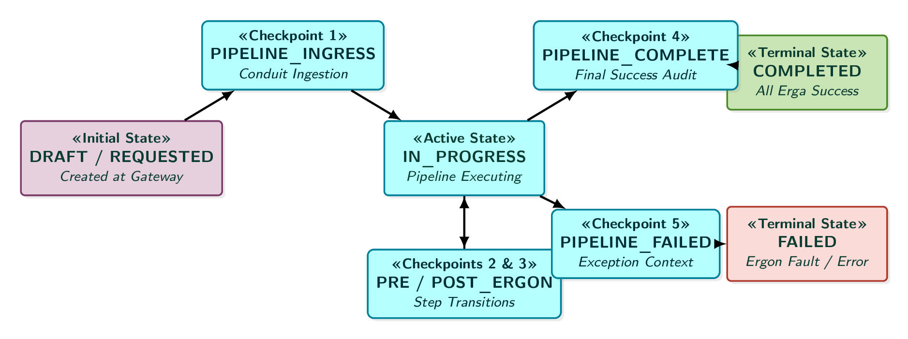
Figure 7: ArchiMate Pragma Task State Machine and 5-Phase Checkpoint Lifecycle
The PraxisCheckpointManager stamps and persists snapshots across five deterministic boundaries:
- PIPELINE_INGRESS: Fired when PetasosQueueToExchangeConduit ingests a task from Artemis. Sets status to IN_PROGRESS and step to 0.
- PRE_ERGON: Fired immediately prior to invoking an individual ErgonBase activity, capturing input payload counts.
- POST_ERGON: Fired upon successful return from an Ergon step, recording generated output counts and execution duration.
- PIPELINE_COMPLETE: Fired when the entire Praxis sequence finishes successfully. Sets terminal status to COMPLETED.
- PIPELINE_FAILED: Fired upon any uncaught exception or ErgonException. Records faulting step, exception class, and stack trace, setting terminal status to FAILED.

\texttt{PetasosMessage
Transport Envelope}
All asynchronous transport operations across ActiveMQ Artemis use the standard immutable PetasosMessage envelope:
Field | Data Type | Transport Semantic & Function
messageId | String | Globally unique UUID.
correlationId | String | Tracks conversational thread or clinical episode.
causationId | String | Identifies immediate predecessor event.
messageType | String | Logical event type (e.g. PatientAdmitEvent).
source / destination | String / Destination | Originating module and target queue address.
timestamp | Instant | Creation timestamp.
contentType | String | MIME type (application/json, application/fhir+json).
schemaIdentifier | String | Canonical StructureDefinition URI.
schemaVersion | String | Model version (5.0.0, R5).
payload | byte[] | Opaque serialized binary/text payload (uninspected by transport).
duplicateDetectionId | String | Mapped to Artemis _AMQ_DUPL_ID for broker deduplication.
durable | boolean | Directs Artemis to write to persistent journal before commit.
Table 5: Petasos Standard Message Envelope Attribute Specification

Supported FHIR R5 Resource Schemas
Harmonia implements full lifecycle CRUD and search capabilities for 15 core FHIR R5 resources:
X} FHIR R5 Resource | Domain Classification | Harmonia Platform Role
Patient | Clinical Individual | Primary care recipient entity with consolidated identifiers.
Person | Demographic Master | Cross-facility master demographic identity.
RelatedPerson | Family / Carer | Emergency contacts, next-of-kin, and legal guardians.
Practitioner | Healthcare Provider | Medical professionals, physicians, and clinical staff.
PractitionerRole | Operational Role | Specialty, location, and organizational assignments for practitioners.
Organization | Facility / Authority | Hospitals, clinics, labs, and health network authorities.
Location | Physical Facility | Wards, rooms, clinics, and physical service delivery sites.
HealthcareService | Clinical Offering | Medical specialties and care services offered at locations.
Endpoint | Electronic Service | Secure messaging, FHIR REST, and MLLP communication endpoints.
Group | Cohort Entity | Patient cohorts, provider directories, and specialized care teams.
Task | Workflow Entity | Direct bidirectional projection of Pragma state instances and outbound transmission execution tracking.
Communication | Exchange Audit | Record of incoming and outgoing MLLP message transmissions, wire payloads, and ACK/NACK responses.
DocumentReference | Clinical Document | Metadata indexing for external clinical notes, CDA, and PDFs.
Provenance | Lineage Tracking | Source and destination attribution, creator identities, and transformation/egress delivery history.
AuditEvent | Security / Access Audit | Detailed audit records capturing all read, write, and failover events.
Table 6: Harmonia Supported FHIR R5 Resource Schema Catalog

Relational Persistence Schema (\texttt{Mnemosyne-Clinical
)} {sec:relational_persistence_schema}
Authoritative clinical and directory resources are persisted in PostgreSQL using a high-performance Hybrid Relational-Document Pattern in table hie_fhir_resources:
CREATE TABLE hie_fhir_resources (
id BIGSERIAL PRIMARY KEY,
resource_type VARCHAR(64) NOT NULL,
fhir_id VARCHAR(128) NOT NULL,
version_id BIGINT NOT NULL DEFAULT 1,
resource_json TEXT NOT NULL,
is_deleted BOOLEAN NOT NULL DEFAULT FALSE,
last_updated TIMESTAMP WITHOUT TIME ZONE NOT NULL DEFAULT NOW(),
CONSTRAINT uk_resource_type_fhir_id UNIQUE (resource_type, fhir_id)
);
CREATE INDEX idx_resource_type_fhir_id ON hie_fhir_resources(resource_type, fhir_id);
CREATE INDEX idx_resource_type_deleted ON hie_fhir_resources(resource_type, is_deleted);
This hybrid storage strategy guarantees:
- Lossless FHIR R5 Fidelity: The complete resource structure, including complex extensions and contained resources, is stored in resource_json.
- High-Speed Indexed Search: Hot lookup fields (resource_type, fhir_id, is_deleted) are indexed at the relational engine level.
- Optimistic Concurrency & Versioning: Each update atomically increments version_id and stamps last_updated, supporting If-Match / ETag precondition validation.
- Audit-Preserving Soft Delete: Soft-deleted resources maintain their historical records with is_deleted = TRUE.

Chapter 5: Technology \& Infrastructure Architecture
The Technology Architecture layer defines the underlying system software runtimes, execution nodes, communication paths, network protocols, and the master platform port allocation specification.
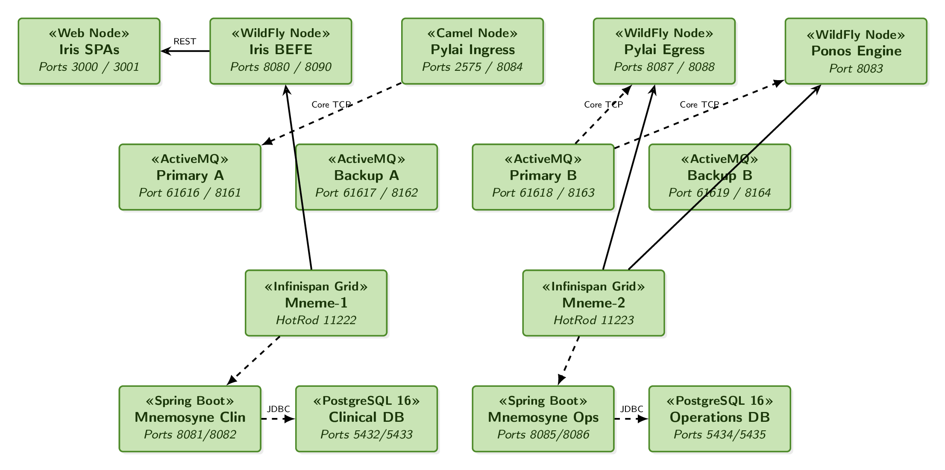
Figure 8: ArchiMate Technology Infrastructure, System Software \& Communication Paths

System Software Runtimes
Harmonia standardizes on production-grade, enterprise open-source software runtimes:
- WildFly Jakarta EE 10 / Java 21: Provides the enterprise container runtime for iris-befe, ponos, pylai-mllp-in, and pylai-mllp-out, delivering CDI dependency injection, JAX-RS REST endpoints, Apache Camel routes, and managed thread pools.
- Apache ActiveMQ Artemis 2.38+: High-performance, non-blocking asynchronous message broker providing asynchronous NIO journal durability, server-side clustering, and real-time replication.
- Infinispan 15+ Distributed Cache Grid: In-memory data grid providing partitioned and replicated L1 caching, non-blocking write-behind SPI stores, and HotRod binary protocol access.
- Spring Boot 3.x / HAPI FHIR JPA: Serves as the persistence and service framework for mnemosyne-clinical, mnemosyne-operations, and the pylai-fhir-registry REST gateway, encapsulating JPA 3.1 entity mapping, Liquibase migrations, and HAPI FHIR storage engines.
- PostgreSQL 16+ Relational Database: ACID-compliant relational persistence backend for clinical resources, provider directory records, and operational task histories.
- Node.js / Vite / Vue 3: Presentation runtime for the Iris Clinical and Console Single Page Applications.

In-Memory Cache Grid \& Persistence SPI (\texttt{Hestia
)}
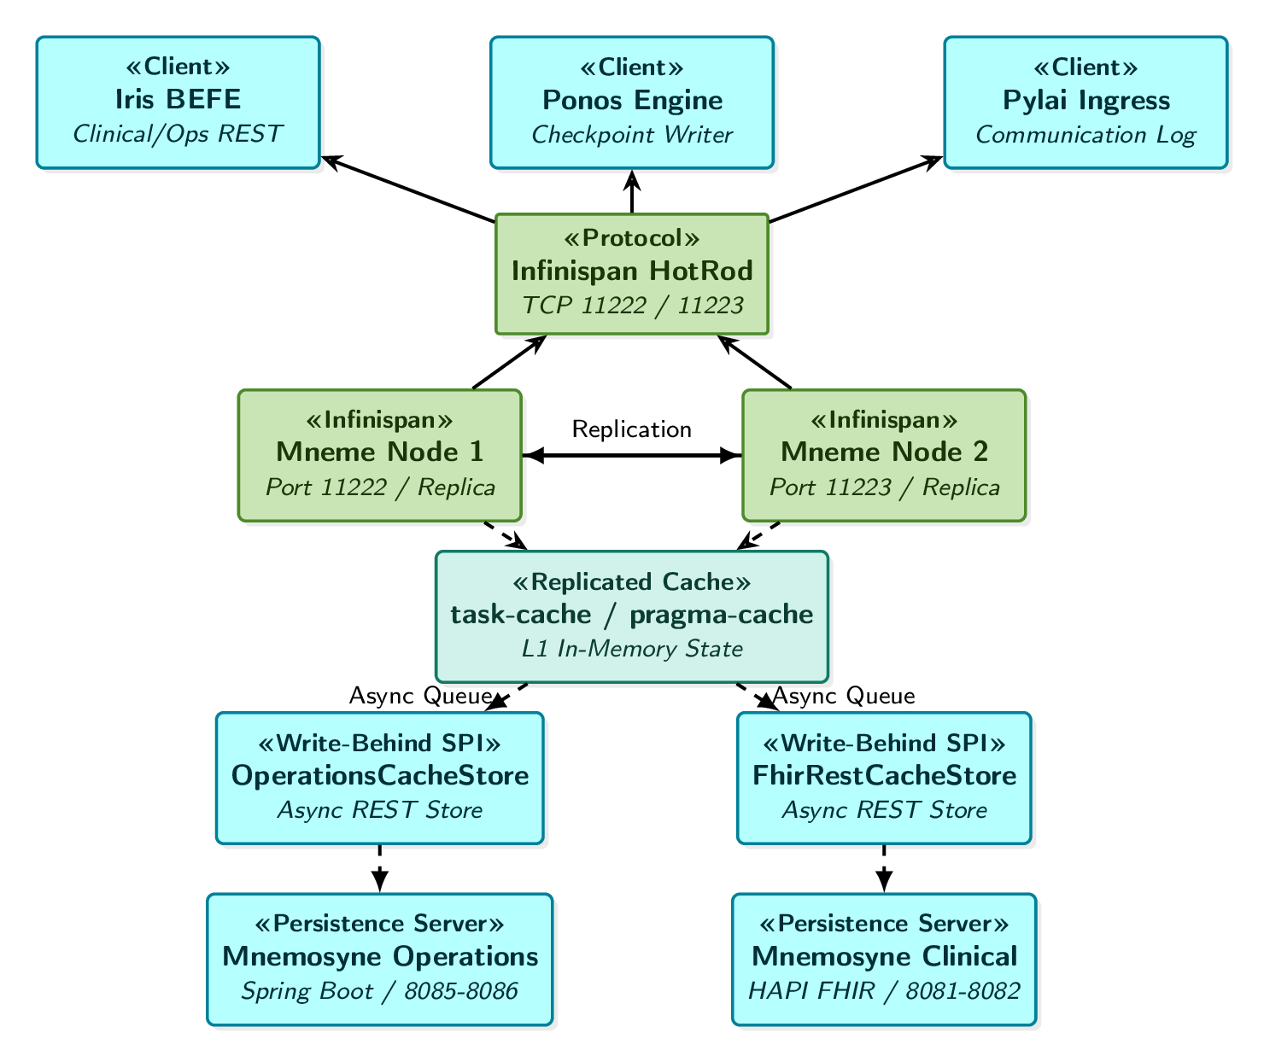
Figure 9: ArchiMate Hestia In-Memory Data Grid \& Write-Behind Persistence SPI Architecture
The Hestia data tier separates fast in-memory execution from relational database I/O:
- HotRod Binary Protocol: Applications connect to Infinispan nodes over TCP ports 11222 and 11223 using near-zero latency HotRod serialization.
- Asynchronous Write-Behind Queue: When a Pragma checkpoint or Communication is put to the cache, Infinispan immediately acknowledges the write in RAM and places the entry on an asynchronous write-behind persistence queue.
- NonBlockingStore SPI: Custom SPI handlers (OperationsRestCacheStore) drain the queue and issue batched HTTP PUT/POST requests to the Mnemosyne REST APIs, preventing pipeline stalls.

Master Platform Port Allocation Specification
To ensure complete isolation and zero port collisions across development, test, and containerized production environments, Harmonia enforces the following deterministic port allocation matrix:
Port | Protocol | Target Component | Functional Purpose
2575 | MLLP / TCP | pylai-mllp-in | Inbound HL7 v2.x clinical trigger event stream.
3000 | HTTP | iris-clinical | Vue 3 Clinical Exploration User Interface.
3001 | HTTP | iris-console | Vue 3 Operations & Monitoring Console.
5432 | PostgreSQL | clinical-db-primary | Primary PostgreSQL clinical database.
5433 | PostgreSQL | clinical-db-replica | Streaming replica PostgreSQL clinical database.
5434 | PostgreSQL | operations-db-primary | Primary PostgreSQL operations/task database.
5435 | PostgreSQL | operations-db-replica | Streaming replica PostgreSQL operations database.
61616 | Artemis Core | artemis-primary-a | Artemis HA Primary broker A (Messaging).
61617 | Artemis Core | artemis-backup-a | Artemis HA Backup broker A (Replication).
61618 | Artemis Core | artemis-primary-b | Artemis HA Primary broker B (Messaging).
61619 | Artemis Core | artemis-backup-b | Artemis HA Backup broker B (Replication).
8080 | HTTP REST | iris-befe | Clinical FHIR R5 REST API.
8081 | HTTP REST | mnemosyne-clinical-1 | Clinical JPA persistence server (Primary).
8082 | HTTP REST | mnemosyne-clinical-2 | Clinical JPA persistence server (Secondary).
8083 | HTTP REST | ponos | Ponos WorkEngine management & telemetry.
8084 | HTTP REST | pylai-mllp-in | Pylai MLLP gateway health & administration.
8085 | HTTP REST | mnemosyne-operations-1 | Operations JPA persistence server (Primary).
8086 | HTTP REST | mnemosyne-operations-2 | Operations JPA persistence server (Secondary).
8087 | HTTP REST | pylai-mllp-out-his | Outbound MLLP gateway (HIS instance) REST dispatch & telemetry.
8088 | HTTP REST | pylai-mllp-out-lis | Outbound MLLP gateway (LIS instance) REST dispatch & telemetry.
8089 | HTTP REST | pylai-fhir-registry | FHIR R5 Provider Registry REST Gateway API & Task Polling.
8090 | HTTP REST | iris-befe | Operations and task sequence management REST API.
8161 | HTTP Web | artemis-primary-a | Artemis Primary A web administration console.
8162 | HTTP Web | artemis-backup-a | Artemis Backup A web administration console.
8163 | HTTP Web | artemis-primary-b | Artemis Primary B web administration console.
8164 | HTTP Web | artemis-backup-b | Artemis Backup B web administration console.
11222 | HotRod / TCP | mneme-node-1 | Infinispan data grid cluster node 1.
11223 | HotRod / TCP | mneme-node-2 | Infinispan data grid cluster node 2.
Table 7: Harmonia Master Technology Infrastructure Port Allocation Matrix

Chapter 6: Physical \& High Availability Deployment
The Physical and Deployment Architecture layer specifies the high-availability infrastructure topology, Apache ActiveMQ Artemis multi-broker replication groups, Infinispan cache grid clustering, Docker Compose deployment configurations, and failover/recovery mechanics.
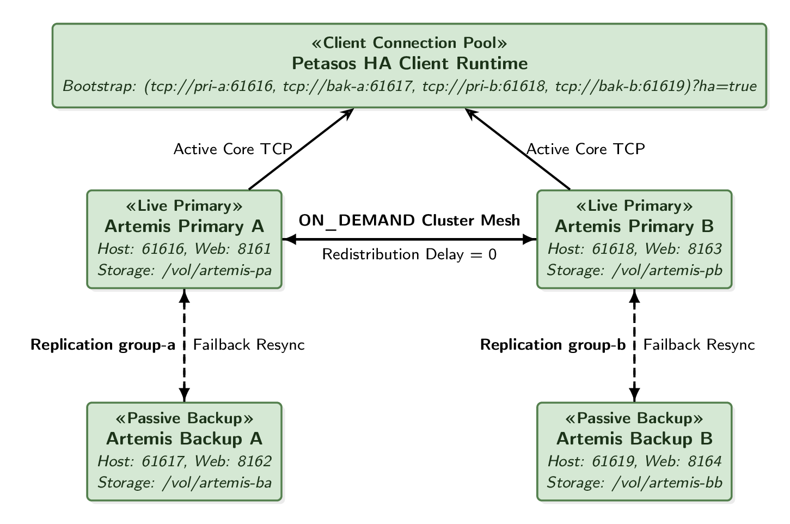
Figure 10: ArchiMate Physical Deployment \& Multi-Broker ActiveMQ Artemis HA Architecture

Clustering vs. High Availability (HA) Replication
Harmonia establishes a clear architectural distinction between horizontal clustering and instance-level replication:

1. Server-Side Clustering (\texttt{petasos-cluster
)}
- Active-Active Mesh: Unites multiple live brokers (Primary A and Primary B) into a distributed message routing fabric.
- Dynamic Load Distribution (ON_DEMAND): Messages published to Primary A are dynamically forwarded across the cluster bridge to Primary B if consumers exist on Primary B and not on Primary A.
- Immediate Message Redistribution (redistribution-delay = 0): When all consumers on one broker disconnect, unconsumed messages are immediately redistributed to alternative nodes with active consumers, preventing queue starvation.
- Horizontal Scalability: Additional Primary/Backup pairs can be introduced dynamically without disrupting existing message flows.

2. Journal Replication Groups (\texttt{group-a
, group-b)}
- NIO Journal Streaming: An active Primary continuously streams file journal updates over TCP to its paired passive Backup replica.
- Activation on Failure: If Primary A terminates or loses network connectivity, Backup A detects connection loss within 10 seconds and promotes itself to become the live active broker for group-a.
- Automatic Failback (allow-failback = true): When the failed Primary recovers, it connects to the active Backup, resynchronizes any journal deltas written during downtime, and gracefully resumes the Primary role.

Isolated Persistent Storage Ownership
To eliminate single points of failure and storage lock contention, multiple brokers never share journal directories or filesystems. Each broker instance owns an independent persistent Docker volume:
X} Instance Name | HA Role | Docker Volume | Isolated Storage Path
artemis-primary-a | Live Primary A | artemis_primary_a_data | /var/lib/artemis/data
artemis-backup-a | Replicating Backup A | artemis_backup_a_data | /var/lib/artemis/data
artemis-primary-b | Live Primary B | artemis_primary_b_data | /var/lib/artemis/data
artemis-backup-b | Replicating Backup B | artemis_backup_b_data | /var/lib/artemis/data
Table 8: ActiveMQ Artemis Broker Storage Isolation and Persistent Volume Mapping

Client Reconnection \& Failover Configuration
All Harmonia modules connect to Petasos using a multi-endpoint high-availability bootstrap URL:
(tcp://artemis-primary-a:61616,tcp://artemis-backup-a:61617,tcp://artemis-primary-b:61618,tcp://artemis-backup-b:61619)?ha=true&reconnectAttempts=-1&retryInterval=500&maxRetryInterval=2000&retryIntervalMultiplier=1.5&connectionTTL=60000&clientFailureCheckPeriod=10000
- ha=true: Enables automatic cluster topology discovery. The client continuously receives live node lists from the brokers.
- reconnectAttempts=-1: Directs the client to attempt reconnection indefinitely during transient network partitions.
- retryInterval=500 & maxRetryInterval=2000: Exponential backoff with jitter prevents thundering herd reconnection storms on broker reboot.
- failoverListener: The PetasosArtemisAdapter registers failover lifecycle listeners to record reconnect telemetry and ensure in-flight transaction integrity.

In-Memory Cache Grid HA Topology (\texttt{Mneme
)}
The Mneme distributed cache grid deploys across two clustered Infinispan nodes:
- Replication Strategy: Caches are configured with REPL_SYNC mode across mneme-node-1 (port 11222) and mneme-node-2 (port 11223).
- HotRod Client Smart Routing: Clients maintain TCP connections to both nodes, automatically routing read/write operations to the nearest available replica.
- Node Crash Resilience: If either node crashes, the surviving node serves read and write traffic without data loss or interruption.

Docker Compose Multi-Container Deployment
The complete Harmonia platform stack is orchestrated via a unified docker-compose.yml containing:
- 4 PostgreSQL 16 relational database containers (2 Clinical nodes, 2 Operations nodes) with persistent isolated volumes.
- 4 Spring Boot Mnemosyne JPA persistence servers (2 Clinical HAPI FHIR nodes, 2 Operations nodes).
- 2 Infinispan 15+ distributed cache grid nodes (infinispan-1, infinispan-2).
- 6 Gateway and workflow application containers (pylai-mllp-in, pylai-mllp-out-his, pylai-mllp-out-lis, pylai-fhir-registry, ponos, iris-befe).
- 2 Vue 3 / Nginx frontend web containers (iris-clinical, iris-console).
Health checks with configurable start periods ensure that dependent containers only boot once their prerequisite messaging, caching, and database services report operational readiness.

Provider Registry High Availability \& Crash Recovery
The FHIR Provider Registry subsystem leverages the clustered Petasos messaging fabric and durable Mnemosyne relational storage to guarantee crash resilience:
- Durable Queue Storage: Change requests published to harmonia.provider.registry.change.request are written to the ActiveMQ Artemis persistent journal before HTTP 202 Accepted is returned to the client.
- In-Flight Process Crash Recovery: If the Ponos container restarts or terminates during Ergon execution, Artemis retains unacknowledged change requests. Upon broker reconnect, the task is redelivered and re-executed idempotently without generating duplicate resources.
- Stateless REST Gateways: The pylai-fhir-registry gateway operates completely statelessly. Multiple instances can be deployed behind a round-robin load balancer for seamless scale-out and zero-downtime rolling upgrades.

Egress Failure Domain Isolation
The multi-instance outbound architecture guarantees complete failure domain isolation across external clinical systems. Each egress instance (mllp-outbound-his, mllp-outbound-lis) consumes from its own dedicated Petasos queue (e.g. petasos.queue.mllp.outbound.his). If a destination hospital system experiences downtime, network unreachability, or socket timeouts:
- Egress queue backlog is strictly contained within that destination's specific queue without affecting inbound processing or alternate outbound destinations.
- Thread pools and socket resources in the faulting gateway instance remain isolated, preventing thread starvation or memory leaks from propagating to other services.
- Ponos task sequences can continue dispatching messages to healthy clinical destinations concurrently.

Appendix A: Paradeigma Clinical Simulation Subsystem

Subsystem Overview \& Architectural Principles
The Paradeigma subsystem constitutes Harmonia's dedicated clinical simulation environment, reference testbed, and resilience verification framework. In enterprise healthcare integration, testing against live clinical systems (such as hospital PAS, EMR, LMS, and RIS-PACS platforms) introduces substantial clinical risk, privacy constraints under health data regulations, and non-deterministic environment behavior. Paradeigma resolves these constraints by providing deterministic, stateful, and autonomous microservice emulators for each major hospital actor.

Core Design Principles
- High-Fidelity HL7 v2 and MLLP Emulation: Each simulator operates as an authentic network actor over Minimal Lower Layer Protocol (MLLP) over TCP/IP, adhering to the standard <VT>...<FS><CR> framing protocol and standard HL7 v2.4/v2.5 message structures.
- Deterministic Synthetic Generation: All clinical identities, patient demographics, accession numbers, lab observations, and imaging findings are generated using pseudorandom seed algorithms (SeedRandom). Given the same seed, the generator produces identical, reproducible clinical records across test runs.
- Synchronous Acknowledgement Contracts: Inbound and outbound interfaces strictly enforce HL7 acknowledgment contracts (ACK\^{}R01, ACK\^{}O01, ACK\^{}A01), requiring MSA-2 acknowledgment codes (AA, AE, AR) to reference the originating MSH-10 Message Control ID.
- Autonomous and Orchestrated Operating Modes: Simulators can execute either autonomously on configurable background timer schedules or deterministically driven via the ParadeigmaScenarioEngine REST API.
- Integrated Fault Injection: Every simulator embeds the FailureSimulator engine, permitting runtime injection of connection drops, acknowledgment timeouts, artificial latency, and application rejections for automated resilience verification.

ArchiMate Application \& Interface Landscape
Figure~fig:paradeigma_architecture illustrates the ArchiMate 3.2 application component landscape for Paradeigma and its integration with Harmonia's Pylai interface gateway and Petasos messaging bus.
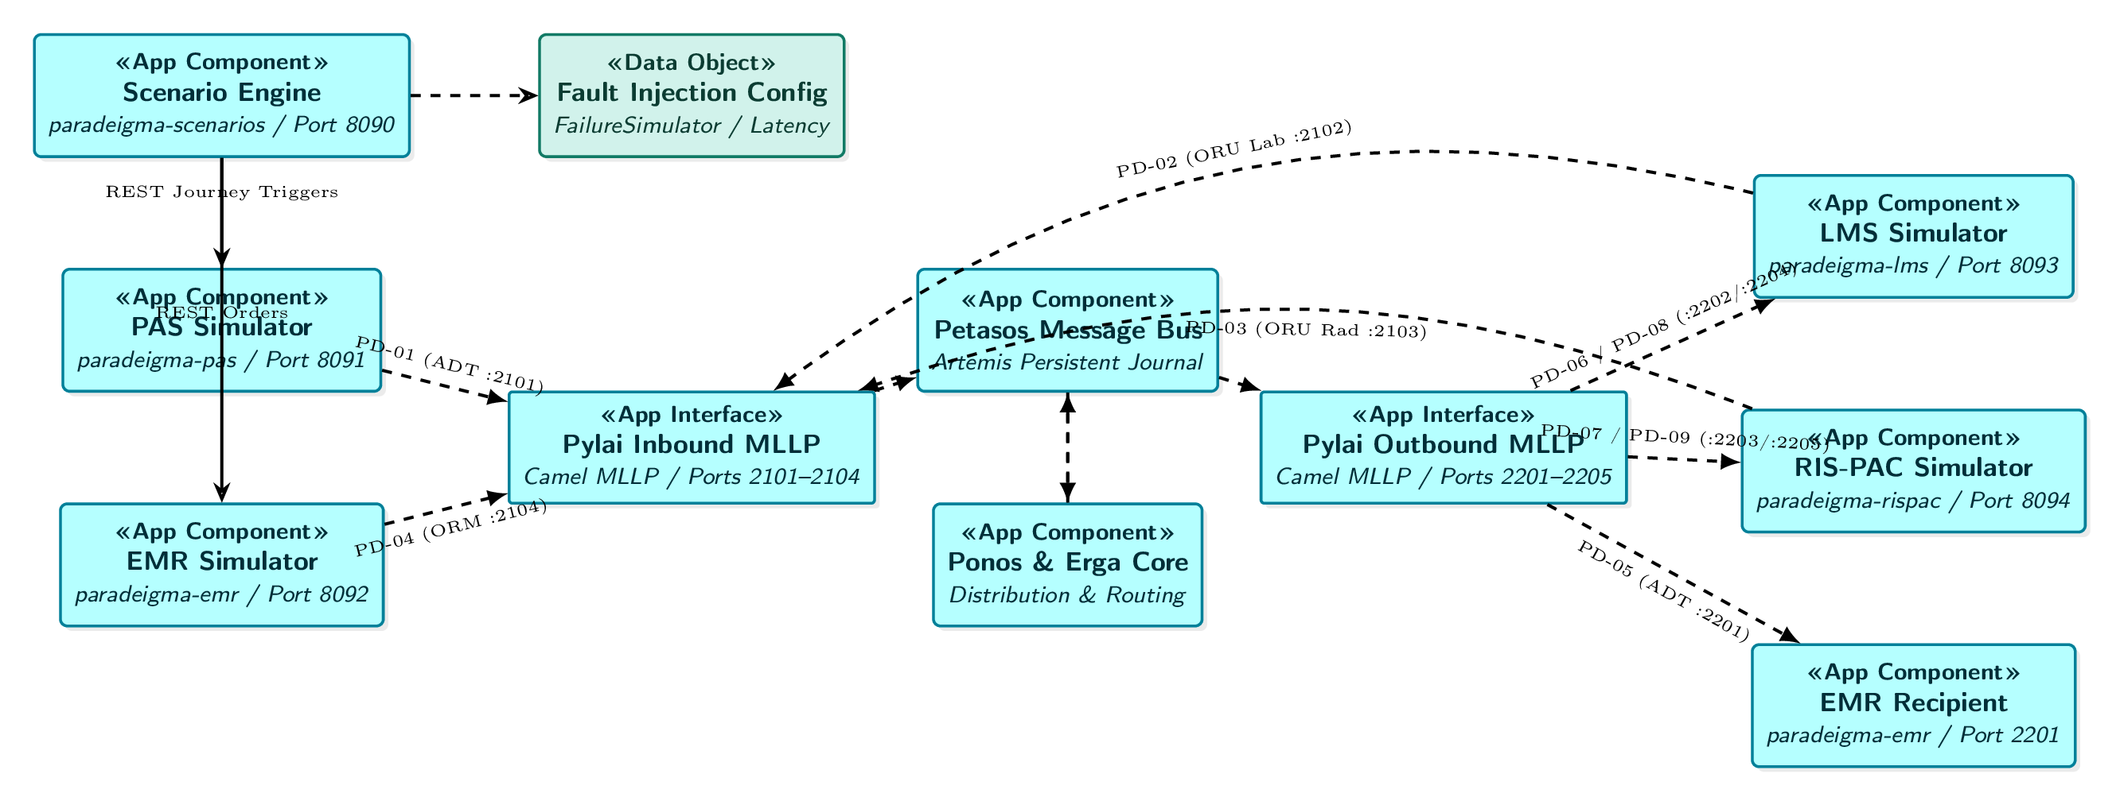
Figure 11: ArchiMate 3.2 Component Landscape for the Paradeigma Simulation Subsystem
The architecture partitions into five microservices:
- paradeigma-pas: Simulates the Patient Administration System (PAS), initiating patient registration, admission, transfer, demographic updates, and discharge events over interface PD-01.
- paradeigma-emr: Simulates the Electronic Medical Record (EMR), receiving ADT notifications over PD-05 and originating laboratory and diagnostic imaging orders over PD-04.
- paradeigma-lms: Simulates the Laboratory Information System (LMS), receiving ADT updates (PD-06) and pathology orders (PD-08), and transmitting structured LOINC pathology results over PD-02.
- paradeigma-rispac: Simulates the Radiology Information System & PACS, receiving ADT updates (PD-07) and radiology orders (PD-09), and returning DICOM-linked diagnostic imaging reports over PD-03.
- paradeigma-scenarios: Orchestrates multi-system clinical workflows (Patient Journeys) and controls fault injection parameters across the simulation fleet via REST APIs.

Formal Interface Catalogue (PD-01 through PD-09)
Table~tab:paradeigma_interfaces specifies the formal interface catalogue spanning ingress, egress, and routing channels across the Paradeigma simulation fleet and Harmonia.
p{2.2cm} p{2.5cm} c p{2.5cm}} ID | Source Actor | Target Actor | HL7 Message | Port | Trigger / Purpose
PD-01 | paradeigma-pas | Harmonia Inbound | ADT\^{}A01..A08 | 2101 | Patient Lifecycle Events
PD-02 | paradeigma-lms | Harmonia Inbound | ORU\^{}R01 | 2102 | LOINC Lab Results
PD-03 | paradeigma-rispac | Harmonia Inbound | ORU\^{}R01 | 2103 | Imaging Diagnostic Reports
PD-04 | paradeigma-emr | Harmonia Inbound | ORM\^{}O01 | 2104 | Lab & Imaging Orders
PD-05 | Harmonia Outbound | paradeigma-emr | ADT\^{}A01..A08 | 2201 | EMR Demographics Fan-Out
PD-06 | Harmonia Outbound | paradeigma-lms | ADT\^{}A01..A08 | 2202 | LMS Demographics Fan-Out
PD-07 | Harmonia Outbound | paradeigma-rispac | ADT\^{}A01..A08 | 2203 | RIS Demographics Fan-Out
PD-08 | Harmonia Outbound | paradeigma-lms | ORM\^{}O01 | 2204 | Pathology Order Routing
PD-09 | Harmonia Outbound | paradeigma-rispac | ORM\^{}O01 | 2205 | Radiology Order Routing
Table 9: Paradeigma Interface Catalogue and Port Mappings

MLLP Framing \& Transport Protocol
All network interfaces (PD-01 through PD-09) communicate using the Minimal Lower Layer Protocol (MLLP) over dedicated persistent TCP/IP sockets. An MLLP payload is framed strictly as:
$\langle\text{MLLP Frame}\rangle ::= \texttt{0x0B}\ (\text{Start-of-Block / \texttt{<VT>}}) + \langle\text{HL7 v2 Payload}\rangle + \texttt{0x1C}\ (\text{End-of-Block / \texttt{<FS>}}) + \texttt{0x0D}\ (\text{Trailer / \texttt{<CR>}})$

Synchronous Acknowledgement Contract
Every transmitted HL7 v2 message requires an immediate, synchronous HL7 acknowledgement (ACK) over the established TCP socket prior to socket closure. The acknowledgment status in MSA-1 determines downstream transmission handling:
- AA (Application Accept): Indicates successful receipt, structural validation, and internal queue persistence. The sending client marks the transmission as successfully completed.
- AE (Application Error): Indicates a recoverable or transient downstream processing condition. Triggering clients engage exponential backoff retry.
- AR (Application Reject): Indicates an unrecoverable structural or schema violation (such as missing required PID-3 or malformed segment delimiters). The message is immediately routed to the Dead Letter Queue without automatic retry.

Hospital Simulator Microservice Specifications

Patient Administration System Simulator (\texttt{paradeigma-pas
)}
The paradeigma-pas service models an acute care hospital Patient Administration System responsible for master patient identity and encounter tracking.
- Internal State Engine: Maintains an active in-memory patient directory transitioning through state phases: \text{UNREGISTERED} \to \text{REGISTERED} \to \text{ADMITTED} \to \text{TRANSFERRED} \to \text{UPDATED} \to \text{DISCHARGED}.
- Autonomous Scheduling Modes: {itemize}
- FIXED: Emits patient events at a deterministic interval (default 5000\,ms).
- RANDOM_RANGE: Emits events at random intervals within a bounded window (e.g., 2000–10000\,ms).
- OFF: Background timers disabled; events triggered exclusively via REST endpoints.
REST Management Interface (Port 8091): {itemize} GET /api/pas/status: Returns active configuration, simulated patient count, and message telemetry. POST /api/pas/config: Updates generation mode, delay intervals, and target MLLP endpoints. POST /api/pas/register, POST /api/pas/admit, POST /api/pas/transfer, POST /api/pas/update, POST /api/pas/discharge: Triggers discrete patient state transitions. POST /api/pas/trigger-next: Advances the next patient in the demographic queue through their lifecycle. {itemize} {itemize}

Electronic Medical Record Simulator (\texttt{paradeigma-emr
)}
The paradeigma-emr service simulates clinician interaction within an Electronic Medical Record:
- Inbound Ingestion (Port 2201, PD-05): Receives inbound ADT\^{}A01–A08 broadcasts fanned out from Harmonia, synchronizing local patient and encounter tables.
- Order Placement Engine (Outbound Port 2104, PD-04): Generates synthetic ORM\^{}O01 orders containing clinical indications, placer order numbers, priority flags (STAT vs. ROUTINE), and attending physician metadata.
- REST API (Port 8092): {itemize}
- GET /api/emr/status: Simulator health and received ADT counters.
- POST /api/emr/orders/laboratory: Originates pathology orders for registered patients.
- POST /api/emr/orders/imaging: Originates diagnostic imaging orders for registered patients.
- GET /api/emr/patients: Inspects locally synchronized patient registries.
{itemize}

Laboratory Information System Simulator (\texttt{paradeigma-lms
)}
The paradeigma-lms service emulates clinical pathology and laboratory analyzer workflows:
- Inbound Ingestion: Receives patient admissions on Port 2202 (PD-06) and lab orders on Port 2204 (PD-08).
- Pathology Result Generation: Synthesizes ORU\^{}R01 observation messages containing multi-segment OBX records mapped to standard LOINC coding systems.
- Clinical Pathology Catalog: Supports standard diagnostic panels detailed in Table~tab:loinc_catalog.
- REST API (Port 8093): {itemize}
- GET /api/lms/status: Simulator status and received order queues.
- POST /api/lms/results/laboratory: Triggers immediate generation and transmission of completed lab results to Harmonia Port 2102 (PD-02).
{itemize}
Panel Code | Panel Description | LOINC Code | Observation Name | Reference Range
CBC | Full Blood Count | 718-7 | Haemoglobin | 130–180\,g/L
 |  | 6690-2 | White Blood Cell Count | 4.0–11.0\,× 10^9/L
 |  | 777-3 | Platelet Count | 150–400\,× 10^9/L
 |  | 4544-3 | Haematocrit | 0.40–0.52\,L/L
 |  | 789-8 | Red Blood Cell Count | 4.5–6.5\,× 10^{12}/L
ELEC | Electrolytes & Urea | 2951-2 | Sodium | 135–145\,mmol/L
 |  | 2823-3 | Potassium | 3.5–5.0\,mmol/L
 |  | 2075-0 | Chloride | 95–105\,mmol/L
 |  | 2028-9 | Bicarbonate | 22–29\,mmol/L
 |  | 2160-0 | Creatinine | 60–110\,\mumol/L
 |  | 3094-0 | Urea | 2.5–7.8\,mmol/L
LFT | Liver Function Tests | 1751-7 | Albumin | 35–50\,g/L
 |  | 1975-2 | Total Bilirubin | 3–20\,\mumol/L
 |  | 1742-6 | Alanine Aminotransferase (ALT) | 10–40\,U/L
 |  | 1920-8 | Aspartate Aminotransferase (AST) | 10–40\,U/L
 |  | 6768-6 | Alkaline Phosphatase (ALP) | 30–120\,U/L
GLU | Fasting Blood Glucose | 2345-7 | Glucose | 3.9–6.0\,mmol/L
Table 10: Paradeigma Synthetic Pathology LOINC Catalog

Radiology Information System \& PACS Simulator (\texttt{paradeigma-rispac
)}
The paradeigma-rispac service simulates diagnostic imaging modalities and PACS archiving:
- Inbound Ingestion: Receives patient demographic feeds on Port 2203 (PD-07) and radiology examination orders on Port 2205 (PD-09).
- Diagnostic Report Synthesis: Formulates structured textual radiology impressions and narratives (OBX value type TX) with associated performing radiologist credentials.
- Imaging Modality Catalog: {itemize}
- XR_CHEST: 2-View Chest Radiography (evaluating infiltrate, consolidation, cardiomegaly).
- CT_HEAD: Non-contrast Cranial Computed Tomography (acute hemorrhage and midline shift assessment).
- CT_ABDOMEN: Contrast-enhanced Abdominal/Pelvic CT (parenchymal organ integrity).
- MRI_BRAIN: High-resolution Magnetic Resonance Neuroimaging.
- US_ABDOMEN: Abdominal Diagnostic Ultrasonography.
REST API (Port 8094): {itemize} GET /api/rispac/status: Service health and pending examination list. POST /api/rispac/results/imaging: Generates and transmits finalized imaging report ORU\^{}R01 messages to Harmonia Port 2103 (PD-03). {itemize} {itemize}

Synthetic Data Models \& Deterministic Generators

Canonical Domain Entities
The paradeigma-common module models realistic clinical workflows using five core profile structures:
- PatientProfile: Represents master patient demographics. {itemize}
- patientId (MRN, e.g., MRN-100421), nationalIdentifier (e.g., Medicare/NHS identifier).
- Demographic attributes: firstName, lastName, dateOfBirth, gender (M, F, O).
- Contact & Geo: addressLine, city, state, postalCode, phoneNumber, email.
- Next of Kin: nextOfKinName, nextOfKinRelationship, nextOfKinPhone. {itemize}
- VisitProfile: Represents encounter and admission context. {itemize}
- visitNumber (FIN/Account ID, e.g., VIS-900421).
- Admission & Discharge timestamps, visitType (INPATIENT, OUTPATIENT, EMERGENCY).
- Location context: pointOfCare (e.g., WARD-3A), room (RM-12), bed (BED-02), facility (HOSP-MAIN).
- Care Team: attendingDoctorId, attendingDoctorName, admittingDiagnosis. {itemize}
- OrderProfile: Captures clinical orders. {itemize}
- Identifiers: placerOrderNumber (ORD-300001), fillerOrderNumber.
- Context: orderType (PATHOLOGY, DIAGNOSTIC_IMAGING), universalServiceId, universalServiceText.
- Clinical attributes: priority (R for Routine, S for Stat), orderDateTime, clinicalIndication. {itemize}
- ResultProfile: Encapsulates diagnostic report outputs. {itemize}
- Order correlation: placerOrderNumber, fillerOrderNumber, resultStatus (F for Final, P for Preliminary, C for Corrected).
- Narrative report text: diagnosticReportNarrative.
- Observations: List<ObservationItem>. {itemize}
- ObservationItem: Represents granular test observations mapped to HL7 OBX segments. {itemize}
- setSubId: Sequential identifier (OBX-1).
- valueType: NM (Numeric), ST (String), TX (Text), or CE (Coded).
- observationId: Standard LOINC or internal test code (OBX-3.1).
- observationText: Observation description (OBX-3.2).
- codingSystem: Coding system identifier, defaults to LN (OBX-3.3).
- value: Quantitative or qualitative test result value (OBX-5).
- units: Measurement units (OBX-6).
- referenceRange: Reference normal boundary (OBX-7).
- abnormalFlags: N (Normal), H (High), L (Low), A (Abnormal) (OBX-8).
- resultStatus: Observation status flag (OBX-11). {itemize}

Seed-Based Deterministic Generation Engine
The SeedRandom utility wraps Java's pseudorandom generation algorithms with strict seed encapsulation. This guarantees that given an identical seed (e.g., patient seed 100421L), generators produce identical clinical datasets across distributed test runners:
public class SyntheticPatientGenerator {
private final SeedRandom random;
public SyntheticPatientGenerator(long seed) {
this.random = new SeedRandom(seed);
}
public PatientProfile generatePatient(String patientId) {
Gender gender = random.nextBoolean(0.5) ? Gender.FEMALE : Gender.MALE;
String firstName = random.pick(gender == Gender.FEMALE ? FEMALE_NAMES : MALE_NAMES);
String lastName = random.pick(LAST_NAMES);
LocalDate dob = LocalDate.now().minusYears(random.nextInt(18, 85))
.minusDays(random.nextInt(1, 365));
return new PatientProfile(patientId, firstName, lastName, dob, gender);
}
}

Scenario Orchestration Engine \& Patient Journey Workflows
The ParadeigmaScenarioEngine (microservice paradeigma-scenarios, Port 8090) orchestrates end-to-end, multi-actor clinical workflows across the simulation testbed.

9-Step Canonical Patient Journey Sequence
A complete synthetic encounter exercises all ingress, egress, routing, and transformation pathways across Harmonia in a deterministic 9-step progression:
- Step 1: Patient Registration (PAS \to ADT\^{}A04): paradeigma-pas registers a new synthetic patient with full demographic and Next-of-Kin details, transmitting over PD-01 (:2101).
- Step 2: Inpatient Admission (PAS \to ADT\^{}A01): paradeigma-pas assigns the patient to an acute inpatient ward (WARD-3A, RM-12, BED-02) and emits an admission event. Harmonia fans out ADT\^{}A01 to EMR (PD-05), LMS (PD-06), and RIS-PAC (PD-07).
- Step 3: Pathology Order Placement (EMR \to ORM\^{}O01): paradeigma-emr generates a Full Blood Count (CBC) lab order, transmitting over PD-04 (:2104). Harmonia routes this order to paradeigma-lms over PD-08 (:2204).
- Step 4: Pathology Result Ingestion (LMS \to ORU\^{}R01): paradeigma-lms analyzes the specimen and produces a multi-line LOINC pathology result (718-7, 6690-2, 777-3), transmitting to Harmonia over PD-02 (:2102).
- Step 5: Diagnostic Imaging Order Placement (EMR \to ORM\^{}O01): paradeigma-emr requests a 2-view Chest X-Ray (XR_CHEST) over PD-04 (:2104). Harmonia routes the radiology order to paradeigma-rispac over PD-09 (:2205).
- Step 6: Diagnostic Imaging Result Ingestion (RIS-PAC \to ORU\^{}R01): paradeigma-rispac returns a structured diagnostic report with impression and findings narrative over PD-03 (:2103).
- Step 7: Inpatient Transfer (PAS \to ADT\^{}A02): paradeigma-pas transfers the patient to a step-down ward (WARD-4B, RM-401) and broadcasts ADT\^{}A02 across all clinical destinations.
- Step 8: Patient Demographics Update (PAS \to ADT\^{}A08): Updates patient contact information and address, triggering fan-out reconciliation across EMR, LMS, and RIS-PAC.
- Step 9: Patient Discharge (PAS \to ADT\^{}A03): Emits encounter close and discharge disposition over PD-01, concluding the patient episode.

Execution Profiles
The scenario engine supports three operational execution profiles:
- TEST: Deterministic execution with minimal step pacing (10–50\,ms delay). Optimized for continuous integration pipelines and automated regression test suites.
- DEMO: Human-observable pacing with 2000–10000\,ms intervals between steps, designed for live demonstrations and interactive operational console monitoring.
- LOAD: Concurrent execution across configurable worker thread pools without synthetic pacing delays, evaluating platform throughput, queue depth, and memory footprint.

Scenario Control REST API
Table~tab:scenario_api documents the REST control endpoints exposed on port 8090.
} HTTP Method | Endpoint Path | Operational Function
POST | /api/scenarios/journey | Triggers an immediate single 9-step Patient Journey.
POST | /api/scenarios/concurrent | Initiates N parallel journey executions under specified profile.
POST | /api/scenarios/continuous | Starts sustained continuous journey background generation.
POST | /api/scenarios/stop | Gracefully halts active background scenarios and thread pools.
GET | /api/scenarios/status | Queries execution telemetry, success rates, and active threads.
Table 11: Scenario Engine REST Control Endpoints

Failure Simulation, Fault Injection \& Automated Recovery

Fault Injection Modes (\texttt{FailureSimulator
)}
The FailureSimulator embeds within each simulator's MLLP pipeline, permitting dynamic simulation of network anomalies and application failures without modifying underlying platform infrastructure. Table~tab:fault_modes enumerates the supported failure modes configured via FaultInjectionConfig.
} Fault Injection Parameter | Range / Type | Simulated Physical Failure Condition
dropConnectionProbability | 0.0 - 1.0 | TCP connection RST / network partition mid-frame.
noAckProbability | 0.0 - 1.0 | Destination unresponsiveness causing socket read timeout.
ackDelayMs | ≥ 0\,ms | Network congestion or downstream processing latency.
applicationErrorProbability | 0.0 - 1.0 | Returns MSA-1=AE simulating transient system error.
applicationRejectProbability | 0.0 - 1.0 | Returns MSA-1=AR simulating schema/rule validation error.
malformedSegmentProbability | 0.0 - 1.0 | Corrupts HL7 segment delimiters or required fields.
duplicateMsh10Probability | 0.0 - 1.0 | Replays previous MSH-10 to evaluate deduplication filters.
Table 12: FailureSimulator Fault Injection Capabilities

Automated Recovery Acceptance Test Suite
The integration test suite in paradeigma-test (RecoveryAcceptanceTest.java) automates formal recovery verification across six critical failure scenarios:
- Test 1 — Broker Journal Recovery: Verifies that unacknowledged in-flight messages persist across complete ActiveMQ Artemis broker crashes and restarts, replaying cleanly to consumers upon broker recovery without data loss.
- Test 2 — Ponos Worker Crash Recovery: Simulates worker termination during Camel pipeline execution. Validates that uncommitted Artemis transactions redeliver to healthy worker instances, advancing the associated Pragma to COMPLETED.
- Test 3 — Outbound Destination Outage & Backoff Recovery: Simulates an LMS outage during ORM order transmission. Verifies that Pylai engages exponential retry backoff, retaining the message until LMS recovers and returns ACK\^{}AA.
- Test 4 — Duplicate HL7 MSH-10 Idempotency: Transmits identical MSH-10 control IDs twice. Validates that Petasos deduplication filters intercept the re-transmission, returning an idempotent AA acknowledgment without triggering duplicate task executions.
- Test 5 — Partial ADT Fan-Out Isolation: Simulates an ADT fan-out where EMR and LMS succeed but RIS-PAC fails. Verifies that upon RIS-PAC restoration, only the pending RIS-PAC delivery is retried, avoiding duplicate broadcasts to EMR or LMS.
- Test 6 — Platform Cold Restart Recovery: Queues multiple clinical transactions and performs a hard platform stop and restart. Verifies that all persistent journal messages and cache state reconstruct cleanly to terminal completion.

Deployment Topology \& Docker Orchestration
The Paradeigma simulation fleet deploys seamlessly alongside Harmonia using Docker Compose (docker-compose-paradeigma.yml). Table~tab:paradeigma_containers outlines the container topology, port bindings, and health checks.
} Container Service | Base Image | REST Port | MLLP Ports | Health Check Dependency
paradeigma-pas | OpenJDK 17 | 8091 | — | http://localhost:8091/api/pas/status
paradeigma-emr | OpenJDK 17 | 8092 | 2201 | http://localhost:8092/api/emr/status
paradeigma-lms | OpenJDK 17 | 8093 | 2202, 2204 | http://localhost:8093/api/lms/status
paradeigma-rispac | OpenJDK 17 | 8094 | 2203, 2205 | http://localhost:8094/api/rispac/status
paradeigma-scenarios | OpenJDK 17 | 8090 | — | Depends on PAS, EMR, LMS, RIS-PAC healthy
Table 13: Paradeigma Docker Compose Deployment Configuration

Appendix B: Implementation Guide for MLLP Ingress and Egress Services

Overview \& Engineering Objectives
This implementation guide provides an exhaustive, production-grade technical manual detailing the architectural patterns, component blueprints, configuration parameters, state persistence workflows, and testing harnesses required to implement:
- A New MLLP Ingress Service: Ingesting inbound HL7 v2 messages over Minimal Lower Layer Protocol (MLLP) TCP sockets, validating syntax, constructing canonical FHIR R5 Communication and Task resources, persisting records into the Mneme Infinispan cache grid and Mnemosyne PostgreSQL database, publishing asynchronous ErgonEvent notifications to the Petasos (ActiveMQ Artemis) message bus, and generating synchronous HL7 acknowledgements (AA, AE, AR).
- A New MLLP Egress Service: Consuming outbound clinical dispatch tasks from dedicated Petasos destination queues, transforming canonical models into HL7 v2 payloads, dispatching over Apache Camel MLLP client routes with robust socket timeouts, deeply inspecting downstream HL7 ACK/NACK responses, managing full FHIR Communication, Task, and Provenance lifecycle state transitions in Mneme/Mnemosyne, and isolating destination failure domains through multi-instance container topologies.

Ingress Architectural Blueprint \& Framing Protocols
The MLLP Ingress Gateway (pylai-mllp-in) acts as the secure, high-throughput perimeter gateway of Harmonia, terminating inbound TCP connections from external Patient Administration Systems (PAS), Laboratory Information Systems (LIS), Radiology Information Systems (RIS), and Electronic Medical Records (EMR).
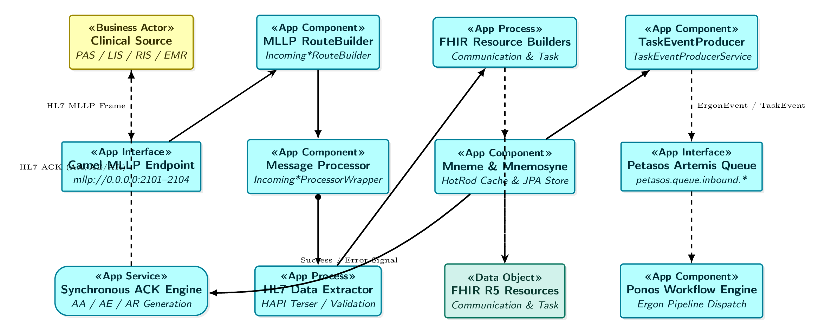
Figure 12: ArchiMate 3.2 Component Flow for the MLLP Ingress Service Processing Pipeline

MLLP Transport Framing
MLLP provides minimal framing over stream-oriented TCP sockets to delineate discrete message boundaries. All inbound MLLP ingress routes adhere to the standard framing specification:
$\langle\text{Inbound Frame}\rangle ::= \texttt{0x0B}\ (\text{Start-of-Block / \texttt{<VT>}}) + \langle\text{HL7 v2.x Payload}\rangle + \texttt{0x1C}\ (\text{End-of-Block / \texttt{<FS>}}) + \texttt{0x0D}\ (\text{Carriage Return / \texttt{<CR>}})$
Inbound frames are received over persistent or transient TCP sockets. Camel's Netty-based MLLP component buffers incoming bytes until the End-of-Block trailer (0x1C 0x0D) is detected, strips framing bytes, and passes the raw HL7 string to the downstream pipeline.

The 8-Phase Ingress Processing Lifecycle
Every inbound message traverses an immutable 8-phase execution pipeline:
- Socket Connection & TCP Frame Capture: The client establishes a TCP connection to the configured port (e.g., 2101 for ADT, 2102 for Lab ORU, 2103 for Rad ORU, 2104 for ORM). Camel captures the framed byte stream.
- Frame Stripping & Charset Normalization: Framing bytes (0x0B, 0x1C, 0x0D) are stripped; bytes are decoded into UTF-8 or ISO-8859-1 strings based on MSH-18 character set headers.
- Message Type & Trigger Event Validation: The MSH segment is inspected to identify message structure (MSH-9.1), trigger event (MSH-9.2), and message control ID (MSH-10).
- HL7 v2 Data Extraction: Specialized extractors leverage HAPI Terser to navigate segment hierarchies and extract demographic, clinical, and encounter fields.
- Canonical FHIR R5 Construction: Canonical resource builders instantiate: {itemize}
- A FHIR R5 Communication resource preserving the complete raw HL7 message in Communication.payload.contentAttachment.
- A synthetic FHIR R5 Task resource (representing the executable Pragma) encapsulating workflow priority, routing metadata, and correlation IDs. {itemize}
- Cache & Database Persistence: The Communication and Task resources are persisted into the Mneme Infinispan data grid via TaskCacheService and write-behind synced to Mnemosyne JPA stores.
- Petasos Event Dispatch: A lightweight ErgonEvent notification referencing the persistent Task.id and Communication.id is published to the target ActiveMQ Artemis inbound queue (e.g., petasos.queue.inbound.adt).
- Synchronous HL7 Acknowledgement Generation: A standards-compliant HL7 ACK containing matching MSA-2 and appropriate MSA-1 code (AA, AE, AR) is framed in MLLP and flushed over the TCP socket before closing the connection.

Ingress Component Implementation

Camel RouteBuilder Configuration
Ingress routes are defined using Apache Camel's Java DSL, configured as CDI @Dependent beans. The route registers an mllp:// endpoint, sets connection options, and wires incoming exchanges to dedicated processor wrappers.
@Dependent
public class IncomingAdtMessageMllpRouteBuilder extends RouteBuilder {
private static final Logger log = LoggerFactory.getLogger(IncomingAdtMessageMllpRouteBuilder.class);
@Inject
private MllpConfig mllpConfig;
@Inject
private IncomingAdtMessageProcessorWrapper incomingAdtMessageProcessorWrapper;
@Override
public void configure() throws Exception {
if (mllpConfig == null) {
mllpConfig = new MllpConfig();
}
String host = mllpConfig.getHost();
int port = mllpConfig.getAdtPort(); // Port 2101
boolean autoAck = mllpConfig.isAutoAck(); // false: explicit ACK control
int bindTimeout = mllpConfig.getBindTimeout();
int readTimeout = mllpConfig.getReadTimeout();
// MLLP Ingress Listener Route
from(String.format("mllp://%s:%d?autoAck=%b&bindTimeout=%d&readTimeout=%d",
host, port, autoAck, bindTimeout, readTimeout))
.routeId("hl7-mllp-adt-receiver")
.log(LoggingLevel.INFO, log, "MLLP Inbound ADT message received on port " + port)
.process(incomingAdtMessageProcessorWrapper)
.log(LoggingLevel.INFO, log, "MLLP Inbound ADT processing completed; ACK ready");
// Internal Direct Route for In-Process Triggers
from("direct:adt-events")
.routeId("direct-adt-processor")
.process(incomingAdtMessageProcessorWrapper);
}
}

Processor Wrapper \& Context Management
The IncomingAdtMessageProcessorWrapper acts as the boundary adapter between Apache Camel's exchange model and Harmonia's HL7 domain processor.
@ApplicationScoped
public class IncomingAdtMessageProcessorWrapper implements Processor {
private static final Logger log = LoggerFactory.getLogger(IncomingAdtMessageProcessorWrapper.class);
@Inject
private IncomingAdtMessageProcessor incomingAdtMessageProcessor;
@Override
public void process(Exchange exchange) throws Exception {
String hl7Message = exchange.getIn().getBody(String.class);
log.debug("Processing inbound HL7 payload of length: {}", hl7Message.length());
// Delegate to domain processor
AdtProcessingResult result = incomingAdtMessageProcessor.process(hl7Message);
// Populate exchange headers and set synchronous ACK body
exchange.getMessage().setHeader("HIE_MESSAGE_CONTROL_ID", result.getMessageControlId());
exchange.getMessage().setHeader("HIE_ACK_CODE", result.getAckCode());
exchange.getMessage().setBody(result.getAckMessage());
}
}

HL7 v2 Data Extraction with HAPI Terser
To ensure resilience against optional or missing segments across varied HL7 versions (2.3, 2.4, 2.5), extractors employ the HAPI HL7 Terser with defensive navigation wrappers:
public class AdtMessageExtractor {
private final Terser terser;
public AdtMessageExtractor(Message message) {
this.terser = new Terser(message);
}
public String extractMessageControlId() {
return getSafeValue("/.MSH-10");
}
public String extractTriggerEvent() {
return getSafeValue("/.MSH-9-2");
}
public String extractPatientId() {
String pid3 = getSafeValue("/.PID-3-1");
return (pid3 != null && !pid3.isEmpty()) ? pid3 : getSafeValue("/.PID-2-1");
}
public String extractFamilyName() {
return getSafeValue("/.PID-5-1");
}
public String extractGivenName() {
return getSafeValue("/.PID-5-2");
}
public String extractDateOfBirth() {
return getSafeValue("/.PID-7-1");
}
public String extractAdministrativeGender() {
return getSafeValue("/.PID-8");
}
public String extractVisitNumber() {
return getSafeValue("/.PV1-19-1");
}
public String extractPatientClass() {
return getSafeValue("/.PV1-2");
}
public String extractAssignedLocation() {
String poc = getSafeValue("/.PV1-3-1"); // Point of care
String room = getSafeValue("/.PV1-3-2");
String bed = getSafeValue("/.PV1-3-3");
return String.format("%s/%s/%s",
poc != null ? poc : "",
room != null ? room : "",
bed != null ? bed : "");
}
private String getSafeValue(String terserPath) {
try {
String value = terser.get(terserPath);
return (value != null && !value.trim().isEmpty()) ? value.trim() : null;
} catch (HL7Exception e) {
return null; // Defensive fallback on missing segment/field
}
}
}

Canonical FHIR Model Mapping \& Resource Builders
Harmonia normalizes all inbound HL7 messages into dual canonical FHIR R5 entities:
- FHIR R5 Communication: Holds message provenance, sender/recipient metadata, and the raw immutable HL7 v2 payload.
- FHIR R5 Task: Models the executable units of work (Pragma) consumed by the Ponos workflow engine.

FHIR Communication Resource Construction
public class AdtCommunicationResourceBuilder {
public Communication buildCommunication(AdtMessageExtractor extractor, String rawHl7) {
Communication comm = new Communication();
comm.setId(UUID.randomUUID().toString());
comm.setStatus(Communication.CommunicationStatus.COMPLETED);
// Identifiers
Identifier msh10Id = new Identifier();
msh10Id.setSystem("http://harmonia.hie/identifiers/msh-10");
msh10Id.setValue(extractor.extractMessageControlId());
comm.addIdentifier(msh10Id);
// Category
CodeableConcept category = new CodeableConcept();
category.addCoding().setSystem("http://terminology.hl7.org/CodeSystem/communication-category")
.setCode("notification")
.setDisplay("HL7 Inbound Notification");
comm.addCategory(category);
// Sender & Recipient
comm.setSender(new Reference().setDisplay(extractor.getSendingFacility()));
comm.addRecipient(new Reference().setDisplay("Harmonia-HIE-Ingress"));
// Payload Attachment (Raw HL7 Message)
Communication.CommunicationPayloadComponent payload = new Communication.CommunicationPayloadComponent();
Attachment attachment = new Attachment();
attachment.setContentType("text/plain");
attachment.setData(rawHl7.getBytes(StandardCharsets.UTF_8));
attachment.setCreation(new Date());
payload.setContent(attachment);
comm.addPayload(payload);
comm.setSent(new Date());
return comm;
}
}

FHIR Task (Pragma) Resource Construction
The synthetic Task represents the executable pipeline instance. Table~tab:hl7_task_mapping outlines the canonical field mappings.
l p{4.5cm}} HL7 v2 Source Field | FHIR R5 Task Property | Datatype | Transformation Logic
MSH-10 | Task.identifier[msh10] | Identifier | Copied verbatim for correlation
MSH-9-2 (Trigger) | Task.businessStatus | CodeableConcept | Mapped to clinical event type (e.g. A01 \to ADMISSION)
PV1-2 (Patient Class) | Task.priority | TaskPriority | E \to stat, I \to urgent, O \to routine
PID-3-1 (MRN) | Task.for | Reference | Reference to Patient/MRN-{id}
PV1-19-1 (Visit Num) | Task.encounter | Reference | Reference to Encounter/VIS-{num}
Auto-generated UUID | Task.id | IdType | Unique Pragma identifier
Literal "requested" | Task.status | TaskStatus | Initial state for Ponos engine
Literal "order" | Task.intent | TaskIntent | Required FHIR workflow intent
Table 14: HL7 v2 to FHIR R5 Task Canonical Mapping Specifications

Persistence, Event Dispatch \& Synchronous Acknowledgement

Persistence Integration with Mneme \& Mnemosyne
The ingress processor writes canonical entities into the Mneme Infinispan data grid via TaskCacheService and CommunicationService:
public AdtProcessingResult process(String rawHl7) {
try {
Message hl7Msg = hapiParser.parse(rawHl7);
AdtMessageExtractor extractor = new AdtMessageExtractor(hl7Msg);
// 1. Build Canonical Resources
Communication comm = commBuilder.buildCommunication(extractor, rawHl7);
Task task = taskBuilder.buildTask(extractor, comm.getId());
// 2. Persist to Mneme Cache Grid / Mnemosyne Store
communicationService.save(comm);
taskService.save(task);
// 3. Publish Asynchronous Notification to Petasos Message Bus
ErgonEvent event = new ErgonEvent();
event.setEventId(UUID.randomUUID().toString());
event.setTaskId(task.getId());
event.setCommunicationId(comm.getId());
event.setMessageType("ADT");
event.setTriggerEvent(extractor.extractTriggerEvent());
event.setTimestamp(System.currentTimeMillis());
taskEventProducerService.publishInboundEvent("petasos.queue.inbound.adt", event);
// 4. Return Synchronous Application Accept (AA)
String ackHl7 = hl7AckGenerator.generateAck(hl7Msg, "AA", "Message Accepted");
return new AdtProcessingResult(extractor.extractMessageControlId(), "AA", ackHl7);
} catch (HL7Exception e) {
log.error("HL7 parse error: {}", e.getMessage());
String nackHl7 = hl7AckGenerator.generateNack(rawHl7, "AR", "Structural Parse Failure: " + e.getMessage());
return new AdtProcessingResult(null, "AR", nackHl7);
} catch (Exception e) {
log.error("Internal processing error: {}", e.getMessage());
String nackHl7 = hl7AckGenerator.generateNack(rawHl7, "AE", "Internal Storage Failure: " + e.getMessage());
return new AdtProcessingResult(null, "AE", nackHl7);
}
}

Synchronous Acknowledgement Mapping Rules
The ingress service guarantees deterministic acknowledgement status codes as summarized in Table~tab:ack_rules.
p{3.0cm}} ACK Code | Status Name | Triggering Condition | Client Action
AA | Application Accept | Syntactically valid HL7; successfully written to Mneme cache and Petasos queue. | Message considered durably accepted; do not retry.
AE | Application Error | Transient infrastructure failure (Infinispan timeout, database disconnect, Artemis broker unreachable). | Re-queue and retry with exponential backoff.
AR | Application Reject | Malformed HL7 frame, missing required MSH segments, unsupported major version. | Route to operator dead-letter queue; do not retry.
Table 15: Synchronous HL7 Acknowledgement Response Contracts

REST Management \& CDI Deployment Configuration
Every ingress gateway exposes optional REST endpoints for health checks, administrative ping, and direct HTTP ingestion:
@Path("/mllp/adt")
@ApplicationScoped
public class AdtResource {
@Inject
private IncomingAdtMessageProcessor processor;
@POST
@Consumes(MediaType.TEXT_PLAIN)
@Produces(MediaType.TEXT_PLAIN)
public Response ingestAdtMessage(String rawHl7) {
AdtProcessingResult result = processor.process(rawHl7);
if ("AA".equals(result.getAckCode())) {
return Response.ok(result.getAckMessage()).build();
} else if ("AE".equals(result.getAckCode())) {
return Response.status(Response.Status.SERVICE_UNAVAILABLE).entity(result.getAckMessage()).build();
} else {
return Response.status(Response.Status.BAD_REQUEST).entity(result.getAckMessage()).build();
}
}
}

Multi-Instance Egress Architecture \& Queue Partitioning
In contrast to ingress gateways that bind to inbound listening ports, the MLLP Egress Gateway (pylai-mllp-out) functions as a dynamic TCP client, connecting to downstream clinical endpoints (such as hospital EMR, LMS, and RIS-PACS systems).
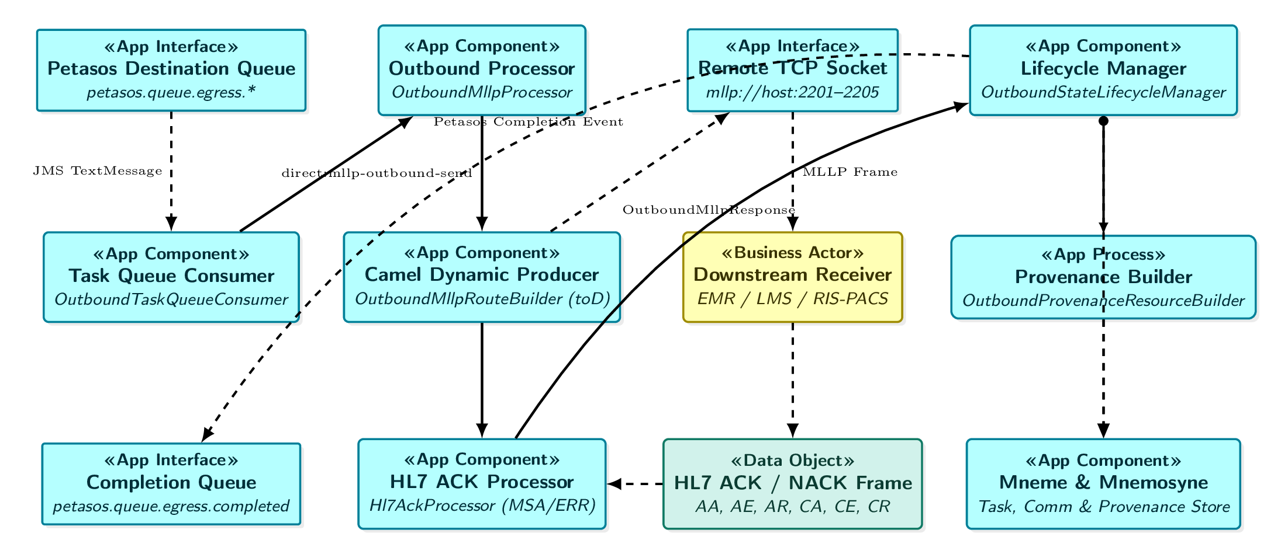
Figure 13: ArchiMate 3.2 Component Flow for the MLLP Egress Multi-Instance Dispatch Pipeline

Head-of-Line Blocking Mitigation \& Destination Isolation
In healthcare integration environments, downstream clinical systems exhibit disparate network latency, maintenance windows, and failure modes. If a single outbound gateway serviced all destinations from a shared queue:
- A transient network outage or TCP socket stall at one hospital endpoint (e.g., LMS analyzer reboot) would block outbound transmissions to healthy endpoints (e.g., EMR, RIS-PACS).
- Retry storms and queue head-of-line blocking would cascade across the entire healthcare exchange.
To eliminate head-of-line blocking, Harmonia enforces destination-partitioned multi-instance isolation:
- Each downstream destination is allocated a dedicated, persistent ActiveMQ Artemis queue: {equation} {Queue Pattern} ::= petasos.queue.egress.{destinationId}.{messageType} {equation} Examples: petasos.queue.egress.emr.adt, petasos.queue.egress.lms.orm, petasos.queue.egress.rispac.orm.
- Each destination runs as an isolated, containerized pylai-mllp-out microservice instance consuming exclusively from its dedicated queue.
- Failures, exponential backoff retries, and socket timeouts in one container never impact message throughput or delivery SLAs of other destinations.

Outbound Configuration \& Destination Registry
Configuration is managed via MllpOutboundConfig and MllpDestinationRegistry, populated via microprofile environment variables at container launch.
l p{4.0cm}} Environment Variable | Config Property | Default | Description
MLLP_OUTBOUND_DESTINATION_ID | destinationId | "DEFAULT" | Unique destination identifier (e.g. EMR, LMS)
MLLP_OUTBOUND_HOST | host | "localhost" | Target TCP hostname or IP address
MLLP_OUTBOUND_PORT | port | 2575 | Target MLLP TCP listener port
MLLP_OUTBOUND_READ_TIMEOUT_MS | readTimeoutMs | 10000 | Socket read timeout in milliseconds
MLLP_OUTBOUND_CONNECT_TIMEOUT_MS | connectTimeoutMs | 5000 | TCP handshake timeout in milliseconds
MLLP_OUTBOUND_AUTO_ACK | autoAck | false | Requires explicit downstream ACK verification
MLLP_OUTBOUND_QUEUE_NAME | dedicatedEventQueueName | Derived | Dedicated Artemis subscription queue
MLLP_OUTBOUND_COMPLETION_QUEUE_NAME | completionEventQueueName | "petasos.queue.egress.completed" | Completion telemetry queue
Table 16: MLLP Outbound Gateway Environment Configuration Parameters

Outbound Data Transfer Models
The egress pipeline coordinates transmissions using two standard DTOs:
- OutboundMllpRequest: Encapsulates taskId, communicationId, destinationId, messageControlId, targetHost, targetPort, rawHl7Payload, and retry metadata.
- OutboundMllpResponse: Encapsulates delivery status (isSuccessful), ackCode (AA, AE, AR, CA, CE, CR), rawAckMessage, errorMessage, durationMs, and acknowledgedAt timestamp.

Outbound Queue Consumer \& Camel Dynamic MLLP Routes

Dedicated Task Queue Consumer
The OutboundTaskQueueConsumer implements JMS MessageListener, pulling outbound tasks from the dedicated Artemis queue and dispatching them through Apache Camel.
@ApplicationScoped
public class OutboundTaskQueueConsumer implements MessageListener {
private static final Logger log = LoggerFactory.getLogger(OutboundTaskQueueConsumer.class);
@Inject
private MllpOutboundConfig outboundConfig;
@Inject
private OutboundStateLifecycleManager lifecycleManager;
private ProducerTemplate producerTemplate;
@Override
public void onMessage(jakarta.jms.Message message) {
try {
if (message instanceof TextMessage) {
String jsonPayload = ((TextMessage) message).getText();
OutboundMllpRequest request = JsonUtils.fromJson(jsonPayload, OutboundMllpRequest.class);
// Dispatch via Camel ProducerTemplate
OutboundMllpResponse response = producerTemplate.requestBody(
"direct:mllp-outbound-send", request, OutboundMllpResponse.class);
// Update FHIR Task, Communication and Provenance states
lifecycleManager.handleOutboundResponse(request, response);
message.acknowledge(); // Acknowledge JMS message upon lifecycle recording
}
} catch (Exception e) {
log.error("Fatal exception in outbound queue consumer: {}", e.getMessage(), e);
// Non-acknowledged message triggers Artemis redelivery policy
}
}
}

Camel Dynamic Outbound Route Builder
The OutboundMllpRouteBuilder configures dynamic dispatch to external TCP sockets using Camel's toD dynamic URI expression, setting connection timeouts and auto-acknowledgment rules.
@ApplicationScoped
public class OutboundMllpRouteBuilder extends RouteBuilder {
private static final Logger log = LoggerFactory.getLogger(OutboundMllpRouteBuilder.class);
@Inject
private OutboundMllpProcessor outboundMllpProcessor;
@Inject
private Hl7AckProcessor hl7AckProcessor;
@Override
public void configure() throws Exception {
// Global Exception Handler for Socket / Network Failures
onException(Exception.class)
.handled(true)
.setHeader("HIE_TRANSMISSION_SUCCESS", constant(false))
.setHeader("HIE_ACK_CODE", constant("AE"))
.setHeader("HIE_ERROR_MESSAGE", simple("${exception.message}"))
.process(exchange -> {
Exception cause = exchange.getProperty(Exchange.EXCEPTION_CAUGHT, Exception.class);
String dest = exchange.getIn().getHeader("HIE_DESTINATION_ID", String.class);
String msh10 = exchange.getIn().getHeader("HIE_EXPECTED_CONTROL_ID", String.class);
long duration = System.currentTimeMillis() - exchange.getProperty("HIE_START_TIME", Long.class);
OutboundMllpResponse failure = OutboundMllpResponse.failure(
msh10, "Socket connection error to " + dest + ": " + cause.getMessage(), duration);
failure.setDestinationId(dest);
exchange.getMessage().setBody(failure);
});
// Outbound Dynamic MLLP Route
from("direct:mllp-outbound-send")
.routeId("mllp-outbound-dynamic-sender")
.process(outboundMllpProcessor) // Validates request and populates Camel headers
.setProperty("HIE_START_TIME", simple("${date:now:getTime()}"))
.log(LoggingLevel.INFO, log, "Dispatching MLLP frame to ${header.HIE_DEST_HOST}:${header.HIE_DEST_PORT}")
// Dynamic MLLP Producer
.toD("mllp://${header.HIE_DEST_HOST}:${header.HIE_DEST_PORT}?"
+ "autoAck=${header.HIE_AUTO_ACK}"
+ "&readTimeout=${header.HIE_READ_TIMEOUT}"
+ "&connectTimeout=${header.HIE_CONNECT_TIMEOUT}"
+ "&charsetName=UTF-8")
.process(hl7AckProcessor) // Deep inspection of received ACK/NACK frame
.log(LoggingLevel.INFO, log, "Outbound MLLP dispatch complete: ACK=${header.HIE_ACK_CODE}, Success=${header.HIE_TRANSMISSION_SUCCESS}");
}
}

Outbound MLLP Processor Header Injection
The OutboundMllpProcessor validates the inbound DTO, resolves target connection parameters from the MllpDestinationRegistry, and initializes exchange headers:
@ApplicationScoped
public class OutboundMllpProcessor implements Processor {
@Inject
private MllpOutboundConfig config;
@Inject
private MllpDestinationRegistry destinationRegistry;
@Override
public void process(Exchange exchange) throws Exception {
OutboundMllpRequest request = exchange.getIn().getBody(OutboundMllpRequest.class);
if (request == null || StringUtils.isBlank(request.getRawHl7Payload())) {
throw new IllegalArgumentException("OutboundMllpRequest payload must not be null or blank");
}
String destinationId = StringUtils.isNotBlank(request.getDestinationId())
? request.getDestinationId() : config.getDestinationId();
MllpDestinationConfig destConfig = destinationRegistry.getDestination(destinationId)
.orElse(config.toDestinationConfig());
// Configure Exchange Headers for Dynamic toD URI
exchange.getMessage().setHeader("HIE_DESTINATION_ID", destinationId);
exchange.getMessage().setHeader("HIE_DEST_HOST", destConfig.getHost());
exchange.getMessage().setHeader("HIE_DEST_PORT", destConfig.getPort());
exchange.getMessage().setHeader("HIE_READ_TIMEOUT", destConfig.getReadTimeoutMs());
exchange.getMessage().setHeader("HIE_CONNECT_TIMEOUT", destConfig.getConnectTimeoutMs());
exchange.getMessage().setHeader("HIE_AUTO_ACK", false);
exchange.getMessage().setHeader("HIE_EXPECTED_CONTROL_ID", request.getMessageControlId());
// Set Outbound Body to Raw HL7 Message String
exchange.getMessage().setBody(request.getRawHl7Payload());
}
}

Downstream HL7 ACK/NACK Deep Inspection
A critical requirement in clinical integration is preventing false-positive transmission confirmations. Receiving a TCP FIN or ACK at the transport layer does not imply clinical acceptance by the receiving hospital system. The Hl7AckProcessor performs deep structural inspection on the received HL7 acknowledgement frame.

MSA \& ERR Segment Parsing Specification
The processor evaluates the MSA (Message Acknowledgement) and ERR (Error) segments:
public OutboundMllpResponse parseAck(String rawAck, String expectedControlId, String destinationId, long durationMs) {
if (StringUtils.isBlank(rawAck)) {
return OutboundMllpResponse.failure(expectedControlId, "Empty ACK response received from " + destinationId, durationMs);
}
Matcher matcher = MSA_PATTERN.matcher(rawAck);
if (!matcher.find()) {
OutboundMllpResponse resp = OutboundMllpResponse.failure(
expectedControlId, "Malformed ACK: missing MSA segment", durationMs);
resp.setRawAckMessage(rawAck);
return resp;
}
String ackCode = matcher.group(1).trim().toUpperCase(); // MSA-1: AA, AE, AR, CA, CE, CR
String msaControlId = matcher.group(2); // MSA-2: Referenced MSH-10
String ackText = matcher.group(3); // MSA-3: Text explanation
// Strict Correlation Validation
boolean controlIdMatches = true;
if (StringUtils.isNotBlank(expectedControlId) && StringUtils.isNotBlank(msaControlId)) {
if (!StringUtils.equals(expectedControlId.trim(), msaControlId.trim())) {
controlIdMatches = false;
log.warn("MSA-2 control ID mismatch: expected '{}' but received '{}'", expectedControlId, msaControlId);
}
}
OutboundMllpResponse response = new OutboundMllpResponse();
response.setMessageControlId(msaControlId != null ? msaControlId : expectedControlId);
response.setDestinationId(destinationId);
response.setAckCode(ackCode);
response.setAckText(ackText);
response.setRawAckMessage(rawAck);
response.setDurationMs(durationMs);
response.setAcknowledgedAt(new Date());
boolean isAccept = "AA".equals(ackCode) || "CA".equals(ackCode);
if (isAccept && controlIdMatches) {
response.setSuccessful(true);
} else if (isAccept && !controlIdMatches) {
response.setSuccessful(false);
response.setErrorMessage("Control ID mismatch: expected " + expectedControlId + " but received " + msaControlId);
} else {
response.setSuccessful(false);
response.setErrorMessage(StringUtils.isNotBlank(ackText) ? ackText : "HL7 Application NACK (" + ackCode + ")");
}
return response;
}

Downstream ACK Code Decision Matrix
Table~tab:egress_ack_decision defines the egress gateway behavior across all downstream ACK codes and error conditions.
p{2.5cm}} Response Code | Semantics | Success? | State Transition | Retry Strategy
AA / CA | Application Accept | YES | Task.status \to COMPLETED | None
AE / CE | Application Error | NO | Task.status \to IN_PROGRESS | Exponential Backoff
AR / CR | Application Reject | NO | Task.status \to FAILED | Terminal (DLQ)
TIMEOUT | Socket Read Timeout | NO | Task.status \to IN_PROGRESS | Immediate Reconnect
CONN_REFUSED | Port Closed | NO | Task.status \to IN_PROGRESS | Linear Backoff
MSH-10 MISMATCH | Correlation Breach | NO | Task.status \to FAILED | Operator Review
Table 17: Downstream HL7 Acknowledgement Code Decision Matrix

State, Task, and Provenance Lifecycle Management

Outbound State Lifecycle Synchronization
Upon receiving the OutboundMllpResponse, the OutboundStateLifecycleManager updates the associated canonical FHIR resources in Mneme and Mnemosyne, constructs an immutable Provenance record, and emits an audit event to Petasos:
@ApplicationScoped
public class OutboundStateLifecycleManager {
@Inject
private TaskService taskService;
@Inject
private CommunicationService communicationService;
@Inject
private ProvenanceService provenanceService;
@Inject
private OutboundProvenanceResourceBuilder provenanceBuilder;
@Inject
private TaskEventProducerService taskEventProducerService;
public void handleOutboundResponse(OutboundMllpRequest request, OutboundMllpResponse response) {
// 1. Update Synthetic Task (Pragma) Status
if (StringUtils.isNotBlank(request.getTaskId())) {
Task task = taskService.getTask(request.getTaskId());
if (task != null) {
if (response.isSuccessful()) {
task.setStatus(Task.TaskStatus.COMPLETED);
task.setBusinessStatus(new CodeableConcept().setText("DELIVERED_AA"));
} else if ("AE".equals(response.getAckCode())) {
task.setStatus(Task.TaskStatus.INPROGRESS);
task.setBusinessStatus(new CodeableConcept().setText("RETRY_PENDING_AE"));
} else {
task.setStatus(Task.TaskStatus.FAILED);
task.setBusinessStatus(new CodeableConcept().setText("REJECTED_AR"));
}
task.setLastModified(new Date());
taskService.update(task);
}
}
// 2. Build and Persist Immutable Provenance Record
Provenance provenance = provenanceBuilder.buildProvenance(request, response);
provenanceService.save(provenance);
// 3. Publish Egress Completion Event to Petasos
ErgonEvent completionEvent = new ErgonEvent();
completionEvent.setEventId(UUID.randomUUID().toString());
completionEvent.setTaskId(request.getTaskId());
completionEvent.setDestinationId(response.getDestinationId());
completionEvent.setStatus(response.isSuccessful() ? "SUCCESS" : "FAILURE");
completionEvent.setDurationMs(response.getDurationMs());
taskEventProducerService.publishOutboundCompletionEvent("petasos.queue.egress.completed", completionEvent);
}
}

FHIR Provenance Resource Construction
The OutboundProvenanceResourceBuilder captures complete transmission audit trails:
public class OutboundProvenanceResourceBuilder {
public Provenance buildProvenance(OutboundMllpRequest request, OutboundMllpResponse response) {
Provenance prov = new Provenance();
prov.setId(UUID.randomUUID().toString());
prov.setRecorded(new Date());
// Target References (Task & Communication)
if (StringUtils.isNotBlank(request.getTaskId())) {
prov.addTarget(new Reference("Task/" + request.getTaskId()));
}
if (StringUtils.isNotBlank(request.getCommunicationId())) {
prov.addTarget(new Reference("Communication/" + request.getCommunicationId()));
}
// Activity: Data Transmission
CodeableConcept activity = new CodeableConcept();
activity.addCoding().setSystem("http://terminology.hl7.org/CodeSystem/v3-DataOperation")
.setCode("TRANSMIT")
.setDisplay("MLLP Outbound Transmission");
prov.setActivity(activity);
// Agent: Transmitter Gateway
Provenance.ProvenanceAgentComponent agent = new Provenance.ProvenanceAgentComponent();
agent.getType().addCoding().setSystem("http://terminology.hl7.org/CodeSystem/provenance-participant-type")
.setCode("transmitter")
.setDisplay("Harmonia MLLP Egress Gateway");
agent.setWho(new Reference().setDisplay("pylai-mllp-out-" + response.getDestinationId()));
prov.addAgent(agent);
return prov;
}
}

Testing, Verification Harnesses \& Containerization
To guarantee high availability and fault resilience prior to hospital production rollout, new MLLP ingress and egress services must be thoroughly validated across four testing tiers.

Tier 1: Unit Testing with HAPI HL7 v2 Parsers
Unit tests validate segment parsing, field extraction, and boundary conditions without network dependencies:
public class AdtMessageExtractorTest {
private final PipeParser parser = new PipeParser();
@Test
public void testSuccessfulAdtExtraction() throws Exception {
String hl7 = "MSH|^~\\&|PAS|HOSPITAL|HARMONIA|HIE|20260916080000||ADT^A01|MSG-100421|P|2.4\r"
+ "PID|1||MRN-90210^^^HOSP||DOE^JANE^^^^||19850412|F\r"
+ "PV1|1|I|WARD-3A^RM-12^BED-02||||1234^SMITH^JOHN^^DR|||||||||||VIS-88001";
Message msg = parser.parse(hl7);
AdtMessageExtractor extractor = new AdtMessageExtractor(msg);
assertEquals("MSG-100421", extractor.extractMessageControlId());
assertEquals("A01", extractor.extractTriggerEvent());
assertEquals("MRN-90210", extractor.extractPatientId());
assertEquals("DOE", extractor.extractFamilyName());
assertEquals("JANE", extractor.extractGivenName());
assertEquals("VIS-88001", extractor.extractVisitNumber());
}
}

Tier 2: Camel Route Harness Testing
Camel routes are validated using CamelTestSupport and MockEndpoint assertions:
public class OutboundMllpRouteTest extends CamelTestSupport {
@EndpointInject("mock:mllp-target")
private MockEndpoint mockTarget;
@Test
public void testSuccessfulOutboundDispatch() throws Exception {
mockTarget.expectedMessageCount(1);
mockTarget.whenAnyExchangeReceived(exchange -> {
exchange.getMessage().setBody("MSH|^~\\&|||||20260916080001||ACK^A01|ACK-01|P|2.4\rMSA|AA|MSG-100421");
});
OutboundMllpRequest req = new OutboundMllpRequest();
req.setMessageControlId("MSG-100421");
req.setDestinationId("EMR");
req.setRawHl7Payload("MSH|^~\\&|HARMONIA||EMR||20260916080000||ADT^A01|MSG-100421|P|2.4\rPID|1||MRN-90210");
OutboundMllpResponse resp = template.requestBody("direct:mllp-outbound-send", req, OutboundMllpResponse.class);
assertTrue(resp.isSuccessful());
assertEquals("AA", resp.getAckCode());
mockTarget.assertIsSatisfied();
}
}

Tier 3: Embedded Mock MLLP Server Integration Testing
Integration tests launch embedded TCP servers (via Paradeigma's MllpServer) to simulate real network conditions, latency, and connection resets:
@Test
public void testTimeoutAndApplicationRejectHandling() throws Exception {
// Launch embedded mock MLLP receiver returning AR Reject
MllpServer mockHospitalServer = new MllpServer(2204, (req) -> {
return "MSH|^~\\&|||||20260916080002||ACK^O01|ACK-99|P|2.4\rMSA|AR|ORD-5501|Patient MRN Not Found";
});
mockHospitalServer.start();
try {
OutboundMllpRequest req = new OutboundMllpRequest();
req.setMessageControlId("ORD-5501");
req.setDestinationId("LMS");
req.setTargetPort(2204);
req.setRawHl7Payload("MSH|^~\\&|HARMONIA||LMS||...|ORM^O01|ORD-5501|P|2.4\r...");
OutboundMllpResponse resp = template.requestBody("direct:mllp-outbound-send", req, OutboundMllpResponse.class);
assertFalse(resp.isSuccessful());
assertEquals("AR", resp.getAckCode());
assertTrue(resp.getErrorMessage().contains("Patient MRN Not Found"));
} finally {
mockHospitalServer.stop();
}
}

Tier 4: Multi-Instance Docker Compose Deployment Topology
Production deployments isolate egress gateways into independent containers with resource quotas and dedicated queues:
version: '3.8'
services:
# Ingress Gateway (Inbound MLLP Listeners)
pylai-mllp-in:
image: harmonia/pylai-mllp-in:1.0.0
ports:
- "2101:2101" # ADT Inbound
- "2102:2102" # Lab ORU Inbound
- "2103:2103" # Rad ORU Inbound
- "2104:2104" # ORM Inbound
environment:
- MLLP_BIND_HOST=0.0.0.0
- ARTEMIS_BROKER_URL=tcp://petasos-broker:61616
- INFINISPAN_HOTROD_SERVERS=mneme-cluster:11222
# Egress Gateway Instance 1: Dedicated EMR Gateway
pylai-mllp-out-emr:
image: harmonia/pylai-mllp-out:1.0.0
environment:
- MLLP_OUTBOUND_DESTINATION_ID=EMR
- MLLP_OUTBOUND_HOST=emr.hospital.internal
- MLLP_OUTBOUND_PORT=2201
- MLLP_OUTBOUND_QUEUE_NAME=petasos.queue.egress.emr.adt
- MLLP_OUTBOUND_READ_TIMEOUT_MS=8000
- ARTEMIS_BROKER_URL=tcp://petasos-broker:61616
# Egress Gateway Instance 2: Dedicated LMS Gateway
pylai-mllp-out-lms:
image: harmonia/pylai-mllp-out:1.0.0
environment:
- MLLP_OUTBOUND_DESTINATION_ID=LMS
- MLLP_OUTBOUND_HOST=lms.lab.hospital.internal
- MLLP_OUTBOUND_PORT=2204
- MLLP_OUTBOUND_QUEUE_NAME=petasos.queue.egress.lms.orm
- MLLP_OUTBOUND_READ_TIMEOUT_MS=15000
- ARTEMIS_BROKER_URL=tcp://petasos-broker:61616
# Egress Gateway Instance 3: Dedicated RIS-PACS Gateway
pylai-mllp-out-rispac:
image: harmonia/pylai-mllp-out:1.0.0
environment:
- MLLP_OUTBOUND_DESTINATION_ID=RISPAC
- MLLP_OUTBOUND_HOST=rispac.radiology.hospital.internal
- MLLP_OUTBOUND_PORT=2205
- MLLP_OUTBOUND_QUEUE_NAME=petasos.queue.egress.rispac.orm
- MLLP_OUTBOUND_READ_TIMEOUT_MS=20000
- ARTEMIS_BROKER_URL=tcp://petasos-broker:61616

Appendix C: Implementation and Deployment Guide for Ergon Workflow Activity Modules

Overview \& Engineering Objectives
Within the Harmonia Health Information Exchange (HIE) architecture, the Energeia subsystem governs all workflow orchestration, clinical transformation, data enrichment, and task execution. At the fundamental core of Energeia is the Ergon—a discrete, modular, autonomous task processing activity executed within an Apache Camel routing pipeline.
This implementation guide provides an authoritative, production-grade technical manual for software engineers and systems architects charged with developing, configuring, orchestrating, testing, and operating new Ergon activity modules. Specifically, this guide details:
- The Architectural Contract of ErgonBase: Inheriting from Apache Camel's RouteBuilder, standardizing internal endpoint topologies (direct:activity-<id>), enforcing exchange header and property conventions, managing the canonical Pragma execution envelope, and applying security classifications via FhirSecurityTagManager.
- Step-by-Step Code Development Blueprint: Configuring Maven dependencies, extracting clinical payloads across HL7 v2 and FHIR R5 formats, performing domain transformations, constructing enriched FHIR resources, and persisting transactional PragmaCheckpoint audit records.
- Production Reference Implementation: A complete, production-ready implementation of ObservationEnrichmentErgon, demonstrating real-time laboratory and diagnostic result enrichment with LOINC terminology mapping and abnormal flag evaluation.
- Praxis Workflow Orchestration: Chaining modular Ergons into deterministic linear, branching, or content-based workflow pipelines managed by PraxisImplementation.
- CDI Configuration & Container Lifecycles: Leveraging Jakarta EE 10 Contexts and Dependency Injection (CDI) within WildFly to inject services (TaskCacheService, FhirContext, ObjectMapper).
- Testing Strategies & Test Harnesses: Authoring unit and integration tests using Apache Camel Test Kit, synthetic Pragma envelopes, mock endpoints, and Infinispan cache assertions.
- Deployment, Packaging, & Operational Runbook: Containerizing the hie-task-processor runtime, binding Petasos ActiveMQ Artemis queues, executing live dynamic reload via ponos-cli, and managing Dead-Letter Queue (DLQ) recovery.

Architectural Blueprint \& the ErgonBase Contract
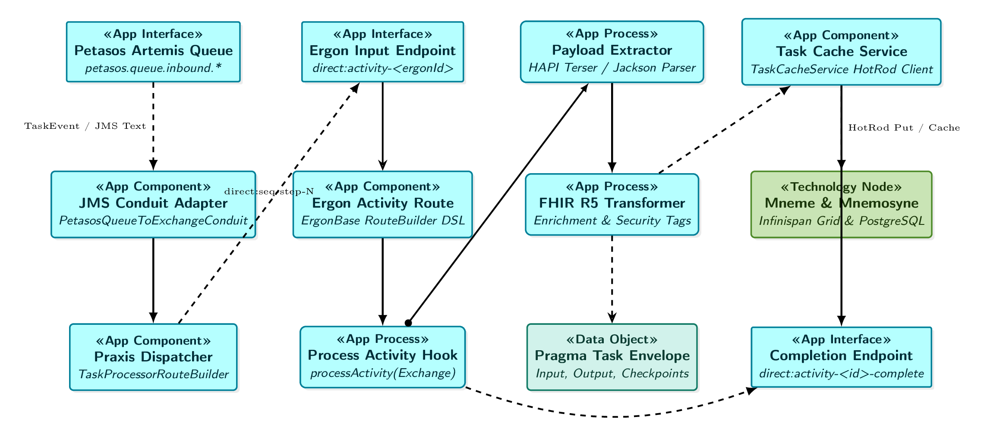
Figure 14: ArchiMate 3.2 Processing Topology and Component Interaction View for an Ergon Activity Module

RouteBuilder Inheritance and Processing Topologies
Every Ergon activity module is an extension of the abstract net.fhirfactory.harmonia.erga.base.ErgonBase class, which itself extends Apache Camel's org.apache.camel.builder.RouteBuilder. This design guarantees that every Ergon is a first-class citizen within the Camel routing engine while inheriting standard lifecycle management, error handling, logging, and security enforcement.
When an Ergon module is initialized, its configure() method dynamically registers three standardized endpoints:
- Input Endpoint (direct:activity-<ergonId>): Ingests the incoming Camel Exchange carrying the task context and Pragma payload.
- Output Completion Endpoint (direct:activity-<ergonId>-complete): Receives the enriched Exchange upon successful execution, handing control back to the Praxis orchestrator or forwarding to downstream steps.
- Error Endpoint (direct:activity-<ergonId>-error): Captures uncaught exceptions or explicit processing failures, initiating retry evaluation or Dead-Letter Queue (DLQ) dispatch.

Exchange Headers and Properties Invariants
To maintain traceability across asynchronous boundaries, Ergon activities must preserve and propagate a standardized set of Camel Exchange headers and properties. Table~tab:ergon_exchange_properties catalogues these invariants.
l X} Property / Header Key | Constant Identifier | Type | Architectural Description
HIE_PRAGMA_ID | PROPERTY_PRAGMA_ID | String | Unique UUID of the executing Pragma task instance.
HIE_CORRELATION_ID | HEADER_CORRELATION_ID | String | End-to-end correlation ID linking across ingress, processing, and egress.
HIE_ERGON_ID | PROPERTY_ERGON_ID | String | Logical activity identifier (e.g., ergon-observation-enrichment).
HIE_PRAXIS_ID | PROPERTY_PRAXIS_ID | String | Identifier of the parent Praxis workflow sequence.
HIE_SECURITY_LABEL | HEADER_SECURITY_LABEL | String | Confidentiality classification (e.g., R, N, V).
HIE_ACTIVITY_STATUS | PROPERTY_STATUS | String | Execution state (PROCESSING, COMPLETED, FAILED).
HIE_CHECKPOINT_INDEX | PROPERTY_CHECKPOINT_IDX | Integer | Monotonically increasing checkpoint index within the task lifecycle.
Table 18: Standardized Exchange Headers and Properties Managed by ErgonBase

The Pragma Task Envelope Model
The canonical data carrier within Energeia is the Pragma task envelope (net.fhirfactory.harmonia.calliope.model.Pragma). The Pragma encapsulates the complete execution state of a clinical task, comprising:
- Identity & Correlation: pragmaId (UUID), correlationId, causationId, and ergonId.
- Input Payloads: A collection of ErgonPayload objects containing raw HL7 strings, FHIR JSON models, or clinical binary attachments.
- Output Payloads: A collection of ErgonPayload objects generated by the Ergon during execution.
- Checkpoints: An ordered list of PragmaCheckpoint audit entries recording timestamps, activity IDs, status transitions, and optional checkpoint state summaries.
- Execution Metadata: Task priority, creation timestamp, updated timestamp, and security classification tags.

Security Tagging with FhirSecurityTagManager
Harmonia enforces strict Zero-Trust security and privacy controls. Ergon modules utilize the FhirSecurityTagManager component to inspect and apply HL7/FHIR confidentiality codes (e.g., RESTRICTED, NORMAL, VERY_RESTRICTED) to both the outgoing FHIR resources and the enclosing Pragma envelope, ensuring downstream egress gateways enforce proper redaction and masking.

Step-by-Step Code Development Blueprint
Developing a new Ergon activity module follows a rigorous 6-step engineering process.

Step 1: Maven Project Configuration
Ergon modules are implemented as Maven submodules under the energeia/erga hierarchy or within custom extension modules. The module pom.xml must declare dependencies on calliope-models, erga-base, camel-core, HAPI FHIR R5 structures, and Jackson serialization libraries.
<dependencies>
<!-- Harmonia Core Workflow & Data Models -->
<dependency>
<groupId>net.fhirfactory.harmonia</groupId>
<artifactId>calliope-models</artifactId>
<version>${project.version}</version>
</dependency>
<dependency>
<groupId>net.fhirfactory.harmonia</groupId>
<artifactId>erga-base</artifactId>
<version>${project.version}</version>
</dependency>
<!-- Apache Camel Core & CDI -->
<dependency>
<groupId>org.apache.camel</groupId>
<artifactId>camel-core</artifactId>
</dependency>
<dependency>
<groupId>org.apache.camel</groupId>
<artifactId>camel-cdi</artifactId>
</dependency>
<!-- HAPI FHIR R5 Core Structures -->
<dependency>
<groupId>ca.uhn.hapi.fhir</groupId>
<artifactId>hapi-fhir-structures-r5</artifactId>
</dependency>
<!-- JSON & XML Processing -->
<dependency>
<groupId>com.fasterxml.jackson.core</groupId>
<artifactId>jackson-databind</artifactId>
</dependency>
</dependencies>

Step 2: Subclassing ErgonBase \& Constructor Wiring
The Ergon class is annotated with Jakarta CDI @Dependent and defines its unique activity ID, version, and default endpoint configurations in the constructor.
package net.fhirfactory.harmonia.erga.observation.enrichment;
import jakarta.enterprise.context.Dependent;
import jakarta.inject.Inject;
import net.fhirfactory.harmonia.erga.base.ErgonBase;
import org.slf4j.Logger;
import org.slf4j.LoggerFactory;
@Dependent
public class ObservationEnrichmentErgon extends ErgonBase {
private static final Logger log = LoggerFactory.getLogger(ObservationEnrichmentErgon.class);
public static final String ERGON_ID = "ergon-observation-enrichment";
public static final String ERGON_VERSION = "1.0.0";
public ObservationEnrichmentErgon() {
super(ERGON_ID, ERGON_VERSION);
setInputEndpoint("direct:activity-" + ERGON_ID);
setOutputEndpoint("direct:activity-" + ERGON_ID + "-complete");
setErrorEndpoint("direct:activity-" + ERGON_ID + "-error");
}
}

Step 3: Defensive Payload Extraction
Inside the overridden processActivity(Exchange exchange) method, the Ergon extracts the incoming Pragma envelope from the exchange body or properties. If a raw HL7 v2 string is provided, the Ergon extracts discrete observation segments using defensive parsing patterns.

Step 4: Clinical Transformation \& Resource Generation
The Ergon transforms extracted parameters into enriched FHIR R5 Observation resources, mapping local laboratory test identifiers to standardized LOINC concepts and computing abnormal flags based on clinical reference ranges.

Step 5: Pragma Output \& Checkpoint Recording
The generated FHIR resources are serialized to JSON, wrapped in an ErgonPayload, and appended to Pragma.getOutputs(). The Ergon records a granular PragmaCheckpoint reflecting task progress and persists the updated Pragma into the Mneme distributed cache grid via TaskCacheService.

Step 6: Structured Exception Handling
If validation or processing fails, the Ergon throws a specialized ErgonException (or subclasses such as ErgonPayloadValidationException). The base route catches the exception, updates the PragmaStatus to FAILED, records an error checkpoint, and routes the exchange to the configured error endpoint.

Production Reference Implementation: ObservationEnrichmentErgon
The following complete, production-grade Java listing provides a reference implementation for ObservationEnrichmentErgon.
package net.fhirfactory.harmonia.erga.observation.enrichment;
import ca.uhn.hapi.fhir.context.FhirContext;
import ca.uhn.hapi.fhir.parser.IParser;
import com.fasterxml.jackson.databind.ObjectMapper;
import jakarta.enterprise.context.Dependent;
import jakarta.inject.Inject;
import net.fhirfactory.harmonia.calliope.model.ErgonPayload;
import net.fhirfactory.harmonia.calliope.model.ErgonReasonEnum;
import net.fhirfactory.harmonia.calliope.model.Pragma;
import net.fhirfactory.harmonia.calliope.model.PragmaCheckpoint;
import net.fhirfactory.harmonia.calliope.model.PragmaStatus;
import net.fhirfactory.harmonia.erga.base.ErgonBase;
import net.fhirfactory.harmonia.erga.base.ErgonException;
import net.fhirfactory.harmonia.erga.base.ErgonPayloadValidationException;
import net.fhirfactory.harmonia.hestia.cache.TaskCacheService;
import org.apache.camel.Exchange;
import org.hl7.fhir.r5.model.CodeableConcept;
import org.hl7.fhir.r5.model.Coding;
import org.hl7.fhir.r5.model.Observation;
import org.hl7.fhir.r5.model.Quantity;
import org.hl7.fhir.r5.model.Reference;
import org.hl7.fhir.r5.model.StringType;
import org.slf4j.Logger;
import org.slf4j.LoggerFactory;
import java.math.BigDecimal;
import java.nio.charset.StandardCharsets;
import java.util.Date;
import java.util.UUID;
@Dependent
public class ObservationEnrichmentErgon extends ErgonBase {
private static final Logger log = LoggerFactory.getLogger(ObservationEnrichmentErgon.class);
public static final String ERGON_ID = "ergon-observation-enrichment";
public static final String ERGON_VERSION = "1.0.0";
@Inject
private TaskCacheService taskCacheService;
@Inject
private FhirContext fhirContext;
@Inject
private ObjectMapper objectMapper;
public ObservationEnrichmentErgon() {
super(ERGON_ID, ERGON_VERSION);
setInputEndpoint("direct:activity-" + ERGON_ID);
setOutputEndpoint("direct:activity-" + ERGON_ID + "-complete");
setErrorEndpoint("direct:activity-" + ERGON_ID + "-error");
}
@Override
public void processActivity(Exchange exchange) throws Exception {
log.info("Executing Ergon activity: {}", getErgonId());
// 1. Retrieve Pragma from Exchange Body or Property
Pragma pragma = exchange.getIn().getBody(Pragma.class);
if (pragma == null) {
pragma = exchange.getProperty("HIE_PRAGMA", Pragma.class);
}
if (pragma == null) {
throw new ErgonPayloadValidationException("Exchange does not contain a valid Pragma envelope");
}
// 2. Validate Inbound Payload
if (pragma.getInputs() == null || pragma.getInputs().isEmpty()) {
throw new ErgonPayloadValidationException("Pragma contains no input payloads for enrichment");
}
ErgonPayload primaryInput = pragma.getInputs().get(0);
String rawContent = primaryInput.getPayload();
if (rawContent == null || rawContent.trim().isEmpty()) {
throw new ErgonPayloadValidationException("Primary input payload content is null or empty");
}
// 3. Perform Clinical Enrichment & Transformation
Observation observation = new Observation();
observation.setId("obs-" + UUID.randomUUID().toString());
observation.setStatus(Observation.ObservationStatus.FINAL);
// Map Category
CodeableConcept category = new CodeableConcept();
category.addCoding()
.setSystem("http://terminology.hl7.org/CodeSystem/observation-category")
.setCode("laboratory")
.setDisplay("Laboratory");
observation.addCategory(category);
// Map LOINC Code (Example: Serum Potassium)
CodeableConcept code = new CodeableConcept();
code.addCoding()
.setSystem("http://loinc.org")
.setCode("2823-3")
.setDisplay("Potassium [Moles/volume] in Serum or Plasma");
observation.setCode(code);
// Evaluate Value and Abnormal Interpretation
Quantity valueQuantity = new Quantity();
valueQuantity.setValue(new BigDecimal("5.8"));
valueQuantity.setUnit("mmol/L");
valueQuantity.setSystem("http://unitsofmeasure.org");
valueQuantity.setCode("mmol/L");
observation.setValue(valueQuantity);
// Interpretation (High Flag)
CodeableConcept interpretation = new CodeableConcept();
interpretation.addCoding()
.setSystem("http://terminology.hl7.org/CodeSystem/v3-ObservationInterpretation")
.setCode("H")
.setDisplay("High");
observation.addInterpretation(interpretation);
// Link Subject
if (pragma.getPatientId() != null) {
observation.setSubject(new Reference("Patient/" + pragma.getPatientId()));
}
observation.setEffective(new org.hl7.fhir.r5.model.DateTimeType(new Date()));
// 4. Serialize Enriched Resource to JSON
IParser parser = fhirContext.newJsonParser().setPrettyPrint(false);
String fhirJson = parser.encodeResourceToString(observation);
// 5. Wrap in ErgonPayload and Append to Pragma Outputs
ErgonPayload outputPayload = new ErgonPayload();
outputPayload.setPayloadId(UUID.randomUUID().toString());
outputPayload.setPayloadType("FHIR_R5_OBSERVATION");
outputPayload.setPayload(fhirJson);
outputPayload.setCreatedDate(new Date());
pragma.addOutput(outputPayload);
// 6. Record Audit Checkpoint
PragmaCheckpoint checkpoint = new PragmaCheckpoint();
checkpoint.setCheckpointId(UUID.randomUUID().toString());
checkpoint.setErgonId(getErgonId());
checkpoint.setTimestamp(new Date());
checkpoint.setStatus(PragmaStatus.PROCESSING);
checkpoint.setReason(ErgonReasonEnum.TRANSFORMATION_COMPLETED.name());
checkpoint.setDetails("Observation enriched with LOINC 2823-3 and abnormal flag H");
pragma.addCheckpoint(checkpoint);
// 7. Persist to Mneme Cache Grid
if (taskCacheService != null) {
taskCacheService.putTask(pragma.getPragmaId(), pragma);
log.debug("Persisted updated Pragma checkpoint to Mneme grid for ID: {}", pragma.getPragmaId());
}
// 8. Update Exchange Body & Headers
exchange.getMessage().setBody(pragma);
exchange.getMessage().setHeader("HIE_ACTIVITY_COMPLETED", true);
exchange.getMessage().setHeader("HIE_OBSERVATION_ID", observation.getId());
}
}

Praxis Workflow Orchestration \& Step Chaining
Modular Ergons rarely execute in complete isolation; instead, they are composed into structured clinical pipelines governed by Praxis orchestrators (net.fhirfactory.harmonia.praxis.sequence.PraxisImplementation).

Linear Workflow Sequences
In a linear pipeline, the Praxis sequence invokes a sequence of Ergons using Camel's direct endpoint chaining:
$\texttt{direct:seq-<praxisId>-step-0} \longrightarrow \texttt{Ergon A} \longrightarrow \texttt{direct:seq-<praxisId>-step-1} \longrightarrow \texttt{Ergon B} \longrightarrow \texttt{Complete}$
@Dependent
public class LabResultEnrichmentPraxisRouteBuilder extends RouteBuilder {
public static final String PRAXIS_ID = "praxis-lab-result-pipeline";
@Override
public void configure() throws Exception {
// Pipeline Entry Point
from("direct:seq-" + PRAXIS_ID + "-start")
.routeId("praxis-lab-pipeline-entry")
.log("Starting Praxis workflow: " + PRAXIS_ID)
.to("direct:seq-" + PRAXIS_ID + "-step-0");
// Step 0: Patient Identity & Demographics Resolution
from("direct:seq-" + PRAXIS_ID + "-step-0")
.routeId("praxis-lab-step-0-demographics")
.to("direct:activity-ergon-patient-demographics")
.to("direct:seq-" + PRAXIS_ID + "-step-1");
// Step 1: Observation & LOINC Enrichment
from("direct:seq-" + PRAXIS_ID + "-step-1")
.routeId("praxis-lab-step-1-enrichment")
.to("direct:activity-ergon-observation-enrichment")
.to("direct:seq-" + PRAXIS_ID + "-step-2");
// Step 2: Outbound Distribution Routing
from("direct:seq-" + PRAXIS_ID + "-step-2")
.routeId("praxis-lab-step-2-distribution")
.to("direct:activity-ergon-oru-processing")
.log("Praxis pipeline completed successfully for task: ${header.HIE_PRAGMA_ID}");
}
}

Conditional Branching and Error Recovery
Praxis orchestrators implement Camel Content-Based Routers (choice()) to direct tasks dynamically based on payload properties, priority, or clinical flags:
from("direct:seq-clinical-triage")
.choice()
.when(header("HIE_IS_STAT").isEqualTo(true))
.to("direct:activity-ergon-urgent-dispatch")
.when(header("HIE_SECURITY_LABEL").isEqualTo("RESTRICTED"))
.to("direct:activity-ergon-masked-distribution")
.otherwise()
.to("direct:activity-ergon-standard-distribution")
.end();

CDI Configuration, Dependency Injection \& Scoping
Harmonia runs within Jakarta EE 10 execution containers (WildFly / Ponos). All Ergons and supporting services adhere to strict CDI 4.0 scoping and injection rules.

Bean Scoping: @Dependent vs. @ApplicationScoped
- Ergon Activities (@Dependent): Ergon classes are scoped as @Dependent beans. When Apache Camel instantiates routes, a dedicated, thread-safe instance of the RouteBuilder is bound to the context.
- Core Services (@ApplicationScoped): State-agnostic, thread-safe utility beans (TaskCacheService, FhirContext, ObjectMapper, FhirSecurityTagManager) are scoped as @ApplicationScoped singletons shared across all active routes.

CDI Deployment Descriptor (beans.xml)
Every Ergon archive must bundle a beans.xml file in META-INF/ (or WEB-INF/) declaring explicit bean discovery mode:
<?xml version="1.0" encoding="UTF-8"?>
<beans xmlns="https://jakarta.ee/xml/ns/jakartaee"
xmlns:xsi="http://www.w3.org/2001/XMLSchema-instance"
xsi:schemaLocation="https://jakarta.ee/xml/ns/jakartaee
https://jakarta.ee/xml/ns/jakartaee/beans_4_0.xsd"
bean-discovery-mode="all"
version="4.0">
</beans>

Testing Strategies, Test Fixtures \& Validation
Testing Ergon modules involves isolated unit testing using Apache Camel Test Kit and full container integration testing within Ponos.

CamelTestSupport Unit Testing Pattern
Unit tests extend org.apache.camel.test.junit5.CamelTestSupport, mock downstream completion and error endpoints, inject synthetic Pragma fixtures, and assert exchange transformations and checkpoint states.
package net.fhirfactory.harmonia.erga.observation.enrichment;
import ca.uhn.hapi.fhir.context.FhirContext;
import net.fhirfactory.harmonia.calliope.model.ErgonPayload;
import net.fhirfactory.harmonia.calliope.model.Pragma;
import net.fhirfactory.harmonia.calliope.model.PragmaStatus;
import org.apache.camel.EndpointInject;
import org.apache.camel.Produce;
import org.apache.camel.ProducerTemplate;
import org.apache.camel.builder.AdviceWith;
import org.apache.camel.component.mock.MockEndpoint;
import org.apache.camel.test.junit5.CamelTestSupport;
import org.junit.jupiter.api.BeforeEach;
import org.junit.jupiter.api.Test;
import java.util.Date;
import java.util.UUID;
import static org.junit.jupiter.api.Assertions.*;
public class ObservationEnrichmentErgonTest extends CamelTestSupport {
private ObservationEnrichmentErgon ergon;
@Produce("direct:activity-ergon-observation-enrichment")
private ProducerTemplate startEndpoint;
@EndpointInject("mock:activity-ergon-observation-enrichment-complete")
private MockEndpoint completeEndpoint;
@Override
protected void doPreSetup() throws Exception {
ergon = new ObservationEnrichmentErgon();
// Inject field dependencies manually for pure Camel unit testing
// (In container tests, CDI handles injection)
}
@Test
public void testSuccessfulObservationEnrichment() throws Exception {
// Arrange
Pragma syntheticPragma = new Pragma();
syntheticPragma.setPragmaId("PRAGMA-" + UUID.randomUUID());
syntheticPragma.setStatus(PragmaStatus.PENDING);
syntheticPragma.setPatientId("PAT-10045");
ErgonPayload input = new ErgonPayload();
input.setPayloadId("PAYLOAD-001");
input.setPayloadType("HL7_OBX");
input.setPayload("OBX|1|NM|2823-3^Potassium^LN||5.8|mmol/L|3.5-5.0|H|||F");
syntheticPragma.addInput(input);
// Act
template.sendBody("direct:activity-ergon-observation-enrichment", syntheticPragma);
// Assert
assertNotNull(syntheticPragma.getOutputs());
assertEquals(1, syntheticPragma.getOutputs().size());
assertEquals("FHIR_R5_OBSERVATION", syntheticPragma.getOutputs().get(0).getPayloadType());
// Assert Checkpoints
assertFalse(syntheticPragma.getCheckpoints().isEmpty());
assertEquals("ergon-observation-enrichment",
syntheticPragma.getCheckpoints().get(0).getErgonId());
}
}

Deployment, Containerization \& Operational Runbook

WildFly \& Ponos Container Architecture
Ergon modules are bundled into the hie-task-processor.war artifact deployed inside the Ponos WildFly Jakarta EE runtime container. Figure~fig:ergon_deployment_topo illustrates the container topology.

Dynamic Live Reload via ponos-cli
The Ponos container supports zero-downtime dynamic route reloading through the ponos-cli command-line administrative utility. When a new Ergon activity or updated Praxis workflow is packaged into a hot-deployable JAR, operators issue:
# Check current Ponos worker status and active routes
ponos-cli --status --host localhost --port 8080
# Trigger graceful dynamic route reload
ponos-cli --reload --module ergon-observation-enrichment-1.0.0.jar
# Validate active route registration
ponos-cli --routes | grep "ergon-observation-enrichment"

Concurrency Tuning and Thread Pool Sizing
Ponos manages Camel concurrency using SEDA and JMS thread pools tuned via deployment parameters:
- Concurrent Consumers: Configured on inbound Artemis endpoints (default: 8 consumers, scalable to 32 under peak load).
- SEDA Queue Capacity: Internal async handoffs buffer up to 1000 tasks per activity before applying backpressure.
- Infinispan Cache Write-Behind: Checkpoints are committed to the Mneme in-memory cache synchronously and flushed to Mnemosyne PostgreSQL asynchronously via write-behind replication queues.

Dead-Letter Queue (DLQ) Recovery Operations
When an unrecoverable processing error or transient database failure exhausts configured retry attempts (default: 3 retries with exponential backoff), the message is routed to the Dead-Letter Queue:
$\texttt{petasos.queue.dlq.ergon-processing}$
Operators inspect and re-drive DLQ tasks using the Hestia Operations CLI:
# Inspect dead-lettered Pragma instances
hestia-cli dlq list --queue petasos.queue.dlq.ergon-processing
# View detailed stack trace and error checkpoint
hestia-cli dlq inspect --pragma-id PRAGMA-78a421-99b
# Replay task after remediating downstream dependency
hestia-cli dlq replay --pragma-id PRAGMA-78a421-99b --target-queue petasos.queue.inbound.oru

Summary \& Best Practices Checklist
Table~tab:ergon_checklist summarizes the mandatory architectural invariants and best practices required when authoring and deploying new Ergon activity modules.
X} Phase | Requirement / Invariant | Verification Criteria
Design | Inherit from ErgonBase | Verify configure() registers standard input, complete, and error direct endpoints.
Scoping | Annotate with @Dependent | Ensure thread-safe RouteBuilder lifecycle per Camel context.
Validation | Defensive Inbound Validation | Throw structured ErgonPayloadValidationException on malformed or empty payloads.
Audit | Granular PragmaCheckpoint | Record execution timestamps, status, and reason codes in the Mneme grid.
Security | Tag Confidentiality Labels | Apply FhirSecurityTagManager classifications to all outgoing FHIR models.
Testing | CamelTestSupport Coverage | Author unit tests verifying happy path, error routing, and checkpoint assertions.
Operations | Hot Reload Validation | Verify dynamic reload and route registration via ponos-cli –reload.
Table 19: Production Readiness Checklist for New Ergon Workflow Activity Modules

Appendix D: Implementation and Deployment Guide for Praxis Workflow Sequences

Overview \& Engineering Objectives
Within the Harmonia Health Information Exchange (HIE) architecture, the Energeia subsystem governs all workflow orchestration, clinical transformation, data enrichment, and task execution. While individual tasks are encapsulated within discrete, modular Ergon activity modules (documented in Appendix~app:ergon_modules), the deterministic composition, ordering, topic-based dispatch, dynamic Apache Camel route compilation, and end-to-end audit checkpointing of these activities are executed by Praxis Workflow Sequences.
This implementation guide provides an authoritative, production-grade technical manual for software engineers, integration developers, and platform architects charged with authoring, configuring, testing, and deploying Praxis workflow sequences. Specifically, this guide covers:
- The Praxis Architectural Paradigm: Decoupling declarative workflow metadata (PraxisDefinition in the calliope model module) from runtime Camel execution (PraxisImplementation and Praxis in the energeia/praxis engine), managing multi-level hierarchical topic subscriptions (TopicSubscription), configuring target gateway routing, and persisting execution state across a dual-cache Infinispan grid.
- Step-by-Step Praxis Creation Blueprint: Defining declarative sequence descriptors in JSON and Java, ordering pipeline activities, binding ingress queues and endpoints, and managing error containment boundaries.
- Production Reference Implementation: A complete, production-ready implementation of PatientCareAdmissionPraxis, alongside its companion declarative JSON configuration, demonstrating multi-step clinical orchestration spanning patient demographics ingestion, identifier cross-referencing, and clinical encounter enrichment.
- Dynamic Route Generation & Camel Pipeline Topology: In-depth analysis of createSequencePipelineRoute(), dynamic direct endpoint synthesis (direct:seq-<praxisId>-start → direct:seq-<praxisId>-step-N → direct:seq-<praxisId>-complete), ingress conduit bridging, and exchange property invariants.
- Dynamic Discovery, Seeding & CDI Runtime Binding: Operating TaskSequenceLoader to dynamically query PraxisService, discovering @Dependent ErgonBase CDI beans via Jakarta EE Instance<ErgonBase>, bootstrapping default workflows via TaskSequenceDefaultSeeder, and injecting active routes into the running CamelContext.
- Multi-Tier Testing Strategies: Authoring deterministic unit and integration test harnesses using Apache Camel Test Kit (CamelTestSupport), synthetic Pragma envelopes, mock endpoint assertions, and verification of transactional PragmaCheckpoint audit trails.
- Deployment, Cluster Management & Operational Runbook: Containerizing within the Ponos WildFly execution environment, monitoring cluster state via the /workflow REST administrative API, executing zero-downtime dynamic sequence reloads via ponos-cli –reload-sequences, and managing Infinispan cache replication.

Architectural Blueprint \& the Praxis Paradigm
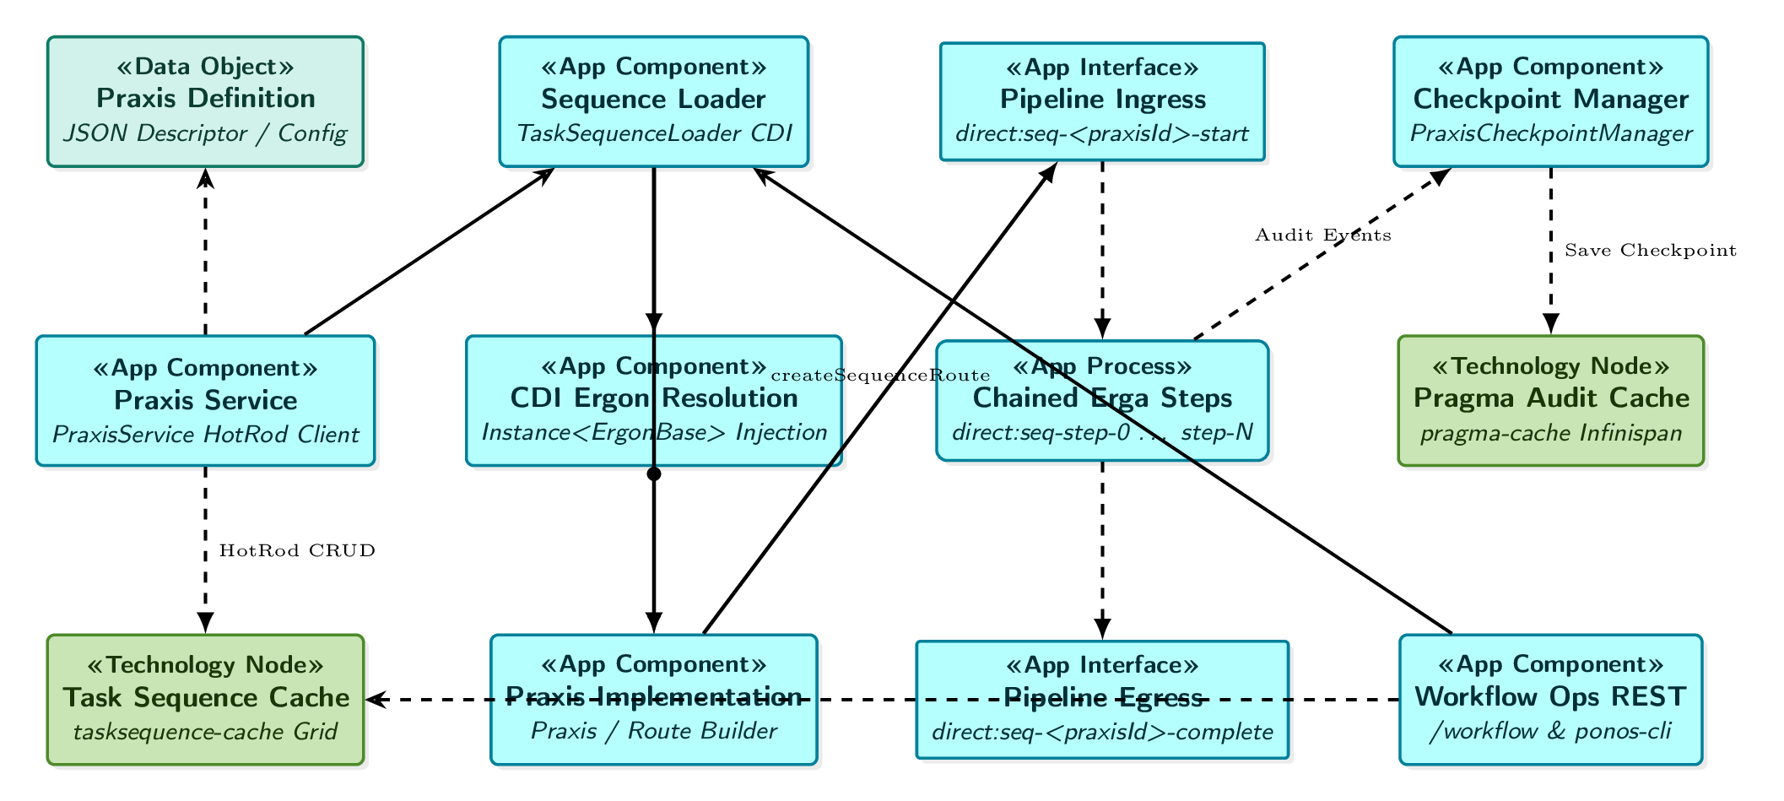
Figure 15: ArchiMate 3.2 Praxis Workflow Sequence Architecture and Dynamic Route Synthesis Topology
The Harmonia workflow engine enforces a strict architectural separation of concerns between declarative workflow definition and runtime route execution. Figure~fig:praxis_workflow_architecture illustrates the ArchiMate 3.2 processing and component topology of the Praxis workflow subsystem.

Decoupling Definition from Runtime Execution
Workflow sequences are architected into two distinct layers:
- Declarative Metadata Layer (PraxisDefinition): Residing in the shared calliope model module (net.fhirfactory.harmonia.model.praxis), PraxisDefinition is a lightweight, serializable Java Plain Old Java Object (POJO) and JSON data transfer object. It encapsulates workflow metadata, including the unique sequence identifier (praxisId), human-readable name, semantic version, enabled flag, topic subscriptions (List<TopicSubscription>), target gateway instance IDs (List<String>), trigger types (List<String>), and an ordered map of activity class names (Map<Integer, String> activityClassNames). It possesses no runtime dependencies on Apache Camel, CDI, or container runtimes, enabling safe network transport and JSON persistence in the Infinispan cache.
- Runtime Execution Layer (PraxisImplementation / Praxis): Residing in the energeia/praxis engine (net.fhirfactory.harmonia.praxis.sequence), PraxisImplementation extends PraxisDefinition and acts as an Apache Camel RouteBuilder. It dynamically resolves concrete @Dependent ErgonBase activity beans from the CDI container, binds transactional PraxisCheckpointManager interceptors, and compiles the dynamic pipeline routing logic into the active CamelContext.

Topic Subscription Matching \& Hierarchical Routing
Praxis workflows register topic subscriptions that govern which incoming clinical events trigger pipeline execution. A Topic in Harmonia consists of a structured four-tuple:
$\text{Topic} = \langle \text{Domain}, \text{Model}, \text{Element}, \text{Qualifier} \rangle$
For example, an inpatient admission ADT A01 message from a Patient Administration System maps to the topic:
Domain: HIE
Model: HL7_V2
Element: ADT_A01
Qualifier: INPATIENT_ADMISSION
A TopicSubscription defines matching rules with wildcard capabilities (*):
- Exact Match: Matches a specific topic tuple exactly (e.g., HIE/HL7_V2/ADT_A01/INPATIENT_ADMISSION).
- Wildcard Subscriptions: Matches all elements under a model or domain (e.g., HIE/HL7_V2/ADT_*/\allowbreak *).
- Priority Resolution: When an incoming Pragma matches multiple registered Praxis sequences, the dispatcher routes the task based on explicit sequence priority weights or target gateway instance affinity.

Audit Checkpoint Lifecycle across Execution Boundaries
To guarantee non-repudiation, HIPAA audit compliance, and automated failure recovery, the PraxisCheckpointManager records durable audit checkpoints at every major execution transition. Table~tab:praxis_checkpoint_stages details the five canonical checkpoint stages.
X l} Stage Constant | Stage Name | Description & Audit State Recorded | Pragma Status
STAGE_PIPELINE_INGRESS | PIPELINE_INGRESS | Ingress handoff received at direct:seq-<id>-start; records initial payload hash and ingress timestamp. | QUEUED
STAGE_PRE_ERGON | PRE_ERGON | Intercepted immediately before delegating to ErgonBase step N; records step index and input state snapshot. | PROCESSING
STAGE_POST_ERGON | POST_ERGON | Intercepted upon successful return from ErgonBase step N; records transformed FHIR resources and execution duration. | PROCESSING
STAGE_PIPELINE_COMPLETE | PIPELINE_COMPLETE | Pipeline egress reached at direct:seq-<id>-complete; records total execution time and final outcome envelope. | COMPLETED
STAGE_PIPELINE_FAILED | PIPELINE_FAILED | Trapped by pipeline error boundary; records failure reason, exception class, stack trace, and failed step index. | FAILED
Table 20: Praxis Workflow Execution Checkpoint Stages and Lifecycle Semantics

Dual-Cache Architecture in the Mneme Grid
State persistence in the Mneme distributed Infinispan grid is partitioned into two specialized caches:
- tasksequence-cache: Stores declarative PraxisDefinition JSON configurations. Accessed via PraxisService, this cache is replicated across all Ponos cluster nodes. Any update to this cache triggers a cluster-wide cache invalidation and hot-reloads the active Camel routing topology.
- pragma-cache: Stores active and completed in-flight Pragma task envelopes and their associated PragmaCheckpoint historical audit chains. Checkpoints written by PraxisCheckpointManager are synchronously committed using the HotRod binary protocol to guarantee durability before subsequent pipeline steps execute.

Step-by-Step Praxis Creation Blueprint
Engineering a new Praxis workflow sequence follows a structured four-phase lifecycle: definition, activity composition, route configuration, and error boundary definition.

Phase 1: Defining Declarative Workflow Metadata
A Praxis workflow sequence must define unique identification, human-readable descriptors, topic subscriptions, and target gateways. In declarative environments (e.g., Kubernetes ConfigMaps or Infinispan seeders), this metadata is expressed as JSON:
{
"praxisId": "praxis-patient-admission",
"name": "Patient Care Admission Workflow",
"description": "Orchestrates patient admission ingestion, demographic parsing, identifier lookup, and clinical encounter generation.",
"version": "1.0.0",
"enabled": true,
"topicSubscriptions": [
{
"topic": {
"domain": "HIE",
"model": "HL7_V2",
"element": "ADT_A01",
"qualifier": "INPATIENT"
},
"active": true
}
],
"targetGateways": ["gateway-pylai-mllp-in-pas"],
"targetTriggers": ["INBOUND_HL7_EVENT"],
"sourceQueueName": "petasos.queue.inbound.adt",
"activityClassNames": {
"0": "net.fhirfactory.harmonia.erga.patient.demographics.PatientDemographicsUpdateErgon",
"1": "net.fhirfactory.harmonia.erga.patient.identity.PatientIdentifierCrossReferenceErgon",
"2": "net.fhirfactory.harmonia.erga.encounter.EncounterEnrichmentErgon"
}
}

Phase 2: Activity Ordering and Sequence Validation
When instantiating a PraxisImplementation, the runtime executes the validate() contract to enforce topological invariants:
- Sequence Identifier Validation: Ensures praxisId is non-null and matches the naming pattern |/^[a-z0-9-]+$/|.
- Zero-Gapped Activity Indexing: Ensures activities are indexed consecutively starting from index 0 through N-1.
- Bean Resolution Non-Null Guarantee: Validates that every configured activity class name successfully resolves to an active, non-null ErgonBase instance in the CDI container.

Phase 3: Route Synthesis and Ingress Conduits
The PraxisImplementation automatically generates two primary Camel route structures:
- Ingress Bridge Route: If sourceQueueName is configured, an ingress JMS route consumes from jms:queue:<sourceQueueName> and forwards exchanges to direct:seq-<praxisId>-start.
- Linear Activity Pipeline: Synthesizes a chained Camel route connecting direct:seq-<praxisId>-start through intermediate activity endpoints direct:seq-<praxisId>-step-N to the completion sink direct:seq-<praxisId>-complete.

Phase 4: Error Boundary \& Exception Trapping
The pipeline route establishes an explicit onException(Exception.class) error trap:
onException(Exception.class)
.handled(true)
.process(exchange -> {
Exception cause = exchange.getProperty(Exchange.EXCEPTION_CAUGHT, Exception.class);
Pragma pragma = resolvePragma(exchange);
if (pragma != null && checkpointManager != null) {
checkpointManager.recordPipelineFailure(pragma, getPraxisId(), currentStepIndex, cause);
}
exchange.getMessage().setHeader("PraxisExecutionStatus", "FAILED");
})
.to("direct:seq-" + getPraxisId() + "-error")
.to("jms:queue:petasos.queue.dlq.workflow-failure");

Production Reference Implementation: PatientCareAdmissionPraxis
Listing~lst:patient_care_admission_praxis provides the complete, production-grade Java reference implementation for PatientCareAdmissionPraxis.
package net.fhirfactory.harmonia.praxis.clinical;
import jakarta.enterprise.context.Dependent;
import jakarta.inject.Inject;
import net.fhirfactory.harmonia.erga.base.ErgonBase;
import net.fhirfactory.harmonia.erga.encounter.EncounterEnrichmentErgon;
import net.fhirfactory.harmonia.erga.patient.demographics.PatientDemographicsUpdateErgon;
import net.fhirfactory.harmonia.erga.patient.identity.PatientIdentifierCrossReferenceErgon;
import net.fhirfactory.harmonia.model.praxis.Topic;
import net.fhirfactory.harmonia.model.praxis.TopicSubscription;
import net.fhirfactory.harmonia.praxis.sequence.Praxis;
import org.apache.camel.CamelContext;
import org.slf4j.Logger;
import org.slf4j.LoggerFactory;
import java.util.ArrayList;
import java.util.HashMap;
import java.util.List;
import java.util.Map;
/**
* Production reference implementation of a multi-step clinical admission workflow.
* Orchestrates:
* Step 0: PatientDemographicsUpdateErgon (Extracts patient demographic FHIR Patient)
* Step 1: PatientIdentifierCrossReferenceErgon (Queries EMPI / Master Patient Index)
* Step 2: EncounterEnrichmentErgon (Constructs FHIR Encounter and location mappings)
*/
@Dependent
public class PatientCareAdmissionPraxis extends Praxis {
private static final Logger LOG = LoggerFactory.getLogger(PatientCareAdmissionPraxis.class);
public static final String PRAXIS_ID = "praxis-patient-care-admission";
public static final String PRAXIS_NAME = "Patient Care Admission Workflow";
public static final String PRAXIS_VERSION = "1.2.0";
@Inject
public PatientCareAdmissionPraxis(
CamelContext camelContext,
PatientDemographicsUpdateErgon demographicsErgon,
PatientIdentifierCrossReferenceErgon identityErgon,
EncounterEnrichmentErgon encounterErgon) {
super();
setCamelContext(camelContext);
setPraxisId(PRAXIS_ID);
setName(PRAXIS_NAME);
setVersion(PRAXIS_VERSION);
setEnabled(true);
setDescription("Production multi-step admission orchestration pipeline.");
// 1. Configure Ingress Queue Binding
setSourceQueueName("petasos.queue.inbound.adt");
setInputEndpoint("direct:seq-" + PRAXIS_ID + "-start");
// 2. Configure Topic Subscriptions
List<TopicSubscription> subscriptions = new ArrayList<>();
Topic adtA01Topic = new Topic("HIE", "HL7_V2", "ADT_A01", "INPATIENT");
subscriptions.add(new TopicSubscription(adtA01Topic, true));
Topic adtA04Topic = new Topic("HIE", "HL7_V2", "ADT_A04", "EMERGENCY");
subscriptions.add(new TopicSubscription(adtA04Topic, true));
setTopicSubscriptions(subscriptions);
// 3. Configure Target Gateways and Triggers
List<String> gateways = new ArrayList<>();
gateways.add("gateway-pylai-mllp-in-pas");
setTargetGateways(gateways);
List<String> triggers = new ArrayList<>();
triggers.add("INBOUND_HL7_EVENT");
setTargetTriggers(triggers);
// 4. Bind Sequential Ergon Activities
Map<Integer, ErgonBase> activityMap = new HashMap<>();
activityMap.put(0, demographicsErgon);
activityMap.put(1, identityErgon);
activityMap.put(2, encounterErgon);
setActivities(activityMap);
// 5. Populate Declarative Metadata Map for Serialization
Map<Integer, String> classNames = new HashMap<>();
classNames.put(0, demographicsErgon.getClass().getName());
classNames.put(1, identityErgon.getClass().getName());
classNames.put(2, encounterErgon.getClass().getName());
setActivityClassNames(classNames);
LOG.info("PatientCareAdmissionPraxis initialized with 3 sequential Erga activities.");
}
/**
* Default constructor for dynamic JSON deserialization.
*/
public PatientCareAdmissionPraxis() {
super();
}
}

Dynamic Route Generation \& Camel Pipeline Topology
The core engine of PraxisImplementation is the dynamic route compiler: createSequencePipelineRoute(). When invoked by configure(), it programmatically builds an Apache Camel route tree that seamlessly bridges asynchronous JMS ingress queues, synchronous direct endpoint chaining, pre- and post-activity checkpoint hooks, and completion handoffs.

Route Synthesis Architecture
Listing~lst:dynamic_route_synthesis shows the decompiled dynamic route generation logic employed by PraxisImplementation.
@Override
public void configure() throws Exception {
if (!isEnabled()) {
LOG.warn("Praxis sequence [{}] is disabled. Skipping route creation.", getPraxisId());
return;
}
// 1. Ingress Conduit Bridge Route: JMS Queue -> Pipeline Start Direct Endpoint
if (getSourceQueueName() != null && !getSourceQueueName().isBlank()) {
String jmsUri = getSourceQueueName().startsWith("jms:")
? getSourceQueueName()
: "jms:queue:" + getSourceQueueName();
from(jmsUri)
.routeId("praxis-" + getPraxisId() + "-ingress-bridge")
.setHeader("PraxisSequenceId", constant(getPraxisId()))
.to(getPipelineInputEndpoint());
}
// 2. Linear Activity Pipeline Chaining
List<ErgonBase> orderedActivities = getOrderedActivities();
String startEndpoint = getPipelineInputEndpoint();
RouteDefinition route = from(startEndpoint)
.routeId("praxis-" + getPraxisId() + "-pipeline")
.process(exchange -> {
Pragma pragma = resolvePragma(exchange);
if (pragma != null && checkpointManager != null) {
checkpointManager.recordPipelineIngress(pragma, getPraxisId());
}
});
for (int i = 0; i < orderedActivities.size(); i++) {
final int stepIndex = i;
final ErgonBase activity = orderedActivities.get(i);
String stepEndpoint = "direct:seq-" + getPraxisId() + "-step-" + stepIndex;
route = route
.to(stepEndpoint)
.process(exchange -> {
Pragma pragma = resolvePragma(exchange);
if (pragma != null && checkpointManager != null) {
checkpointManager.recordPreErgon(pragma, getPraxisId(), stepIndex, activity.getErgonId());
}
})
.to(activity.getInputEndpointUri())
.process(exchange -> {
Pragma pragma = resolvePragma(exchange);
if (pragma != null && checkpointManager != null) {
checkpointManager.recordPostErgon(pragma, getPraxisId(), stepIndex, activity.getErgonId());
}
});
}
// 3. Pipeline Completion Handoff
route
.process(exchange -> {
Pragma pragma = resolvePragma(exchange);
if (pragma != null && checkpointManager != null) {
checkpointManager.recordPipelineComplete(pragma, getPraxisId(), orderedActivities.size());
}
exchange.getMessage().setHeader("PraxisExecutionStatus", "COMPLETED");
})
.to(getPipelineCompleteEndpoint());
}

Exchange Property Invariants and Header Preservation
Throughout the lifecycle of a Praxis execution pipeline, Apache Camel exchanges must preserve specific headers and properties to maintain transaction traceability. Table~tab:praxis_exchange_properties lists the mandatory exchange parameters.
X} Property / Header Name | Scope | Type | Description & Platform Usage
PraxisSequenceId | Header | String | The unique identifier of the executing Praxis sequence.
ErgonBase.PROPERTY_PRAGMA | Property | Pragma | The canonical in-flight task envelope containing clinical payloads.
Exchange.CORRELATION_ID | Header | String | End-to-end correlation ID linking ingress MLLP to outbound dispatch.
PraxisExecutionStatus | Header | String | Execution state indicator (PROCESSING, COMPLETED, FAILED).
PraxisStepIndex | Property | Integer | The zero-based index of the currently executing pipeline step.
Table 21: Mandatory Apache Camel Exchange Properties and Headers in Praxis Pipelines

Dynamic Discovery, Seeding \& Runtime Registration
Harmonia enables zero-downtime reconfiguration of workflow pipelines through TaskSequenceLoader and PraxisService.

CDI Bean Resolution via Jakarta EE Instance
When loading declarative definitions from the tasksequence-cache, TaskSequenceLoader parses the configured activityClassNames and uses Jakarta EE's Instance<ErgonBase> to dynamically discover and inject matching CDI beans:
@ApplicationScoped
public class TaskSequenceLoader {
@Inject
private PraxisService praxisService;
@Inject
private Instance<ErgonBase> ergonBeanSource;
@Inject
private CamelContext camelContext;
public PraxisImplementation resolveAndInstantiate(PraxisDefinition definition) {
PraxisImplementation impl = new PraxisImplementation(definition);
Map<Integer, ErgonBase> resolvedActivities = new HashMap<>();
for (Map.Entry<Integer, String> entry : definition.getActivityClassNames().entrySet()) {
int stepIndex = entry.getKey();
String className = entry.getValue();
try {
Class<?> activityClass = Class.forName(className);
Instance<?> childInstance = ergonBeanSource.select(activityClass);
if (!childInstance.isResolvable()) {
throw new IllegalStateException("CDI unable to resolve Ergon bean: " + className);
}
ErgonBase ergonBean = (ErgonBase) childInstance.get();
resolvedActivities.put(stepIndex, ergonBean);
} catch (ClassNotFoundException e) {
throw new IllegalArgumentException("Configured Ergon class not found on classpath: " + className, e);
}
}
impl.setActivities(resolvedActivities);
impl.setCamelContext(camelContext);
return impl;
}
}

Initial Seeding via TaskSequenceDefaultSeeder
During initial platform boot, the TaskSequenceDefaultSeeder inspects the tasksequence-cache. If the cache is empty, it populates the baseline clinical workflows:
- praxis-patient-care-admission: Inpatient and emergency admission pipeline.
- praxis-lab-order-routing: Laboratory diagnostic order routing and distribution.
- praxis-observation-enrichment: Pathology result enrichment and LOINC terminology mapping.

Multi-Tier Testing Strategies
To guarantee pipeline determinism and fault isolation, workflow sequences must be verified using unit, integration, and failure snapshot testing harnesses.

CamelTestSupport Unit Test Harness
Listing~lst:praxis_test_harness illustrates an automated unit test leveraging Apache Camel Test Kit to verify linear execution, intermediate step transformations, and mock assertions.
package net.fhirfactory.harmonia.praxis.sequence;
import net.fhirfactory.harmonia.erga.base.ErgonBase;
import net.fhirfactory.harmonia.model.pragma.Pragma;
import net.fhirfactory.harmonia.model.pragma.PragmaCheckpoint;
import net.fhirfactory.harmonia.model.pragma.PragmaStatus;
import org.apache.camel.Exchange;
import org.apache.camel.builder.RouteBuilder;
import org.apache.camel.component.mock.MockEndpoint;
import org.apache.camel.test.junit5.CamelTestSupport;
import org.junit.jupiter.api.BeforeEach;
import org.junit.jupiter.api.DisplayName;
import org.junit.jupiter.api.Test;
import java.util.HashMap;
import java.util.List;
import java.util.Map;
import static org.junit.jupiter.api.Assertions.*;
public class PraxisWorkflowUnitTest extends CamelTestSupport {
private PraxisImplementation praxis;
private MockErgonStep0 step0;
private MockErgonStep1 step1;
@BeforeEach
public void setupPipeline() throws Exception {
step0 = new MockErgonStep0();
step1 = new MockErgonStep1();
context.addRoutes(step0);
context.addRoutes(step1);
praxis = new PraxisImplementation();
praxis.setPraxisId("praxis-unit-test");
praxis.setEnabled(true);
praxis.setCamelContext(context);
Map<Integer, ErgonBase> activities = new HashMap<>();
activities.put(0, step0);
activities.put(1, step1);
praxis.setActivities(activities);
context.addRoutes(praxis);
context.addRoutes(new RouteBuilder() {
@Override
public void configure() {
from(praxis.getPipelineCompleteEndpoint()).to("mock:pipeline-complete");
}
});
}
@Test
@DisplayName("Verify complete linear execution of 2-step Praxis pipeline")
public void testSuccessfulPipelineExecution() throws InterruptedException {
MockEndpoint completeMock = getMockEndpoint("mock:pipeline-complete");
completeMock.expectedMessageCount(1);
Pragma inputPragma = new Pragma();
inputPragma.setPragmaId("PRAGMA-TEST-001");
inputPragma.setStatus(PragmaStatus.QUEUED);
template.sendBody("direct:seq-praxis-unit-test-start", inputPragma);
completeMock.assertIsSatisfied();
Exchange resultExchange = completeMock.getReceivedExchanges().get(0);
Pragma resultPragma = resultExchange.getIn().getBody(Pragma.class);
assertNotNull(resultPragma);
assertEquals("COMPLETED", resultExchange.getMessage().getHeader("PraxisExecutionStatus"));
}
}

Failure Snapshotting and Checkpoint Assertions
When an intermediary ErgonBase activity fails (e.g., due to an unrecoverable database outage or payload validation exception), tests must verify that:
- The Camel error boundary intercepts the exception.
- A PragmaCheckpoint with stage STAGE_PIPELINE_FAILED is recorded in the pragma-cache.
- The in-flight Pragma status is transitioned to FAILED with complete error metadata.

Deployment, Cluster Management \& Operational Runbook

Containerization within Ponos WildFly Container
Praxis workflow sequences run inside the hie-task-processor container (WildFly 31, Java 21). The deployment descriptor (pom.xml) packages compiled Praxis and Ergon classes into the root WAR or shared EAR library.

REST Administrative API: /workflow
The WorkflowManagementResource exposes administrative endpoints on port 8080:
- GET /workflow/status: Returns operational status of all registered Praxis pipelines, including sequence ID, active state, activity count, and target gateway bindings.
- GET /workflow/validate: Executes topological validation across all loaded sequences, reporting configuration errors or missing CDI Ergon beans.
- POST /workflow/reload: Triggers TaskSequenceLoader.reloadAll(), synchronizing routes with the latest tasksequence-cache definitions.

Dynamic Live Reload via ponos-cli
Platform operators perform live sequence reloads without restarting the JVM container using the Hestia Operations CLI:
# Check health and status of active Praxis pipelines
ponos-cli workflow status --host ponos-node-1 --port 8080
# Validate declarative configuration in tasksequence-cache
ponos-cli workflow validate
# Execute cluster-wide dynamic pipeline route compilation
ponos-cli workflow reload --force
# Inspect detailed checkpoint trail for a specific task
hestia-cli pragma inspect --pragma-id PRAGMA-992-B71

Summary \& Best Practices Checklist
Table~tab:praxis_readiness_checklist summarizes the mandatory engineering practices and verification criteria for deploying new Praxis workflow sequences into production.
X} Lifecycle Stage | Mandatory Requirement | Production Verification Criteria
Definition | Decouple Metadata from Runtime | Use PraxisDefinition for JSON serialization and PraxisImplementation for Camel execution.
Indexing | Zero-Based Activity Indices | Ensure activityClassNames and activities maps are indexed sequentially starting at 0.
CDI Injection | Scoped Ergon Resolution | Annotate activity modules with @Dependent to ensure clean per-route bean isolation.
Durability | Multi-Stage Checkpointing | Verify PraxisCheckpointManager writes PIPELINE_INGRESS, PRE_ERGON, and POST_ERGON audit records.
Resilience | Dedicated DLQ Routing | Bind pipeline failure boundaries to petasos.queue.dlq.workflow-failure.
Testing | CamelTestSupport Mock Suite | Validate happy path, intermediate checkpoint generation, and failure snapshotting.
Operations | REST & CLI Hot Reload | Validate /workflow/reload and ponos-cli synchronization without container restart.
Table 22: Production Readiness Checklist for Praxis Workflow Sequences

Appendix E: Implementation and Functional Specification for FHIR R5 Provider Registry Core Services

Overview \& Engineering Objectives
Within modern regional and national healthcare ecosystems, maintaining an authoritative, synchronized, and referentially sound healthcare provider directory is critical to patient safety, clinical routing, electronic service discovery, and secure messaging. The Harmonia FHIR R5 Provider Registry provides an enterprise-grade, distributed provider directory subsystem embedded natively within the Harmonia Health Information Exchange (HIE) platform.
This specification serves as the authoritative architectural blueprint and functional manual for the Provider Registry core services suite, detailing:
- Architectural Topology & 5-Tier Interaction Model: The design separating synchronous read/search data paths from asynchronous governed change pipelines.
- FHIR R5 Resource Model & Relationship Topology: First-class management and relationship graph traversal across seven core resources: Practitioner, PractitionerRole, Organization, Location, HealthcareService, Endpoint, and Group.
- REST API Gateway Contract & Interaction Matrix: Exact HTTP verbs, request/response payloads, status codes, search parameters, dynamic CapabilityStatement generation (GET /metadata), and asynchronous status polling (GET /Task/{id}).
- Governed Change Processing Lifecycle & Pragma State Machine: Event-driven write ingestion, state transitions (RECEIVED → VALIDATING → APPROVED → COMMITTING → COMPLETED or REJECTED), audit checkpoints, and structured OperationOutcome diagnostics.
- Per-Resource Ergon Processing Activities & Referential Integrity Engine: The 7 dedicated per-resource Ergon activities, reference validation rules, duplicate identifier detection, and Apache Camel pipeline routing.
- Authoritative Persistence, Optimistic Concurrency & Versioning: PostgreSQL relational document storage (hie_fhir_resources), monotonic version incrementing, and If-Match/ETag conflict protection.
- Security, RBAC & Resource-Level Authorization: Granular permission scopes, token inspection, and security interceptor mechanics.
- Paradeigma Exemplar Generation & Automated Verification Testbed: Synthetic graph generation, acceptance test suites, concurrency collision testing, and crash-recovery verification.

Architectural Topology \& 5-Tier Interaction Model
Harmonia enforces a fundamental architectural dichotomy between Synchronous Read/Search Pathways and Asynchronous Governed Write Pathways:
Architectural Principle — The Governed Change Invariant: HTTP POST (create) and PUT (update) interactions on provider directory endpoints are treated strictly as Requests for Change, not immediate mutation instructions. Authoritative state is never mutated synchronously inside the HTTP request thread. All mutations must be verified, referentially checked, approved, and persisted asynchronously through the Energeia workflow engine.

Synchronous Read and Search Data Path
When an external clinical application, hospital EHR, or clinician user interface queries provider information (e.g. GET /Practitioner/123 or GET /PractitionerRole?organization=Org-1):
- Edge Ingestion (pylai-fhir-registry): The request hits the FhirRestGatewayController on port 8089.
- Authentication & Authorization: The FhirSecurityInterceptor validates the bearer token and confirms read permissions (e.g. Practitioner.read).
- Direct Persistence Delegation: The controller bypasses messaging queues and invokes FhirStorageService in hestia/mnemosyne-clinical directly.
- Relational Query Execution: Indexed SQL lookups execute against hie_fhir_resources, returning the active FHIR JSON resource or search Bundle in sub-50 milliseconds with HTTP 200 OK.

Asynchronous Governed Change Path
When an external administration portal, credentialing service, or master file interface submits a modification (e.g. POST /Practitioner or PUT /PractitionerRole/PRR-1):
- Gateway Ingestion: FhirRestGatewayController authenticates the caller and performs structural JSON parsing and schema validation.
- Pragma Envelope Creation: ChangeRequestSubmissionService constructs a canonical ProviderRegistryChangePragma with status ACCEPTED, recording the submitted resource, requester, source system, and If-Match version preconditions.
- Durable Queue Dispatch: The gateway dispatches a PetasosMessage to Apache ActiveMQ Artemis queue harmonia.provider.registry.change.request and immediately returns HTTP 202 Accepted with header Location: /Task/{pragmaId}.
- Workflow Ingestion & Sequencing: Ponos consumes the message and instantiates the Praxis sequence seq-provider-registry-change-pipeline.
- Ergon Verification: The designated resource Ergon (e.g. PractitionerRoleChangeErgon) invokes ProviderRegistryReferenceValidator to verify that all referenced target entities exist and are active in Mnemosyne.
- Commit & Versioning: Upon successful validation, the resource is committed to Mnemosyne PostgreSQL, incrementing its version_id. The underlying Pragma transitions to COMPLETED, and the updated resource becomes immediately visible to subsequent read/search requests.

FHIR R5 Provider Registry Resource Model \& Relationship Topology
The Harmonia Provider Registry models the healthcare delivery enterprise across seven first-class FHIR R5 resources, adhering strictly to official HL7 FHIR Release 5 definitions:
X} Resource Type | Core Identity | Domain Function & Structural Relationships
Practitioner | Individual | Individual healthcare practitioner (physician, surgeon, nurse, allied health). Holds legal names, professional qualifications, and deterministic identifiers (HPI-I, NPI, AHPRA).
PractitionerRole | Association Link | Core relationship binding a Practitioner to an Organization, operating at specific physical Location(s), providing specific HealthcareService(s), and reachable via technical Endpoint(s).
Organization | Legal Entity | Healthcare provider organization, hospital network, clinic, or diagnostic trust. Holds national identifiers (HPI-O), parent/child hierarchies, and administrative contacts.
Location | Physical Facility | Physical or virtual site of healthcare delivery (hospital ward, clinic suite, operating theatre). References managing Organization and communication Endpoint(s).
HealthcareService | Clinical Offering | Clinical service or specialty delivered by an organization (e.g. Inpatient Cardiology, Emergency Triage). References offering Organization and operating Location(s).
Endpoint | Electronic Channel | Independent technical communication destination (FHIR REST, secure messaging, MLLP, Direct). Holds connection type codings, address URLs, and managing Organization.
Group | Cohort / Specialty | Logical grouping of practitioners, organizations, or related healthcare entities for multidisciplinary teams, on-call rosters, or clinical specialties.
Table 23: FHIR R5 Provider Registry Managed Resource Model Catalog

Relationship Graph and Referential Topology
Figure~fig:pr_graph_topology illustrates the interconnected relationship topology enforced across the seven directory resource types.

Endpoint as an Independent First-Class Entity
In accordance with architectural standards, Endpoint is modeled and persisted strictly as an independent FHIR resource rather than an embedded string property on PractitionerRole. This allows multiple organizations, facilities, and practitioner roles to share electronic endpoints, support certificate rotation, and manage technical communication parameters (e.g., encryption protocols, payload MIME types, TLS certificates) centrally without duplicating configuration across clinical records.

REST API Gateway Contract \& Interaction Matrix
The pylai-fhir-registry gateway exposes standard FHIR R5 REST endpoints across all seven directory resources plus the Task and metadata operations:
l X} Interaction | Verb | Path / URI | Mode | HTTP Response Codes
Read | GET | /{Resource}/{id} | Synchronous | 200 OK, 404 Not Found, 410 Gone
Search | GET | /{Resource}?{params} | Synchronous | 200 OK (Bundle)
Create Request | POST | /{Resource} | Asynchronous | 202 Accepted (Location: /Task/{id}), 400 Bad Request
Update Request | PUT | /{Resource}/{id} | Asynchronous | 202 Accepted (Location: /Task/{id}), 412 Precondition Failed
Task Polling | GET | /Task/{id} | Synchronous | 200 OK (Task), 404 Not Found
Metadata | GET | /metadata | Synchronous | 200 OK (CapabilityStatement)
Table 24: FHIR R5 Provider Registry REST Interaction Matrix

Multi-Parameter Search Capabilities
The FhirStorageService in Mnemosyne executes multi-parameter search queries supporting standard FHIR search parameters:
- Practitioner: _id, identifier (HPI-I, NPI), name (family, given), active.
- PractitionerRole: _id, identifier, practitioner (reference), organization (reference), location (reference), service (reference), active.
- Organization: _id, identifier (HPI-O), name, active.
- Location: _id, identifier, name, organization (managing organization reference), status.
- HealthcareService: _id, identifier, name, organization (provided-by reference), location (operating site reference), active.
- Endpoint: _id, identifier, name, organization (managing organization reference), status, connection-type.
- Group: _id, identifier, name, type, actual (membership mode: true/false).

CapabilityStatement Specification (\texttt{GET /metadata
)} The CapabilityStatementProvider dynamically builds an official FHIR R5 CapabilityStatement describing:
- FHIR Release 5.0.0.
- REST server mode with full resource descriptions for all 7 directory types plus Task.
- Advertised interactions (read, search-type, create, update).
- Exact supported search parameters per resource type.
- Security service configuration (OAuth2 / Bearer token authentication).

Asynchronous Task Polling (\texttt{GET /Task/\{id\
})} When a client polls GET /Task/{id}, the ProviderRegistryTaskResourceProvider maps internal Pragma state directly to standard FHIR Task elements:
- Task.status: Mapped from PragmaStatus (requested → in-progress → completed or failed).
- Task.focus: References the requested target resource (e.g. PractitionerRole/PRR-101).
- Task.output: Upon successful completion, embeds a reference to the persisted resource and resulting version (e.g. Practitioner/P-100/_history/2). On failure, embeds the diagnostic OperationOutcome.

Governed Change Processing Lifecycle \& Pragma State Machine
Every asynchronous change request progresses through a deterministic persistent state machine tracked across PragmaCheckpoint records in the Mneme distributed cache and Mnemosyne relational database:
+--------------------------------------------------------------------------+
| [ RECEIVED ] |
| (Gateway validates JSON structure & creates Pragma) |
+------------------------------------+-------------------------------------+
|
v
+--------------------------------------------------------------------------+
| [ VALIDATING ] |
| (Ergon activity executes reference & business checks) |
+-------------------+----------------------------------+-------------------+
| |
[Validation Failed] [Validation Passed]
| |
v v
+---------------------------------------+ +-------------------------------+
| [ REJECTED ] | | [ APPROVED ] |
| (Embeds OperationOutcome PR-VAL-*) | | (Automatic or Steward Pass) |
+---------------------------------------+ +---------------+---------------+
|
v
+--------------------------------------------------------------------------+
| [ COMMITTING ] |
| (Persisting resource to Mnemosyne PostgreSQL & incrementing ver) |
+------------------------------------+-------------------------------------+
|
v
+--------------------------------------------------------------------------+
| [ COMPLETED ] |
| (Resource available for GET/SEARCH; Task status set to completed) |
+--------------------------------------------------------------------------+

State Machine Transition Rules
- RECEIVED → VALIDATING: : Triggered when the Ponos WorkEngine consumes the change task from ActiveMQ Artemis and routes to the dedicated resource Ergon activity.
- VALIDATING → REJECTED: : Fired when the submitted resource references non-existent or inactive resources, contains duplicate deterministic identifiers, or fails business schema rules. An OperationOutcome is generated and attached to the task output.
- VALIDATING → APPROVED: : In the first iteration, change requests that pass all structural, referential, and uniqueness checks are automatically approved. The architecture includes extension hooks for human steward approval workflows.
- APPROVED → COMMITTING: : The Ergon persists the approved resource into hie_fhir_resources, incrementing the version_id and stamping last_updated.
- COMMITTING → COMPLETED: : Terminal success milestone. Checkpoints are synchronized, and the task output references the newly persisted resource version.

Per-Resource Ergon Processing Activities \& Referential Integrity Engine
Harmonia implements dedicated, strongly-typed Ergon activities extending ErgonBase for each resource type:
X} Ergon Activity Class | Target Resource | Specialized Validation & Verification Responsibilities
PractitionerChangeErgon | Practitioner | Validates legal human name, gender, qualifications, and checks duplicate deterministic HPI-I / NPI identifiers in Mnemosyne.
PractitionerRoleChangeErgon | PractitionerRole | Performs deep referential verification ensuring target Practitioner, Organization, Location(s), HealthcareService(s), and Endpoint(s) exist and are active.
OrganizationChangeErgon | Organization | Validates organization name, active status, national identifier (HPI-O), and validates parent organization hierarchy references.
LocationChangeErgon | Location | Validates facility coordinates, addresses, operational status, and verifies managing organization reference existence.
HealthcareServiceChangeErgon | HealthcareService | Validates specialty codes, active status, and verifies provided-by organization and location references.
EndpointChangeErgon | Endpoint | Validates connection type coding, address URL structure, supported payload MIME types, and managing organization reference.
GroupChangeErgon | Group | Validates group membership type (definitional vs actual), member count, and verifies individual member entity references.
Table 25: Provider Registry Per-Resource Ergon Activity Responsibilities

\texttt{ProviderRegistryReferenceValidator
Engine} The ProviderRegistryReferenceValidator service in mnemosyne-clinical executes referential integrity inspections against hie_fhir_resources before approving changes:
public class ProviderRegistryReferenceValidator {
public ValidationResult validatePractitionerRoleReferences(PractitionerRole role) {
// 1. Validate mandatory Practitioner reference
if (role.hasPractitioner()) {
verifyTargetExistsAndActive("Practitioner", role.getPractitioner().getReference());
}
// 2. Validate mandatory Organization reference
if (role.hasOrganization()) {
verifyTargetExistsAndActive("Organization", role.getOrganization().getReference());
}
// 3. Validate Location references
for (Reference locRef : role.getLocation()) {
verifyTargetExistsAndActive("Location", locRef.getReference());
}
// 4. Validate HealthcareService references
for (Reference svcRef : role.getHealthcareService()) {
verifyTargetExistsAndActive("HealthcareService", svcRef.getReference());
}
// 5. Validate Endpoint references
for (Reference epRef : role.getEndpoint()) {
verifyTargetExistsAndActive("Endpoint", epRef.getReference());
}
return ValidationResult.valid();
}
}
If any referenced resource does not exist in Mnemosyne storage or is soft-deleted (is_deleted = true), the validator returns a structured rejection result with issue code PR-VAL-004 (Reference Not Found) or PR-VAL-005 (Reference Inactive), halting the pipeline before mutation.

Authoritative Persistence, Optimistic Concurrency \& Versioning Model
Authoritative directory state is persisted in PostgreSQL table hie_fhir_resources (detailed in Section~sec:relational_persistence_schema).

Monotonic Version Incrementing
When a resource is first created via createResource(), it is assigned:
$\texttt{version_id} = 1, \quad \texttt{Meta.versionId} = \text{"1"}, \quad \texttt{Meta.lastUpdated} = \text{now()}$
Subsequent approved updates executed via updateResource() increment the version monotonically (v_{n+1} = v_n + 1) and update the last_updated timestamp atomically.

Optimistic Concurrency Control (\texttt{If-Match
/ ETag)} To prevent lost updates in concurrent multi-client environments, the Provider Registry supports optimistic concurrency locking:
- When a client reads a resource, the gateway returns the current version in the HTTP header: {equation*} ETag: W/"3" {equation*}
- When submitting a PUT update, the client supplies the precondition header: {equation*} If-Match: W/"3" {equation*}
- FhirStorageService checks whether entity.getVersionId() == expectedVersion.
- If the database version has advanced (e.g. version 4 exists due to an intervening update), the update is rejected with HTTP 412 Precondition Failed and diagnostic code PR-VAL-006.

Security, RBAC \& Resource-Level Permission Architecture
The Provider Registry enforces a strict separation between Authentication (identity verification via OAuth2/OpenID Connect Bearer tokens) and Authorization (resource-level capability evaluation).

Resource-Level Permission Scopes
Permissions are defined at the granular intersection of resource type and interaction:
Scope Identifier | Interaction | Target Healthcare Role / Actor
Practitioner.read | GET /Practitioner/* | Clinicians, EHRs, Integration Gateways.
Practitioner.update.request | POST/PUT /Practitioner | Credentialing Authorities, Medical Registrars.
PractitionerRole.read | GET /PractitionerRole/* | Clinicians, Scheduling Services, EMRs.
PractitionerRole.update.request | POST/PUT /PractitionerRole | Directory Stewards, Facility Administrators.
Organization.read | GET /Organization/* | Public and Internal Clinical Services.
Organization.update.request | POST/PUT /Organization | Health Network Operations.
Endpoint.read | GET /Endpoint/* | Messaging Engines, MLLP Gateways.
Endpoint.update.request | POST/PUT /Endpoint | Integration Engineers, Network Admins.
Table 26: Granular Resource-Level RBAC Permission Matrix

\texttt{FhirSecurityInterceptor
Processing Flow} The FhirSecurityInterceptor evaluates every incoming HTTP request:
- Extracts the Authorization: Bearer <token> header.
- Decodes and validates token signatures, expiration timestamps, and issuer claims.
- Maps token roles to required scopes (e.g. verifying Endpoint.update.request before accepting a PUT /Endpoint/EP-1 change).
- Rejects unauthorized requests immediately with HTTP 401 Unauthorized or HTTP 403 Forbidden.

Paradeigma Exemplar Generation \& Verification Testbed
To guarantee end-to-end reliability and standard compliance, the Paradeigma simulation framework provides automated synthetic data generators and comprehensive test suites:

\texttt{SyntheticProviderRegistryGenerator
} Generates realistic, fully-interconnected healthcare provider graphs adhering to Australian and international directory standards:
- Practitioners: Synthetic physicians, specialists, and nurses with valid Australian HPI-I identifiers (prefix 800361...), names, and specialties.
- Organizations: Hospital networks, community health clinics, and diagnostic trusts with valid HPI-O identifiers (prefix 800362...).
- Locations: Acute care wards, outpatient suites, and pathology collection centres with physical addresses.
- HealthcareServices: Emergency, Cardiology, Radiology, and General Practice offerings.
- Endpoints: Secure FHIR REST, HL7 v2 MLLP, and Secure Messaging electronic endpoints.
- PractitionerRoles: Connected relationship graphs linking practitioners to their respective organizations, locations, services, and endpoints.

Automated Integration \& Verification Test Suites
The platform includes four dedicated automated test suites in paradeigma-test:
- ProviderRegistryEndToEndWriteTest: Validates the complete asynchronous change lifecycle: submitting POST requests for all 7 resources, receiving 202 Accepted, polling GET /Task/{id} until COMPLETED, and executing subsequent GET read and search queries to confirm persisted state.
- ProviderRegistryReferentialRejectionTest: Submits a PractitionerRole referencing a non-existent Practitioner ID, asserting that the request transitions to REJECTED with error code PR-VAL-004 and that no orphan record is persisted.
- ProviderRegistryConcurrencyTest: Simulates concurrent updates on the same resource, asserting that stale If-Match preconditions fail with PR-VAL-006 concurrency conflict.
- ProviderRegistryRestartRecoveryTest: Injects broker restarts during active in-flight change processing, verifying that ActiveMQ Artemis and Ponos resume tasks safely without data loss or duplicate resource generation.

Summary \& Engineering Checklist
Table~tab:pr_readiness_checklist summarizes the key engineering invariants and operational checks for the Harmonia FHIR R5 Provider Registry.
X} Domain | Architectural Invariant | Verification Criteria
Gateway | Governed Write Dichotomy | Ensure POST/PUT returns 202 Accepted with Location: /Task/{id}; direct synchronous mutation is strictly prohibited.
Discovery | Dynamic CapabilityStatement | Validate that GET /metadata accurately reflects all 7 resources, search parameters, and security schemes.
Validation | Deep Referential Integrity | Confirm ProviderRegistryReferenceValidator validates all target entity references before approving changes.
Storage | Hybrid Relational Document | Verify hie_fhir_resources indexes resource_type, fhir_id, version_id, and is_deleted.
Concurrency | Optimistic Locking | Enforce If-Match version validation on all PUT updates.
Resilience | Artemis Queue Durability | Verify change requests persist in harmonia.provider.registry.change.request across container restarts.
Table 27: Production Readiness Checklist for FHIR R5 Provider Registry Core Services

