Build Connection between Client and DialogFlow

1. Generate Service account key and saved in local in this [link](https://console.cloud.google.com/apis/credentials/serviceaccountkey?_ga=2.43169190.201717479.1598482933-166792765.1595439476&project=dialogflow-284620&folder&organizationId). Our project please see the json file from wiki.
2. Save json file in local and added in to Environment” GOOGLE_APPLICATION_CREDENTIALS”, for example in Windows:

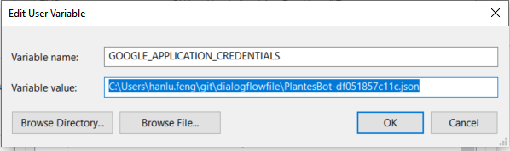

1. Set projectId, texts ,sessionId and lanuageCode follow [instruction](https://cloud.google.com/dialogflow/docs/quick/api).
2. Restart PC
3. Download the Server code and run it

