- Problems
- Generate small datasets of 2D feature vectors that the class are linearly separately and not separately. .
- Implement a linear SVM with hard margin with the data.
- Develop the expression of the dual L_{D}
- Implement at linear SVM with soft margin with the data.
- Implement a kernel-based SVM using polynomial and Gaussian kernel functions.
- Test the result when one of the class has substantially more examples.
- Solutions
- Create Three different datasets, one is linearly separately,the second is not linearly separately, the third one(substantially more examples) based on the second but have more examples in one class.
- Create Hard Margin Support Vector machine function based on the definition of soft support vector and formula in Implementation 3, to get the python function of support vector.
- Create Soft Margin Support Vector machine function based on the definition of hard support vector and formula in implementation 3, to get the python function of hard margin support vector.
- Test the third dataset and compare the result with the second dataset.
- Implementation
Soft Vector Machine(Hard-Margin)
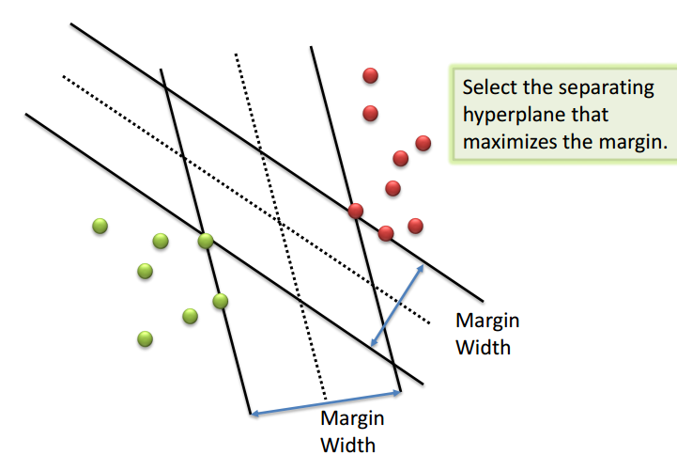

We try to get the maximum hard margin between two class.
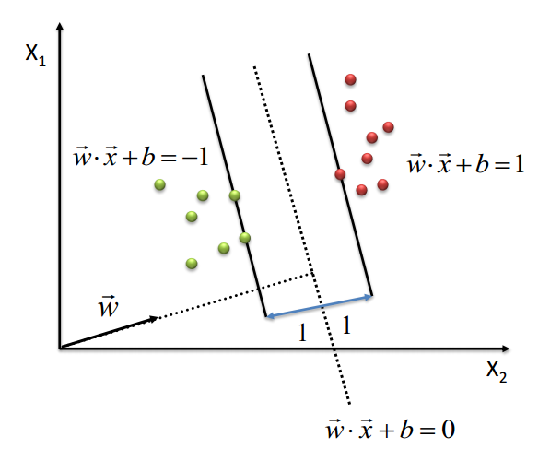
In this graph, constraint is
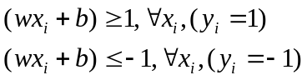
The width
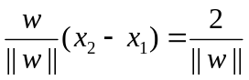
So we get Primal function
min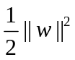
And get the minimize function:
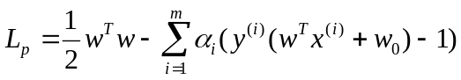
Soft Vector Machine(Soft-Margin)
Soft margin is that part vectors of the class are in the other class side as follows.
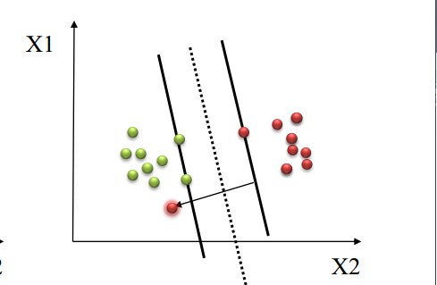

The constraints is :
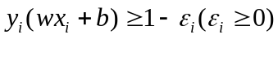
Primal function is
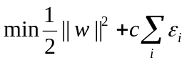
We get minimize function:
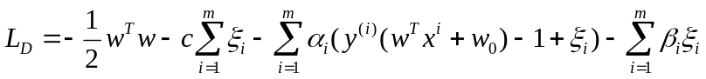
The support vector is the vectors that is on the margin
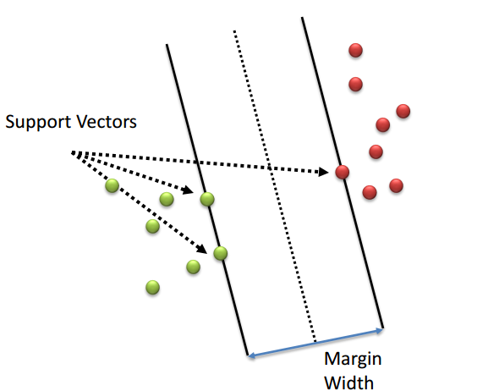
- Result and discussion.
Primal objective function of soft margins SVM is
Depends on the differential equation:
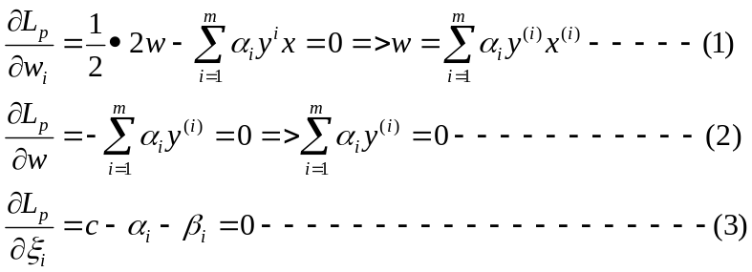
We put (1),(2),(3) in L_{D}, then we get
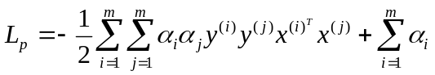
User linear-based hard margin SVM, we draw the two class and Support Vector(“Red” vectors is class A,”Blue” vectors is class B,”Yellow” vectors is support Vectors)
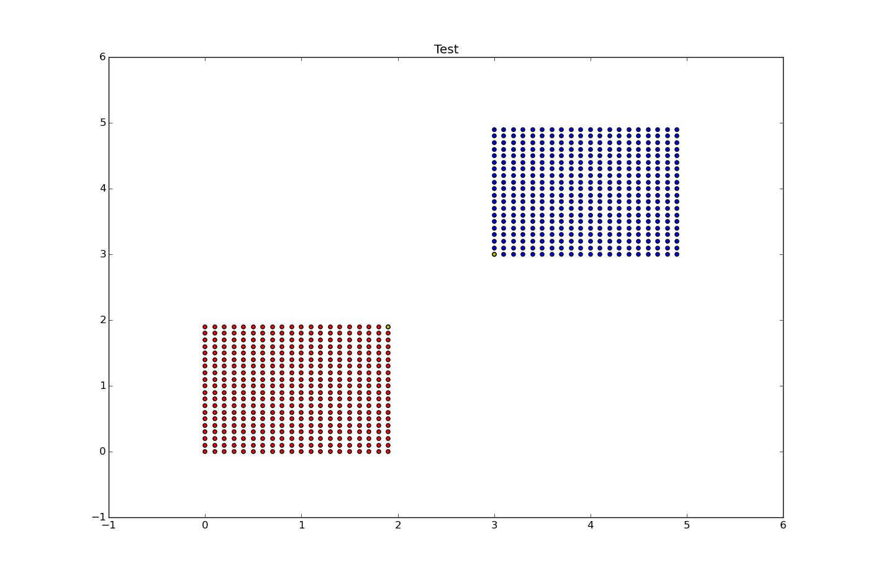
User Gaussian-kernel based SVM, we draw the two class and Support Vector(“Red” vectors is class A,”Blue” vectors is class B,”Yellow” vectors is support Vectors)
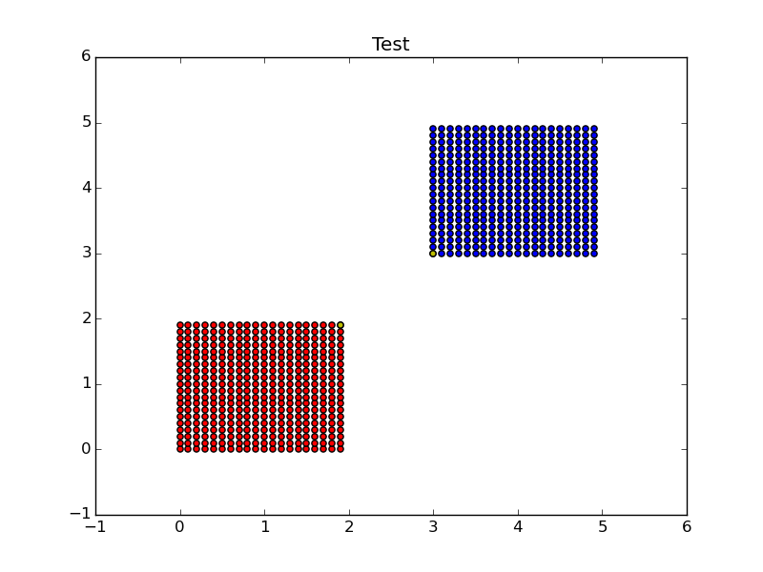
User Polynomial-based kernel SVM, we draw the two class and Support Vector(“Red” vectors is class A,”Blue” vectors is class B,”Yellow” vectors is support Vectors)
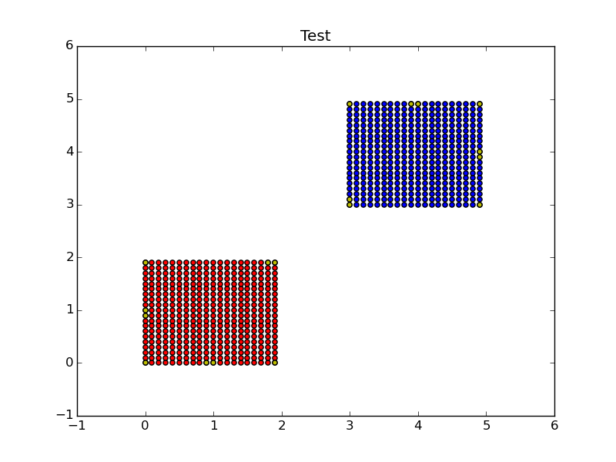

Let class B has more examples and then use linear based hard margin SVM, we draw the two class and Support Vector(“Red” vectors is class A,”Blue” vectors is class B,”Yellow” vectors is support Vectors)
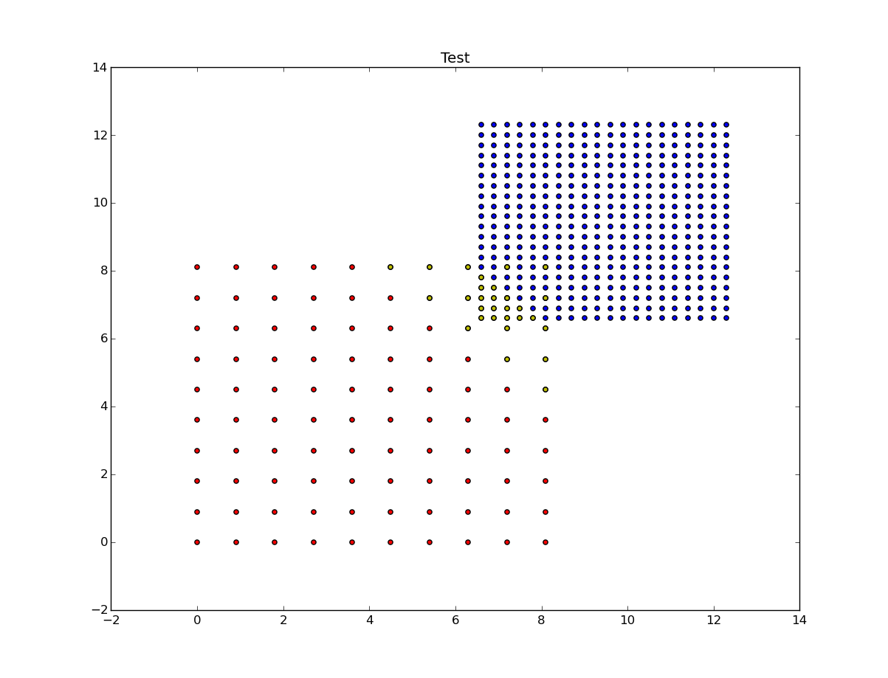

User linear-based soft margin SVM, we draw the two class and Support Vector(“Red” vectors is class A,”Blue” vectors is class B,”Yellow” vectors is support Vectors)
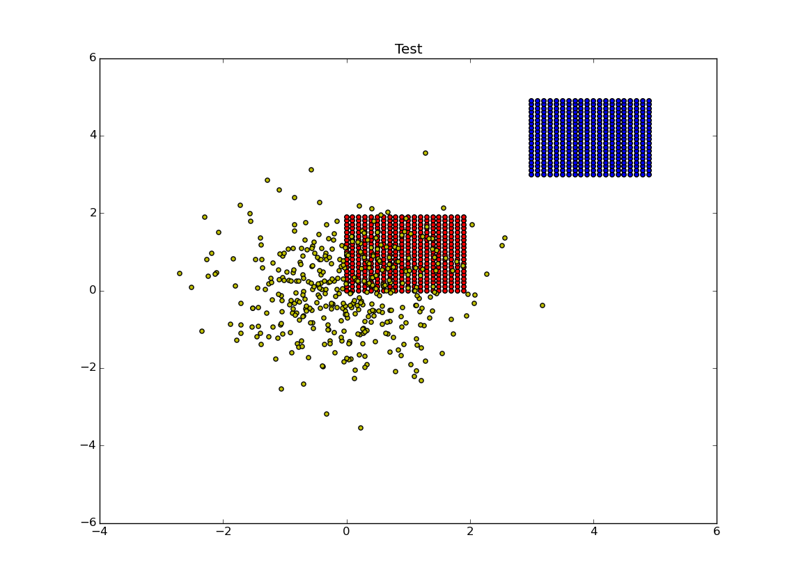
- Reference
Elements ofStatistical Learning (Second Edition )
http://tullo.ch/articles/svm-py/

