Function:
- Consume the following JSON feed: http://s3.amazonaws.com/jon-hancock-phunware/nflapi-static.json
- App is a master/detail type app
  - ListView that shows all the venues, and then show the details of a venue when tapped.
- Use 3rd party libraries “Gson” and “AQuery”
- Run on both handset devices and larger Android devices such as 7” or 10” tablets.
- Work on Android 2.3+
- Each Venue may or may not have an image associated with it.
  - For the ones that do, load the image appropriately and display it to the user according to the wireframes. (These images are available online with full links in the JSON feed.)
- Each Venue may or may not have schedule information associated with it.
- All schedule times are in GMT, and it represented in the user’s timezone.
- When the share button is pressed, the share text should be composed of the current venue’s name and address.

Sample Venue Data

{
"zip": "70130",
"phone": "(504) 582-3000",
"ticket_link": "http://www.nfl.com/superbowl/47/events/nfl-experience",
"state": "LA ",
"pcode": 10,
"city": "New Orleans",
"id": 16150,
"tollfreephone": "(555) 555-5555",
"schedule": [
{
"end_date": "2013-01-30 20:00:00 -0800",
"start_date": "2013-01-30 13:00:00 -0800"
},
{
"end_date": "2013-01-31 20:00:00 -0800",
"start_date": "2013-01-31 08:00:00 -0800"
}
],
"address": "900 Convention Center Blvd",
"image_url": "http://lorempixel.com/900/500/city/",
"description": "",
"name": "Verizon Training Ground @ NFL Experience",
"longitude": -90.064287,
"latitude": 29.941511
}

HandSet Home ScreenShot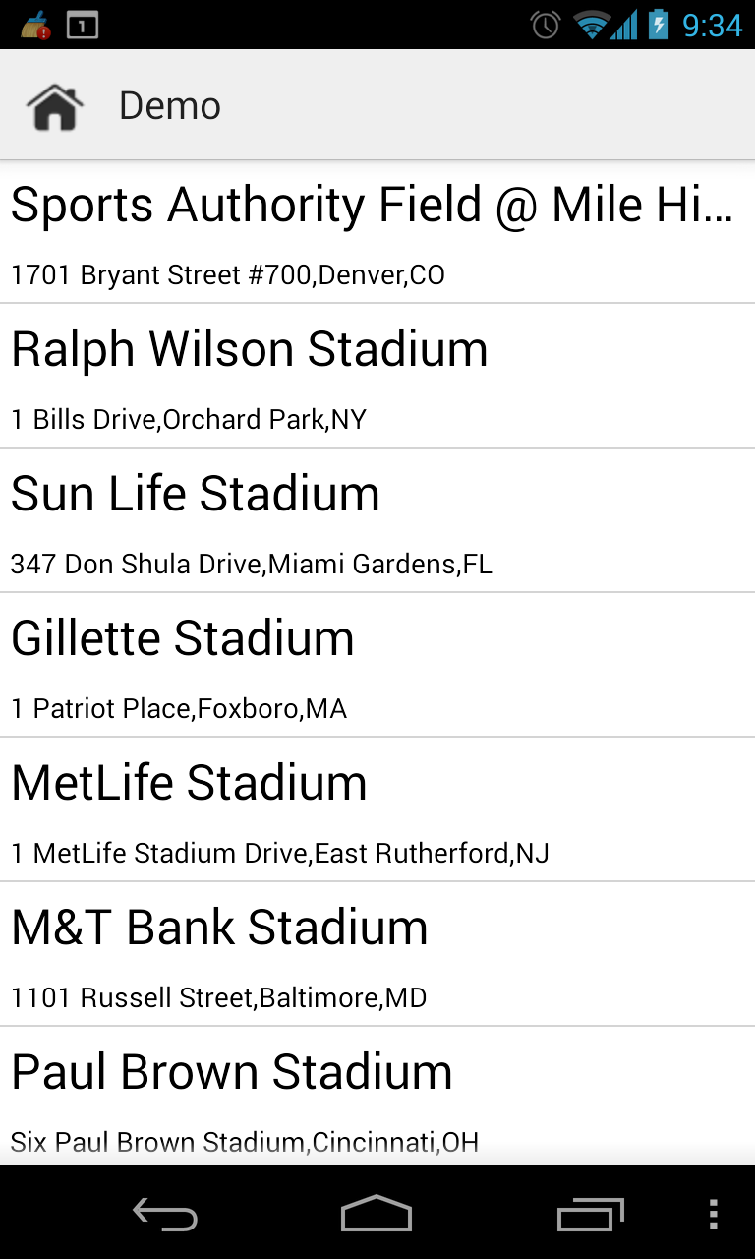

HandSet Detail ScreenShot
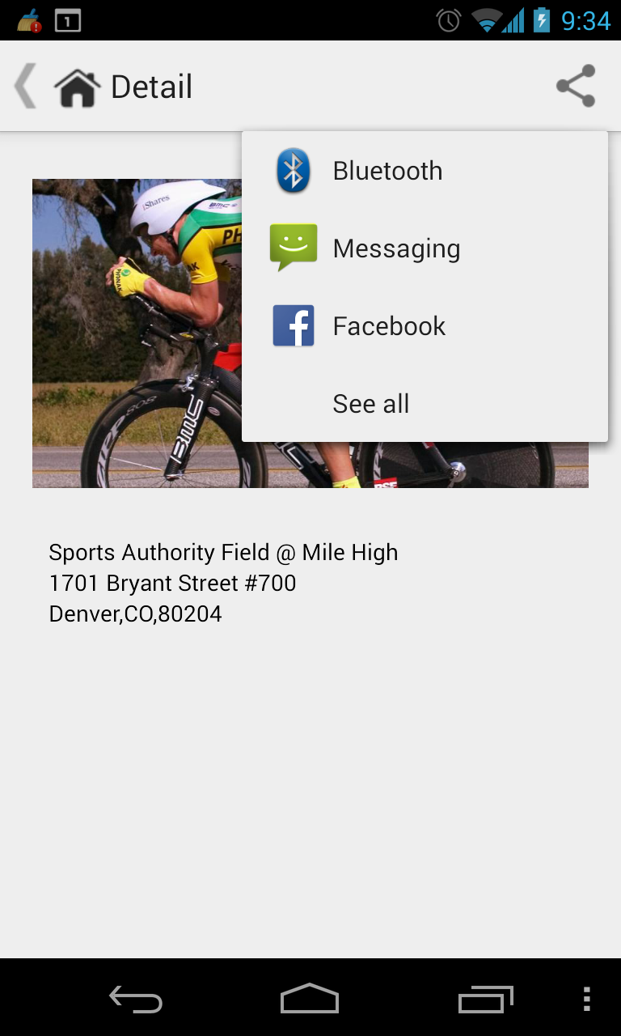

Tablet ScreenShot
