MovementTracking
In project movement tracking ,we calculate steps , strides length(feet) and draw the movement. After you click the start button, the app will calculate the strides length and steps number. The screen shots as follows:
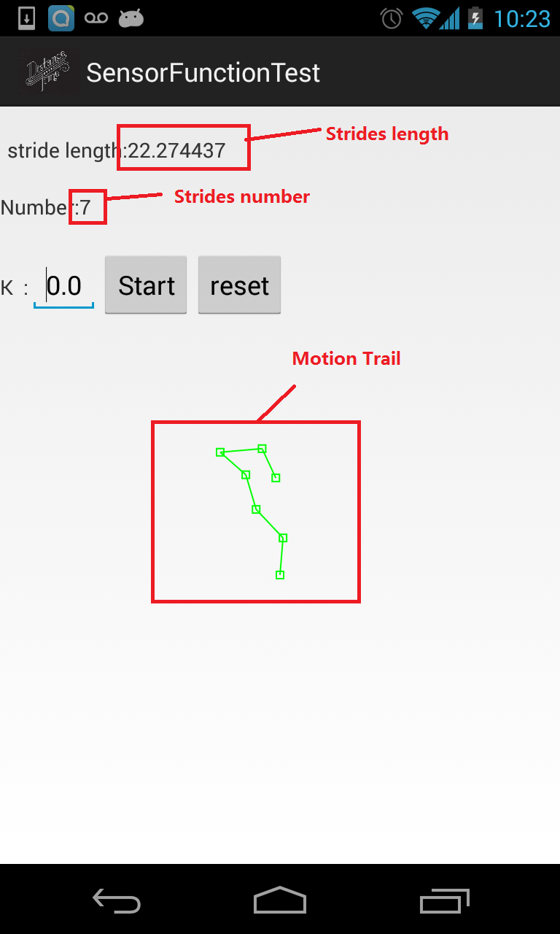
WiFiDirectDemo2
In the project we can connect two smart phone by WIFI direct. The the connected smart phone can share information by WIFI. The screen shot as follows:
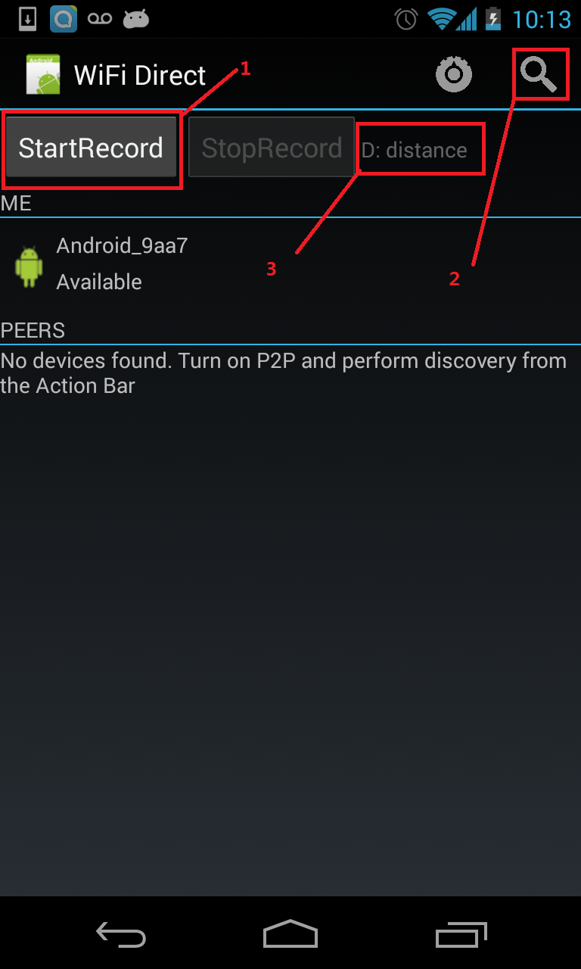
After you click button 2, you can find the devices that can peer with this smart phone.
After you click button 1, the smart phone will continually send signal with sample rate 44100, 2000HZ and duration 0.1s.
Because only 3000 samples will be calculated in 3s. So currently we can’t the distance. Because the smart phone will die if it keep on working at the background.

