Friends Prediction Based on User’s Features
- Topic Introduction
We try to create a friends prediction based on users’ feature. In our system we can predict which person will have more friends or followers in the future. We believe that users’ features can influence his social network and then influence their friends.
There are many algorithm that can help to make a recommendation system. In order to build a good recommendation system, we need to know a lot of users’ information to create a user graph. And by analysing the graph, we can get a good recommendation system. However, depends on the information limitation, we can just get a tiny information from the internet that is far from enough to make a recommendation system. Besides for the brand new users, it is hard for us to get information from them.
In our system, it is especially useful for brand new user. Even we just have a few features, we try to predict his followers in the future. We believe that features show user’s identity, occupation ,nationality,etc. All of this will influence his relationship in social network.There are a few examples we used in our research:
- Localization influence the number of friends. In China and some countries, their is a few people who have Facebook and twitter accounts. And most of these people’s friends don’t have Facebook or twitter accounts. Even they do, most of the accounts are not active. So we think the localization can influence the number of friends.
- Age is another important factor. Different ages have different habits. It is very hard for 70 or 10 years people to use Facebook or twitter. Because Facebook and twitter just built in recently 10 years. And too old or too young are obviously hard to use it.
- Identity is very important in social network. Most of the time celebrities have more friends or followers(in twitter). Just like “Justin Bieber”, “Beyonce” and “Taylor Swift”, they have a very big influence(Justin Bieber has 57.2M followers). Senator Dick Durbin has 47.9 followers. So we believe has identity is an very important factors that can influence friends number.
- Language play an very important rule in social network. The people who can speak English may have more friends that who can only speak Cantonese. And the people who can speak several languages is easier to have more friends the people who can only speak one language.
- Description is another very important factors that can’t be ignored. Actually, most of the time, description reflect the characters of the users. Or it is popular news. Because description can show users’ underly information, we think description is very important.
- Verification is very important. Users would like to know the real information rather than fake one. Verified celebrities obviously has more influence than unverified.
- Time Zone can reflect the geographic information which is very important in social network.
- Profile image is a very important factors in social network. Good profile in most instances has a good influence in social network.
- Contribution can show the active degree of the users account. It is very important to show his role or the relationship in social network. We think it is very important for the social network analysis.
- Gender is a very important factors in every social network. It is an features that can’t ignored in our research.
Above all are just part of the features we used in our project. Actually we have more factors that have to use such as: “follow request”, “default profile image”, “profile color”,etc. We try to find the relationship between the features and friends number.
- Data
In our project our data comes from “Twitter”and “Stanford University”. We try to compare the result of different data to get our conclusion.
The data of “Stanford University” is in data folder.
We created a database to store the information that get from twitter. And we user several twitter account to collect the data at the same time.This is the screen shot of our database.(The data is in “MACHINELEARNING_USERSHORTINF.sql”).
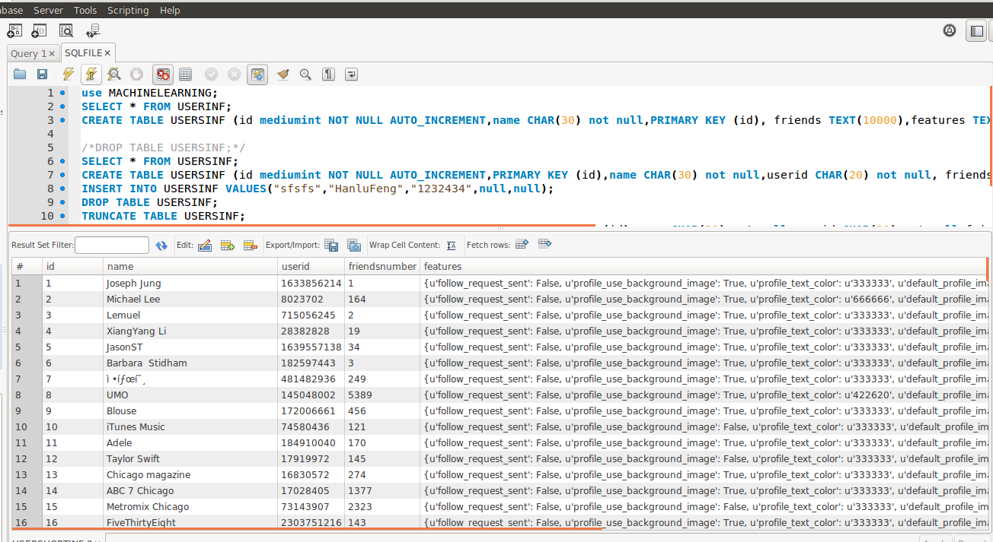

The tweeter api is:
https://api.twitter.com/1.1/friends/list.json
The information format is:
{
"profile_sidebar_fill_color": "252429",
"profile_sidebar_border_color": "181A1E",
"profile_background_tile": false,
"name": "Sylvain Carle",
"profile_image_url":"http://a0.twimg.com/profile_images/2838630046/4b82e286a659fae310012520f4f756bb_normal.png",
"created_at": "Thu Jan 18 00:10:45 +0000 2007",
"location": "San Francisco",
"follow_request_sent": false,
"profile_link_color": "2FC2EF",
"is_translator": false,
"id_str": "657693",
"default_profile": false,
"contributors_enabled": true,
"favourites_count": 1973,
"url": "http://afroginthevalley.com/",
"profile_banner_url":"https://si0.twimg.com/profile_banners/657693/1353537845",
"profile_image_url_https":"https://si0.twimg.com/profile_images/2838630046/4b82e286a659fae310012520f4f756bb_normal.png",
"utc_offset": -18000,
"id": 657693,
"profile_use_background_image": true,
"listed_count": 324,
"profile_text_color": "666666",
"lang": "en",
"followers_count": 4993,
"protected": false,
"notifications": false,
"profile_background_image_url_https":"https://si0.twimg.com/images/themes/theme9/bg.gif",
"profile_background_color": "1A1B1F",
"verified": false,
"geo_enabled": true,
"time_zone": "Eastern Time (US & Canada)",
"description": "Developer Advocate at Twitter.\r\n\r\nInternet, opensource, media & geo/local geek.\r\n\r\nFollow @sylvain for LANG=FR.",
"default_profile_image": false,
"profile_background_image_url":"http://a0.twimg.com/images/themes/theme9/bg.gif",
"statuses_count": 8504,
"friends_count": 2743,
"following": true,
"screen_name": "froginthevalley"
},

- Data Processing
DATA PREPARATION
- Data Quantity: We crawler 5773 users and there basic profiles from twitter.
- Data Type: It is json, but it convert to string after stored in database.
- Object: We want to create a csv file which contains all the users and their features in it. The columns are the features and the rows are the users. And the last feature is the number of this user’s friends.
After we select all the data from database, the features are stored in string type.
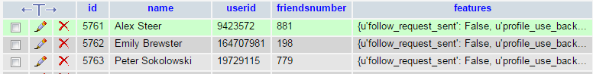

These users may have different numbers of features, and the features they have may distinct too.
We considered two approaches to reach this object.
First is use Python’s Json library to convert string to json. And add every feature to the columns if it doesn’t exist in csv file. Use this approach we can add all the features to the csv file, but it will be a sparse matrix. We want to remove some useless features by hand.
The second way is to code a program which will iterate all the features twice. The first time, it gets every feature, if this feature is in the csv file’s columns, it will continue. If it doesn’t it will ask user if input this feature into csv file. So we can handle which feature we want ourselves. Then we can get the titles of features.
On the second time, the program will add all the value of each user’s features to the csv file. If user has this feature, all the value to the csv file, if not, leaves this feature blank.
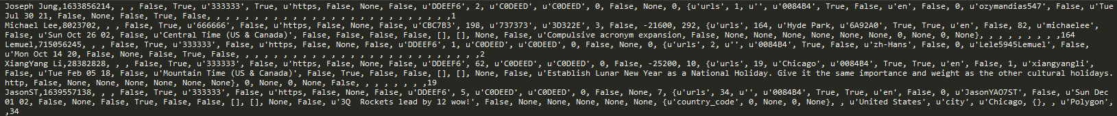

- Data Analysis：
DATA PREPROCESS
Actually, not every kind of data is useful for our data mining process, and there also exist some good valuable data to be joined in. So we need to preprocess to make data better for our project and here is a list and operation for these data:
First, here is all the operations and examples:
- Delete:
- Take it as grand truth, make it to 2 categories: LOTS(Top 10% largest value will be defined as lots), FEW(The other 90%)
- For those data with default value, we add a new feature “DEFAULT OR NOT” instead the old one
- For those data about time or date, we make it into 3 categories in hours: MORNING, NOON, NIGHT and 2 categories in days: WEEKDAYS, WEEKENDS
- Keep
- For those data with url data, we analysis from the format to consider if it is from Local or Internet, and make it into 2 categories: LOCAL, INTERNET
- For those data with city, we make into 2 categories: LARGE, SMALL
Then, a list of features with operation
Contributors_enabled: 5
Created_at: 4
Default_profile: 5
Default_profile_image: 5
Description: 5 (But we didn’t use it in our current work)
Favourites_count: 1
Follow_request_sent: 5
Following: 5
Followers_count: 2
Friends_count: 2
Geo_enabled: 5
ID: 1
Is_translator: 5
Lang: 5
Listed_count: 1
Location: 5
Username: 1
Notifications: 5
Profile_background_color: 3
Profile_background_img_url: 6
Profile_background_image_url_https: 6
Profile_background_tile: 5
Profile_banner_url: 3, 6
Profile_image_url: 6
Profile_image_url_https: 6
Profile_link_color: 3
Profile_sidebar_border_color: 3
Profile_sidebar_fill_color: 3
Profile_text_color: 3
Profile_use_background_image: 5
Protected: 5
Screen_name: 1
Show_all_inline_media: 5
Time_zone: 5
Url: 1
Utc_offset: 1
Verified: 1
Withheld_in_countri: 1
Withheld_scope: 1
Coordinates: 1
Current_user_retweet: 1
Favorite_count: 1
Favourited: 1
Filter_level: 5
Retweet_count: 1
Possibly_sensitive: 5
Country: 5
Country_code: 5
Place_type: 5
Truncated: 5
Full name: 7
And we need to delete all those records of public parties or organizations, we delete those records with over 1000 followers and reduce the size of the dataset from 5722 to 4246.

ANALYSIS
We chose Naïve Bayes as the classifier because of the highest accuracy among those classifiers we tested, including logistic regression (hard to implemented with Strings), linear regression (hard to implemented with Strings), Naïve Bayes, NBTree.
We use 10-folds-cross-validation to test the accuracy of our project.
Here is the confusion matrix as the result:
a b
- 272 | a = c2
- 153 | b = c1
The accuracy is 23.53%. (NBTree is only 21.39%)
It is seems this technique is useless with this low accuracy, but we still think it is useful. What this technique will benefit is to consider if a user will be have lots of followers in the future by using the profile information just after he/she create the account, companies are willing to keep these valuable users stay by using some strategies. Because of the low cost of the company to benefit those valuable users but these users will feed back high utility. Some of the current techniques using history information, even some side information to do the de-anonymous, only get 60% accuracy.
And also there are huge limitations of the dataset we can get from the networks. Lots of valuable features we can not get, for example: Age, Education. And only 5000+ records may not be good for our idea, it is too small for a social network.
Then, we use another dataset from Stanford Large Network Dataset Collection to do the same thing in order to see if it will get a better result, because they have 225 features which must be really nice.
Here is the confusion matrix:
a b
226 83 | a = c2
26 12 | b = c1
The accuracy is 68.59%. But we can see that the precision of B class which is LOTS class only has 12.6% as the precision, this is really bad for our problem. Only 347 record may be the problem. The learning can not well done with too few records.
But the accuracy is high, so it means we can really have lots of things to be improved in the future.

FUTURE WORK
The description of the user is really valuable, but we didn’t do the analysis of it. This may highly improve the accuracy.
And still another interesting point, because using only these kind of features seems not enough for a high precision and accuracy result, but we still want find out the valuable user with shortest latency. So it is interesting that if we can find out this shortest latency.

- Work Assignment：
Hanlu Feng is responsible for collecting data
ZhouXin Zhou is responsible for processing data to help data analysis.
XueSi Jian is responsible for analyzing data and get conclusion.
All of our three work together to determine topic, find research method, make Powerpoint and write report.

Reference:
http://www.statista.com/statistics/282087/number-of-monthly-active-twitter-users/
http://thenextweb.com/facebook/2014/01/29/facebook-passes-1-23-billion-monthly-active-users-945-million-mobile-users-757-million-daily-users/

