# day1, product value analysis

1. **brief introduce to meituan**

Meituan app is a mobile application launched by meituan.com, which integrates browsing, payment and consumption services. It can provide you with all kinds of discount and electronic exchange volume for gourmet, movie, hotel, KTV and tourism. All you have to do is to buy the goods you want and participate in the group purchase. As long as you gather enough people, you can buy the goods you want with the discount price and enjoy high-quality service. In addition, you can query the business information and so on. While you are simple and convenient, you can enjoy various safe and convenient group buying services.

1. **Elements of value**

* Functional

Functional elements are based on a product attribute thar provides the customer with functional utility.

* order online, no need to go to the restaurant. Just stay at home. —— simplifies 、 avoids hassles、 saves time
* Online group buying website——reduces effort
* including Eat, drink, play, have fun——variety，integrates
* Emotional

Emotional elements provide customers with a positive feeling when they purchase or use a particular product. they add richness and depth to the experience of owing and using the product.

* automatically recommend food for you——attractiveness
* buy medicine online——therapeutic value
* online mini-games ——Fun/entertainment

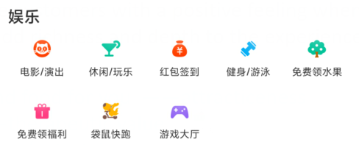

* Life change

Life changing elements provide shelter, food and transportation.

* MeiTuan mobike （摩拜单车）
* Meituan takeout
* Meituan taxi
* Meituan Hotel
* …

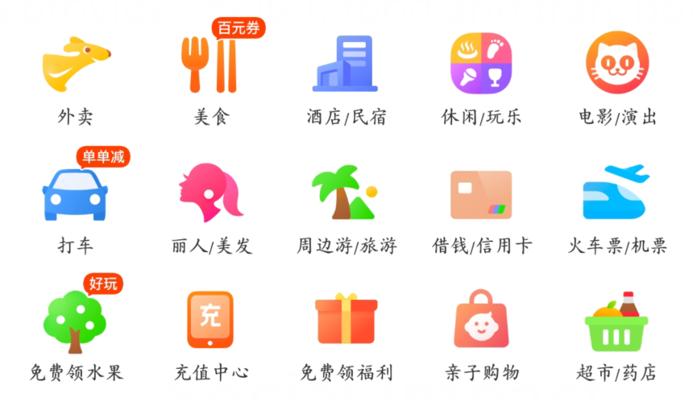

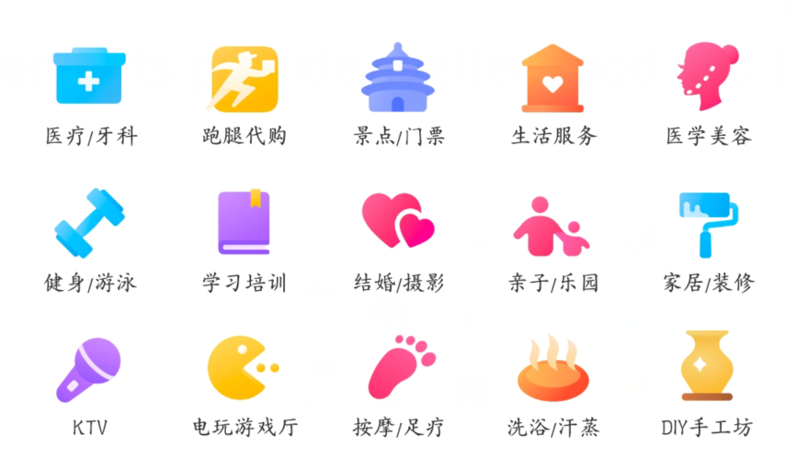

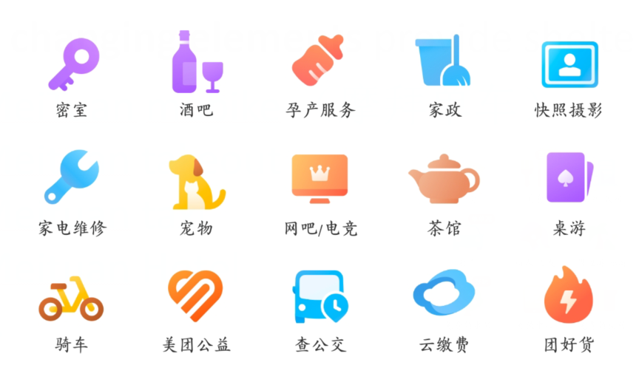

* Social impact

Social impact elements convey the sense of doing good for others and helping other people or society more broadly.

* During the outbreak of the new coronavirus, meituan had no contact with takeout, and delivered daily necessities free of charge in the disaster areas.

1. **Other elements which critical but missing or insufficiently delivered**

* besides the elements of value elements delivered by the selected product. I think the “Quality” is critical but missing. It's not sure that the product is of good quality when we buy it online.
* So all merchants on Meituan need to be examined strictly to guarantee quality.