HPC MC1 – Report

Introduction

Problem Statement
Stock prices change fast according to many external factors. One of them being marketing hype. News portals like Bloomberg, CNN as well as social media threads in reddit or X have valuable information to extract sentiment towards certain companies / their products. Positive sentiment might indicate a possible increase in stock market price and negative sentiment might indicate the opposite.

Proposed Solution
A solution could be an app that scrapes, analyses and evaluates the sentiment of the public / news of these companies and predicts the trend of the stock prices in the immediate future.

Part 1

Architecture & Design overview
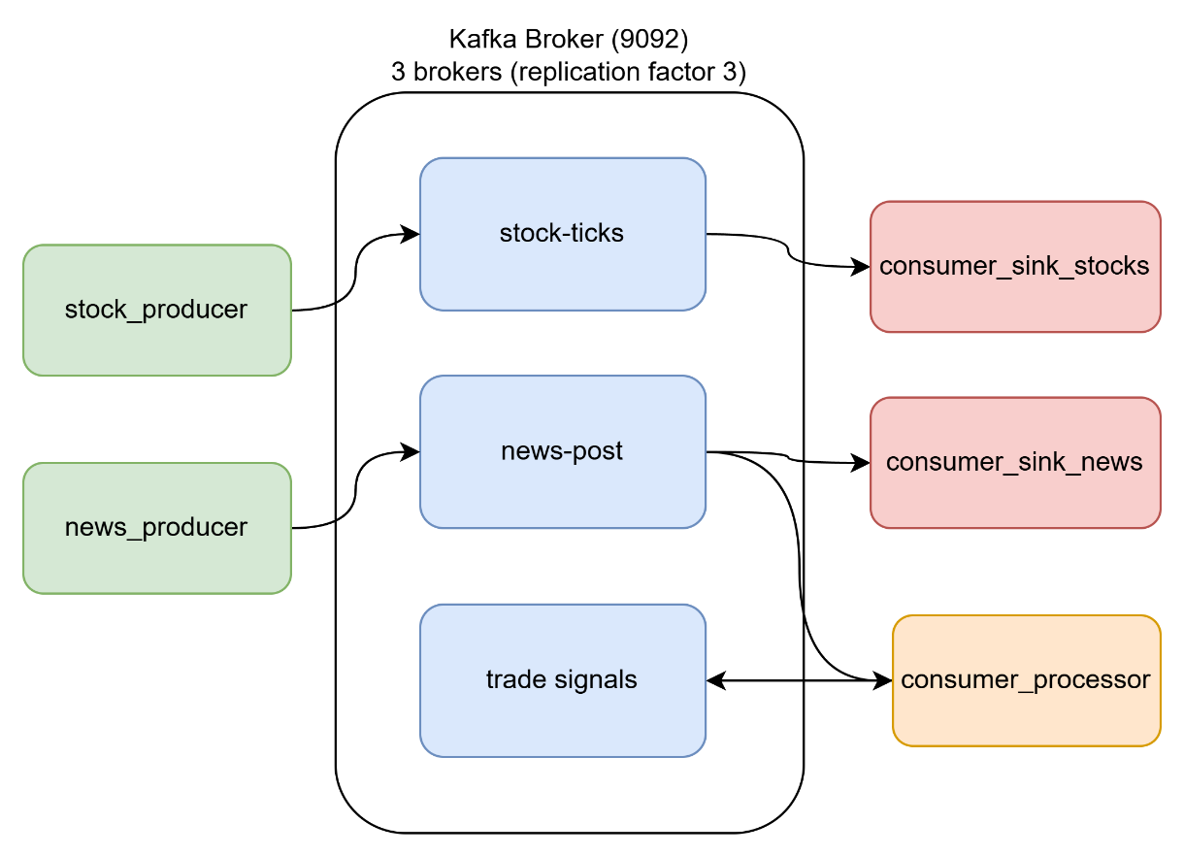

Stock_producer
docker-compose -f docker-compose-kafka.yaml --profile producers up stock-producer
- Simulates a live stock exchange feed.
- Generates price tick messages for 5 symbols at 10Hz with random jumps and writes to Kafka

News_producer
docker-compose -f docker-compose-kafka.yaml --profile producers up news-producer
- Simulates a news / social media feed
- Generates one post per second containing a stock symbol, sentiment hint, source and author and writes to Kafka

Consumer_processor
docker-compose -f docker-compose-kafka.yaml --profile consumers up consumer-processor
- Reads from Kafka and writes back to Kafka
- Reads news-posts, extracts stock symbols from tags field and publishes derived trade-signals message indicating BUY or SELL direction based on sentiment

Consumer_sink_[stock, news]
docker-compose -f docker-compose-kafka.yaml --profile consumers up consumer-sink-stocks consumer-sink-news
- Data sinks, read from topics and append rows to CSVs (disk)

Stock-ticks, news-posts, trade-signals
- Kafka topic for stock ticks
- Persistent for 7 days

Component Choice
Kafka was chosen because of the definition of the MC. Further more because the use case has assymetric producers and consumers. Stock ticks arrive at 10Hz but don’t need to be processed in lockstep with the slower news streams. Each consumer reads at its own pace without affecting others.
The split between processor consumer and sink consumers map to the requirement of the MC. One component that enriches / transforms data and re-inserts it, and two that persist data to disk. They can be started and stopped independently because of their seperation.
msgpack was chosen over JSON as the serializer (Bonus 1) because it is binary, smaller per message and faster to encode/decode.

Design decisions & requirements
- Put Topic names & servers in a config file for reusibility
- All scripts run in Jupyter container
- CSV sinks call flush() after every row to force immediate write to disk -> no data loss if process interrupted mid-run
- Libraries required:
  - Kafka-python
  - Msgpack

Kafka features used
- Consumer groups: Each consumer belongs to a named group. Both sinks are independant, so both groups receive every message on their topic. Processor is in a seperate group.
- Replication factor 3 set in docker compose: Every partition is replicated across all 3 brokers. -> Cluster tolerates one broker failure without data loss
- Kraft: Cluster uses new Kafka architecture. Each broker also akts as controller (no Zookeeper)
- Offset Earliest: Not too much data or heavy processing in stream, so it consumer crashes, we can stream all the data in the partitions

Docker Setup
- docker-compose-kafka.yaml defines all services in a single file
- 3 Kafka broker containers (kafka1, kafka2, kafka3): KRaft mode, no Zookeeper, replication factor 3
- Kafdrop: monitoring UI on port 9000
- Jupyter: interactive notebook environment on port 8888, mounts notebooks/ as volume (not used in my implementation)
- 5 Python services built from Dockerfile.app (python:3.11-slim + kafka-python + msgpack)
  - stock-producer, news-producer → profile producers
  - consumer-sink-stocks, consumer-sink-news, consumer-processor → profile consumers
- Docker Compose profiles: brokers always start, producers/consumers started selectively with --profile producers / --profile consumers
- wait_for_kafka() in every Python service: retries connection until brokers are ready, prevents crash-on-startup
- Named volume ./data:/app/data: CSV sink output persisted to host filesystem
- All services on the same Docker bridge network: inter-container communication via hostname (e.g. kafka1:9092)

Part 2

Consumer Groups
A consumer group is a way to have multiple consumers work together on the same topic. Kafka tracks each group's progress independently using offsets. Every group gets its own cursor into the topic log, so two groups reading the same topic never interfere with each other. Within a group, each partition is assigned to exactly one consumer, which is how Kafka distributes work across multiple instances.
This application already uses consumer groups in its normal setup: news-sink-group and signal-processor-group both read from the news-posts topic, but because they are separate groups each receives every message independently. The two experiments below explore the two main use cases for consumer groups: fan-out between independent groups, and load balancing within a single group.

Experiment 1: Fan out
Two consumers in different groups both receive every message. This is basically how my current setup already works (news-sink-group and signal-processor-group consume all messages from the news-post topic).
Two different consumers (instance-1 and instance-2) will run in different consumer groups (group-a & group-b). As expected, both receive all data from the topic stock-ticks, because they consume independently from each other.

Terminal 1
docker exec -it jupyter1 python consumers/consumer_group_demo.py group-a instance-1

Terminal 2
docker exec -it jupyter1 python consumers/consumer_group_demo.py group-b instance-2

Experiment 2: Load balancing (failure)
Now 2 consumers (instance-1 and instance-2) will run in tha same group (group-a) consuming messages from the same sink.
The output shows, that if 1 consumer is running, the other is blocked. The maximum parallelism within a consumer group is limitted by the number of partitions. Since there is only 1 partition in the stock-tick topic, only 1 consumer can receive all messages at the same time.
Since we have 1 partition, we cannot demonstrate load balancing effectively. The purpose of having 2 consumers in 1 group is so the consumers withing the group can process data from different partitions (same topic). This Load balancing can be effective, when used with partitioning, which we will discuss in the following section.

Terminal 1
docker exec -it jupyter1 python consumers/consumer_group_demo.py group-a instance-1

Terminal 2
docker exec -it jupyter1 python consumers/consumer_group_demo.py group-a instance-2

Partition counts & Replication factors
Two of the most important configuration decisions when creating a Kafka topic are the number of partitions and the replication factor.
Partitions are the unit of parallelism. A topic is split into one or more partitions, each of which is an independent ordered log. Within a consumer group, each partition is assigned to exactly one consumer, so the number of partitions sets a hard ceiling on how many consumers in the same group can work in parallel. One partition means one active consumer regardless of how many are running. Three partitions means up to three consumers can process data simultaneously.
Replication factor determines how many copies of each partition exist across the broker cluster. With replication factor 3 (like in our application), every partition is stored on all three brokers. If one broker fails, the other two still hold a complete copy and the cluster continues without data loss. One broker is always the leader for each partition: it handles all reads and writes while the others are followers that stay in sync.
Partitians affect throughput and parallelism, replication affects fault tolerance. The experiments below demonstrate both by creating topics with different configurations and observing how the cluster and consumers behave under each.

Experiment 1: Attempted Partition Parallelism
3 consumers run in the same group against topic stock-ticks-p3-r3. Each consumer gets assigned the same partition.

Terminal 1: producer
docker exec -it jupyter1 python producers/producer_experiment.py stock-ticks-p3-r3
Terminal 2,3,4: 3 consumers in same group
docker exec -it jupyter1 python consumers/consumer_group_demo.py group-p3 inst-1 stock-ticks-p3-r3
docker exec -it jupyter1 python consumers/consumer_group_demo.py group-p3 inst-2 stock-ticks-p3-r3
docker exec -it jupyter1 python consumers/consumer_group_demo.py group-p3 inst-3 stock-ticks-p3-r3
Because they are assigned to the same partition only one consumer gets assigned the partition (the first one). The others show an empty list as their assigned partitions:
But once you stop a consumer, one of the others takes over consuming the messages. This extends Experiment 2: Loadbalancing insight, that not only per topic, but also per partition multiple consumers in the same consumer group can’t access the same messages.

Experiment 2: Broker failure & replication
created a script (setup_topics.py) that creates topics with specific partition/replication configs so I can compare them. I created 3 versions of stock-ticks with different settings:
Topic | Partition | Replication Factor | Purpose
stock-ticks-p1-r1 | 1 | 1 | Baseline, no parallelism, no fault tolerance
stock-ticks-p3-r1 | 3 | 1 | Parallelism, no fault tolerance
stock-ticks-p3-r3 | 3 | 3 | Parallelism + fault tolerance

Terminal
docker exec -it jupyter1 python consumers/setup_topics.py

Partition details
The details show information about the topic. To note is the Leader Node for further experiments. This is assigned by kafka automatically across brokers. This partition contains the active stream of messages published by the producer, the others are synchronized replications of the leader node.

Terminal 1: produce to the replicated topic
docker exec -it jupyter1 python producers/producer_experiment.py stock-ticks-p3-r3

Terminal 2: consume (just watch it keep running)
docker exec -it jupyter1 python consumers/consumer_group_demo.py group-fault inst-1 stock-ticks-p3-r3
While producing to stock-ticks-p3-r3, I stop one broker (e.g. docker stop kafka2) and observe in Kafdrop that the cluster elects new partition leaders and keeps running.

Then in Docker Desktop (or CLI):
docker stop kafka2

stock-ticks-p3-r3 – before dropping kafka2
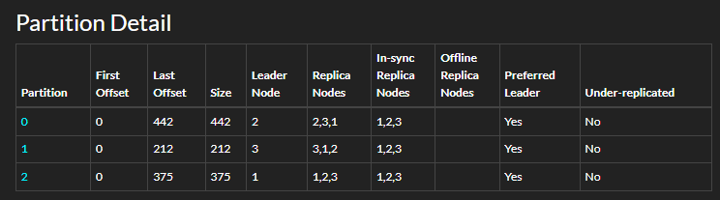
In Kafdrop, before stopping a broker, note the leader for each partition above. After stopping, Kafka elects a new leader from the replicas (3). The consumer log shows no gap.

stock-ticks-p3-r3 – after dropping kafka2
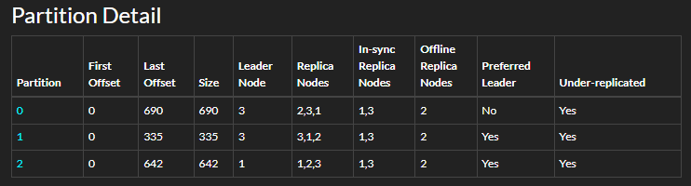
Then I try the same with stock-ticks-p1-r1. if that partition's only broker dies, the topic becomes unavailable. This shows why replication factor matters.

stock-ticks-p1-r1 – before dropping kafka2


stock-ticks-p1-r1 – after dropping kafka2
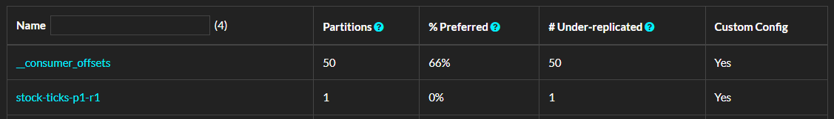
% Prefered Leader is 0, since there is no kafka 2 anymore and there was no replication for this topic.

Experiment 3: Consumer Group and Partitions
I run 3 consumers in the same group against stock-ticks-p3-r3. Each gets assigned exactly 1 partition.

Terminal 1: producer on the 3-partition topic
docker exec -it jupyter1 python producers/producer_experiment.py stock-ticks-p3-r3

Terminals 2, 3, 4: 3 consumers, same group
docker exec -it jupyter1 python consumers/consumer_group_demo.py group-p3 inst-1 stock-ticks-p3-r3
docker exec -it jupyter1 python consumers/consumer_group_demo.py group-p3 inst-2 stock-ticks-p3-r3
docker exec -it jupyter1 python consumers/consumer_group_demo.py group-p3 inst-3 stock-ticks-p3-r3
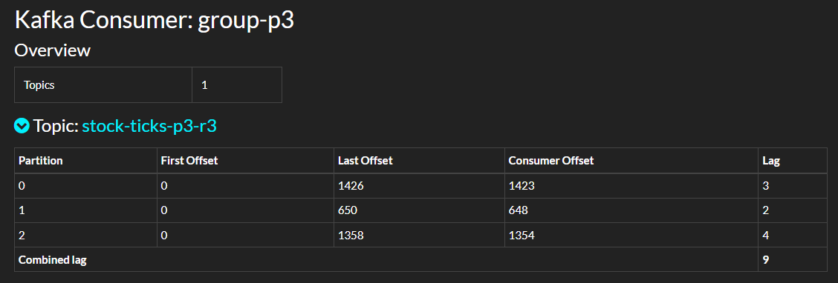
We see how now each consumer in the group has its own partition assigned, and therefore the message stream is consumed in parallel.
The differences in partition sizes is explained by the chosen key for the partitioning defined by the producer (Symbol). Here, the same symbol goes to the same partition.

Part 3

Architecture & Design overview
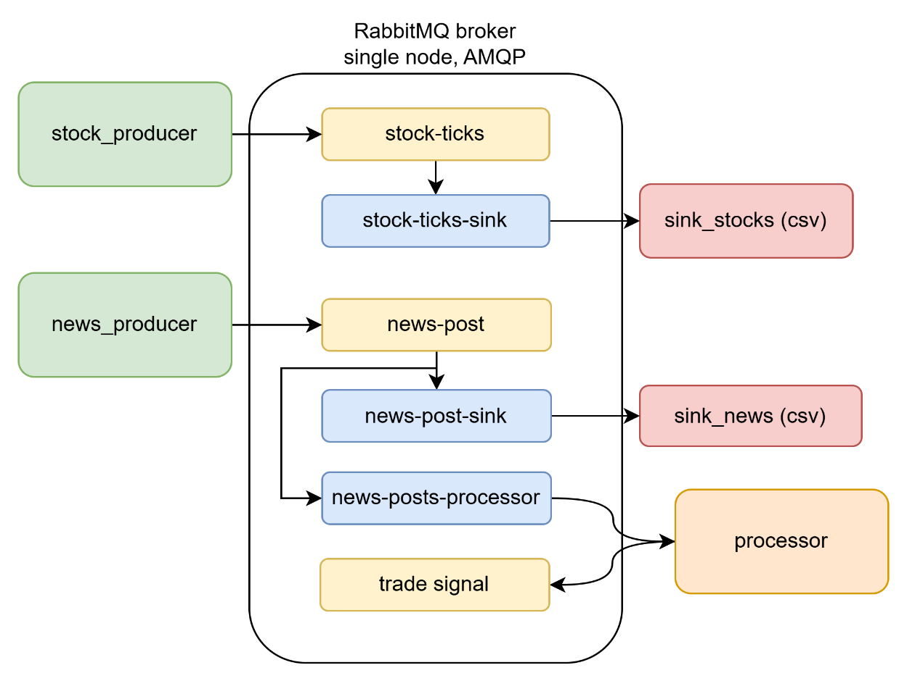
The stock producer publishes 10 messages per second to the stock-ticks fanout exchange. Because there is only one consumer for stock ticks (sink_stocks), there is exactly one bound queue (stock-ticks-sink), therefore this exchange could also have the type topic instead of fanout. The exchange copies every message into that queue, and sink_stocks pulls each one, appends a row to CSV, and calls basic_ack. Once acknowledged, the message is deleted.
The news producer publishes 1 message per second to news-posts. This exchange has 2 bound queues: news-posts-sink and news-posts-processor. The fanout exchange copies every news message into both simultaneously. This is what enables the sink and the processor to each receive the full stream independently, without any coordination. sink_news writes to CSV: the processor reads the same message, derives a BUY/SELL signal, and publishes it to the trade-signals exchange. From there it lands in whatever queue is bound to that exchange (extensible for any downstream consumer).

Communication patterns
Exchanges
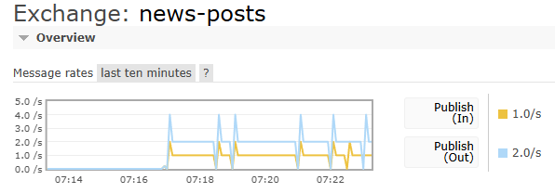
The chart shows Publish In at 1.0/s (yellow) and Publish Out at 2.0/s (blue). The 1.0/s in rate matches exactly the news producer's configured rate of one message per second. The 2.0/s out rate is twice the in rate because the fanout exchange copies every incoming message into two queues simultaneously: news-posts-sink and news-posts-processor. This directly confirms that the fanout routing is working correctly: one published message becomes two delivered messages.
The periodic spikes visible in the chart (up to 4–5/s) correspond to brief bursts when the producer publishes slightly faster than the 1Hz. I cannot explain why that might happen.

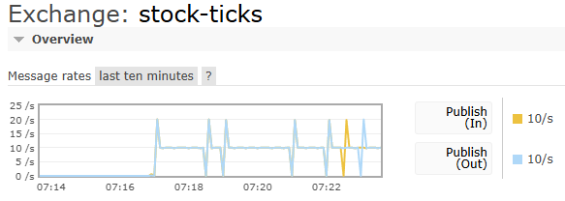
Publish In and Publish Out are both at 10/s, matching the stock producer's 10Hz rate exactly. Unlike the news exchange, there is only one bound queue (stock-ticks-sink), so in and out rates are equal. The spikes to 20/s here are similar to the ones before.
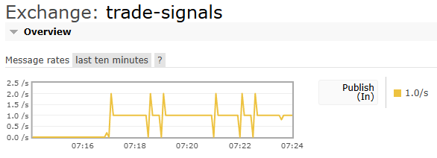
Publish In at 1.0/s with no Publish Out shown. This exchange receives one trade signal per second from the processor consumer. One signal per news post, since each news post contains exactly one stock symbol tag. There is currently no consumer bound to this exchange (no sink for trade signals is implemented), which is why there is no Publish Out line. Messages published here are not queued anywhere and are discarded by the broker. This is expected behaviour for the current implementation.
Queues
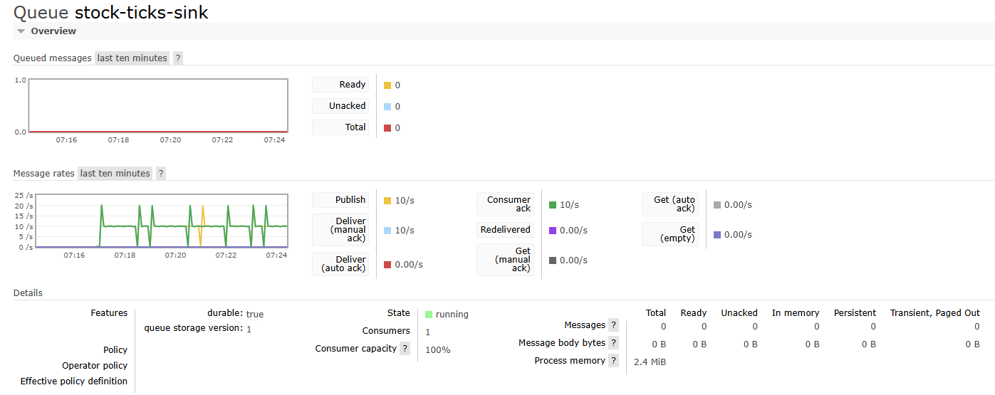
The queued messages chart shows a flat line at zero throughout the entire observation window. Ready, Unacked, Total: 0. The message rates show Publish and Deliver (manual ack) both at 10/s. Consumer capacity is 100%. This means the rmq-sink-stocks consumer is keeping up perfectly with the 10Hz producer. Every message is consumed and acknowledged immediately, with zero backlog. The queue never builds up.
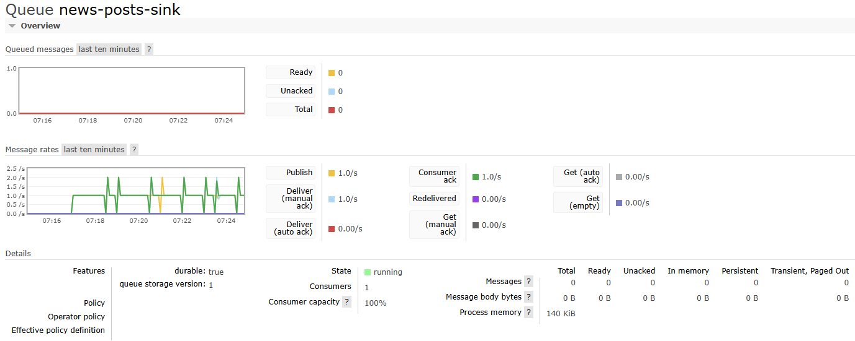
Queued messages at zero, Publish and Consumer ack both at 1.0/s, Consumer capacity 100%. The news sink also keeps up perfectly with the 1Hz producer. The queue depth never grows.
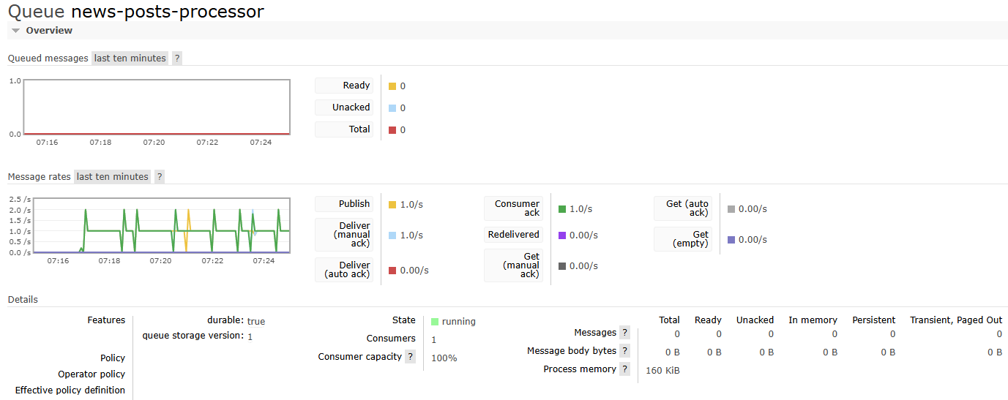

Why are they similar (Kafka & RabbitMQ)
Both are broker-based pub/sub systems: producers and consumers don't know about each other, multiple consumers can receive the same stream independently, and both support message persistence and delivery acknowledgment. The business logic in Parts 1 and 3 is nearly identical, only the broker API changed.

Core Differences
Kafka is meant for stream processing. It enables high throughput of messages and is by design fan-out. Meanwhile RabbitMQ is a traditional message queue system ideal for moderate data volumes. We can see in the architecture for RabbitMQ, had to create seperate queues for the processor and the sink_news, whereas in the kafka architecture the consumers consume the messages from the same topic.
RabbitMQ enables complex message routing, where messages are intended for one specific consumer.
Kafka is a distributed commit log. Messages are written to disk and stay there regardless of whether anyone has read them. Consumers track their own position (offset) in the log and can replay history by resetting it. The broker is passive storage.
RabbitMQ is a message queue. A message exists until one consumer acknowledges it, then it's deleted forever. There's no offset, no log, no replay. The broker actively pushes messages to consumers and handles all routing logic.
In Kafka the message routing is done by the producer. The producers define the properties of messages, which define their route (including which partition). In RabbitMQ the routing happens in the exchange. The exchange routs messages based on properties of the queues. These exchanges can also be used to duplicate messages in multiple queues, simulating kafkas built in fan-out approach (like I did).

Scalability
Kafka scales by adding brokers and increasing partition counts. More partitions = more parallel consumers. My 3-broker setup already tolerates one broker failure with no data loss. To handle 10x more stock ticks, I have to create the topic with 10 partitions, run 10 sink instances. The main challenge is planning partition counts upfront, since reducing them later is not ideal.
RabbitMQ scales consumer throughput easily by adding more consumers to the same queue and the broker round-robins delivery automatically, no configuration needed. Scaling the broker itself is harder: all messages for one queue pass through one process on one node, so there's no clean equivalent to Kafka's "add a partition."
For this application (11 messages/s) RabbitMQ is more than sufficient and far simpler to run. Kafka becomes the better choice if the system scaled to hundreds of symbols with real market feeds, where replay and high throughput would matter.

Part 4

Setup
Three profiling scripts were written and executed. Each measures a different component in isolation:
- profile_stock_producer.py: Kafka stock producer, 5 runs × 500 messages
- profile_stock_producer_rmq.py: RabbitMQ stock producer, 5 runs × 500 messages
- profile_consumer_sink.py: consumer sink loop, 10,000 iterations
All timing is captured with time.perf_counter() per loop iteration. cProfile was used to generate .prof files visualized with SnakeViz.

Experiment 1: Producer Loop Timing: Kafka vs RabbitMQ
Method: Run the producer loop 500 times per run, 5 runs, no sleep(). Measure wall time per iteration in milliseconds.
 | Run 1 | Run 2 | Run 3 | Run 4 | Run 5 | Mean | Stdev
Kafka | 0.448 ms | 0.020 ms | 0.024 ms | 0.021 ms | 0.024 ms | 0.107 ms | 4.313 ms
RabbitMQ | 0.075 ms | 0.073 ms | 0.065 ms | 0.064 ms | 0.068 ms | 0.029 ms | 0.700 ms

The most important pattern in the Kafka results is the warm-up effect in Run 1. The first run's mean of 0.448ms is roughly 20× higher than runs 2–5 (~0.022ms). On the first send() call, the Kafka client performs a metadata fetch from the broker. It discovers which topics exist, which partitions they have, and which broker is the leader. This blocks the calling thread until complete. Once cached, all subsequent calls skip this entirely, which is why runs 2–5 are nearly identical and very fast.
RabbitMQ shows no warm-up effect at all. All five runs are within 0.011ms of each other (0.064–0.075ms). The connection is established once before the loop, so every basic_publish call pays the same cost each time. Interestingly, in this run RabbitMQ's warmed-up mean (0.069ms) is actually slightly faster than Kafka's (0.107ms overall, pulled up by Run 1). Once Kafka is warmed up its per-call cost of ~0.022ms is faster, but the overall mean is distorted by the cold start. Kafka's producer is faster per call because it is asynchronous and batches internally. RabbitMQ's producer pays a small but consistent per-call network cost.

Experiment 2: cProfile: Where Does Time Actually Go?
Kafka Producer Profile
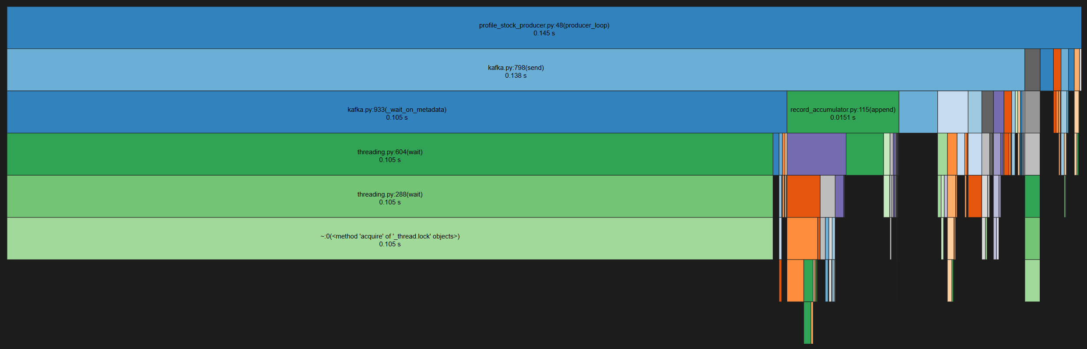
The SnakeViz icicle shows producer_loop (0.145s total) calling kafka.py:send (0.138s), which immediately calls _wait_on_metadata (0.105s), which drops into threading.wait → threading.288:wait → _thread.lock.acquire (all 0.105s).
The metadata wait dominates — it accounts for 72% of the entire profiled time. On the right side of the chart, record_accumulator.append (0.0151s) represents the actual work of adding a message to the in-memory batch buffer, which is negligible in comparison.
Most time consuming functions in the profile are:
- _thread.lock.acquire: Blocks waiting for metadata from broker
- kafka.py:_wait_on_metadata: Triggers and awaits the metadata fetch
- kafka.py:send: Top-level send, most time spent in metadata wait
RabbitMQ Producer Profile
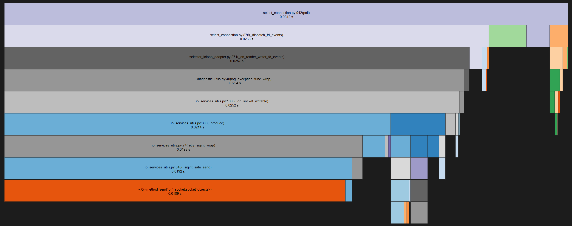
The icicle shows producer_loop (0.0646s) split into the outbound write path. basic_publish (0.0559s) → _flush_output (0.0368s) → select_connection.poll (0.0314s) → _dispatch_fd_events (0.0268s) → io_services_utils.on_socket_writable (0.0252s). The right branch shows channel.basic_publish (0.0186s) → _send_method (0.0177s) handling AMQP framing.
The three most time-consuming functions in the RabbitMQ profile:
- select_connection.poll: Polls socket for writability
- _flush_output: Writes buffered bytes to TCP socket
- blocking_connection.basic_publish: Entire publish call including socket I/O
The dominant cost is socket I/O, not message construction or serialization.

Experiment 3: cProfile: Consumer Sink: Deserialization vs Full Callback
This experiment measures two things separately: deserialization cost in isolation, and the full sink callback cost including file I/O.
Deserialization only (msgpack vs JSON):
 | Mean | Stdev | Total (10k msgs)
msgpack | 0.0006 ms | 0.0006 ms | 5.86 ms
JSON | 0.0013 ms | 0.0007 ms | 12.71 ms
speedup | 2.17x |  | saves 6.85ms per 10k msgs

JSON Consumer profile:
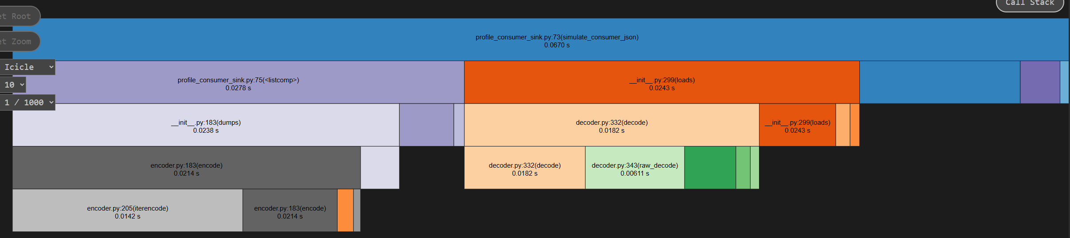

Msgpack Consumer profile:
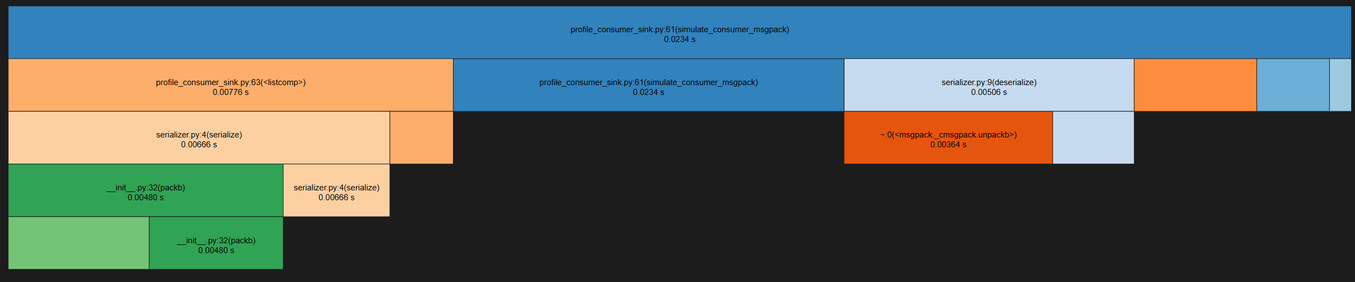
This confirms that deserialization is fast. serialize (0.00666s) and deserialize (0.00506s) together account for only half the total profile time of simulate_consumer_msgpack (0.0234s), with list comprehension overhead making up most of the rest.
The full callback measurement reveals a much more significant finding. Deserialization alone costs 0.0006ms per message. The full callback, which adds file open, CSV write, and f.flush(), costs 0.0167ms per message. That means file I/O adds approximately 0.0161ms per message, making it 27x more expensive than deserialization.
Full sink callback (deserialize + file open + CSV write + flush):
 | Mean | Stdev | Total (10k msgs)
Per-message flush (production) | 0.0167 ms | 0.0078 ms | 166.64 ms
Batched flush (100 msgs, mitigation) | 0.0022 ms | 0.0160 ms | 22.31 ms
Speedup | 7.47x

Switching to batched writes (flush every 100 messages instead of every 1) reduces the mean callback time from 0.0167ms to 0.0022ms. That is a 7.47× speedup. At the application's normal rate of 10Hz the difference is negligible (0.6s vs 0.08s per hour). At high throughput (e.g. 10,000 msg/s) per-message flushing would consume 167ms of CPU per second on file I/O alone, while batched flushing would consume only 22ms.
The msgpack vs JSON comparison is also valid but less impactful in this context.

Part 5
Setup
Three experiments were conducted for each system while both stacks ran simultaneously under normal application load. End-to-end latency was measured by tagging each message with a send timestamp and measuring elapsed time at the consumer. Throughput was measured by publishing as fast as possible for 30 seconds with no sleep(). Stability was measured over 60 seconds with throughput reported every 10 seconds. The tests can be replicated by using the docker-compose-tests.yaml and docker-compose-rabbitmq.yaml files (I had issues with paths at the notebook level and no time to mittigate it). The results are found under notebooks/profiling/results/ as text files. They were coppied from the output of the test-containers.

Experiment 1: End-to-End Latency
Each message was tagged with a send timestamp. The consumer measured elapsed time from send to receipt. 200 messages were sent per system.
Metric | Kafka | RabbitMQ
Mean | 108.36 ms | 41.12 ms
Stdev | 104.53 ms | 13.97 ms
Min | 11.11 ms | 16.87 ms
Max | 688.18 ms | 64.94 ms
P95 | 177.93 ms | 63.07 ms

RabbitMQ delivers lower and more predictable latency than Kafka across every metric. Its mean of 41.12ms is 2.6x lower, its p95 of 63.07ms is 2.8x lower, and its maximum of 64.94ms is 10x lower. The stdev of 13.97ms vs 104.53ms shows that RabbitMQ's delivery time is far more consistent.
This is explained by the push model. When a message arrives at the RabbitMQ broker it is immediately routed to the bound queue and pushed to the waiting consumer callback. The entire path (publish, persist, route, deliver) completes synchronously before basic_publish returns. The consumer receives the message almost immediately after it is sent.
Kafka's higher and more variable latency comes from its asynchronous batching model. send() writes to a local in-memory buffer and returns immediately, but the message does not reach the broker until the background I/O thread flushes the batch. The consumer then needs to poll for the message. Depending on when the flush happens relative to the poll cycle, a message can arrive very quickly (11ms minimum) or after several flush-poll cycles (688ms maximum). This is the tradeoff for kafka’s high throughput.
For the news-to-signal pipeline in this application, where a trade signal should be generated as quickly as possible after a news post arrives, RabbitMQ's consistent sub-65ms delivery is a meaningful advantage.

Experiment 1: Peak Throughput
Both producers ran without throttling for 30–42 seconds. We meassure how fast the producer loop can fill the buffer.
System | Msgs sent | Duration | Throughput
Kafka | 1’384’076 | 41.7s | 33’214 msg/s
RabbitMQ | 311’683 | 30.0s | 10’389 msg/s

Kafka achieves 3.2× higher peak throughput than RabbitMQ. This is the direct consequence of the same architectural difference that causes higher latency. Kafka's send() only appends to a local buffer.
RabbitMQ's basic_publish with delivery_mode=2 pays the full network and disk cost on every single message. For the application's normal workload of 11 messages per second, both systems are running more than well enough. The throughput difference is completely irrelevant at this scale.

Experiment 3: Stability Under Sustained Load
Both producers ran continuously for 60 seconds, with throughput measured every 10 seconds.
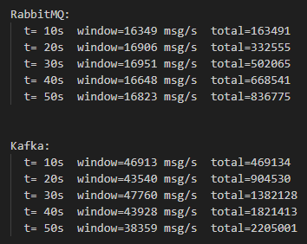
RabbitMQ is highly stable. All five windows fall between 16’349 and 16’951 msg/s with a variance of only 3.7%. There is no upward or downward trend. This is the expected behaviour of a synchronous per-call model: each basic_publish pays the same cost regardless of how long the system has been running, so throughput stays flat.
RabbitMQ is highly stable. All five windows fall between 16’349 and 16’951 msg/s with a variance of only 3.7%. There is no upward or downward trend. This is the expected behaviour of a synchronous per-call model: each basic_publish pays the same cost regardless of how long the system has been running, so throughput stays flat.
Neither system degrades under 60 seconds of sustained maximum load. Both are production-stable at these throughput levels.

Reflexion
The mini-challenge took significantly more time than expected, mostly in areas that had nothing to do with the actual content. A large portion of time was spent on environment and network issues. Getting the profiling scripts to run inside the right containers, discovering that Jupyter and RabbitMQ were on separate Docker networks, figuring out that the RabbitMQ tests needed to run from the host because of network isolation, and then later fixing this properly with dedicated test containers in the compose files. These are the kinds of problems that are invisible until you actually run something, and they consumed hours that should have gone into analysis.
The code structure grew organically and ended up messy as a result. Shared modules like kafka_config.py, rmq_config.py, serializer.py and the helpers are scattered across different folders (shared/, rabbitmq/shared/) with inconsistent import paths that broke repeatedly when scripts ran from different working directories. The sys.path.append workarounds throughout the profiling scripts are a direct consequence of not having a clean package structure from the start. If I were doing this again I would define a proper Python package layout with a single src/ root and install it as an editable package inside the containers, which would have eliminated every import error encountered.
The Part 5 latency measurements had to be redone twice: first because the RabbitMQ tests ran from the Windows host instead of inside Docker, making the results incomparable to Kafka, and second because the compose files needed to be updated to include dedicated test containers. The final results with both systems running container-to-container gave much more meaningful and comparable numbers.
What went well was the actual implementation. The Kafka and RabbitMQ applications mirror each other cleanly at the business logic level, the profiling scripts produced real measurable data, and the SnakeViz visualisations gave genuine insight into where time is spent in each system. The consumer bottleneck experiment (Part 4 Bonus 4) was particularly satisfying. The 7.47× speedup from batching file writes was a concrete, measured result rather than a theoretical claim.
In the future I would invest more time upfront in the Docker and package setup before writing any application code, and I would run all performance tests from inside containers from the beginning to avoid the measurement environment problems encountered here.

