Final Exam Econ 140 – Summer 2022

[YIGE and ELENA: In red are my first quick response for proposed solutions for you to review and keep in a separate file. Also notice that this file with solutions has the numberings incorrect]

* IV
  1. During class and section, we reviewed a total of 9 (!) studies that use instrumental variables (this include those with a Fuzzy RDD design): KIPP, Domestic Violence, Twin and same sex births, Queens, Peers, College Admissions, twins and measurement error, compulsory laws, QOB, Sheepskin. Choose any 3 studies from this list and complete the table below with the variable definition of each study. For the case of studies with multiple instruments and/or outcomes, choose only one. [9pts, 1pt per cell]

|  |  |  |  |
| --- | --- | --- | --- |
| Study | Main Outcome | Treatment | Instrument |
| OHP  (example) | Mental Health index | 1: Received OHP  0: did not receive OHP | 1: winning lottery  0: losing lottery |
|  |  |  |  |
|  |  |  |  |
|  |  |  |  |

* 1. For the study of Family Size and Years of Education Discussed in class, choose one instrument and discuss whether the three IV assumptions hold. (hint to help you remember which study is this: this is the study that address the potential “Quantity Quality” trade off, with some quasi-random variation related to the treatment variable) [6pts, 2 for each assumption].
* Using twin birth of second birth as instrument:

Relevancy: yes as it increases FS;

Indep: yes, as twins births are more or less at random, but it might not hold with older mothers or in more recent times do to IVF (IVF more likely to result in twins and more likely to be taken up by wealthier families).

ER: Twins births affect education of older child only through family child.

* 1. For the study that uses quarter of birth as an instrument for the effect of education on wages. Describe the population of compliers. [3pts, 2-3 sentences]

Compliers are those that stay in school if mandates and leave if they are allowed.

* 1. As we mentioned in class, and RCT with imperfect compliance can be improved using IV. Given the following tables with results from the OHP study [8pts, 2pts each]:

(hint: remember that when we discuss this study in RCTs the definition of treatment was different from when we discussed a similar study in the IV context)

* 1. What is the estimated first stage effect (phi) for the Portland sample? If you can’t find it, describe in words what the first stage is to get partial credit.

0.247

* 1. What is the estimated reduced form for the effect on mental health? If you can’t find it, describe in words what the reduce form is to get partial credit.

0.47

* 1. Compute the LATE? If you can’t find it, describe in words what the estimated LATE is to get partial credit.

0.47/.25 ~ 1.6

* 1. If we estimate the LATE using (a) and (b) using OLS and then compare to the same estimate using 2SLS. Which standard errors would be larger: the ones that correspond to lambda 2SLS or lambda OLS?

2SLS are larger due to uncertainty in the predicted treatment.

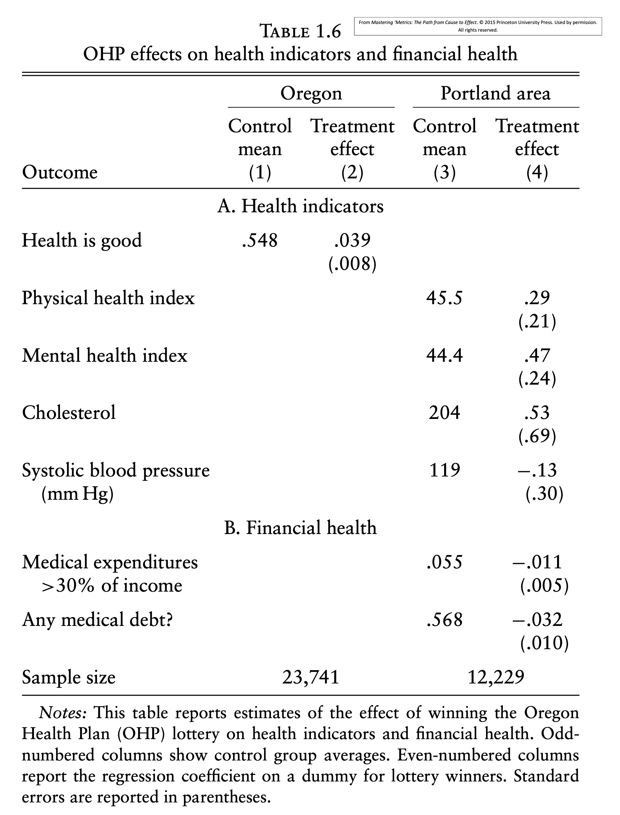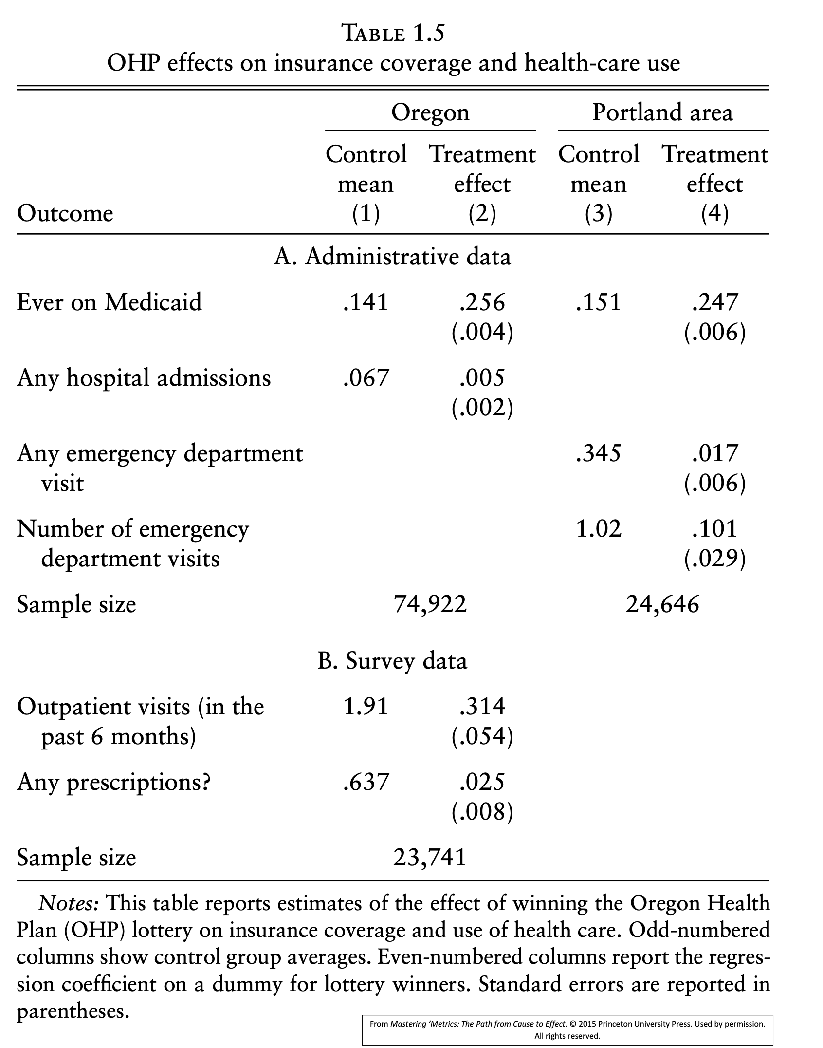

* 1. Describe how to use subpopulations with few compliers to indirectly test for the exclusion restriction. Use as an example any study discussed in class and/or section [3pts, 4-5 sentences].

Few compliers mean a weak first stage. When focusing on pops that have many always takers or never takers there should be a weak FS. If there is a reduce form effect in these groups then there might be another channel for Z to affect Y. Examples of population with few compliers could be religious groups with large family size in the twin birth study (always takers)

- RDD. For the study on Peer Effects in Boston Exam Schools. If you don’t remember this study, pick one RDD study that you do remember, different from the MLDA, and respond the same following questions to get **partial** credit

* 1. What was the outcome and treatment of interest [2pts, 1-2 sentences]

Test scores of students in their 7th or 8th grades, treatment was the quality of peers measured by their average math score in 4th grade.

* 1. Using OVB (for example: assume that parental resources are omitted) explain how an OLS regression would generate biased causal estimates. [4pts, 3-4 sentences/equations]

Short with only own test scores int 7th or 8th against peer quality.

Long: add parental resources positive rel. Aux: PR and quality, positive rel. OVB is positive, effect in short is positive, hence overestimating.

* 1. Is this a Fuzzy or Sharp RDD? Why? [2pt, 1 Sentence]

Fuzzy as treatment intensity, not status, changes at cutoff

* 1. Describe the running variable. Make sure to mention to whom this characteristic belongs and when it was measured [1pt, 1 sentence]

Entrance exam score of students relative to cutoff

* 1. How should we interpret the 3 IV assumptions in this case? [6pts, 2pts for each, 1-2 sentences each]

Rel: yes, there is a jump in per quality at cut-off

Ind: yes, the instrument is deterministically determined by running var, hene no space for OVB

* DD
  1. Write down the DD estimator as the difference between four averages [2pts, 1 equation]

Delta_dd = (Avg Y_T, t+1 - Avg Y_T, t) - (Avg Y_C, t+1 - Avg Y_C, t)

* 1. Show how the DD estimator is the same as the coefficient delta in the following regression (help: here you can answer this using the notation use in class or with expectations) [3 pts, 3-5 lines]

(insert eq 5.3 from here)

Eval each average or CE and compute diffs.

For the case of the Minimum Wage Study discuss in section (if you missed this section: all required details are in the help box below)

Being of help box for DD Minimum Wage question

From the abstract:

On April 1, 1992, New Jersey's minimum wage rose from \$4.25 to \$5.05 per hour. To evaluate the impact of the law we surveyed 410 fast-food restaurants in New Jersey and eastern Pennsylvania before and after the rise. Comparisons of employment growth at stores in New Jersey and Pennsylvania (where the minimum wage was constant) provide simple estimates of the effect of the higher minimum wage.

Table 3: Highlighted section contains all the required information

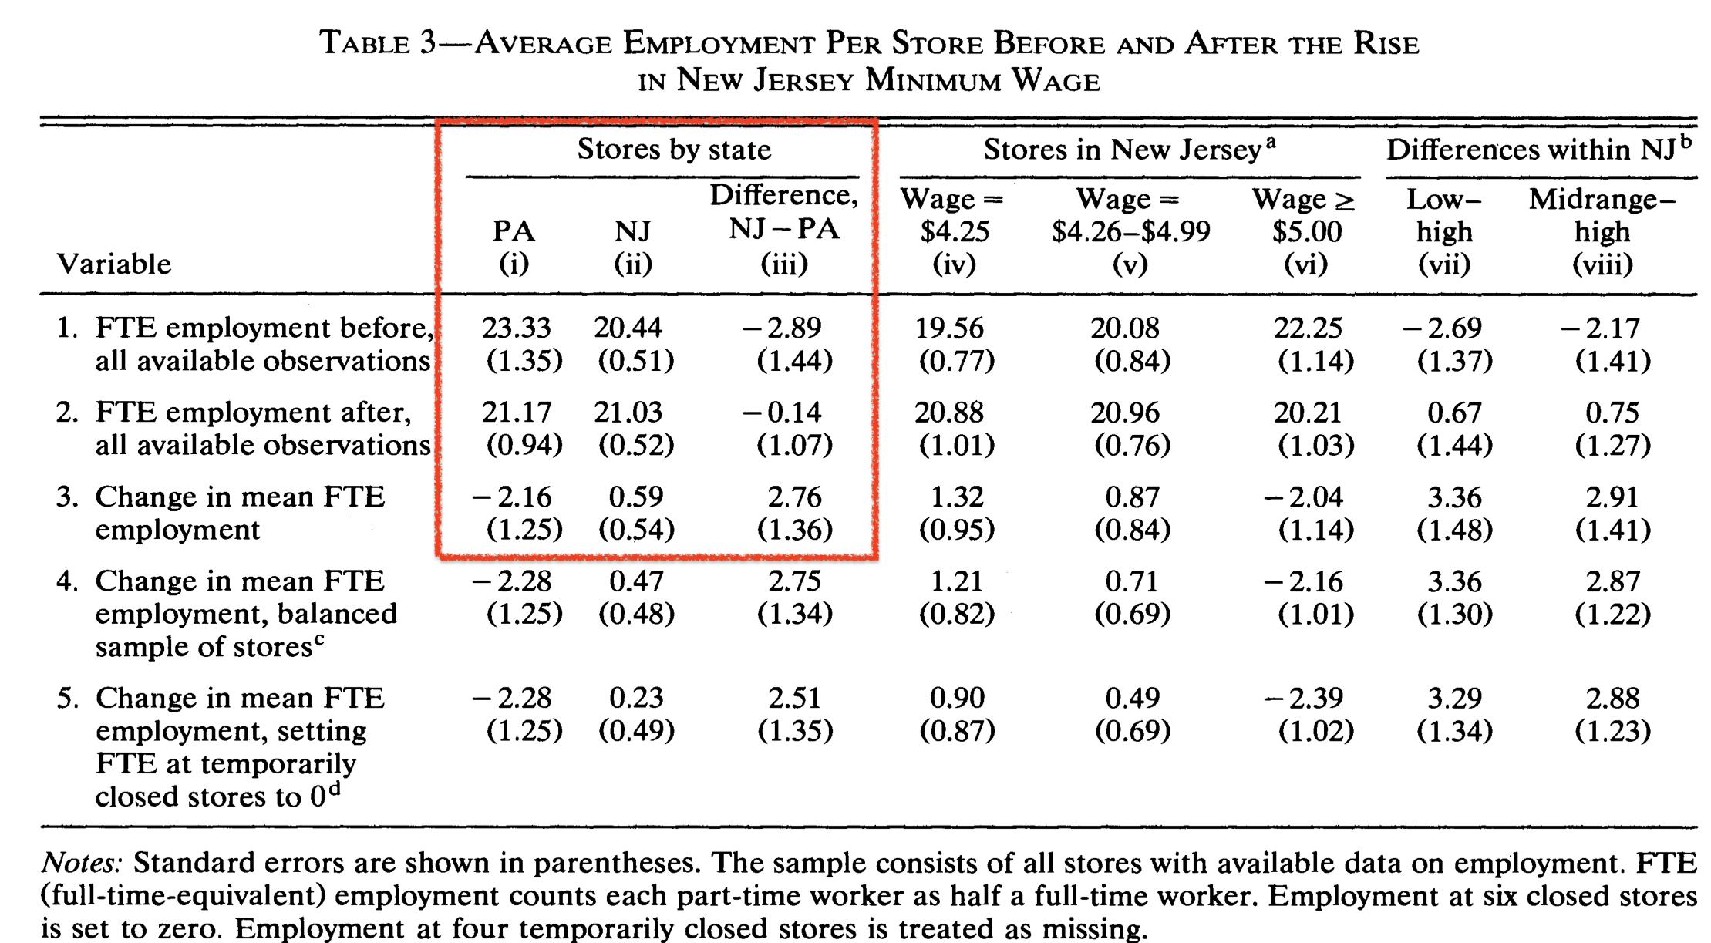

End of help box for DD Minimum Wage question

* 1. Draw a plot with two lines. One for treatment one for controls with only two periods each: pre-treatment and post treatment. Indicate where in the plot is the treatment effect. [3pts, 1 figure]
* positive NJ sloping, downward sloping PA where delta is diff from counterfactual trend
  1. For a toy data set with 8 observations: construct the TREAT variable, the POST variable, and the interaction between the two of them. [3pts]

|  |  |  |  |  |  |  |
| --- | --- | --- | --- | --- | --- | --- |
| State | Year | restaurant id | Num. Worker | TREAT | POST | TREATxPOST |
| NJ | 1991 | 1 | 24 | 1 | 0 | 0 |
| NJ | 1991 | 2 | 15 | 1 | 0 | 0 |
| PA | 1991 | 3 | 23 | 0 | 0 | 0 |
| PA | 1991 | 4 | 16 | 0 | 0 | 0 |
| NJ | 1993 | 1 | 25 | 1 | 1 | 1 |
| NJ | 1993 | 2 | 14 | 1 | 1 | 1 |
| PA | 1993 | 3 | 22 | 0 | 1 | 0 |
| PA | 1993 | 4 | 16 | 0 | 1 | 0 |

* 1. Describe the main DD assumption in this context. [2tps, 2 sentences]
* Similar trends in economic activity in both states
  1. Imagine that you have data on all 50 states with multiple observations over time. In this data set you can observe multiple changes in the minimum wage (in the US states can set their own minimum wage above the federal minimum) Construct the two-way fixed effect regression for this new DD estimate. If you can’t figure out the equation, describe in words what the variables should be. [3pts, 1-3 sentences/equations]
* Eq 5.5 but instead of legal have Minwage
  1. How would you modify your DD estimation to address a violation in DD main assumption (7)? What do you need to be able to properly identify this effect? Write down the new fixed effect equations. [3pts, 2-3 sentences/equations]

Eq 5.6 but instead of legal have Minwage. Large and sharp effects can be detected with this approach.

* 1. This study had a total of 410 restaurants over 2 periods, for a total of 820 observations. Think of a second hypothetical study with the same number of observations but instead of a panel data it measured 820 independent units (restaurants) sampled at one point in time (also known as a cross-section). Assuming no selection or OVB bias, which study is more likely to reject the null hypothesis of no effect?

The second one. In the first one, observations are serially correlated which creates larger standard errors, hence less likely to reject the null by design

Previous material (combined with some of latest material)

* Independence has been a core concept used throughout the course. In this question we ask you to demonstrate your knowledge about this core concept in several stages:
  1. Define the concept of independence in plain English [1pt, 1-2 sentences]
* Eq 5.6 but instead of legal have Minwage. Large and sharp effects can be detected with this approach.
  1. Given two random variables X and Y, define the concept of independence in terms of conditional probabilities. [1pt, 1-2 sentences/equations]
  2. What roles does independence plays in distribution of the sample mean? [1pt, 1 sentence]
  3. What role does independence plays in addressing the problem of selection bias for the case of simple difference in groups, with constant effects (hint: this equation connects E(SDG) and causal effects plus selection bias) [1pt, 1-2 sentences/equations]
  4. If an omitted variable is independent of the included variable, what would that imply for the auxiliary regression and for OVB overall? [2pt, 2-3 sentences/equations]
  5. What does independence mean in the context of Instrumental Variables? Explain using the example of an instrument discuss in class or section. [2pt, 2-3 sentences]
  6. How is independence achieved in the context or Sharp and Fuzzy RDD? [2pts, 2 sentences (one for sharp, one for fuzzy)]
  7. How does lack of independence affects the standard errors in DD? [1pt, 1 sentence]
  8. For the case of the gender gap discussed in class.
     1. Write down the equations for short regression that represents the interviewers point (“the gender pay gap in the UK is 9%”), the long equations that represents the commentators point using only one omitted variable (“you break it down by personality (and others) and the gap disappear”), the auxiliary regression, and the OVB formula. [3pts]
     2. Explain what is wrong with the commentators point. [2pts]

ADDITIONAL QUESTIONS IN NEXT PAGE (to bring up, or to use in make-up exam if needed)