Final Exam Econ 140 – Summer 2022

* IV
  1. For the following studies, complete the table below with the variable definition of each study. For the case of studies with multiple instruments and/or outcomes, choose only one. [9pts, 1pt per cell]

|  |  |  |  |
| --- | --- | --- | --- |
| Study | Main Outcome | Treatment | Instrument |
| OHP  (example) | Mental Health index | 1: Received OHP  0: did not receive OHP | 1: winning lottery  0: losing lottery |
| KIPP |  |  |  |
| Queens |  |  |  |
| Years of schooling and wages (Angrist and Krueger, Ch6) |  |  |  |

* 1. For the study of Family Size and Years of Education Discussed in class, choose one instrument and discuss whether the three IV assumptions hold. [6pts, 2 for each assumption].
  2. For the study that uses quarter of birth as an instrument for the effect of education on wages. Describe the population of compliers. [3pts, 2-3 sentences]
  3. As we say in class, and RCT with imperfect compliance can be improved using IV. Given the following tables with results from the OHP study [8pts, 2pts each]:

(hint: remember that when we discuss this study in RCTs the definition of treatment was different from when we discussed a similar study in the IV context)

* 1. What is the estimated first stage effect (phi) for the Portland sample? If you can’t find it, describe in words what the first stage is to get partial credit.
  2. What is the estimated reduced form for the effect on mental health? If you can’t find it, describe in words what the reduce form is to get partial credit.
  3. Compute the LATE? If you can’t find it, describe in words what the estimated LATE is to get partial credit.
  4. If we estimate the LATE using (a) and (b) using OLS and then compare to the same estimate using 2SLS. Which standard errors would be larger: the ones that correspond to lambda 2SLS or lambda OLS?

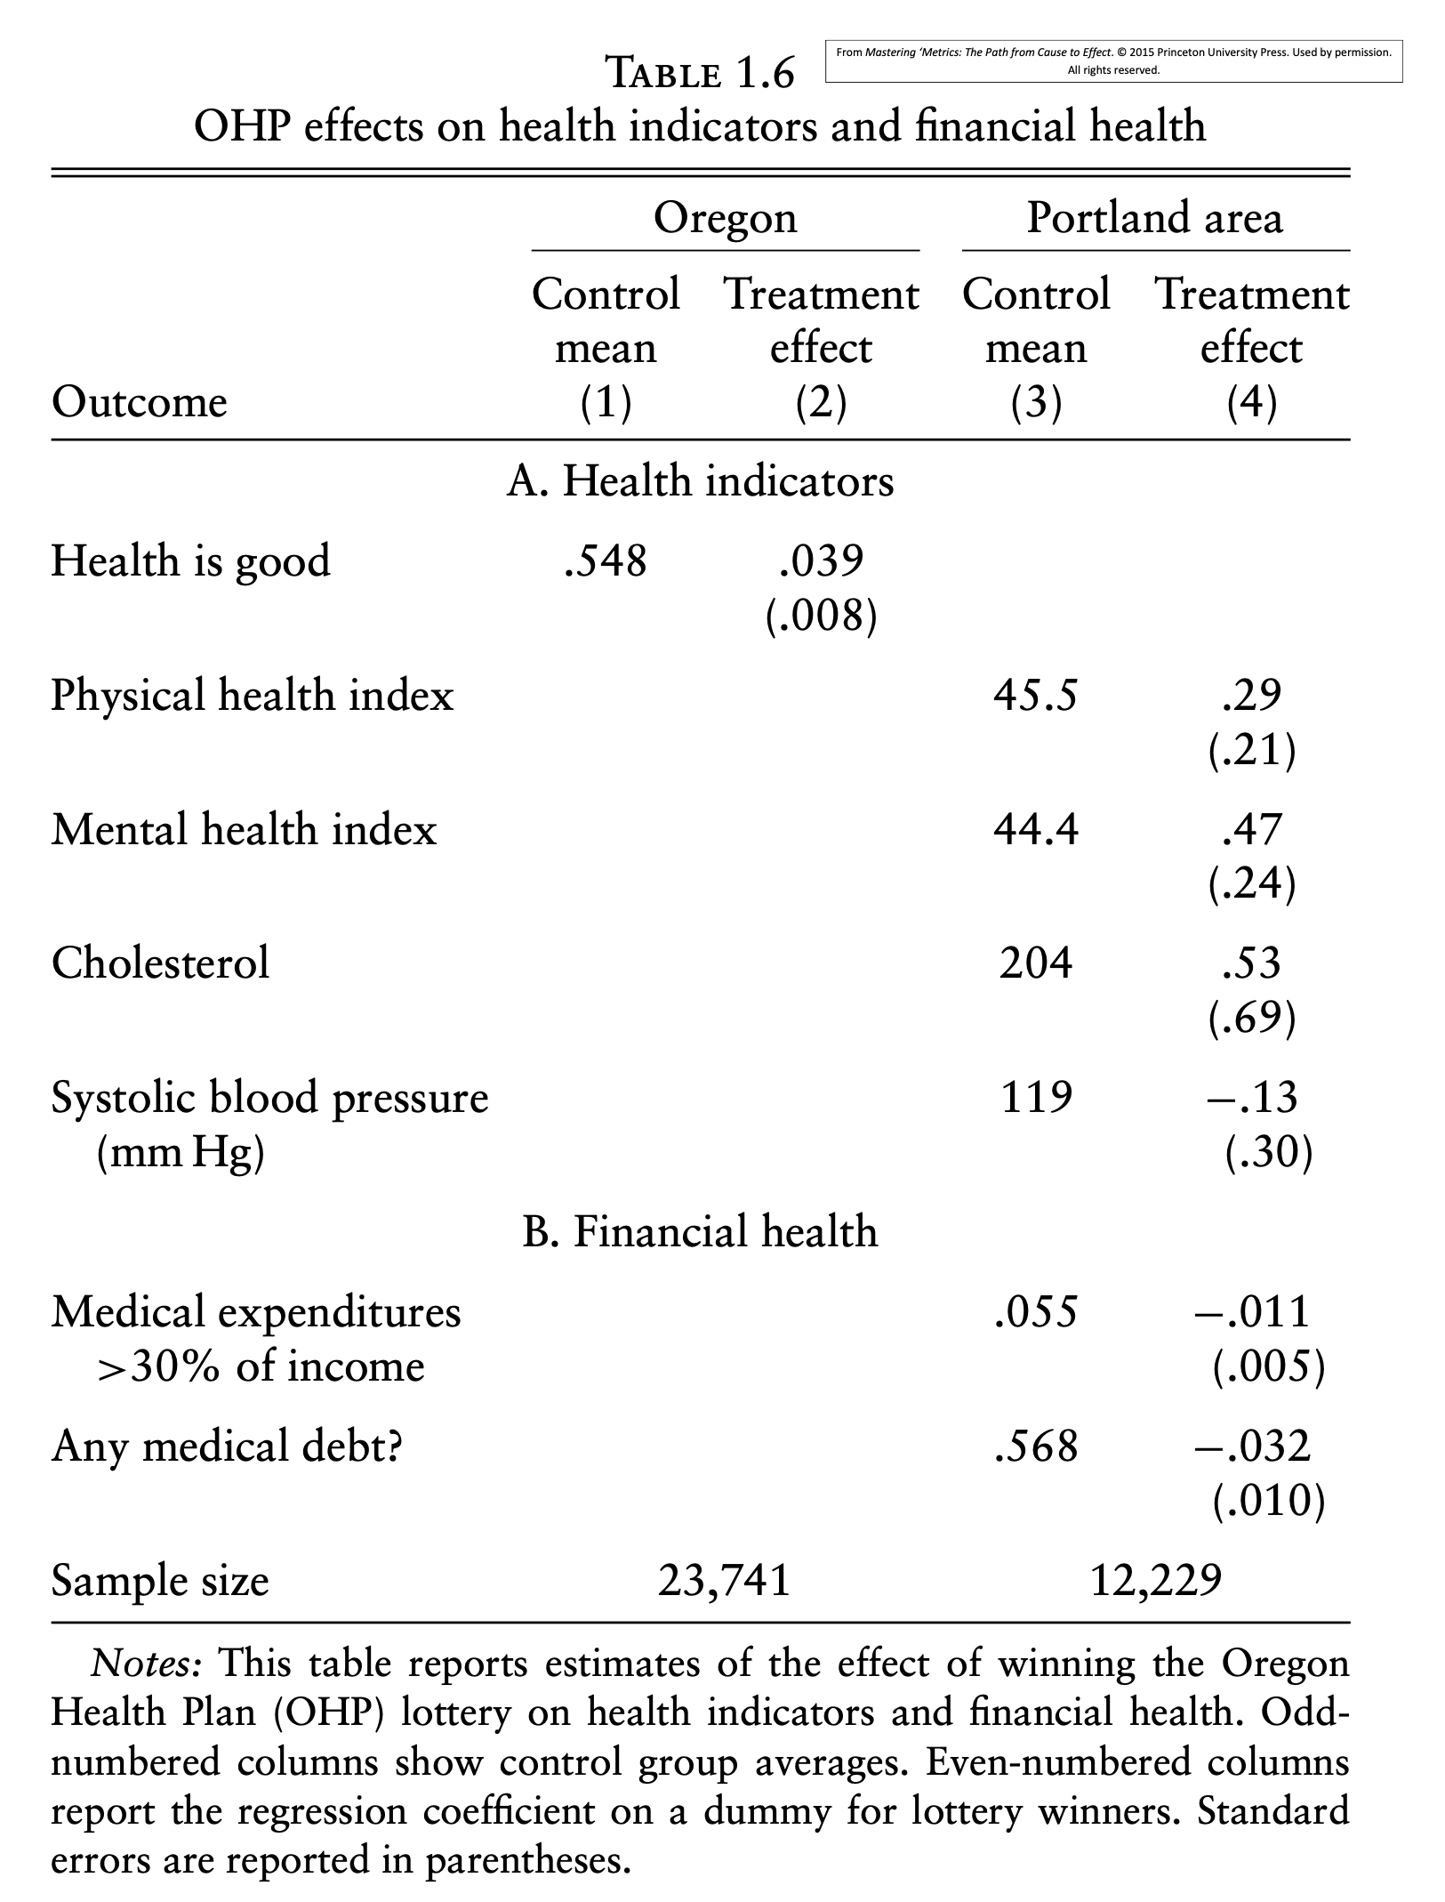

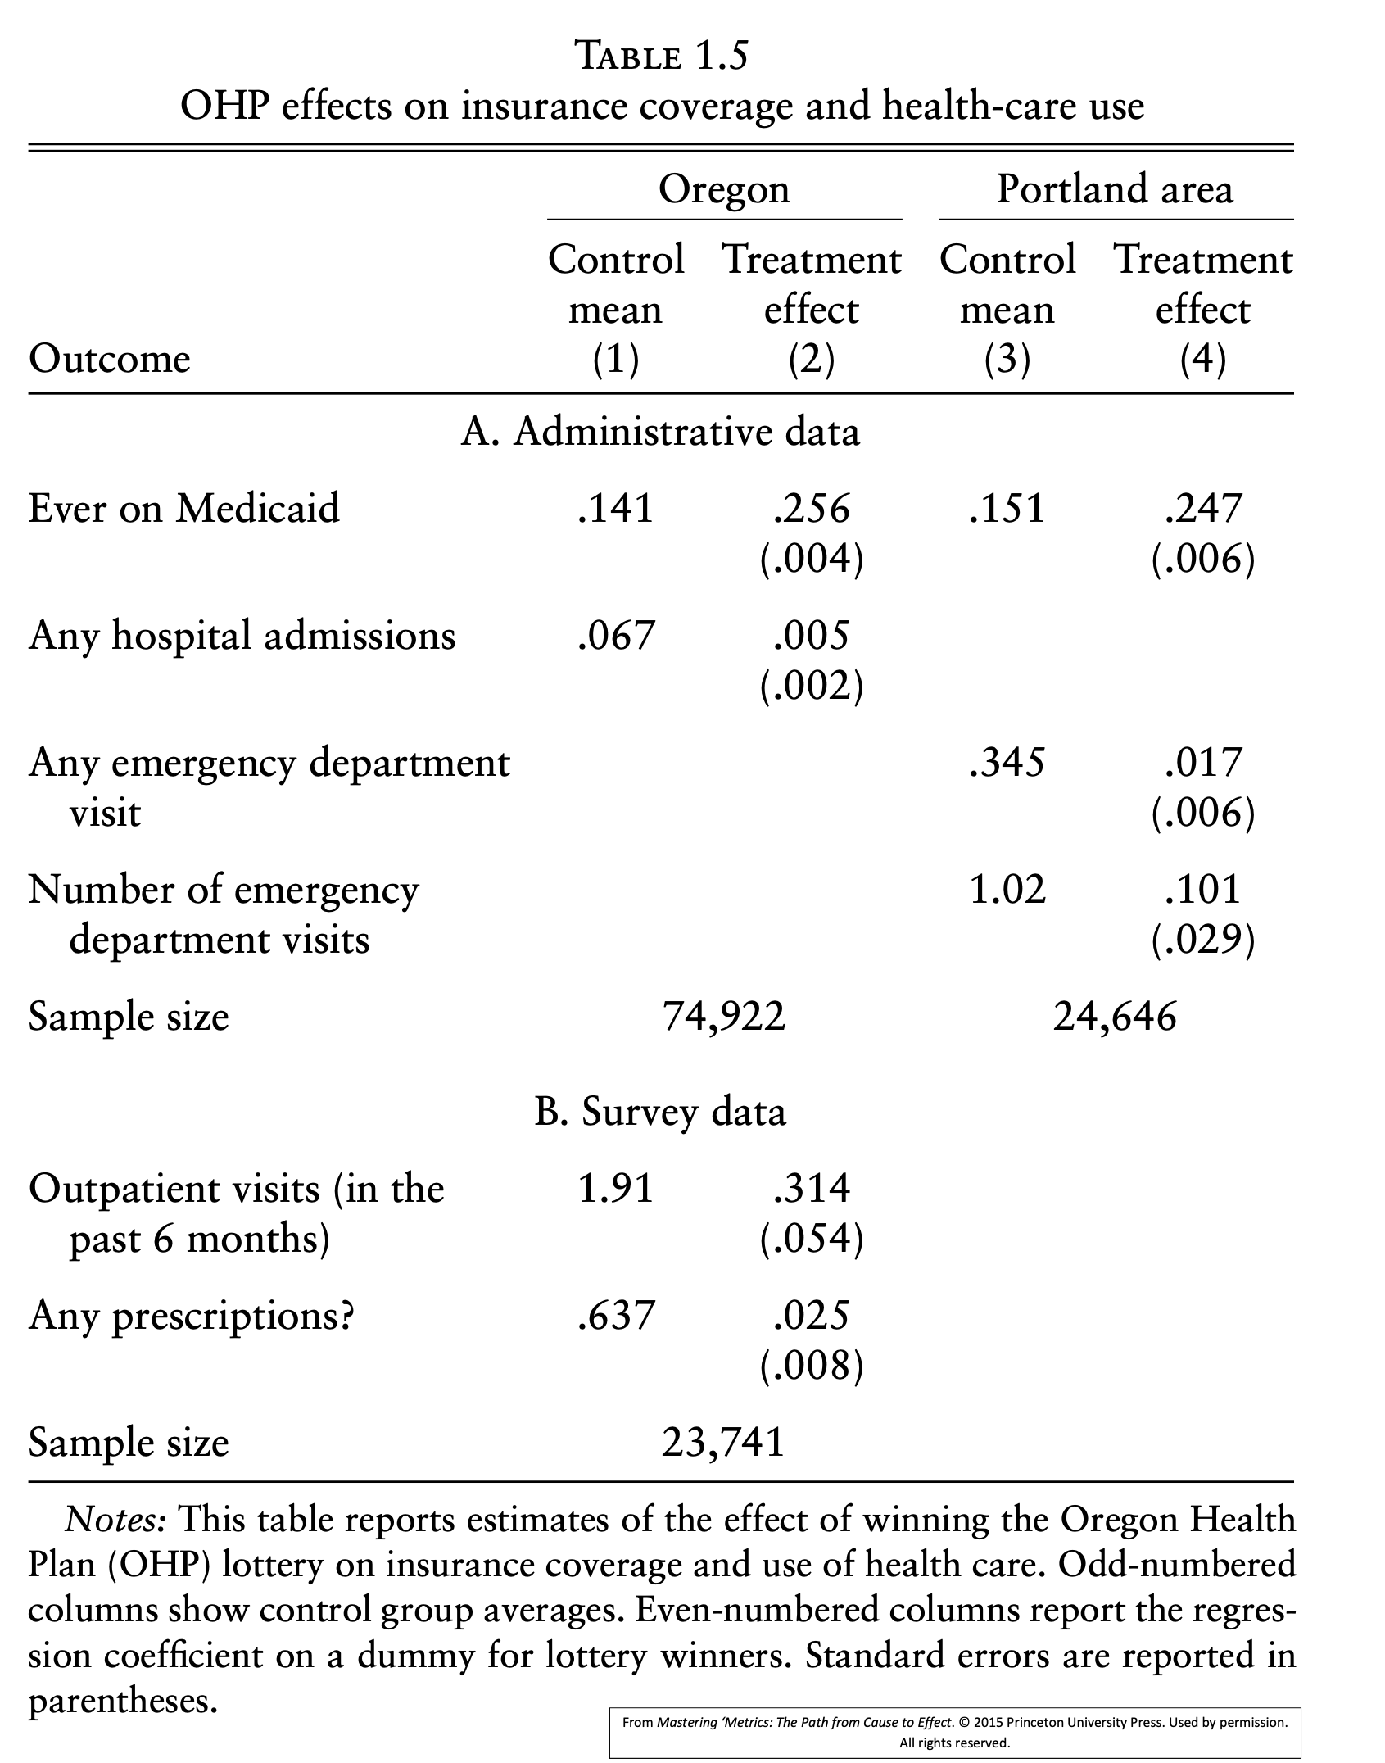

* 1. Describe how to use subpopulations with few compliers to indirectly test for the exclusion restriction. Use as an example any study discussed in class and/or section [3pts, 4-5 sentences].

- RDD. For the study on Peer Effects in Boston Exam Schools.

* 1. What was the outcome and treatment of interest [2pts, 1-2 sentences]
  2. Using OVB (for example: assume that parental resources are omitted) explain how an OLS regression would generate biased causal estimates. [4pts, 3-4 sentences/equations]
  3. Is this a Fuzzy or Sharp RDD? [2pt, 1 word]
  4. Describe the running variable. Make sure to mention to whom this characteristic belongs [1pt, 1 sentence]
  5. How should we interpret the 3 IV assumptions in this case? [6pts, 2pts for each, 1-2 sentences each]
* DD
  1. Write down the DD estimator as the difference between four averages [2pts, 1 equation]
  2. Show how the DD estimator is the same as the coefficient delta in the following regression (help: here you can answer this using the notation use in class or with expectations) [3 pts, 3-5 lines]

For the case of the Minimum Wage Study discuss in section (if you missed this section: details are below. ELENA: PLEASE ADD A SHORT SUMMARY WITH ALL THE NECESSARY DETAILS BELOW)

* 1. Draw a plot with two lines. One for treatment one for controls with only two periods each pre-treatment and post treatment. Indicate where in the plot is the treatment effect. [3pts, 1 figure]
  2. For a toy data set with 8 observations: construct the TREAT variable, the POST variable, and the interaction between the two of them. [3pts]

|  |  |  |  |  |  |  |
| --- | --- | --- | --- | --- | --- | --- |
| State | Year | restaurant id | Num. Worker | TREAT | POST | TREATxPOST |
| NJ | 1994 | 1 | 24 |  |  |  |
| NJ | 1994 | 2 | 15 |  |  |  |
| PA | 1994 | 3 | 23 |  |  |  |
| PA | 1994 | 4 | 16 |  |  |  |
| NJ | 1995 | 1 | 25 |  |  |  |
| NJ | 1995 | 2 | 14 |  |  |  |
| PA | 1995 | 3 | 22 |  |  |  |
| PA | 1995 | 4 | 16 |  |  |  |

* 1. Describe the main DD assumption in this context. [2tps, 2 sentences]
  2. Imagine that you have data on all 50 states with multiple observations over time. In this data set you can observe multiple changes in the minimum wage (in the US states can set their own minimum wage above the federal minimum) Construct the two-way fixed effect regression for this new DD estimate. If you can’t figure out the equation, describe in words what the variables should be. [3pts, 1-3 sentences/equations]
  3. Assume that you have more data on the plot for (4), with more periods before the intervention. What would the plot look like if the main assumption doesn't hold (draw and exaggerate version, to remove any confusion)? [3pts, 1 plot]
  4. How would you modify your DD estimation to address the problem described in (7)? What do you need to be able to properly identify this effect? Write down the new fixed effect equations. [3pts, 2-3 sentences/equations]
  5. Given the DD design of this study. Was the result more or less likely to reject the null hypothesis of no effect compared with an analysis in levels. Why? [2pts, 1-2 sentences

Previous material (combined with some of latest material)

* Independence has been a core concept used throughout the course. In this question we ask you to demonstrate your knowledge about this core concept in several stages:
  1. Define the concept of independence in plain English [1pt, 1-2 sentences]
  2. Given two random variable X and Y, define the concept of independence in terms of conditional probabilities. [1pt, 1-2 sentences/equations]
  3. What roles does independence plays in distribution of the sample mean? [1pt, 1 sentence]
  4. What role does independence plays in addressing the problem of selection bias in the for the case of simple difference in groups, with constant effects (hint: this equation connects E(SDG) and causal effects plus selection bias) [1pt, 1-2 sentences/equations]
  5. If an omitted variable is independent of the included variable, what would that imply for the auxiliary regression and for OVB overall? [2pt, 2-3 sentences/equations]
  6. What does independence mean in the context of Instrumental Variables? Explain using the example of an instrument discuss in class or section. [2pt, 2-3 sentences]
  7. How is independence achieved in the context or Sharp and Fuzzy RDD? [2pts, 2 sentences (one for sharp, one for fuzzy)]
  8. How does lack of independence affects the standard errors in DD? [1pt, 1 sentence]

- OVB, BS and Bad controls

* 1. OVB and Gender Gap with Bad Controls (NOTE TO GSIs: I will add after reviewing bad controls, assume mins for this) [5pts, 2-5 sentences/equations]

ADDITIONAL QUESTIONS IN NEXT PAGE (to bring up, or to use in make-up exam if needed)