Lidgren Basic Setup Guide
This document will show you how to build and run the Lidgren Basic Setup asset from the Unity Asset Store. When you first import the package into Unity, you will see something like this:

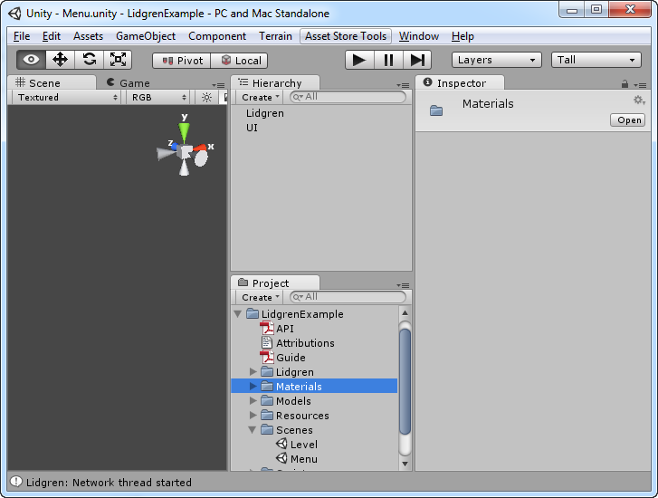
If you wanna run the project from inside unity, open the “Menu” scene and hit play:
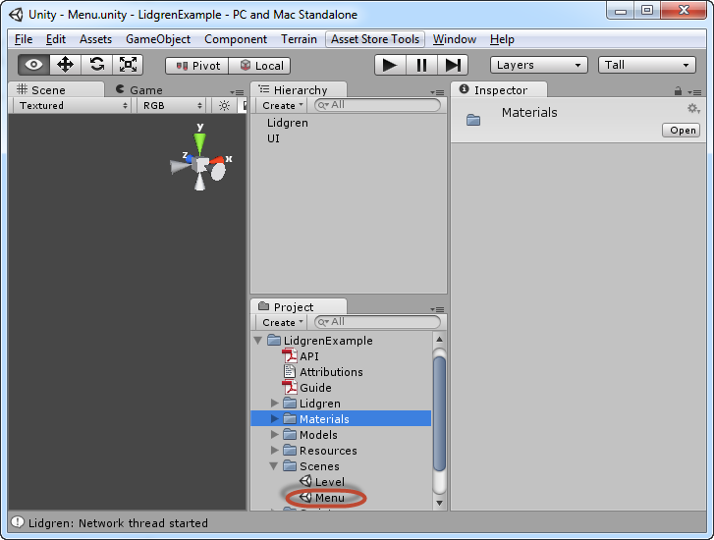
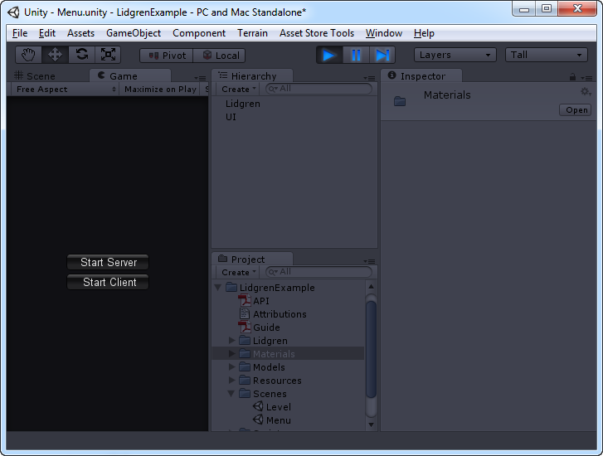
You can then select to start the Server or Client, but since we want to have some sort of multiplayer, we need several instances running of the project – which requires us to build it. So we will! Stop the player and go to File → Build Settings. Make sure both Menu and Level is selected, and that Menu is index “0” and Level is index “1”, also make sure you have selected PC and Mac standalone, like this:

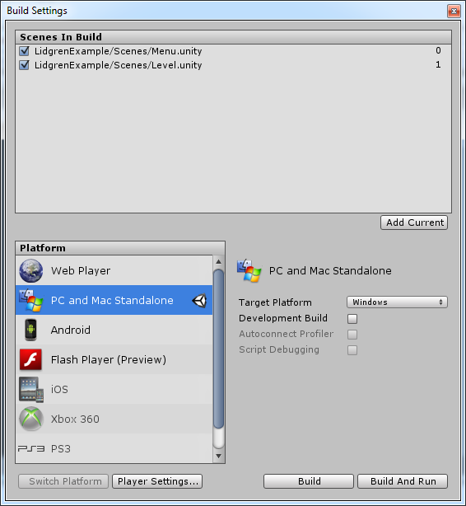
Then hit build and save it somewhere, I choose a folder on the desktop called “LidgrenBasicSetup”:
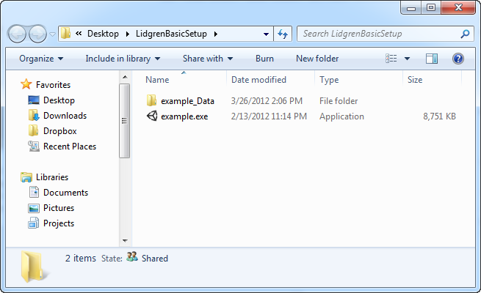
The next step is to first start the server in the Unity Editor:
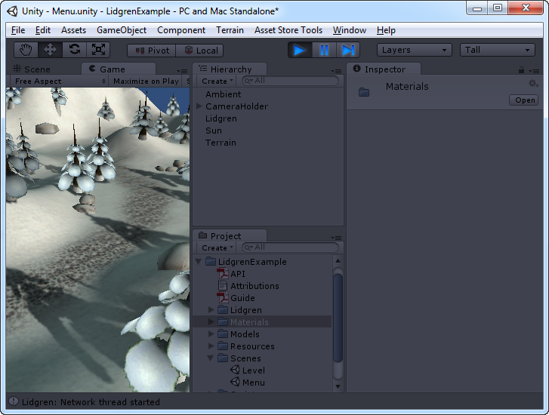
And then start two clients (yellow squares) from the compiled project (blue square), and both connect to the server (red square), it will end up looking like this:

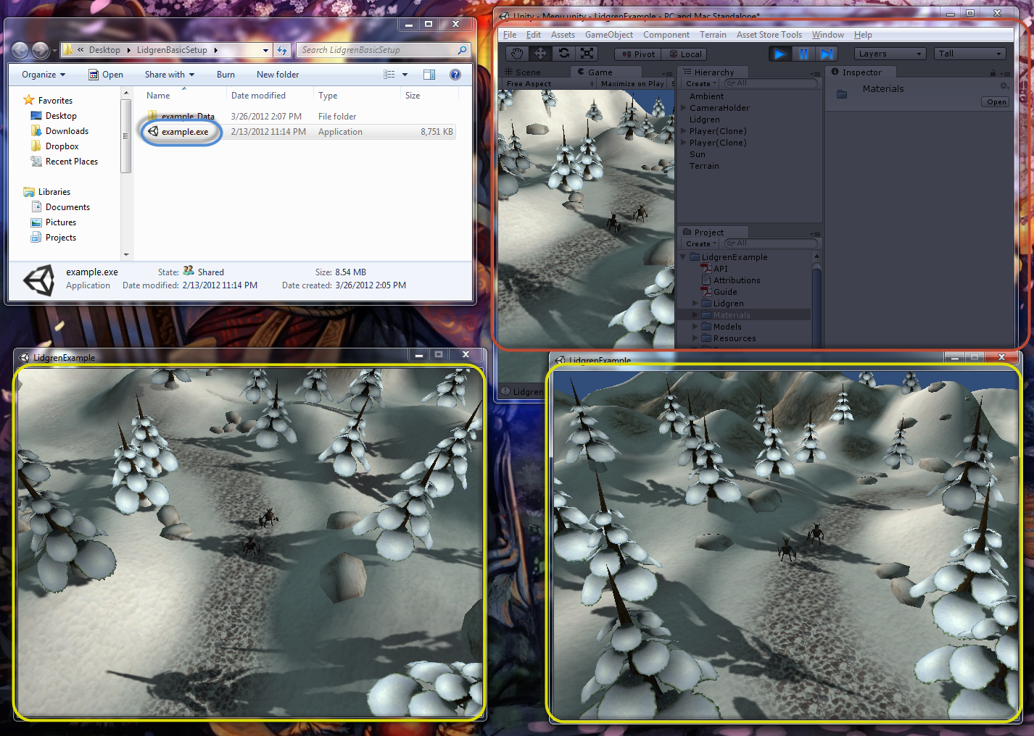
That is all for the basic setup guide, if you have any questions or comments I direct you to the thread about this asset on the “Assets and Asset Store” forum on the official Unity Forum.

