RPG Controller & Camera Guide

After importing the package and opening the scene located in RPGController/Demo/Scenes/Demo you will see something like this.

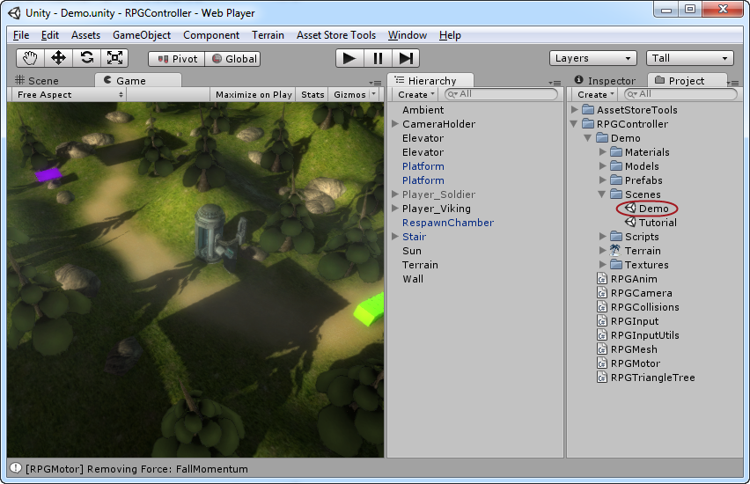
This is the demo scene that ships with the package, the default controller activated is the Viking one, but if you want to see an example of how to setup strafing then you should deactivate the Player_Viking object (red circle) and activate the Player_Solider object (blue circle) and then drag the Player_Solider into the Target property on the RPGCamera script attached to the CameraHolder object (orange arrow), like this:

