ACI Configuration for tenant Pod2

# Networking configuration

## Private networks (VRFs)

This tenant has the following private networks (VRFs) defined:

Pod2-PN

The following bridge domains are defined in this VRF:

* Pod2-BD. The following subnets are configured in this bridge domain: 192.168.20.1/24

The following external IP connections are associated to his VRF:

* ACI-ISR

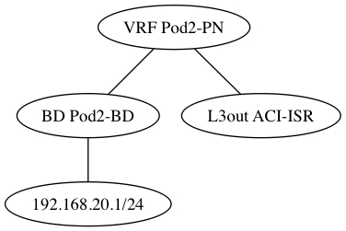

## External IP connections

This tenant has the following external IP connections defined:

- ACI-ISR. The following subnets are configured to be received by this L3 connection: 0.0.0.0/0. The following subnets are configured to be announced by this IP connection: 192.168.20.0/24. The following contracts are consumed by this IP connection: EPG1-services.

# Application Network Profiles (ANPs)

The following application network profiles are defined in this tenant:

## ANP Pod2

This application network profile has the following End Point Groups (EPGs) defined:

- EPG1: This EPG is associated to Bridge Domain Pod2-BD. The following contracts are consumed by this EPG: EPG2-services. The following contracts are provided by this EPG: EPG1-services

- EPG2: This EPG is associated to Bridge Domain Pod2-BD. No contracts are consumed by this EPG. The following contracts are provided by this EPG: EPG2-services

