PawelBot Build Instructions

CoderDojoDC Version

The PawelBot is an open source, low cost version of the SumoBot robot design. It was original developed for NodeBots Day, and we’ve modified it to work with CoderDojoDC. The original plans can be found at <http://sumobotkit.com>.

Don’t worry about breaking the PawelBot! Accidents happen, but most can be fixed. The chassis is wood, so paint it, drill it, glue things on to it or do whatever you like. This activity goes through assembling the basics of the robot, and we’ll extend it in the future. You control the personality of your robot, so give it some character after you’ve completed this activity.

# Chassis and Servo Assembly

Parts needed:

1. 2 wheels
2. Left, right, top, and bottom laser cut pieces
3. Front shovel piece
4. 16 mm chrome steel ball
5. Ball holder
6. Eight 3/8” #6 screws for mounting servo and ball holder
7. 2 Continuous rotation servos and horns (SpringRC SM-S4303R)
8. Two 5/16” #2 screws to mount servo horns (short black screws that come with the servo)
9. Four 3/8” or 5/16” #4 screws to mount wheels

**Be careful: the laser cut wood pieces can have splinters**

Step 1: Use a hot glue gun or wood glue to glue the left, right, top, bottom, and shovel pieces together. Make sure that the arrows on the top and bottom pieces point to the front of the robot (the shovel is in the front). The word “top” should be visible from the top of the robot. This is necessary if you would like to mount the Arduino to the robot using screws.

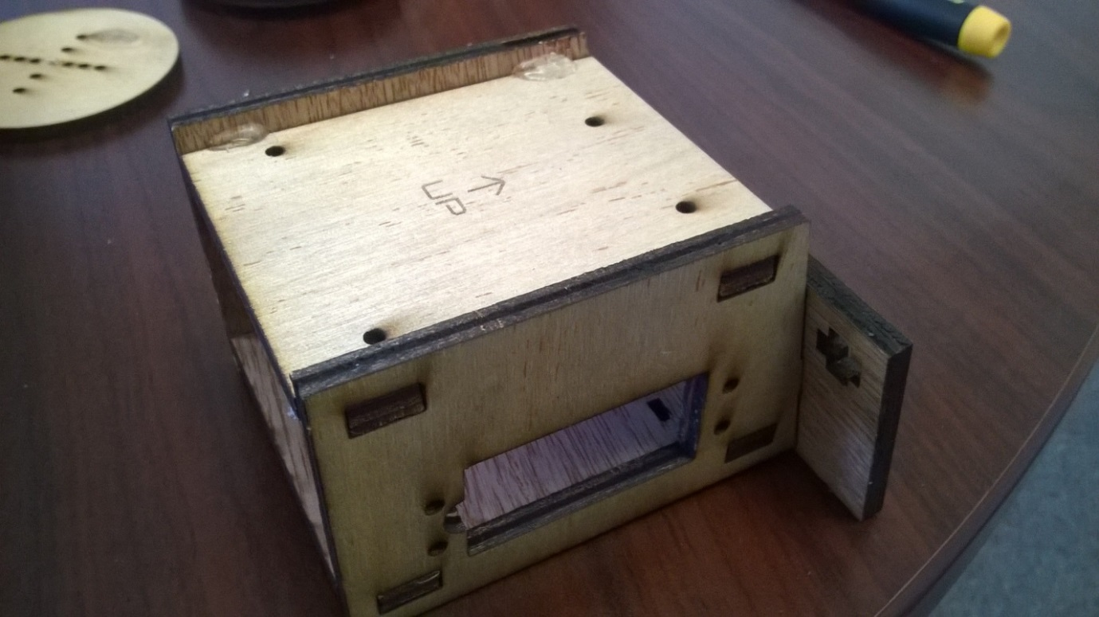

Step 2: Screw the ball holder to the bottom using 3/8” #6 screws:  
**UPDATE: Update picture now that this step is earlier. Also, #4 screws didn’t work – too small for holes**  
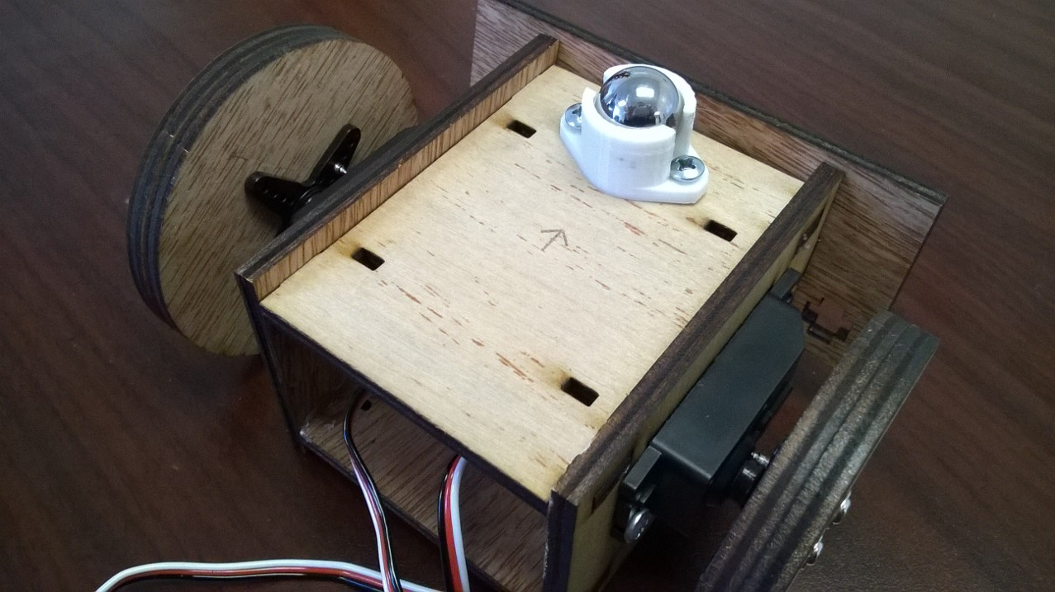

Step 3: Gently insert and screw in a servo using two 3/8” #6 screws. Repeat for the other side.  
**UPDATE: Do not attach the servo horn yet.**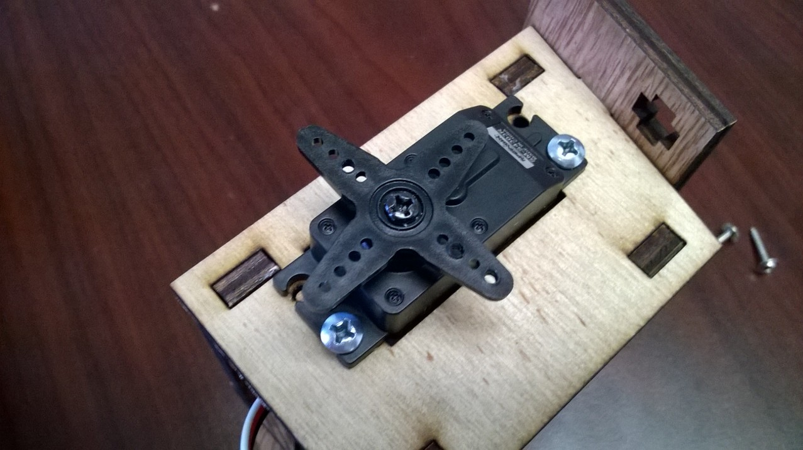

Step 4: Attach a servo horn to the wheel using two 3/8” or 5/16” #4 screws:

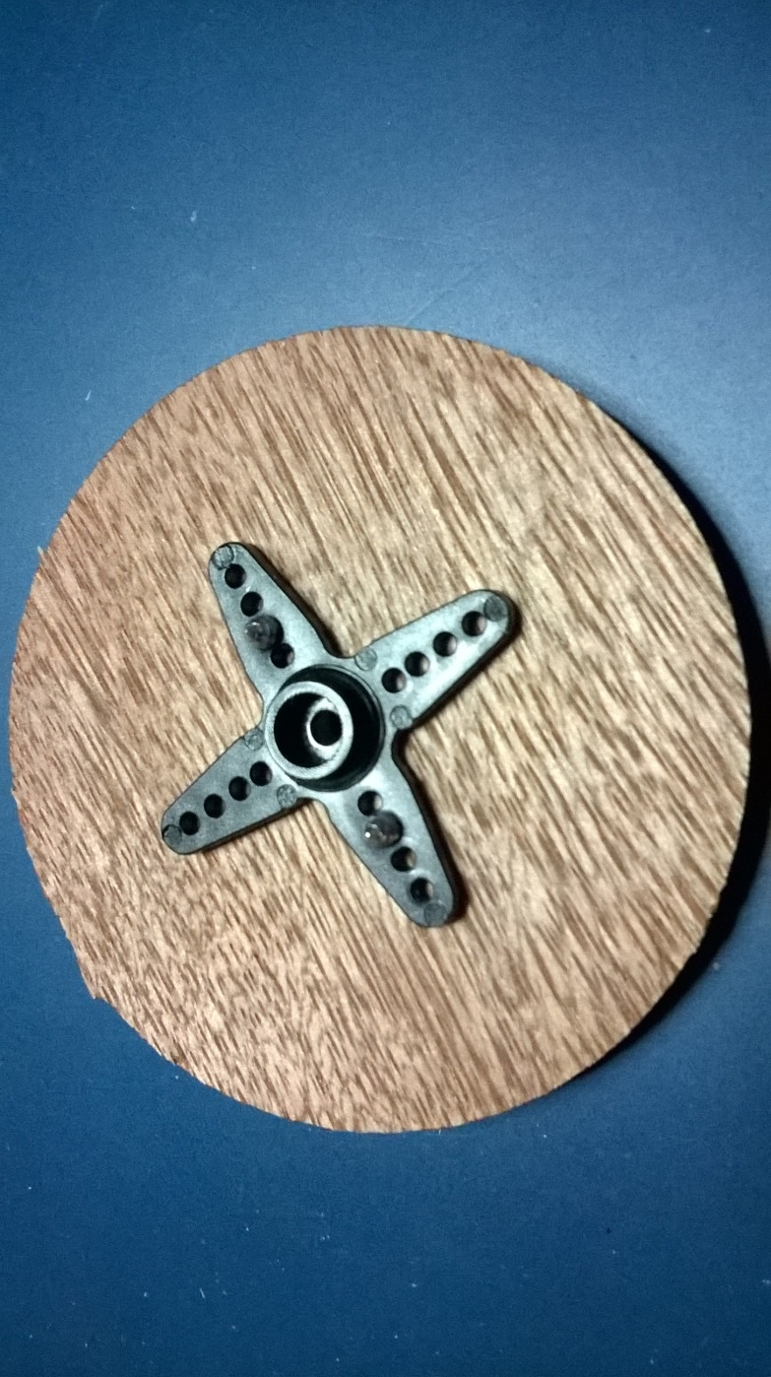

Step 5: Attach the wheel to the servo using a 5/16” #2 screw:  
**UPDATE: #4 screws from step 3 look different than what’s shown in the picture.**

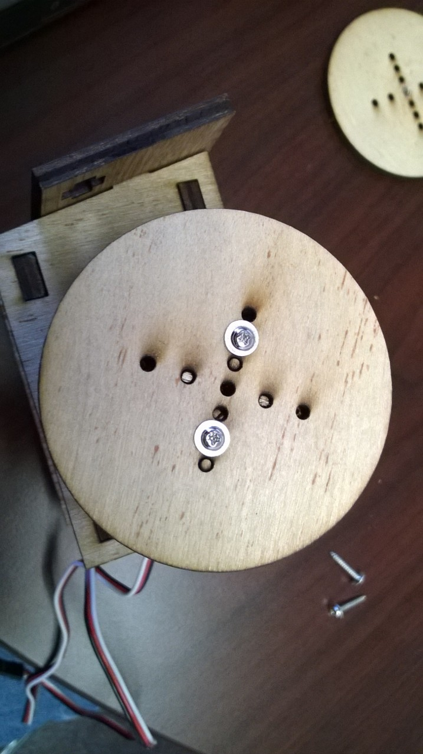

When complete, the robot should look like this: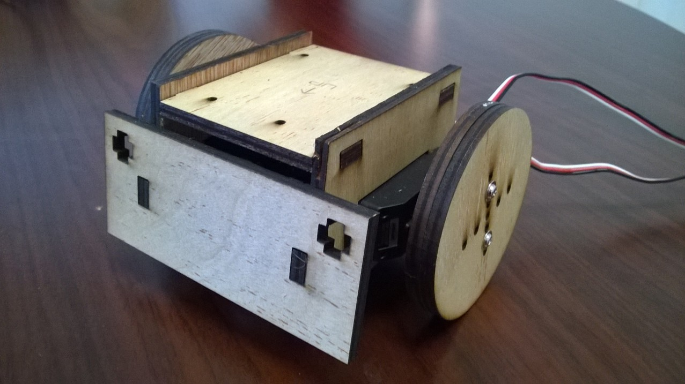

# Electronics

If you have a PawelBot connection board, just connect up the servos and battery to the board. Be sure to disconnect the battery when not using the robot or the batteries will be drained.

If you do not have a connection board, you can wire up the servos and the battery using a small solderless breadboard as shown below:

Parts needed:

1. Arduino Uno or Leonardo
2. 4 AA battery holder and batteries
3. Small solderless breadboard
4. Jumper cables
5. Double-sided .1” headers – Two 3-pin and one 2-pin

The double-sided headers are required to connect the servo and battery cables.

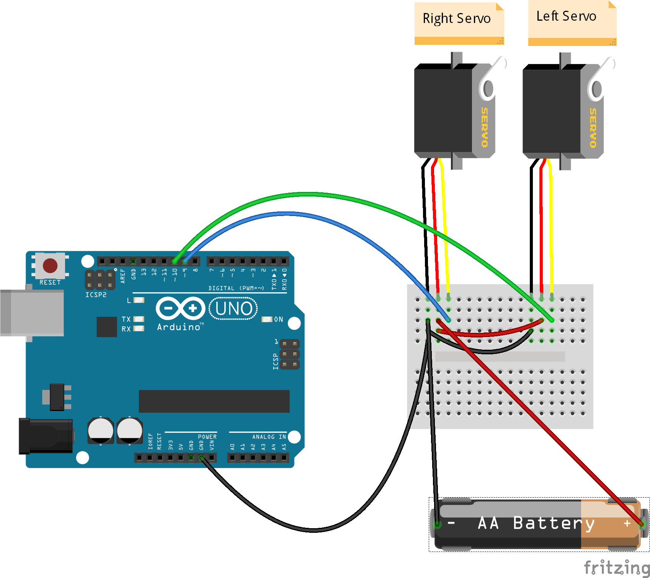

# Programming

The PawelBot can be programmed in JavaScript or a Scratch-like language called Snap4Arduino (<http://s4a.cat/snap/>). The instructions below are assume Snap4Arduino.

The first step is to program the Arduino with the Standard Firmata software. To do this, download and install the Arduino IDE from <http://arduino.cc>. In the IDE, load Examples->Firmata->Standard Firmata. Make sure that the board and serial port settings are correct, compile the program and upload it to the Arduino. You do not have to run this step again unless you reprogram the Arduino for another project.

The next step is to install Snap4Arduino. Run Snap4Arduino and go to the Arduino tab. Make sure that you can connect to the Arduino. Enter in the following program to initialize the Arduino pins 9 and 10 to servos and stop the servos.

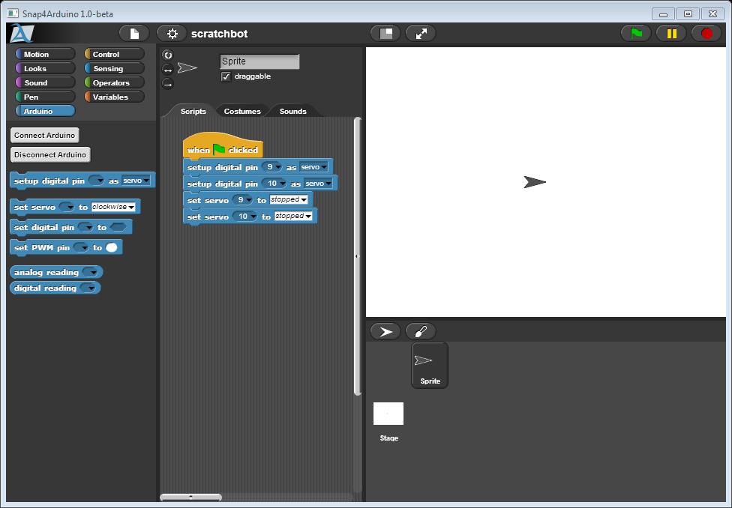

Add some keys for controlling the robot:

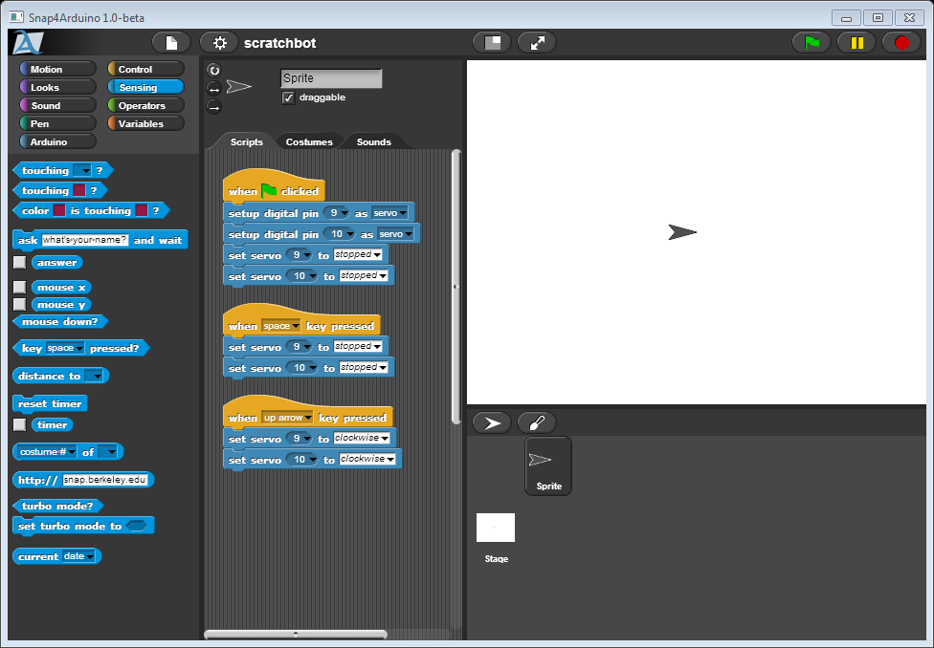

Once the robot moves as you would expect, try out the following ideas:

1. Add more keys that will make the robot do a dance or some other special move
2. Rewrite the program so that when you hold down the up, down, left, and right keys the robot moves, but as soon as you let go of the keys, the robot stops. (Hint: change the program to a forever loop and use the “key ____ pressed?” condition block)
3. Try making a graphical user interface in Snap to control the robot.

# Troubleshooting

|  |  |
| --- | --- |
| **Problem** | **Solution** |
| Wheel turns when it is supposed to be stopped | Your servo may not be adjusted correctly. Pick up your PawelBot and turn the servo adjustment screw with a phillips head screwdriver until the wheel stops. This should only need to be done once. If adjustment isn’t the problem, check the batteries. |
| Wheels turn slowly | When the batteries are low the servos run slower. If the batteries are too low the servos can behave strangely and not respond. Replace the batteries with new ones or fully charged |

# Bill of Materials

|  |  |  |  |
| --- | --- | --- | --- |
| **Part** | **Description** | **Suppliers** | **Cost** |
| Arduino Uno R3, Arduino Leonardo, or a clone | Processor board for robot | [Microcenter](http://www.microcenter.com/product/431997/Uno_R3_MainBoard)  [Adafruit](http://www.adafruit.com/products/50)  [Sparkfun](https://www.sparkfun.com/products/11021) | $25 for official Arduinos  $10-15 for clones |
| 6ft USB 2.0 A Male to B Male Cable | Connects your laptop to the Arduino. If you’re using an Arduino Leonardo, you’ll need a cable with a MicroUSB connector. | Amazon, Best Buy, etc.  [Monoprice](https://www.sparkfun.com/products/11021) | $2-$10 |
| Two SpringRC SM-S4303R Continuous Rotation Servos | Motors for wheels | [Pololu](http://www.pololu.com/product/1248) Ebay and hobby stores | $10-$13 each |
| 5/8” or 16 mm chrome steel ball | Front wheel | [McMaster-Carr](http://www.mcmaster.com/#9528k26/=vb59qy)  [Amazon](http://amzn.com/B00EYUTB2A) | $0.40-$0.50 per ball, but need to buy in 25-30 at a time |
| 4xAA battery holder | Hold batteries | [Pololu](http://www.pololu.com/product/1153) [Radio Shack](http://www.radioshack.com/radioshack-4-aa-battery-holder/2700391.html) | $1.19-$2.50 |
| #84 rubber bands | 3.5” x .5” rubber bands to give traction to the wheels | Staples |  |
| 3D-printed ball holder | Holds front ball. See [STL file](https://github.com/makenai/sumobot-jr/tree/master/3d_print). |  |  |
| Laser cut parts | PawelBot frame. See [cutting plans](https://github.com/makenai/sumobot-jr/tree/master/cutting_plans). |  |  |
| PawelBot Connection Board | Small PCB to connect the Arduino, servos, and power together | [OSH Park](https://oshpark.com/projects/AF9AwVrB) | $4.05 for 3 |
| 3/8” #6 sheet metal or wood screws | Attach the servos and ball holder to frame | [McMaster-Carr](http://www.mcmaster.com/#90190a146/=vb63xl) | $2.40 for 100 |
| 3/8” #4 sheet metal screws | Attach wheels to servo horns | [McMaster-Carr](http://www.mcmaster.com/#90190a108/=vb64m9) | $2.12 for 100 |
| 0.1” Breakaway Male Header: 1x40-Pin, Straight | Header pins for PawelBot Connection Board | [Digikey](http://www.digikey.com/product-detail/en/PREC040SAAN-RC/S1012EC-40-ND/2774814)  [Pololu](http://www.pololu.com/product/965)  Microcenter | $0.50-$1.00 each |
| 0.1” Crimp Connector Housing: 1x2 | Housing for making a connector for the battery pack | [Pololu](http://www.pololu.com/product/1901) | $0.69 for 25 |
| Wires with pre-crimped terminals. F-F 3” | If you don’t want to crimp pins onto the battery wires manually, this provides an easier way. | [Pololu](http://www.pololu.com/product/1806) | $9 for a pack of 25 |
| Double sided sticky tape | Attach the Arduino onto the top of the bot | Staples |  |